A Proposed Controller for Real-Time Management of Electrical Vehicle Battery Fleet with MATLAB/SIMULINK
Mahmoud M.Kiasari, Hamed H.Aly
Department of Electrical and Computer Engineering, Dalhousie University, Halifax, Canada
Abstract
The proliferation of smart grids (SG) has facilitated the integration of Renewable Energy (REs) sources, such as photovoltaic (PV) systems, into traditional grid infrastructure. As governments strive to mitigate the negative impacts of global warming, investment in these transparent energy sources has increased significantly. This research aims to develop a real-time management system utilizing MATLAB/Simulink for optimization of charging and discharging of Electrical Vehicle (EV) batteries, enhancing their role as auxiliary power sources. The key objectives are power consumption reduction, grid stability improvement, and bidirectional vehicle-to-grid (V2G) and grid-to-vehicle (G2V) power flow. The proposed simulation tackles challenges such as voltage and frequency regulations, power loss, and harmonic distortion. By the usage of commercial data, the model considers flexibility for EV owner based on their preferences and represents the power consumption of four EV batteries and four households. Key findings demonstrate that the system effectively maximized the utilization of EV batteries, leading to a significant enhancement in grid efficiency and stability. Moreover, the modified system supports the integration of other distributed energy sources, such as energy storage systems and demand-side management strategies. This paper provides a solution for enhancing rid performance with better sustainability through advanced EV battery management.
Keywords—Smart Grids, Renewable Energy Integration, Electric Vehicle Batteries, MATLAB/Simulink, Real-Time Management, Bidirectional Charging, Vehicle-to-Gird (V2G), Grid Stability and Efficiency
© 2024 Elsevier Inc. All rights reserved.

INTRODUCTION
Clean and efficient electric energy generation, transmission, and consumption are now required to offset the consequences of global warming. Because transportation-related greenhouse gas (GHG) emissions account for roughly 27% of total US GHG emissions, it is the leading source of US GHG emissions[1]. Between 1990 and 2020, GHG emissions in the transportation industry increased faster than in any other sector. As mentioned here[2], the European target is an EV share of 80% by 2050. The development of RE generation, energy storage, and EVs are among the critical stages toward cleaner and more efficient electricity and transportation sectors. With the growing number of electric vehicles, the interplay between the electric automobile and the energy grid is becoming increasingly apparent.
REs, particularly wind and PV, are grappling with generation unpredictability, as are other technologies that may assist humanity in solving daily difficulties. This is a widespread problem since most REs are inextricably linked to the weather. Despite the modern prediction equipment, this issue raises additional problems for affluent countries seeking to shift their power output to renewables. Another area for improvement is the high cost of the first equipment required to increase the budgets to ensure their existence at proper times. To some extent, EV batteries can solve some of these issues[3]. EV batteries or used as a storage system can manipulate mentioned challenges. Nowadays, alongside the V2X ( Vehicle to Everything), companies are looking to use used batteries to store energy and use them as the backup source of renewables, which could cause some problems for the grid[4]. On the other hand, the management of EVs or any RE link to the grid poses additional difficulty to the system. Some of the drawbacks include voltage and frequency variations, as well as system usage overloading[5].
Since there are infinite participants in the fleet, such as homes and vehicles, the system should be able to adapt to any situation. In recent years, MATLAB has assisted manufacturers and researchers in overcoming these types of difficulties and other related issues. By executing the proper structure of parts in that program, engineers may ensure that their project can be implemented appropriately for its utilization in most circumstances. Additionally, reducing mistakes and boosting efficiency are considered in this software.
Several research efforts and pilot projects have focused on developing and implementing V2G charging systems. These efforts have aimed to explore the potential benefits of V2G charging and to identify and address any technical or regulatory challenges that may arise. Some key challenges identified include developing compatible EVs and charging infrastructure, designing robust and reliable control systems, and addressing potential issues related to power quality and grid stability[6]. One challenge identified in the development of bidirectional EV charging systems is the limited scope of many current studies and pilot projects. Many of these studies have focused on small fleets of EVs, which may need to accurately reflect the behaviour or impact of V2G systems at larger scales. It can be challenging to forecast the advantages and difficulties of V2G systems and create effective plans for their implementation.
Another challenge is the need for the adjustability of renewable energy sources (REs) in some V2G systems. To optimize the use of an EV's battery, it is important to adjust the charging and discharging patterns based on the availability of REs and the grid's needs. However, if the REs are not adjustable, it can be difficult to effectively match the supply and demand of electricity and maximize the benefits of V2G systems.
A related challenge is using manual control units to decide when to switch between V2G or G2V mode. This can be time-consuming and may not be able to respond quickly enough during peak times or other periods of high demand. This may limit the ability of V2G systems to effectively support the grid and maximize the benefits of V2G charging.
Scaling up V2G systems introduces additional complexities. As more and more EVs are equipped with V2G chargers and connected to the grid, it can become increasingly complex to manage the flow of electricity and ensure that the grid remains stable and reliable. This may require the development of advanced control algorithms and technologies that can effectively coordinate the charging and discharging of multiple EVs in real-time.
This paper addresses the issues identified in previous works by proposing a novel, modified controller for a bidirectional EV charger. The main contribution of this paper is the development of this modified controller, which will be described in detail in a subsequent section. This paper will also provide a comprehensive analysis of the effectiveness of the proposed controller through extensive simulations and experiments. By doing so, this paper aims to make a significant contribution to the field of bidirectional EV charging and enhance the functionality and performance of such systems:
- Improved prediction of reference current for optimizing EV battery charging and discharging patterns, leading to efficiency and effectiveness of V2G systems enhancements.
- Utilization of logical elements to manage each battery situation, improving the scalability and reliability of V2G systems by conducting seamless switching between, V2G, G2V, and idle modes in response to changing demand or supply conditions.
- Integration of additional RE sources into the grid, promoting sustainability, reducing environmental impact, and providing economic benefits to owners and power companies.
- Providing flexibility and adjustment for EV owners based on their preferences offering three distinct operational options.

ENERGY MANAGEMENT

Introduction to the Energy Management System
The first generation of EV charging focused on injecting Energy from the grid into the EV. This one-way connection is referred to as unidirectional charging. In a subsequent form of charging, where the EV may also operate as a power source, injecting electricity into the grid is proposed. This type of charging is known as bi-directional charging[7]. EV batteries may be employed as an additional source for the grid with the aid of this innovative technology. In addition, an intelligent system is vital to make decisions regarding the state of each battery (Charge, Discharge, or Idle). This system's primary role is to manage EVs to operate as a source or load when other elements like power usage, time of day, and other sources are present. Recent papers [8], [9], [10], [11], [12] have proposed a bi-directional EV charging structure. The control portion of these models is crucial since it assists the system in determining its purpose for real-time prediction.
  - Objection and contribution
By increasing the number of fleet elements, having unmanaged charging for EVs has caused some problems. Flaws like voltage, frequency fluctuations, and power consumption overload could cause blackouts and harmonics distortion in tough times. These problems have led researchers to find a proper way to manage these increasing numbers of charging and discharging[13]. Some flaws and positive impacts after using controlled charging can be seen in Figure 1.
The main focus of this subject, as just mentioned before, is to modify a real-time management system by using MATLAB to mitigate problems in the minimum amount of time to handle any upcoming issues for the grid. In addition, by extending the model, it may become flexible enough to accommodate a large number of loads and sources in the scenarios that may occur in the future. Another novelty of this work is that the best effort has been made to use SIMULINK most specific element of this software, to decrease the complexity alongside increasing efficiency. This model, which can be implemented practically, could help EVs determine what condition they need in, V2G, G2V, and Idle. Since time was essential in this part, this model has been designed to have the best functionality, theoretically or practically. Moreover, the owner choice also should be considered in this work to encourage more EVs to participate in this grid. By allowing owners to choose between different modes, such as V2G, G2V, or a hybrid mode that combines both, they can align their vehicle's functionality with their individual preferences and needs. This level of customization empowers EV owners, as they can decide how their vehicles contribute to the grid or utilize Energy from it.

Figure 1 Uncontrolled and controlled EV charging impacts on the grid

DC fast charging station configuration for V2G/G2V
Figure 2[8] depicts the layout for a DC rapid charging station that may deploy V2G-G2V infrastructure in a microgrid. Off-board connections allow electric vehicle batteries to be linked to the DC bus. Charges. The DC bus and the grid are brought together via a grid-connected inverter—utility grid through a low-pass filter (LCL) and a step-up transformer. The essential parts of the charging station have been broken down here below. In the following parts, each element that has been used for this model is going to be discussed:
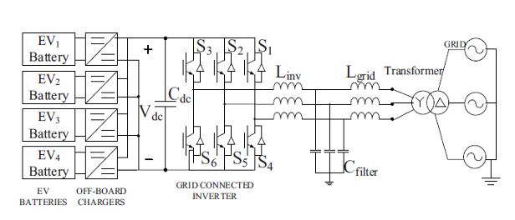
Figure 2 DC fast charging coupling
LCL Filter: A grid-side AC/DC converter designer must consider the effect of high-frequency harmonics created by traditional power devices that operate under high switching frequencies. As a result, a filter is installed to lower the high-frequency harmonics and protect the other sensitive electric equipment from disruption and power loss. Because of the intended system's high frequency, using a high-value inductance that would function as a high-frequency filter is impossible. Doing so would drive up the cost of the system while simultaneously lowering the system's dynamic responsiveness. For this reason, an LCL filter is used to reduce the harmonics of high-frequency current[14], [8]
 | $${\text{L}}_{\text{inv}}\text{= }\frac{{{\text{V}}_{\text{grid}}}^{\text{2}}\sqrt{\frac{{\text{Π}}^{\text{2}}}{\text{18}}\text{(}\frac{\text{3}}{\text{2}}\text{-}\frac{\text{4}\sqrt{\text{3}}}{\text{Π}}\text{+ }\frac{\text{9}}{\text{8}}{\text{m}}_{\text{a}}^{\text{2}}}}{{\text{S}}_{\text{rated}}\text{.THD.2Π}{\text{f}}_{\text{sw}}}$$ | $$( SEQ Equation \backslash * ARABIC 1)$$
 | $$C_{f}≤\frac{0.05S_{rated}}{2Π.f_{grid}.{V_{grid}}^{2}}$$ | $$(2)$$
 | $$L_{grid}= \frac{RAF+1}{RAF.C_{f}.2Π{f_{sw}}^{2}}$$ | $$(3)$$
 | $$C_{dc}= \frac{S_{rated}}{V_{dc}^{2}} \frac{2nT∆rCos∅}{∆x}$$ | $$(4)$$

In the context of electrical power conversion, the value of an inductor and capacitor in a converter circuit can be chosen based on several factors, including the switching frequency (f_{SW}) of the converter, the frequency (f_{grid}) of the grid voltage, the modulation index (ma) of the converter, the allowable range of total harmonic distortion (THD), and the ripple attenuation factor (RAF) for the specific design.
The f_{sw} is the rate at which the converter switches between different states, and it is typically chosen to be much higher than the f_{grid} to minimize switching losses and improve the converter's efficiency. The ma measures the extent to which the converter modulates the input voltage to control the output power, and it is an important factor in determining the converter's performance. The allowable range of THD is a measure of the amount of harmonic content present in the converter's output voltage of the converter, and it is important to keep it within acceptable limits to avoid negative impacts on the power quality of the grid. The RAF is a measure of the converter's ability to reduce the output voltage's ripple content, and it can be used to optimize the converter's performance in terms of voltage stability and ripple reduction. To determine the appropriate values of the inductor and capacitor for a given converter design, it is necessary to use equations that take into account these factors, as well as other variables such as the period (T) of the AC voltage waveform and the allowable range of change in the DC power (∆r) and DC bus voltage (∆x) during transients. These equations can provide valuable insights into the optimal design of a converter for a given application and can help to ensure that the converter operates with maximum efficiency and reliability$ADDIN ZOTERO_ITEM CSL_CITATION \{"citationID":"5cN6IiDd","properties":\{"formattedCitation":"[15]","plainCitation":"[15]","noteIndex":0\},"citationItems":[\{"id":176,"uris":["http://zotero.org/users/9870935/items/Z6S5FH5Q"],"itemData":\{"id":176,"type":"paper-conference","container-title":"The 2010 International Power Electronics Conference - ECCE ASIA -","DOI":"10.1109/IPEC.2010.5542131","event-place":"Sapporo, Japan","event-title":"2010 International Power Electronics Conference (IPEC - Sapporo)","ISBN":"978-1-4244-5394-8","page":"1688-1694","publisher":"IEEE","publisher-place":"Sapporo, Japan","source":"DOI.org (Crossref)","title":"LCL-filter design for grid-connected PCS using total harmonic distortion and ripple attenuation factor","URL":"http://ieeexplore.ieee.org/document/5542131/","author":[\{"family":"Park","given":"Min-Young"\},\{"family":"Chi","given":"Min-Hun"\},\{"family":"Park","given":"Jong-Hyoung"\},\{"family":"Kim","given":"Heung-Geun"\},\{"family":"Chun","given":"Tae-Won"\},\{"family":"Nho","given":"Em-Cheol"\}],"accessed":\{"date-parts":[["2022",11,16]]\},"issued":\{"date-parts":[["2010",6]]\}\}\}],"schema":"https://github.com/citation-style-language/schema/raw/master/csl-citation.json"\} [15]$. Different parts of the LCL filter also can be seen in Figure 3.
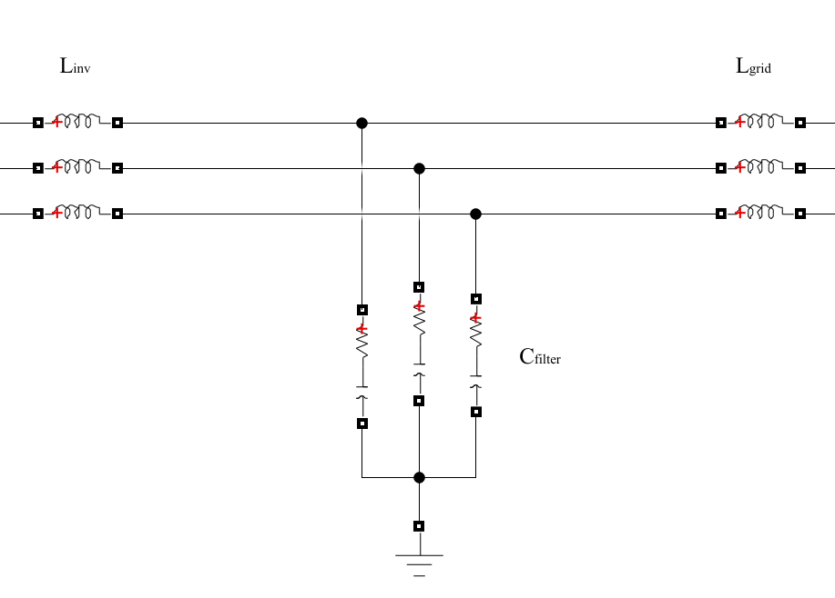
Figure 3 LCL filter
Inverter: Electric car inverters convert the DC flow from the battery pack to an AC that powers the electric traction motor[16]. Inverters are essential for EVs since lithium-ion batteries can only absorb DC power, and electric traction motors need AC electricity. The frequency of the AC sent to the motor is another function of inverters, which directly affects how fast an EV travels. Figure 2 depicts the structure of converting AC to DC inverters. The input below is the three-phase AC from the grid that will do this conversion using electronic parts like MOSFET and Pulse Width Modulator (PWM).
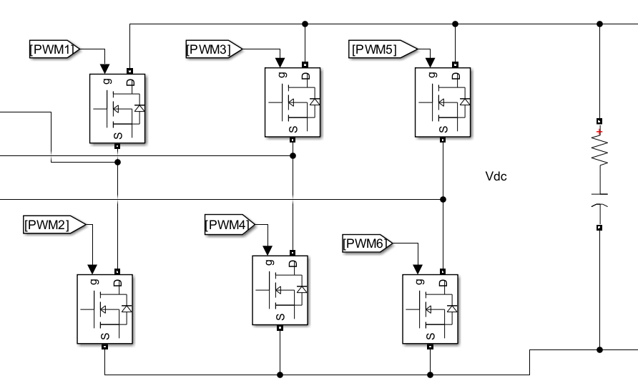
Figure 4 Inverter
Buck-Boost Converter: A buck-boost converter facilitates the power flow between an EV and the grid in a bidirectional EV charger. The converter can operate in either a "buck" mode or a "boost" mode, depending on the direction of power flow. In the "buck" mode, the converter functions as a buck converter and brings the input voltage down to the level needed to charge the battery of the EV. In the "boost" mode, the converter functions as a boost converter and increases the input voltage to the level needed for V2G[8]. A smart condition management system can be used to decide which mode the converter should operate in based on feedback characteristics such as the voltage of each battery and the power consumption of the grid. The system can continuously monitor these parameters and use algorithms to determine the optimal mode of operation for the converter. For example, if the grid power consumption is high and the voltage of the EV battery is low, the system may decide to operate the converter in the "boost" mode to discharge power from the battery to the grid.
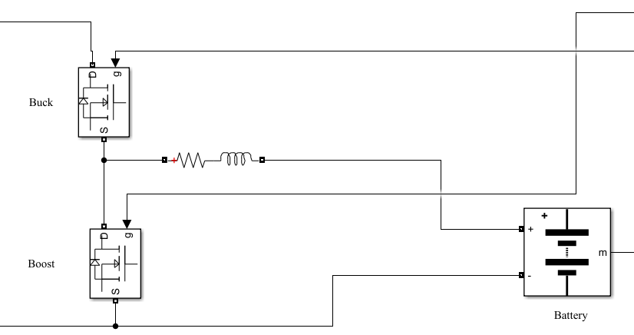
Figure 5 Buck/Boost converter
On the other hand, if the grid power consumption is low and the voltage of the EV battery is high, the system may decide to operate the converter in the "buck" mode to charge the battery from the grid. Using a smart condition management system can improve the performance and efficiency of the bidirectional EV charger by ensuring that the converter is always operating in the most appropriate mode for the current conditions. It can also help to maximize the use of the EV battery as a grid storage resource by enabling the system to respond dynamically to changes in grid power demand.
Three-Phase Voltage/Current to Two-Phase: The transformation from the three-phase voltage components V_{ABC} to the direct-quadrature (DQ) components V_{DQ} is a critical process in the power systems analysis and control of electric machines and power systems. This transformation is achieved by the usage of Park transformation, which converts the three-phase stationary reference frame (ABC) into the two-phase rotating reference frame (DQ). The main idea behind this transformation is to convert sinusoidal signals into DC quantities for the control systems of electrical machines simplification. In this form, D-axis represents the rortor magnetic field, while the Q-axis is a vector that is perpendicular to the D-axis. Utilizing this transformation helps in decoupling the torque and flux control in motor drives that leads to enhancement in the performance and efficiency of the control systems. Similarly, there is a three-phase to two-phase conversion in the current, where I_{ABC} would transform to I_{DQ}. This transformation leads to independent control of the current components, that correspond to torque and flux in AC machines. I_{D} is responsible for magnetizing current, for flux stabilization, and I_{Q} controls the torque-producing current. This decoupling of currents simplifies the implementation of vector control techniques, that improve the dynamic performance and precision in AC machine control and conversion In various industrial applications[17].
 | $$V_{D} = \frac{2}{3} ( V_{A}\cos{θ + V_{B}\cos\left(θ - \frac{2π}{3}\right){+ V_{C}\cos{(θ + \frac{2π}{3}))}}}$$ | $$(5)$$
 | $$V_{Q} = \frac{2}{3} ( V_{A}\sin{θ}{ + V_{B}\sin\left(θ - \frac{2π}{3}\right)+ V_{C}\sin{(θ + \frac{2π}{3}))}}$$ | $$(6)$$
 | $$V_{0} = \frac{1}{3} (V_{A} + V_{B} + V_{C})$$ | $$(7)$$
 | $$I_{D} = \frac{2}{3} ( I_{A}\cos{θ + I_{B}\cos\left(θ - \frac{2π}{3}\right){+ I_{C}\cos{(θ + \frac{2π}{3}))}}}$$ | $$(8)$$
 | $$I_{Q} = \frac{2}{3} ( I_{A}\sin{θ}{ + I_{B}\sin\left(θ - \frac{2π}{3}\right)+ I_{C}\sin{(θ + \frac{2π}{3}))}}$$ | $$(9)$$
 | $$I_{0} = \frac{1}{3} (I_{A} + I_{B} + I_{C})$$ | $$(10)$$
In these equations, which it depicts the Park transformation, $V_{A}, V_{B}, V_{C}$ represent the three-phase voltages in the stationary reference frame. Alongside with $I_{A}, I_{B}, I_{C}$ that show the current related to previous voltages. $V_{D}, V_{Q}$ and $I_{D}, I_{Q}$ respectively symbolize the voltage and current for direct and quadrature components in the rotating reference frame. $V_{0}$ or zero-sequence shows the average of the three-phase voltages in the previous equations alongside with $I_{0}$ in the current domain. Lastly, $θ$ is the angle of the rotating reference frame, that is typically the angle of the rotor in synchronous machines[17].
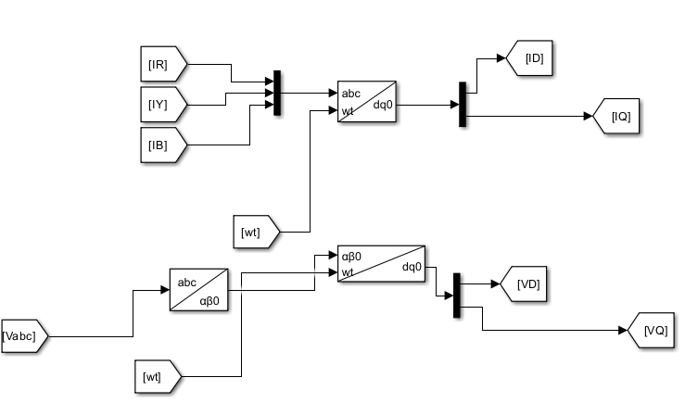
Figure 6 Three-Phase Voltage/Current to Two-Phase

Battery charging
Lithium-ion batteries are widely used in various applications, including EVs and mobile phones. The typical voltage range for these batteries is 320-400 volts, but some manufacturers seek to produce EVs with higher battery pack output voltages to improve performance and efficiency. The benefits of higher battery pack voltages include higher RPM (revolutions per minute) and the ability to use lighter charging cables. However, several challenges are associated with higher battery pack voltages, including potential issues with maintenance and safety and using more costly fuses to control the voltage. In addition, the capacity of a battery pack can be limited by its weakest cell, which is a consideration when designing packs with a large number of cells wired in series. It is generally more favourable to use packs of numerous lower-capacity cells connected in parallel, followed by series connections, rather than single giant format cells wired in series[18], [19].

Control system
The most important part of the bi-directional charging circuit is the control part. Where PWM executing signal, buck-boost mode, reference current or voltage of the battery and the operational mode of each battery will be selected. In the upcoming parts, each part of Figure 4 shows the structure of the control parts[8]. An inverter controller is responsible for converting DC from the battery pack into AC to power the electric traction motor in an EV. The inverter controller is an essential component of the EV, as lithium-ion batteries can only provide DC power, and the electric traction motor requires AC electricity. This paper will talk about one potential innovation in inverter controllers: the development of smart control systems that can automatically determine the appropriate reference current and voltage values rather than requiring these values to be manually specified. Such a system could improve the efficiency and performance of the inverter controller and make the charging process more convenient for the user. The approach to achieving this goal is to use feedback control techniques that allow the inverter controller to continuously adjust the reference current and voltage values based on the measured performance of the system. Using sensors and algorithms to monitor the system's behaviour, the inverter controller can make real-time adjustments to optimize the charging process and ensure that the EV receives the appropriate power.

FLEET MODEL ANALYSIS AND DISCUSSION
A model for a fleet of electric vehicles that is capable of bidirectional charging is presented in this paper[8]. The problems related to that model have been discussed in Chapter 1. In this part of the paper, the proposed model will be elaborated. Also, since the model implementation on it employed battery current as a reference of V2G/G2V/Idle operation, this updated one will likewise concentrate on that aspect of the process. The present forecast will be made automatically and carried out entirely using the logical components available in MATLAB/Simulink. Without the assistance of the feedback system, which the control component will acquire from each element at a given moment, this problem will not be able to be resolved.
Several options have been considered to give owners control over their electric vehicles (EVs) integration into the grid. These options give owners the ability to adjust their EVs' behaviour. Figure 8 illustrates the three available options for each EV. Option 1 allows users to participate in vehicle-to-grid (V2G) or grid-to-vehicle (G2V) plans. Option number -1 enables the user to charge their car without grid interaction. Lastly, option 0 allows users to disconnect their car from charging altogether. Considering that different owners have varying preferences regarding EV involvement, an additional option called Min-Soc has been implemented.

Figure 7 Options for EV Integration into the Grid
This option allows users to determine the minimum battery level at which they are comfortable discharging their car. By selecting the Min-Soc value, users can signal the controller system to regulate the usage of their EV based on specific circumstances. Three mentioned options can be seen in Figure 7.
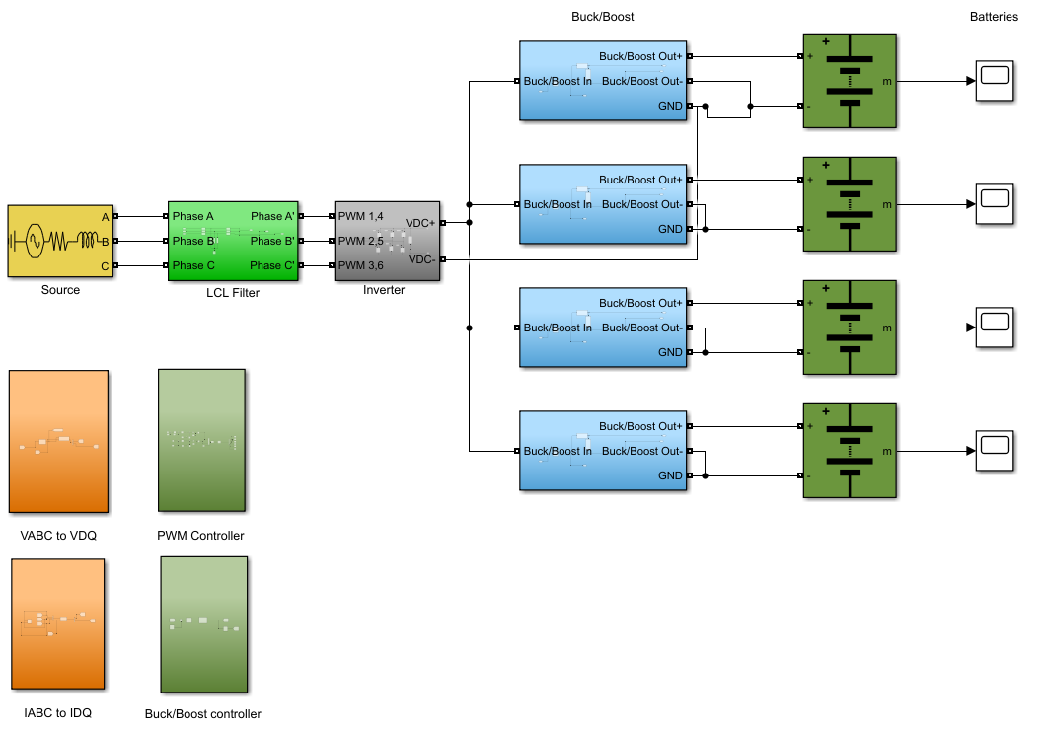
Figure 8 Modified fleet model

Buck/Boost Controller

Figure 9 represents a control system for managing the SoC and an EV battery's operational modes (V2G, G2V, and Idle) using a buck-boost converter. Utilizing various inputs in this simulation section is for identifying the appropriate mode of operation and controlling the charging or discharging of the EV battery according to the dedicated conditions. Inputs include minimum SoC set by the user ( where they have this flexibility to decide if their battery is used as an ancillary source, and for how long the grid can use it ), mode selector input ( allowing users to set the EV mode based on their preferences ). The system also monitors the current SoC and the current that the battery absorbs (which has a direct relationship with the temperature of the battery ), alongside the reference current (which can be modifed by the expert to optimize the charging or discharging process. Another condition considered for this work is the time, as based on different times of the day, some default ( or modifed condition ) is used to enhance the user convenience throughout the EV usage. By combining all of these inputs, the system can decide that at each specific time, the EV should act in which conditions of charging/discharging/idle mode. Figure 10, depicts the main idea of decision making that by using different inputs and having controller components making decisions for each battery condition.
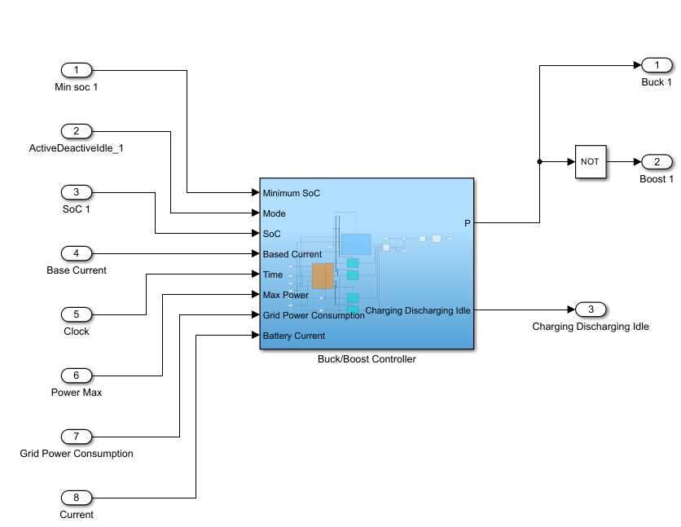
Figure 9 Buck/Boost controller for each battery
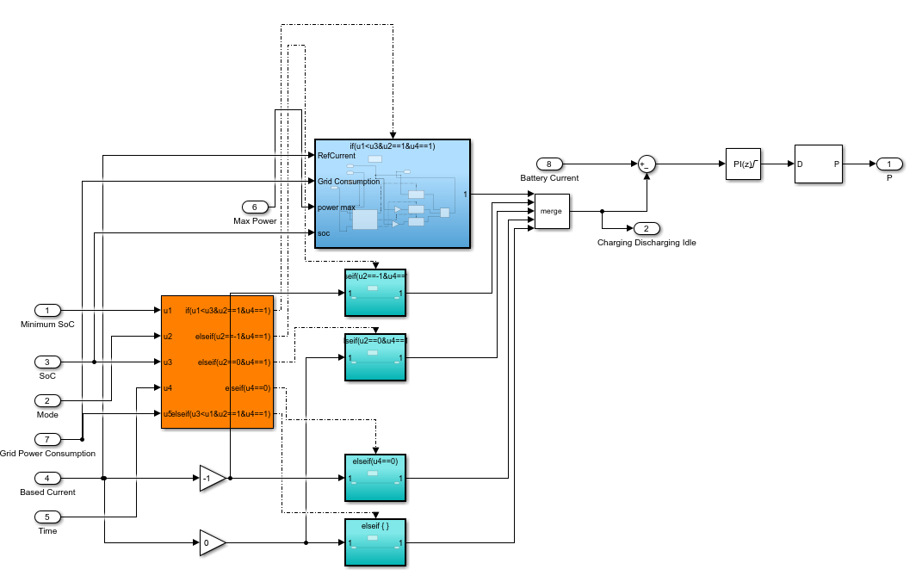
Figure 10 Buck/Boost controller for each battery in detail
For the current model, as shown in Figure 10, 9 different inputs are considered to make Simulink decide the condition of each EV battery. However, Battery Soc Min and Owner Choice are two options related to the EV owner by which they can adjust their EV car for availability in this system. Power Consumption Min and Power Consumption Max are two default options that would be considered for the system based on the previous data. For instance, in this paper[20], the vehicle will do the V2G operation if the home's power usage is more than 9 kW and the car has an excessive charge SOC of less than 60%. If the power usage is modest, less than 3 kW, and the battery's capacity is below 40%, the vehicle will be charged between midnight and 6 am.

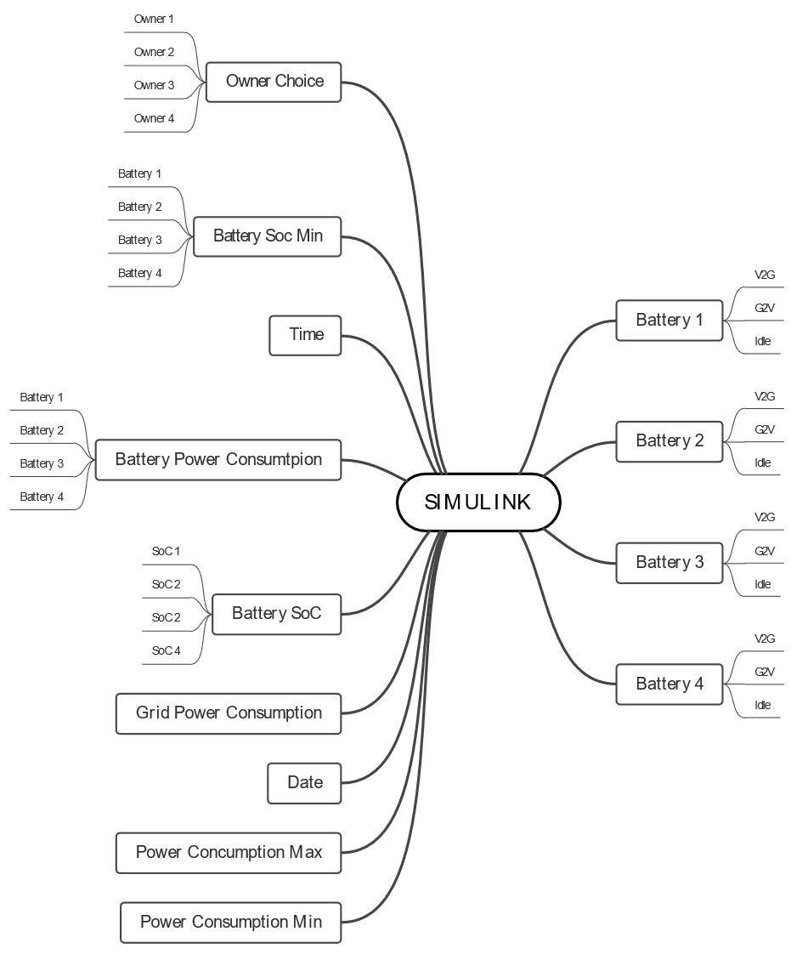
Figure 11 SIMULINK input/output
Table 1 Values for model parameters
Parameters | Values
Phase-to-phase voltage | 480 V
Source frequency | 60 Hz
Source resistance | 0.8929e-3 Ω
Source inductance | 16.58e-9 H
L _{grid} / L _{inv} | 0.69e-3 H / 0.49e-3 H
C_{f} | 8100e-3F
Inverter output DC resistance | 1e-3 Ω
Inverter output DC inductance | 5600e-6 F
Inverter output capacity initial voltage | 800 V
Series RL for battery input | 13e-3 H / 0.0001 Ω
Parallel RC for battery input | 0.0001 H / 20e-6 F
Battery 1 / 2 / 3 / 4 nominal voltage | 360 V
Battery 1 / 2 / 3 / 4 rated capacity | 150 Ah
Battery 1 / 2 / 3 / 4 initial SOC | 75% / 35% / 25% / 85%
Switching frequency | 10 kHz
Rated power | 10 kW
PID VDC reference | 800 V
PID VDC for IQ gains | 0.376 / 2
PID IQ reference | 0
P for PID controller VDC and IQ | 0.5 / 25
I for PID controller VDC and IQ | 25
P for PID controller PLL | 10
I for PID controller PLL | 50000
P for PID controller for Ibatt reference | 0.005
I for PID controller for Ibatt reference | 10
I_{batt} reference | 200 A
This paper has chosen another approach for determining the condition checker threshold. To arrive at these decision criteria, statistical data from the previous day was used to make assumptions about possible power usage and battery capacity values. In particular, the quantiles of the data were employed to determine the minimum and maximum power usage values. The first quantile (Q1) represents the value below which 25% of the data points fall when sorted in ascending order, while the third quantile (Q3) represents the value at which 75% of the data points fall when the data is sorted in descending order. In this study, Q1 was treated as the minimum power consumption value, while Q3 was treated as the maximum.
This approach has several advantages over more rigid decision-making frameworks. For example, it allows for greater flexibility in determining the appropriate power usage range, as it can be adjusted to accommodate both centralized and decentralized grids with varying consumption levels. Additionally, relying on statistical data from the previous day helps ensure that actual usage patterns inform the decision-making process rather than relying on assumptions that may not accurately reflect the reality of the system.
The number of possibilities that the system should check based on the number of EVs can be concluded from the below formula:
 | $$2^{N+1}+1$$ | $$\left(10\right)$$
N is the number of inputs for this management. To evaluate the performance of this system, data was collected and used in the modified model. Each battery's charge state was represented by a constant number block in the model, with 1 indicating the period from 3 pm to 12 am and 0 indicating the period from 12 am to 6 am.
Due to the limitations of the research model and the available hardware for simulating the model, the fleet consisted of only four ancillary sources and four loads. Each decision made by the if block would trigger a corresponding action for a particular battery, and all of these actions would be carried out in sequence.
It was assumed that EVs would not charge during the day unless special circumstances warranted discharging their batteries or remaining idle. However, after midnight, they would shift their focus to charging if the conditions remained unchanged. A positive current value indicates that the EV is operating in V2G mode, a negative value indicates that the battery is functioning as a load or in G2V mode, and a zero value indicates that the battery is in idle mode.

MATLAB/Simulink model
Figure 5 depicts the model just proposed for the decision-making of each battery current based on its inputs. They will be discussed in depth in future parts.
- Condition Checking Part: As it is shown in Figure 8, the inputs that are for this subject will be connected to the decision maker part, and this section, based on its default assumptions just mentioned before, will determine which blocks should be activated. Power consumption consists of two blocks; one is from 12 am to 6 am, and the other one is from 3 pm to 12 am.
- PID Controller: After deducting each current to the specific battery, the output of "merge" in Figure 8 would be a current that goes to each battery PID. The positive current means the EV battery is charging, the negative one means discharging, and the 0 means idle. The important part is that having that PID would adjust the battery's current to help it understand its condition. This process will take a little time; however, this time would be so low that it could not affect the whole process. An essential part of PID controllers is their output. As seen in Figure 8, PID controllers not only have the responsibility to lead their specific battery current to the one just received from the signal accumulator but also specify the output value that determines each battery's buck/boost mode. The output of this logical component would be 1 or 0; based on that, only one of the modes (Buck/Boost) will be activated. In this manner, each battery knows in which situation should act as a source, load, or idle. To categorize each battery condition, a positive one (+1) is assumed as V2G mode, a negative one (-1) is considered as G2V mode, and the zero (0) one is Idle mode. Dedicating numbers to each condition is arbitrary, and every number can be assumed. However, these numbers have been chosen based on this paper[29].
- Buck/Boost converter: After having a positive, negative, or 0 current, this number would lead to a "PWM Generator" component that has the responsibility of converting the current to 1 or 0. The output of this logical component would be 1 or 0; based on that, only one of the modes (Buck/Boost) will be activated. In this manner, each battery knows in which situation should act as a source, load, or idle. To categorize each battery condition, a positive one (+1) is assumed as V2G mode, a negative one (-1) is considered as G2V mode, and the zero (0) one is Idle mode. Dedicating numbers to each condition is arbitrary, and every number can be assumed. However, these numbers have been chosen based on this paper[29]. One important note about this one is that since there is no specific Idle mode for the output since there are 1 and 0, in a time that a battery would be in Idle situations, the PWM Generator would be 1 and 0 in a short time with a high frequency of 10,000hz to satisfy the Idle situation of not charging a battery.

RESULTS
As previously indicated, this fleet simulation is broken into two separate daylight periods. The first one is from three in the afternoon to noon when the vehicles just arrived in the fleet will be linked to it. Furthermore, the second half is between twelve midnight and six in the morning when the consumption is not as high, and the electric vehicles have the opportunity to charge their batteries. Also, Table 2 demonstrates each user's preference for EV availability. As can be seen, two users have decided to give their EVs to the system while one of the EVs is disconnected, and another only wants the car to be charged. Based on these choices and since there is also a minimum soc for each EV, only the first EV can be accessible for the grid to be used in the peak mode.
Table 2 EV owner's choice and min soc
Owner Number | Owner Choice | Min Soc
#1 | 1 | 40%
#2 | 0 | --
#3 | -1 | --
#4 | 1 | 50%

3 pm to 12 pm
For this time of the day, based on mentioned conditions, if the EV battery capacity was more than 60 per cent and fleet consumption for each house was more than 9kW, batteries can act as an ancillary source and be V2G. For others who can not demand this situation, they will remain Idle or be charged if the load consumption is less than 3kW not to put pressure on the grid during peak load times. This fact can be seen in Figure 11.

Figure 12 Grid power consumption from 3 pm to 12 am

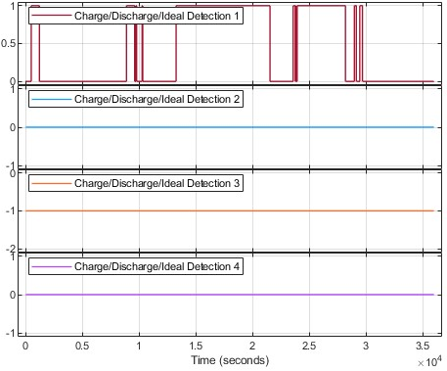
Figure 13 Charge/discharge 3 pm to 12 am
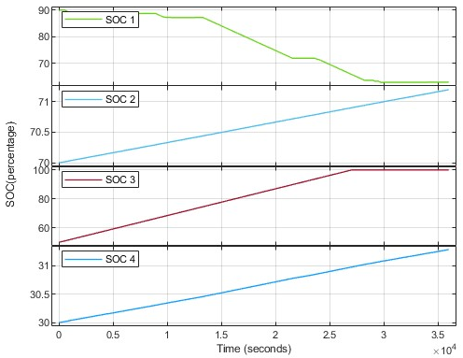
Figure 14 Soc 3 pm to 12 am
Figure 10 shows the power usage during that period based on the statistics. Figure 11 also shows each V2G/G2V/Idle mode's battery condition. As it can be seen since the grid is exposed to peak load, the batteries with ideal conditions work in V2G mode (-1), and the others act in idle modes (0). Figure 12 also depicts the same scenario of the current situation. The timing is in seconds, representing the same range of 3 pm to 12 am.

12 am to 6 am
For the second time span, since the default assumption is to ensure each owner could have their car fully charged for the next day, all EVs would act as charging or G2V condition. In this way, as shown in Figure 13, all EVs are automatically -1 or G2V. Also, in Figure 14, all of them are charging to reach the fully charged situation.
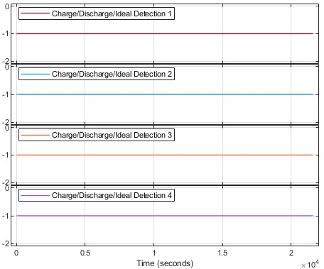
Figure 15 Charge/discharge 12 am to 6 am
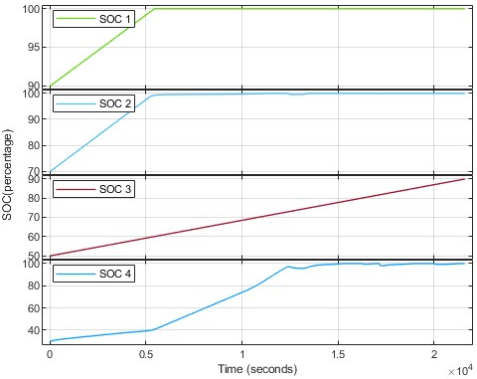
Figure 16 Soc 12 am to 6 am

CONCLUSION
The paper presents a MATLAB model for EV battery management fleets that aims to improve the existing models in the field. The efficient management of EV battery fleets is becoming increasingly important as the number of electric vehicles on the road grows. The proposed model addresses the challenges of managing large fleets of EV batteries by introducing a simplified yet accurate approach. The model proposed in the paper is designed to be more efficient and accurate than previous models while also being able to handle large fleet numbers without adding unnecessary complexity. The proposed model is a valuable contribution to the field as it offers a simplified yet accurate approach to managing EV battery fleets. Practitioners can easily implement this approach, allowing them to manage large fleets of EV batteries more efficiently while reducing the overall cost of EV fleet management. The proposed model can be seen as an important step forward in developing EV battery management systems, and it can be expected to be widely adopted in the industry.

FUTURE WORKS
It is important to note that the model presented in this paper is limited in scope and only considers a limited number of fleets. This is due to the theoretical considerations involved and the constraints imposed by the technology. However, it is important to recognize the significant potential for future work in this area, enabling the system to accommodate unlimited EVs and residences. One potential area of future work could focus on the programming aspect of the model. By utilizing more advanced programming techniques, the model could be optimized to handle larger chunks of data more efficiently. This would allow the system to handle unlimited EVs and residences without slowing down.
Additionally, using fewer actual blocks in the model would be beneficial as this can slow down the system when dealing with larger chunks of data. Another area of future work could involve the integration of other loads and energy sources into the model. For example, the system could be expanded to include renewable energy sources such as photovoltaics (PV) or other forms of Renewable Energy. This would enable the system to consider the availability of renewable energy sources and optimize the management of EV battery fleets accordingly. This could lead to the development of more sustainable and eco-friendly EV fleet management systems.

REFERENCES
[1] EPA, “Carbon Pollution from Transportation,” Carbon Pollution from Transportation. Accessed: Aug. 06, 2022. [Online]. Available: https://www.epa.gov/transportation-air-pollution-and-climate-change/carbon-pollution-transportation
[2] European Environment Agency., Electric vehicles in Europe. LU: Publications Office, 2016. Accessed: Oct. 10, 2022. [Online]. Available: https://data.europa.eu/doi/10.2800/100230
[3] Q. Dang, D. Wu, and B. Boulet, “Electric Vehicle Battery as Energy Storage Unit Consider Renewable Power Uncertainty,” in 2021 IEEE Energy Conversion Congress and Exposition (ECCE), Vancouver, BC, Canada: IEEE, Oct. 2021, pp. 668–673. doi: 10.1109/ECCE47101.2021.9595375.
[4] M. H. S. M. Haram, J. W. Lee, G. Ramasamy, E. E. Ngu, S. P. Thiagarajah, and Y. H. Lee, “Feasibility of utilising second life EV batteries: Applications, lifespan, economics, environmental impact, assessment, and challenges,” Alex. Eng. J., vol. 60, no. 5, pp. 4517–4536, Oct. 2021, doi: 10.1016/j.aej.2021.03.021.
[5] S. Alshahrani, M. Khalid, and M. Almuhaini, “Electric Vehicles Beyond Energy Storage and Modern Power Networks: Challenges and Applications,” IEEE Access, vol. 7, pp. 99031–99064, 2019, doi: 10.1109/ACCESS.2019.2928639.
[6] O. N. Nezamuddin, C. L. Nicholas, and E. C. D. Santos, “The Problem of Electric Vehicle Charging: State-of-the-Art and an Innovative Solution,” IEEE Trans. Intell. Transp. Syst., vol. 23, no. 5, pp. 4663–4673, May 2022, doi: 10.1109/TITS.2020.3048728.
[7] X. Yan, B. Guan, and X. Du, “Bidirectional Charging Strategy of Electric Vehicle based on Predictive Control Method,” in 2021 International Conference on Power System Technology (POWERCON), Haikou, China: IEEE, Dec. 2021, pp. 789–793. doi: 10.1109/POWERCON53785.2021.9697595.
[8] F. M. Shakeel and O. P. Malik, “Vehicle-To-Grid Technology in a Micro-grid Using DC Fast Charging Architecture,” in 2019 IEEE Canadian Conference of Electrical and Computer Engineering (CCECE), Edmonton, AB, Canada: IEEE, May 2019, pp. 1–4. doi: 10.1109/CCECE.2019.8861592.
[9] A. Arancibia and K. Strunz, “Modeling of an electric vehicle charging station for fast DC charging,” in 2012 IEEE International Electric Vehicle Conference, Greenville, SC, USA: IEEE, Mar. 2012, pp. 1–6. doi: 10.1109/IEVC.2012.6183232.
[10] G. B. Sahinler and G. Poyrazoglu, “Modeling and Simulation of Three-Phase Bidirectional Electric Vehicle Charger,” in 2021 3rd Global Power, Energy and Communication Conference (GPECOM), Antalya, Turkey: IEEE, Oct. 2021, pp. 21–27. doi: 10.1109/GPECOM52585.2021.9587631.
[11] E. H. E. Bayoumi, “Design of Three-Phase LCL-Filter for Grid-Connected PWM Voltage Source Inverter Using Bacteria Foraging Optimization,” in Electricity Distribution, P. Karampelas and L. Ekonomou, Eds., in Energy Systems. , Berlin, Heidelberg: Springer Berlin Heidelberg, 2016, pp. 199–219. doi: 10.1007/978-3-662-49434-9_8.
[12] S. R. B. and V. C., “Analysis of modified plug-in electric vehicle charger controller with grid support functionalities,” PLOS ONE, vol. 17, no. 1, p. e0262365, Jan. 2022, doi: 10.1371/journal.pone.0262365.
[13] M. Nour, J. P. Chaves-Ávila, G. Magdy, and Á. Sánchez-Miralles, “Review of Positive and Negative Impacts of Electric Vehicles Charging on Electric Power Systems,” Energies, vol. 13, no. 18, p. 4675, Sep. 2020, doi: 10.3390/en13184675.
[14] P. Thomas and F. M. Chacko, “Electric vehicle integration to distribution grid ensuring quality power exchange,” in 2014 International Conference on Power Signals Control and Computations (EPSCICON), Thrissur, India: IEEE, Jan. 2014, pp. 1–6. doi: 10.1109/EPSCICON.2014.6887512.
[15] M.-Y. Park, M.-H. Chi, J.-H. Park, H.-G. Kim, T.-W. Chun, and E.-C. Nho, “LCL-filter design for grid-connected PCS using total harmonic distortion and ripple attenuation factor,” in The 2010 International Power Electronics Conference - ECCE ASIA -, Sapporo, Japan: IEEE, Jun. 2010, pp. 1688–1694. doi: 10.1109/IPEC.2010.5542131.
[16] L. Chen and B. Ge, “High Power Traction Inverter Design and Comparison for Electric Vehicles,” in 2018 IEEE Transportation Electrification Conference and Expo (ITEC), Long Beach, CA, USA: IEEE, Jun. 2018, pp. 583–588. doi: 10.1109/ITEC.2018.8450259.
[17] V. Totev and V. Gueorgiev, “Comparison of different types of space vector modulation for electric vehicle’s application,” in 2022 14th Electrical Engineering Faculty Conference (BulEF), Varna, Bulgaria: IEEE, Sep. 2022, pp. 1–6. doi: 10.1109/BulEF56479.2022.10021162.
[18] Q. Zhang, C. Li, and Y. Wu, “Analysis of Research and Development Trend of the Battery Technology in Electric Vehicle with the Perspective of Patent,” Energy Procedia, vol. 105, pp. 4274–4280, May 2017, doi: 10.1016/j.egypro.2017.03.918.
[19] J. Jenkins, “High-voltage EV battery packs: benefits and challenges. More voltage, more better?” [Online]. Available: https://chargedevs.com/features/high-voltage-ev-battery-packs-benefits-and-challenges-more-voltage-more-better/
[20] S. Morsalin, K. Mahmud, and G. Town, “Electric vehicle charge scheduling using an artificial neural network,” in 2016 IEEE Innovative Smart Grid Technologies - Asia (ISGT-Asia), Melbourne, Australia: IEEE, Nov. 2016, pp. 276–280. doi: 10.1109/ISGT-Asia.2016.7796398.

