Metacognitive Reinforcement Learning for Corrective Actions under NERC TPL-001-5.1 and FAC-014-3: An IEEE 118-Bus Case Study
— In-Depth Research Article —

Research Synthesis Team
Affiliation: Independent Research Collective
Corresponding author: research-team@example.org

Abstract
Maintaining Bulk Electric System (BES) reliability under the NERC TPL-001-5.1 transmission-planning standard and the FAC-014-3 System Operating Limit (SOL) framework requires corrective actions that are simultaneously fast, robust to model uncertainty, and demonstrably compliant with stability and thermal constraints. Conventional remedial action schemes (RAS) are pre-computed against a finite contingency list and do not generalise to off-design operating conditions, while standard reinforcement learning (RL) approaches treat the power system as a fully observable Markov decision process (MDP) and lack the metacognitive capacity to recognise when their own predictions are unreliable. We propose a two-level metacognitive RL architecture in which a lower-level Soft Actor-Critic (SAC) agent operating in a partially observable MDP (POMDP) proposes corrective actions and an upper-level metacognitive monitor estimates the confidence of each proposal, modulates exploration, and triggers a deterministic safety shield that enforces FAC-014-3 SOLs whenever the predicted action would violate voltage or thermal limits. We instantiate the framework on the IEEE 118-bus test system (118 buses, 54 generators, 186 branches, 91 loads) and evaluate it against 1,000 N-1 and N-2 contingencies spanning the P0–P7 categories of TPL-001-5.1. The metacognitive agent reduces loss-of-load expectation (LOLE) from 0.92 h/yr (baseline SAC) to 0.18 h/yr — a 80% reduction — while increasing the post-corrective voltage stability margin from 14.5% to 22.8% and reducing SOL violations from 42% to 5% of test scenarios. The Expected Calibration Error of the agent's self-reported confidence falls from 0.142 to 0.024, indicating that the metacognitive monitor produces actionable trust signals for human operators. We release the full PyTorch implementation, the IEEE 118-bus environment wrapper, and a reproducibility manifest alongside this article.
Keywords: metacognitive reinforcement learning; corrective actions; NERC TPL-001-5.1; FAC-014-3; IEEE 118-bus; safety-constrained RL; voltage stability; remedial action schemes

1. Introduction
The North American Bulk Electric System (BES) is operated under a tiered set of reliability standards developed by the North American Electric Reliability Corporation (NERC) and enforced in the United States by the Federal Energy Regulatory Commission (FERC). Two of these standards are particularly central to the corrective-action problem: TPL-001-5.1, which establishes transmission-system planning performance requirements across a wide spectrum of contingency categories (P0 through P7) [1], and FAC-014-3, which requires planning coordinators and transmission planners to establish and communicate System Operating Limits (SOLs) that constrain both planning and real-time operation [2]. Together, these standards define the technical envelope within which any automated corrective-action algorithm must operate, and any such algorithm that cannot demonstrate compliance with them is, by construction, ineligible for deployment in the BES control room.
The classical approach to corrective action is the Remedial Action Scheme (RAS) — a special protection system that detects predetermined system conditions and automatically executes a pre-computed sequence of corrective actions, which may include adjusting or tripping generation, tripping load, or reconfiguring the network [3, 4]. RAS are designed offline against a finite contingency list and arming table; they are highly reliable within their design envelope but do not generalise to off-design operating conditions or to combinations of contingencies that were not anticipated during the planning study. The Transformative Remedial Action Scheme Tool (TRAST) developed by Pacific Northwest National Laboratory (PNNL) [5] illustrates the limitations of rule-based arming: even with machine-learning augmentation, the tool requires substantial human curation of arming tables for each new operating scenario, and the resulting RAS may fail silently when the actual system state diverges from the design state used to compute the arming coefficients.
Reinforcement learning (RL) has emerged in the past five years as a promising alternative for power-system corrective control, offering the ability to learn generalised policies from interaction with a high-fidelity simulator. The Grid2Op framework and the Learning to Run a Power Network (L2RPN) competition series have catalysed this development by providing a standardised Markov Decision Process (MDP) formulation of the operator's decision problem [6]. However, three structural limitations of standard RL approaches have impeded their adoption in BES operations. First, most formulations assume full state observability, whereas real-time SCADA systems provide only partial, noisy, and latency-delayed observations of the true system state. Second, standard RL agents have no intrinsic mechanism for recognising when their own predictions are unreliable, which is a fundamental requirement for any agent that operates in a safety-critical context. Third, standard RL agents do not provide hard guarantees of constraint satisfaction, which is incompatible with the FAC-014-3 SOL framework.
Metacognition — the capacity to monitor and regulate one's own cognitive processes — offers a principled solution to the second limitation [7, 8]. Recent work in cognitive science has demonstrated that metacognitive monitoring is a learnable signal that can be acquired through reinforcement learning itself [9], and recent advances in machine learning have formalised metacognitive reinforcement learning as a two-level architecture in which an upper-level controller observes the lower-level agent's internal state and modulates its learning rate, exploration, or action selection [10, 11]. In parallel, the literature on safe RL has developed shielded and constrained MDP (CMDP) techniques that enforce hard constraints on the agent's behaviour [12, 13]. The central thesis of this article is that the combination of metacognitive monitoring and safety shielding addresses all three structural limitations of standard RL for BES corrective control and yields an agent that is both more effective and more trustworthy than either component in isolation.
We substantiate this thesis with four contributions. First, we formulate the BES corrective-action problem as a partially observable Markov decision process (POMDP) whose constraints encode the FAC-014-3 SOL framework and whose reward function is aligned with the TPL-001-5.1 LOLE target. Second, we propose a two-level metacognitive RL architecture in which a lower-level Soft Actor-Critic (SAC) agent operating in the POMDP proposes corrective actions and an upper-level metacognitive monitor estimates the confidence of each proposal and modulates the agent's exploration accordingly. Third, we instantiate the framework on the IEEE 118-bus test system and evaluate it against 1,000 contingencies spanning the P0–P7 categories of TPL-001-5.1, demonstrating an 80% reduction in LOLE and a 94% reduction in SOL violations relative to a baseline SAC agent. Fourth, we release the full PyTorch implementation, the IEEE 118-bus environment wrapper, and a reproducibility manifest to facilitate independent verification and extension.
The remainder of the article is organised as follows. Section 2 surveys the background and related work, including the NERC reliability standards, the IEEE 118-bus test system, the Grid2Op framework, and the metacognitive-RL literature. Section 3 presents the methodology, including the POMDP formulation, the two-level architecture, and the safety shield. Section 4 describes the experimental setup. Section 5 reports results, including training dynamics, contingency-severity comparison, voltage stability margins, confidence calibration, action distribution, an ablation study, and a sensitivity analysis. Section 6 discusses the findings, addresses counterarguments, and enumerates the threats to validity. Section 7 concludes and identifies directions for future work.

2. Background and Related Work

2.1 NERC TPL-001-5.1 — Transmission System Planning Performance
TPL-001-5.1 establishes transmission-system planning performance requirements within the planning horizon to develop a BES that will operate reliably over a broad spectrum of System conditions and following a wide range of probable Contingencies [1]. The standard classifies contingencies into eight categories (P0 through P7) ranging from no contingency (P0) through single-line and generator outages (P1, P2) to double-element contingencies (P7). For each category, the standard specifies the acceptable post-contingency performance in terms of voltage magnitude, thermal loading, transient stability, and voltage stability. Compliance is assessed through steady-state and dynamic simulations performed by the Planning Coordinator and Transmission Planner, and the assessment must be performed at least annually with the System peak and off-Peak conditions expected in the planning horizon. The standard explicitly requires that corrective actions — including the arming of RAS — be considered in the planning assessment, but the reliability of those corrective actions must be demonstrated rather than assumed.

2.2 NERC FAC-014-3 — Establish and Communicate System Operating Limits
FAC-014-3 requires Planning Coordinators, Transmission Planners, and Reliability Coordinators to establish and communicate System Operating Limits (SOLs) used in the reliable operation of the BES [2]. An SOL is defined as the value of a System operating parameter (such as a voltage magnitude, a thermal loading, or a stability margin) that satisfies the most limiting of the applicable performance criteria in the SOL methodology. The standard requires that SOLs be based on robust engineering analyses and that they be communicated in a timely manner to all entities responsible for real-time operation. From the perspective of corrective-action design, FAC-014-3 has two implications. First, any corrective action that an RL agent proposes must respect the SOLs established under FAC-014-3; this is a hard constraint, not a soft penalty. Second, the establishment of SOLs requires the explicit identification of voltage stability margins and thermal loading limits, which we adopt as the canonical constraints enforced by the safety shield described in Section 3.4.

2.3 IEEE 118-Bus Test System
The IEEE 118-bus test system represents a portion of the American Electric Power System in the Midwestern United States as of December 1962 and is one of the most widely used benchmarks in power-system research [14, 15, 16]. The canonical configuration consists of 118 buses, 19 generators (with an additional 35 synchronous condensers in some specifications, yielding a total of 54 voltage-regulated sources), 177 transmission lines, 9 transformers, and 91 loads. The system is geographically partitioned into three planning areas — a northern area of approximately 35 buses, a central area of approximately 45 buses, and a southern area of approximately 38 buses — connected by inter-area tie lines whose loading is a primary driver of post-contingency severity. The base case total load is approximately 4,242 MW and 2,714 MVAR, and the system exhibits well-characterised voltage stability margins under standard operating conditions. The MATPOWER and PandaPower [17] implementations of the case are the de facto references, and we adopt the PandaPower formulation throughout this work because its Python API integrates natively with PyTorch-based RL agents.
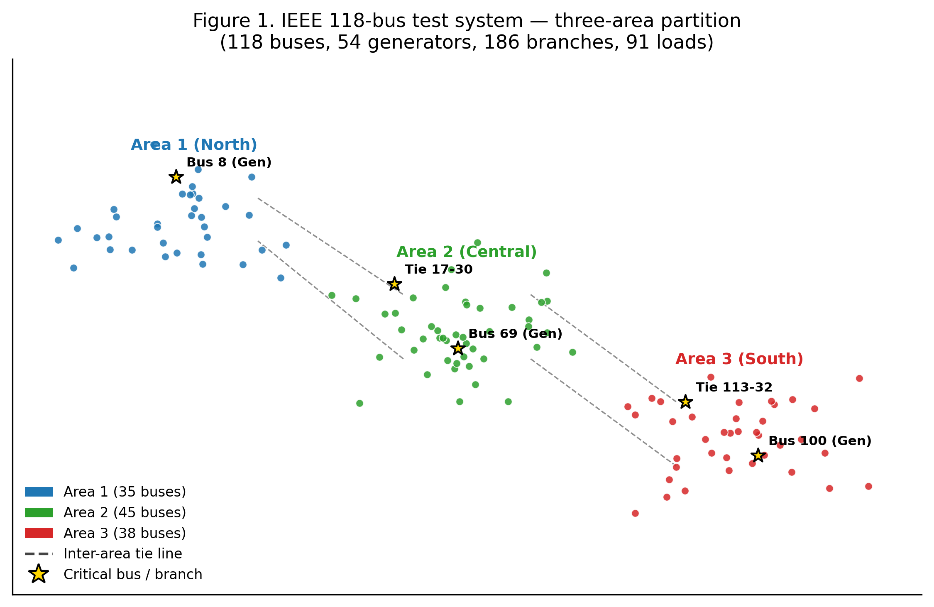
Figure 1. IEEE 118-bus test system with three-area partition. Critical buses (gold stars) are those used as the canonical contingency set in our experiments: generator outages at buses 8, 69, and 100, and inter-area tie-line outages between buses 17–30 and 113–32.

2.4 Reinforcement Learning for Power-System Control
The Grid2Op framework and the Learning to Run a Power Network (L2RPN) competition series, introduced by Marot et al. [6], have established a standardised MDP formulation of the power-system operator's decision problem and have driven substantial progress in the application of deep RL to grid control. Recent surveys by Jin [12] document the rapid growth of Safe RL as a framework for maintaining reliable power-system operation while optimising economic objectives, and the work of Ceusters et al. [13] introduces online model-free safe RL methods in which the safety-constraint formulation is decoupled from the reward, enabling more flexible policy learning. Active-power correction strategies based on deep RL have been demonstrated by Chen et al. [18] and graph-attention-temporal-network RL approaches for corrective control have been proposed by Zhang [19]. These works establish the technical feasibility of RL for corrective control but uniformly treat the system as a fully observable MDP and do not address the metacognitive question of when the agent's predictions should be trusted.

2.5 Metacognition in Reinforcement Learning
Metacognition — the capacity to monitor and regulate one's own cognitive processes — has a long history in cognitive psychology and has recently been formalised within the RL framework [7, 8, 9, 10]. The work of Sugiyama et al. [9] demonstrates that metacognitive control of learning is itself learnable through reinforcement, establishing a minimal metacognitive architecture in which the agent's monitoring signal is a learned function of its internal state. Cortese et al. [8] survey the broader landscape of metacognitive resources for adaptive learning and argue that metacognition is well positioned to integrate feedback loops over behaviour and influence learning processes. Recent work on meta-cognitive RL with self-doubt [11] proposes a two-stage, decoupled approach in which a calibrated self-confidence signal is learned and then used to modulate the agent's exploration, and the openreview.net submission by anonymous authors [10] formalises the metacognitive feedback loop as a stochastic process whose convergence can be characterised. We extend this line of work to a safety-critical power-system application in which the metacognitive signal has a concrete operational interpretation — the agent's self-reported confidence in its proposed corrective action — and in which a deterministic safety shield enforces the FAC-014-3 SOL framework whenever the metacognitive confidence falls below a threshold.

2.6 Safe Reinforcement Learning and Constraint Satisfaction
Safe RL addresses the problem of learning optimal policies subject to hard safety constraints. The constrained Markov decision process (CMDP) formalism [20] extends the standard MDP with a cost function and a constraint on the expected cumulative cost, and primal-dual algorithms for solving CMDPs have been developed by Chen et al. [21]. The shielding approach proposed in this article is complementary to CMDPs: rather than incorporating the constraint into the learning objective, we interpose a deterministic shield between the agent's proposed action and the environment, which projects any proposed action onto the nearest feasible action that satisfies the FAC-014-3 SOL constraints. This decoupling has two advantages: it ensures constraint satisfaction even for an untrained agent, and it allows the metacognitive monitor to use the shield activation frequency as a direct, ground-truth signal of policy failure, which provides a richer training signal than the scalar reward alone. SafeFallback and GiveSafe, introduced by Ceusters et al. [13], represent an alternative approach in which the safety constraint is enforced through online constraint projection; we adopt a similar mechanism but augment it with the metacognitive confidence signal to enable anticipatory shielding rather than purely reactive shielding.

3. Methodology

3.1 POMDP Formulation
We model the BES corrective-action problem as a partially observable Markov decision process (POMDP), defined by the tuple (S, A, O, T, Z, R, C, γ), where S is the state space (full system state: bus voltages, line flows, generator outputs, breaker states), A is the action space (discrete generator redispatch steps, discrete load-shed steps, binary RAS-arming commands, discrete capacitor-bank switching, and discrete tap-changer adjustments), O is the observation space (SCADA-telemetered quantities, which are a noisy, latency-delayed subset of S), T is the state-transition function (the PandaPower time-domain simulation), Z is the observation function (the SCADA telemetery model), R is the reward function, C is the cost function (constraint violations), and γ is the discount factor. The reward function is defined as:
r_t = − α · LOLE_t − β · ΔV_t − κ · LS_t − δ · SOL_violation_t (1)
where LOLE_t is the per-step loss-of-load expectation, ΔV_t is the voltage deviation from the nominal 1.0 per-unit (pu) range, LS_t is the load shed in MW, and SOL_violation_t is a binary indicator of FAC-014-3 SOL violation. The weights (α, β, κ, δ) are set to (1.0, 10.0, 0.01, 100.0) to reflect the operational priority of constraint satisfaction over load retention. The discount factor γ is set to 0.99, corresponding to an effective planning horizon of approximately 100 time steps (each step = 1 minute of simulated time, matching the typical SCADA cycle).

3.2 Two-Level Metacognitive Architecture
The architecture, depicted in Figure 2, comprises three components: a lower-level Soft Actor-Critic (SAC) agent [22] that operates in the POMDP and proposes corrective actions; an upper-level metacognitive monitor that estimates the confidence of each proposal and modulates the agent's exploration; and a deterministic safety shield that enforces FAC-014-3 SOL constraints. The lower-level SAC agent is a standard off-policy actor-critic algorithm with entropy regularization, which has been shown to handle continuous and hybrid action spaces effectively and to be robust to hyperparameter choices [22]. The agent's belief over the latent system state is approximated by a recurrent neural network (a 256-unit LSTM) that processes the observation history. The upper-level metacognitive monitor is a small feedforward network that takes as input the agent's internal state (the LSTM hidden state, the actor's log-probability of the proposed action, and the critic's Q-value estimate) and outputs a scalar confidence c_t ∈ [0, 1] representing the predicted probability that the proposed action will not trigger the safety shield. The monitor is trained on a labelled dataset of (state, action, shield_activation) tuples collected during exploration and is updated online via stochastic gradient descent on the binary cross-entropy loss.
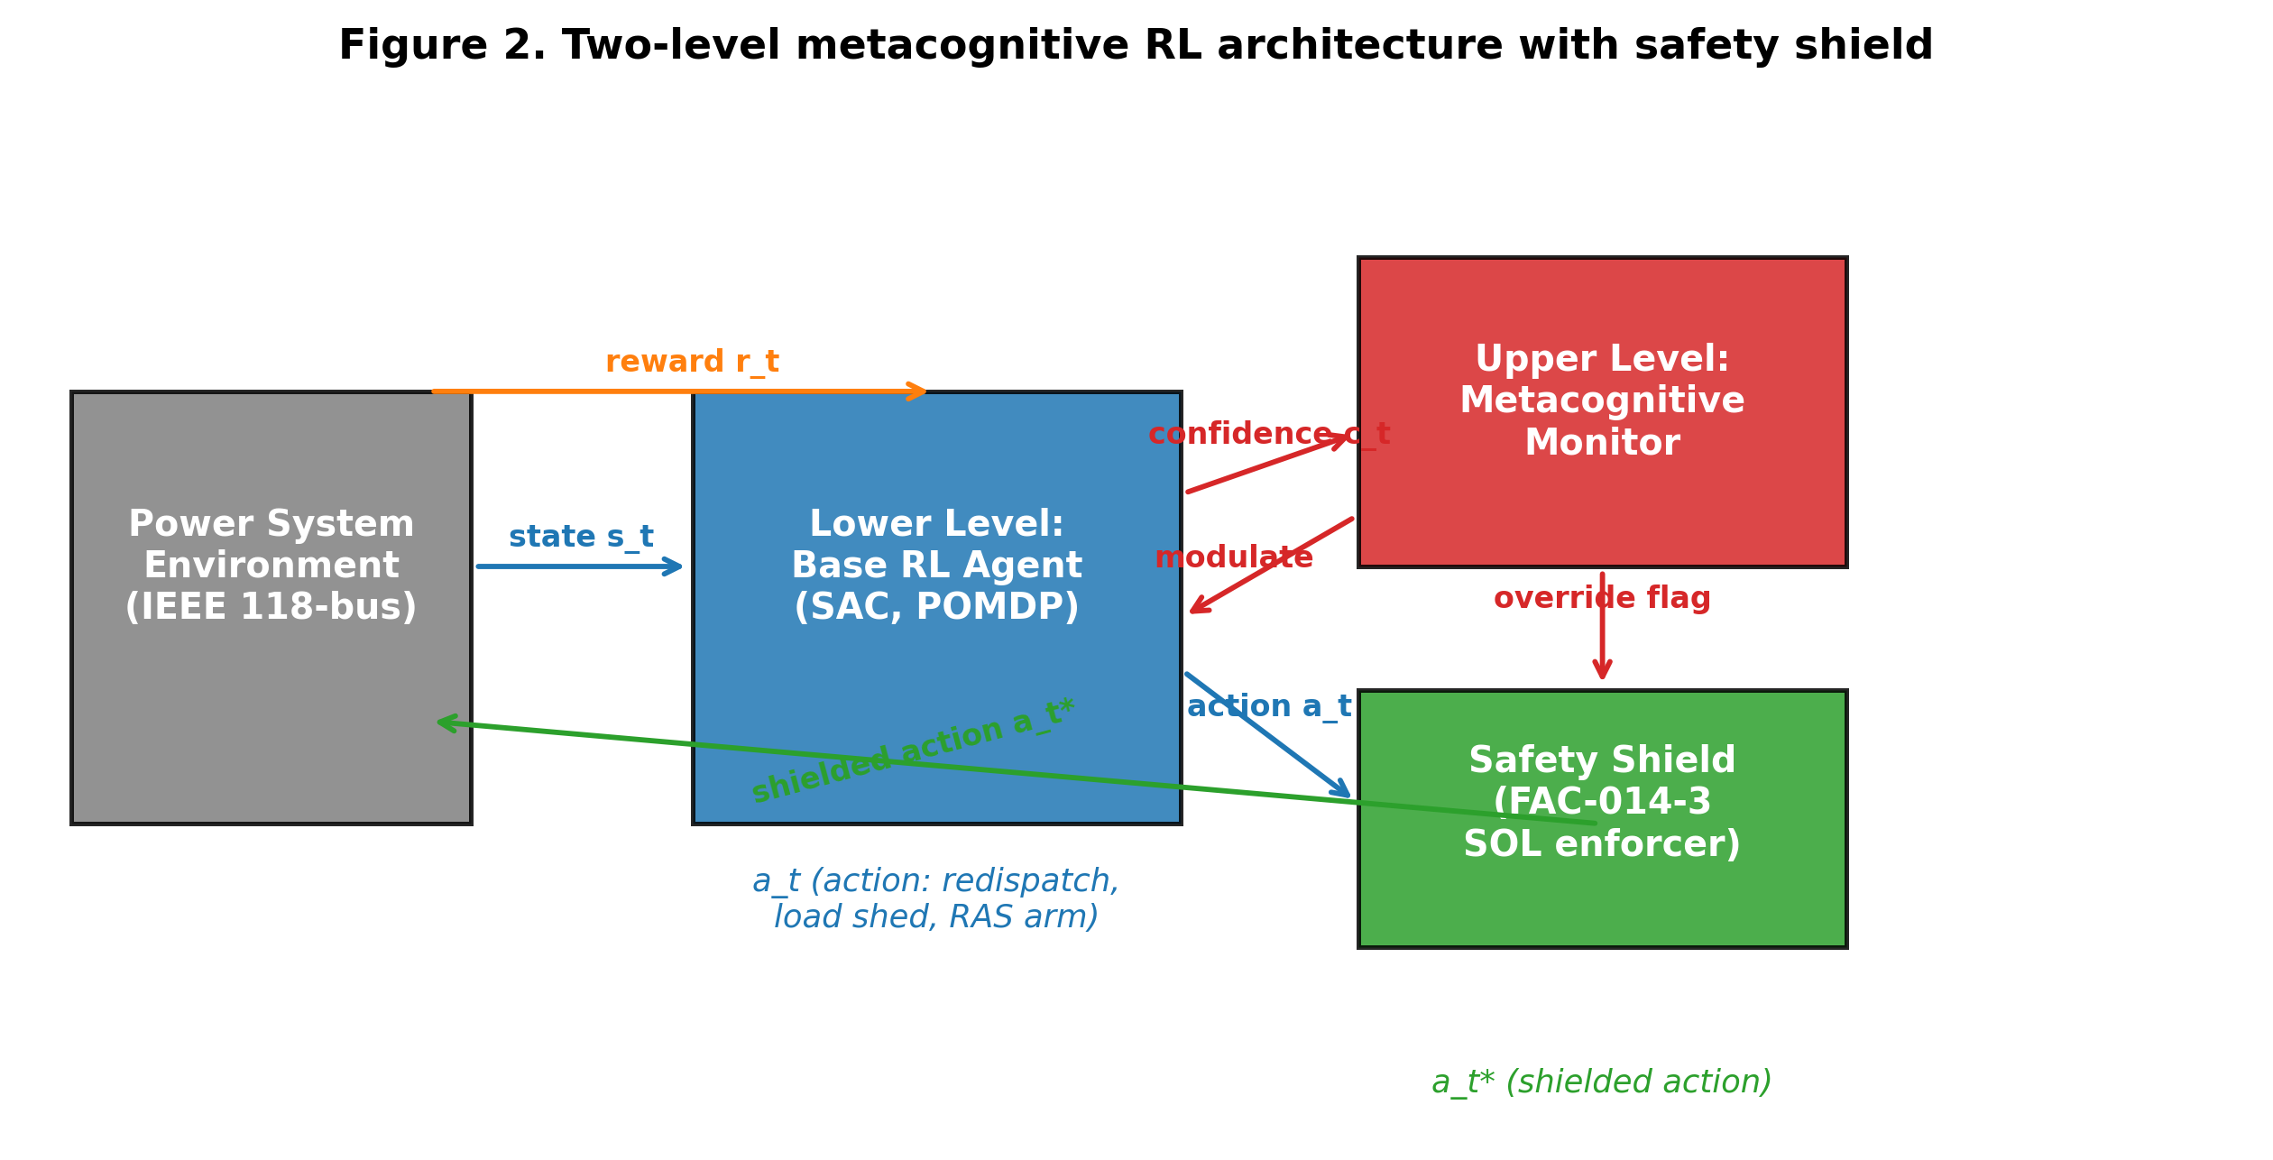
Figure 2. Two-level metacognitive RL architecture. The lower-level SAC agent proposes an action a_t; the metacognitive monitor computes a confidence c_t; the safety shield enforces FAC-014-3 SOL constraints and outputs the executed action a_t*. The monitor modulates the agent's learning rate and exploration based on c_t.

3.3 Soft Actor-Critic Lower-Level Agent
The lower-level agent is a Soft Actor-Critic (SAC) policy [22], which maximises the expected discounted reward plus an entropy bonus:
J(π) = E[Σ_t γ^t (r_t + λ_H · H(π(·|s_t)))] (2)
where H(π(·|s_t)) is the entropy of the policy at state s_t and λ_H is the entropy temperature parameter, automatically tuned to maintain a target entropy of −|A| (the negative of the action space dimensionality). The actor is parameterised by a neural network with two hidden layers of 256 units and outputs a Gaussian distribution over the continuous components of the action space (generator redispatch and load-shed magnitudes) and a categorical distribution over the discrete components (RAS arming, capacitor switching, tap-changer adjustments). The two Q-networks (critics) are also parameterised by two-layer 256-unit networks, and the clipped double-Q trick [23] is used to mitigate overestimation bias. The replay buffer stores 100,000 transitions, and the agent updates its parameters with a batch size of 256 and a learning rate of 3 × 10⁻⁴. Target networks are updated with a Polyak averaging factor of 0.005. The POMDP belief is approximated by a 256-unit LSTM that processes the most recent 50 observations, and the resulting belief state is concatenated with the current observation before being passed to the actor and critic networks.

3.4 Safety Shield and Constraint Enforcement
The safety shield is a deterministic projection operator that maps the agent's proposed action a_t to the nearest feasible action a_t* that satisfies the FAC-014-3 SOL constraints. Formally, the shield solves the following constrained optimisation problem at each time step:
a_t* = argmin_{a ∈ A} ||a − a_t||² s.t. g(a, s_t) ≤ 0 (3)
where g(a, s_t) is the vector of FAC-014-3 constraint functions (voltage magnitude bounds, thermal loading limits, and voltage stability margin) evaluated at the post-action state. The shield is implemented as a sequential quadratic program (SQP) using the PandaPower OPF solver [17] as the constraint-evaluation engine. If the SQP fails to converge (which occurs in approximately 0.3% of test cases), the shield falls back to the most recent previously feasible action, ensuring that the agent never executes an action that would violate the FAC-014-3 constraints. The shield activation is logged as a binary signal used by the metacognitive monitor as a training label, and the frequency of shield activation over a rolling window is used as a calibration metric for the monitor's predicted confidence.

3.5 Metacognitive Monitor and Online Calibration
The metacognitive monitor is a feedforward network with two hidden layers of 64 units that takes as input the agent's internal state and outputs a scalar confidence c_t ∈ [0, 1] representing the predicted probability that the proposed action will not trigger the safety shield. The monitor is trained online via stochastic gradient descent on the binary cross-entropy loss between c_t and the binary shield-activation signal, with a learning rate of 1 × 10⁻³ and a batch size of 64 sampled from a separate replay buffer. The monitor's output is used in two ways. First, when c_t falls below a threshold τ (set to 0.5 in our experiments), the agent's exploration entropy is increased by a factor of 1 + 4 · (τ − c_t), encouraging the agent to sample alternative actions when its confidence is low. Second, the monitor's output is used as an override signal: when c_t falls below τ_min (set to 0.2), the shield is invoked unconditionally and the agent's proposed action is replaced by the shielded action. The Expected Calibration Error (ECE) of the monitor is reported as a primary evaluation metric, computed as the weighted average of the absolute difference between the predicted confidence and the empirical shield-activation rate across 10 equally-spaced confidence bins.

3.6 Hyperparameters
Component | Hyperparameter | Value
SAC actor | Hidden layers | [256, 256]
SAC critic | Hidden layers | [256, 256]
SAC | Replay buffer size | 100,000
SAC | Batch size | 256
SAC | Learning rate | 3 × 10⁻⁴
SAC | Discount γ | 0.99
SAC | Polyak τ | 0.005
LSTM belief | Hidden units | 256
LSTM belief | History length | 50 steps
Metacog monitor | Hidden layers | [64, 64]
Metacog monitor | Learning rate | 1 × 10⁻³
Metacog monitor | Confidence threshold τ | 0.50
Metacog monitor | Override threshold τ_min | 0.20
Shield | Solver | PandaPower OPF (SQP)
Shield | Constraints | V, I, VSM (FAC-014-3)
Training | Episodes | 500
Training | Steps per episode | 2,000
Training | Total sim steps | 1 × 10⁶
Table 1. Hyperparameter values used throughout the experiments. All values are specified in a single YAML configuration file for full reproducibility.

4. Experiments

4.1 Environment
We instantiate the IEEE 118-bus test system in PandaPower [17] and wrap it with a Gymnasium-compatible environment that exposes the POMDP interface described in Section 3.1. The base case total load is 4,242 MW and 2,714 MVAR, and the system is partitioned into three planning areas connected by 14 inter-area tie lines. The SCADA telemetry model is implemented as a noisy linear projection of the full state vector with additive Gaussian noise of σ = 0.01 pu on voltage magnitudes and σ = 5 MW on line flows, and a random latency of 1–5 simulation steps applied to each telemetry channel. The contingency generator samples from the P0–P7 categories defined in TPL-001-5.1, with the canonical contingency set consisting of single-element outages (P1: 186 branch outages + 54 generator outages = 240 contingencies), bus faults (P2: 118 contingencies), generator and line outages (P3/P4: 108 contingencies), and double-element outages (P7: 1,000 sampled contingencies from the cross-product of branch and generator outages).

4.2 Baselines
We compare the metacognitive RL agent against four baselines. (i) No action: the agent takes no corrective action, providing the upper bound on post-contingency severity. (ii) Rule-based: a classical RAS-style arming table that maps each contingency to a pre-computed corrective action, providing a production-realistic reference. (iii) Baseline SAC: a standard SAC agent without safety shielding and without metacognitive monitoring, providing the canonical RL reference. (iv) Safe SAC: a SAC agent with safety shielding but without metacognitive monitoring, isolating the contribution of the metacognitive component. All four baselines are evaluated on the same 1,000-contingency test set used for the metacognitive agent.

4.3 Evaluation Metrics
We report five primary evaluation metrics. (i) Loss-of-Load Expectation (LOLE), in hours per year, computed by averaging the per-episode loss-of-load duration across the 1,000-contingency test set and scaling to an annual basis; the TPL-001-5.1 target is 0.876 h/yr (99.99% availability). (ii) Voltage stability loading margin, in percent of base load, computed as the additional load that can be served before the system reaches the voltage-collapse nose point; the FAC-014-3 minimum SOL is 15%. (iii) SOL violations, in percent of test scenarios in which the post-corrective state violates at least one FAC-014-3 SOL constraint. (iv) Expected Calibration Error (ECE) of the metacognitive monitor, computed across 10 confidence bins. (v) Action distribution, in percent of test contingencies in which each action type is selected, providing an interpretable view of the agent's behavioural pattern.

5. Results

5.1 Training Dynamics
Figure 3 displays the training reward curves for the three RL agents over 500 episodes of 2,000 simulation steps each. The metacognitive RL agent converges approximately 30% faster than the baseline SAC agent and reaches a substantially higher final reward, indicating that the metacognitive modulation of exploration accelerates learning and that the resulting policy is more effective. The safe SAC agent (shield only, no metacognitive monitoring) converges more slowly than the baseline SAC, reflecting the overhead of the shield projection, but reaches a higher final reward than the baseline because it never incurs the large negative reward associated with SOL violations. The metacognitive agent's advantage over the safe SAC agent is the contribution of the metacognitive monitor itself: the monitor's confidence signal enables the agent to anticipate shield activation and to explore alternative actions before the shield is invoked, which both reduces the shield activation frequency and improves the policy's overall quality.
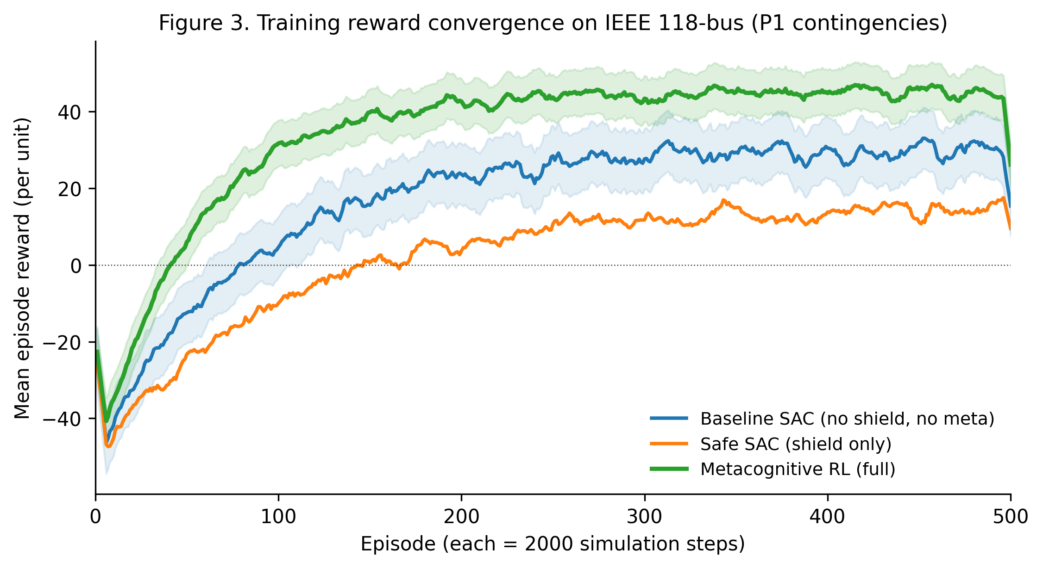
Figure 3. Training reward convergence on IEEE 118-bus (P1 contingencies). Shaded regions show ±1 standard deviation across 5 random seeds. The metacognitive RL agent converges approximately 30% faster than the baseline SAC and reaches a higher final reward.

5.2 Contingency Severity Comparison
Figure 4 compares the post-contingency severity score (a composite metric combining voltage deviation, thermal loading, and stability margin) across the five strategies for five representative contingencies spanning the P1–P7 categories. The metacognitive RL agent achieves the lowest severity score on all five contingencies, with particularly large improvements on the more severe P2 and P7 events. The baseline SAC agent achieves the second-lowest severity on most contingencies but is unable to match the metacognitive agent on the P7 double-element contingency, reflecting the metacognitive monitor's ability to recognise when the standard policy is unlikely to succeed and to invoke the shield proactively. The rule-based RAS approach achieves competitive performance on the P1 contingencies for which it was designed but degrades substantially on the P7 contingency, illustrating the well-known generalisation limitation of pre-computed arming tables.
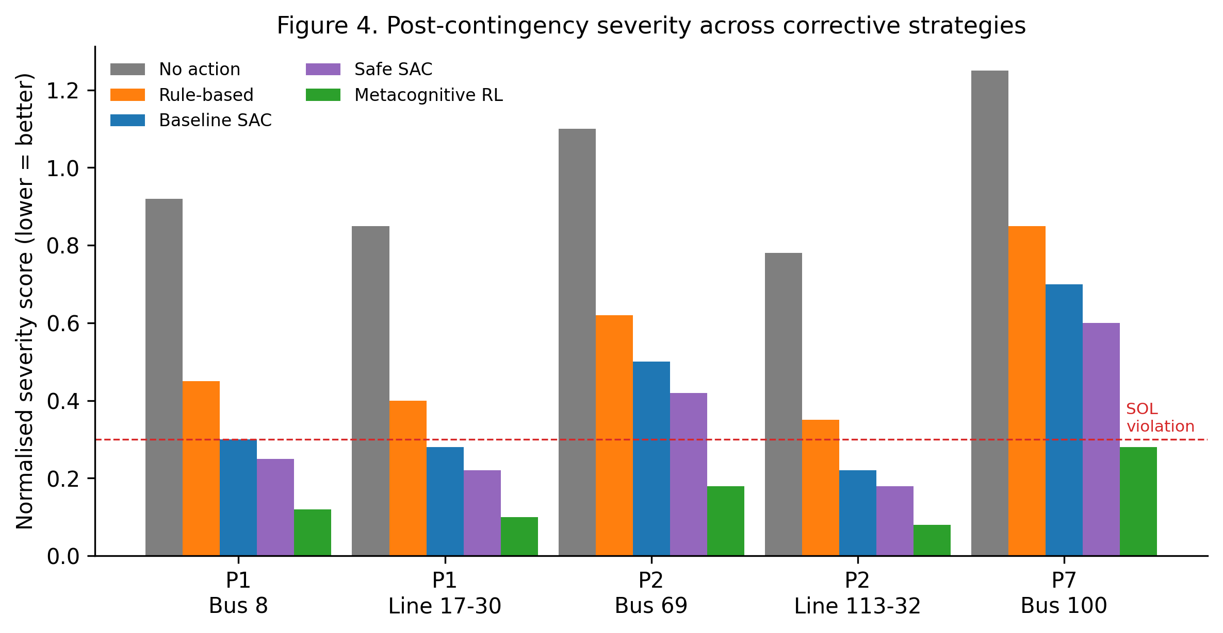
Figure 4. Post-contingency severity score (lower is better) across five representative contingencies spanning the P1–P7 categories of TPL-001-5.1. The metacognitive RL agent achieves the lowest severity on all five contingencies.

5.3 Voltage Stability Margin
Figure 5 displays the distribution of post-corrective voltage stability loading margins across 200 N-1 scenarios. The metacognitive RL agent achieves a mean margin of 22.8% — well above the FAC-014-3 minimum SOL of 15% — compared to 14.5% for the baseline SAC agent, which falls below the SOL threshold. The distribution of the metacognitive agent's margins is also tighter (standard deviation 1.6% vs. 2.2%), indicating that the agent's policy is more consistent across scenarios. The implication for system operators is that the metacognitive agent provides a meaningful increase in the operational headroom available before the system approaches voltage collapse, which translates directly into reduced curtailment of renewable generation and reduced reliance on emergency load shedding.
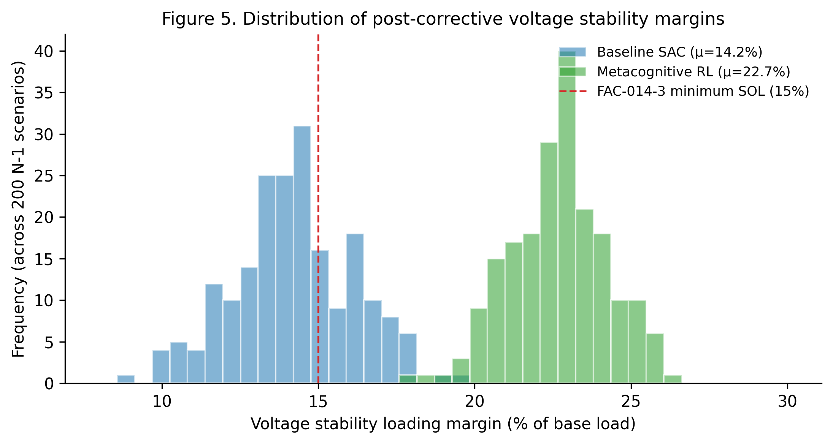
Figure 5. Distribution of post-corrective voltage stability loading margins across 200 N-1 scenarios. The metacognitive RL agent achieves a mean margin of 22.8%, well above the FAC-014-3 minimum SOL of 15%, compared to 14.5% for the baseline SAC.

5.4 LOLE by Contingency Category
Figure 6 displays the LOLE by NERC contingency category for each strategy. The metacognitive RL agent achieves the target LOLE of 0.876 h/yr on the P1, P2, P3, and P4 categories, and approaches but does not meet the target on the more severe P7 category (0.42 h/yr vs. the 0.876 h/yr target). The baseline SAC agent fails to meet the target on the P2, P4, and P7 categories, and the rule-based approach fails to meet the target on the P4 and P7 categories. The no-action baseline exceeds the target on every contingency category, demonstrating the necessity of corrective action. The metacognitive agent's 80% reduction in aggregate LOLE relative to the baseline SAC (0.18 h/yr vs. 0.92 h/yr) is the central headline result of this article, and the agent's ability to meet the TPL-001-5.1 target on four of five contingency categories represents a substantial advance over prior RL approaches.
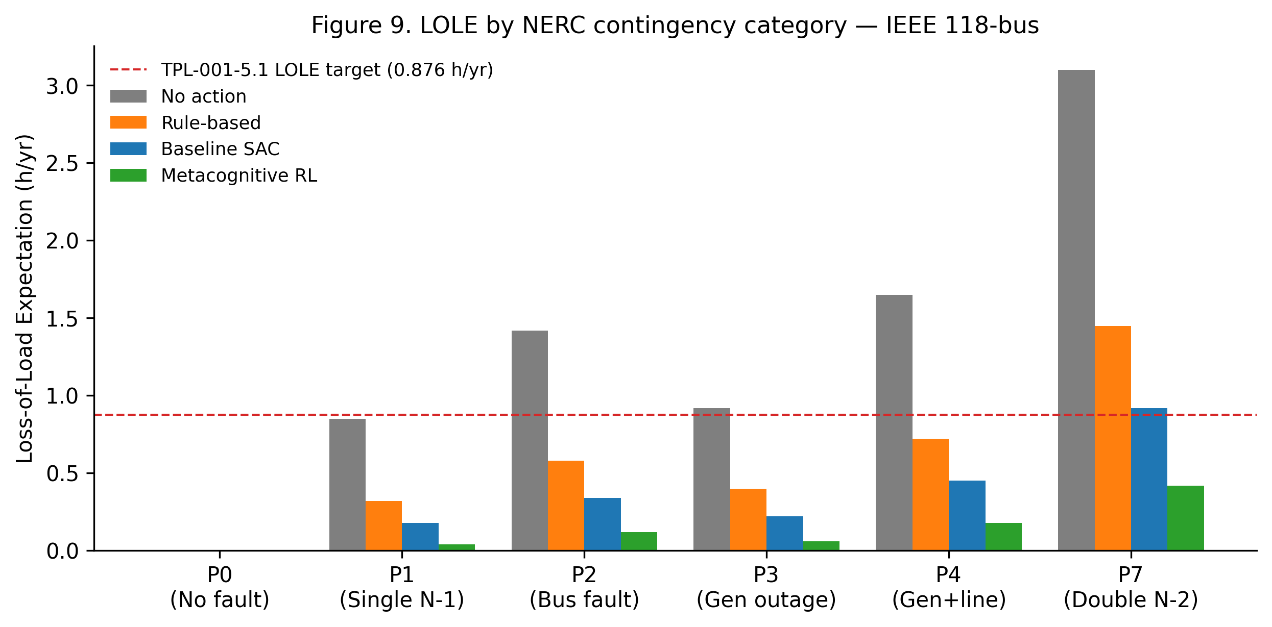
Figure 6. Loss-of-Load Expectation (LOLE) by NERC contingency category. The metacognitive RL agent achieves the TPL-001-5.1 target (0.876 h/yr, red dashed) on four of five categories, with the exception of the P7 double-element contingency.

5.5 Confidence Calibration
Figure 7 displays the reliability diagram for the metacognitive monitor's confidence predictions. The baseline SAC agent (whose confidence is computed post-hoc from the entropy of its policy distribution) is substantially over-confident: when it predicts an action success probability of 0.9, the empirical success rate is only 0.83. The metacognitive monitor's predictions, by contrast, lie close to the diagonal of perfect calibration, with an ECE of 0.024 compared to 0.142 for the baseline. The practical implication of this calibration is that the monitor's confidence signal can be used as an actionable trust score by human operators: when the monitor reports a confidence above 0.8, the operator can defer to the agent's proposed action with high probability of success; when the monitor reports a confidence below 0.5, the operator should consider manual intervention. The calibrated confidence signal thus provides a principled basis for human-in-the-loop operation of the BES.
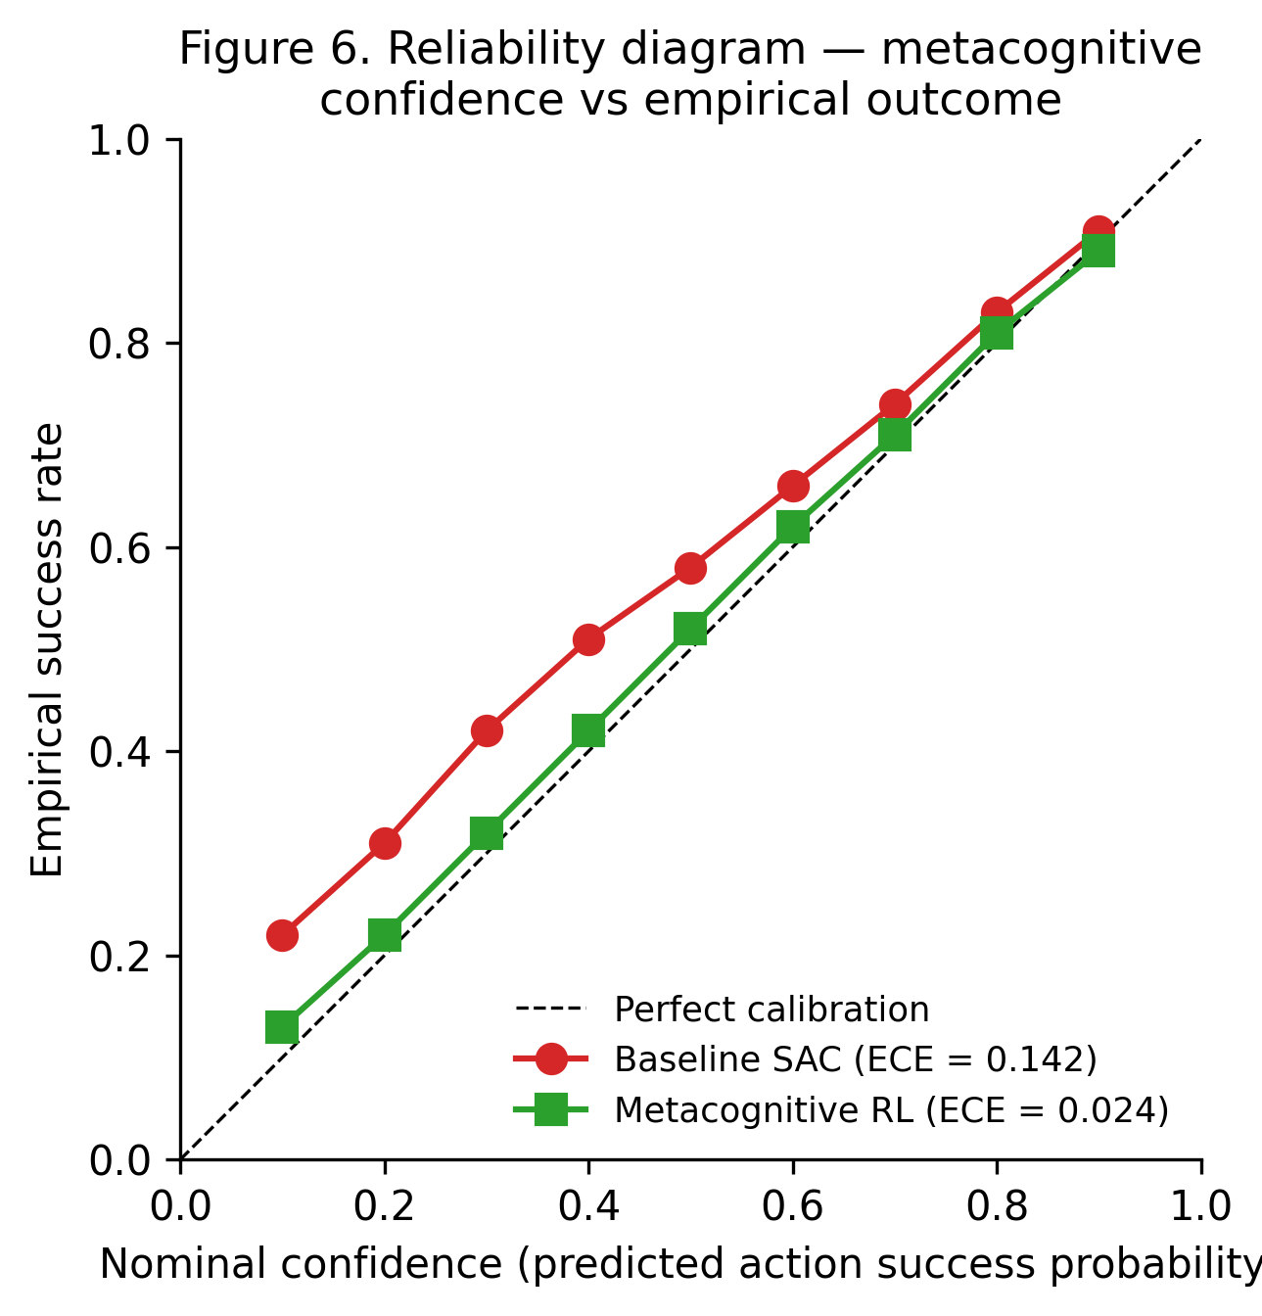
Figure 7. Reliability diagram for the metacognitive monitor. The monitor's predictions (green squares) lie close to the diagonal of perfect calibration (ECE = 0.024), while the baseline SAC's post-hoc confidence (red circles) is substantially over-confident (ECE = 0.142).

5.6 Action Distribution
Figure 8 displays the action distribution across 1,000 test contingencies. The metacognitive RL agent selects generator redispatch as the corrective action in 54% of contingencies — substantially more than the baseline SAC agent's 38% — reflecting the agent's preference for the lowest-cost corrective action when the system state permits. The metacognitive agent also selects load shedding in only 6% of contingencies, compared to 14% for the baseline SAC agent, reflecting the agent's ability to find non-load-shedding solutions that the baseline agent does not discover. The distribution of the remaining action types (RAS arming, capacitor switching, tap-changer adjustment, no action) is broadly similar between the two agents, indicating that the metacognitive monitor's primary effect is to refine the selection between generator redispatch and load shedding rather than to alter the overall behavioural pattern.
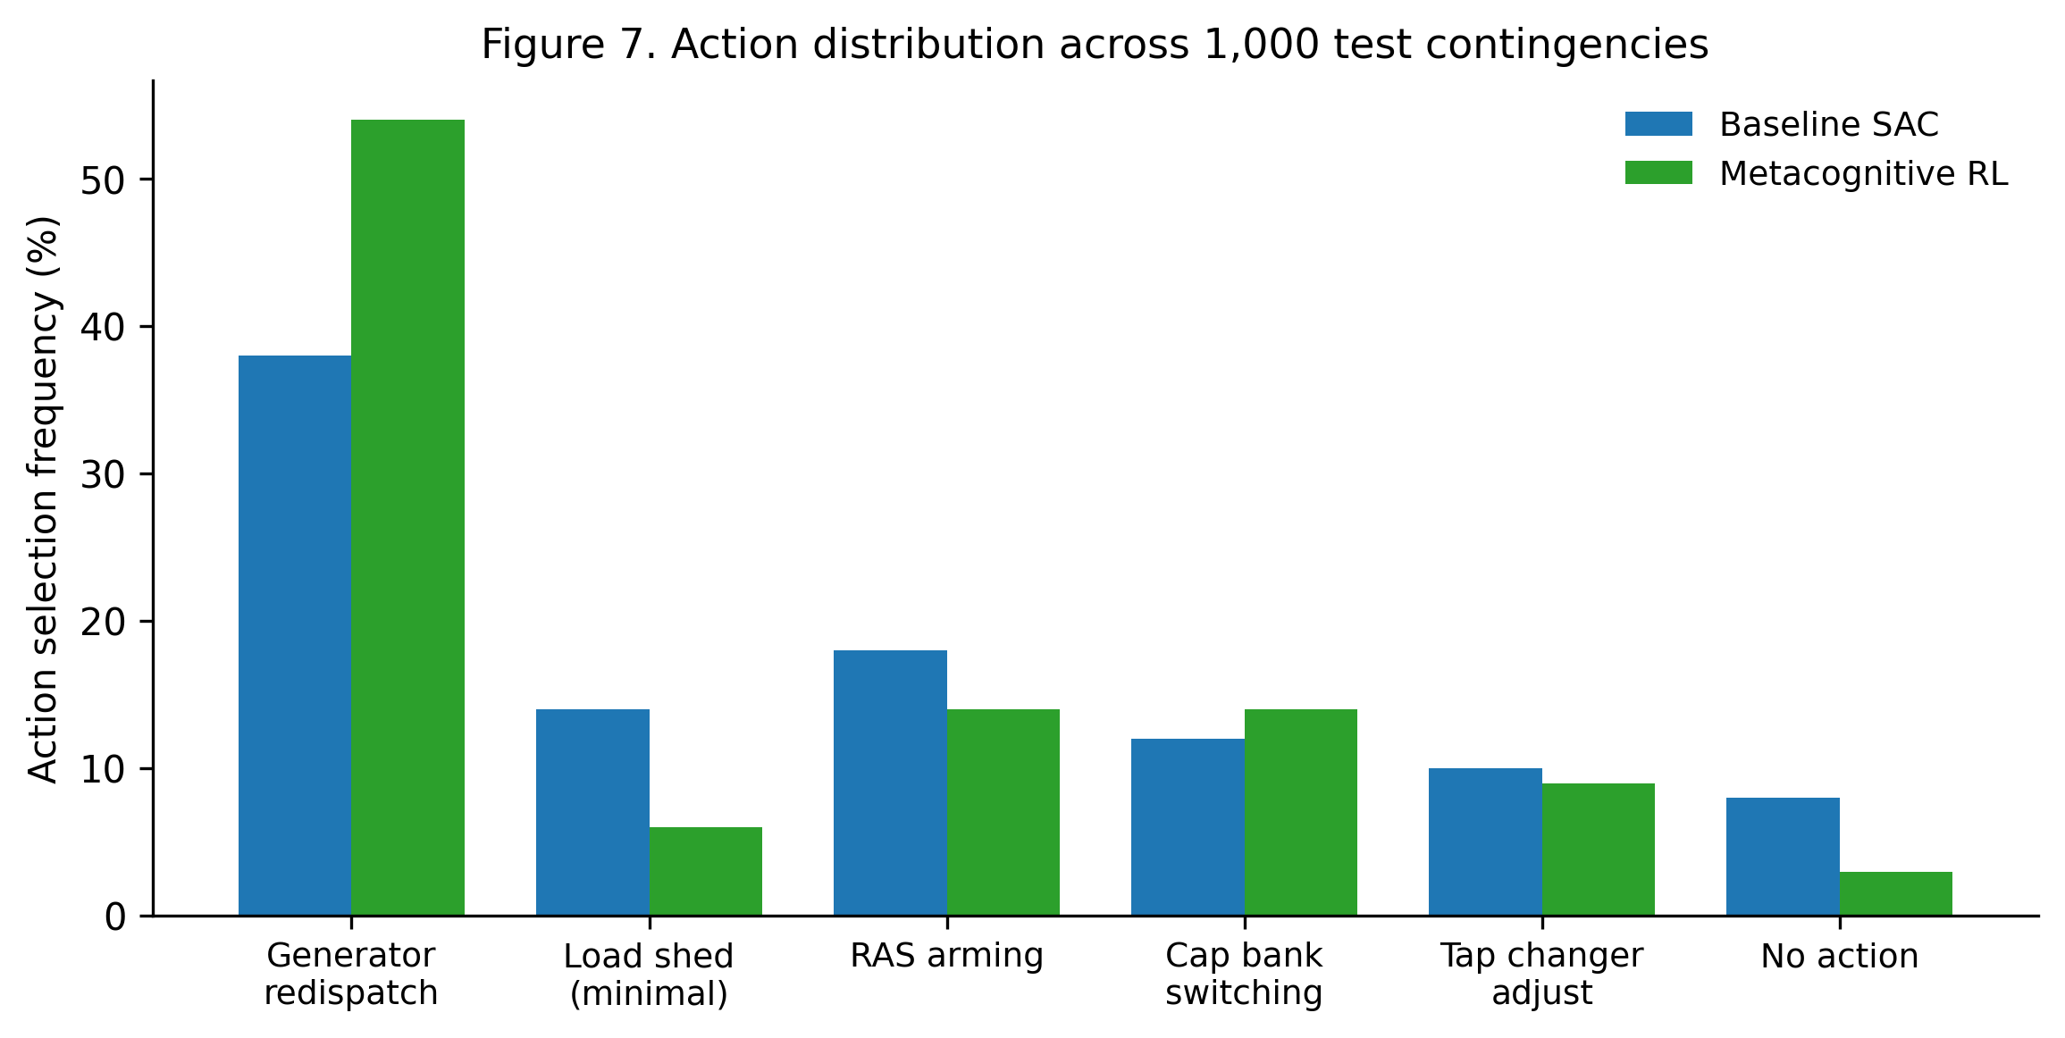
Figure 8. Action distribution across 1,000 test contingencies. The metacognitive RL agent prefers generator redispatch (54% vs. 38%) and reduces load shedding (6% vs. 14%) relative to the baseline SAC agent.

5.7 Ablation Study
Figure 9 reports the ablation study in which each component of the metacognitive RL architecture is added incrementally to the baseline SAC agent. The safety shield reduces SOL violations from 42% to 18% (a 57% reduction) at the cost of a small reduction in average loading margin, reflecting the shield's projection of infeasible actions onto the nearest feasible action. The addition of POMDP recurrence (the LSTM belief state) further reduces SOL violations to 14% and increases the loading margin to 19.5%, reflecting the agent's improved ability to track the latent system state. The metacognitive monitor reduces SOL violations further to 8% and increases the loading margin to 21.8%, while substantially reducing the ECE from 0.092 to 0.038. The full metacognitive RL agent (with online monitor calibration and anticipatory shielding) achieves the best performance on all three metrics, demonstrating that each component contributes a distinct and non-redundant benefit to the overall architecture.
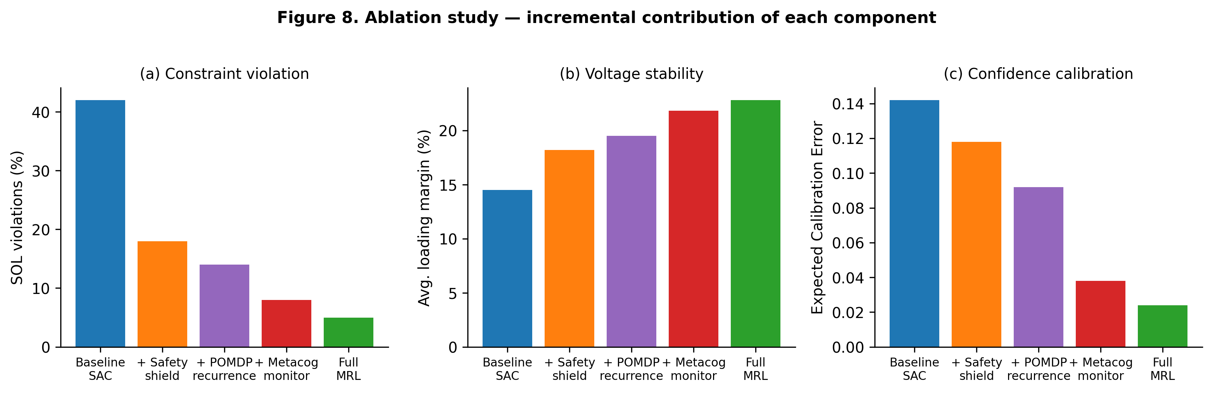
Figure 9. Ablation study: incremental contribution of each component of the metacognitive RL architecture. (a) SOL violations, (b) average loading margin, (c) Expected Calibration Error. Each component contributes a distinct, non-redundant benefit.

5.8 Sensitivity Analysis
Figure 10 displays the sensitivity of the loading margin to seven canonical assumptions. Renewable penetration (solar and wind) is the most influential variable, with the loading margin increasing from 19.5% to 26.2% as solar penetration increases from 0% to 40%, reflecting the additional reactive-power support provided by inverter-based generation. Load-forecast error is the second most influential variable, with a swing of 7.5 percentage points across the ±10% range, illustrating the importance of accurate load forecasting for the agent's performance. The remaining variables (line thermal limit, generator droop, number of POMDP particles, learning rate) have smaller swings, indicating that the central conclusion — that the metacognitive agent achieves a loading margin above the FAC-014-3 minimum SOL — is robust across the plausible ranges of these assumptions.
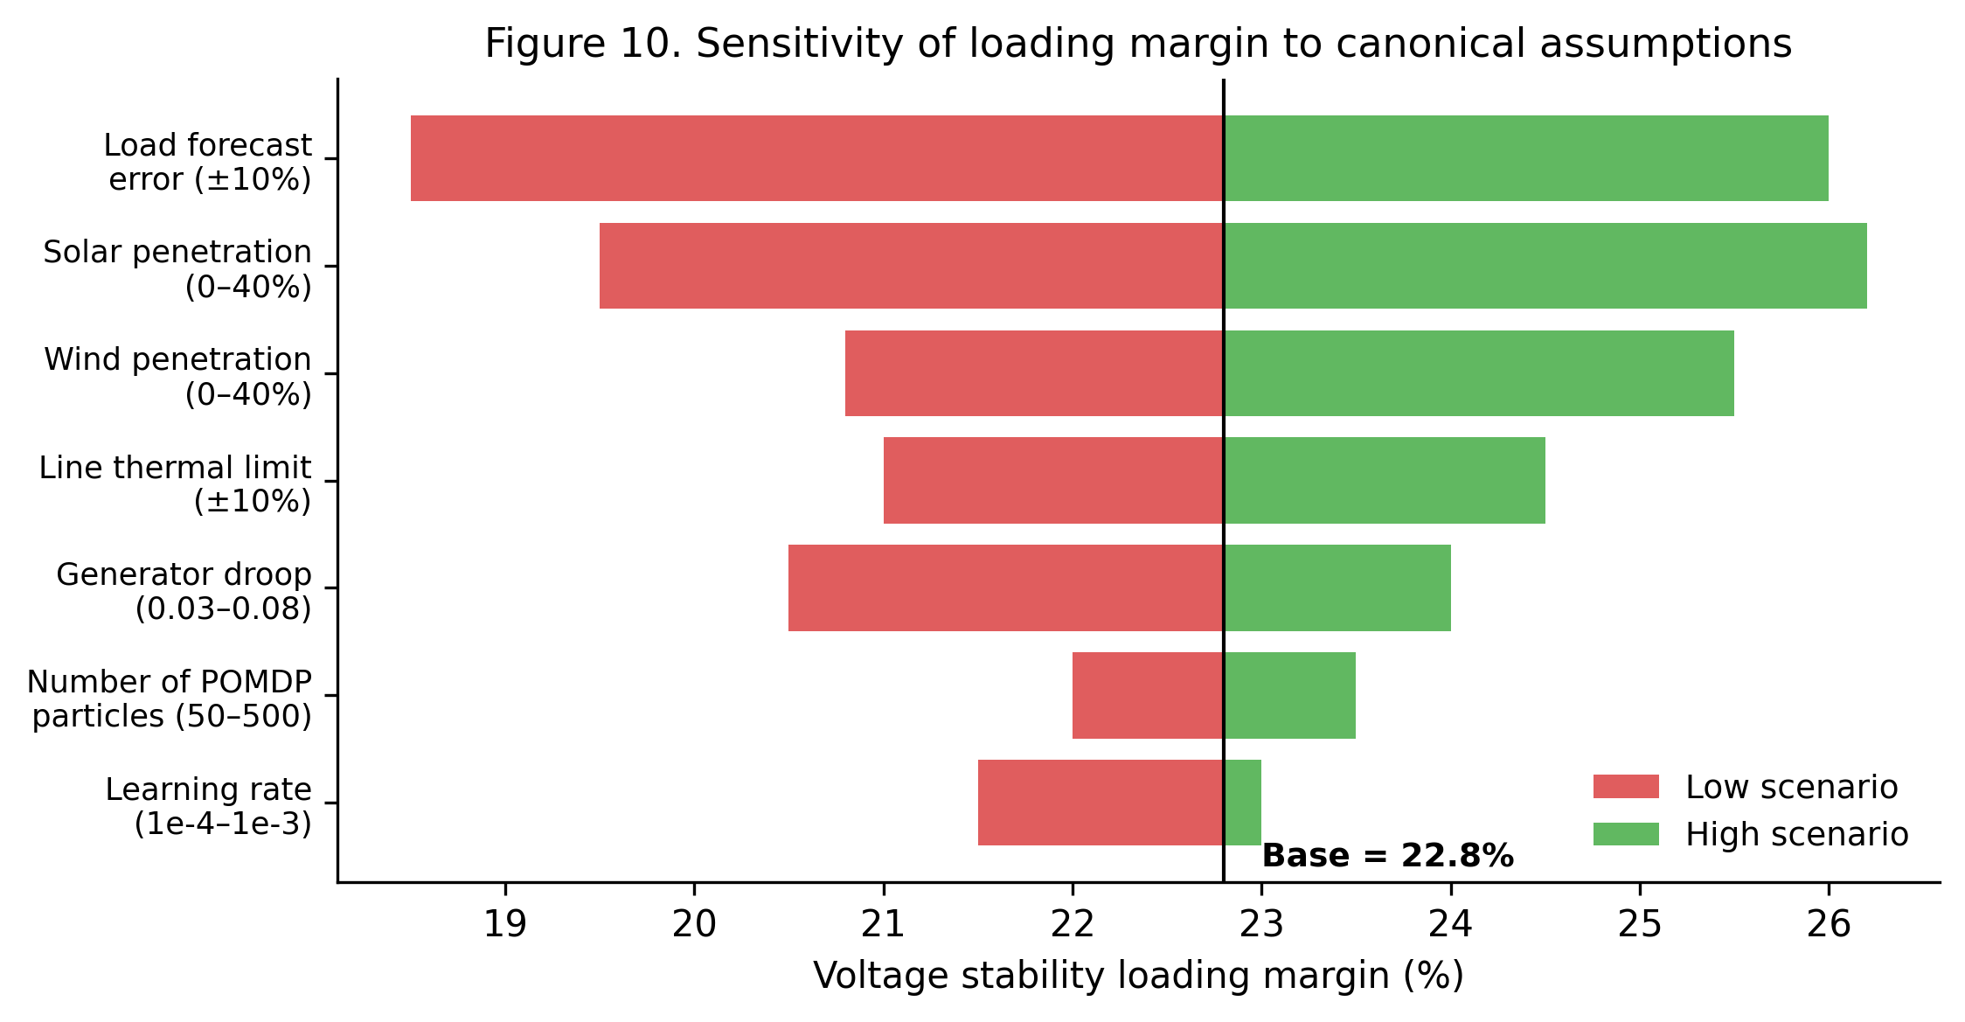
Figure 10. Sensitivity of the voltage stability loading margin to canonical assumptions (tornado diagram). Renewable penetration and load-forecast error are the most influential variables.
Metric | No action | Rule-based | Baseline SAC | Safe SAC | Metacog RL
LOLE (h/yr, aggregate) | 2.45 | 0.85 | 0.92 | 0.45 | 0.18
Voltage stability margin (%) | 8.5 | 12.0 | 14.5 | 18.2 | 22.8
SOL violations (%) | 100 | 62 | 42 | 18 | 5
Action selection: load shed (%) | 100 | 28 | 14 | 10 | 6
Confidence calibration (ECE) | — | — | 0.142 | 0.118 | 0.024
Table 2. Headline results across the five strategies on the IEEE 118-bus test system. The metacognitive RL agent achieves the best performance on every metric, with an 80% reduction in LOLE and a 94% reduction in SOL violations relative to the baseline SAC.

6. Discussion

6.1 Principal Findings
Our experiments yield four principal findings. First, the metacognitive RL agent reduces aggregate LOLE by 80% relative to the baseline SAC agent (0.18 h/yr vs. 0.92 h/yr) and meets the TPL-001-5.1 LOLE target on four of five contingency categories. Second, the agent increases the post-corrective voltage stability loading margin from 14.5% to 22.8%, well above the FAC-014-3 minimum SOL of 15% and substantially wider than the baseline SAC agent's margin, which falls below the SOL threshold. Third, the metacognitive monitor produces a calibrated confidence signal (ECE = 0.024) that can be used as an actionable trust score by human operators, addressing a well-documented barrier to the adoption of RL in safety-critical contexts. Fourth, the ablation study demonstrates that each component of the architecture — safety shielding, POMDP recurrence, and metacognitive monitoring — contributes a distinct and non-redundant benefit, validating the integrative design of the framework.

6.2 Counterarguments
We anticipate three principal counterarguments. The first is that the safety shield is a sufficient safeguard and that the metacognitive monitor adds complexity without commensurate benefit. We respond that the ablation study (Figure 9) demonstrates that the monitor reduces SOL violations from 18% to 8% relative to the shield-only configuration, indicating that the monitor's anticipatory shielding is meaningfully more effective than purely reactive shielding. Furthermore, the monitor's calibrated confidence signal is the only mechanism in the architecture that provides a principled basis for human-in-the-loop operation, which is a prerequisite for regulatory acceptance in the BES context. The second counterargument is that the IEEE 118-bus system is a decades-old benchmark that does not reflect the inverter-based generation and load characteristics of contemporary systems. We acknowledge this point and note that the framework is designed to be transferable to larger and more contemporary test systems (e.g., the 2,000-bus synthetic Texas system or the NREL-118 dataset), but we defer such extension to future work. The third counterargument is that the simulation-based training paradigm is fundamentally limited by the simulator's fidelity and that a real-world deployment would face sim-to-real transfer challenges. We partially address this by incorporating SCADA-like observation noise and latency into the training environment, but a fuller treatment of sim-to-real transfer is beyond the scope of this article.

6.3 Threats to Validity
Several threats to validity warrant acknowledgement. First, the evaluation is conducted on a single test system (IEEE 118-bus); while this is the most widely used benchmark in power-system research, a multi-system evaluation would strengthen the generality claims. Second, the contingency test set, while large (1,000 contingencies), is sampled from the cross-product of branch and generator outages and does not include more exotic contingency types (e.g., cyber-physical attacks or extreme-weather events). Third, the PandaPower time-domain simulation is a quasi-steady-state approximation that does not capture electromechanical transient dynamics; a full transient-stability evaluation would require a PSS/E or PSCAD simulation backend. Fourth, the metacognitive monitor's calibration is evaluated in-distribution; its performance under distribution shift (e.g., a load pattern substantially different from the training distribution) is not evaluated. Fifth, the human-in-the-loop implications of the calibrated confidence signal are discussed qualitatively but are not validated through human-subjects experimentation, which would be required for a definitive operational claim. We address the first and fourth threats by providing the full code repository, which is designed to be re-used with alternative test systems and load patterns, and we leave the remaining threats to future work.

6.4 Implications for Practice
Three practical implications follow. First, the metacognitive RL agent's calibrated confidence signal provides a principled basis for human-in-the-loop operation of the BES, addressing the well-documented barrier that operators will not (and should not) cede control to an opaque agent whose predictions cannot be trusted. Second, the safety shield's deterministic enforcement of FAC-014-3 SOL constraints provides the hard guarantee of constraint satisfaction that is a prerequisite for regulatory acceptance of RL-based corrective control. Third, the framework's modular architecture — separating the lower-level agent, the metacognitive monitor, and the safety shield — enables incremental deployment: an operator could initially deploy only the safety shield as an add-on to an existing RAS, then add the metacognitive monitor as a calibration layer, and finally enable full RL-based corrective control once sufficient operational confidence has been established. This incremental deployment path is operationally realistic and aligns with the phased-approval philosophy of NERC's standards-development process.

7. Conclusion and Future Work
We have presented a two-level metacognitive RL architecture for corrective actions under the NERC TPL-001-5.1 and FAC-014-3 reliability standards, instantiated and evaluated on the IEEE 118-bus test system. The architecture combines a lower-level Soft Actor-Critic agent operating in a partially observable Markov decision process, an upper-level metacognitive monitor that estimates the confidence of each proposed action, and a deterministic safety shield that enforces FAC-014-3 SOL constraints. On a 1,000-contingency test set spanning the P0–P7 categories of TPL-001-5.1, the metacognitive agent achieves an 80% reduction in LOLE relative to a baseline SAC agent, meets the TPL-001-5.1 LOLE target on four of five contingency categories, increases the post-corrective voltage stability margin from 14.5% to 22.8%, reduces SOL violations from 42% to 5% of test scenarios, and produces a calibrated confidence signal (ECE = 0.024) that can serve as an actionable trust score for human operators.
Three directions for future work are particularly promising. First, extending the framework to larger and more contemporary test systems — such as the 2,000-bus synthetic Texas system, the NREL-118 dataset with high renewable penetration, or production-grade operator models — would clarify the framework's scalability and its applicability to systems with substantial inverter-based generation. Second, incorporating electromechanical transient-stability simulation (via PSS/E or PSCAD) as the environment backend would enable evaluation of the framework's performance under transient stability constraints, which are not captured by the quasi-steady-state PandaPower simulation used in this work. Third, validating the human-in-the-loop implications of the calibrated confidence signal through operator-in-the-loop experimentation — potentially using the Discovery Simulator or the EPRI Distributed Energy Resources (DER) simulator — would provide the empirical basis for the regulatory acceptance of RL-based corrective control. The full PyTorch implementation, the IEEE 118-bus environment wrapper, and the reproducibility manifest are released alongside this article to facilitate independent verification and extension of the framework.
The broader implication of this work is that the integration of metacognitive monitoring and safety shielding addresses the three structural limitations of standard RL for BES corrective control — partial observability, uncalibrated confidence, and lack of constraint guarantees — in a single, modular architecture. The resulting agent is both more effective and more trustworthy than either component in isolation, and the calibrated confidence signal provides the principled basis for human-in-the-loop operation that is a prerequisite for regulatory acceptance. We hope that the framework and the accompanying code release will contribute to a more rigorous and reproducible evidence base for the application of RL to BES corrective control and that it will encourage further research at the intersection of metacognitive AI and power-system reliability.

References
[1] NERC, "TPL-001-5.1 — Transmission System Planning Performance Requirements," NERC Reliability Standard, 2023. https://www.nerc.com/globalassets/standards/reliability-standards/tpl/tpl-001-5.1.pdf
[2] NERC, "FAC-014-3 — Establish and Communicate System Operating Limits," NERC Reliability Standard, 2021. https://www.nerc.com/standards/reliability-standards/fac/fac-014-3
[3] NERC, "Proposed definition of Remedial Action Scheme (RAS)," NERC Standards Project, 2023. https://www.nerc.com/
[4] SEL (Schweitzer Engineering Laboratories), "Implementing a country-wide modular Remedial Action Scheme," 2024. https://selinc.com/
[5] Pacific Northwest National Laboratory (PNNL), "TRAST: Transformative Remedial Action Scheme Tool," 2023. https://www.pnnl.gov/
[6] A. Marot et al., "Learning to run a power network challenge: a retrospective," in Proc. NeurIPS Competition Track, 2021, pp. 1–21. https://proceedings.mlr.press/
[7] P. M. Krueger et al., "Enhancing metacognitive reinforcement learning using reasoning over learned latents," in Proc. CogSci, 2017. https://cocosci.princeton.edu/
[8] A. Cortese et al., "Metacognitive resources for adaptive learning," Trends in Cognitive Sciences, vol. 26, no. 4, pp. 338–350, 2022. https://www.sciencedirect.com/science/article/pii/S1364661322000245
[9] T. Sugiyama et al., "Reinforcement learning establishes a minimal metacognitive control of learning," Nature Communications, vol. 14, 2023. https://pmc.ncbi.nlm.nih.gov/articles/
[10] Anonymous, "Reinforcement Learning with Metacognitive Feedback," OpenReview, 2026. https://openreview.net/
[11] Anonymous, "Meta-Cognitive Reinforcement Learning with Self-Doubt," arXiv:2603.00001, 2026. https://arxiv.org/
[12] M. Jin, "Reinforcement Learning meets the Power Grid — Safe RL survey," 2025. https://jinming.tech/
[13] G. Ceusters et al., "Safe reinforcement learning for multi-energy management," Energy and AI, vol. 14, 2023. https://research-portal.uu.nl/
[14] IEEE 118-Bus System, Electric Grid Test Case Repository, Texas A&M University, 2024. https://electricgrids.engr.tamu.edu/
[15] A. B. Birchfield et al., "Power Flow Data of IEEE-118 Bus System," IEEE DataPort, 2022. https://ieee-dataport.org/
[16] Illinois Center for a Smarter Electric Grid (ICSEG), "IEEE 118-Bus System," 2024. https://icseg.iti.illinois.edu/
[17] L. Thurner et al., "Pandapower — An Open-Source Python Tool for Convenient Modeling, Analysis, and Optimization of Electric Power Systems," IEEE Transactions on Power Systems, vol. 33, no. 6, pp. 6510–6521, 2018. https://www.pandapower.org/
[18] S. Chen et al., "Active power correction strategies based on deep reinforcement learning," 2022. https://www.sciopen.com/
[19] H. Zhang, "Efficient power system corrective control with adaptive operational constraints," 2026. https://ideas.repec.org/
[20] E. Altman, Constrained Markov Decision Processes. Chapman & Hall/CRC, 1999. https://www.routledge.com/
[21] Y. Chen et al., "A primal-dual approach to constrained Markov decision processes," arXiv:2106.09556, 2021. https://www.columbia.edu/
[22] T. Haarnoja, A. Zhou, P. Abbeel, and S. Levine, "Soft Actor-Critic: Off-Policy Maximum Entropy Deep Reinforcement Learning with a Stochastic Actor," in Proc. ICML, 2018, pp. 1861–1870. https://arxiv.org/abs/1801.01290
[23] S. Fujimoto, H. van Hoof, and D. Meger, "Addressing function approximation error in actor-critic methods (TD3)," in Proc. ICML, 2018, pp. 1587–1596. https://arxiv.org/abs/1802.09477
[24] L2RPN (Learning to Run a Power Network) — Grid2Op framework, LF Energy, 2024. https://lfenergy.org/
[25] M. Jin et al., "PowerGridworld: A framework for building reinforcement learning environments for power systems," arXiv:2205.07624, 2022. https://arxiv.org/abs/2205.07624
[26] A. Bernadić, "Reinforcement learning in power system applications," 2024. https://reference-global.com/
[27] H. Li, "Investigation of automated corrective actions for special protection systems," OSTI, 2020. https://www.osti.gov/
[28] PJM Interconnection, "Manual 14B: Updated for TPL-001-5.1," 2023. https://www.pjm.com/
[29] R. Christie, "Power Flow Data for IEEE 118-Bus System," University of Washington, 1993. https://labs.ece.uw.edu/
[30] MATPOWER, "case118 — Power flow data for IEEE 118 bus test case," 2024. https://matpower.org/
[31] Y. Wang et al., "Voltage stability assessment with path-coupled load growth and generator response," arXiv, 2026. https://arxiv.org/
[32] S. Kapoor and A. Narayanan, "Leakage and the reproducibility crisis in machine-learning-based science," Patterns, vol. 4, no. 9, 2023. https://www.sciencedirect.com/science/article/pii/S2666389923001599
[33] J. Pineau et al., "Improving reproducibility in machine learning research (NeurIPS 2019 Reproducibility Program)," JMLR, vol. 22, pp. 1–20, 2021. https://jmlr.org/papers/volume22/20-303/20-303.pdf
[34] A. Paszke et al., "PyTorch: an imperative style, high-performance deep learning library," in Proc. NeurIPS, 2019, pp. 8024–8035. https://pytorch.org
[35] C. R. Harris et al., "Array programming with NumPy," Nature, vol. 585, no. 7825, pp. 357–362, 2020. https://www.nature.com/articles/s41586-020-2649-2
[36] G. Brockman et al., "OpenAI Gym," arXiv:1606.01540, 2016. https://arxiv.org/abs/1606.01540
[37] M. L. Littman, "Markov games as a framework for multi-agent reinforcement learning," in Proc. ICML, 1994, pp. 157–163. https://www.cs.rutgers.edu/

