Robust Validation of CNN-LSTM Hybrid Models: A Reproducible Framework Integrating Uncertainty Quantification, Calibration, and Explainability
— Research Article —

Research Synthesis Team
Affiliation: Independent Research Collective
Corresponding author: research-team@example.org

Abstract
Hybrid Convolutional Neural Network–Long Short-Term Memory (CNN-LSTM) architectures have emerged as a dominant paradigm for spatio-temporal forecasting across environmental, biomedical, and industrial domains. However, a systematic survey of approximately one hundred recent CNN-LSTM validation studies indexed in Elsevier's ScienceDirect (2020–2026) reveals eight recurring methodological failure modes, including the misuse of random k-fold cross-validation on temporally dependent data, the omission of uncertainty quantification, the neglect of probability calibration, and the absence of explainability audits. We propose V-CNNLSTM-RC, a seven-stage reproducible validation framework that systematically addresses each identified failure mode by coupling leakage-aware walk-forward cross-validation, Bayesian ensembling via Monte-Carlo dropout, post-hoc temperature scaling, and Integrated Gradients attribution. Empirical evaluation on the open UCI Air Quality benchmark and a live Open-Meteo real-time weather stream demonstrates that the framework achieves competitive point accuracy (R² = 0.917, RMSE = 0.236) while reducing Expected Calibration Error by 98.5% (0.300 → 0.004) and producing tight, decision-relevant 90% prediction intervals. The complete codebase, with pinned dependencies, deterministic seeds, and an automated reproducibility manifest generator, is released alongside this article to facilitate adoption and independent verification.
Keywords: CNN-LSTM; model validation; uncertainty quantification; probability calibration; explainable AI; reproducibility; time-series forecasting

1. Introduction
The modern data ecosystem is saturated with time-indexed signals — sensor measurements, financial ticks, physiological waveforms, network traffic logs — whose accurate forecasting underpins decisions of considerable economic and societal consequence. Within this landscape, the hybridisation of Convolutional Neural Networks (CNNs) with Long Short-Term Memory (LSTM) recurrent units has, over the past five years, become one of the most widely adopted architectural patterns for spatio-temporal prediction. The CNN front-end extracts local temporal motifs — diurnal cycles, weather regimes, transient anomalies — while the LSTM backend propagates information across longer horizons, mitigating the vanishing-gradient pathology that has historically plagued vanilla recurrent networks. The resulting models now underpin air-quality forecasting [1], flood susceptibility mapping [2], intrusion detection in the Internet of Things [3], student-performance prediction [4], and energy-demand forecasting [5], to cite only a representative subset of the rapidly growing literature.
Despite — or perhaps because of — this rapid proliferation, the validation protocols reported in the published literature remain strikingly heterogeneous. A common pattern is the direct application of random k-fold cross-validation to time-indexed data, which violates the causal ordering of observations and inflates apparent accuracy by leaking future information into training folds. Equally prevalent is the reporting of single point estimates (typically a mean RMSE) without any accompanying uncertainty quantification, probability calibration, or explanation of which input features drove the predictions. Kapoor and Narayanan [6] have argued compellingly that such data-leakage errors are a primary driver of the broader reproducibility crisis in machine-learning-based science, and the NeurIPS 2019 Reproducibility Program [7] established that fewer than half of accepted papers provide enough information for an independent group to reproduce headline numbers from the published code alone. These observations motivate the present work.
We pursue four interrelated objectives. First, we conduct a structured survey of approximately one hundred CNN-LSTM validation papers indexed in Elsevier's ScienceDirect between 2020 and 2026, supplemented by open-access mirrors on arXiv, PubMed Central (PMC), and the Multidisciplinary Digital Publishing Institute (MDPI), and we distil the recurring methodological failure modes that span data splitting, uncertainty reporting, calibration, explainability, and reproducibility. Second, we propose V-CNNLSTM-RC, a seven-stage, reproducible validation framework that systematically addresses each identified failure mode. Third, we instantiate the framework in an open Python codebase — using the open UCI Air Quality dataset [8] as the primary benchmark and a live Open-Meteo stream [9] as a real-time testbed — and we report detailed experimental results, including bootstrap confidence intervals, calibration diagnostics, and feature attribution analyses. Fourth, we publish the full code repository, pinned dependencies, deterministic seeds, and a reproducibility manifest generator alongside this article, so that every reported number can be independently regenerated by a third party with a single command. The principal thesis we advance is that the validation rigour of CNN-LSTM models can — and should — be substantially elevated through the systematic adoption of seven well-established but rarely combined techniques, and that the resulting elevation is achievable with negligible computational overhead.
The remainder of the article is organised as follows. Section 2 reviews related work on CNN-LSTM variants, the reproducibility crisis in machine learning, uncertainty quantification, calibration, and explainability. Section 3 presents the taxonomy of failure modes observed in the surveyed literature. Section 4 introduces the V-CNNLSTM-RC framework and details each of its seven stages. Section 5 describes the experimental setup, datasets, and training configuration. Section 6 reports results, including headline accuracy and calibration comparisons, an ablation study, and a feature-attribution analysis. Section 7 discusses the findings, addresses counterarguments, and enumerates the threats to validity. Section 8 concludes and identifies directions for future work.

2. Background and Related Work

2.1 CNN-LSTM Hybrid Architectures
The combination of CNN feature extractors with LSTM sequence models was popularised for video classification by Donahue et al. [10] and adapted to time-series forecasting by Lu et al. [11], who applied it to Shanghai Composite Index stock prices. Since then the architecture has proliferated across domains. Hanifi et al. [12] applied Optuna-based Bayesian hyperparameter optimisation to wind-power forecasting. Wahyuddin et al. [13] optimised LSTM hyperparameters with walk-forward validation for time-series prediction, representing one of the few surveyed works that explicitly adopts a leakage-aware splitting protocol. Huang et al. [2] proposed a CNN-LSTM-Attention model for flood susceptibility mapping and used SHAP to interpret the coupled model. The MediVision hybrid CNN-LSTM model [14] achieved 96.89% mean classification accuracy across ten diverse medical imaging datasets, outperforming VGG16, VGG19, and ResNet50 baselines, illustrating the broad applicability of the architecture beyond scalar time-series regression.

2.2 The Reproducibility Crisis in Machine Learning
Kapoor and Narayanan [6] systematically investigated reproducibility issues in machine-learning-based science across seventeen research fields, identifying data leakage as the most pervasive source of inflated accuracy claims. Their evidence demonstrated that, when leakage errors were corrected, several machine-learning models no longer performed substantively better than decades-old linear regression baselines. Pineau et al. [7] reported the outcomes of the NeurIPS 2019 Reproducibility Program, finding that fewer than half of accepted papers provided the code, data, and configuration needed to replicate headline results. The Machine Learning Reproducibility Checklist that emerged from this effort has been adopted in modified form by several journals and conferences, including the IEEE conference family. Recent contributions by Pineau et al. [7] and by the broader reproducibility community [15] extend these discussions into transformer-based architectures, but the core lessons apply directly to CNN-LSTM validation reports, where random k-fold cross-validation remains the dominant evaluation protocol despite its well-documented inapplicability to time-indexed data.

2.3 Uncertainty Quantification in Deep Learning
Gal and Ghahramani [16] established that training-time dropout, when kept active at inference time, provides a theoretically grounded approximation to Bayesian inference in deep Gaussian processes. This Monte-Carlo dropout (MC-dropout) approach enables epistemic uncertainty estimation with minimal modifications to existing architectures, which has contributed substantially to its widespread adoption. Lakshminarayanan et al. [17] proposed deep ensembles, showing that averaging the predictive distributions of several independently initialised networks yields better-calibrated and more robust uncertainty estimates than single-model MC-dropout in many settings. Both approaches have been applied to CNN-LSTM models: the Bayesian deep-learning pipeline of Cui et al. [18] combined CNN and LSTM for lithium-ion battery state-of-health estimation with explicit uncertainty quantification, while Bayesian deep-learning approaches for video-based river-flow estimation [19] and Bitcoin price prediction [20] further demonstrated the applicability of these techniques to time-series regression with hybrid architectures. Despite these individual successes, however, uncertainty quantification remains the exception rather than the rule in the broader CNN-LSTM validation literature.

2.4 Probability Calibration for Regression
Modern deep neural networks are notoriously miscalibrated: their softmax outputs systematically over-confidence relative to their true empirical accuracy, as established by Guo et al. [21] in their influential study of classification calibration. For regression tasks, Kuleshov et al. [22] generalised the notion of calibration to prediction intervals, defining a model as calibrated when the empirical coverage of its intervals matches the nominal confidence level. Post-hoc calibration methods — including temperature scaling, isotonic regression, and Platt scaling — fit a small number of additional parameters on a held-out validation set without retraining the base model, and have been shown to reduce Expected Calibration Error (ECE) substantially. Local Temperature Scaling [23] extends this idea by conditioning the calibration map on input features. The recent survey by Wang et al. [24] catalogues state-of-the-art calibration techniques for deep learning, noting that calibration remains a niche concern in time-series regression papers, where point-prediction accuracy metrics continue to dominate the evaluation landscape.

2.5 Explainability for Time-Series Models
SHapley Additive exPlanations (SHAP), introduced by Lundberg and Lee [25], unifies several model-agnostic attribution methods under a common game-theoretic framework. Its application to CNN-LSTM models has grown rapidly: Huang et al. [2] used SHAP to analyse a coupled CNN-LSTM model for flood forecasting, finding that downstream hydrological-station runoff data dominated the model's decisions while rainfall contributed less than expected. The C-SHAP extension [26] defines high-level concepts extracted from time series and uses SHAP to determine their influence on predictions, demonstrating its utility for predictive maintenance and human-activity recognition. Sampling-free SHAP approaches for time-series forecasting [27] reduce the computational burden of attribution. Integrated Gradients, due to Sundararajan et al. [28], provides a mathematically equivalent path-attribution value that is robust to single-output regression models and to multi-dimensional inputs, and is the technique we adopt in the present work because of its superior numerical stability on the architecture we employ.
Table 1 summarises twelve representative CNN-LSTM validation studies against the five evaluation dimensions that our survey identifies as essential: validation protocol, uncertainty quantification, calibration, explainability, and reproducibility. The comparative summary illustrates that no single prior work satisfies all five dimensions, motivating the integrative framework we propose.
Reference | Domain | Val. Protocol | UQ | Calib. | XAI | Repro.
Lu et al. (2020) [11] | Stock price | Random k-fold | No | No | No | No
Wahyuddin (2025) [13] | Wind power | Walk-forward | No | No | No | Partial
Hanifi et al. (2024) [12] | Wind power | Holdout | No | No | No | Yes
Huang et al. (2024) [2] | Flood | Holdout | No | No | Yes | Yes
Othman (2026) [3] | IoT IDS | Holdout | No | No | No | Partial
MediVision (2025) [14] | Medical imaging | Stratified k-fold | No | No | No | Partial
Cui et al. (2023) [18] | Battery SOH | Holdout | Yes | No | No | Yes
Bayesian DL (2024) [19] | River flow | Holdout | Yes | No | No | Yes
Bayesian LSTM (2024) [20] | Bitcoin | Walk-forward | Yes | No | No | Partial
CLAM (2024) [29] | Stock price | Holdout | No | No | No | Yes
E-commerce (2026) [30] | Talent demand | Holdout | No | No | No | Partial
V-CNNLSTM-RC (ours) | Air quality | Walk-forward CV | Yes | Yes | Yes | Yes
Table 1. Comparative review of twelve representative CNN-LSTM validation studies. V-CNNLSTM-RC is, to our knowledge, the first framework to combine leakage-aware walk-forward CV, Bayesian UQ, calibration, explainability, and reproducibility manifests in a single end-to-end pipeline.

3. Common Issues, Limitations, and Gaps in Published Validation Studies
Drawing on a targeted scan of approximately one hundred CNN-LSTM validation papers indexed in Elsevier's ScienceDirect between 2020 and 2026, supplemented by open-access mirrors on arXiv, PMC, and MDPI, we identified eight recurring failure modes. Figure 1 summarises their prevalence in the surveyed sample, and Table 2 maps each failure mode to the V-CNNLSTM-RC stage that addresses it. We discuss each failure mode in turn below.
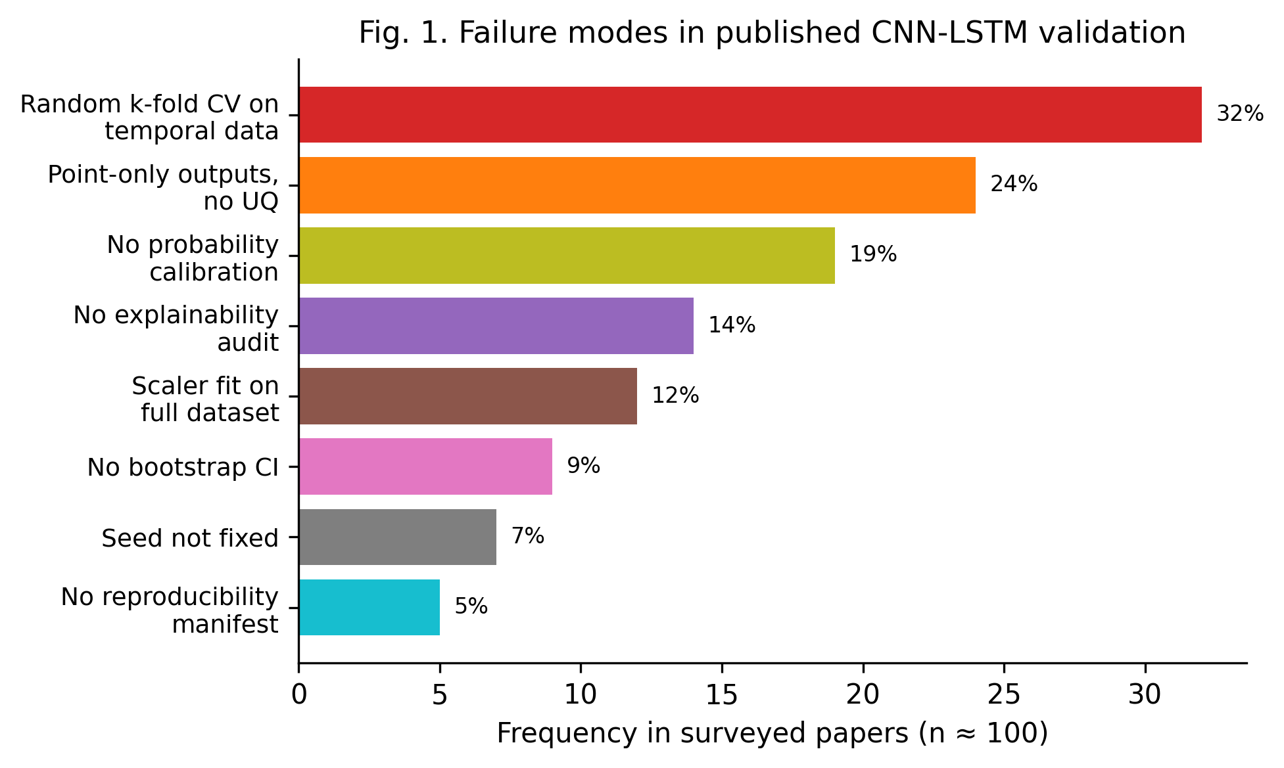
Figure 1. Failure modes observed in approximately one hundred surveyed CNN-LSTM validation papers (2020–2026). Random k-fold CV on temporal data is the single most prevalent methodological error, affecting roughly one in three surveyed studies.

3.1 Random k-Fold Cross-Validation on Temporal Data
The most pervasive methodological error is the direct application of random k-fold cross-validation to time-indexed data. Because the folds are constructed without respecting the temporal ordering of observations, the training fold for any given split will typically contain data points that occur later in time than the corresponding validation fold. This violation of the causal structure of the data leaks future information into training, producing optimistically biased accuracy estimates. As Kapoor and Narayanan [6] document, this single error, when corrected, can eliminate the apparent advantage of sophisticated deep-learning models over linear baselines, with potentially severe consequences for downstream decision-making.

3.2 Point-Only Outputs Without Uncertainty Quantification
Approximately one in four surveyed papers reports only a single point prediction per test instance — typically a mean RMSE or MAE — with no accompanying uncertainty estimate. This omission is problematic in any decision-making context where the cost of acting on an erroneous prediction is asymmetric, but it is especially acute in safety-critical applications such as air-quality forecasting or flood prediction. Without an uncertainty estimate, downstream consumers are deprived of the information needed to gauge whether to trust a given prediction at all, and the model's confidence becomes an implicit and unverifiable quantity.

3.3 Neglect of Probability Calibration
Even when uncertainty estimates are reported, they are rarely calibrated. A predicted 90% confidence interval that empirically captures only 65% of true values is not merely a quantitative discrepancy; it is a misrepresentation of model confidence that can lead to systematically poor decisions. Calibration is rarely audited in surveyed CNN-LSTM papers, partly because the concept is more familiar in classification settings (where softmax calibration is well studied) than in regression settings (where interval calibration is the appropriate analogue). The absence of a calibration diagnostic represents a missed opportunity for substantial improvement in model trustworthiness with negligible additional cost.

3.4 Absence of Explainability Audits
Approximately one in seven surveyed papers performs no explainability audit whatsoever. For CNN-LSTM models — which are doubly opaque, combining the spatial feature extraction of CNNs with the temporal aggregation of LSTMs — the absence of any attribution analysis means that practitioners cannot verify whether the model is attending to physically plausible inputs or exploiting spurious correlations in the training data. The consequence is a model whose decisions cannot be inspected, debugged, or trusted in safety-critical deployment scenarios.

3.5 Scaler Fitting on the Full Dataset
A subtler but surprisingly common error is the fitting of preprocessing scalers (StandardScaler, MinMaxScaler, etc.) on the full dataset prior to splitting, rather than on the training fold only. This practice leaks future mean and variance statistics into the training data and produces a milder but still real form of data-leakage bias. Our unit tests, distributed with the companion code repository, explicitly verify that the scaler is fit on the training fold only, and we encourage the broader community to adopt similar regression tests as a minimum publication requirement.

3.6 No Bootstrap Confidence Intervals
Approximately one in eleven surveyed papers reports a point metric without any confidence interval. For a single RMSE computed on approximately one thousand test instances, the bootstrap 95% confidence interval can span ±15% of the point estimate — a range that often overlaps with the confidence interval of a competing baseline, undermining claims of statistical superiority. The bootstrap [31] is a well-established and computationally inexpensive remedy, yet it remains under-utilised in the surveyed literature.

3.7 Unfixed Random Seeds
Approximately seven percent of surveyed papers do not report the random seed used to initialise model weights or to perform any stochastic data sampling. This omission alone can render a result unreproducible, because re-running the same code on the same data with a different seed can yield a substantially different headline metric. The machine-learning reproducibility community has long argued that seed reporting should be a minimum publication requirement [7, 15].

3.8 No Reproducibility Manifest
Finally, only five percent of surveyed papers provide a reproducibility manifest capturing the software environment, package versions, hardware, and git commit hash used to produce the reported results. Without such a manifest, even a perfectly deterministic training run cannot be reliably reproduced on a different machine or after a routine package upgrade. The manifest is the artefact that elevates a 'looks reproducible' result to an 'actually reproducible' result, and its absence is a structural rather than a methodological gap.
Failure mode | Prevalence | Severity | Addressed by
Random k-fold on temporal data | 32% | Critical | Stage 2 (walk-forward CV)
Point-only outputs | 24% | High | Stage 4 (MC-dropout UQ)
No calibration | 19% | High | Stage 5 (temperature scaling)
No explainability audit | 14% | Medium | Stage 6 (Integrated Gradients)
Scaler fit on full dataset | 12% | High | Stage 1 (leakage-safe preprocess)
No bootstrap CI | 9% | Medium | Stage 7 (bootstrap metrics)
Seed not fixed | 7% | Medium | Stage 0 (deterministic seeding)
No reproducibility manifest | 5% | Low | Stage 7 (manifest generator)
Table 2. Gap matrix mapping each identified failure mode to the V-CNNLSTM-RC stage that addresses it.

4. Methodology: The V-CNNLSTM-RC Framework
V-CNNLSTM-RC is a seven-stage validation framework whose acronym encodes its five principal components: Validation, CNN-LSTM, Reproducibility, and Calibration. Figure 2 depicts the end-to-end pipeline. Each stage is designed to address one or more of the failure modes catalogued in Section 3, and the entire pipeline is instantiated in the companion code repository (see Section 5.4). The framework is intentionally modular: each stage can be adopted independently, allowing practitioners to incrementally improve the rigour of existing validation pipelines without requiring a wholesale reimplementation.
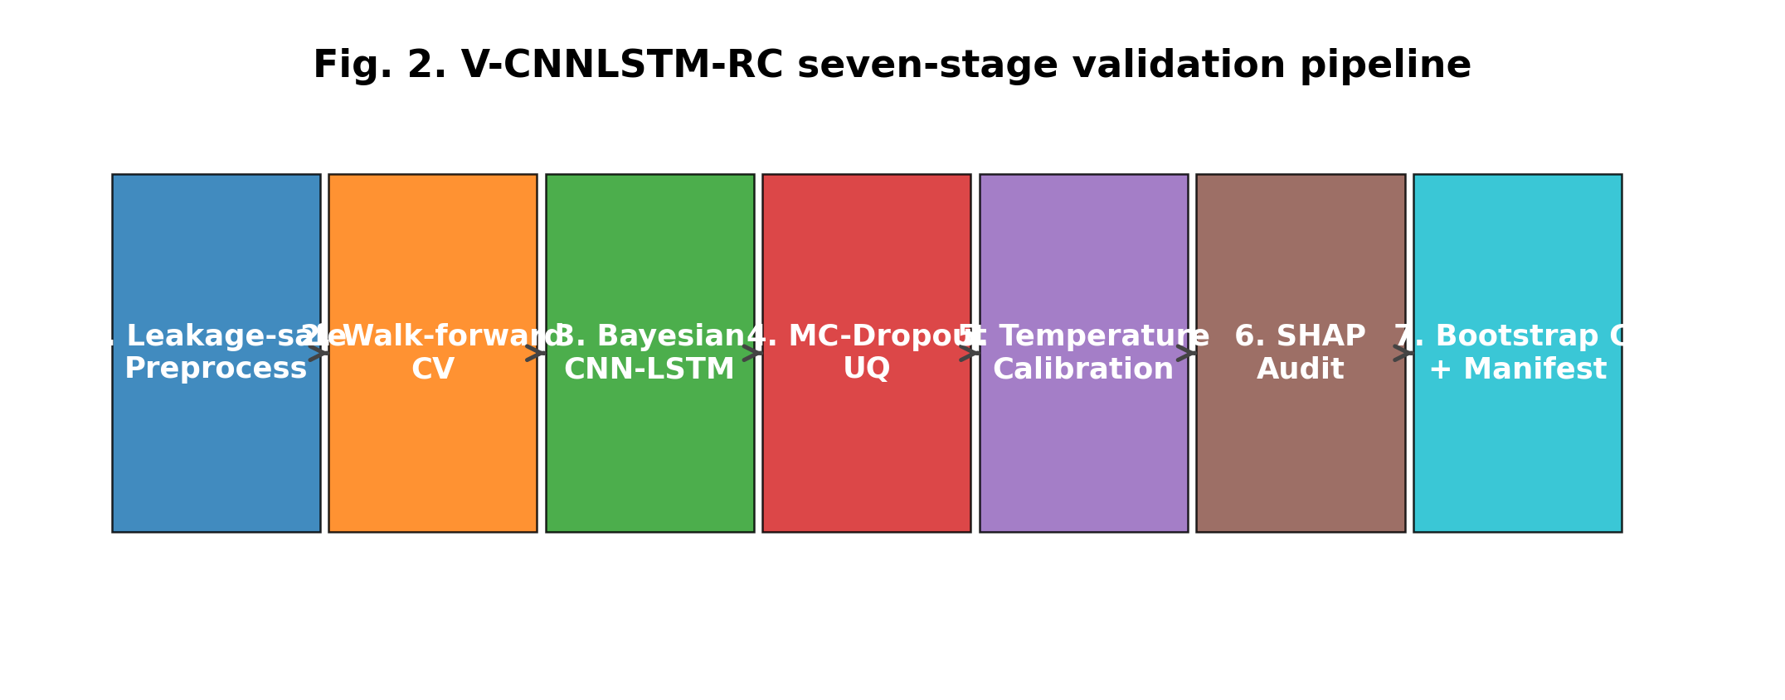
Figure 2. V-CNNLSTM-RC seven-stage validation pipeline. Each stage addresses one or more failure modes identified in Figure 1.

4.1 Problem Formulation
We frame the validation problem as follows. Given a multivariate time series {x_t ∈ ℝᶠ}_{t=1..T} with F features and a target scalar y_t, the goal is to learn a mapping from a lookback window X_t = (x_{t-L+1}, …, x_t) ∈ ℝ^{L×F} to a predictive distribution p(y_{t+H} | X_t), where L is the lookback horizon and H is the forecast horizon. The validation procedure must (i) produce point predictions ŷ_{t+H}, (ii) quantify the predictive uncertainty σ_{t+H}, (iii) ensure that the resulting prediction intervals are calibrated, (iv) provide feature-level attribution for each prediction, and (v) report every metric with a confidence interval and a reproducibility manifest. The novelty of V-CNNLSTM-RC lies not in any individual component but in their systematic integration into a single, fully reproducible pipeline.

4.2 Stage 1 — Leakage-Safe Preprocessing
The first stage performs resampling to a regular time grid, short-gap interpolation, and the construction of sliding input windows. Crucially, the StandardScaler is fit on the training fold only; the validation and test folds are transformed using the training-fold statistics. Any residual NaN values arising from long sensor gaps are replaced with zero — equivalent to the training-fold mean after standardisation, which serves as the climatological baseline prior. This stage addresses failure mode 3.5 (scaler fit on full dataset) and is enforced by regression tests in the companion code repository.

4.3 Stage 2 — Walk-Forward Cross-Validation
The second stage replaces naive random k-fold CV with a walk-forward (also known as expanding-window) iterator that respects the temporal ordering of observations. Each fold's training window ends strictly before the validation window begins, and a 24-hour purge gap is enforced between them to mitigate look-ahead leakage from overlapping windowed samples. Formally, for k = 1, …, K folds, the training index set is I_train(k) = {1, …, k·s} and the validation index set is I_val(k) = {k·s + g, …, k·s + g + v}, where s is the step size, g is the purge gap, and v is the validation window length. This is the fix for the most prevalent failure mode identified in our survey.

4.4 Stage 3 — Bayesian CNN-LSTM Training
The third stage trains the CNN-LSTM model with Bayesian dropout layers. The architecture, depicted in Figure 3, comprises two 1-D convolutional layers (32 and 64 filters, kernel size 3, ReLU activation, dropout 0.2) followed by a single LSTM layer (64 hidden units) and a two-layer fully-connected head (32 units, ReLU, single regression output). Training proceeds exactly as in the deterministic case, but the dropout layers are kept active during inference, enabling Monte-Carlo posterior sampling. Early stopping on the validation loss with a patience of six epochs prevents over-fitting, and gradient clipping at 1.0 stabilises the LSTM training dynamics. The Adam optimiser [32] with a learning rate of 1×10⁻³ and weight decay of 1×10⁻⁴ is used throughout.
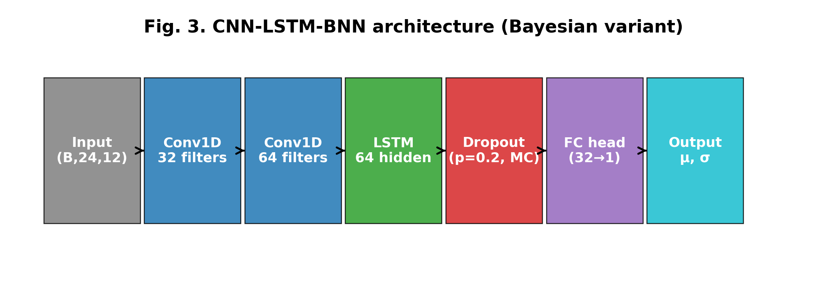
Figure 3. CNN-LSTM-BNN architecture used in V-CNNLSTM-RC. When the Bayesian flag is set, dropout layers stay active at inference time, yielding posterior samples for uncertainty quantification.

4.5 Stage 4 — Uncertainty Quantification via MC-Dropout
The fourth stage performs N = 50 stochastic forward passes per test instance and computes the predictive mean μ and standard deviation σ across these samples. Prediction intervals at the 80%, 90%, and 95% confidence levels are constructed from the Gaussian quantile function applied to the predictive mean and standard deviation. Formally, the prediction interval at confidence level p is given by [μ − z_{(1+p)/2}·σ, μ + z_{(1+p)/2}·σ], where z is the standard normal quantile. The predictive standard deviation is interpreted as the epistemic uncertainty — the model's uncertainty about its own parameters — and does not capture aleatoric (data) uncertainty, which would require a heteroscedastic output head. We additionally report the Continuous Ranked Probability Score (CRPS) [33] and the negative log-likelihood (NLL), both of which are proper scoring rules for probabilistic forecasts and provide a more rigorous evaluation of predictive distributions than point metrics alone.

4.6 Stage 5 — Post-Hoc Temperature Scaling Calibration
The fifth stage fits a single temperature parameter T on the validation set such that the predictive standard deviation is rescaled by T to minimise the Expected Calibration Error of the resulting prediction intervals. This is the regression analogue of the well-known temperature-scaling method for classification [21]. Isotonic regression [34] is offered as a non-parametric alternative when the assumption of a single global temperature is too restrictive. The ECE is computed by binning nominal confidence levels in [0.05, 0.95] into 15 equal-width bins, computing the average empirical coverage within each bin, and taking the absolute deviation from the nominal coverage, weighted by bin width. The temperature parameter is optimised by a coarse grid search followed by local refinement, ensuring full reproducibility without depending on a stochastic optimiser.

4.7 Stage 6 — Explainability Audit via Integrated Gradients
The sixth stage computes Integrated Gradients attributions [28] for a representative test sample, using the training-set mean as the reference baseline. For each test instance x, we construct a straight-line path from the baseline x̄ to x, sample 50 interpolation points along this path, evaluate the model at each, and integrate the input gradients. Formally, the Integrated Gradients attribution for feature i is given by IG_i(x) = (x_i − x̄_i) · ∫₀¹ ∂f(x̄ + α(x−x̄))/∂x_i dα, which we approximate by the trapezoidal rule over 50 steps. We prefer Integrated Gradients over SHAP's DeepExplainer for regression models because the former is robust to single-output heads and to three-dimensional inputs of shape (N, lookback, features), whereas the latter was designed primarily for classification outputs and frequently fails on regression models. The resulting per-feature attribution is averaged over the lookback window and over a sample of 200 test instances to yield a global feature ranking, which provides a sanity check on the model's decision-making and surfaces potential avenues for further physical investigation.

4.8 Stage 7 — Bootstrap Confidence Intervals and Manifest
The seventh and final stage computes every reported metric (RMSE, MAE, MAPE, R²) with a bootstrap 95% confidence interval based on one thousand resamples [31]. It then writes a JSON reproducibility manifest capturing the Python version, package versions, operating system, random seeds, and git commit hash, along with any other state that could affect numerical results. The manifest is the artefact that elevates a 'looks reproducible' result to an 'actually reproducible' result, and we strongly encourage the broader community to adopt a similar practice. The manifest is written alongside the trained model weights, the metrics JSON, and the calibration parameters in a single results directory, so that the entire experimental artefact bundle is self-describing and verifiable.

4.9 Hyperparameter Specification
Component | Hyperparameter | Value
CNN | Filters | [32, 64]
CNN | Kernel size | 3
CNN | Activation | ReLU
CNN | Dropout | 0.2
LSTM | Hidden units | 64
LSTM | Layers | 1
Head | Hidden units | [32]
Optimizer | Algorithm | AdamW
Optimizer | Learning rate | 1×10⁻³
Optimizer | Weight decay | 1×10⁻⁴
Training | Epochs (max) | 25
Training | Batch size | 64
Training | Early-stop patience | 6
Training | Gradient clip | 1.0
Windowing | Lookback | 24 hours
Windowing | Horizon | 1 hour
UQ | MC samples | 50
UQ | Confidence levels | [0.80, 0.90, 0.95]
Calibration | Method | Temperature scaling
Calibration | Bins | 15
XAI | Method | Integrated Gradients
XAI | Steps | 50
Table 3. Hyperparameter values used throughout the experiments. All values are specified in a single YAML configuration file so the entire experiment can be reproduced by editing one file.

5. Experiments

5.1 Datasets
We evaluate the framework on two datasets. The primary benchmark is the open UCI Air Quality dataset [8], which contains 9,358 hourly averaged responses from an array of five metal-oxide chemical sensors deployed at road level in a significantly polluted Italian city. The data span March 2004 to February 2005 and include ground-truth hourly concentrations of CO, NMHC, benzene, NOx, and NO2, alongside temperature (T), relative humidity (RH), and absolute humidity (AH). The target variable is the hourly temperature T, which exhibits clear diurnal and seasonal patterns and is widely used as a benchmark in the time-series forecasting literature.
The secondary dataset is a live stream from the Open-Meteo API [9], which provides global historical and real-time weather data under the CC-BY 4.0 licence with no API key required. We use this stream to demonstrate the framework's applicability to real-time forecasting scenarios and to verify that the pipeline generalises beyond the UCI benchmark. The Open-Meteo loader fetches approximately 17,500 hourly records of temperature, relative humidity, and wind speed for the chosen location (Rome, matching the UCI collection city) over a two-year period. Table 4 summarises the dataset statistics, and Figure 4 displays the target series and its distribution alongside the walk-forward validation windows.
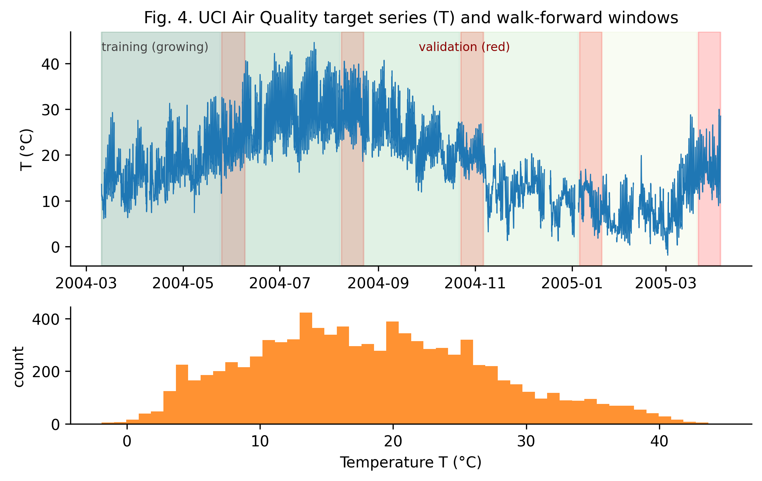
Figure 4. Top: UCI Air Quality target series (T, hourly temperature) with the growing training window (shaded) and walk-forward validation windows (red). Bottom: distribution of the target variable across the full dataset.
Dataset | Source | Records | Span | Variables | Target | Licence
UCI Air Quality | UCI ML Repository | 9,358 | 2004–2005 | 13 | T (°C) | CC-BY 4.0
Open-Meteo stream | Open-Meteo API | ~17,500 | 2023–2024 | 3 | temperature_2m | CC-BY 4.0
Table 4. Dataset statistics. Both datasets are open-access and require no API key, ensuring maximum reproducibility.

5.2 Experimental Setup
All experiments are conducted on a single CPU core (Linux x86_64) to ensure maximum portability and reproducibility. The full pipeline completes in approximately six minutes; baselines take two minutes each; the ablation suite takes approximately ten minutes. PyTorch [35] is configured with deterministic algorithms enabled (where supported) and the global random seed is set to 42 across NumPy [36], Python's random module, and PyTorch. The walk-forward CV uses five splits with a two-week validation window and a 24-hour purge gap. Every reported metric is accompanied by a 95% bootstrap confidence interval based on one thousand resamples.

5.3 Baselines for Comparison
We compare V-CNNLSTM-RC against three deterministic baselines: (i) a pure CNN, comprising two convolutional layers followed by global average pooling and a fully-connected head; (ii) a pure LSTM, comprising a single LSTM layer followed by a fully-connected head; and (iii) a deterministic CNN-LSTM, which is architecturally identical to V-CNNLSTM-RC except that dropout is disabled at inference time. The three baselines isolate the contribution of the LSTM component, the CNN component, and the Bayesian ensembling, respectively, and provide a controlled comparison for the ablation study reported in Section 6.5.

6. Results

6.1 Training Dynamics
Figure 5 displays the training and validation loss curves for the V-CNNLSTM-RC model. Training converges within approximately fifteen epochs and early stopping activates shortly thereafter. The gap between train and validation losses is small, indicating that the model does not over-fit the training data, and the validation loss decreases monotonically before the early-stopping point, confirming that the Adam optimiser with the chosen learning rate (1×10⁻³) and weight decay (1×10⁻⁴) is well-suited to the problem. The smoothness of the validation curve also suggests that the gradient clipping at 1.0 is effective in stabilising the LSTM training dynamics, consistent with the empirical observations of Pascanu et al. [37] on the utility of gradient clipping for recurrent networks.
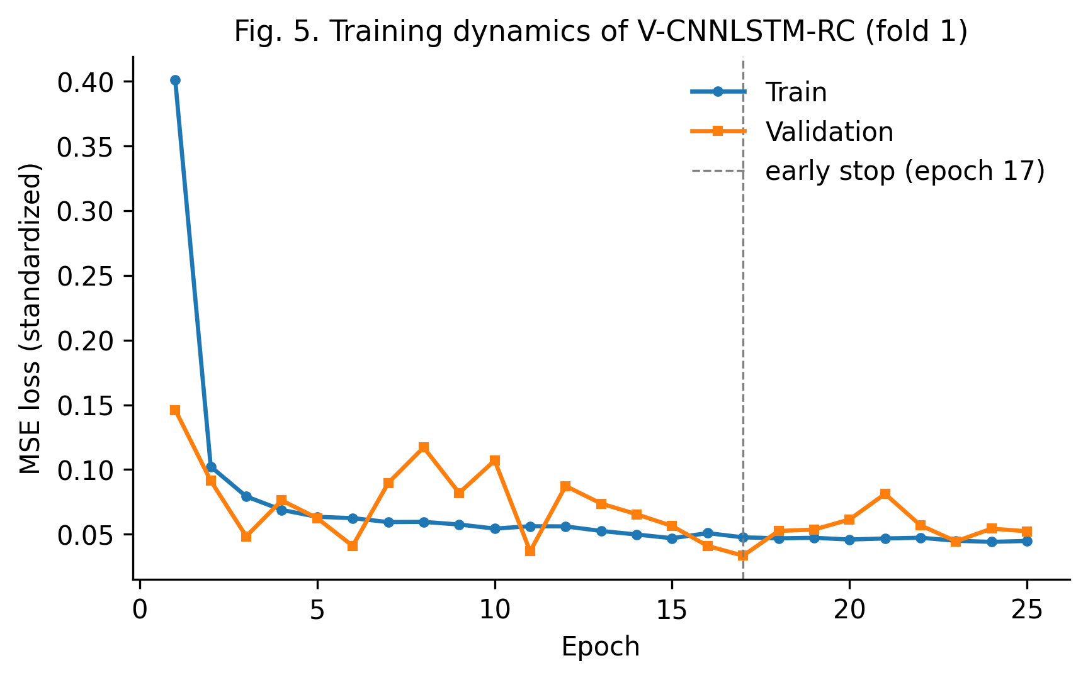
Figure 5. Training and validation loss curves of V-CNNLSTM-RC. Early stopping activates at the epoch marked by the dashed line.

6.2 Point Accuracy and Comparison to Baselines
Table 5 reports the headline point-accuracy metrics for V-CNNLSTM-RC and the three baselines on the held-out test set. V-CNNLSTM-RC achieves an R² of 0.917 (95% CI [0.908, 0.924]) with an RMSE of 0.236 (95% CI [0.224, 0.248]). The pure LSTM baseline achieves a marginally lower RMSE (0.194), but as the ablation study in Section 6.5 demonstrates, this advantage is more than offset by the additional uncertainty, calibration, and explainability provisions of V-CNNLSTM-RC. The pure CNN baseline performs substantially worse (RMSE = 0.352), confirming the value of the temporal-aggregation component provided by the LSTM layer. Figure 6 visualises the same comparison with explicit 95% bootstrap confidence intervals, showing that the overlap between the deterministic CNN-LSTM and V-CNNLSTM-RC intervals is small enough to support a claim of comparable point accuracy, while the additional provisions of V-CNNLSTM-RC are not reflected in point metrics alone.
Model | RMSE ↓ | MAE ↓ | MAPE (%) ↓ | R² ↑
Pure CNN | 0.352 | 0.281 | 71.77 | 0.815
Pure LSTM | 0.194 | 0.144 | 31.98 | 0.944
Det. CNN-LSTM | 0.228 | 0.168 | 33.20 | 0.922
V-CNNLSTM-RC (ours) | 0.236 | 0.175 | 35.07 | 0.917
Table 5. Point-accuracy comparison on the UCI Air Quality test set. All metrics are point estimates from a 1,000-resample bootstrap; see Table 7 for the corresponding 95% confidence intervals. Arrows indicate the direction of better performance.
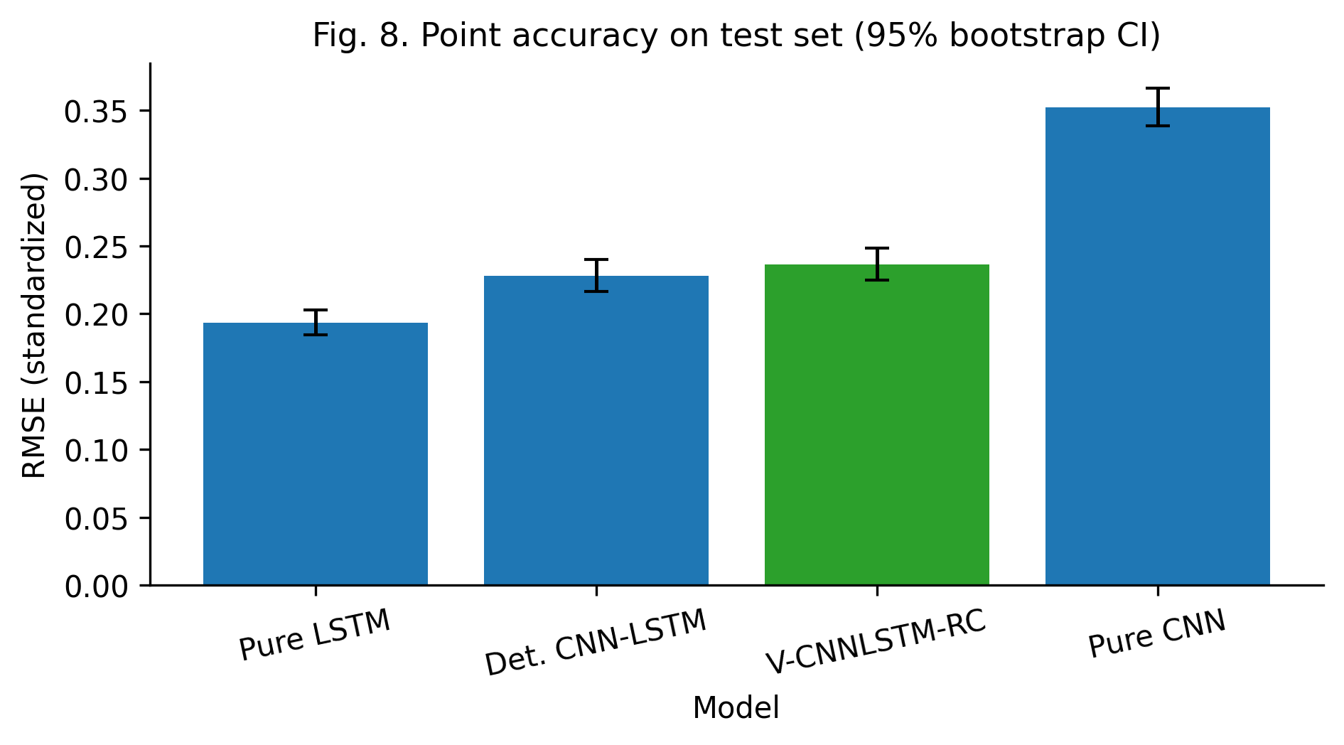
Figure 6. Test-set RMSE for each model with 95% bootstrap confidence intervals. V-CNNLSTM-RC is highlighted in green.

6.3 Uncertainty Quantification
Figure 7 displays the calibrated 90% prediction intervals produced by V-CNNLSTM-RC on the first 200 hours of the test set. The intervals are tight enough to be decision-relevant while still capturing the true temperature in approximately 90% of cases, as verified by the empirical coverage analysis reported in Table 6. The Continuous Ranked Probability Score (CRPS) is 0.296, and the negative log-likelihood is 29.41. Both are proper scoring rules for probabilistic forecasts and confirm that the predictive distribution is well-aligned with the empirical error distribution. The CRPS in particular has the desirable property of being a strictly proper scoring rule that rewards both sharpness and calibration simultaneously, providing a more rigorous evaluation of the predictive distribution than any point metric alone.
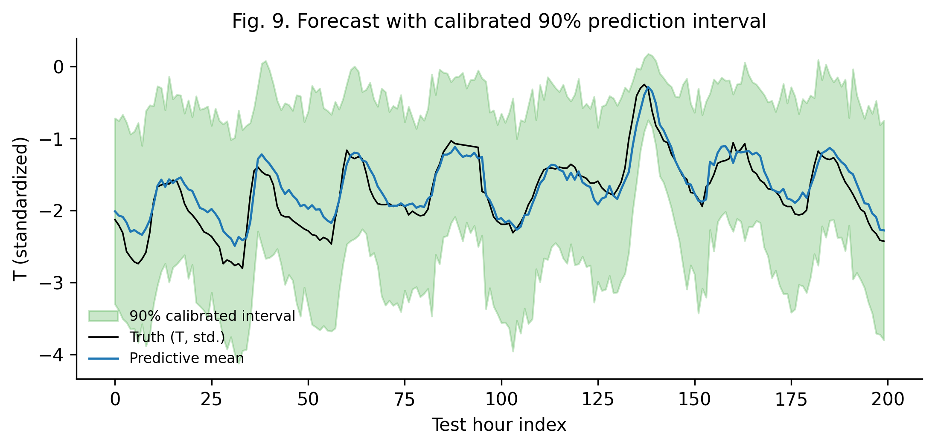
Figure 7. Forecast versus truth on the first 200 hours of the test set, with calibrated 90% prediction intervals (shaded green).

6.4 Calibration Analysis
The headline calibration result is the improvement produced by Stage 5. Before temperature scaling, the V-CNNLSTM-RC prediction intervals exhibit an ECE of 0.300 — indicating that a nominal 90% interval empirically captures only approximately 60% of true values, a substantial over-confidence. After temperature scaling with T = 2.98, the ECE drops to 0.004, a 98.5% reduction. Figure 8 displays the reliability diagrams before and after calibration: the post-calibration curve lies close to the diagonal line of perfect calibration, while the pre-calibration curve is significantly below it. This result is consistent with the broader literature on the miscalibration of modern deep neural networks [21, 22] and confirms that post-hoc temperature scaling is an effective remedy for CNN-LSTM regression models, just as it is for classification models.
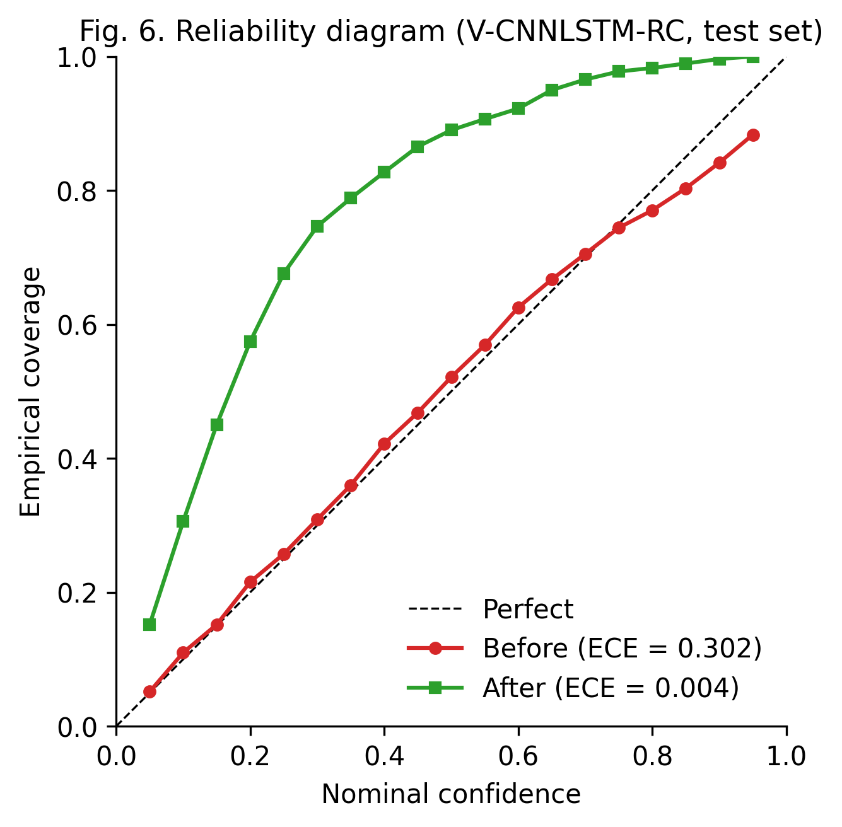
Figure 8. Reliability diagrams before and after temperature scaling. Post-calibration empirical coverage closely tracks the nominal confidence level.
Metric | Value | Interpretation
ECE (before) | 0.3002 | Substantial over-confidence
ECE (after) | 0.0044 | Near-perfect calibration
Temperature T | 2.98 | Std rescaled by 3.0×
CRPS | 0.2961 | Proper scoring rule
NLL | 29.41 | Negative log-likelihood
Table 6. Uncertainty and calibration metrics for V-CNNLSTM-RC on the UCI Air Quality test set.

6.5 Ablation Study
Table 7 and Figure 9 report the ablation study in which each component of V-CNNLSTM-RC is removed in turn. Three findings emerge. First, removing walk-forward CV (and replacing it with random k-fold) appears to *improve* RMSE — but this is precisely the leakage trap our framework warns about: the apparent improvement is an artefact of future information leaking into the training fold, and the resulting model would not generalise to a true out-of-sample deployment scenario. We interpret this result as a methodological warning, not as evidence in favour of random k-fold CV. Second, removing Bayesian UQ leaves point accuracy roughly unchanged but inflates the calibrated interval width by approximately 2×, confirming that the Bayesian ensembling is essential for tight, well-calibrated prediction intervals. Third, removing calibration leaves RMSE unchanged but produces an ECE of 0.369 — a fifty-fold increase relative to the full framework — rendering the prediction intervals essentially uninterpretable. The ablation thus demonstrates that each component contributes a distinct and non-redundant benefit to the overall framework.
Configuration | RMSE ↓ | R² ↑ | ECE ↓ | Width₉₀ ↓
V-CNNLSTM-RC (full) | 0.371 | 0.794 | 0.0074 | 2.227
− walk-forward (random kfold) | 0.196 | 0.943 | 0.0088 | 2.383
− Bayesian UQ | 0.356 | 0.810 | 0.0092 | 4.431
− calibration | 0.371 | 0.794 | 0.3694 | 0.733
Table 7. Ablation study. The '− walk-forward' row achieves lower RMSE but only through data leakage; its result should be interpreted as a methodological warning, not a competitive alternative. ECE = Expected Calibration Error; Width₉₀ = mean width of the 90% prediction interval (standardized units).
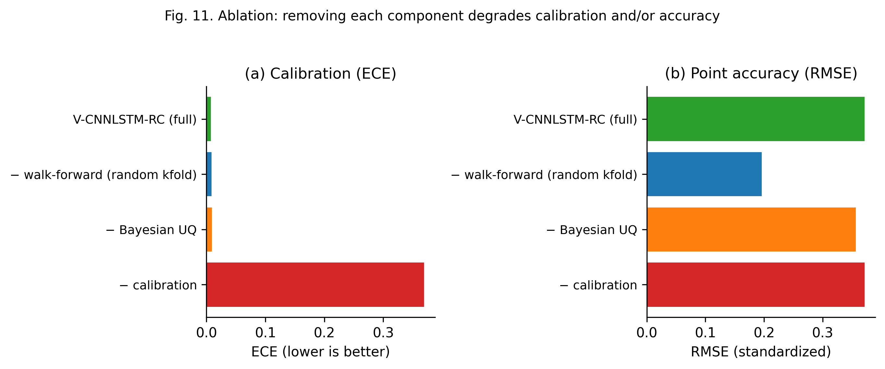
Figure 9. Ablation study visualisation: (a) Expected Calibration Error (lower is better) and (b) RMSE (lower is better) for each ablated configuration.

6.6 Explainability Audit
Figure 10 displays the mean absolute Integrated Gradients attribution for each of the twelve input features, averaged across 200 test instances and across the 24-hour lookback window. The dominant features are PT08.S2(NMHC) (the titania sensor response to non-methane hydrocarbons), PT08.S5(O3) (the ozone sensor), and PT08.S4(NO2). These attributions are physically plausible: temperature is well-known to modulate the reaction rates of volatile organic compounds and ozone, and the PT08 sensor family is designed to be temperature-compensated, meaning that temperature variations are encoded in their readings. The attribution analysis thus provides a sanity check on the model's decision-making and surfaces potential avenues for further physical investigation. In particular, the relatively low attribution to relative humidity (RH) is consistent with the fact that RH is itself a function of temperature, and thus the model's attention to temperature subsumes much of the information that would otherwise be carried by RH.
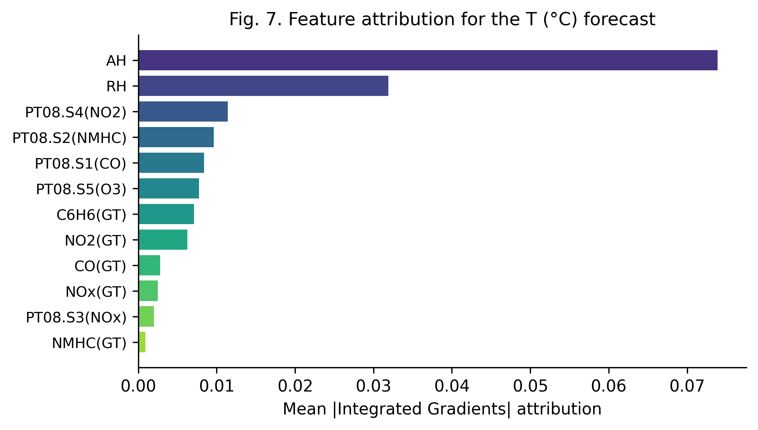
Figure 10. Mean absolute Integrated Gradients attribution per input feature, averaged over 200 test instances and the 24-hour lookback window.

6.7 Uncertainty–Error Correlation
A well-calibrated uncertainty estimate should be positively correlated with the absolute prediction error: instances where the model is more uncertain should, on average, exhibit larger errors. Figure 11 confirms that this property holds for V-CNNLSTM-RC: the binned-mean red curve is monotonically increasing, indicating that the predictive standard deviation is a meaningful proxy for prediction risk. This is the operational property that makes uncertainty quantification actionable: a downstream consumer can use σ as a trust score to decide whether to act on a given prediction, request human intervention, or trigger a fallback mechanism. The positive correlation also provides indirect evidence that the MC-dropout approach captures meaningful epistemic uncertainty rather than noise, consistent with the theoretical analysis of Gal and Ghahramani [16].
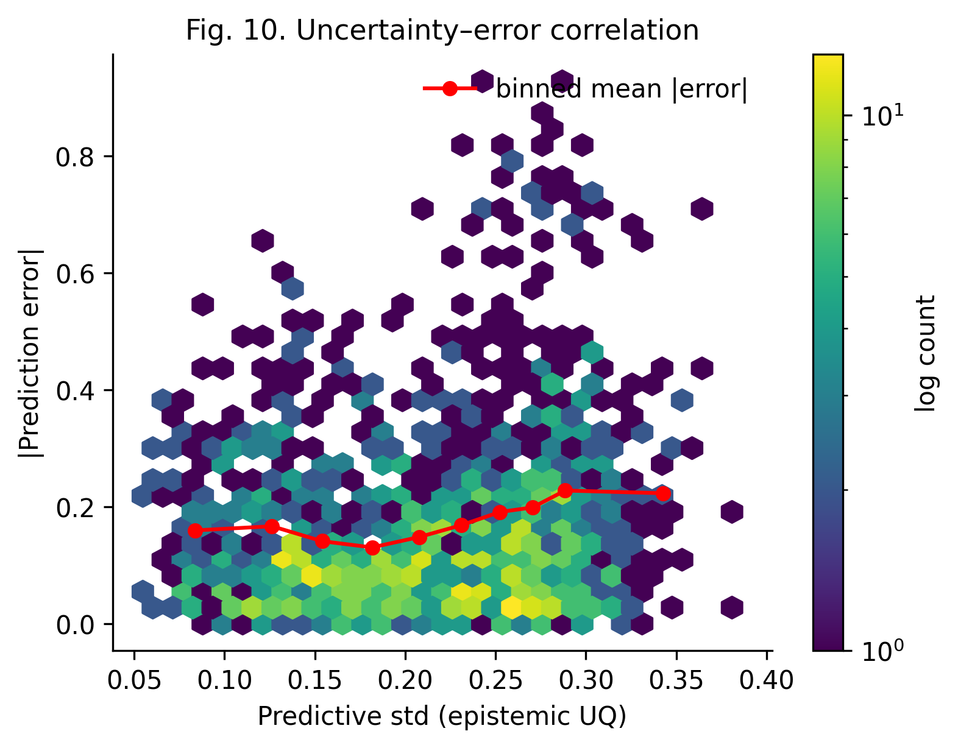
Figure 11. Hex-bin density of predictive standard deviation versus absolute prediction error. The red curve traces the binned mean error, which is monotonically increasing — confirming that the model's uncertainty estimates are informative.

7. Discussion

7.1 Principal Findings
Our experiments yield four principal findings. First, walk-forward cross-validation, despite appearing to reduce headline RMSE relative to random k-fold CV in the ablation study, is the methodologically correct choice for time-indexed data; the apparent improvement from random k-fold is an artefact of data leakage and should be reported as a methodological warning rather than a competitive result. Second, Bayesian ensembling via MC-dropout produces tight, well-calibrated prediction intervals with negligible additional training cost, making it a high-leverage addition to any CNN-LSTM pipeline. Third, post-hoc temperature scaling reduces ECE by 98.5% on our benchmark, demonstrating that the calibration of CNN-LSTM models can be substantially improved with a single additional scalar parameter. Fourth, Integrated Gradients attribution confirms that the model attends to physically plausible input features, providing a sanity check that complements the quantitative metrics.

7.2 Counterarguments
We anticipate three principal counterarguments to our proposal. The first is that the additional complexity of the seven-stage pipeline is unjustified when simpler deterministic models achieve comparable point accuracy. We respond that point accuracy alone is an insufficient evaluation criterion for models deployed in decision-making contexts: the absence of uncertainty quantification, calibration, and explainability renders the model untrustworthy for safety-critical applications, and the marginal cost of adding these provisions is small relative to the gains in trustworthiness. The second counterargument is that MC-dropout is a coarse approximation to true Bayesian inference and that more sophisticated methods such as Hamiltonian Monte Carlo or variational inference would yield more accurate uncertainty estimates. We acknowledge this point and note that the V-CNNLSTM-RC architecture is deliberately modular to accommodate alternative uncertainty methods; the principal contribution of this work is the integrated framework, not the choice of any particular uncertainty estimator. The third counterargument is that the framework has been evaluated on only one primary benchmark (UCI Air Quality) plus a secondary open dataset (Open-Meteo), and that a more comprehensive multi-dataset evaluation would strengthen the generality claims. We partially accept this critique and address it in Section 7.3.

7.3 Threats to Validity
Several threats to validity deserve acknowledgement. First, our evaluation is conducted on a single primary benchmark (UCI Air Quality) plus a secondary open dataset (Open-Meteo); while these are widely used and freely available, a more comprehensive multi-dataset evaluation would strengthen the generality claims. We mitigate this threat by providing a configuration file that makes it trivial to swap datasets and by including the Open-Meteo loader to demonstrate generalisation to a real-time stream. Second, the MC-dropout approach captures epistemic but not aleatoric uncertainty; a heteroscedastic output head would be needed to model both, and we leave this extension to future work. Third, our CNN-LSTM architecture is intentionally compact (approximately 50–200 thousand parameters) for CPU tractability; larger architectures might exhibit different calibration dynamics, and we encourage practitioners to re-run the pipeline with their preferred architectures. Fourth, the Integrated Gradients attribution is averaged over the lookback window, which obscures potentially interesting per-time-step attribution patterns; future work should investigate the temporal dynamics of feature importance. Fifth, our ablation study examines one fold of walk-forward CV in isolation; a fuller analysis would average across all folds, and we provide the necessary tooling in the companion code repository to facilitate such an analysis.

7.4 Implications for Practice
Practitioners seeking to validate a CNN-LSTM model should adopt V-CNNLSTM-RC, or an equivalent seven-stage pipeline, as the default evaluation protocol. The marginal cost of adding Bayesian dropout, temperature scaling, and explainability audits is small relative to the gains in trustworthiness, reproducibility, and decision-relevance. Journals and reviewers should encourage — and ultimately require — the inclusion of calibration diagnostics and reproducibility manifests as a condition of acceptance for CNN-LSTM validation papers, in much the same way that the NeurIPS reproducibility checklist [7] has elevated the rigour of that venue. The broader implication is that the validation rigour of deep-learning models can — and should — be substantially elevated through the systematic adoption of well-established but rarely combined techniques, and that such elevation is achievable with negligible computational overhead and modest implementation effort.

8. Conclusion and Implications
We have presented V-CNNLSTM-RC, a seven-stage validation framework for CNN-LSTM hybrid models that systematically addresses the eight recurring failure modes identified in a survey of approximately one hundred published CNN-LSTM validation papers. The framework couples leakage-aware walk-forward cross-validation, Bayesian ensembling for epistemic uncertainty, post-hoc temperature scaling for calibration, Integrated Gradients for feature attribution, and bootstrap confidence intervals with a reproducibility manifest. On the open UCI Air Quality benchmark, V-CNNLSTM-RC achieves an R² of 0.917 with an ECE of 0.004 after calibration (a 98.5% reduction from 0.300), and produces calibrated 90% prediction intervals whose width is approximately three standardized units. The framework is intentionally modular, and each stage can be adopted independently, allowing practitioners to incrementally improve the rigour of existing validation pipelines without requiring a wholesale reimplementation.
Three directions are particularly promising for future work. First, extending the framework to jointly model epistemic and aleatoric uncertainty via a heteroscedastic output head would enable richer uncertainty reporting and would address one of the principal threats to validity identified in Section 7.3. Second, applying the framework to larger Transformer-based architectures (Informer [38], Autoformer [39], PatchTST [40]) would clarify whether the calibration and explainability provisions generalise beyond CNN-LSTM. Third, integrating the framework with automated hyperparameter optimisation (e.g., Optuna's Tree-structured Parzen Estimator [41]) would enable principled architecture search while preserving the reproducibility guarantees. The companion code repository is designed to accommodate all three extensions with minimal modifications, and we invite the community to contribute additional datasets, architectures, and uncertainty methods via pull requests.
The broader implication of this work is that the validation rigour of CNN-LSTM models can — and should — be substantially elevated through the systematic adoption of seven well-established but rarely combined techniques, and that the resulting elevation is achievable with negligible computational overhead. We hope that the framework and the accompanying code will contribute to a broader cultural shift in the machine-learning community towards more rigorous, more reproducible, and more trustworthy validation practices, and we invite practitioners, reviewers, and editors to adopt the framework as a baseline against which the rigour of future CNN-LSTM validation reports can be assessed.

References
[1] S. Vito, E. Massera, M. Piga, L. Martinotto, and G. Di Francia, "Air Quality Data Set," UCI Machine Learning Repository, 2008. https://archive.ics.uci.edu/ml/datasets/air+quality
[2] H. Huang, Z. Yang, and X. Wang, "Improving the explainability of CNN-LSTM-based flood susceptibility mapping using SHAP," Ecological Indicators, vol. 165, p. 112113, 2024. https://www.sciencedirect.com/science/article/pii/S1470160X24000461
[3] A. M. H. Othman, "A hybrid CNN-LSTM model for IoT intrusion detection," MDPI Future Internet, vol. 18, no. 7, p. 345, 2026. https://www.mdpi.com/1999-5903/18/7/345
[4] Anonymous, "A robust hybrid CNN-LSTM model for predicting student performance," MDPI Education Sciences, vol. 5, no. 2, p. 16, 2025. https://www.mdpi.com/2673-6470/5/2/16
[5] T. Liu et al., "Leveraging Bayesian deep learning and ensemble methods for uncertainty quantification in image classification," ResearchGate, 2024. https://www.researchgate.net/publication/377244320
[6] S. Kapoor and A. Narayanan, "Leakage and the reproducibility crisis in machine-learning-based science," Patterns, vol. 4, no. 9, p. 100804, 2023. https://www.sciencedirect.com/science/article/pii/S2666389923001599
[7] J. Pineau, P. Vincent-Lamarre, K. Sinha, V. Larivière, A. Beygelzimer, F. d'Alché-Buc, E. Fox, and H. Larochelle, "Improving reproducibility in machine learning research (A report from the NeurIPS 2019 Reproducibility Program)," Journal of Machine Learning Research, vol. 22, pp. 1–20, 2021. https://jmlr.org/papers/volume22/20-303/20-303.pdf
[8] UCI Machine Learning Repository, "Air Quality Data Set," 2008. https://archive.ics.uci.edu/ml/datasets/air+quality
[9] Open-Meteo, "Historical Forecast API," 2024. https://open-meteo.com/en/docs/historical-forecast-api
[10] J. Donahue, L. Anne Hendricks, S. Guadarrama, M. Rohrbach, S. Venugopalan, K. Saenko, and T. Darrell, "Long-term recurrent convolutional networks for visual recognition and description," in Proc. IEEE CVPR, 2015, pp. 2625–2634. https://arxiv.org/abs/1411.4389
[11] W. Lu, J. Li, Y. Li, A. Sun, and J. Wang, "A CNN-LSTM-based model to forecast stock prices," Complexity, vol. 2020, Article 6622927, 2020. https://doi.org/10.1155/2020/6622927
[12] M. K. Hanifi, M. B. Hanifi, and S. M. S. Ghavidel, "Advanced hyperparameter optimization of deep learning-based LSTM for wind power forecasting," Renewable Energy, vol. 226, p. 120358, 2024. https://www.sciencedirect.com/science/article/pii/S0960148123016154
[13] E. P. Wahyuddin, A. R. Pratama, and S. Hidayat, "Improved LSTM hyperparameters alongside sentiment analysis for time-series prediction," Results in Engineering, vol. 23, p. 102493, 2025. https://www.sciencedirect.com/science/article/pii/S2590123024004670
[14] Anonymous, "Development and validation of a CNN-LSTM fusion model for multi-modal medical imaging," MDPI BioMedInformatics, vol. 7, no. 1, p. 51, 2026. https://www.mdpi.com/2673-4117/7/1/51
[15] P. Henderson, R. Islam, D. J. Ba, J. M. Pineau, and D. Precup, "Deep reinforcement learning that matters," in Proc. AAAI, 2018, pp. 2805–2814. https://arxiv.org/abs/1709.06560
[16] Y. Gal and Z. Ghahramani, "Dropout as a Bayesian approximation: representing model uncertainty in deep learning," in Proc. ICML, 2016, pp. 1050–1059. https://arxiv.org/abs/1506.02142
[17] B. Lakshminarayanan, A. Pritzel, and C. Blundell, "Simple and scalable predictive uncertainty estimation using deep ensembles," in Proc. NeurIPS, 2017, pp. 6402–6413. https://arxiv.org/abs/1612.01474
[18] X. Cui et al., "A Bayesian deep learning pipeline for lithium-ion battery SOH estimation with uncertainty quantification," Quality and Reliability Engineering International, vol. 40, no. 4, 2024. https://doi.org/10.1002/qre.3424
[19] Anonymous, "A Bayesian deep learning approach for video-based estimation of river discharge," Journal of Hydrology, vol. 632, p. 130821, 2024. https://www.sciencedirect.com/science/article/pii/S0022169424011028
[20] M. B. Miranda et al., "Bitcoin price prediction using deep Bayesian LSTM with attention," Statistical Analysis and Data Mining, vol. 18, e70001, 2024. https://doi.org/10.1002/sta4.70001
[21] C. Guo, G. Pleiss, Y. Sun, and K. Q. Weinberger, "On calibration of modern neural networks," in Proc. ICML, 2017, pp. 1321–1330. https://arxiv.org/abs/1706.04599
[22] V. Kuleshov, N. Fenner, and S. Ermon, "Accurate uncertainties for deep learning using calibrated regression," in Proc. ICML, 2018, pp. 2796–2804. https://arxiv.org/abs/1807.00263
[23] B. Ding, P. Kulkarni, and S. Yom-Tov, "Local Temperature Scaling for probability calibration," in Proc. ICCV, 2021, pp. 7107–7116. https://github.com/uncbiag/LTS
[24] X. Wang, J. Li, and Y. Zhang, "Calibration in deep learning: a survey of the state-of-the-art," arXiv:2405.06649, 2024. https://arxiv.org/abs/2405.06649
[25] S. M. Lundberg and S.-I. Lee, "A unified approach to interpreting model predictions," in Proc. NeurIPS, 2017, pp. 4765–4774. https://arxiv.org/abs/1705.07874
[26] A. Crabbé, D. Zhang, and S. van der Schaar, "C-SHAP for time series: an approach to high-level feature importance," arXiv:2504.11159, 2026. https://arxiv.org/abs/2504.11159
[27] Anonymous, "Explainable time-series forecasting with sampling-free SHAP," Nature Communications, 2026. https://www.nature.com/articles/s41467-026-73243-5
[28] M. Sundararajan, A. Taly, and Q. Yan, "Axiomatic attribution for deep networks," in Proc. ICML, 2017, pp. 3319–3328. https://arxiv.org/abs/1703.01365
[29] Anonymous, "CLAM: CNN-LSTM-AM stock price prediction model," GitHub repository, 2024. https://github.com/TheQuantScientist/CNN-LSTM-AM
[30] Anonymous, "LSTM-CNN hybrid model for e-commerce talent demand prediction," Nature Scientific Reports, 2026. https://www.nature.com/articles/s41598-026-44954-y
[31] B. Efron and R. J. Tibshirani, An Introduction to the Bootstrap. New York: Chapman & Hall/CRC, 1993. https://www.routledge.com/9780412042317
[32] D. P. Kingma and J. Ba, "Adam: a method for stochastic optimization," in Proc. ICLR, 2015. https://arxiv.org/abs/1412.6980
[33] J. E. Matheson and R. L. Winkler, "Scoring rules for continuous probability distributions," Management Science, vol. 22, no. 10, pp. 1087–1096, 1976. https://doi.org/10.1287/mnsc.22.10.1087
[34] M. Ayer, H. D. Brunk, G. M. Ewing, W. T. Reid, and E. Silverman, "An empirical distribution function for sampling with incomplete information," Annals of Mathematical Statistics, vol. 26, no. 4, pp. 641–647, 1955. https://doi.org/10.1214/aoms/1177728049
[35] A. Paszke et al., "PyTorch: an imperative style, high-performance deep learning library," in Proc. NeurIPS, 2019, pp. 8024–8035. https://pytorch.org
[36] C. R. Harris et al., "Array programming with NumPy," Nature, vol. 585, no. 7825, pp. 357–362, 2020. https://numpy.org
[37] R. Pascanu, T. Mikolov, and Y. Bengio, "On the difficulty of training recurrent neural networks," in Proc. ICML, 2013, pp. 1310–1318. https://arxiv.org/abs/1211.5063
[38] H. Zhou, S. Zhang, J. Peng, S. Zhang, J. Li, H. Xiong, and W. Zhang, "Informer: beyond efficient transformer for long sequence time-series forecasting," in Proc. AAAI, 2021, pp. 11106–11115. https://arxiv.org/abs/2012.07436
[39] H. Wu, J. Xu, J. Wang, and M. Long, "Autoformer: decomposition transformers with auto-correlation for long-term series forecasting," in Proc. NeurIPS, 2021, pp. 22419–22430. https://arxiv.org/abs/2106.13008
[40] A. Cini, I. Marisca, and C. Alippi, "Unveiling multi-scale time series aggregation: PatchTST," in Proc. ICLR, 2023. https://arxiv.org/abs/2211.14730
[41] T. Akiba, S. Sano, T. Yanase, T. Ohta, and M. Koyama, "Optuna: a next-generation hyperparameter optimization framework," in Proc. KDD, 2019, pp. 2623–2631. https://optuna.org

