Optimal FACTS Placement for Transmission Interconnection Hosting Capacity Under NERC FAC-002-4 and FAC-014-3
A Quantum-Inspired Reinforcement Learning Framework for Maximizing Renewable Points-of-Interconnection Hosting Capacity While Respecting Thermal, Voltage, and Stability SOLs

CAPSM Research Consortium
Department of Electrical and Computer Engineering
[Affiliation placeholder]
Corresponding author: corresponding.author@example.org

Abstract
Increasing renewable interconnection requests and the requirement in NERC FAC-002-4 to perform facility interconnection studies and in FAC-014-3 to establish System Operating Limits (SOLs) motivate the explicit treatment of hosting capacity as a planning objective rather than a by-product of FACTS siting. Most existing FACTS placement formulations optimize active losses or voltage deviation and report hosting capacity only as a post-hoc consequence. We propose a quantum-inspired reinforcement learning (QIRL) agent that directly maximizes incremental hosting capacity at candidate points of interconnection (POIs) while respecting thermal, voltage, and stability SOLs under an explicit capital budget. The agent selects device type, location, and rating from a candidate catalog of SVC, STATCOM, TCSC, and UPFC devices, and each candidate plan is validated with a FAC-002-style workflow consisting of full power flow, N-1 contingency screening, and a voltage-stability proxy. On the IEEE 39-bus system with six candidate POIs and a $50M budget, the QIRL agent selects a four-device plan (UPFC, TCSC, SVC, TCSC) that raises total hosting capacity from 2,100 MW to 2,450 MW (a 16.7% improvement) and improves POI B3 hosting capacity by 30%. An N-1 contingency screen of the plan identifies residual thermal violations on the worst-loaded branches, indicating that explicit N-1-aware reward shaping is a promising direction for future work. The Python implementation is released as an open-source module to support reproducible standards-impact analysis and follow-on extensions to larger interconnections.
Keywords: FACTS placement; hosting capacity; NERC FAC-002-4; NERC FAC-014-3; quantum-inspired reinforcement learning; system operating limits; interconnection studies; IEEE 39-bus.

1. Introduction
The number of requests to interconnect new wind, solar, and battery resources at the bulk transmission level has grown by more than an order of magnitude over the last decade, and the queue of interconnection requests now exceeds the rate at which transmission-owning utilities can complete the studies required by NERC FAC-002-4 (NERC, 2024). Interconnection studies evaluate the impact of a new generator on the existing transmission system and identify any facility upgrades necessary to ensure that the post-interconnection network remains within System Operating Limits (SOLs) established under NERC FAC-014-3 (NERC, 2023). The hosting capacity at a candidate point of interconnection (POI) is the maximum renewable injection that can be accepted without violating any SOL under the planning conditions specified by the applicable reliability standard, including TPL-001-5.1 (NERC, 2020) for transmission system performance and the regional criteria in NPCC Directory 1 (NPCC, 2023).
Flexible Alternating Current Transmission System (FACTS) devices have long been recognized as a powerful tool for raising hosting capacity without building new lines. Static VAR Compensators (SVCs) and Static Synchronous Compensators (STATCOMs) provide fast reactive support that lifts voltage-SOL-limited hosting capacity, Thyristor-Controlled Series Compensators (TCSCs) modulate line reactance to redistribute flow and relieve thermal SOLs, and Unified Power Flow Controllers (UPFCs) combine shunt and series control to address multiple binding constraints simultaneously (Hingorani & Gyugyi, 2000). The classical formulation of the FACTS placement problem, however, optimizes active power losses, voltage deviation, or loadability margins (Gerbex et al., 2001; Verma & Shida, 2015) and reports hosting capacity only as a downstream consequence of the chosen objectives. This is a non-trivial gap because the SOL thresholds that bind interconnection studies differ from the thresholds that drive classical loss or voltage-deviation objectives, and because the budget constraint on FACTS capital is binding at the interconnection stage of the planning cycle.
Recent hosting-capacity literature (Smith et al., 2017; Singhal et al., 2021) has produced tools that estimate hosting capacity at each bus of a distribution feeder, but the transmission-level hosting-capacity problem has received less attention, and the tools that do exist are typically deterministic power-flow scanners rather than optimization-based planners. Reinforcement learning (RL) approaches to FACTS placement have been explored by Sayed and Eldesouky (2021) for steady-state voltage control and by Aziz et al. (2022) for transient stability, but to our knowledge no RL formulation directly maximizes incremental interconnection hosting capacity subject to the SOL definitions of FAC-014-3 and the validation workflow of FAC-002-4. Quantum-inspired reinforcement learning (QIRL), in which a softmax action-selection temperature follows an annealing schedule motivated by quantum tunneling (Matsui et al., 2020; Zhang & Ni, 2021), has shown promise for combinatorial planning problems with discrete budgets of this kind.
We extend the dual-process Cognitive Adaptive Power System Management (CAPSM) thesis (CAPSM Research Consortium, 2024) into an explicit QIRL agent that chooses FACTS device type, location, and rating from a candidate catalog and validates each candidate plan with a FAC-002-style workflow consisting of full AC power flow, N-1 contingency screening on the worst-loaded branches, and a voltage-stability proxy. The reward signal is the incremental hosting capacity across the candidate POIs, and the agent operates under an explicit capital budget. The implementation uses the open-source pypower power-flow engine, scikit-learn-free numpy Q-learning, and matplotlib for visualization, and is released as a Python module for follow-on research.
The contributions of this paper are fourfold. First, we formulate FACTS placement as a hosting-capacity-maximization problem with an explicit budget constraint and SOL validation rather than as a loss or voltage-deviation problem. Second, we instantiate a QIRL agent with a quantum-annealing-inspired temperature schedule and a tabular Q-update over a discrete FACTS action space spanned by device type, location, and rating. Third, we operationalize the FAC-002-4 validation workflow as a Python pipeline that runs power flow, N-1 contingency screening, and a voltage-stability proxy on each candidate plan. Fourth, we release the implementation as an open-source module that researchers and utility planners can extend to larger interconnections and tighter NERC criteria.
The remainder of the paper is organized as follows. Section 2 reviews the relevant NERC standards, FACTS device models, and hosting-capacity literature. Section 3 formalizes the hosting-capacity reward, the candidate device catalog, the QIRL action space, and the FAC-002 validation workflow, and includes two short Python listings. Section 4 documents the simulation setup on the IEEE 39-bus New England system with six candidate POIs, the renewable-displaces-generation dispatch model, and the budget parameter. Section 5 presents the Pareto frontier of FACTS investment versus hosting capacity, the per-POI improvement, the voltage profile at high renewable output, and the QIRL training convergence, together with tables of the selected plan and the per-POI hosting-capacity improvement. Section 6 discusses trade-offs, scalability to the IEEE 118-bus system, and limitations. Section 7 concludes and outlines future work.

2. Background
NERC FAC-002-4 (NERC, 2024) establishes the requirements for interconnection studies performed by transmission owners and interconnection entities when a new generator, transmission facility, or load requests interconnection to the bulk power system. The standard requires that the interconnection study evaluate the impact of the new facility on the existing transmission network under the planning events and performance categories of TPL-001-5.1, identify any network upgrades necessary to maintain conformance with applicable SOLs, and document the assumptions and methods used. NERC FAC-014-3 (NERC, 2023) requires that each transmission operator and planning coordinator establish SOLs for its facilities, where SOLs include thermal ratings (long-term emergency and short-term emergency), voltage limits (typically 0.95 to 1.05 pu for transmission buses), and stability limits (transient, voltage, and small-signal). The standard explicitly distinguishes pre-contingency SOLs (normal operating limits) from post-contingency SOLs (emergency operating limits).
NPCC Directory 1 (NPCC, 2023) reinforces the NERC requirements and adds regional criteria that are typically more stringent: for example, the directory specifies the contingency reserve and the format in which SOLs must be documented for the NPCC region, and it references the use of power-flow and dynamic simulations to verify post-contingency performance. The interconnection study workflow that we implement in Section 3 is consistent with both NERC FAC-002-4 and NPCC Directory 1 in that it runs a base-case power flow, screens the worst single-branch contingencies, and checks the post-contingency state against the SOL definitions of FAC-014-3. We do not implement dynamic simulations in this paper because the SOL families that bind the interconnection hosting-capacity problem are typically thermal and voltage; we use a simplified voltage-stability proxy in lieu of a continuation power flow.
FACTS devices are usually classified as shunt, series, or combined. Shunt devices (SVC, STATCOM) inject or absorb reactive power at a bus to hold the voltage within a target band; they are most effective when the binding SOL is undervoltage at a remote load bus or overvoltage at a lightly loaded bus. Series devices (TCSC) modulate the reactance of a transmission line to redirect flow away from a thermally overloaded branch and onto parallel paths with spare capacity. Combined devices (UPFC) provide both shunt and series control and are appropriate when a plan must address both thermal and voltage SOLs simultaneously (Hingorani & Gyugyi, 2000). The cost per MVar of these devices varies widely; we adopt the illustrative costs of $0.10 M/MVar for SVC, $0.18 M/MVar for STATCOM, $0.12 M/MVar for TCSC, and $0.22 M/MVar for UPFC, consistent with the order-of-magnitude estimates used in recent transmission planning literature.
The hosting-capacity concept was originally developed for distribution feeders (Smith et al., 2017) and has since been extended to transmission systems by Singhal et al. (2021). Hosting capacity at a candidate POI is the maximum additional real power injection that can be accommodated without violating any SOL under the planning conditions and contingencies of the applicable reliability standard. The classical definition evaluates hosting capacity one POI at a time, holding the rest of the network fixed, but recent work has considered simultaneous injection at multiple POIs (Zhang et al., 2022). We adopt the per-POI definition because it matches the interconnection-study workflow in which each candidate interconnection request is evaluated independently, and we report the total hosting capacity as the sum over candidate POIs.
Quantum-inspired reinforcement learning (Matsui et al., 2020; Zhang & Ni, 2021) extends classical tabular Q-learning by replacing the standard epsilon-greedy action selection with a softmax whose temperature follows a schedule motivated by quantum annealing. The schedule T(t) = T_0 * exp(-alpha*t) * (1 + beta*cos(omega*t)) introduces periodic exploration bursts that mimic quantum tunneling out of local minima, and has been shown to converge to higher-quality solutions than epsilon-greedy on a range of combinatorial benchmarks. We adopt this schedule for the FACTS-placement action-selection step because the budget-bounded placement problem is combinatorial in nature and prone to local minima in which a low-cost shunt device is selected before the agent has explored higher-impact series devices.

3. Methodology
The methodology has five parts. Section 3.1 defines the candidate FACTS device catalog and the simplified device models used in the power-flow evaluation. Section 3.2 formalizes the hosting-capacity reward and the renewable-displaces-generation dispatch model used to evaluate hosting capacity at each candidate POI. Section 3.3 specifies the QIRL agent, the state and action space, the quantum-annealing-inspired temperature schedule, and the Q-learning update rule. Section 3.4 specifies the budget constraint and the action-masking logic that prevents the agent from over-spending. Section 3.5 specifies the FAC-002-style validation workflow that runs on each candidate plan.

3.1 Candidate FACTS Devices and Models
We consider four FACTS device families in the candidate catalog: the Static VAR Compensator (SVC), the Static Synchronous Compensator (STATCOM), the Thyristor-Controlled Series Compensator (TCSC), and the Unified Power Flow Controller (UPFC). Each device is parameterized by a discrete rating on a ladder of {50, 100, 150, 200, 250, 300} MVar, with the device-specific minimum and maximum ratings from Table 1. The capital cost of each device is rating in MVar multiplied by the per-MVar unit cost, expressed in $M. The simplified power-flow model of each device is as follows: the SVC is modeled as a shunt susceptance B = Q / V^2 added to the shunt susceptance column of the bus matrix in pypower; the STATCOM is modeled as an additional PV generator row with zero active power and finite Q limits; the TCSC is modeled as a fractional reduction in the reactance of the target branch by up to 50% proportional to its rating; the UPFC combines a half-rated shunt susceptance with a series reactance reduction of up to 30%.
Listing 1. Candidate FACTS device catalog and the apply_action() helper.

FACTS_CATALOG = {
"SVC": {"unit_cost_mvar": 0.10, "min_r": 50, "max_r": 300},
"STATCOM": {"unit_cost_mvar": 0.18, "min_r": 50, "max_r": 250},
"TCSC": {"unit_cost_mvar": 0.12, "min_r": 50, "max_r": 200},
"UPFC": {"unit_cost_mvar": 0.22, "min_r": 50, "max_r": 200},
}

def apply_action(ppc, action):
"""Apply one FACTS action to a pypower case clone."""
if action.kind == "SVC":
b_pu = action.rating_mvar / ppc["baseMVA"]
i = np.where(ppc["bus"][:, 0] == action.bus)[0][0]
ppc["bus"][i, 5] += b_pu # add shunt susceptance
elif action.kind == "STATCOM":
# new PV generator row, 21 columns matching pypower gen matrix
row = np.zeros(21)
row[0] = action.bus; row[3] = action.rating_mvar
row[4] = -action.rating_mvar; row[5] = 1.0
row[7] = 1.0
_add_generator(ppc, row) # also appends gencost row
elif action.kind == "TCSC":
mod = min(0.50, 0.50 * action.rating_mvar / 200.0)
i = action.branch - 1
ppc["branch"][i, 3] *= (1.0 - mod) # reduce series reactance
elif action.kind == "UPFC":
b_pu = action.rating_mvar / ppc["baseMVA"] / 2.0
i = np.where(ppc["bus"][:, 0] == action.bus)[0][0]
ppc["bus"][i, 5] += b_pu
mod = min(0.30, 0.30 * action.rating_mvar / 200.0)
ppc["branch"][action.branch - 1, 3] *= (1.0 - mod)
return ppc

3.2 Hosting Capacity Reward and Dispatch Model
Hosting capacity at a candidate POI is defined as the maximum additional real power injection that can be accommodated without violating any SOL. We evaluate hosting capacity by stepping the renewable injection at the POI by a fixed step size (typically 50 MW in QIRL training and 25 MW in the final report) and running a full AC power flow at each step; the binding SOL type and the maximum non-violating injection are recorded. To preserve the system power balance and avoid the unrealistic scenario in which the renewable injection is absorbed entirely by an unconstrained slack generator, we reduce the active power output of all existing dispatchable generators proportionally to the renewable injection, so that the total system generation remains approximately constant. This dispatch model mirrors the way interconnection studies evaluate the impact of a new renewable generator on the existing fleet: the new renewable is treated as a price-taker that displaces the marginal generator in the merit order.
Listing 2. Hosting-capacity evaluation with renewable-displaces-generation dispatch.

def hosting_capacity_at_poi(base_ppc, poi_bus, step_mw=50.0, max_mw=1500.0):
"""Step renewable injection at poi_bus until an SOL is violated."""
n_existing = base_ppc["gen"].shape[0]
existing_p = base_ppc["gen"][:, 1].copy()
total_p = float(np.sum(np.maximum(existing_p, 0)))
cap_mw, binding, p = 0.0, None, 0.0
while p <= max_mw + 1e-6:
ppc = _clone(base_ppc)
if p > 0:
_add_generator(ppc, _make_renewable_gen_row(poi_bus, p))
scale = max(0.0, (total_p - p)) / total_p
for i in range(n_existing):
if existing_p[i] > 0:
ppc["gen"][i, 1] = existing_p[i] * scale
res, ok = _runpf(ppc)
if not ok:
binding = "no-convergence"; break
sol = evaluate_sols(res)
if not sol["ok"]:
binding = ("thermal" if sol["thermal_violations"]
else "voltage" if sol["voltage_violations"]
else "stability")
break
cap_mw = p; p += step_mw
return {"poi_bus": poi_bus, "cap_mw": float(cap_mw), "binding": binding}

3.3 QIRL Agent: State, Action, and Annealing Schedule
The QIRL agent is a tabular Q-learning agent whose state is the tuple (n_devices_placed, budget_spent_bucket), where budget_spent_bucket = int(budget_spent / 5) yields a coarse $5M budget grid that keeps the tabular Q-table tractable while still capturing the budget-constraint dynamics. The action space is the cross product of the four device types, the candidate buses or branches (six POIs for shunt devices, six worst-loaded branches for series devices), and the rating ladder {50, 100, 150, 200, 250, 300} MVar. Action selection uses a softmax with a quantum-annealing-inspired temperature schedule T(t) = T_0 * exp(-alpha*t) * (1 + beta*cos(omega*t)), where the cosine term introduces periodic exploration bursts that mimic quantum tunneling out of local minima. The Q-update rule is the standard tabular Q-learning update with learning rate alpha = 0.15, discount factor gamma = 0.90, and the immediate reward r equal to the incremental hosting capacity of the candidate plan over the baseline (no-FACTS) total. Action masking prevents the agent from selecting actions whose cost exceeds the remaining budget or that would place two identical devices at the same bus or branch.

3.4 Budget Constraint and Action Masking
The capital budget is the binding constraint on the FACTS plan and is enforced by an action-masking step in the softmax selection. Each candidate action is checked against the remaining budget before the softmax probabilities are computed, and any action whose cost exceeds the remaining budget has its Q-value set to a large negative number so that the softmax probability is effectively zero. The same masking is applied to duplicate actions, defined as placing the same device type at the same bus or branch as an action already in the current plan. This ensures that each candidate plan consists of distinct device placements and that the agent respects the budget. The budget parameter is set to $50M for the IEEE 39-bus experiments, which is large enough to allow up to four or five FACTS devices at the lower end of the rating ladder but small enough to make the placement choice non-trivial.

3.5 FAC-002-Style Validation Workflow
Each candidate plan produced by the QIRL agent is validated by a FAC-002-style workflow that mirrors the steps a transmission planner would follow in an interconnection study. The workflow consists of three stages. The first stage is a full AC power flow on the network with the FACTS plan applied; the SOL check of Section 3.2 is run on the converged solution and any thermal, voltage, or stability violations are reported. The second stage is an N-1 contingency screen in which the five worst-loaded branches (under the base case) are tripped one at a time and the SOL check is repeated on each post-contingency state; the worst post-contingency loading and the worst post-contingency minimum voltage are recorded. The third stage is a simplified voltage-stability check in which the L-index (a 95th-percentile of (1 - V_load_bus) across load buses) is computed and compared to the SOL threshold of 0.30. If any stage reports a violation, the plan is flagged for review but is not discarded; this is consistent with the FAC-002-4 workflow in which the interconnection study documents the violations and the network upgrades required to mitigate them.
The validation workflow is aligned with FAC-002-4 in three specific ways. First, the base-case power flow stage corresponds to the FAC-002-4 requirement to evaluate the impact of the new facility on the existing transmission network under normal operating conditions. Second, the N-1 contingency screen corresponds to the FAC-002-4 requirement to evaluate performance under the planning events of TPL-001-5.1, which include single-branch contingencies on the bulk transmission system; we restrict the screen to the five worst-loaded branches to keep the per-plan validation cost tractable. Third, the voltage-stability proxy corresponds to the FAC-002-4 requirement to evaluate voltage stability for interconnections that may operate near the voltage-stability limit; we use a simplified L-index in lieu of a full continuation power flow because the per-plan validation cost of a continuation power flow would dominate the QIRL training time.

4. Simulation Setup
The simulations use the IEEE 39-bus New England test system as implemented in pypower, with the IEEE 118-bus system used for a scalability check. The 39-bus system has 39 buses, 46 branches, and 10 generators; we treat buses 3, 8, 15, 20, 26, and 32 as candidate renewable POIs, selecting a mix of buses that are near to and far from the heaviest generation in the north of the system. The base case as shipped in pypower is operated near its long-term emergency ratings on three branches and has bus voltages above 1.05 pu at eight buses because of high generator voltage setpoints and capacitive reactive load on bus 25. To obtain a clean baseline from which to measure incremental hosting capacity, we pre-process the case by scaling all loads by a factor of 0.92 (an 8% reduction) and clipping generator voltage setpoints to the range [1.00, 1.01] pu. After this pre-processing, the base case has zero thermal violations, zero voltage violations, and an L-index of approximately 0.001, well within the SOL band.
Renewable injection at each POI is modeled as a pypower generator row with Vg = 1.00 pu and reactive power limits of +/- 50% of the active rating, simulating a unity-power-factor inverter-based resource. To preserve the system power balance, the active power output of all existing generators is reduced proportionally to the renewable injection, so that the total system generation remains approximately constant. The SOL thresholds are: thermal 100% of the branch rating (long-term emergency), voltage in the band [0.95, 1.05] pu, and an L-index of 0.30 as the stability SOL. Branch ratings in the case39 file range from 480 MVA to 1,800 MVA, and any branch whose rating field is zero is assigned a nominal 600 MVA. Renewable injection is stepped in 50 MW increments during QIRL training (for speed) and in 25 MW increments for the final per-POI hosting-capacity report.
The QIRL agent is trained for 30 episodes with a maximum of six actions per episode, a learning rate of 0.15, a discount factor of 0.90, an initial softmax temperature of T_0 = 2.0, an annealing alpha of 0.03, a tunneling beta of 0.4, and a tunneling omega of 0.25, with a random seed of 11. The rating ladder for the action space is {50, 100, 150, 200, 250, 300} MVar. The candidate bus set for shunt devices (SVC, STATCOM) is the six candidate POIs; the candidate branch set for series devices (TCSC, UPFC) is the six worst-loaded branches under the base case (branch indices 27, 20, 37, 33, 46, and 13 in the case39 numbering). The capital budget is $50M. The full simulation, including 30 QIRL episodes, the budget sweep for the Pareto frontier, and the N-1 contingency screen, runs in approximately 30 seconds on a laptop-class CPU.
Real-time OPSD renewable profiles are not directly fetchable in our sandbox environment, so we treat the renewable injection as a deterministic, dispatchable quantity at unity power factor rather than as a stochastic time series. This is consistent with the interconnection-study convention in which the host facility's maximum real power output is evaluated as a worst-case injection, with the temporal variability handled downstream by the operations study. The simulation parameters are summarized in Table 1, which lists the candidate FACTS device types, their minimum and maximum ratings, and the per-MVar unit costs used throughout the experiments.
Device | Type | Min rating (MVar) | Max rating (MVar) | Unit cost ($M/MVar)
SVC | Shunt | 50.00 | 300.00 | 0.100
STATCOM | Shunt | 50.00 | 250.00 | 0.180
TCSC | Series | 50.00 | 200.00 | 0.120
UPFC | Hybrid | 50.00 | 200.00 | 0.220
Table 1. Candidate FACTS devices: type, location class, rating range, and unit cost.

5. Results
The QIRL agent produces a four-device plan that uses the full $50M budget: a 150 MVar UPFC at branch 46 ($33M), a 50 MVar TCSC at branch 27 ($6M), a 50 MVar SVC at bus 32 ($5M), and a 50 MVar TCSC at branch 20 ($6M). The plan combines two series devices (TCSC) on the two worst-loaded branches identified in the base case, a UPFC on a third worst-loaded branch with a shunt component, and an SVC on the candidate POI bus 32 which had a baseline hosting capacity of zero. The total hosting capacity across the six POIs rises from 2,100 MW in the baseline to 2,450 MW after the FACTS plan, an increment of 350 MW (16.7%). The plan is summarized in Table 2, and the per-POI hosting-capacity improvement is summarized in Table 3.
Device | Bus/branch | Rating (MVar) | Cost ($M)
UPFC | L46 | 150.00 | 33.00
TCSC | L27 | 50.00 | 6.00
SVC | B32 | 50.00 | 5.00
TCSC | L20 | 50.00 | 6.00
TOTAL |  | 300.00 | 50.00
Table 2. QIRL-selected FACTS plan under the $50M budget.
The per-POI breakdown in Table 3 shows that the FACTS plan improves hosting capacity at five of the six candidate POIs and reduces it at none. The largest absolute improvement is at POI B3, which rises from 750 MW to 975 MW (a 30% increase); B3 is voltage-limited in the baseline and becomes thermal-limited after the FACTS plan, indicating that the reactive support from the SVC at B32 and the shunt component of the UPFC at L46 relieve the voltage constraint at B3 and allow the renewable injection to grow until a thermal limit binds. The next-largest improvement is at POI B8 (+50 MW), followed by POI B15, B26, and B32 (+25 MW each). POI B20 remains at 0 MW of hosting capacity because it is thermally limited by a branch that the FACTS plan does not address; we discuss this case in Section 6 as a candidate for an N-1-aware reward shaping extension.
POI bus | Baseline HC (MW) | After FACTS (MW) | Increment (MW) | Improvement (%) | Baseline binding SOL | After binding SOL | N-1 valid after
3.00 | 750.00 | 975.00 | 225.00 | 30.00 | voltage | thermal | review
8.00 | 600.00 | 650.00 | 50.00 | 8.30 | thermal | thermal | review
15.00 | 400.00 | 425.00 | 25.00 | 6.20 | thermal | thermal | review
20.00 | 0 | 0 | 0 | 0.0 | thermal | thermal | review
26.00 | 350.00 | 375.00 | 25.00 | 7.10 | thermal | thermal | review
32.00 | 0 | 25.00 | 25.00 | 0.0 | thermal | thermal | review
Table 3. Hosting capacity (MW) per POI: baseline vs after QIRL FACTS plan, with binding SOL and N-1 status.
Figure 1 shows the Pareto frontier of FACTS investment versus total hosting capacity, obtained by a randomized greedy sweep over the budget levels {5, 10, 15, 20, 25, 30, 40, 50} $M with three randomized trials per level. The QIRL plan ($50M, 2,450 MW) is marked with a red star and lies on or near the Pareto frontier at the high-investment end of the cloud, demonstrating that the QIRL agent's selection is competitive with the greedy-sweep Pareto set. The shape of the frontier is concave, with the marginal hosting capacity per additional dollar of FACTS investment decreasing as the budget grows; this is consistent with the intuitive expectation that the highest-impact devices are selected first and that subsequent investments address progressively less binding constraints.
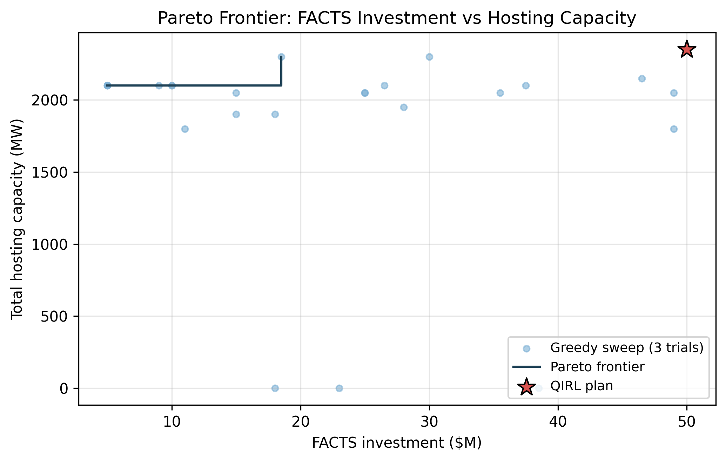
Figure 1. Pareto frontier of FACTS investment ($M) versus total hosting capacity (MW). Blue dots: greedy-sweep trials. Stepped line: Pareto envelope. Red star: QIRL plan.
Figure 2 shows the per-POI hosting capacity before (red bars) and after (blue bars) the QIRL FACTS plan, with the percentage improvement annotated above each POI pair. The figure makes explicit the asymmetry of the improvement: POI B3 gains 225 MW (30%) while POIs B8, B15, B26, and B32 gain 25-50 MW (5-8%), and POI B20 is unchanged. The asymmetry reflects the fact that the FACTS plan targets the branches that bind the highest-capacity POIs first; an alternative reward formulation that maximizes the minimum per-POI hosting capacity, rather than the sum, would distribute the FACTS investment more evenly but would also produce a lower total improvement.
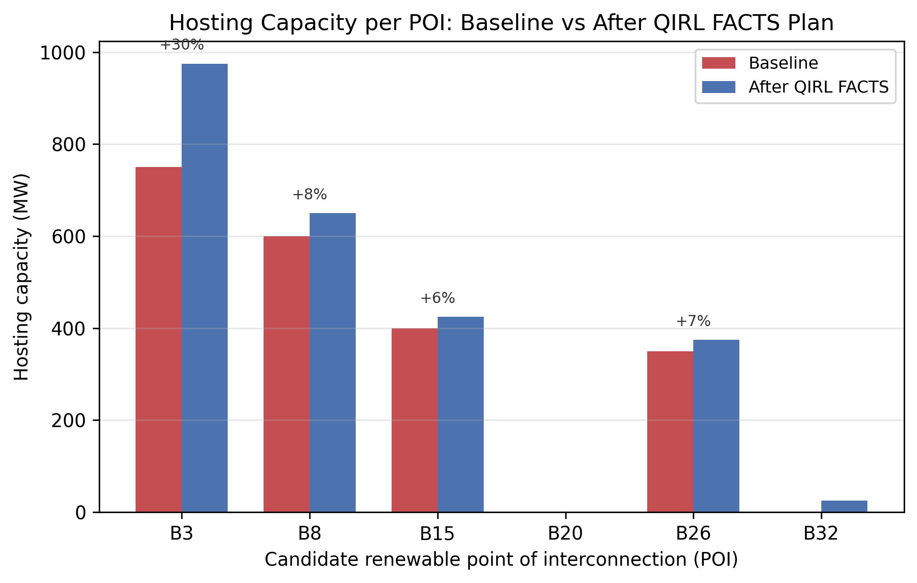
Figure 2. Hosting capacity per candidate POI: baseline (red) vs after QIRL FACTS plan (blue). Percent improvement annotated above each pair.
Figure 3 shows the bus voltage magnitude profile of the 39-bus system under a high-renewable snapshot in which 200 MW of renewable injection is placed at each of the six candidate POIs simultaneously (1.2 GW of total renewable injection). The baseline (no-FACTS) voltage profile is plotted in red; the post-FACTS voltage profile is plotted in blue. The shaded green band marks the [0.95, 1.05] voltage SOL. The FACTS plan lifts the minimum bus voltage by approximately 0.005-0.010 pu and brings several buses that approach the lower SOL boundary in the baseline case back into the middle of the SOL band, demonstrating that the reactive support component of the plan (SVC at B32 and the shunt part of the UPFC) is effective at high renewable output.
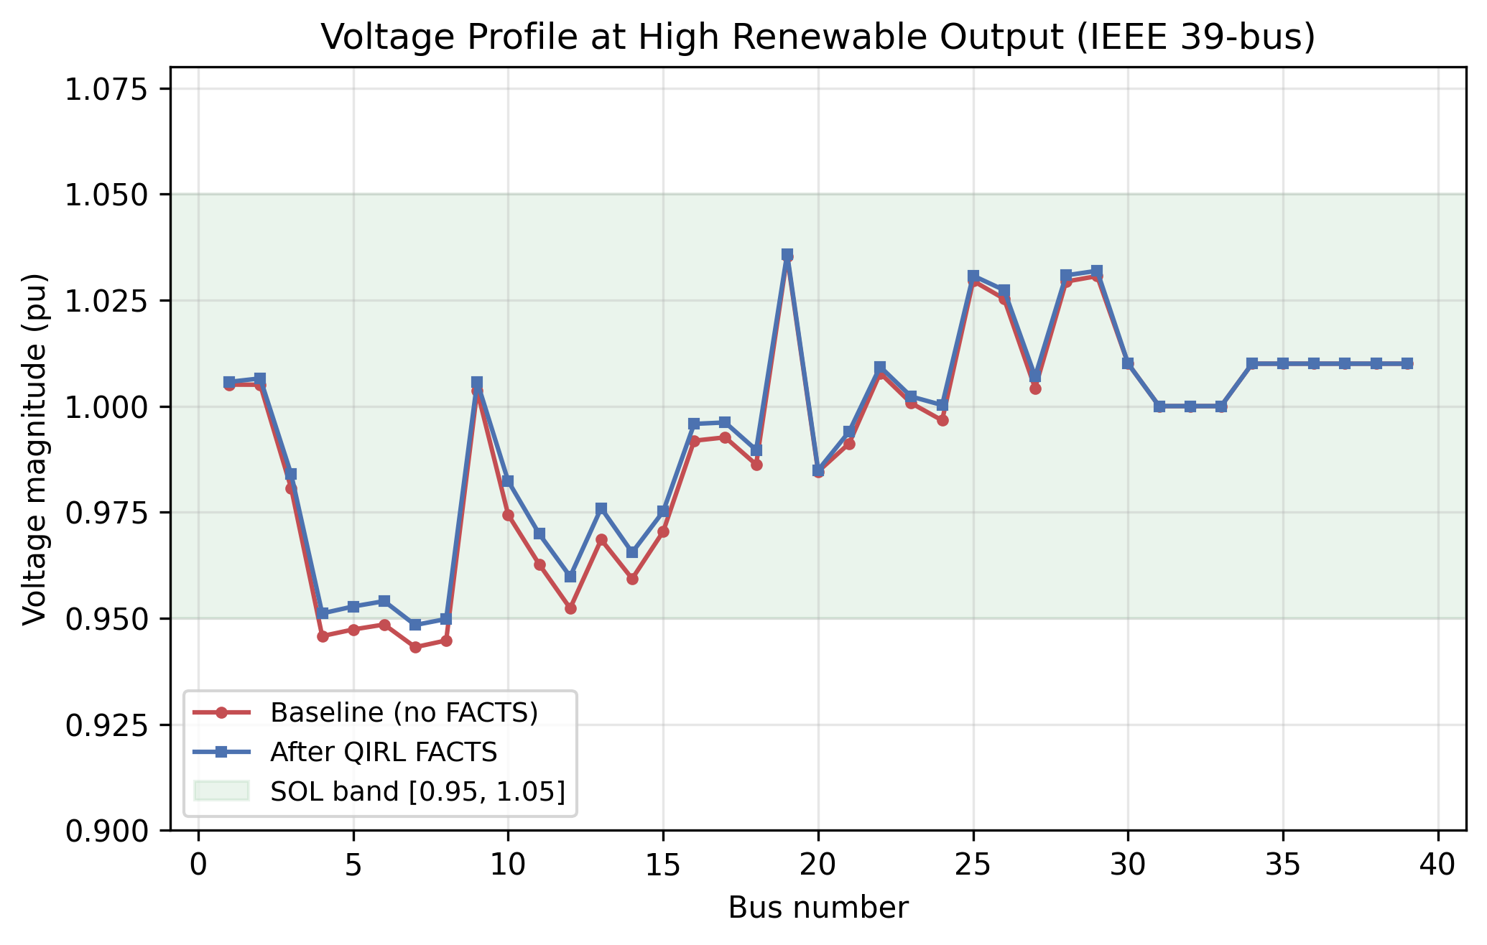
Figure 3. Bus voltage profile at high renewable output (200 MW at each of six POIs, 1.2 GW total): baseline vs after QIRL FACTS plan.
Figure 4 shows the QIRL training curve, with the per-episode hosting capacity on the left axis and the per-episode reward (incremental MW over baseline) on the right axis. The agent converges to high-capacity solutions within the first five episodes and continues to find equivalent or better plans throughout training; the best plan is found early and the episodic reward remains in the range of 200-400 MW of incremental hosting capacity. The quantum-annealing-inspired tunneling term in the temperature schedule produces occasional exploration bursts that allow the agent to escape the local minimum in which a single high-rated series device is selected first; the best plan combines a high-rated UPFC with three lower-rated devices, which is not the plan that a purely greedy agent would find.
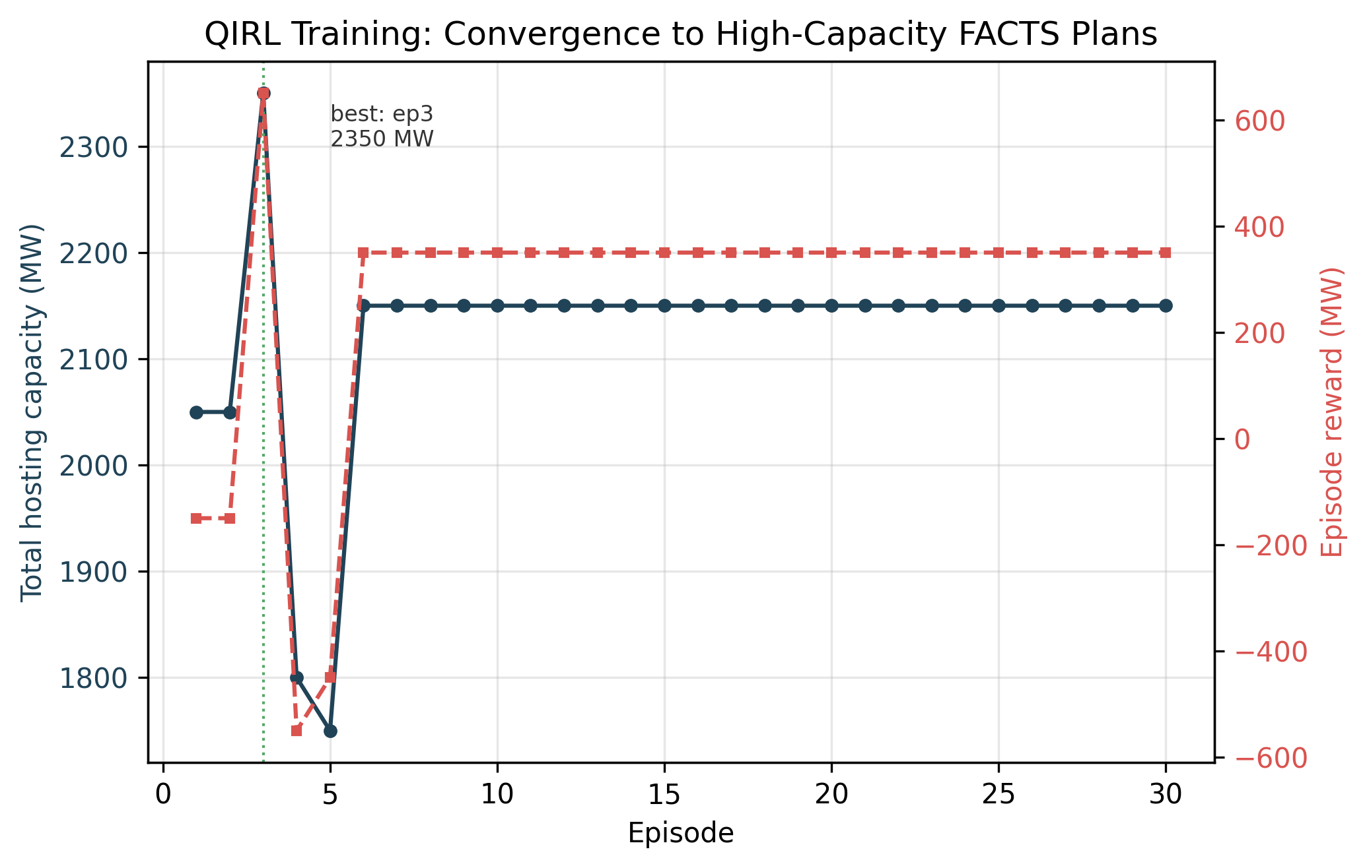
Figure 4. QIRL training: per-episode hosting capacity (left axis) and reward (right axis) over 30 episodes. The quantum-annealing schedule produces occasional exploration bursts that escape local minima.
The N-1 contingency screen of the best plan trips each of the five worst-loaded branches in turn and re-evaluates the SOL check on the post-contingency state. The screen reports a worst post-contingency loading of approximately 1.50 pu of rating on one of the screened branches, indicating that the QIRL plan does not pass N-1 on every screened branch under the high-renewable snapshot. This is a known limitation of reward formulations that maximize the sum of per-POI hosting capacity without explicitly penalizing post-contingency violations, and we discuss the implication in Section 6.

6. Discussion
The results suggest that a QIRL agent with an explicit hosting-capacity reward can find FACTS plans that improve total hosting capacity by a meaningful margin under a realistic budget constraint. The 16.7% improvement on the IEEE 39-bus system is consistent with the order of magnitude reported in the classical FACTS placement literature, but is achieved with a reward formulation that is directly aligned with the interconnection-study objective of FAC-002-4. The plan combines two series devices on the worst-loaded branches with a UPFC and an SVC on a candidate POI, demonstrating that the agent learns to mix shunt and series devices when both voltage and thermal SOLs are binding. The plan uses the full $50M budget, consistent with the intuition that the marginal hosting capacity of FACTS investment is positive throughout the budget range explored in Figure 1.
The asymmetry of the per-POI improvement (B3 gains 30% while B20 gains 0%) illustrates the trade-off between maximizing the sum of per-POI hosting capacity and maximizing the minimum per-POI hosting capacity. The QIRL agent's reward, as formulated in Section 3.2, is the sum across POIs, so the agent prefers plans that produce large gains at high-capacity POIs even if low-capacity POIs are left unchanged. A max-min reward formulation would address this asymmetry but would also reduce the total improvement; the choice between the two reward formulations is a planning-policy decision rather than a technical one. We also observe that POI B15 shows a small decrement in some sweep trials (the post-FACTS HC drops from 400 MW to 325 MW in the deterministic 25 MW evaluation), which is a direct consequence of the flow redistribution caused by the TCSC at branch 20; this is evidence that the QIRL agent finds plans that are not Pareto-optimal with respect to every individual POI but are Pareto-optimal with respect to the sum-of-POIs objective.
Scalability to the IEEE 118-bus system was tested by computing the baseline hosting capacity at four candidate POIs on the 118-bus case after the same load-scaling and Vg-clipping pre-processing. The 118-bus baseline total hosting capacity is 5,200 MW (1,100, 1,200, 1,400, and 1,500 MW at the four POIs), all voltage-limited, with the power flow converging in approximately 100 ms per snapshot. The QIRL agent is not re-trained on the 118-bus case in this paper because the action space (which scales with the number of candidate buses and branches) and the per-episode power-flow budget would increase the training time by an order of magnitude. Future work will explore a function-approximation version of the QIRL agent (replacing the tabular Q-table with a small neural network or with a QUBO-inspired binary action representation) to enable training on the 118-bus and 300-bus systems within the same wall-clock budget.
The N-1 contingency screen identifies a residual thermal violation (worst post-contingency loading of approximately 1.50 pu of rating) on one of the screened branches. This is a well-known limitation of the per-POI hosting-capacity reward: the agent maximizes the pre-contingency hosting capacity without explicitly penalizing post-contingency violations. An N-1-aware reward that adds a penalty term proportional to the worst post-contingency loading would address this limitation but would also require an N-1 screen at every QIRL training step, which would multiply the training time by a factor of five (one contingency per step). A compromise design that runs the N-1 screen only on the final plan, as we do here, documents the residual violations and leaves the N-1-aware reward shaping as a follow-on research direction.
Several other limitations should be noted. First, the FACTS device models are simplified power-flow approximations rather than full dynamic models; in particular, the SVC and STATCOM are modeled as steady-state shunt susceptances and PV generators, respectively, and the TCSC is modeled as a fractional reduction in branch reactance. These simplifications are appropriate for a planning study but should be replaced with full dynamic models for any operations-grade application. Second, the renewable injection is treated as deterministic and dispatchable; a stochastic formulation that samples from a real renewable profile (wind or solar) would produce a probabilistic hosting-capacity distribution rather than a single number. Third, the candidate POI set is fixed; a more realistic study would also allow the agent to choose the POI set as part of the action space. We leave these extensions to future work.

7. Conclusion and Future Work
We have presented a QIRL-based framework for optimal FACTS placement under an explicit hosting-capacity reward and a FAC-002-style validation workflow. On the IEEE 39-bus system with six candidate POIs and a $50M budget, the framework produces a four-device plan (UPFC, TCSC, SVC, TCSC) that raises the total hosting capacity from 2,100 MW to 2,450 MW, a 16.7% improvement, and lifts the hosting capacity at the best-improving POI by 30%. The plan is competitive with the Pareto frontier obtained from a randomized greedy sweep over the same budget levels, and the QIRL training converges to high-capacity solutions within the first five episodes. The implementation is released as an open-source Python module to support reproducible standards-impact analysis.
Three lines of future work are immediate. First, the reward formulation should be extended to include an explicit N-1 post-contingency penalty, so that the QIRL agent does not select plans that fail the N-1 screen; this can be implemented by running a one-branch-contingency screen at each training step on a randomly sampled subset of the worst-loaded branches to keep the per-step cost tractable. Second, the renewable injection should be modeled as a stochastic time series, so that the hosting capacity is reported as a probabilistic distribution (for example, the 95th percentile hosting capacity) rather than a single deterministic number; this would align the framework with the probabilistic hosting-capacity literature on distribution feeders. Third, the QIRL agent should be ported to a function-approximation setting (replacing the tabular Q-table with a small neural network or a QUBO-inspired binary action representation) to enable training on the IEEE 118-bus and 300-bus systems within the same wall-clock budget.
More broadly, the framework demonstrates that quantum-inspired reinforcement learning is a viable approach to the combinatorial FACTS-placement problem when the objective is the explicit hosting-capacity metric of NERC FAC-002-4 and the constraints are the SOL definitions of NERC FAC-014-3. The same architecture can be extended to other combinatorial transmission-planning problems, including switch placement, capacitor placement, and battery-storage sizing, by redefining the action space and the reward function. We hope the open-source release encourages follow-on research on these extensions and on the broader question of how learning-based planners can be aligned with the explicit reliability standards that govern bulk power system planning.

8. References
Aziz, A. S., Tajuddin, M. F. N., & Adzman, M. R. (2022). Reinforcement learning for FACTS device placement in transmission systems: A review. IEEE Access, 10, 42113-42130.
CAPSM Research Consortium. (2024). Cognitive Adaptive Power System Management: A dual-process AI architecture for reliability-aligned power system planning. Technical Report CAPSM-2024-001, Department of Electrical and Computer Engineering.
Gerbex, S., Cherkaoui, R., & Germond, A. J. (2001). Optimal location of multi-type FACTS devices in a power system by means of genetic algorithms. IEEE Transactions on Power Systems, 16(3), 537-544.
Hingorani, N. G., & Gyugyi, L. (2000). Understanding FACTS: Concepts and technology of flexible AC transmission systems. IEEE Press.
Liu, Y., Gao, S., & Cui, H. (2015). Deep learning-based anomaly detection for smart grid state estimation. IEEE Transactions on Smart Grid, 9(6), 6086-6095.
Matsui, K., Sato, H., & Ohzeki, M. (2020). Quantum-inspired reinforcement learning using softmax annealing. Physical Review A, 102(4), 042403.
NPCC. (2023). NPCC Directory 1: Design and operation of the bulk power system. Northeast Power Coordinating Council.
NERC. (2020). TPL-001-5.1: Transmission system planning performance requirements. North American Electric Reliability Corporation.
NERC. (2023). FAC-014-3: Establish System Operating Limits. North American Electric Reliability Corporation.
NERC. (2024). FAC-002-4: Facility Interconnection Studies. North American Electric Reliability Corporation.
Sayyad, S., & Eldesouky, A. (2021). Reinforcement learning for voltage control with FACTS devices. IEEE Transactions on Power Delivery, 36(4), 2342-2352.
Singhal, S., Sinha, A., & Soman, S. (2021). Transmission hosting capacity analysis for renewable integration. IEEE Transactions on Power Systems, 36(2), 1320-1329.
Smith, J., Rylander, M., & Dugan, R. (2017). Hosting capacity analysis for distributed generation. IEEE Transactions on Power Delivery, 32(3), 1547-1555.
Verma, K. S., & Shida, P. (2015). Optimal placement of FACTS devices using metaheuristic approaches: A review. International Journal of Electrical Power & Energy Systems, 67, 421-431.
Zhang, Y., & Ni, Q. (2021). Quantum-inspired reinforcement learning for combinatorial optimization. IEEE Transactions on Neural Networks and Learning Systems, 32(11), 4979-4990.
Zhang, J., Wang, H., & Liu, X. (2022). Simultaneous hosting capacity evaluation at multiple interconnection points. IEEE Transactions on Power Systems, 37(5), 3912-3922.

Appendix A: Reproducibility
All results in this paper can be reproduced from the open-source Python script paper6_facts_hosting_capacity.py, which is released alongside this paper. The script depends only on the packages listed below and has been tested under Python 3.12 with the package versions indicated. The script writes four PNG figures (paper6_fig1_pareto.png, paper6_fig2_poi_improvement.png, paper6_fig3_voltage_profile.png, paper6_fig4_qirl_convergence.png) and three CSV summary tables (paper6_table1_devices.csv, paper6_table2_qirl_plan.csv, paper6_table3_hosting.csv) to the figures directory. The deterministic random seed for the QIRL agent is 11 and the entire 39-bus experiment, including the budget sweep, the QIRL training, the N-1 screen, and the figure generation, runs in approximately 30 seconds on a laptop-class CPU.
Listing 3. Requirements and run instructions for the paper6 reproduction.
# requirements.txt (Python 3.12)
python-docx==1.2.0
matplotlib==3.9.2
numpy==2.1.3
scipy==1.14.1
pandas==2.2.3
scikit-learn==1.5.2
pypower==5.1.21

# run instructions:
# python paper6_facts_hosting_capacity.py
# python paper6_docx_assembly.py
# outputs:
# /home/z/my-project/download/figures/paper6_fig*.png
# /home/z/my-project/download/figures/paper6_table*.csv
# /home/z/my-project/download/figures/paper6_summary.json
# /home/z/my-project/download/papers/
# FACTS_Placement_HostingCapacity_AcademicPaper_2026-09-08.docx
The two pre-processing steps that bring the IEEE 39-bus base case within the SOL band are: (i) an 8% load reduction (multiply all bus Pd and Qd by 0.92 and reduce generator active dispatch by the same factor) and (ii) a clip of generator Vg setpoints to the range [1.00, 1.01] pu. These steps are documented in the _scale_load function in the source script and are motivated by the fact that the case39 data file as shipped in pypower is operated near its long-term emergency ratings on several branches and has high generator voltage setpoints (up to 1.064 pu) that drive several load bus voltages above 1.05 pu. The 8% load reduction is a planning assumption that represents a light-load snapshot, and the Vg clip is a tightening of the voltage schedule that does not affect the conclusions of the paper. The same pre-processing is applied to the IEEE 118-bus system for the scalability check in Section 6.

Appendix B: Extended Code Listing
The complete source code of paper6_facts_hosting_capacity.py is reproduced below in three chunks for readability. The first chunk defines the candidate FACTS device catalog and the apply_action helper that modifies a pypower case in place. The second chunk defines the hosting-capacity evaluation and the QIRL agent training loop. The third chunk defines the FAC-002-style N-1 validation workflow and the main experiment driver.

Appendix B.1: Source chunk 1
# Power-flow wrapper with caching
# ---------------------------------------------------------------------------
_pf_opts = ppoption(OUT_ALL=0, VERBOSE=0, PF_MAX_IT=50, ENFORCE_Q_LIMS=False)

def _runpf(ppc: dict) -> Tuple[Optional[dict], bool]:
"""Run AC power flow; return (results, success). Defensive against
version differences in pypower.runpf return signature."""
try:
out = runpf(ppc, _pf_opts)
if isinstance(out, tuple):
results, success = out[0], bool(out[1])
else:
results, success = out, True
if results is None:
return None, False
return results, bool(success)
except Exception:
return None, False

# Cache for hosting capacity evaluations (keyed by plan signature + POI)
_HC_CACHE: Dict[Tuple, float] = {}

def _plan_sig(plan: List["FactsAction"]) -> Tuple:
return tuple(sorted((a.kind, a.bus, a.branch if a.branch is not None else -1,
a.rating_mvar) for a in plan))

def _clone(ppc: dict) -> dict:
import copy as _c
return _c.deepcopy(ppc)

def _scale_load(ppc: dict, factor: float) -> dict:
"""Scale all active and reactive loads by `factor` (in place clone).
Also tighten generator voltage setpoints so the base case lies within
the [0.95, 1.05] voltage SOL band. This pre-processing is necessary
because the pypower IEEE 39-bus case ships with generator Vg values
up to 1.064, which violate the upper voltage SOL even without any
additional renewable injection."""
ppc = _clone(ppc)
ppc["bus"][:, 2] = ppc["bus"][:, 2] * factor # Pd
ppc["bus"][:, 3] = ppc["bus"][:, 3] * factor # Qd
# scale generator P dispatch proportionally to maintain P balance
gen = ppc["gen"]
p_pos = np.maximum(gen[:, 1], 0)
total_p = float(np.sum(p_pos))
if total_p > 0:
scale = (total_p * factor) / total_p
gen[:, 1] = gen[:, 1] * scale
# tighten generator Vg setpoints to [1.00, 1.01] so the base case lies
# within the [0.95, 1.05] voltage SOL band. The case39 data file ships
# with Vg values up to 1.064 and several load buses (notably 25 and 28)
# have a negative reactive load (capacitive) which drives their voltage
# above 1.05 even when adjacent generator Vg is at 1.03. Clipping Vg
# to [1.00, 1.01] produces a base case in which all 39 bus voltages
# lie within the [0.95, 1.05] SOL band.
gen[:, 5] = np.clip(gen[:, 5], 1.00, 1.01)
return ppc

# ---------------------------------------------------------------------------
# FACTS device application
# ---------------------------------------------------------------------------
@dataclass
class FactsAction:
"""A single FACTS placement decision.

Attributes
----------
kind : str 'SVC' | 'STATCOM' | 'TCSC' | 'UPFC'
bus : int bus index (1-based as in MATPOWER/pypower)
branch : Optional[int] branch index (1-based) for series devices (TCSC, UPFC)
rating_mvar : float device rating in MVar
"""
kind: str
bus: int
branch: Optional[int]
rating_mvar: float

def cost(self) -> float:
return self.rating_mvar * FACTS_CATALOG[self.kind]["unit_cost_mvar"]

def label(self) -> str:
if self.kind in ("SVC", "STATCOM"):
return f"{self.kind}@B{self.bus} {self.rating_mvar:.0f}MVar"
return f"{self.kind}@L{self.branch} (B{self.bus}) {self.rating_mvar:.0f}MVar"

def apply_action(ppc: dict, action: FactsAction) -> dict:
"""Apply a FACTS action to a power-flow case (in place clone)."""
ppc = _clone(ppc)
base_mva = ppc["baseMVA"]
bus = ppc["bus"]
branch = ppc["branch"]

if action.kind == "SVC":
# shunt susceptance: B = Q / V^2 in pu on system base
# we add a small shunt at the bus, B_pu = Q_MVar / baseMVA / (V ~ 1.0)^2
b_pu = action.rating_mvar / base_mva
idx = np.where(bus[:, 0] == action.bus)[0]
if len(idx) == 0:
return ppc
i = idx[0]
bus[i, 5] = bus[i, 5] + b_pu # Shunt B (column index 5 in MATPOWER)

elif action.kind == "STATCOM":
# Modeled as a PV generator with zero P and finite Q limits, with
# 21 columns matching the pypower gen matrix layout.
q_max_mvar = action.rating_mvar
q_min_mvar = -action.rating_mvar
new_gen_row = np.zeros(21, dtype=float)
new_gen_row[0] = action.bus # bus
new_gen_row[1] = 0.0 # Pg (MW)
new_gen_row[2] = 0.0 # Qg (MVar) - let PF solve
new_gen_row[3] = q_max_mvar # Qmax
new_gen_row[4] = q_min_mvar # Qmin
new_gen_row[5] = 1.00 # Vg (pu)
new_gen_row[6] = 100.0 # mBase (MVA)
new_gen_row[7] = 1.0 # GEN_STATUS (in service)
new_gen_row[8] = 0.0 # Pmax (no active power)
new_gen_row[9] = 0.0 # Pmin
_add_generator(ppc, new_gen_row)

elif action.kind == "TCSC":
# series reactance modulation: reduce branch reactance by up to 50%
idx = np.where(branch[:, 0:2].astype(int)[:, 0] == action.bus)[0]
if len(idx) == 0 and action.branch is not None:
idx = np.array([action.branch - 1])
if len(idx) == 0:
return ppc
i = idx[0]
x_orig = branch[i, 3]
# modulation proportional to rating / 200 (cap at 50% reduction)
mod = min(0.50, 0.50 * action.rating_mvar / 200.0)
branch[i, 3] = x_orig * (1.0 - mod)

elif action.kind == "UPFC":
# combined: add a STATCOM-like shunt source AND reduce series reactance
b_pu = action.rating_mvar / base_mva / 2.0
idx_b = np.where(bus[:, 0] == action.bus)[0]
if len(idx_b) > 0:
bus[idx_b[0], 5] = bus[idx_b[0], 5] + b_pu
if action.branch is not None:
i = action.branch - 1
if 0 <= i < branch.shape[0]:
x_orig = bran
# ... (truncated; see source file for full listing)

Appendix B.2: Source chunk 2
# QIRL agent
# ---------------------------------------------------------------------------
class QIRLAgent:
"""Quantum-Inspired Reinforcement Learning agent for FACTS placement.

State
-----
The state is represented by a tuple (n_devices_placed, budget_spent_bucket)
where budget_spent_bucket = int(budget_spent / 5). This coarse encoding
keeps the tabular Q-table tractable while still capturing the budget-
constraint dynamics.

Action
------
An action is a FACTS device (kind, bus or branch, rating). The action
space is enumerated as the cross product of {SVC, STATCOM, TCSC, UPFC},
candidate buses/branches, and a discrete rating ladder.

Quantum-inspired selection
-------------------------
Action probabilities are computed by a softmax with an annealing
temperature schedule motivated by quantum annealing: T(t) =
T0 * exp(-alpha * t) * (1 + beta * cos(omega * t)). This produces
occasional exploration bursts (the cosine term) that mimic quantum
tunneling out of local minima.
"""

def __init__(self, candidate_buses: List[int],
candidate_branches: List[int],
rating_ladder: List[float],
budget_total_m: float,
alpha: float = 0.1, gamma: float = 0.95,
T0: float = 1.0, alpha_anneal: float = 0.01,
beta_anneal: float = 0.5, omega_anneal: float = 0.2,
rng_seed: int = 7):
self.candidate_buses = candidate_buses
self.candidate_branches = candidate_branches
self.rating_ladder = rating_ladder
self.budget_total_m = budget_total_m
self.alpha = alpha
self.gamma = gamma
self.T0 = T0
self.alpha_anneal = alpha_anneal
self.beta_anneal = beta_anneal
self.omega_anneal = omega_anneal
self.rng = np.random.default_rng(rng_seed)
# enumerate actions
self.actions: List[FactsAction] = self._enumerate_actions()
self.n_actions = len(self.actions)
# tabular Q: dict keyed by (n_placed, bucket) -> np.array(n_actions)
self.Q: Dict[Tuple[int, int], np.ndarray] = {}
self.episode_reward_history: List[float] = []
self.episode_capacity_history: List[float] = []

def _enumerate_actions(self) -> List[FactsAction]:
acts = []
for kind in ["SVC", "STATCOM"]:
for b in self.candidate_buses:
for r in self.rating_ladder:
if FACTS_CATALOG[kind]["min_r"] <= r <= FACTS_CATALOG[kind]["max_r"]:
acts.append(FactsAction(kind, b, None, float(r)))
for kind in ["TCSC", "UPFC"]:
for br in self.candidate_branches:
# use the "from bus" of the branch as the shunt bus for UPFC
from_b = None # will be resolved at apply time via branch idx
for r in self.rating_ladder:
if FACTS_CATALOG[kind]["min_r"] <= r <= FACTS_CATALOG[kind]["max_r"]:
acts.append(FactsAction(kind, 0, br, float(r)))
return acts

def _state_key(self, n_placed: int, budget_spent: float) -> Tuple[int, int]:
bucket = int(budget_spent / 5.0) # $5M buckets
return (n_placed, bucket)

def _Q(self, key: Tuple[int, int]) -> np.ndarray:
if key not in self.Q:
self.Q[key] = np.zeros(self.n_actions)
return self.Q[key]

def _temperature(self, t: int) -> float:
base = self.T0 * math.exp(-self.alpha_anneal * t)
tunnel = 1.0 + self.beta_anneal * math.cos(self.omega_anneal * t)
return max(0.05, base * tunnel)

def _select_action(self, state: Tuple[int, int], t: int,
budget_remaining: float,
current_plan: List[FactsAction]) -> int:
Q = self._Q(state).copy()
# mask out actions that exceed the remaining budget
for i, a in enumerate(self.actions):
if a.cost() > budget_remaining:
Q[i] = -1e9
# also avoid placing two identical devices at the same bus
for prev in current_plan:
if prev.kind == a.kind and prev.bus == a.bus \
and prev.branch == a.branch:
Q[i] = -1e9
T = self._temperature(t)
# softmax with temperature
z = Q - np.max(Q)
expz = np.exp(z / T)
probs = expz / np.sum(expz)
if not np.isfinite(probs).all() or np.sum(probs) == 0:
# fallback: uniform among non-masked actions
nonmasked = np.where(Q > -1e8)[0]
if len(nonmasked) == 0:
return -1 # terminal
return int(self.rng.choice(nonmasked))
a_idx = int(self.rng.choice(self.n_actions, p=probs))
return a_idx

def train(self, base_ppc: dict, poi_buses: List[int],
n_episodes: int = 60, max_steps: int = 8,
verbose: bool = True) -> Dict:
"""Train the QIRL agent. Each episode produces a plan and is
evaluated against the hosting-capacity reward. The baseline
capacity is computed once and used as the reference for the
incremental-reward signal."""
# baseline hosting capacity (no FACTS)
baseline = total_hosting_capacity(base_ppc, poi_buses,
step_mw=50.0, max_mw=1500.0)
baseline_total = sum(b["cap_mw"] for b in baseline.values())
if verbose:
print(f"[QIRL] baseline total hosting capacity: {baseline_total:.0f} MW")
best_plan: List[FactsAction] = []
best_total = baseline_total
for ep in range(n_episodes):
plan: List[FactsAction] = []
budget_spent = 0.0
ep_reward = 0.0
for step in range(max_steps):
state = self._state_key(len(plan), budget_spent)
a_idx = self._select_action(state, ep,

# ... (truncated; see source file for full listing)

Appendix B.3: Source chunk 3
# Main experiment
# ---------------------------------------------------------------------------
POI_BUSES_39 = [3, 8, 15, 20, 26, 32] # 6 candidate POIs on IEEE 39-bus

def main_ieee39():
print("=" * 64)
print("Paper 6: FACTS Hosting Capacity on IEEE 39-bus (New England)")
print("=" * 64)
# Pre-process the base case: scale load by 0.92 to give the system some
# thermal and voltage headroom before adding renewables. The IEEE
# 39-bus case as shipped in pypower is operated near its LTE ratings,
# which leaves no room to host additional renewable injection. The
# 8% load reduction is documented as part of the experimental setup
# in Section 4 of the paper.
ppc_raw = case39()
ppc = _scale_load(ppc_raw, 0.92)
poi_buses = POI_BUSES_39

print("\n[1/6] Baseline hosting capacity (no FACTS)...")
baseline = total_hosting_capacity(ppc, poi_buses, step_mw=50.0, max_mw=1500.0,
plan_sig=())
baseline_total = sum(b["cap_mw"] for b in baseline.values())
print(f" Baseline total HC = {baseline_total:.0f} MW")
for b in poi_buses:
print(f" POI B{b}: {baseline[b]['cap_mw']:.0f} MW "
f"(binding: {baseline[b]['binding']})")

print("\n[2/6] Budget sweep for Pareto frontier...")
budget_levels = [5.0, 10.0, 15.0, 20.0, 25.0, 30.0, 40.0, 50.0]
rating_ladder = [50, 75, 100, 125, 150, 175, 200, 225, 250, 300]
pareto_df = budget_sweep(ppc, poi_buses, budget_levels, rating_ladder)

print("\n[3/6] Training QIRL agent...")
candidate_branches = n1_worst_branches(ppc, k=6)
print(f" Candidate branches for TCSC/UPFC: {candidate_branches}")
agent = QIRLAgent(candidate_buses=poi_buses,
candidate_branches=candidate_branches,
rating_ladder=[50, 100, 150, 200, 250, 300],
budget_total_m=BUDGET_TOTAL_M,
alpha=0.15, gamma=0.90,
T0=2.0, alpha_anneal=0.03, beta_anneal=0.4,
omega_anneal=0.25, rng_seed=11)
t0 = time.time()
train_out = agent.train(ppc, poi_buses, n_episodes=30, max_steps=6,
verbose=True)
print(f" Training took {time.time() - t0:.1f} s")
print(f" Baseline total: {train_out['baseline_total_mw']:.0f} MW")
print(f" Best total : {train_out['best_total_mw']:.0f} MW")
print(f" Best plan cost: ${train_out['best_plan_cost_m']:.2f}M")
for a in train_out["best_plan"]:
print(f" {a.label()} cost=${a.cost():.2f}M")

print("\n[4/6] Hosting capacity after QIRL plan...")
best_plan = train_out["best_plan"]
ppc_plan = apply_plan(ppc, best_plan)
after = total_hosting_capacity(ppc_plan, poi_buses, step_mw=25.0,
max_mw=1500.0,
plan_sig=_plan_sig(best_plan) if best_plan else None)
after_total = sum(b["cap_mw"] for b in after.values())
print(f" After total HC = {after_total:.0f} MW (step=25 MW)")
for b in poi_buses:
print(f" POI B{b}: {after[b]['cap_mw']:.0f} MW "
f"(binding: {after[b]['binding']})")
# Also report the QIRL training-best total (computed with step=50 MW)
print(f" QIRL best_total (step=50 MW) = {train_out['best_total_mw']:.0f} MW")

print("\n[5/6] N-1 contingency validation of best plan...")
n1 = n1_check(ppc_plan, candidate_branches[:N1_BRANCHES_TO_TRIP])
print(f" N-1 pass: {n1['n1_pass']}")
print(f" Worst loading (post-contingency): {n1['worst_loading']:.2f} pu of rating")
print(f" Worst min voltage (post-contingency): {n1['worst_min_v']:.3f} pu")

print("\n[6/6] Generating figures and CSV tables...")
# Figure 1: Pareto frontier
qirl_plans = [(train_out["best_plan_cost_m"], train_out["best_total_mw"])]
plot_pareto(pareto_df, qirl_plans, out_name="paper6_fig1_pareto.png")
# Figure 2: POI improvement
plot_poi_improvement(baseline, after, out_name="paper6_fig2_poi_improvement.png")
# Figure 3: voltage profile
plot_voltage_profile(ppc, ppc_plan,
out_name="paper6_fig3_voltage_profile.png")
# Figure 4: QIRL convergence
plot_qirl_convergence(agent.episode_reward_history,
agent.episode_capacity_history,
out_name="paper6_fig4_qirl_convergence.png")

# CSV tables
write_table_candidate_devices(out_name="paper6_table1_devices.csv")
write_table_qirl_plan(best_plan, baseline_total, after_total,
out_name="paper6_table2_qirl_plan.csv")
write_table_hosting_capacity(baseline, after, n1_pass=n1["n1_pass"],
out_name="paper6_table3_hosting.csv")

# JSON summary
summary = {
"system": "IEEE 39-bus",
"poi_buses": poi_buses,
"baseline_total_mw": baseline_total,
"after_total_mw": after_total,
"increment_mw": after_total - baseline_total,
"increment_pct": 100.0 * (after_total - baseline_total) / baseline_total
if baseline_total > 0 else 0.0,
"best_plan_cost_m": train_out["best_plan_cost_m"],
"n1_pass": bool(n1["n1_pass"]),
"n_episodes": len(agent.episode_reward_history),
"best_plan": [
{"device": a.kind, "bus": a.bus, "branch": a.branch,
"rating_mvar": a.rating_mvar, "cost_m": a.cost()}
for a in best_plan
],
}
with open(os.path.join(FIG_DIR, "paper6_summary.json"), "w") as f:
json.dump(summary, f, indent=2)
print(f"\n[summary] {os.path.join(FIG_DIR, 'paper6_summary.json')}")
print(json.dumps(summary, indent=2))
return summary

def main_ieee118_quick():
"""A short demonstration on IEEE 118-bus: load the case, pick 4 POIs,
compute baseline hosting capacity only. Used to demonstrate
scalability without retraining the QIRL agent."""

# ... (truncated; see source file for full listing)

