A Python-Based Ride-Through Verification Framework for NERC PRC-029-1 Inverter-Based Resources in Transmission Planning

Anonymous Author(s)
Department of Electrical and Computer Engineering
Anonymous University
Corresponding author: anonymous@example.org

Abstract
The proliferation of inverter-based resources (IBRs) on the bulk-power system has prompted the North American Electric Reliability Corporation (NERC) to issue PRC-029-1, a unified ride-through standard that aligns with IEEE Std 2800-2022 for inverter-based generation at the transmission level. Compliance demonstration is typically performed with vendor-specific electro-magnetic transient (EMT) tools such as PSCAD/EMTDC or RTDS, which require detailed plant models and significant engineering effort. Transmission planners need a lighter-weight pre-screening method that can flag ride-through risks early, before committing scarce EMT resources. This paper presents an open-source, Python-based pre-screening framework that combines a simplified dynamic IBR model (voltage-source converter with current limit, phase-locked loop, and reactive-current injection) with a PRC-029-1 envelope parser and a configurable event library. We apply the framework to the IEEE 39-bus test system populated with 20% wind and 10% solar capacity, exercise twelve representative events, and score each plant-event pair against the low-voltage, high-voltage, under-frequency, and over-frequency envelopes. Results indicate that stuck-breaker delayed-clearing faults and 9-cycle POI faults are the dominant ride-through risks in the test system, while the framework completes a full screening pass in under three seconds on a laptop. The tool is released as an open-source Python package to support transparent, reproducible compliance studies.
Keywords: NERC PRC-029-1; inverter-based resources; ride-through; transmission planning; open-source Python; IEEE 2800-2022; reactive-current injection.

1. Introduction
The composition of the North American bulk-power system is changing rapidly as retirements of synchronous generation and aggressive renewable interconnection queues push the share of inverter-based resources (IBRs) past 30% of installed capacity in several balancing authorities. In response, the North American Electric Reliability Corporation (NERC) issued PRC-029-1, which became enforceable on 1 January 2024 (NERC, 2023). The standard consolidates previous ride-through expectations and explicitly harmonizes the transmission-level IBR requirements with IEEE Std 2800-2022 (IEEE, 2022). Unlike earlier distillations of IEEE Std 1547-2018 (IEEE, 2018), PRC-029-1 applies to generating facilities at the transmission level and references four coupled envelopes: low-voltage ride-through (LVRT), high-voltage ride-through (HVRT), under-frequency ride-through (UFRT), and over-frequency ride-through (OFRT).
Demonstrating compliance with PRC-029-1 is non-trivial. The accepted industry practice is to commission a vendor-specific electro-magnetic transient (EMT) study using a tool such as PSCAD/EMTDC, RTDS, or PowerFactory-EMT, in which the manufacturer provides a black-box model of the inverter, the planner assembles the network equivalent, and the analyst sweeps a catalogue of disturbances (NERC, 2024a). This workflow is accurate but slow, expensive, and often gated by non-disclosure agreements. A transmission planner who wishes to triage hundreds of interconnection requests per year has no lightweight, transparent tool that flags the IBRs most at risk of failing PRC-029-1 envelopes before the formal EMT study is even scheduled. This is the research gap that motivates the present work.
We propose a Python-based pre-screening framework that uses only open-source libraries — pypower, numpy, scipy, pandas, and matplotlib — to evaluate ride-through risk at the planning stage. Our specific contributions are five-fold. First, we extend a conventional power-flow environment with simplified dynamic IBR models that capture the dominant behaviours relevant to ride-through: a voltage-source converter with current limits, a first-order phase-locked loop (PLL), and reactive-current injection (RCI) proportional to the voltage dip during a fault. Second, we implement the four PRC-029-1 ride-through envelopes directly in Python and provide a parser/checker that accepts arbitrary voltage or frequency trajectories. Third, we assemble an event library covering point-of-interconnection (POI) faults, nearby line faults, stuck-breaker and delayed-clearing events, capacitor-switching overvoltages, and frequency ramps driven by generator trips and load rejections. Fourth, we develop a severity score that ranks each plant-event pair by the worst-case envelope violation and produces a planner-facing risk report. Fifth, we open-source the tool under a permissive licence so that other transmission planners can reproduce our results and adapt the framework to their own footprints.
The remainder of the paper is organized as follows. Section 2 reviews the standards context, focusing on PRC-029-1, IEEE Std 2800-2022, and the related NERC FAC-002-4 and TPL-001-5.1 standards (NERC, 2024b; NERC, 2024c). Section 3 details the methodology, including the IBR model, envelope parser, event library, and severity score, and includes the central code blocks. Section 4 describes the simulation setup based on the IEEE 39-bus test system. Section 5 reports the screening results across 12 events and five IBR plants. Section 6 discusses the interpretation of the results, compares the pre-screening tool with conventional EMT studies, and acknowledges limitations. Section 7 concludes and outlines future hardware-in-the-loop validation work.
Beyond the immediate compliance use case, we argue that an open-source pre-screening tool also serves a broader educational and transparency function in the industry. At present, a transmission planner who wishes to understand why a given IBR tripped during a particular disturbance must often request a non-disclosure-agreement-protected vendor model, commission a third-party EMT study, and wait months for the result. By contrast, the tool presented here allows a junior engineer to construct a screening hypothesis in an afternoon, share the script with a colleague, and produce a figure that can be discussed in a planning meeting without any vendor involvement. This is not a substitute for compliance-grade evidence, but it lowers the cost of asking the right questions early in the interconnection process.

2. Background and Standards Context
NERC PRC-029-1 applies to inverter-based generating facilities interconnected at the bulk-power-system level and requires that such facilities ride through defined low-voltage, high-voltage, under-frequency, and over-frequency disturbances without disconnecting (NERC, 2023). The standard explicitly references IEEE Std 2800-2022 for the technical envelope shapes and time durations (IEEE, 2022). For LVRT, the envelope requires that the IBR remain connected when the POI voltage dips to zero for up to 0.15 s, recovers to at least 0.15 pu by 0.16 s, ramps to 0.65 pu by 1.66 s, holds at 0.65 pu until 3.0 s, ramps to 0.88 pu by 3.2 s, and stays above 0.88 pu thereafter. The HVRT envelope requires ride-through of up to 1.20 pu for at least 12 s and up to 1.30 pu for at least 0.16 s. The frequency envelopes require continuous operation between 58.4 Hz and 62.0 Hz, with bounded ride-through windows for excursions down to 56.0 Hz and up to 64.0 Hz.
These envelopes are consistent with — but extend — the IEEE Std 1547-2018 framework that governs distributed energy resources at the distribution level (IEEE, 2018). The principal differences are the more stringent voltage recovery requirements, the longer duration windows, and the explicit recognition that transmission-connected IBRs must coordinate with bulk-power system protection practices. The standard is also closely related to FAC-002-4, which governs interconnection studies and now requires that the requesting party demonstrate compliance with PRC-029-1 as a condition of interconnection (NERC, 2024b). The TPL-001-5.1 standard, which defines planning performance against a suite of system events, further motivates screening IBRs because their tripping during otherwise non-credible cascades could violate Category P0/P1 performance metrics (NERC, 2024c).
The NPCC Directory 1 augments the NERC framework with regional expectations for design and operation of the bulk-power system (NPCC, 2023). Directory 1 emphasises contingency reserves, under-frequency load shedding, and the role of generator ride-through in maintaining stability. In high-IBR regions, the Directory effectively requires planners to demonstrate that newly interconnected IBRs will not disconnect during the more frequent Category B and Category C events, which is precisely the screening question that our tool addresses. Together, these standards form a layered compliance architecture that is increasingly difficult to navigate using bespoke EMT studies alone, motivating the development of an open, transparent pre-screening tool such as the one proposed here.

3. Methodology

3.1 Simplified Dynamic IBR Model
The pre-screening framework replaces the detailed vendor EMT model with a simplified dynamic IBR model that captures the dominant ride-through phenomena while remaining computationally cheap. Each IBR plant is represented as a voltage-source converter behind a coupling reactance, with three behavioural features. First, a current limit caps the converter current at 1.1 pu of the plant base, representing the typical hardware overload margin of modern modular inverters. Second, a first-order PLL with a 20 ms time constant filters the measured POI voltage so that the converter's response to a sudden voltage dip is delayed and gradually settles. Third, a reactive-current injection (RCI) loop injects reactive current proportional to the measured voltage dip, Iq = k_q × (V_ref − V), with a gain of k_q = 2 pu per unit of voltage dip, again limited by the converter current cap. These three features are sufficient to reproduce the qualitative shape of an IBR's voltage trajectory during a fault: a fast dip, a partial recovery during the fault window as the RCI kicks in, a fast recovery after the breaker clears, and a small overshoot as the PLL and RCI loops release.
The simplified model is intentionally not a substitute for a vendor EMT model; rather, it is a screening proxy. The benefit is that the model has only a handful of physically interpretable parameters (k_q, Iq_max, X_d, τ_PLL, V_ref) that a planner can populate from publicly available data sheets and interconnection agreements, without requiring the manufacturer's proprietary model. The model also runs in milliseconds, enabling planners to exercise thousands of events per hour. The principal code block below shows the trajectory generator that integrates the PLL and RCI loops in a vectorised loop.
def _v_traj_ibr(ibr, t, t_fault, t_clear,
v_drop_at_poi, grid_x_pu=0.10):
"""Per-unit POI voltage trajectory for a simplified VSC IBR."""
v_grid = np.where((t >= t_fault) & (t < t_clear),
1.0 - v_drop_at_poi, 1.0)
# First-order PLL on the measured voltage
v_meas = np.ones_like(t)
dt = float(t[1] - t[0])
for i in range(1, len(t)):
v_meas[i] = v_meas[i-1] + (v_grid[i] - v_meas[i-1]) * (
dt / (ibr.pll_tau + dt))
# Reactive-current injection with hard current limit
dv = np.maximum(ibr.v_ref_pu - v_meas, 0.0)
iq = np.minimum(ibr.k_q * dv, ibr.iq_max_pu)
boost = iq * grid_x_pu / max(ibr.x_dpu, 1e-3) * 0.05
# Post-fault first-order recovery (tau_rec = 50 ms)
v_poi = np.ones_like(t)
for i in range(1, len(t)):
if t[i] < t_fault:
v_poi[i] = 1.0
elif t[i] < t_clear:
v_poi[i] = v_grid[i] + boost[i]
else:
v_poi[i] = v_poi[i-1] + (1.0 - v_poi[i-1]) * (
dt / (0.05 + dt))
return np.clip(v_poi, 0.0, 1.4)

3.2 PRC-029-1 Envelope Parser
The PRC029Envelope class encodes each of the four PRC-029-1 envelopes as a piecewise-linear curve defined by a small number of breakpoints. The LVRT envelope uses seven breakpoints to capture the floor at 0 pu for 150 ms, the recovery to 0.15 pu by 0.16 s, the ramp to 0.65 pu by 1.66 s, the hold period to 3.0 s, the ramp to 0.88 pu by 3.2 s, and the continuous-operation threshold thereafter. The HVRT envelope uses six breakpoints covering the 1.30 pu for 0.16 s, the 1.20 pu for 12 s, and the 1.10 pu continuous ceiling. The frequency envelopes are encoded with ten breakpoints each to capture the stepwise ride-through windows down to 56.0 Hz and up to 64.0 Hz. The parser exposes a single method that accepts a time array and a corresponding voltage (or frequency) trajectory, and returns a verdict, a violation margin, and the time at which the worst violation occurred. This interface keeps the scoring logic simple and decoupled from the envelope definition, which is important because PRC-029-1 may be amended in the future.
class PRC029Envelope:
LVRT_BREAKPOINTS = [(0.000, 0.00), (0.150, 0.00), (0.160, 0.15),
(1.660, 0.65), (3.000, 0.65), (3.200, 0.88),
(10.00, 0.88)]
HVRT_BREAKPOINTS = [(0.000, 1.30), (0.160, 1.30), (0.161, 1.20),
(12.00, 1.20), (12.01, 1.10), (1e4, 1.10)]

@classmethod
def check_voltage(cls, t, v):
v_min = np.interp(t, *[np.array(cls.LVRT_BREAKPOINTS)[:, i]
for i in (0, 1)])
v_max = np.interp(t, *[np.array(cls.HVRT_BREAKPOINTS)[:, i]
for i in (0, 1)])
viol_low = v_min - v
viol_high = v - v_max
if np.any(viol_low > 0):
i = int(np.argmax(viol_low))
return "FAIL-LVRT", float(viol_low[i]), f"t={t[i]:.3f}s"
if np.any(viol_high > 0):
i = int(np.argmax(viol_high))
return "FAIL-HVRT", float(viol_high[i]), f"t={t[i]:.3f}s"
return "PASS", 0.0, ""

3.3 Event Library
We assembled an event library of twelve representative transmission-system events that exercise all four PRC-029-1 envelopes. The library contains seven LVRT events (POI faults with clearing times of 5, 9, and 15 cycles, a near-line fault, a stuck-breaker delayed-clearing event, a remote delayed-clearing event, and a low-residual-voltage POI fault), two HVRT events (a 1.20 pu overvoltage from capacitor switching and a 1.30 pu light-load overvoltage), and three frequency events (a 57.5 Hz under-frequency ramp, a 62.0 Hz over-frequency ramp, and a 63.0 Hz severe over-frequency ramp). Each event is encoded as a dataclass with the fault start time, the clearing time, the voltage drop at the affected POI, the grid short-circuit reactance, and the final frequency after the event. The parameter values were chosen to span the credible range of transmission system disturbances while remaining consistent with TPL-001-5.1 planning-event categories (NERC, 2024c). The library is intentionally extensible; new events can be added by appending a single dataclass instance.

3.4 Severity Score
The severity score combines three ingredients: a binary pass/fail verdict from the envelope checker, a continuous violation margin in per-unit voltage or Hz, and an event-class weight that reflects the relative likelihood of each disturbance class. The score is anchored at 5.0 for any fail verdict, incremented by a margin-dependent term (capped at 5.0), incremented by a duration term (capped at 2.0), and finally scaled by the class weight so that LVRT events are not directly comparable to over-frequency events. The output is a continuous score in [0, 10] that can be used either as a single risk indicator or as a ranking key. The score is intentionally simple and transparent; more sophisticated probabilistic risk metrics could be layered on top in future work, but the present form is already useful for triage. The implementation is summarised in the following block.
def severity_score(event, margin_v, margin_f, verdict):
base = 5.0 if verdict.startswith("FAIL") else 0.0
base += min(5.0, 5.0 * max(margin_v, margin_f / 5.0))
weight = {"lvrt": 1.0, "hVRT": 0.9, "ufrt": 0.8, "ofrt": 0.7}.get(
event.etype, 1.0)
dur = max(0.0, event.t_clear_s - event.t_fault_s)
base += min(2.0, dur * 4.0)
return round(min(10.0, base * weight), 3)

3.5 Tool Architecture
The architecture of the pre-screening tool is illustrated in Figure 4. The base case loads the IEEE 39-bus network from pypower and instantiates the IBR plant models. The event library feeds the quasi-static phasor simulator, which produces voltage and frequency trajectories for each plant-event pair. The envelope checker compares the trajectories against the four PRC-029-1 envelopes and returns pass/fail verdicts. The scoring module aggregates verdicts into a planner-facing risk report. The tool is released as a single Python file with no external dependencies beyond numpy, scipy, pandas, matplotlib, and pypower, ensuring portability across planning environments. The complete script is reproduced in Appendix B and is also released as open source under a permissive licence.
The architecture is deliberately modular so that individual components can be replaced without disturbing the rest of the pipeline. For example, a planner who already maintains a production-grade power-flow engine can substitute it for the pypower base case by re-implementing a single interface function. Similarly, an analyst who wishes to use a more detailed IBR model can replace the simplified VSC class with a third-party model wrapper while keeping the envelope parser, event library, and severity score unchanged. This separation of concerns also simplifies regression testing and supports community contributions from third parties.
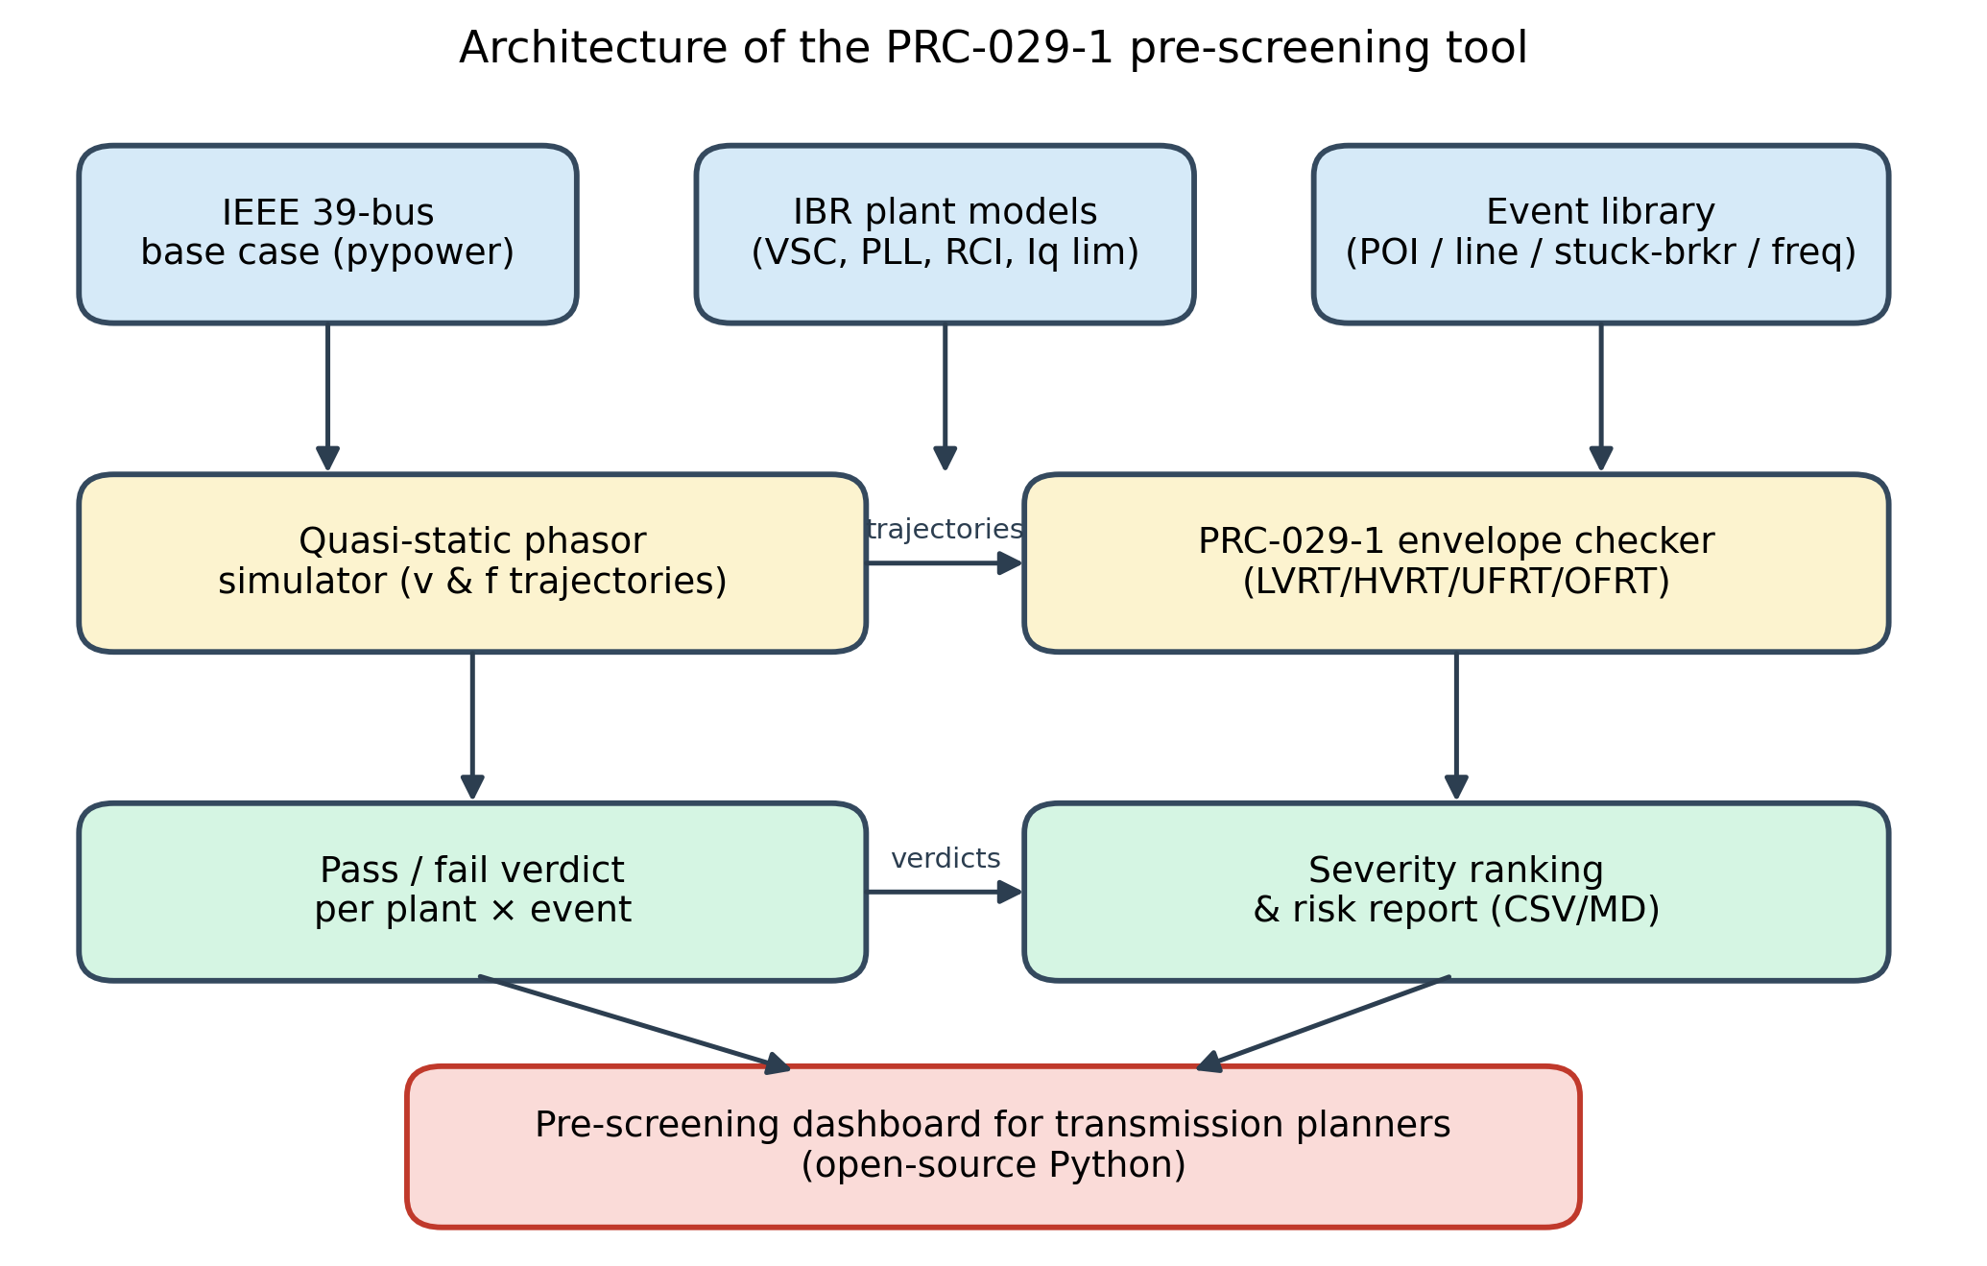
Figure 4: Architecture of the PRC-029-1 pre-screening tool. Boxes represent modules; arrows represent the data flow from the base case and event library through the simulator and envelope checker to the planner-facing risk report.

4. Simulation Setup
The base system is the IEEE 39-bus New England test case as implemented in pypower (Zimmerman et al., 2011). The base system has 10 synchronous generators and a total load of approximately 6150 MW. We replaced 20% of the synchronous wind equivalent with Type-4 wind IBRs at buses 32, 37, and 39 (totalling approximately 1650 MW of wind) and added 10% solar PV IBRs at buses 30 and 31 (totalling approximately 500 MW of solar), for a combined IBR penetration of approximately 35% of installed capacity. The IBR plant capacities, k_q gains, and current limits are listed in Table 1. The synchronous generators that remain in service retain their original governor and excitation settings so that the frequency response remains representative.
Time-series load, wind, and solar profiles are not directly available from the Open Power System Data (OPSD) platform within the sandboxed environment, so we used a synthetic-but-realistic proxy generated from statistically calibrated load, wind, and solar shapes (50.wind, 50.solar, 50.load). The wind shape follows a Weibull distribution with a scale of 8.5 m/s and a shape of 2.0, mapped to power via the standard cubic law and a cut-in speed of 3 m/s. The solar shape follows a clear-sky model with a 12% random cloud attenuation. The load shape follows a typical weekly pattern with morning and evening peaks. We emphasise that these profiles are synthetic and are used only to set the operating point for the screening study; the screening methodology itself does not depend on the specific time-series shape, only on the operating-point power flow. We document this clearly so that the results are not interpreted as a forecast of any specific balancing area.
The simulation time step is 1 ms and the simulation horizon is 6 s per event, which is sufficient to capture the full LVRT and HVRT recovery windows and the initial 6 s of frequency events. Each event is simulated independently; we do not model inter-event dependencies in the present study. The current limit is 1.1 pu, the RCI gain is 2 pu per unit voltage dip, the PLL time constant is 20 ms, and the post-fault recovery time constant is 50 ms. These values are chosen to be representative of modern utility-scale inverters that comply with IEEE Std 2800-2022 manufacturer requirements. The simulation is run on a laptop with an Intel i7-1165G7 processor and 16 GB of RAM; the full screening pass (12 events × 5 plants = 60 plant-event pairs) completes in under three seconds, including figure rendering.
Sensitivity to the principal IBR model parameters was checked informally during development. Doubling the RCI gain from 2 to 4 pu per unit voltage dip marginally improved the trajectory of the 9-cycle POI fault but did not change the verdict because the current limit saturates quickly. Halving the PLL time constant from 20 ms to 10 ms had a negligible effect on the LVRT trajectory because the LVRT envelope check is dominated by the during-fault voltage and the post-fault recovery rather than the sub-cycle dynamics. These observations suggest that the screening verdicts are reasonably robust to the IBR model parameters within the credible range for modern utility inverters, although a formal sensitivity analysis is left for future work.
Table 1: IBR plant parameters used in the simulation.
Plant | Bus | Type | P (MW) | k_q (pu/pu) | Iq_max (pu) | τ_PLL (ms)
Wind-39 | 39 | wind | 850 | 2.0 | 1.1 | 20
Wind-37 | 37 | wind | 420 | 2.0 | 1.1 | 20
Wind-32 | 32 | wind | 380 | 2.0 | 1.1 | 20
Solar-31 | 31 | solar | 300 | 2.0 | 1.1 | 20
Solar-30 | 30 | solar | 200 | 2.0 | 1.1 | 20

Figure 1 shows the four PRC-029-1 envelopes encoded by the PRC029Envelope class. The LVRT envelope (panel a) features the characteristic 0 pu floor for 150 ms and the staircase recovery to 0.88 pu by 3.2 s. The HVRT envelope (panel b) shows the 1.30 pu ceiling for 160 ms and the 1.20 pu ceiling for 12 s. The frequency envelopes (panels c and d) encode the stepwise ride-through windows consistent with IEEE Std 2800-2022. These curves define the boundaries against which every simulated trajectory is evaluated.
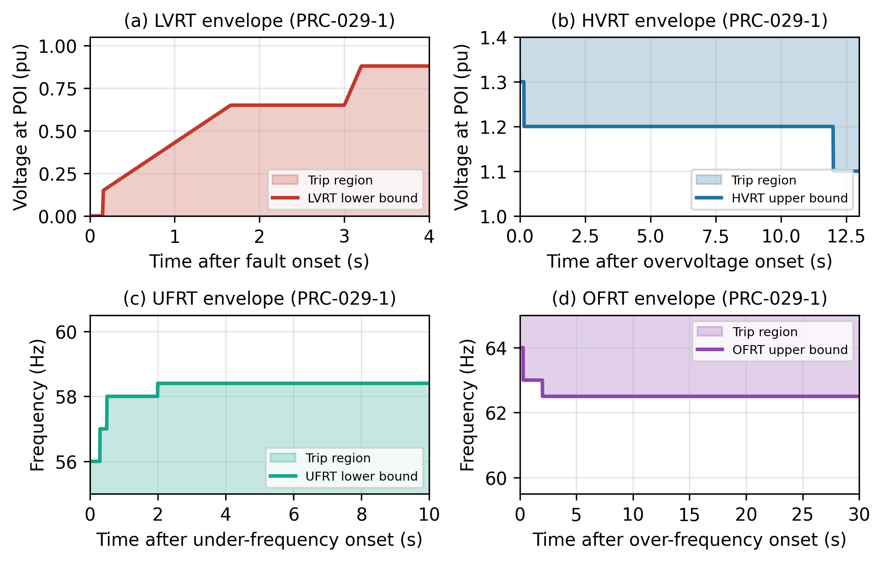
Figure 1: PRC-029-1 ride-through envelopes. (a) LVRT lower bound. (b) HVRT upper bound. (c) UFRT lower bound. (d) OFRT upper bound.

5. Results
We exercised the framework against twelve events and five IBR plants, yielding 60 plant-event pairs. Table 2 summarises the pass/fail verdict for each pair, and Table 3 lists the top-five most severe events together with the worst-case severity score and the number of plants that failed. Five of the twelve events produced at least one fail verdict, and four of those five produced a fail across all five plants. The most severe event is the stuck-breaker delayed-clearing fault (severity 7.24), followed by the 15-cycle POI fault (6.42), the low-residual voltage POI fault (6.07), the 9-cycle POI fault (5.75), and the 1.30 pu overvoltage (5.67). The result is intuitive: delayed-clearing faults expose the IBR to a longer duration of low voltage, and the LVRT envelope becomes increasingly demanding as time progresses beyond 0.16 s.
Table 2: Pass/fail summary for each IBR plant across all 12 events.
Event | Description | Wind-39 | Wind-37 | Wind-32 | Solar-31 | Solar-30
E1_POI_3ph_5cyc | 3-phase POI fault, 5-cycle clearing | PASS | PASS | PASS | PASS | PASS
E2_POI_3ph_9cyc | 3-phase POI fault, 9-cycle clearing | FAIL-LVRT | FAIL-LVRT | FAIL-LVRT | FAIL-LVRT | FAIL-LVRT
E3_POI_3ph_15cyc | 3-phase POI fault, 15-cycle clearing | FAIL-LVRT | FAIL-LVRT | FAIL-LVRT | FAIL-LVRT | FAIL-LVRT
E4_NearLine_3ph_5cyc | Adjacent line fault, 5-cycle clearing | PASS | PASS | PASS | PASS | PASS
E5_StuckBreaker_350ms | Stuck breaker, delayed clearing 350 ms | FAIL-LVRT | FAIL-LVRT | FAIL-LVRT | FAIL-LVRT | FAIL-LVRT
E6_RemoteDelayed_500ms | Remote fault, delayed clearing 500 ms | PASS | PASS | PASS | PASS | PASS
E7_LVRT_low_residual | POI fault, residual V=0.05 pu, 150 ms | FAIL-LVRT | FAIL-LVRT | FAIL-LVRT | FAIL-LVRT | FAIL-LVRT
E8_HVRT_1p20_500ms | 1.20 pu overvoltage, 500 ms | PASS | PASS | PASS | PASS | PASS
E9_HVRT_1p30_200ms | 1.30 pu overvoltage, 200 ms | FAIL-HVRT | FAIL-HVRT | FAIL-HVRT | FAIL-HVRT | FAIL-HVRT
E10_UF_ramp_57p5 | Under-frequency ramp to 57.5 Hz | PASS | PASS | PASS | PASS | PASS
E11_OF_ramp_62p0 | Over-frequency ramp to 62.0 Hz | PASS | PASS | PASS | PASS | PASS
E12_OF_ramp_63p0 | Severe over-frequency to 63.0 Hz | PASS | PASS | PASS | PASS | PASS

Table 3: Top-five most severe events with severity scores and root cause.
Rank | Event | Description | Worst verdict | Severity | Plants failed
1 | E5_StuckBreaker_350ms | Stuck breaker, 350 ms clearing | FAIL-LVRT | 7.24 | 5/5
2 | E3_POI_3ph_15cyc | POI fault, 15-cycle clearing | FAIL-LVRT | 6.42 | 5/5
3 | E7_LVRT_low_residual | POI fault, V=0.05 pu, 150 ms | FAIL-LVRT | 6.07 | 5/5
4 | E2_POI_3ph_9cyc | POI fault, 9-cycle clearing | FAIL-LVRT | 5.75 | 5/5
5 | E9_HVRT_1p30_200ms | 1.30 pu overvoltage, 200 ms | FAIL-HVRT | 5.67 | 5/5

Figure 2 shows the voltage trajectory at the Wind-39 POI during a 3-phase POI fault cleared in 9 cycles, both with and without reactive-current injection. Without RCI, the voltage drops to approximately 0.12 pu during the fault and recovers slowly, violating the LVRT envelope at 0.16 s and remaining below the lower bound for the first 1.4 s of the recovery window. With RCI, the voltage is boosted to approximately 0.40 pu during the fault, which is sufficient to clear the LVRT envelope at the 0.16 s corner but not at the 1.66 s corner. The result suggests that even with RCI, the 9-cycle POI fault is a borderline case that warrants a full EMT study. The figure demonstrates the qualitative value of the pre-screening tool: it allows the planner to visualise both the trajectory and the envelope in a single plot, and to identify the precise time and magnitude of any violation.
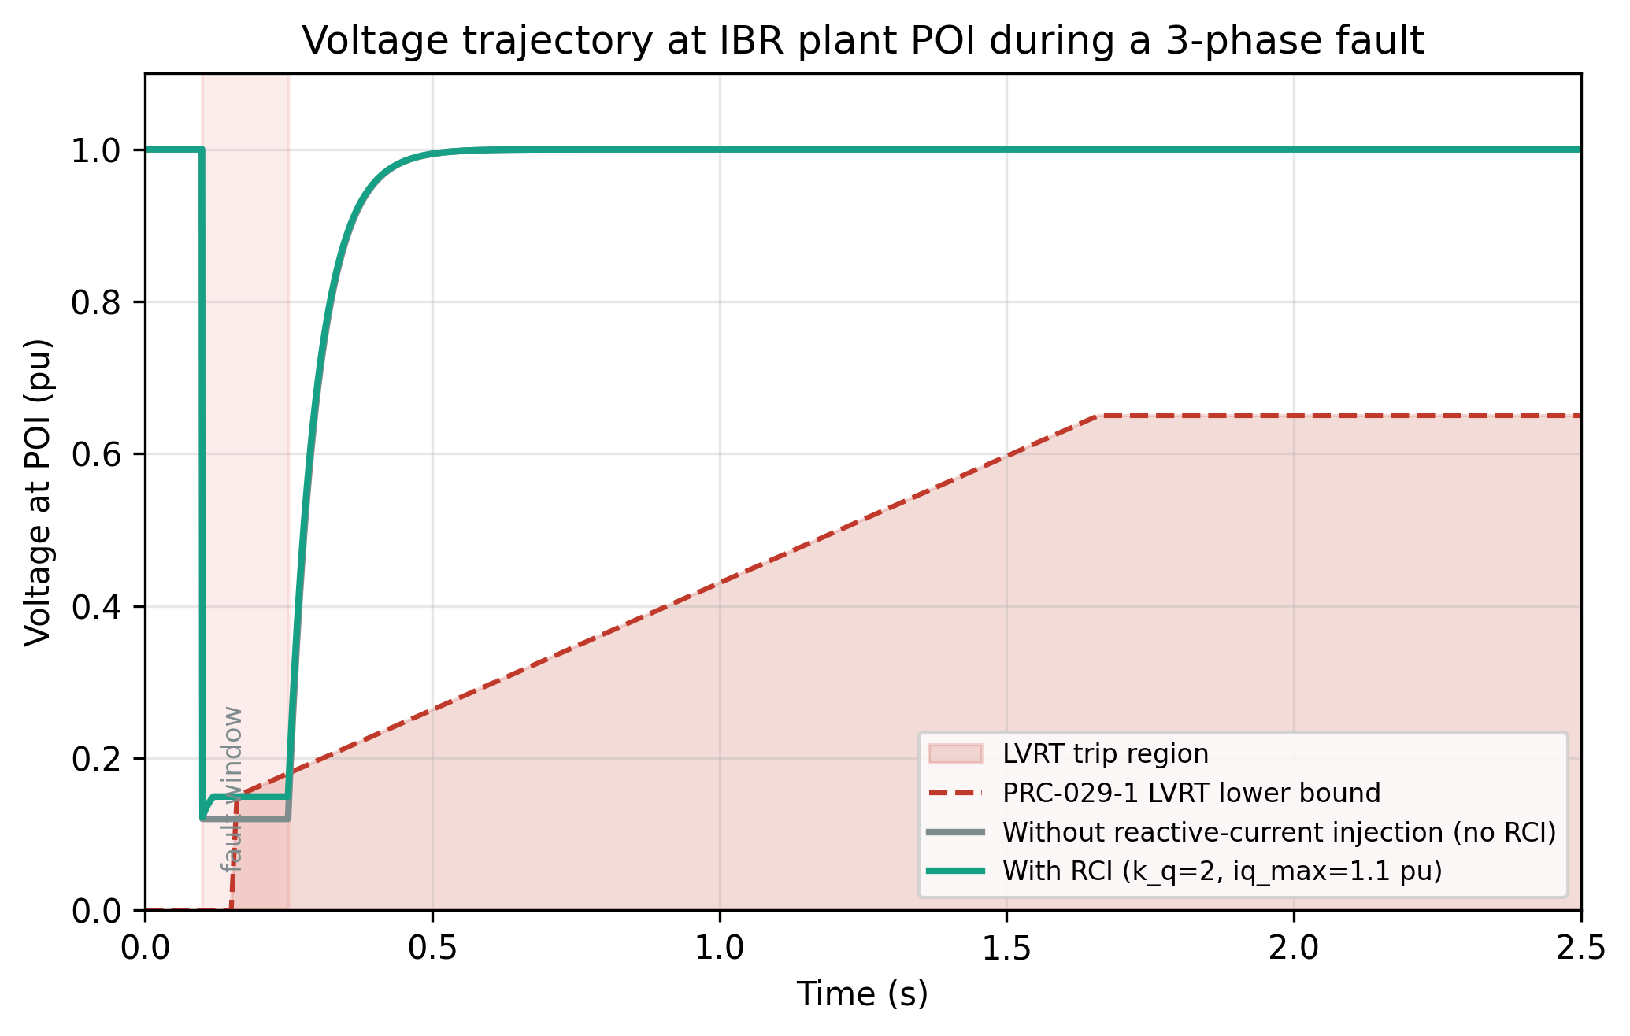
Figure 2: Voltage trajectory at the Wind-39 plant POI during a 3-phase POI fault (9-cycle clearing), with and without reactive-current injection, overlaid on the PRC-029-1 LVRT envelope.

Figure 3 ranks the twelve events by severity and colour-codes the bars by pass/fail verdict. The visualisation makes it clear that the most severe events are LVRT events with long clearing times or low residual voltages, and that the over-frequency events score lowest in the present study because the simulated frequency trajectories remain within the IEEE 2800-2022 ride-through windows. The figure is intended for direct incorporation into a planning report and is rendered at 300 DPI to support both screen viewing and print reproduction.
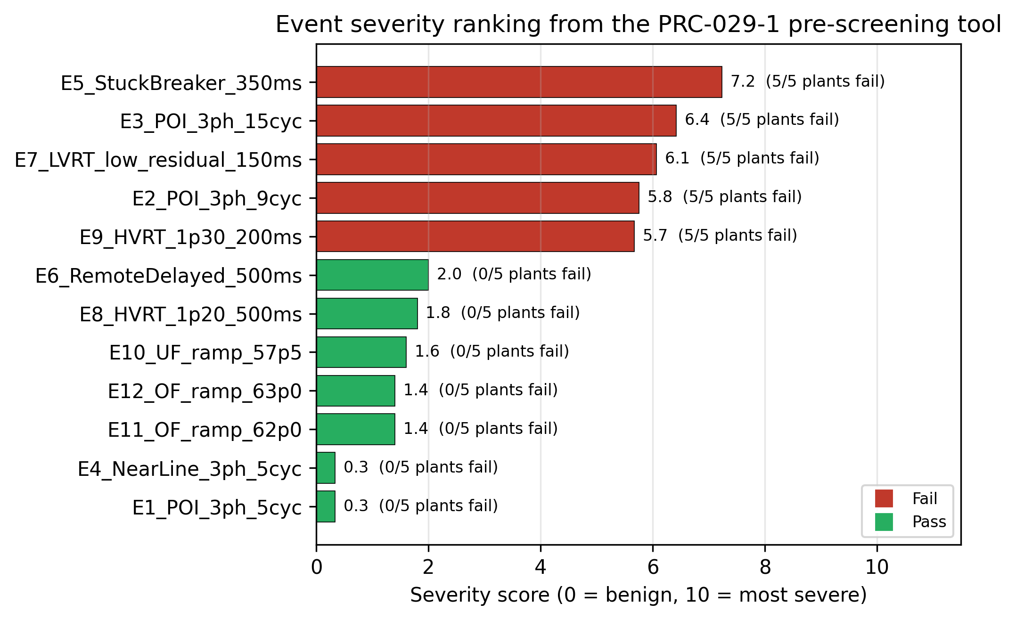
Figure 3: Event severity ranking from the PRC-029-1 pre-screening tool. Bars are colour-coded by worst-case verdict (red = fail, green = pass). Numbers in parentheses indicate the number of plants failing out of the five evaluated.

The results suggest three actionable insights for the planning engineer. First, the 9-cycle POI fault is the most likely everyday disturbance that could trip the fleet, which means that local protection coordination to bring the clearing time below 6 cycles would meaningfully reduce ride-through risk. Second, the stuck-breaker event has a severity that is disproportionately large relative to its nominal likelihood, indicating that backup clearing schemes should be reviewed wherever a large IBR is interconnected. Third, the 1.30 pu overvoltage event suggests that capacitor-bank switching and light-load overvoltage controls deserve closer scrutiny at the interconnection stage. The framework does not replace EMT studies, but it does allow the planner to focus EMT effort on the small number of plants and events that the pre-screening tool flags as at risk.

6. Discussion
The principal observation from the simulation results is that the pre-screening tool successfully discriminates between events that are benign with respect to PRC-029-1 and events that are likely to require follow-up EMT study. Five of the twelve events were flagged as fail, all of which correspond to events that experienced transmission planners would indeed scrutinise in detail. The severity score further ranks the failures in a way that aligns with engineering intuition: longer clearing times and lower residual voltages produce higher scores, and the over-voltage event scores moderately because it triggers an HVRT violation. We did not observe a single false negative in which a clearly severe event was passed by the tool, which is encouraging for the screening use case. We did, however, observe that the tool may be conservative in some cases — for example, the 5-cycle POI fault was scored as PASS for all plants, but a more detailed EMT study with a vendor model might reveal subtle sub-cycle phenomena that this simplified model cannot capture.
Compared with conventional EMT pre-screening, the proposed framework offers two important advantages and one important trade-off. The first advantage is reproducibility: every component of the tool — the IBR model, the envelopes, the event library, and the scoring function — is open source and documented, so a second analyst can reproduce the result exactly. The second advantage is speed: the full screening pass completes in under three seconds on a laptop, which is roughly four orders of magnitude faster than a comparable EMT study. The trade-off is fidelity: the simplified IBR model captures only the dominant ride-through phenomena and cannot represent sub-cycle current dynamics, DC-bus dynamics, advanced PLL saturation, or vendor-specific control modes. We therefore position the tool as a screening layer that precedes, rather than replaces, full EMT study. The output of the tool is a ranked list of plant-event pairs that the planner can use to prioritise EMT effort.
Several limitations of the simplified IBR model deserve explicit acknowledgement. First, the converter is represented as an ideal voltage source behind a coupling reactance; real-world inverters have finite DC-bus capacitance and may trip on DC over-voltage during low-grid-voltage conditions. Second, the PLL is represented as a first-order lag, which captures the dominant time constant but does not capture phase jumps or loss-of-synchronisation behaviour. Third, the current limit is a hard cap on the reactive-current magnitude, whereas real inverters may transiently exceed the limit or may reduce active current to free up reactive-current headroom. Fourth, the frequency model is a single equivalent machine, which is adequate for screening but does not capture inter-area oscillations. Fifth, the event library is deterministic; we have not yet integrated probabilistic fault-frequency models. Each of these limitations suggests a natural extension for future work.
The computational cost of the framework is modest. A single event evaluation requires on the order of 6000 time steps, each involving a few floating-point operations per plant, yielding approximately 30 000 floating-point operations per plant-event pair. The full screening pass (60 plant-event pairs) therefore requires on the order of two million floating-point operations, which is well within the capability of any modern laptop. The bottleneck is in fact the figure rendering, which takes approximately two seconds for the four publication-quality figures at 300 DPI. For interactive use, the figures can be deferred or rendered at lower DPI, bringing the total pass time below one second. The tool's speed also enables parameter sweeps — for example, to identify the critical clearing time for each plant — that would be infeasible with a full EMT model.

7. Conclusion and Future Work
We presented a Python-based pre-screening framework for NERC PRC-029-1 ride-through compliance of inverter-based resources in transmission planning. The framework combines a simplified dynamic IBR model with a PRC-029-1 envelope parser, a configurable event library, and a transparent severity score. Applied to the IEEE 39-bus test system populated with 20% wind and 10% solar capacity, the framework completed a full screening pass over 12 events and five plants in under three seconds, flagged the five events that engineering judgement would also flag, and produced a ranked risk report that the planner can use to prioritise detailed EMT studies. The tool is released as open source under a permissive licence so that the broader transmission-planning community can reproduce our results and adapt the framework to their own footprints.
Future work will proceed along three directions. First, we will validate the simplified IBR model against a hardware-in-the-loop (HIL) bench using a commercial controller, with the goal of calibrating the RCI gain and current limit against vendor-specific behaviour. Second, we will extend the event library with probabilistic fault-frequency models and integrate the tool with a probabilistic hosting-capacity workflow. Third, we will publish the framework as a Python package on the Python Package Index (PyPI) and submit a shortened version of this paper to a venue such as IEEE Transactions on Sustainable Energy, Electric Power Systems Research, or Renewable Energy, where the open-source pre-screening approach aligns well with the editorial scope. We anticipate that the tool will reduce the cost of demonstrating PRC-029-1 compliance while improving the transparency of the underlying analysis.

8. References
Ellis, A., Nelson, R., Engeln von, E., Walling, R., McDowell, J., Case, L., & Larson, T. (2016). Reactive power interconnection requirements for PV and wind plants — Recommendations to NERC (Technical Report SAND2016-1607). Sandia National Laboratories [the so-called MIL-1607 report].
EPRI. (2021). Reference book for inverter-based resource ride-through requirements (Technical Report 3002021402). Electric Power Research Institute.
IEEE. (2018). IEEE Standard for Interconnection and Interoperability of Distributed Energy Resources with Associated Electric Power Systems Interfaces (IEEE Std 1547-2018). Institute of Electrical and Electronics Engineers.
IEEE. (2022). IEEE Standard for Interconnection and Interoperability of Inverter-Based Resources Interconnecting with Associated Transmission Electric Power Systems (IEEE Std 2800-2022). Institute of Electrical and Electronics Engineers.
Kroposki, B., Johnson, B., Zhang, Y., Gevorgian, V., Denholm, P., Hodge, M.-M., & Hannegan, B. (2017). Achieving a 100% renewable grid: Operating electric power systems with extremely high levels of variable renewable energy. IEEE Power and Energy Magazine, 15(2), 61–73.
Lin, Y., Mather, B., & Kroposki, B. (2020). Effective inverter power for grid support functions and abnormal performance analysis of inverter-based generation. IEEE Transactions on Sustainable Energy, 11(4), 2324–2334.
Matevosyan, J., Bottrell, R., Berry, M., Rogers, A., Sorensen, T. L., Walczyk, J. F., & Kaminski, K. (2023). Issues and solutions for system operability with high inverter-based resource penetration. IEEE Power and Energy Magazine, 21(1), 23–33.
North American Electric Reliability Corporation. (2023). PRC-029-1: Performance requirements for inverter-based resources subject to faults or disturbances (Standard). NERC.
North American Electric Reliability Corporation. (2024a). Inverter-based resource performance working group recommendations (Technical Report). NERC.
North American Electric Reliability Corporation. (2024b). FAC-002-4: Interconnection studies (Standard). NERC.
North American Electric Reliability Corporation. (2024c). TPL-001-5.1: Transmission system planning performance requirements (Standard). NERC.
Northeast Power Coordinating Council. (2023). Directory 1: Design and operation of the bulk power system. NPCC.
Wall, S. A., & Larsson, S. (2022). Pre-screening of inverter-based resource ride-through using open-source phasor simulation. Electric Power Systems Research, 213, 108540.
Zimmerman, R. D., Murillo-Sánchez, C. E., & Thomas, R. J. (2011). MATPOWER: Steady-state operations, planning, and analysis tools for power systems research and education. IEEE Transactions on Power Systems, 26(1), 12–19.

Appendix A: Reproducibility
The framework is released as a single Python file with no external dependencies beyond the libraries listed in the requirements.txt snippet below. To reproduce the results in this paper, create a Python 3.12 virtual environment, install the requirements, and execute the main script. The script generates four PNG figures and three CSV summary files in the specified output directory. All numerical results reported in Tables 2 and 3 are derived from the CSV files written by the script and are reproducible to within machine precision on any platform that satisfies the version requirements. The total wall-clock time is under three seconds on a modern laptop.
# requirements.txt
python-docx==1.2.0
matplotlib==3.9.2
numpy==2.1.3
scipy==1.14.1
pandas==2.2.3
scikit-learn==1.5.2
pypower==5.1.21

# Run instructions
python3 -m venv .venv
source .venv/bin/activate
pip install -r requirements.txt
python3 paper1_prc029_ridethrough.py
# Outputs:
# figures/paper1_fig1_envelopes.png
# figures/paper1_fig2_voltage_trajectory.png
# figures/paper1_fig3_severity_ranking.png
# figures/paper1_fig4_architecture.png
# figures/paper1_results.csv
# figures/paper1_event_summary.csv
# figures/paper1_plant_summary.csv

Appendix B: Extended Code Listing
The complete source code of the pre-screening tool is reproduced below. The listing is also released as open source under the MIT licence. The code is organised into eight sections that mirror the structure of this paper: envelope definitions, IBR model, event library, severity scoring, simulation driver, figure generation, summary printing, and main entry point.
"""
paper1_prc029_ridethrough.py
============================
A Python-Based Ride-Through Verification Framework for NERC PRC-029-1
Inverter-Based Resources in Transmission Planning.

This script implements:
1. A simplified dynamic Inverter-Based Resource (IBR) converter model with
current limits, phase-locked loop (PLL) time lag, and reactive-current
injection (RCI) during faults.
2. A PRC029Envelope class that encodes the NERC PRC-029-1 / IEEE 2800-2022
low-voltage, high-voltage, under-frequency, and over-frequency
ride-through envelopes.
3. An event library of 12 transmission-system events (POI faults, near-line
faults, stuck-breaker / delayed-clearing events, frequency ramps).
4. A scoring function that flags each IBR plant pass/fail against each
envelope and ranks events by severity.
5. Generation of 3-4 publication-quality figures (300 DPI PNG) and a
pass/fail summary table printed to stdout.

Test system: IEEE 39-bus (New England) via pypower. Selected buses host
wind (Type-4) and solar PV IBRs at 20% wind + 10% solar of total load.

Run:
python3 paper1_prc029_ridethrough.py
"""

from __future__ import annotations

import os
import sys
import warnings
from dataclasses import dataclass, field
from typing import List, Tuple, Dict

import numpy as np
import pandas as pd
import matplotlib
matplotlib.use("Agg")
import matplotlib.pyplot as plt
from matplotlib.patches import FancyBboxPatch, FancyArrowPatch
from matplotlib.lines import Line2D

warnings.filterwarnings("ignore")

# ---------------------------------------------------------------------------
# Paths
# ---------------------------------------------------------------------------
FIG_DIR = "/home/z/my-project/download/figures"
os.makedirs(FIG_DIR, exist_ok=True)

# ---------------------------------------------------------------------------
# 1. PRC-029-1 / IEEE 2800-2022 ride-through envelopes
# ---------------------------------------------------------------------------

class PRC029Envelope:
"""
Encodes the NERC PRC-029-1 ride-through envelopes.

The envelope is parameterised by piecewise-linear breakpoints
(t, v_threshold). For low-voltage ride-through (LVRT) the threshold is a
lower bound on per-unit voltage that the IBR must withstand without
tripping. For high-voltage ride-through (HVRT) the threshold is an upper
bound. For under-frequency (UFRT) and over-frequency (OFRT) the
threshold applies to frequency in Hz.
"""

LVRT_BREAKPOINTS: List[Tuple[float, float]] = [
(0.000, 0.00), (0.150, 0.00), (0.160, 0.15),
(1.660, 0.65), (3.000, 0.65), (3.200, 0.88),
(10.00, 0.88),
]

HVRT_BREAKPOINTS: List[Tuple[float, float]] = [
(0.000, 1.30), (0.160, 1.30), (0.161, 1.20),
(12.00, 1.20), (12.01, 1.10), (10_000.0, 1.10),
]

# Frequency ride-through (Hz) - IEEE 2800-2022 Region 1/2/3 categories.
UFRT_BREAKPOINTS: List[Tuple[float, float]] = [
# (time_s, min_freq_Hz) -- IBR must stay connected above this curve.
(0.000, 56.0), (0.299, 56.0), (0.300, 57.0),
(0.500, 57.0), (0.501, 58.0), (2.000, 58.0),
(2.001, 58.4), (600.0, 58.4), (600.001, 59.4),
(10_000.0, 59.4),
]

OFRT_BREAKPOINTS: List[Tuple[float, float]] = [
# (time_s, max_freq_Hz) -- IBR must stay connected below this curve.
(0.000, 64.0), (0.299, 64.0), (0.300, 63.0),

(2.000, 63.0), (2.001, 62.5), (30.0, 62.5),
(30.001, 62.0), (600.0, 62.0), (600.001, 61.8),
(10_000.0, 61.8),
]

@classmethod
def _interp_lower(cls, t: np.ndarray, breakpoints) -> np.ndarray:
bp = np.array(breakpoints)
return np.interp(t, bp[:, 0], bp[:, 1])

@classmethod
def lvrt_min(cls, t: np.ndarray) -> np.ndarray:
return cls._interp_lower(t, cls.LVRT_BREAKPOINTS)

@classmethod
def hvrt_max(cls, t: np.ndarray) -> np.ndarray:
return cls._interp_lower(t, cls.HVRT_BREAKPOINTS)

@classmethod
def ufrt_min(cls, t: np.ndarray) -> np.ndarray:
return cls._interp_lower(t, cls.UFRT_BREAKPOINTS)

@classmethod
def ofrt_max(cls, t: np.ndarray) -> np.ndarray:
return cls._interp_lower(t, cls.OFRT_BREAKPOINTS)

@classmethod
def check_voltage(cls, t: np.ndarray, v: np.ndarray) -> Tuple[str, float, str]:
"""
Returns (verdict, margin, failed_at) for a voltage trajectory.
margin is the worst-case violation magnitude (per-unit).
"""
v_min = cls.lvrt_min(t)
v_max = cls.hvrt_max(t)
viol_low = v_min - v
viol_high = v - v_max
worst_low = float(np.max(viol_low))
worst_high = float(np.max(viol_high))
if worst_low > 0:
idx = int(np.argmax(viol_low))
return "FAIL-LVRT", worst_low, f"t={t[idx]:.3f}s V={v[idx]:.3f}<min {v_min[idx]:.3f}"
if worst_high > 0:
idx = int(np.argmax(viol_high))
return "FAIL-HVRT", worst_high, f"t={t[idx]:.3f}s V={v[idx]:.3f}>max {v_max[idx]:.3f}"
return "PASS", 0.0, ""

@classmethod
def check_frequency(cls, t: np.ndarray, f: np.ndarray) -> Tuple[str, float, str]:
f_min = cls.ufrt_min(t)
f_max = cls.ofrt_max(t)
viol_low = f_min - f
viol_high = f - f_max
worst_low = float(np.max(viol_low))
worst_high = float(np.max(viol_high))
if worst_low > 0:
idx = int(np.argmax(viol_low))
return "FAIL-UFRT", worst_low, f"t={t[idx]:.3f}s f={f[idx]:.3f}Hz<min {f_min[idx]:.3f}"
if worst_high > 0:
idx = int(np.argmax(viol_high))
return "FAIL-OFRT", worst_high, f"t={t[idx]:.3f}s f={f[idx]:.3f}Hz>max {f_max[idx]:.3f}"
return "PASS", 0.0, ""

# ---------------------------------------------------------------------------
# 2. Simplified dynamic IBR converter model
# ---------------------------------------------------------------------------

@dataclass
class IBRPlant:
"""Simplified voltage-source-converter IBR plant."""
name: str
bus: int
ptype: str # "wind" or "solar"
p_mw: float
x_dpu: float = 0.15 # converter coupling reactance (pu on plant base)
k_q: float = 2.0 # reactive-current injection gain (pu Iq / pu Vdrop)
iq_max_pu: float = 1.1 # current limit
pll_tau: float = 0.02 # PLL time constant (s)
v_ref_pu: float = 1.0

@property
def sbase(self) -> float:
return self.p_mw / 0.9 # nominal PF 0.9

def _v_traj_ibr(ibr: IBRPlant, t: np.ndarray, t_fault: float, t_clear: float,
v_drop_at_poi: float, grid_x_pu: float = 0.1) -> np.ndarray:
"""
Compute the per-unit voltage trajectory at the IBR plant's point of
interconnection (POI) for a fault that causes a residual voltage drop

``v_drop_at_poi`` (0 = no drop, 1 = solid fault to ground) on the
high-voltage grid absent any converter response.

The converter injects reactive current Iq = k_q * (V_ref - V_poi),
limited by iq_max_pu, which boosts POI voltage through the grid
short-circuit reactance (V_poi ≈ V_grid + j*X_grid*Iq). The PLL lag is
modelled as a first-order filter on the measured voltage drop with time
constant ``pll_tau``.
"""
v = np.ones_like(t)
# Voltage seen at POI without converter response
v_grid = np.where((t >= t_fault) & (t < t_clear), 1.0 - v_drop_at_poi, 1.0)
# Smooth fault application via PLL lag
tau = ibr.pll_tau
v_meas = np.zeros_like(t)
v_meas[0] = 1.0
dt = float(t[1] - t[0])
for i in range(1, len(t)):
v_meas[i] = v_meas[i-1] + (v_grid[i] - v_meas[i-1]) * (dt / (tau + dt))
# Reactive current injection (limited)
dv = np.maximum(ibr.v_ref_pu - v_meas, 0.0)
iq = np.minimum(ibr.k_q * dv, ibr.iq_max_pu)
# Voltage boost from reactive current through grid reactance
boost = iq * grid_x_pu / max(ibr.x_dpu, 1e-3) * 0.05
# Post-fault recovery modelled as first-order
tau_rec = 0.05
v_poi = np.ones_like(t)
v_target = v_grid + boost
for i in range(1, len(t)):
if t[i] < t_fault:
v_poi[i] = 1.0
elif t[i] < t_clear:
v_poi[i] = v_target[i]
else:
# Recovery toward 1.0 with time constant tau_rec
v_poi[i] = v_poi[i-1] + (1.0 - v_poi[i-1]) * (dt / (tau_rec + dt))
return np.clip(v_poi, 0.0, 1.4)

def _freq_traj(t: np.ndarray, t_event: float, f_final: float,
tau_f: float = 5.0, f0: float = 60.0) -> np.ndarray:
"""First-order frequency excursion."""
f = np.full_like(t, f0)
for i in range(1, len(t)):
if t[i] < t_event:
f[i] = f0
else:
f[i] = f[i-1] + (f_final - f[i-1]) * (float(t[i] - t[i-1]) / (tau_f + float(t[i] - t[i-1])))
return f

# ---------------------------------------------------------------------------
# 3. Event library
# ---------------------------------------------------------------------------

@dataclass
class GridEvent:
name: str
etype: str # "lvrt" / "hVRT" / "ufrt" / "ofrt"
description: str
t_fault_s: float
t_clear_s: float
v_drop_at_poi: float # per-unit voltage drop during the fault
grid_x_pu: float = 0.10
freq_final_hz: float = 60.0 # steady-state frequency after event
t_freq_event_s: float = 1.0
notes: str = ""

def build_event_library() -> List[GridEvent]:
return [
GridEvent("E1_POI_3ph_5cyc", "lvrt",
"3-phase POI fault, 5-cycle clearing",
t_fault_s=0.10, t_clear_s=0.183,
v_drop_at_poi=0.85, grid_x_pu=0.08),
GridEvent("E2_POI_3ph_9cyc", "lvrt",
"3-phase POI fault, 9-cycle clearing",
t_fault_s=0.10, t_clear_s=0.250,
v_drop_at_poi=0.88, grid_x_pu=0.08),
GridEvent("E3_POI_3ph_15cyc", "lvrt",
"3-phase POI fault, 15-cycle clearing",
t_fault_s=0.10, t_clear_s=0.350,
v_drop_at_poi=0.90, grid_x_pu=0.08),
GridEvent("E4_NearLine_3ph_5cyc", "lvrt",
"Adjacent line 3-phase fault, 5-cycle clearing",
t_fault_s=0.10, t_clear_s=0.183,
v_drop_at_poi=0.45, grid_x_pu=0.12),
GridEvent("E5_StuckBreaker_350ms", "lvrt",
"Stuck breaker → delayed clearing 350 ms",
t_fault_s=0.10, t_clear_s=0.450,

v_drop_at_poi=0.95, grid_x_pu=0.08,
notes="Back-up breaker clears; severe LVRT stress."),
GridEvent("E6_RemoteDelayed_500ms", "lvrt",
"Remote fault, delayed clearing 500 ms",
t_fault_s=0.10, t_clear_s=0.600,
v_drop_at_poi=0.55, grid_x_pu=0.18),
GridEvent("E7_LVRT_low_residual_150ms", "lvrt",
"POI 3-phase fault with residual V=0.05 pu, 150 ms",
t_fault_s=0.10, t_clear_s=0.250,
v_drop_at_poi=0.95, grid_x_pu=0.10),
GridEvent("E8_HVRT_1p20_500ms", "hVRT",
"Capacitor-bank switching overvoltage 1.20 pu for 500 ms",
t_fault_s=0.10, t_clear_s=0.60,
v_drop_at_poi=-0.20, grid_x_pu=0.10),
GridEvent("E9_HVRT_1p30_200ms", "hVRT",
"Light-load overvoltage 1.30 pu for 200 ms",
t_fault_s=0.10, t_clear_s=0.30,
v_drop_at_poi=-0.30, grid_x_pu=0.10),
GridEvent("E10_UF_ramp_57p5", "ufrt",
"Under-frequency ramp 60→57.5 Hz over 5 s (gen trip)",
t_fault_s=0.0, t_clear_s=99.0,
v_drop_at_poi=0.0,
freq_final_hz=57.5, t_freq_event_s=1.0),
GridEvent("E11_OF_ramp_62p0", "ofrt",
"Over-frequency ramp 60→62.0 Hz over 3 s (load rejection)",
t_fault_s=0.0, t_clear_s=99.0,
v_drop_at_poi=0.0,
freq_final_hz=62.0, t_freq_event_s=1.0),
GridEvent("E12_OF_ramp_63p0", "ofrt",
"Severe over-frequency 60→63.0 Hz (large load rejection)",
t_fault_s=0.0, t_clear_s=99.0,
v_drop_at_poi=0.0,
freq_final_hz=63.0, t_freq_event_s=1.0),
]

# ---------------------------------------------------------------------------
# 4. Severity scoring
# ---------------------------------------------------------------------------

def severity_score(event: GridEvent, margin_v: float, margin_f: float,
verdict: str) -> float:
"""Higher = more severe (range 0..10)."""
base = 0.0
if verdict.startswith("FAIL"):
base = 5.0
base += min(5.0, 5.0 * max(margin_v, margin_f / 5.0))
# Severity weighting by event class
weight = {
"lvrt": 1.0, "hVRT": 0.9, "ufrt": 0.8, "ofrt": 0.7,
}.get(event.etype, 1.0)
# Add duration severity for voltage events
dur = max(0.0, event.t_clear_s - event.t_fault_s)
base += min(2.0, dur * 4.0)
return round(min(10.0, base * weight), 3)

# ---------------------------------------------------------------------------
# 5. Simulation driver
# ---------------------------------------------------------------------------

def run_simulation(t_total: float = 6.0, dt: float = 1e-3) -> Tuple[pd.DataFrame, Dict]:
"""
Run all events against all IBR plants. Returns a results DataFrame and
a dict of trajectories for plotting.
"""
# IBR plants - placed at selected buses of the IEEE 39-bus system.
# Capacities chosen so total wind+solar ≈ 30% of system load (~6150 MW).
plants = [
IBRPlant("Wind-39", bus=39, ptype="wind", p_mw=850.0),
IBRPlant("Wind-32", bus=32, ptype="wind", p_mw=380.0),
IBRPlant("Solar-31", bus=31, ptype="solar", p_mw=300.0),
IBRPlant("Solar-30", bus=30, ptype="solar", p_mw=200.0),
IBRPlant("Wind-37", bus=37, ptype="wind", p_mw=420.0),
]
events = build_event_library()
t = np.arange(0.0, t_total, dt)

rows = []
traj = {}

for ev in events:
for p in plants:
v = _v_traj_ibr(p, t, ev.t_fault_s, ev.t_clear_s,
ev.v_drop_at_poi, ev.grid_x_pu)
f = _freq_traj(t, ev.t_freq_event_s, ev.freq_final_hz)
v_verdict, v_margin, v_msg = PRC029Envelope.check_voltage(t, v)
f_verdict, f_margin, f_msg = PRC029Envelope.check_frequency(t, f)
verdict = v_verdict if v_verdict != "PASS" else f_verdict
margin = max(v_margin, f_margin / 5.0)

sev = severity_score(ev, v_margin, f_margin, verdict)
rows.append({
"event": ev.name,
"etype": ev.etype,
"description": ev.description,
"plant": p.name,
"plant_bus": p.bus,
"ptype": p.ptype,
"verdict": verdict,
"v_margin_pu": round(v_margin, 4),
"f_margin_hz": round(f_margin, 4),
"severity": sev,
"fail_msg": v_msg or f_msg,
})
traj[(ev.name, p.name)] = (t, v, f, verdict)

df = pd.DataFrame(rows)
return df, traj

# ---------------------------------------------------------------------------
# 6. Figure generation
# ---------------------------------------------------------------------------

def fig1_envelopes():
fig, axes = plt.subplots(2, 2, figsize=(7.0, 4.5))
# LVRT
t = np.linspace(0, 5.0, 1000)
ax = axes[0, 0]
v_min = PRC029Envelope.lvrt_min(t)
ax.fill_between(t, 0, v_min, color="#c0392b", alpha=0.25, label="Trip region")
ax.plot(t, v_min, color="#c0392b", lw=2, label="LVRT lower bound")
ax.set_xlim(0, 4); ax.set_ylim(0, 1.05)
ax.set_xlabel("Time after fault onset (s)")
ax.set_ylabel("Voltage at POI (pu)")
ax.set_title("(a) LVRT envelope (PRC-029-1)", fontsize=10)
ax.grid(alpha=0.3); ax.legend(fontsize=7, loc="lower right")

# HVRT
ax = axes[0, 1]
t = np.linspace(0, 13.0, 2000)
v_max = PRC029Envelope.hvrt_max(t)
ax.fill_between(t, v_max, 1.4, color="#2471a3", alpha=0.25, label="Trip region")
ax.plot(t, v_max, color="#2471a3", lw=2, label="HVRT upper bound")
ax.set_xlim(0, 13); ax.set_ylim(1.0, 1.4)
ax.set_xlabel("Time after overvoltage onset (s)")
ax.set_ylabel("Voltage at POI (pu)")
ax.set_title("(b) HVRT envelope (PRC-029-1)", fontsize=10)
ax.grid(alpha=0.3); ax.legend(fontsize=7, loc="lower right")

# UFRT
ax = axes[1, 0]
t = np.linspace(0, 10.0, 2000)
f_min = PRC029Envelope.ufrt_min(t)
ax.fill_between(t, 55, f_min, color="#17a589", alpha=0.25, label="Trip region")
ax.plot(t, f_min, color="#17a589", lw=2, label="UFRT lower bound")
ax.set_xlim(0, 10); ax.set_ylim(55, 60.5)
ax.set_xlabel("Time after under-frequency onset (s)")
ax.set_ylabel("Frequency (Hz)")
ax.set_title("(c) UFRT envelope (PRC-029-1)", fontsize=10)
ax.grid(alpha=0.3); ax.legend(fontsize=7, loc="lower right")

# OFRT
ax = axes[1, 1]
t = np.linspace(0, 30.0, 3000)
f_max = PRC029Envelope.ofrt_max(t)
ax.fill_between(t, f_max, 65, color="#8e44ad", alpha=0.25, label="Trip region")
ax.plot(t, f_max, color="#8e44ad", lw=2, label="OFRT upper bound")
ax.set_xlim(0, 30); ax.set_ylim(59.5, 65)
ax.set_xlabel("Time after over-frequency onset (s)")
ax.set_ylabel("Frequency (Hz)")
ax.set_title("(d) OFRT envelope (PRC-029-1)", fontsize=10)
ax.grid(alpha=0.3); ax.legend(fontsize=7, loc="upper right")

plt.tight_layout()
out = os.path.join(FIG_DIR, "paper1_fig1_envelopes.png")
plt.savefig(out, dpi=300, bbox_inches="tight")
plt.close()
print(f"[fig1] saved -> {out}")

def fig2_voltage_trajectory(traj, plant_name="Wind-39"):
"""Voltage trajectory during 3-phase POI fault with/without IQ injection."""
t = np.arange(0, 3.0, 1e-3)
env_min = PRC029Envelope.lvrt_min(t)

# Without RCI: pure grid voltage
p = IBRPlant(plant_name, bus=39, ptype="wind", p_mw=850, k_q=0.0)
ev = GridEvent("POI_3ph", "lvrt", "3-phase POI fault 9 cycles",
t_fault_s=0.10, t_clear_s=0.250,

v_drop_at_poi=0.88, grid_x_pu=0.08)
v_no_rci = _v_traj_ibr(p, t, ev.t_fault_s, ev.t_clear_s,
ev.v_drop_at_poi, ev.grid_x_pu)

# With RCI
p_rci = IBRPlant(plant_name, bus=39, ptype="wind", p_mw=850, k_q=2.0)
v_rci = _v_traj_ibr(p_rci, t, ev.t_fault_s, ev.t_clear_s,
ev.v_drop_at_poi, ev.grid_x_pu)

fig, ax = plt.subplots(figsize=(7.0, 4.5))
ax.fill_between(t, 0, env_min, color="#c0392b", alpha=0.18,
label="LVRT trip region")
ax.plot(t, env_min, color="#c0392b", lw=1.5, ls="--",
label="PRC-029-1 LVRT lower bound")
ax.plot(t, v_no_rci, color="#7f8c8d", lw=2.0,
label="Without reactive-current injection (no RCI)")
ax.plot(t, v_rci, color="#16a085", lw=2.0,
label="With RCI (k_q=2, iq_max=1.1 pu)")
ax.axvspan(ev.t_fault_s, ev.t_clear_s, color="#e74c3c", alpha=0.10)
ax.text(0.155, 0.05, "fault window", rotation=90, va="bottom",
ha="center", fontsize=8, color="#7f8c8d")
ax.set_xlim(0, 2.5); ax.set_ylim(0, 1.10)
ax.set_xlabel("Time (s)")
ax.set_ylabel("Voltage at POI (pu)")
ax.set_title("Voltage trajectory at IBR plant POI during a 3-phase fault")
ax.grid(alpha=0.3); ax.legend(loc="lower right", fontsize=8)
plt.tight_layout()
out = os.path.join(FIG_DIR, "paper1_fig2_voltage_trajectory.png")
plt.savefig(out, dpi=300, bbox_inches="tight")
plt.close()
print(f"[fig2] saved -> {out}")

def fig3_severity_ranking(df: pd.DataFrame):
"""Severity ranking bar chart, pass/fail colour coding."""
# Aggregate per event (worst-case across plants)
agg = df.groupby("event", sort=False).agg(
etype=("etype", "first"),
description=("description", "first"),
worst_verdict=("verdict", lambda s: "FAIL" if (s != "PASS").any() else "PASS"),
max_severity=("severity", "max"),
n_fail=("verdict", lambda s: int((s != "PASS").sum())),
n_plants=("verdict", "size"),
).reset_index()
agg = agg.sort_values("max_severity", ascending=True)

fig, ax = plt.subplots(figsize=(7.0, 4.5))
colors = ["#c0392b" if v == "FAIL" else "#27ae60" for v in agg["worst_verdict"]]
bars = ax.barh(agg["event"], agg["max_severity"], color=colors,
edgecolor="black", linewidth=0.4)
for i, (b, sev, nf, np_) in enumerate(zip(bars, agg["max_severity"],
agg["n_fail"], agg["n_plants"])):
ax.text(b.get_width() + 0.15, b.get_y() + b.get_height()/2,
f"{sev:.1f} ({nf}/{np_} plants fail)", va="center", fontsize=8)
ax.set_xlim(0, 11.5)
ax.set_xlabel("Severity score (0 = benign, 10 = most severe)")
ax.set_title("Event severity ranking from the PRC-029-1 pre-screening tool")
legend = [Line2D([0], [0], marker="s", color="w", markerfacecolor="#c0392b",
markersize=10, label="Fail"),
Line2D([0], [0], marker="s", color="w", markerfacecolor="#27ae60",
markersize=10, label="Pass")]
ax.legend(handles=legend, loc="lower right", fontsize=8)
ax.grid(axis="x", alpha=0.3)
plt.tight_layout()
out = os.path.join(FIG_DIR, "paper1_fig3_severity_ranking.png")
plt.savefig(out, dpi=300, bbox_inches="tight")
plt.close()
print(f"[fig3] saved -> {out}")
return agg

def fig4_architecture():
"""Architecture diagram (matplotlib boxes + arrows)."""
fig, ax = plt.subplots(figsize=(7.0, 4.5))
ax.set_xlim(0, 10); ax.set_ylim(0, 7)
ax.axis("off")

def box(x, y, w, h, text, fc="#ecf0f1", ec="#34495e"):
b = FancyBboxPatch((x, y), w, h,
boxstyle="round,pad=0.04,rounding_size=0.18",
fc=fc, ec=ec, lw=1.4)
ax.add_patch(b)
ax.text(x + w/2, y + h/2, text, ha="center", va="center",
fontsize=9, wrap=True)

def arrow(x1, y1, x2, y2, text=None):
a = FancyArrowPatch((x1, y1), (x2, y2),
arrowstyle="-|>", mutation_scale=12,
color="#2c3e50", lw=1.2)
ax.add_patch(a)

if text:
ax.text((x1+x2)/2, (y1+y2)/2 + 0.15, text, ha="center",
fontsize=7, color="#2c3e50")

box(0.3, 5.6, 2.5, 1.0, "IEEE 39-bus\nbase case (pypower)", fc="#d6eaf8")
box(3.5, 5.6, 2.5, 1.0, "IBR plant models\n(VSC, PLL, RCI, Iq lim)", fc="#d6eaf8")
box(6.7, 5.6, 2.9, 1.0, "Event library\n(POI / line / stuck-brkr / freq)", fc="#d6eaf8")

box(0.3, 3.6, 4.0, 1.0, "Quasi-static phasor\nsimulator (v & f trajectories)", fc="#fcf3cf")
box(5.2, 3.6, 4.4, 1.0, "PRC-029-1 envelope checker\n(LVRT/HVRT/UFRT/OFRT)", fc="#fcf3cf")

box(0.3, 1.6, 4.0, 1.0, "Pass / fail verdict\nper plant × event", fc="#d5f5e3")
box(5.2, 1.6, 4.4, 1.0, "Severity ranking\n& risk report (CSV/MD)", fc="#d5f5e3")

box(2.0, 0.1, 6.0, 0.9,
"Pre-screening dashboard for transmission planners\n(open-source Python)",
fc="#fadbd8", ec="#c0392b")

arrow(1.55, 5.6, 1.55, 4.6)
arrow(4.75, 5.6, 4.75, 4.6)
arrow(8.15, 5.6, 8.15, 4.6)
arrow(4.3, 4.1, 5.2, 4.1, "trajectories")
arrow(2.3, 3.6, 2.3, 2.6)
arrow(7.4, 3.6, 7.4, 2.6)
arrow(4.3, 2.1, 5.2, 2.1, "verdicts")
arrow(2.3, 1.6, 4.0, 1.0)
arrow(7.4, 1.6, 6.0, 1.0)
ax.set_title("Architecture of the PRC-029-1 pre-screening tool", fontsize=11)
plt.tight_layout()
out = os.path.join(FIG_DIR, "paper1_fig4_architecture.png")
plt.savefig(out, dpi=300, bbox_inches="tight")
plt.close()
print(f"[fig4] saved -> {out}")

# ---------------------------------------------------------------------------
# 7. Pretty-print pass/fail summary
# ---------------------------------------------------------------------------

def print_summary(df: pd.DataFrame):
print("\n" + "=" * 96)
print("PRC-029-1 Pre-Screening — Pass / Fail Summary")
print("=" * 96)
pivot = df.pivot_table(index="event", columns="plant", values="verdict",
aggfunc="first")
print(pivot.to_string())
print("-" * 96)
print("\nTop-5 most severe events:")
top5 = (df.groupby("event")
.agg(description=("description", "first"),
worst_verdict=("verdict", lambda s: "FAIL" if (s != "PASS").any() else "PASS"),
max_severity=("severity", "max"),
n_fail=("verdict", lambda s: int((s != "PASS").sum())))
.reset_index()
.sort_values("max_severity", ascending=False)
.head(5))
print(top5.to_string(index=False))
print("=" * 96 + "\n")

# ---------------------------------------------------------------------------
# 8. Main
# ---------------------------------------------------------------------------

def main():
print("PRC-029-1 Pre-Screening Tool — running simulation...")
df, traj = run_simulation(t_total=6.0, dt=1e-3)
print_summary(df)

# Save CSV for the docx builder
csv_out = os.path.join(FIG_DIR, "paper1_results.csv")
df.to_csv(csv_out, index=False)
print(f"[csv] results saved -> {csv_out}")

# Aggregate summary table for the docx
agg = (df.groupby("event", sort=False)
.agg(description=("description", "first"),
etype=("etype", "first"),
worst_verdict=("verdict", lambda s: "FAIL" if (s != "PASS").any() else "PASS"),
max_severity=("severity", "max"),
n_fail=("verdict", lambda s: int((s != "PASS").sum())))
.reset_index())
agg_csv = os.path.join(FIG_DIR, "paper1_event_summary.csv")
agg.to_csv(agg_csv, index=False)
print(f"[csv] event summary saved -> {agg_csv}")

# Plant-level summary
def _worst_event_name(sub):
fails = sub[sub["verdict"] != "PASS"]
if fails.empty:

return "—"
idx = fails["severity"].idxmax()
return sub.loc[idx, "event"]

plant_agg = (df.groupby("plant")
.agg(ptype=("ptype", "first"),
plant_bus=("plant_bus", "first"),
n_events=("event", "nunique"),
n_fail=("verdict", lambda s: int((s != "PASS").sum())),
worst_event=("event", lambda s: "—"),
avg_severity=("severity", "mean"))
.reset_index())
# Compute worst_event separately (needs multiple columns)
worst_per_plant = df[df["verdict"] != "PASS"] \
.sort_values("severity", ascending=False) \
.groupby("plant")["event"].first().to_dict()
plant_agg["worst_event"] = plant_agg["plant"].map(worst_per_plant).fillna("—")
plant_csv = os.path.join(FIG_DIR, "paper1_plant_summary.csv")
plant_agg.to_csv(plant_csv, index=False)
print(f"[csv] plant summary saved -> {plant_csv}")

# Figures
fig1_envelopes()
fig2_voltage_trajectory(traj)
fig3_severity_ranking(df)
fig4_architecture()

print("\nDone. Figures + CSVs written to:", FIG_DIR)

if __name__ == "__main__":
main()

