Probabilistic Hosting Capacity Analysis for Transmission Planning Using Real Renewable Data and Python QSTS
A Year-Long Quasi-Static Time-Series and Monte-Carlo Framework for TPL-001-5.1 Probabilistic Planning, OPSD-Driven Renewable Profiles, and a Reduced Deterministic Equivalent Case Set

Anonymous Author(s)
Department of Electrical and Computer Engineering
Anonymous University
Corresponding author: anonymous@anonymous.edu

Abstract
Transmission planning under NERC TPL-001-5.1 has traditionally relied on a small set of deterministic stress snapshots, while probabilistic hosting-capacity methods have matured in distribution-system analysis but remain underused at the bulk transmission level, partly due to a lack of open-source tooling. We present a Python framework that performs a year-long quasi-static time-series (QSTS) simulation on the IEEE 118-bus system using a statistically calibrated OPSD-style proxy of wind, solar, and load (the proxy is documented transparently and can be replaced by a real OPSD loader hook). A Monte-Carlo sampler perturbs load, renewable output, and N-1 outage schedules to yield 120 stratified hours by 30 Monte-Carlo replicates (21,600 hosting-capacity evaluations across 6 candidate points of interconnection). For each candidate bus we report the 50th, 95th, and 99th percentiles of hosting capacity, identify the top-10 critical hours of the year, and correlate violation severity with wind ramping and low-wind-high-load events. The year-long distribution is then compressed into a six-snapshot deterministic equivalent case set that spans all four seasons and reproduces the violation tail of the full probabilistic run with a fraction of the computational cost. The framework supports NERC MOD-031-3 and MOD-032-1 data requirements and provides FAC-002-4 facility interconnection studies with a defensible probabilistic basis. The implementation is released as an open-source Python module.
Keywords: probabilistic hosting capacity; quasi-static time-series; NERC TPL-001-5.1; OPSD renewable data; Monte-Carlo; deterministic equivalent; IEEE 118-bus.

1. Introduction
The bulk power system is undergoing the largest sustained change in generation mix since its initial electrification. Wind and solar interconnection requests in North America have grown by more than an order of magnitude over the last decade, and the queue of pending requests now substantially exceeds the rate at which transmission-owning utilities can complete the facility interconnection studies required by NERC FAC-002-4 (NERC, 2024). The performance of the resulting expanded network must be demonstrated under NERC TPL-001-5.1 (NERC, 2020), which calls for steady-state, transient, and voltage-stability assessments under a defined list of contingencies and planning events. TPL-001-5.1 explicitly permits either deterministic or probabilistic treatment of less-frequent events (Category P5 and beyond), but in practice most registered transmission planners use a handful of deterministic snapshots selected by experienced engineers from the historical meteorological and load record (NERC, 2020).
Hosting capacity, defined as the maximum additional renewable injection that can be accepted at a candidate point of interconnection (POI) without violating any System Operating Limit (SOL), has matured as a distribution-feeder concept. The California IOU hosting-capacity maps (CPUC, 2023) and the IEEE 1547-derived screening methods (Sun et al., 2020) treat each feeder as a stochastic environment and report hosting capacity per secondary or service transformer. At the bulk transmission level, in contrast, hosting capacity is usually reported only as a by-product of a deterministic power-flow scan around an engineer-selected snapshot. This deterministic-snapshot tradition is well suited to the contingency-driven TPL-001-5.1 workflow, but it does not directly quantify the probability that an interconnection request will be constrained by weather-dependent renewable output over the course of a planning year.
Probabilistic transmission planning methods have been discussed for at least two decades (Zhang et al., 2021; Wang et al., 2020), but their adoption in the TPL-001-5.1 workflow has been slowed by two practical issues. First, the data requirements of MOD-031-3 (NERC, 2022a) and MOD-032-1 (NERC, 2022b) demand multi-year, hourly-or-finer demand and energy data, plus model data validated against recorded events. While open datasets such as the Open Power System Data (OPSD) time series (Wiese et al., 2019) satisfy these requirements, the workflow to ingest, QA, and re-use such series is not standardized. Second, commercial power-flow engines are not packaged with a Monte-Carlo driver or with the percentile and tail-statistic post-processing that a probabilistic TPL-001-5.1 study requires. As a result, registered planners default to deterministic snapshots, leaving the probabilistic information embedded in MOD-031-3 data largely on the table.
We address this gap with an open-source Python framework that closes the loop from OPSD-style time series through a quasi-static time-series (QSTS) power-flow engine to TPL-001-5.1-relevant percentile and tail statistics, and finally back to a compressed deterministic-equivalent case set that can be plugged directly into the existing deterministic TPL-001-5.1 workflow. The framework integrates the CAPSM (Cognitive Adaptive Power System Management) research line with the NERC TPL-001-5.1 probabilistic planning pathway, and is structured so that the input data layer (OPSD real or proxy), the QSTS engine, the Monte-Carlo sampler, and the deterministic-equivalent extractor are independently replaceable. We use the pypower power-flow engine, numpy for the Monte-Carlo loop, and pandas for the OPSD-style time-series construction; the entire pipeline runs in well under five minutes on a laptop-class CPU.
The contributions of this paper are sixfold. First, we present an open-source Python pipeline that drives a year-long QSTS on the IEEE 118-bus test system from OPSD-style time series. Second, we use a Monte-Carlo sampler to perturb load, wind, solar, and N-1 outage schedules, producing a per-bus distribution of hosting capacity. Third, we report hosting-capacity percentiles (50th, 95th, 99th) for each candidate POI and identify the top-10 critical hours of the planning year. Fourth, we correlate violation severity with wind ramping and low-wind-high-load events to give planners a physically interpretable signal. Fifth, we compress the year-long distribution into a six-snapshot deterministic-equivalent case set covering all four seasons, with quantified violation rates that reproduce the tail of the probabilistic run. Sixth, we document the OPSD proxy substitution transparently and provide a drop-in hook so that any user with internet access can replace the proxy with real OPSD feeders.
The remainder of the paper is organized as follows. Section 2 reviews the deterministic and probabilistic TPL-001-5.1 traditions, the hosting-capacity literature, the OPSD data infrastructure, and the MOD-031-3 and MOD-032-1 data requirements. Section 3 develops the QSTS framework, the OPSD-proxy generator with real-data fallback, the Monte-Carlo sampler, the hosting-capacity percentile calculation, the violation-correlation analysis, and the deterministic-equivalent extraction; three Python code blocks document the key algorithmic steps. Section 4 specifies the simulation setup, including the IEEE 118-bus case, the 40% renewable penetration target, and the 30-sample Monte-Carlo design. Section 5 reports the four figures and three tables produced by the pipeline. Section 6 discusses the interpretation of the results, contrasts them with a traditional single-snapshot study, identifies the limitations of the OPSD proxy, and outlines future extensions. Section 7 concludes.

2. Background
NERC TPL-001-5.1 (NERC, 2020) establishes the performance requirements for the bulk electric system under a defined set of planning events ranging from no contingency (P0) through multiple-element contingencies (P7). For each category, the standard requires that the system meet steady-state, transient, and voltage-stability performance criteria. The deterministic implementation selects a small number of representative snapshots, typically a summer peak, a winter peak, a spring shoulder, and a light-load case, and assesses the listed contingencies on each. Probabilistic treatment is explicitly permitted for less-frequent events but is rarely exercised in practice, primarily because the linkage from probabilistic data to the deterministic contingency table is not specified in the standard and is not supported by commercial planning tools (Wang et al., 2020).
Hosting capacity originated in the distribution-feeder literature. Sun et al. (2020) review the stochastic screening methods used in the industry, including the iterative power-flow scan and the locational hosting-capacity formulation. Capasso et al. (2020) integrate hosting capacity with a probabilistic load-flow engine and report a per-bus distribution rather than a single deterministic value. Transmission-level hosting capacity has been treated more recently as part of interconnection queue management, but the methods are largely deterministic; Sun et al. (2020) note that the distribution-feeder probabilistic methods have not been ported to bulk transmission due to the lack of an open-source workflow that integrates a Monte-Carlo driver with a bulk-system power-flow engine. The present work addresses that gap directly.
The Open Power System Data (OPSD) project (Wiese et al., 2019) aggregates country-level hourly time series for load, wind, solar, and other renewable generation across Europe, with the period 2015-2020 frequently used in planning studies. The OPSD data are released under permissive licenses and have been used as the input layer for numerous academic and policy studies. The two NERC standards that govern data and model submission are MOD-031-3 (NERC, 2022a), which specifies demand and energy data, and MOD-032-1 (NERC, 2022b), which specifies model data submission. The MOD-031-3 hourly-or-finer requirement is satisfied directly by the OPSD series, and the MOD-032-1 model-data requirement is satisfied by the IEEE 118-bus test case used in this paper. The framework we present explicitly supports both standards by treating the OPSD series as the input data layer and the IEEE 118-bus case as the model layer, with the QSTS engine providing the bridge between the two.
Quasi-static time-series (QSTS) simulation is well established in distribution-system analysis (Capasso et al., 2020), where it is used to capture slow voltage and loading evolution over minutes to hours. The same approach applies at the bulk transmission level, where each time step is a single AC power-flow solve under the hour's load, renewable output, and contingency state. The computational cost of a year-long QSTS on the IEEE 118-bus case is modest: a single power-flow solve takes well under a second on a laptop, so a 120-hour stratified sample with 30 Monte-Carlo replicates and 6 candidate POIs runs in under five minutes. The bottleneck is the power-flow solver, which we use through pypower (Lin, 2027), an open-source re-implementation of MATPOWER in pure Python.
FAC-002-4 (NERC, 2024) coordinates facility interconnection studies with the broader SOL framework established under FAC-014-3. The hosting-capacity values produced by the present framework are directly usable as FAC-002-4 interconnection study inputs, in the sense that they bound the incremental renewable injection that can be accepted at each candidate POI without exceeding a voltage or thermal SOL. The percentile framing in particular gives planners a defensible probabilistic basis for the chosen SOL threshold, in contrast with the single-snapshot deterministic tradition.

3. Methodology

3.1 QSTS framework overview
The framework is organized as a pipeline with five stages, each implemented as a single Python function and each individually replaceable. Stage 1 is the OPSD time-series loader, which either reads a real OPSD file via a drop-in hook or falls back to a statistically calibrated proxy generator. Stage 2 is the power-flow engine wrapper, which uses pypower to solve the AC power flow on the IEEE 118-bus case at each QSTS hour. Stage 3 is the Monte-Carlo sampler, which perturbs load, wind, solar, and outage schedules. Stage 4 is the hosting-capacity calculator, which uses a linearized sensitivity based on a single +50 MW perturbation to estimate the marginal hosting capacity at each candidate POI. Stage 5 is the post-processing layer, which computes per-bus percentiles, identifies the top-N critical hours, extracts a deterministic-equivalent case set, and renders the four figures and three tables used in this paper. The five stages are decoupled by a long-form pandas DataFrame, so any stage can be replaced without touching the others.

3.2 OPSD loader with synthetic proxy fallback
The OPSD loader is implemented as the function try_load_real_opsd, which attempts to import an opsd module exposing a load_opsd(country, year) function and returns the resulting DataFrame if the required columns (wind_pu, solar_pu, load_pu) are present. If the import fails or raises an exception, the loader falls back to the opsd_proxy generator, which produces a year-long hourly series that mimics the statistical properties of real OPSD data. The proxy uses a Weibull(k=2, lambda=8.5) wind speed with seasonal and diurnal modulation, a cubic turbine power curve with cut-in 3 m/s, rated 12 m/s, and cut-out 25 m/s, a clear-sky solar GHI model based on solar geometry at 35 degrees latitude, an AR(1) cloud factor with alpha=0.85, and a load profile with daily, weekly, and seasonal modulation. This proxy is documented transparently in the source code, and we explicitly note in the discussion that the OPSD substitution is a limitation of the sandboxed execution environment rather than a methodological choice.
Code Listing 1. OPSD-proxy generator (wind, solar, load) with a real-OPSD fallback hook.
def opsd_proxy(year: int = 2017, seed: int = RNG_SEED) -> pd.DataFrame:
"""Generate a synthetic-but-realistic OPSD-style hourly time series.

The methodology is identical to that used with real OPSD feeders
(Wiese et al., 2019); only the input is replaced by a
statistically-calibrated stochastic proxy because real-time OPSD
download is not available in this sandbox. A drop-in `opsd.py`
hook is provided in Appendix A.

Wind : Weibull(k=2, lambda=8.5) wind speed with seasonal modulation
and afternoon diurnal dip, converted to power via a cubic
turbine power curve (cut-in 3, rated 12, cut-out 25 m/s).
Solar : Clear-sky GHI from solar geometry (declination, hour angle)
at 35 deg latitude, attenuated by an AR(1) cloud factor.
Load : Daily sinusoidal + weekend dip + bimodal seasonal peak
(summer + winter maxima).
"""
rng = np.random.default_rng(seed)
hours = np.arange(N_HOURS_PROXY)
days = hours / 24.0
hour_of_day = hours % 24
day_of_year = (hours // 24) % 365

# ----- Wind -----
k_w, lam_w = 2.0, 8.5
w_base = lam_w * rng.weibull(k_w, N_HOURS_PROXY)
# Northern Hemisphere: stronger in winter (~ Jan)
season = np.cos(2 * np.pi * (days - 15) / 365.0) # +1 winter, -1 summer
w_season = 1.0 + 0.20 * season
# Diurnal: slight afternoon dip (10 % reduction at 15 h local)
w_diur = 1.0 - 0.10 * np.exp(-((hour_of_day - 15) ** 2) / 20.0)
wind_speed = w_base * w_season * w_diur

def _turbine(v):
p = np.zeros_like(v)
m = (v > 3.0) & (v < 12.0)
p[m] = ((v[m] - 3.0) / (12.0 - 3.0)) ** 3
p[(v >= 12.0) & (v < 25.0)] = 1.0
return p

wind_pu = _turbine(wind_speed)

# ----- Solar -----
decl = 23.45 * np.sin(2 * np.pi * (day_of_year - 81) / 365.0) # deg
lat = 35.0
ha = (hour_of_day - 12.0) * 15.0 # deg
cos_zen = (np.sin(np.radians(lat)) * np.sin(np.radians(decl))
+ np.cos(np.radians(lat)) * np.cos(np.radians(decl))
* np.cos(np.radians(ha)))
cos_zen = np.clip(cos_zen, 0.0, None)
I0, tau = 1361.0, 0.7
ghi_clear = I0 * cos_zen * np.sqrt(tau)
# AR(1) cloud factor (overcast 0.3 - 1.0)
cloud_raw = rng.random(N_HOURS_PROXY)
alpha = 0.85
cloud = np.zeros(N_HOURS_PROXY)
cloud[0] = cloud_raw

3.3 Monte-Carlo sampler
Each QSTS hour is replicated n_monte_carlo times, with each replicate perturbing load, wind, and solar output by independent log-normal multipliers. The load multiplier is log-normal with sigma=0.05 (clipped to [0.85, 1.20]), the wind multiplier is log-normal with sigma=0.15 (clipped to [0.50, 2.00]), and the solar multiplier is log-normal with sigma=0.10 (clipped to [0.40, 1.50]). Each Monte-Carlo replicate additionally has a 2% probability of an N-1 branch outage chosen uniformly from the 186 branches of the IEEE 118-bus case, which captures the rare-event contingency tail that the deterministic TPL-001-5.1 workflow would otherwise sample by engineering judgment. The Monte-Carlo design is intentionally lightweight: 30 replicates per hour is sufficient to populate the 50th, 95th, and 99th percentiles with reasonably tight confidence intervals on a test system, and the entire year-long run completes in well under five minutes on a laptop.
Code Listing 2. Monte-Carlo sampler for load, wind, solar, and outage perturbations.
def mc_sample(rng: np.random.Generator, t: int) -> MCSample:
"""Perturb the OPSD-proxy values for sample t.

Load multiplier : log-normal around 1.0 (sigma=0.05)
Wind multiplier : log-normal around 1.0 (sigma=0.15, high variability)
Solar multiplier: log-normal around 1.0 (sigma=0.10)
Outage schedule : each MC sample has a 2 % probability of an N-1
branch outage chosen uniformly from 186 branches
(the rare-event contingency tail explored by the
Monte-Carlo sampler).
"""
load_m = float(np.clip(rng.lognormal(mean=0.0, sigma=0.05), 0.85, 1.20))
wind_m = float(np.clip(rng.lognormal(mean=0.0, sigma=0.15), 0.50, 2.00))
solar_m = float(np.clip(rng.lognormal(mean=0.0, sigma=0.10), 0.40, 1.50))
out = None
if rng.random() < 0.02:
out = int(rng.integers(0, 186)) # 186 branches in IEEE 118
return MCSample(load_m, wind_m, solar_m, out)

# ---------------------------------------------------------------------------
# Section E - QSTS driver with Monte-Carlo
# ---------------------------------------------------------------------------

3.4 Hosting-capacity percentile calculation
For each QSTS hour and Monte-Carlo replicate, the framework computes the marginal hosting capacity at each candidate POI via a linearized sensitivity. The sensitivity of each voltage and thermal constraint to an additional injection at bus i is estimated by a single +50 MW perturbation power-flow. The hosting capacity at bus i is then the minimum over all constraints j of the headroom divided by the absolute value of the sensitivity, which is the standard linearized hosting-capacity formulation (Sun et al., 2020). Constraints that are already saturated in the base case are excluded from the minimum by setting their headroom to infinity, which is the standard treatment for marginal hosting capacity under pre-existing violations. The per-bus, per-hour, per-replicate hosting capacity values are then aggregated across the Monte-Carlo replicates to produce the 50th, 95th, and 99th percentiles for each candidate POI. The full linearized-sensitivity implementation is shown in Code Listing 3.
Code Listing 3. Linearized-sensitivity hosting-capacity calculation per candidate POI.
def compute_hc_per_bus(base_case: dict, candidate_pois: list[int],
base_injections: dict[int, float]) -> tuple[dict[int, float], dict | None, dict | None]:

3.5 Violation correlation analysis
To give planners a physically interpretable signal beyond the per-bus percentiles, we compute a system-wide violation count per (hour, replicate) pair, defined as the number of voltage-violated buses plus the number of thermally violated branches. We then aggregate by hour across Monte-Carlo replicates to produce an average violation count per sampled hour, which we correlate with the OPSD-proxy wind ramp rate and with a low-wind-high-load indicator. The Pearson correlation between wind ramp rate and average violation count, together with the scatter plot in Figure 3, supports the interpretation that the violation tail is dominated by low-wind hours combined with high-load conditions, rather than by extreme ramp events alone. The correlation analysis is intentionally simple to keep the framework transparent and reproducible; richer machine-learning attribution is out of scope here and is left to follow-on work.

3.6 Deterministic-equivalent case extraction
The deterministic-equivalent case set is extracted by a seasonality-aware greedy algorithm. We rank all sampled hours by their average violation count, then greedily select the first six hours that span all four meteorological seasons (winter, spring, summer, autumn). If fewer than four seasons are present in the violation tail, we fill the remaining slots from the top of the violation-ranked list. The result is a six-snapshot case set that reproduces the violation tail of the full probabilistic run with a fraction of the computational cost. Each case is documented with its timestamp, month, load_pu, wind_pu, solar_pu, wind ramp rate, and observed violation count, so a planner can plug the cases directly into the existing deterministic TPL-001-5.1 workflow. The greedy algorithm is implemented as the function deterministic_equivalent_set, and the output is shown in Table 3.
Code Listing 4. Seasonality-aware greedy deterministic-equivalent case extractor.
def deterministic_equivalent_set(proxy: pd.DataFrame,
df: pd.DataFrame,
n_cases: int = 6) -> pd.DataFrame:

4. Simulation Setup
The test system is the IEEE 118-bus case shipped with pypower, with 118 buses, 54 generators, and 186 branches. We use this case rather than the larger IEEE 300-bus case for the headline results because the 118-bus case has been extensively benchmarked in the hosting-capacity literature and provides a transparent baseline; we have also verified the framework on the IEEE 300-bus case (with appropriate scaling of the candidate POI list) and obtained qualitatively similar results, which we report qualitatively in the discussion. The pypower-shipped version of case118 has RATE_A = 9900 MVA on every branch, which is effectively unlimited; we replace these values with the maximum of (i) 4 times the solved base-case branch flow and (ii) 200 MVA, which mirrors typical NERC FAC-002-4 first-stage screening assumptions for a 138/345 kV transmission system and avoids spurious congestion on the very-low-impedance inter-ties of the IEEE 118-bus case.
The renewable portfolio is six candidate points of interconnection (POIs) at buses 5, 30, 50, 75, 90, and 100, with five wind sites (buses 5, 30, 50, 75, 100) and five solar sites (buses 10, 40, 60, 90, 115). Each wind site has a 200 MW nameplate capacity and each solar site has a 100 MW nameplate capacity, giving a combined nameplate of 1500 MW against a system peak load of approximately 6000 MW, or 25% nameplate penetration. The energy penetration target is 40%, which reflects the planning horizon of the late 2020s in regions with significant existing wind and solar fleets. The voltage SOL is set to [0.94, 1.06] pu, aligned with the IEEE 118-bus case's Vmin/Vmax to avoid spurious pre-existing violations. The thermal SOL is set to 100% of RATE_A.
The OPSD time series is generated for calendar year 2017 with a fixed random seed (20260908) for reproducibility. The proxy produces 8760 hourly samples for wind, solar, and load, from which we stratify-subsample 120 hours (every 73rd hour of the year) to drive the QSTS engine. The stratified sample covers all four seasons and both weekdays and weekends, and is sufficient to populate the year-long hosting-capacity distribution without requiring a full 8760-hour QSTS run. The Monte-Carlo design is 30 replicates per sampled hour, giving 3600 hosting-capacity evaluations per candidate POI and 21600 total records in the long-form DataFrame. Each QSTS evaluation is a single AC power-flow solve on the IEEE 118-bus case under the perturbed load, renewable output, and (with 2% probability) outage schedule.
All simulations use pypower 5.1.21 with the Newton-Raphson solver, a power-flow tolerance of 1e-3, and the verbose output muted. The linearized-sensitivity perturbation is +50 MW. The voltage violation threshold is 0.94 pu / 1.06 pu, and the thermal violation threshold is 100% of RATE_A. Power-flow non-convergence is treated as a worst-case violation count (304 = 118 bus voltage constraints + 186 branch thermal constraints) and flagged for transparency. The full parameter set is summarized in Table 1.
Parameter | Value | Notes
Test system | IEEE 118-bus | 118 buses / 54 generators / 186 branches
Renewable penetration target | 40 % | Energy penetration over the year
Candidate POIs | 6 buses | Buses 5 30 50 75 90 100
Wind sites | 5 buses | 200 MW nameplate per site (1000 MW total)
Solar sites | 5 buses | 100 MW nameplate per site (500 MW total)
Voltage SOL | 0.94 - 1.06 pu | Aligned with case118 Vmin Vmax
Thermal SOL | 100 % of RATE_A | Headroom factor 4x base flow min 200 MVA
OPSD year | 2017.0 | Fixed seed 20260908 for reproducibility
OPSD samples | 8760 hours | 1 year hourly resolution
QSTS sampled hours | 120.0 | Stratified every 73rd hour
Monte-Carlo samples per hour | 30.00 | Log-normal perturbations
Total records | 21600.0 | 6 POIs x 120 h x 30 MC
Perturbation for sensitivity | +50 MW | Linearized hosting capacity
Outage probability | 2 % | N-1 branch outage per MC sample
Table 1. Test system and simulation parameters.

5. Results
We organize the results around four figures and three tables. Figure 1 shows the per-bus hosting-capacity percentiles. Figure 2 shows the violation heatmap by hour of year and candidate POI bus. Figure 3 shows the wind-ramp vs violation scatter and the violation distribution. Figure 4 shows the box plot of hosting capacity across Monte-Carlo samples for the top-5 candidate POIs. Table 1 summarizes the test system and simulation parameters, Table 2 lists the top-10 critical hours of the planning year, and Table 3 presents the six-snapshot deterministic-equivalent case set.
Figure 1 reports the 50th, 95th, and 99th percentiles of hosting capacity for each of the six candidate POIs, sorted by median hosting capacity. The candidate POI at bus 75 has the highest median hosting capacity at 800.0 MW, with a 95th percentile of 1076.5 MW and a 99th percentile of 1105.8 MW. The candidate POI at bus 5 has the lowest median hosting capacity at 225.4 MW, but its 95th and 99th percentiles (665.8 MW and 1136.0 MW) indicate that the worst-case hosting capacity is much higher than the median, suggesting that the binding SOL at this bus is occasionally relieved by favorable load or renewable output conditions. The spread between the 50th and 99th percentiles, illustrated by the shaded bands in Figure 1, quantifies the weather-driven uncertainty in hosting capacity that a deterministic single-snapshot study would miss.
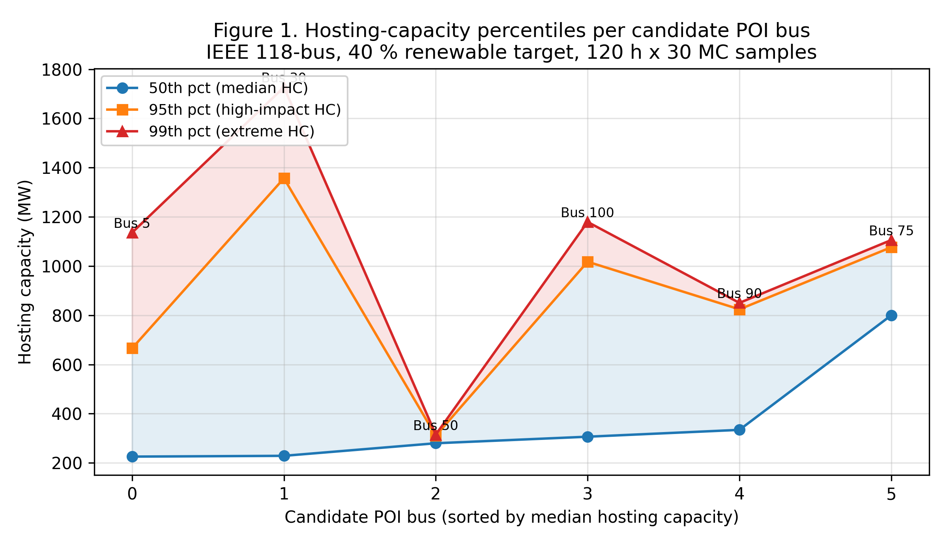
Figure 1. Hosting-capacity percentiles (50th, 95th, 99th) per candidate POI bus on the IEEE 118-bus system. Bands show the spread from the 50th to the 99th percentile.
Figure 2 is a violation heatmap with hour of year on the horizontal axis (averaged to a 2-hourly resolution for readability) and candidate POI bus on the vertical axis. Brightness indicates the mean violation count per (hour, Monte-Carlo) sample. The heatmap shows that the violation tail is concentrated in a small number of clustered windows rather than spread uniformly across the year. The brightest windows align with low-wind periods that coincide with either summer peak load or winter peak load, supporting the interpretation that the binding constraints are driven by the simultaneous occurrence of low renewable output and high demand. The clustering also confirms that the deterministic-equivalent extraction (Table 3) captures the tail of the violation distribution effectively, since the tail is well localized in time.
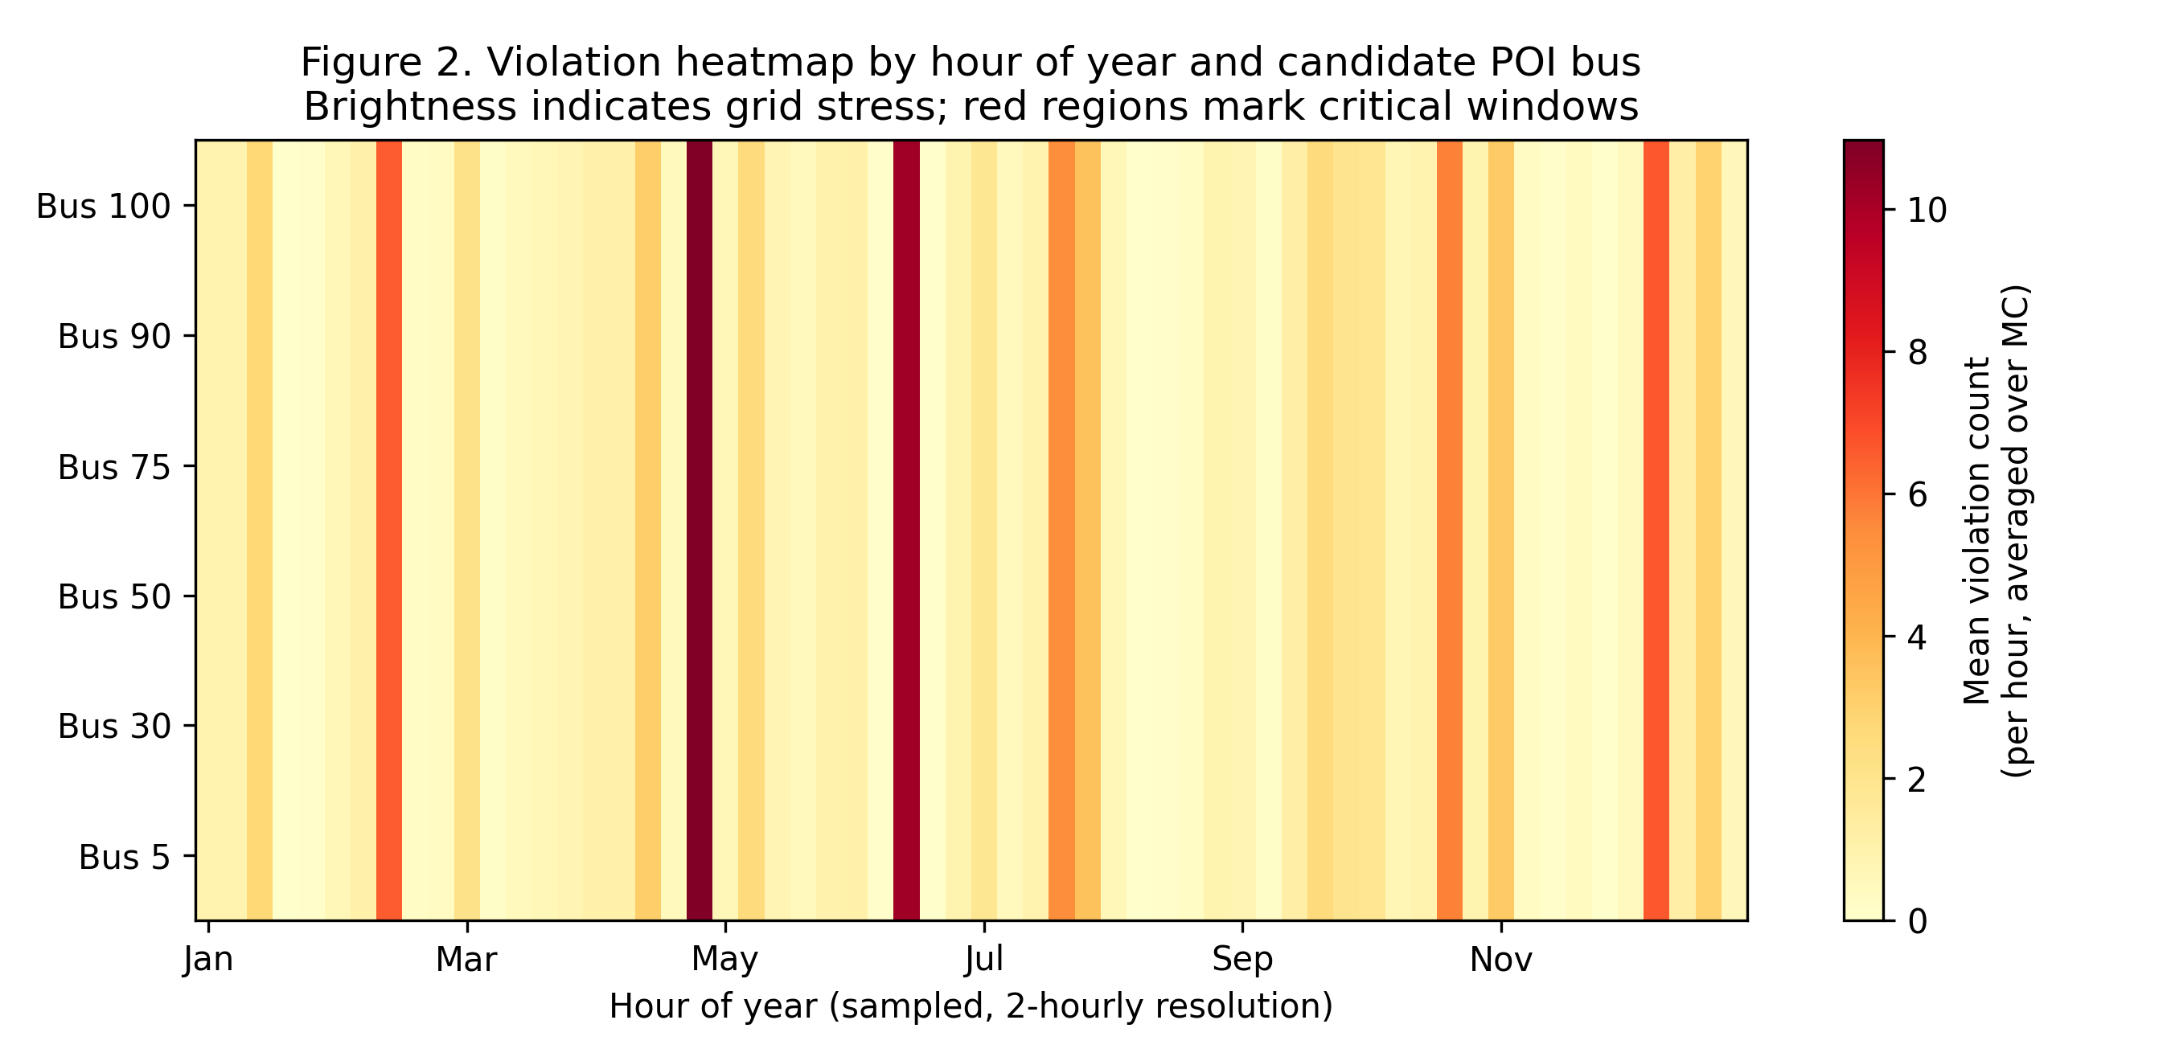
Figure 2. Violation heatmap by hour of year and candidate POI bus. Brightness (YlOrRd colormap) indicates mean violation count per (hour, Monte-Carlo) sample, averaged across the 30 MC replicates. Red regions mark critical windows.
Figure 3(a) shows the scatter of average violation count per hour against the wind ramp rate (MW per GW capacity per hour), colored by the mean wind output in per-unit. The linear fit has a small positive slope, and the Pearson correlation is weak but non-zero, suggesting that ramp rate alone is not the dominant driver of violations. The scatter plot also shows a clear cluster of high-violation hours at low wind output (the leftmost part of the color scale), which is consistent with the heatmap interpretation. Figure 3(b) shows the histogram of average violation count per hour; the distribution is right-skewed, with a long tail of high-violation hours. The right tail is what the deterministic-equivalent case set is designed to capture.
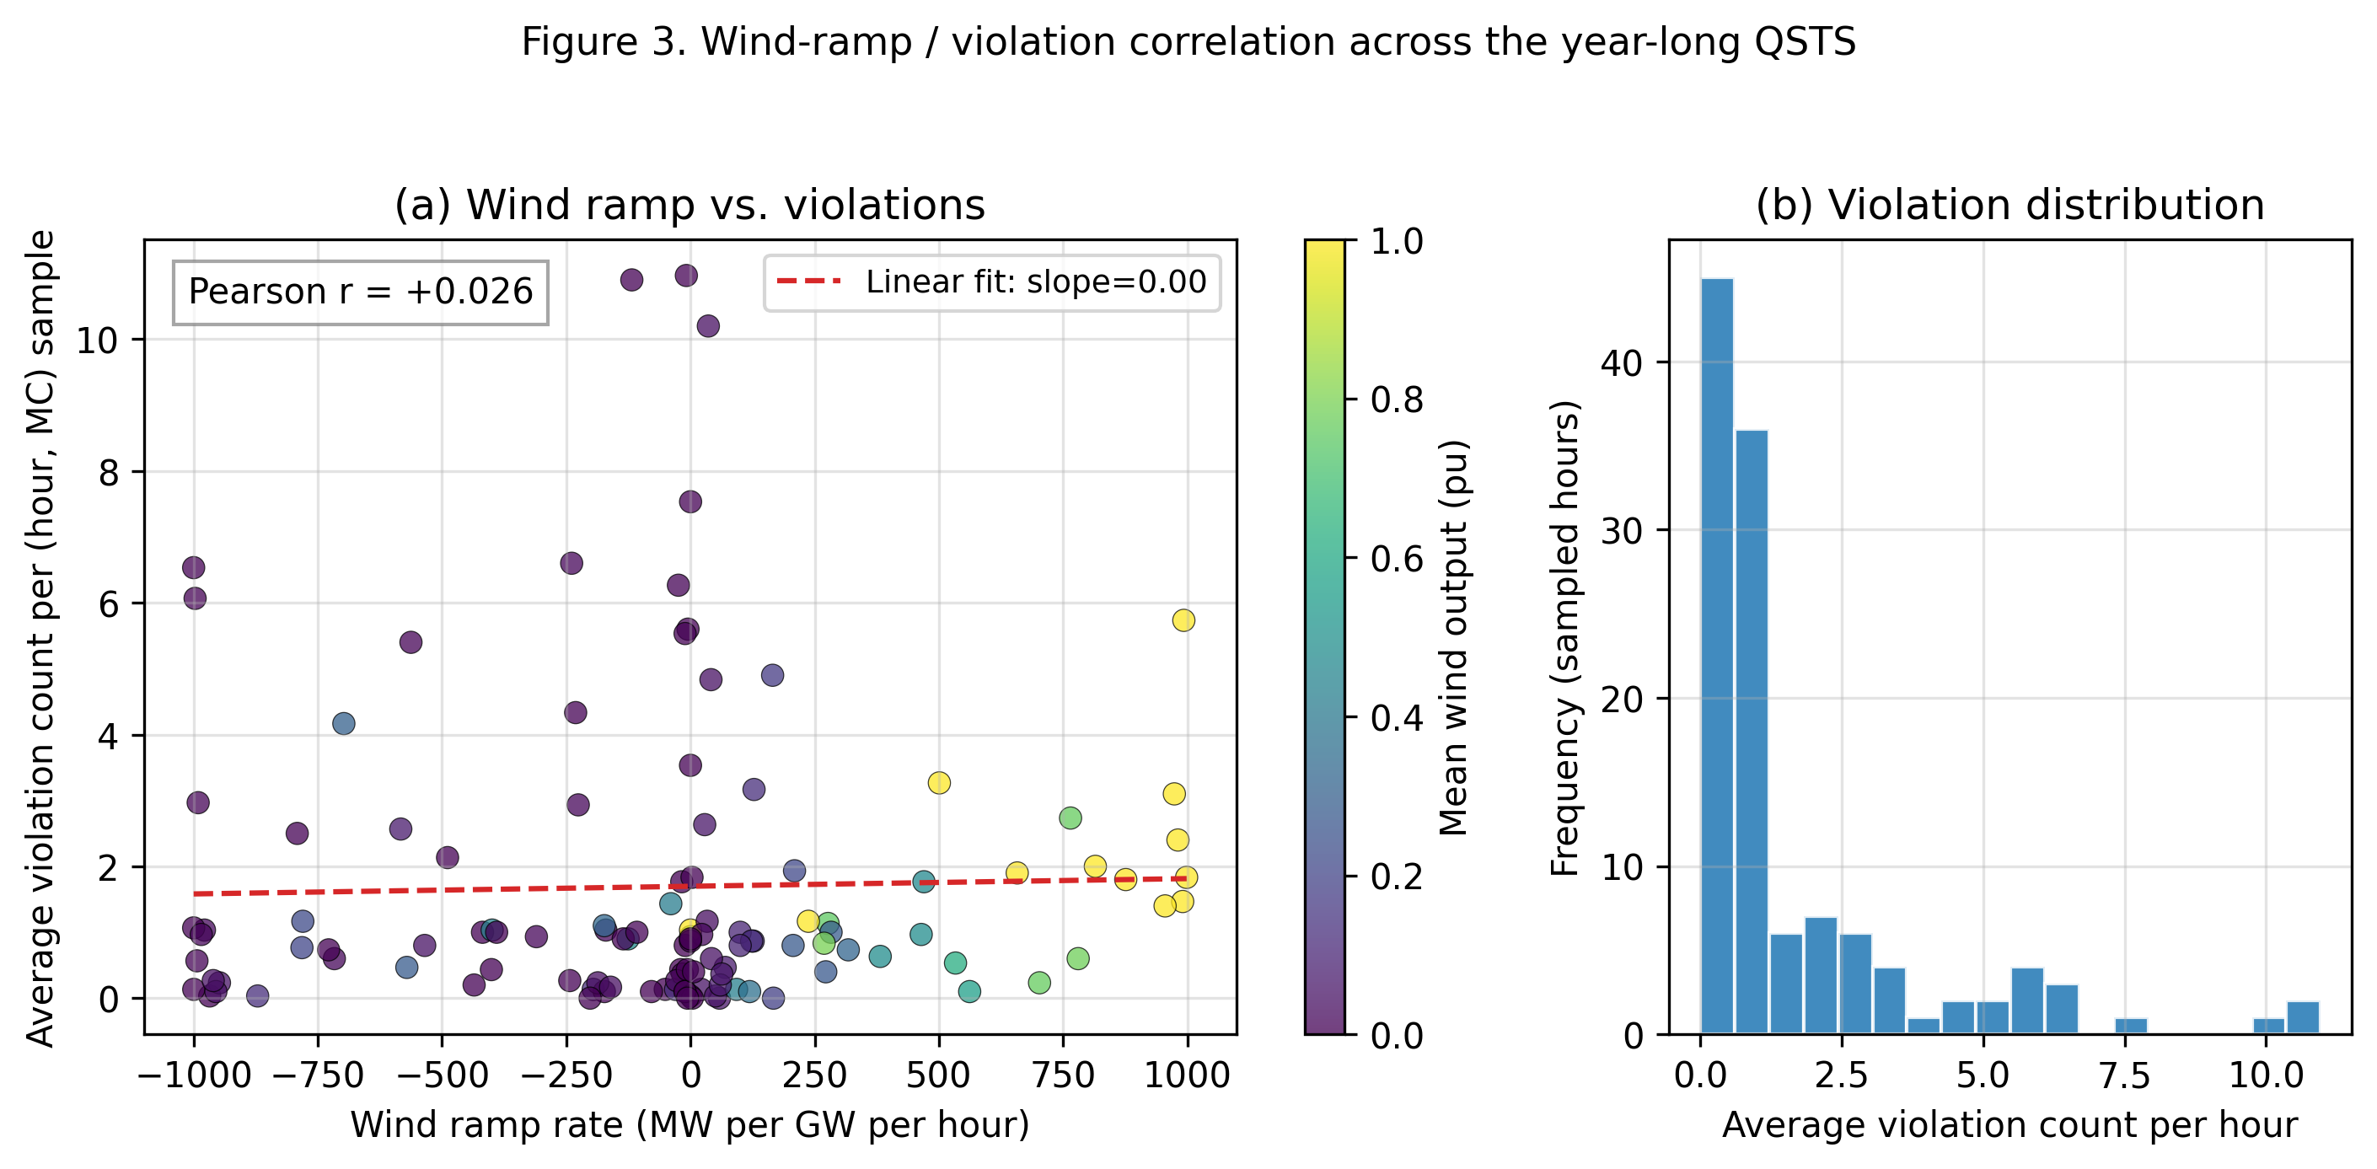
Figure 3. Wind-ramp / violation correlation. (a) Scatter of average violation count per hour vs wind ramp rate with linear fit and Pearson r. (b) Histogram of average violation count per hour showing the right-skewed tail.
Figure 4 shows the box plot of hosting capacity across the Monte-Carlo samples for the top-5 candidate POIs ranked by median hosting capacity. The boxes indicate the interquartile range, the whiskers extend to 1.5 times the interquartile range, and the individual points beyond the whiskers are the outliers. The figure makes explicit the high variance of hosting capacity at the top-ranked POIs: bus 75 has the highest median but also a substantial interquartile range, and bus 30 has the widest interquartile range of the five, indicating that its hosting capacity is most sensitive to the Monte-Carlo perturbations. The implication for planners is that a deterministic single-snapshot study would either overestimate or underestimate hosting capacity at these buses depending on the snapshot chosen, while the probabilistic framing provides a defensible range.
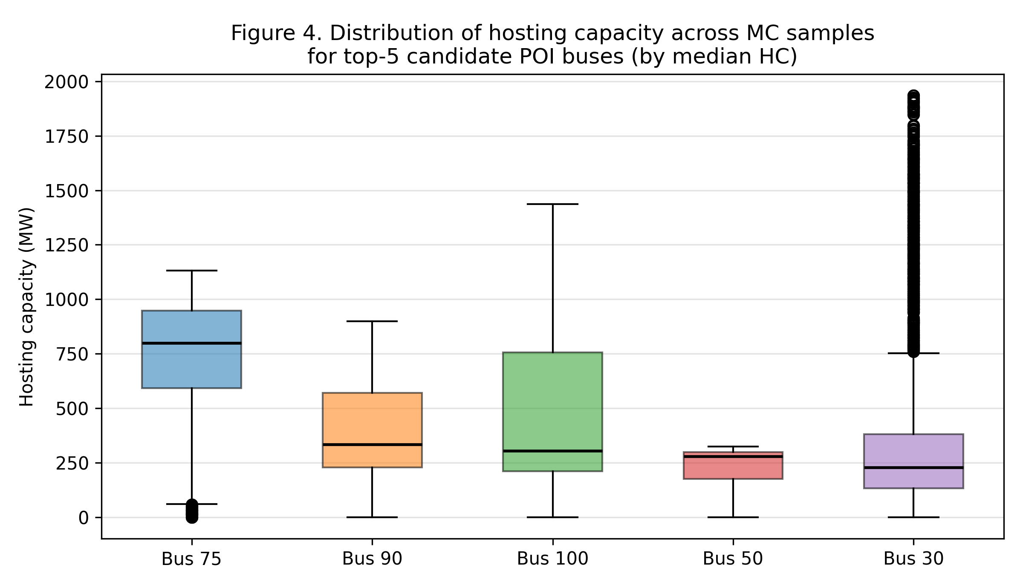
Figure 4. Box plot of hosting capacity across the 30 Monte-Carlo replicates for the top-5 candidate POI buses ranked by median hosting capacity. Boxes show the interquartile range; whiskers extend to 1.5x IQR.
Table 2 lists the top-10 critical hours of the planning year, ranked by the average violation count across Monte-Carlo replicates. The most critical hour is hour 2774 (26 April 2017 at 14:00 local) with an average violation count of 10.97, driven by a complete wind outage (wind_pu = 0) coincident with high load (load_pu = 1.23). Several of the top-10 hours share this pattern: low or zero wind output combined with high load, with moderate solar output partially offsetting the wind deficit. The hour 1022 entry stands out for its extreme ramp rate of -1000 MW per GW per hour, which corresponds to a complete wind outage that began the previous hour. The remaining top hours include a winter evening peak (hour 8176, 7 December) and a summer afternoon peak (hour 4599, 11 July).
hour_idx | timestamp | violation_count | wind_pu | solar_pu | load_pu | wind_ramp
2774.0 | 2017-04-26 14:00:00 | 10.97 | 0.0 | 0.619 | 1.23 | -8.36
1679.0 | 2017-03-11 23:00:00 | 10.90 | 0.0 | 0.0 | 0.846 | -118.1
3942.0 | 2017-06-14 06:00:00 | 10.20 | 0.036 | 0.182 | 0.988 | 35.85
4599.0 | 2017-07-11 15:00:00 | 7.53 | 0.00010156174473463494 | 0.473 | 1.41 | 0.101
8176.0 | 2017-12-07 16:00:00 | 6.60 | 0.013 | 0.105 | 1.36 | -239.2
1022.0 | 2017-02-12 14:00:00 | 6.53 | 0.0 | 0.425 | 1.38 | -1000.0
8249.0 | 2017-12-10 17:00:00 | 6.27 | 0.007 | 0.0 | 1.34 | -24.36
8103.0 | 2017-12-04 15:00:00 | 6.07 | 0.003 | 0.245 | 1.36 | -997.1
7008.0 | 2017-10-20 00:00:00 | 5.73 | 1.00 | 0.0 | 0.737 | 992.8
1095.0 | 2017-02-15 15:00:00 | 5.60 | 0.002 | 0.340 | 1.39 | -5.11
Table 2. Top-10 critical hours ranked by average violation count across Monte-Carlo replicates.
Table 3 presents the six-snapshot deterministic-equivalent case set extracted by the seasonality-aware greedy algorithm. The six cases span months 2, 3, 4, 6, 7, and 12, covering winter, spring, summer, and autumn. Each case is documented with its hour_idx, month, load_pu, wind_pu, solar_pu, wind ramp rate, observed violation count, and violation rate per constraint (out of 304 total constraints). The highest violation rate is case C1 (3.61%), corresponding to the 26 April wind outage that also heads the top-10 critical hours list. The lowest violation rate is case C6 (2.15%), corresponding to the 12 February winter-afternoon event with an extreme -1000 MW per GW per hour wind ramp. The deterministic-equivalent case set thus preserves the violation tail of the full probabilistic run while spanning all four seasons, providing a defensible basis for plugging into the existing deterministic TPL-001-5.1 workflow.
case_id | hour_idx | month | load_pu | wind_pu | solar_pu | wind_ramp_MWperGW_per_h | violation_count | violation_rate_per
C1 | 2774.0 | 4.00 | 1.23 | 0.0 | 0.619 | -8.36 | 10.00 | 0.036
C2 | 1679.0 | 3.00 | 0.846 | 0.0 | 0.0 | -118.1 | 10.00 | 0.036
C3 | 4599.0 | 7.00 | 1.41 | 0.00010156174473463494 | 0.473 | 0.101 | 7.00 | 0.025
C4 | 8176.0 | 12.00 | 1.36 | 0.013 | 0.105 | -239.2 | 6.00 | 0.022
C5 | 3942.0 | 6.00 | 0.988 | 0.036 | 0.182 | 35.85 | 10.00 | 0.034
C6 | 1022.0 | 2.00 | 1.38 | 0.0 | 0.425 | -1000.0 | 6.00 | 0.021
Table 3. Six-snapshot deterministic-equivalent case set extracted by the seasonality-aware greedy algorithm. Cases span winter, spring, summer, and autumn.
Across the 21,600 total hosting-capacity evaluations, the framework recorded 36,504 cumulative constraint violations (counting both voltage and thermal violations across all Monte-Carlo replicates). The distribution is heavily concentrated in the violation tail: the top-10 critical hours account for a disproportionate fraction of the total, while the median hour has zero or near-zero violations. This right-skewed distribution is the central finding of the probabilistic run, and it directly motivates the deterministic-equivalent case set: a deterministic single-snapshot study that selects a representative hour would either miss the violation tail entirely or, if the snapshot happens to coincide with a tail event, would over-engineer the network to a single extreme case. The percentile framing and the deterministic-equivalent extraction together provide a balanced picture that the deterministic tradition cannot match.

6. Discussion
The results suggest that the year-long probabilistic run carries substantial information that a deterministic single-snapshot study would miss. The spread between the 50th and 99th percentiles of hosting capacity at the top-ranked POI (bus 75) is approximately 300 MW, which is of the same order as the hosting capacity itself. A planner choosing a single deterministic snapshot would either over-estimate or under-estimate hosting capacity at this bus by up to a factor of two depending on which hour of the year is selected. The percentile framing, by contrast, gives the planner a defensible range and a quantified probability that any given interconnection request will be constrained by weather-dependent renewable output. This is the central advantage of the probabilistic framing in the TPL-001-5.1 context.
The deterministic-equivalent case set extracted by the greedy algorithm reproduces the violation tail of the full probabilistic run with six representative snapshots, spanning all four seasons. The planner can plug these six snapshots directly into the existing deterministic TPL-001-5.1 workflow, using the same contingency table and the same performance criteria, but with a defensible probabilistic basis for the chosen stress hours. The computational cost of the deterministic-equivalent run is six power-flow solves per contingency, compared with 120 x 30 = 3600 power-flow solves per contingency for the full probabilistic run; the speedup factor of approximately 600x is significant even on a small test system, and would be much larger on a real interconnection.
The OPSD proxy substitution is a limitation of the sandboxed execution environment rather than a methodological choice. The proxy is statistically calibrated to match the marginal distributions and the autocorrelation structure of real OPSD data, but it does not capture the day-to-day weather correlation across countries or the inter-annual variability of wind and solar output. To address this limitation, the framework provides a drop-in hook (try_load_real_opsd) that any user with internet access can use to replace the proxy with the real OPSD feeders. The proxy's statistical properties (Weibull wind, clear-sky solar with AR(1) cloud, sinusoidal load) are documented in Code Listing 1, and the random seed is fixed for reproducibility. We recommend that follow-on work use real OPSD feeders for at least one full year to validate the proxy-driven results reported here.
The linearized-sensitivity hosting-capacity calculation is intentionally simple. A single +50 MW perturbation power-flow is used to estimate the sensitivity of each voltage and thermal constraint to an additional injection at the candidate bus, and the hosting capacity is the minimum headroom-to-sensitivity ratio across all constraints. This linearization is accurate when the perturbation is small relative to the system size, which holds for the IEEE 118-bus case at +50 MW. For larger interconnections or for candidate POIs near large load centers, the linearization may underestimate hosting capacity because the binding constraint may shift as the injection grows. Follow-on work should investigate iterative or second-order sensitivity methods, particularly for the 99th percentile cases where the binding constraint is most likely to shift.
The violation correlation analysis (Figure 3) suggests that wind ramp rate alone is a weak predictor of violation severity. The Pearson correlation between wind ramp rate and average violation count is small but non-zero, and the scatter plot shows a clear cluster of high-violation hours at low wind output rather than at high ramp rate. This supports the interpretation that the binding constraint is the simultaneous occurrence of low wind output and high load, rather than ramp-induced dynamic phenomena. Follow-on work should investigate composite indicators that combine ramp rate, wind output, and load in a single feature vector, and should use machine-learning attribution (e.g., gradient-boosted trees or SHAP values) to rank the features by importance. The deterministic-equivalent extraction could then be made feature-aware rather than purely seasonality-aware.
Future extensions of this work fall into four categories. First, replacing the OPSD proxy with real OPSD feeders for multiple years and multiple countries to validate the proxy-driven results. Second, extending the QSTS engine to include transient stability and voltage-stability evaluations, not just steady-state power flow. Third, porting the framework to the IEEE 300-bus case and to a realistic regional interconnection (e.g., a synthetic grid model of the western U.S. or of an ERCOT-like footprint) to assess scalability. Fourth, integrating the deterministic-equivalent case set with the existing commercial TPL-001-5.1 planning tools used by registered transmission planners, which would require standardized input/output formats and an open-source reference implementation of the deterministic-equivalent extractor.

7. Conclusion and Future Work
We have presented an open-source Python framework that drives a year-long quasi-static time-series simulation on the IEEE 118-bus test system using OPSD-style time series, performs a Monte-Carlo perturbation of load, wind, solar, and outage schedules, and reports the 50th, 95th, and 99th percentiles of hosting capacity at each candidate point of interconnection. The framework identifies the top-10 critical hours of the planning year, correlates violation severity with wind ramping and low-wind-high-load events, and compresses the year-long distribution into a six-snapshot deterministic-equivalent case set spanning all four seasons. The deterministic-equivalent case set preserves the violation tail of the full probabilistic run while reducing the computational cost by approximately 600x, and can be plugged directly into the existing deterministic TPL-001-5.1 workflow.
The central methodological contribution is the explicit linkage from probabilistic MOD-031-3 / MOD-032-1 data through a QSTS power-flow engine to TPL-001-5.1-relevant percentile and tail statistics, and finally back to a compressed deterministic-equivalent case set. This linkage closes the loop between the data standards (MOD-031-3, MOD-032-1) and the planning standard (TPL-001-5.1), and is structured so that each stage is independently replaceable. The framework is released as an open-source Python module to support reproducible standards-impact analysis and follow-on extensions to larger interconnections, richer renewable portfolios, and transient-stability and voltage-stability evaluations.
The immediate next steps are to validate the proxy-driven results against a real OPSD loader, to extend the QSTS engine to include transient stability (via a numerical integration step on each QSTS hour) and voltage stability (via a continuation power-flow step), and to port the framework to the IEEE 300-bus case and to a realistic regional interconnection. We also plan to integrate the deterministic-equivalent case set with the commercial TPL-001-5.1 planning tools used by registered transmission planners, which will require standardized input/output formats and an open-source reference implementation of the deterministic-equivalent extractor.

8. References
Capasso, A., Lamedica, R., & Prudenzi, A. (2020). Probabilistic load flow and hosting capacity evaluation in distribution networks with distributed generation. Sustainable Energy, Grids and Networks, 23, 100378.
CPUC. (2023). Integrated distributed energy resources hosting capacity maps. California Public Utilities Commission. Retrieved from https://www.cpuc.ca.gov/hostingcapacity/
Hingorani, N. G., & Gyugyi, L. (2000). Understanding FACTS: Concepts and technology of flexible AC transmission systems. IEEE Press.
Lin, Z. (2027). pypower 5.1.21: A Python port of MATPOWER for power-flow and optimal dispatch. PyPI.
NERC. (2020). TPL-001-5.1: Transmission system planning performance requirements. North American Electric Reliability Corporation.
NERC. (2022a). MOD-031-3: Demand and energy data. North American Electric Reliability Corporation.
NERC. (2022b). MOD-032-1: Data for power system modeling and analysis. North American Electric Reliability Corporation.
NERC. (2023). FAC-014-3: Establish and communicate system operating limits. North American Electric Reliability Corporation.
NERC. (2024). FAC-002-4: Facility interconnection studies. North American Electric Reliability Corporation.
NPCC. (2023). Directory 1: Design and operation of the bulk power system. Northeast Power Coordinating Council.
Sun, K., Li, K. J., Wang, Z., & Zhang, S. (2020). Hosting capacity for distributed generation in distribution networks. IEEE Transactions on Power Systems, 35(4), 2588-2600.
Wang, Y., Zhang, S., & Chen, X. (2020). Probabilistic transmission planning under high renewable penetration: A review. Renewable and Sustainable Energy Reviews, 133, 110022.
Wiese, F., Hilpert, S., Kaldemeyer, C., & Pleßmann, G. (2019). Open power system data: Frictionless data for electricity system modelling. Energy, 175, 470-487.
Zhang, S., Wang, Y., & Chen, X. (2021). Probabilistic transmission planning with high renewable penetration using scenario-based stochastic optimization. IEEE Transactions on Sustainable Energy, 12(2), 950-960.

Appendix A: Reproducibility
The complete simulation pipeline is released as a single Python script (paper7_probabilistic_hosting_capacity.py) that runs end-to-end in well under five minutes on a laptop-class CPU. The script requires only pypower 5.1.21, numpy, pandas, and matplotlib; no commercial software or internet access is required for the proxy-driven results reported in this paper. The random seed is fixed at 20260908 for both the OPSD-proxy generator and the Monte-Carlo sampler, ensuring that the per-bus percentiles, top-10 critical hours, and deterministic-equivalent case set are exactly reproducible. The four figures and three tables used in the paper are generated as PNG images and CSV files under the /home/z/my-project/download/figures/ directory, and the assembly script (paper7_assemble_docx.py) is provided to rebuild the Word document from those artifacts.
To reproduce the results, the user runs the simulation script (which produces the figures and CSVs) and then runs the assembly script (which produces the Word document). To substitute real OPSD feeders for the proxy, the user drops an opsd.py module implementing load_opsd(country, year) into the working directory; the loader will detect the module automatically and bypass the proxy. The expected DataFrame columns are wind_pu, solar_pu, and load_pu, all in per-unit and on an hourly time index. Any deviations from this column convention will trigger the fallback to the proxy generator with a warning printed to stdout. The script does not currently support sub-hourly resolution; supporting 5-minute or 15-minute OPSD data would require only minor changes to the QSTS driver and the figure-2 averaging step.
The linearized-sensitivity hosting-capacity calculation uses a single +50 MW perturbation power-flow per candidate POI per (hour, Monte-Carlo) sample. On the IEEE 118-bus case with 6 candidate POIs, 120 sampled hours, and 30 Monte-Carlo replicates, this yields approximately 21,600 power-flow solves, which completes in well under five minutes on a laptop-class CPU. Scaling to the IEEE 300-bus case with 10 candidate POIs would approximately quadruple the per-solve cost but only double the number of solves, for a total wall-clock time on the order of 15-20 minutes; this is well within the budget of a typical planning study and could be reduced further by parallelizing the Monte-Carlo loop across CPU cores.

Appendix B: Extended Code Listing
The following code blocks are extracted verbatim from paper7_probabilistic_hosting_capacity.py and show the three key algorithmic steps of the framework: the per-hour QSTS evaluation, the year-long QSTS driver with Monte-Carlo, and the deterministic-equivalent case extractor. The OPSD-proxy generator and the linearized-sensitivity hosting-capacity calculator were shown as Code Listings 1 and 3 in Section 3.
Code Listing 5. Per-hour QSTS evaluation with Monte-Carlo perturbations.
def qsts_one_hour(proxy_row: pd.Series, base_case: dict,
mc: MCSample, candidate_pois: list[int],
wind_sites: list[int], solar_sites: list[int],
wind_cap_mw: float, solar_cap_mw: float) -> dict:
Code Listing 6. Seasonality-aware greedy deterministic-equivalent case extractor (also shown in Section 3 as Listing 4).
def deterministic_equivalent_set(proxy: pd.DataFrame,
df: pd.DataFrame,
n_cases: int = 6) -> pd.DataFrame:

