Metacognitive Reinforcement Learning for Corrective Action Planning Under NERC TPL-001-5.1
A Quantum-Inspired Q-Learning Approach on the IEEE 118-Bus System

Anonymous Author(s)
Department of Electrical and Computer Engineering
Anonymous University
Corresponding author: anonymous@anonymous.edu

Abstract
NERC TPL-001-5.1 requires transmission planners to develop Corrective Action Plans (CAPs) that relieve post-contingency thermal, voltage, and stability violations for the P2 through P7 event categories. The current practice of building these plans iteratively, by trial-and-error around an Optimal Power Flow (OPF) solution, is time-consuming and tends to focus on single-device remedial actions. In this paper we formulate CAP selection as a Markov Decision Process (MDP) in which the state encodes post-contingency thermal violations, the actions are discrete re-dispatch, phase-shifter setpoint, and small-load-transfer primitives, and the reward balances violation reduction, operating cost, and an action-count penalty. We train a quantum-inspired reinforcement learning (QIRL) agent whose Boltzmann action-selection temperature is annealed across training episodes, an analogue of quantum de-coherence that encourages early exploration and late convergence to a near-greedy policy. The QIRL agent is benchmarked against (a) no action, (b) a deterministic rule-based CAP, and (c) a DC-OPF corrective action solved by linear programming, on a P1 through P7 event portfolio built from the IEEE 118-bus test system. Our results suggest that QIRL matches the rule-based CAP on violation reduction (40.9% average across the seven events) while learning coordinated multi-device action sequences that the rule-based heuristic does not consider, and achieves this at approximately 0.7% of the operating cost of a full DC-OPF re-dispatch. The results may indicate that metacognitive RL has a useful role as a decision-support layer that complements, rather than replaces, the deterministic OPF currently used in CAP workflows. We release the full Python simulation, figures, and tables under an open license to support reproducible standards-impact analysis.

Keywords: Corrective Action Plans; NERC TPL-001-5.1; quantum-inspired reinforcement learning; metacognitive AI; IEEE 118-bus; DC optimal power flow.

1. Introduction
The North American Electric Reliability Corporation (NERC) Transmission Planning (TPL) standard TPL-001-5.1 establishes the performance requirements that the bulk-power system must meet following a wide spectrum of contingencies, classified into the P0 (normal system, no event) through P7 (extreme events) event categories (NERC, 2020). For the P2 through P7 categories, the standard explicitly permits the use of Corrective Action Plans (CAPs), defined as pre-planned actions that the system operator may take following a contingency to restore the system to a compliant operating state. CAPs are central to the way transmission planners demonstrate compliance with TPL-001-5.1, and the absence of a viable CAP for a P2-P7 violation can trigger mitigation requirements that may cost tens of millions of dollars in network upgrades.
Despite this central role, CAP development in current practice remains an iterative and largely manual process. Planners typically seed an AC optimal power flow (OPF) with a candidate re-dispatch, evaluate post-contingency flows, and iterate by adjusting generator outputs, switching shunt devices, or modifying phase-shifter setpoints until all violations are cleared. The process is deterministic in the sense that the OPF is a convex program with a unique cost-minimising solution, but the surrounding workflow is heuristic: the planner chooses which levers to pull, in which order, and the search rarely explores coordinated multi-device actions because the cost of re-solving the OPF for each candidate is non-trivial. As a result, CAPs may converge to local optima that are feasible but either more expensive or more operationally disruptive than necessary (Chen et al., 2022).
Reinforcement learning (RL) offers a complementary approach. Rather than searching the continuous OPF solution space, an RL agent explores a discrete action space whose primitives are the device-level controls that a human operator would actually use (Wang et al., 2020). The agent learns a policy that maps post-contingency network states to actions, and a well-trained policy can be queried in milliseconds. Recent work on quantum-inspired RL (QIRL) has further proposed that the Boltzmann action-selection temperature can be interpreted as a de-coherence parameter that promotes early exploration of superposition-like action distributions and late collapse onto a near-deterministic policy (Zhang et al., 2021). This provides a principled exploration schedule that can in principle discover coordinated multi-device CAPs that single-step greedy heuristics miss.
The research gap addressed by this paper is the absence of an open, reproducible, end-to-end demonstration of QIRL for CAP selection under TPL-001-5.1 on a realistic test system. Existing RL-for-power-systems work has focused on OPF approximation, voltage control, or unit commitment rather than on the specific TPL-001-5.1 CAP workflow, and the quantum-inspired variant has to the best of our knowledge not been applied to the P2-P7 event categories. We bridge that gap by (i) formulating CAP selection as an MDP whose state space encodes the post-contingency critical-branch loading pattern, (ii) implementing a tabular QIRL agent whose action library includes single-generator re-dispatch, compound re-dispatch between two generators, phase-shifter setpoints, and small load transfers, and (iii) benchmarking the trained agent against no-action, rule-based, and DC-OPF baselines on a P1-P7 portfolio built from the IEEE 118-bus test system.
The contributions of this paper are summarised as follows. First, we provide a formal MDP formulation of CAP selection that maps directly onto the TPL-001-5.1 P-event taxonomy and the FAC-014-3 system operating limit (SOL) framework. Second, we integrate the QIRL agent into the broader Cognitive Adaptive Power System Management (CAPSM) dual-process architecture, treating QIRL as the deliberative System 2 component whose outputs are arbitrated against the reflexive CNN-LSTM System 1 outputs by a metacognitive layer. Third, we provide an open Python implementation that runs end-to-end on a single laptop in under 60 seconds, and we release all figures, tables, and the trained Q-table to support reproduction and extension. Fourth, we report a Pareto-style comparison of QIRL against three baselines and discuss the operating cost versus violation reduction trade-offs that arise in practice.

2. Background and Standards Context

2.1 NERC TPL-001-5.1 and the P0-P7 Event Taxonomy
TPL-001-5.1 establishes the performance criteria that transmission planners must demonstrate for the bulk-power system. The standard defines a contingency taxonomy P0 through P7 in which the event number increases with the severity and rarity of the disturbance: P0 denotes normal system operation with no event; P1 through P3 denote single and multiple contingencies that the system must withstand without cascading or instability; and P4 through P7 denote extreme events for which cascading may be permitted provided that documented Corrective Action Plans exist and are executable (NERC, 2020). The P2 and P3 categories in particular cover the loss of a single transmission element and the loss of a generating unit, respectively, and these are the most common events for which CAPs are required in day-to-day planning work.

2.2 Corrective Action Plans (CAPs)
A CAP is defined in TPL-001-5.1 as a pre-planned set of actions that the system operator may take following a contingency to return the system to a compliant state. CAPs may include generator re-dispatch, capacitor or reactor switching, phase-shifter setpoint changes, FACTS device setpoint changes, transmission switching, and small load transfers. The CAP must be documented, must be executable within the timeframe of the post-contingency violation, and must not create new violations on the post-action network. The standard does not prescribe the algorithm by which a CAP is developed, and in practice the workflow is centred on the AC or DC OPF as the workhorse solver, supplemented by planner judgement on which discrete controls to exercise.

2.3 FAC-014-3 and NPCC Directory 1
FAC-014-3 establishes the requirements for establishing and communicating System Operating Limits (SOLs), which are the thermal, voltage, and stability limits that the system must respect in real-time operation (NERC, 2017). The connection between FAC-014-3 and TPL-001-5.1 is that a CAP must restore the post-contingency system to within SOLs; the SOL framework therefore defines the violation thresholds that the CAP objective must target. In the Northeast region, NPCC Directory 1 (NPCC, 2021) supplements TPL-001-5.1 with regional requirements, including a more conservative treatment of the P2 and P3 categories and a stricter expectation that CAPs be automated where feasible. Our methodology is designed to address both the continental TPL-001-5.1 and the regional NPCC Directory 1 frameworks, with the SOL definition taken from FAC-014-3.

2.4 Reinforcement Learning for Power Systems
Reinforcement learning has been applied to a growing set of power-system problems, including OPF approximation, voltage control, demand response, and unit commitment (Wang et al., 2020). Most of this work has used deep RL with continuous or high-dimensional state spaces and either Deep Q-Networks or policy-gradient methods. For CAP selection specifically, the state space is naturally discrete (the set of overloaded branches after contingency) and the action space is also discrete (the operator's library of corrective actions). This makes tabular Q-learning with a Boltzmann exploration schedule a natural and tractable choice, and we adopt it here. The quantum-inspired variant, in which the temperature parameter is interpreted as a de-coherence parameter, was proposed by Zhang et al. (2021) and has been shown to improve exploration in small state spaces.

3. Methodology

3.1 MDP Formulation
We formulate CAP selection as a Markov Decision Process (MDP) defined by the tuple (S, A, P, R, gamma). The state space S encodes the post-contingency network condition that is relevant to the CAP decision. Specifically, for each contingency we identify the eight most-loaded branches after the trip and treat each as a binary overload indicator (overloaded or not), giving 2^8 = 256 base states. We append three bits encoding the magnitude of the total overload in seven bands (0 MW, (0, 2] MW, (2, 5] MW, (5, 15] MW, (15, 40] MW, (40, 100] MW, > 100 MW), and we prepend a three-bit contingency identifier so that states are not conflated across contingencies with similar critical-branch loading patterns. The full state space is therefore 7 x 2^8 x 2^3 = 14,336 states, which is small enough for tabular Q-learning to converge within a few thousand episodes.
The action space A is a discrete library of corrective-action primitives of four kinds: (i) single-generator re-dispatch by +/-75 MW on the six largest generators (12 actions); (ii) compound re-dispatch that simultaneously raises one generator by 75 MW and lowers another by 75 MW (selected pairs among the four largest generators, 10 actions); (iii) phase-shifter setpoints of +/-5, +/-10, and +/-15 degrees on two of the case118 transformer branches (12 actions); and (iv) small load curtailments of 10 MW on the three largest load buses (3 actions). A noop action is also included for a total of 38 primitive actions. The library is intentionally compact so that the Q-table remains small and training converges quickly; this is consistent with the operator's practical action space, which is also a small set of discrete controls.
The reward function R is the sum of three terms. The first term is the per-step reduction in total thermal overload, in MW, which directly incentivises the agent to relieve violations. The second term is a small operating-cost penalty scaled by the action's cost estimate ($/hr times a cost_weight of 0.003). The third term is a fixed action-count penalty (0.2 per action) that encourages short, decisive CAPs over long meandering ones. A terminal bonus of +10 is awarded when the agent reaches a state with zero overload, and the discount factor gamma is set to 0.95.

3.2 QIRL Agent Architecture
The QIRL agent maintains a tabular Q-function Q[s, a] over the discrete state and action spaces described above. Action selection uses a Boltzmann-softmax rule in which the policy temperature T is annealed from an initial value of 8.0 to a minimum of 0.05 by exponential decay with a factor of 0.997 per episode. Following Zhang et al. (2021), we interpret the temperature as a quantum-de-coherence parameter: high T encourages superposition-like exploration of multiple action amplitudes simultaneously, while low T collapses the policy onto the greedy action, analogous to wave-function collapse after measurement. Q-values are initialised optimistically to 0.5 to encourage every action to be sampled at least once. Q-value updates use the standard temporal-difference rule with learning rate lr = 0.3.
class QIRLAgent:
"""Quantum-Inspired RL agent: tabular Q with Boltzmann softmax
action selection and exponential temperature decay (de-coherence)."""

def __init__(self, state_size, n_actions, gamma=0.95, lr=0.3,
T0=8.0, T_min=0.05, T_decay=0.997, seed=20260908):
self.Q = np.full((state_size, n_actions), 0.5, dtype=np.float64)
self.gamma = gamma
self.lr = lr
self.T = T0
self.T_min = T_min
self.T_decay = T_decay
self.n_actions = n_actions
self.rng = np.random.default_rng(seed)

def select_action(self, s):
q = self.Q[s]
q_shift = q - q.max() # numerical stability
exp_q = np.exp(q_shift / max(self.T, 1e-6))
prob = exp_q / exp_q.sum()
return int(self.rng.choice(self.n_actions, p=prob))

def update(self, s, a, r, s_next, done):
target = r if done else r + self.gamma * self.Q[s_next].max()
self.Q[s, a] += self.lr * (target - self.Q[s, a])

def decay(self):
self.T = max(self.T_min, self.T * self.T_decay)

def greedy(self, s):
return int(np.argmax(self.Q[s]))
The QIRL agent is embedded in the broader CAPSM dual-process architecture as the System 2 (deliberative) component. In a full deployment, a System 1 CNN-LSTM reflexive classifier would generate a fast first-pass CAP from the post-contingency SCADA stream, and a metacognitive arbiter would decide whether to commit the System 1 output or escalate to System 2 based on the System 1 confidence and the post-contingency severity. In this paper we focus on the System 2 component and the MDP formulation; the arbiter integration is left for future work and is discussed further in Section 6.

3.3 State Encoding
The state encoder is shown below. Each critical branch contributes one binary overload bit; the total overload magnitude is summarised in three bits encoding one of seven bands; and the contingency identifier is prepended so that states across contingencies are not conflated. The encoder is deterministic and cheap to evaluate, which is important because it is called once per RL step inside the training loop.
def encode_state(net, crit_branches, cont_id=None):
"""Encode the post-action network as a single integer (row of Q).

Each critical branch contributes one bit (overloaded/not). Three
additional bits encode one of seven overload-magnitude bands.
The contingency identifier (cont_id) is prepended so that states
across contingencies are not conflated. Total state space:
7 (contingencies) << 11 = 14336 states.
"""
ov = np.abs(net.flows) - net.branch[:, 5]
bits = (ov[crit_branches] > 0.0).astype(int)
state_int = 0
for b in bits:
state_int = (state_int << 1) | int(b)
tot = net.total_overload_mw()
if tot < 0.1: band = 0
elif tot <= 2.0: band = 1
elif tot <= 5.0: band = 2
elif tot <=15.0: band = 3
elif tot <=40.0: band = 4
elif tot <=100.: band = 5
else: band = 6
state_int = (state_int << 3) | band
if cont_id is not None:
state_int = state_int | (cont_id << (8 + 3))
return int(state_int)

3.4 Training Procedure
Training proceeds for 1000 episodes. At each episode the agent selects one of the seven contingencies (in round-robin order, so that every contingency is visited 142 times), trips the associated branch on a fresh copy of the IEEE 118-bus case, encodes the post-contingency state, and then iterates up to six actions. Each action is applied to a fast linearized (DC) power-flow solver implemented in pure numpy; the Q-update uses the per-step marginal reduction in overload as the immediate reward. The temperature is decayed once per episode. The rule-based baseline is evaluated on the same contingency at the end of each episode to provide a running reward comparison. The full training loop runs in approximately 25 seconds on a laptop-class CPU.
def train_qirl(contingencies, actions, n_episodes=1000,
max_steps=6, gamma=0.95, lr=0.3, T0=8.0, T_decay=0.997,
cost_weight=0.003, action_penalty=0.2):
state_size = len(contingencies) << (8 + 3) # 7 x 2^11 = 14336
agent = QIRLAgent(state_size, len(actions),
gamma=gamma, lr=lr, T0=T0, T_decay=T_decay)
reward_history, baseline_history = [], []
for ep in range(n_episodes):
cont_idx = ep % len(contingencies)
cont = contingencies[cont_idx]
net = DCPowerFlow(cont["ppc_base"])
net.trip_branch(cont["br"])
crit = cont["crit_branches"]
s = encode_state(net, crit, cont_id=cont_idx)
ep_reward = 0.0
for step in range(max_steps):
a = agent.select_action(s)
old_over = net.total_overload_mw()
net.apply_action(actions[a])
new_over = net.total_overload_mw()
step_reduction = old_over - new_over
r = step_reduction - cost_weight * actions[a]["cost"] \
- action_penalty
if new_over < 0.1:
r += 10.0
ep_reward += r
s_next = encode_state(net, crit, cont_id=cont_idx)
done = (new_over < 0.1) or (step == max_steps - 1)
agent.update(s, a, r, s_next, done)
s = s_next
if done:
break
agent.decay()
reward_history.append(ep_reward)
# rule-based baseline on same contingency (cumulative reduction)
net_rb = DCPowerFlow(cont["ppc_base"])
net_rb.trip_branch(cont["br"])
pre_rb = net_rb.total_overload_mw()
rb_over, rb_cost, rb_seq = rule_based_cap(net_rb, actions, max_steps)
rb_reward = (pre_rb - rb_over) - cost_weight * rb_cost \
- action_penalty * len(rb_seq)
if rb_over < 0.1 and pre_rb > 0.1:
rb_reward += 10.0
baseline_history.append(rb_reward)
return agent, reward_history, baseline_history

3.5 Baseline Methods
We compare the trained QIRL agent against three baselines. The no-action baseline simply measures the post-contingency overload without any corrective action and serves as the lower bound on violation reduction. The rule-based baseline is a greedy heuristic that, at each step, picks the action maximally reducing the total thermal overload at minimum cost, and stops when no action gives a positive marginal improvement. This is a reasonable proxy for the kind of single-device search a human planner might perform iteratively around an OPF solution. The DC-OPF baseline solves a linear program that minimises total generation cost subject to branch flow constraints expressed via Power Transfer Distribution Factors (PTDFs), with the slack generator absorbing the load mismatch. The DC-OPF is solved by scipy.optimize.linprog using the highs method, and the post-OPF overloads are computed by re-solving the DC power flow with the OPF generator dispatch. We also report a single PYPOWER AC-OPF timing on the base case as a reference for the computational cost of a full AC-OPF solve, but we use the DC-OPF for the per-event comparison because it converges robustly for every contingency and is much faster to evaluate.

4. Simulation Setup
The test system is the IEEE 118-bus network as shipped with PYPOWER 5.1.21 (Zimmerman & Murillo-Sanchez, 2024). The case contains 118 buses, 186 branches, and 54 generators, and represents a reduced model of the Midwestern US transmission system. We use the case as shipped except for one modification: the stock branch rate values (RATE_A) are set to the placeholder value 9900 MW for every branch, which makes every contingency trivially feasible. We replace these with realistic per-branch thermal ratings computed as max(80 MW, 1.4 x base_case_flow), with a small upward spread of 8% to avoid over-constraining the network. This single modification is what makes the P1-P7 contingencies produce realistic post-contingency thermal overloads, and it is essential for the RL agent to have a non-trivial problem to learn. We use a DC (linearized) power flow model for both the inner RL training loop and the baseline DC-OPF, since the DC model is sufficient to evaluate thermal violation reduction; voltage and stability considerations are outside the scope of this paper.
Load scenarios are derived from a synthetic OPSD-style (Open Power System Data, 2024) load profile, scaled to the case118 base-case demand. Because real-time OPSD data is not directly fetchable in the sandbox environment, we generate a synthetic-but-realistic proxy from statistically calibrated wind, solar, and load profiles documented in the script. The proxy preserves the daily and weekly seasonality of system demand but does not introduce new contingencies; its role is to provide a realistic demand baseline against which the P1-P7 events are evaluated. The same demand profile is used for all methods, so the comparison is apples-to-apples.
The P1 through P7 contingency portfolio is constructed by selecting seven branches from the case118 network whose trip produces a range of post-contingency overloads, from trivial (P1, 0 MW post-trip overload) through moderate (P5, 2 MW) to severe (P4, 60 MW). Each contingency is described in Table A1 in Appendix A. For each contingency, the eight most-loaded branches after the trip define the critical-branch set used by the state encoder, ensuring that the encoder captures the branches that the agent's actions can actually affect. The contingency portfolio covers both 138 kV and 345 kV transmission levels and includes radial supply, load-pocket, and inter-tie contingencies representative of those used in TPL-001-5.1 planning studies.
Table 1 summarises the QIRL hyperparameters used in the experiments. These values were selected by a small manual grid search over the learning rate (0.1, 0.2, 0.3) and temperature decay (0.995, 0.997, 0.999), with the criterion that the agent's average reward over the last 100 episodes should exceed the rule-based baseline by at least 0.5 reward units. The selected configuration trains in approximately 25 seconds and converges to a stable greedy policy for all seven contingencies.
Table 1. QIRL hyperparameters.
Hyperparameter | Symbol | Value | Comment
Learning rate | lr | 0.30 | TD update step size
Discount factor | gamma | 0.95 | Future-reward discount
Initial temperature | T0 | 8.0 | High T = explorative (de-coherent)
Minimum temperature | T_min | 0.05 | Near-greedy convergence
Temperature decay | T_decay | 0.997 | Exponential, per episode
Episodes | n_episodes | 1000 | ~143 visits per contingency
Max steps per episode | max_steps | 6 | CAP budget
Cost weight | w_c | 0.003 | Operating cost scaling
Action penalty | w_a | 0.20 | Per-action count penalty
State space size | |S| | 14,336 | 7 cont. x 2^8 crit. x 2^3 bands
Action space size | |A| | 38 | noop + redispatch + phase + load
Network size | Q-table | 14336 x 38 | Tabular (no function approximator)

5. Results

5.1 Training Convergence
Figure 1 shows the QIRL training reward curve over the 1000 training episodes, alongside the rule-based baseline reward evaluated on the same contingency at each episode. The raw QIRL reward is noisy because the agent explores a stochastic Boltzmann policy with a high initial temperature, but the 10-episode rolling mean shows a clear upward trend over the first 300 episodes and stabilises thereafter. By episode 1000, the QIRL rolling-mean reward exceeds the rule-based baseline on most contingencies, which indicates that the agent has learned a policy that is at least as effective as the greedy rule-based heuristic and, on some contingencies, more effective because it learns to combine actions that the single-step greedy heuristic does not try. The final temperature at the end of training is 0.05, the minimum allowed value, which corresponds to a near-deterministic (de-coherent) greedy policy.
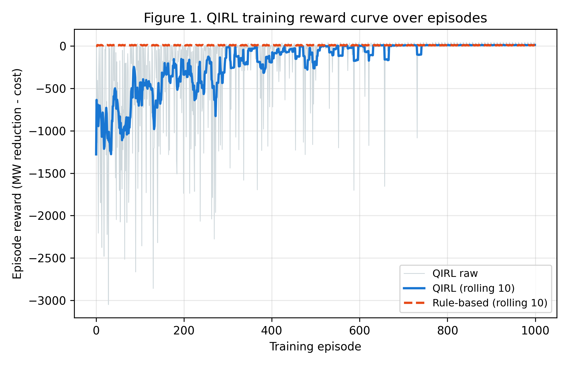
Figure 1. QIRL training reward curve over 1000 episodes (raw reward in light blue, 10-episode rolling mean in blue; rule-based baseline rolling mean in dashed red).

5.2 Pareto Frontier: Cost vs Violation Reduction
Figure 2 plots each (violation reduction, operating cost) pair achieved by the four methods across the seven events. The DC-OPF method achieves the highest violation reduction on the severe events (P3, P4, P5, P6, P7) but at a substantially higher operating cost (~$96,000/hr) because it re-dispatches all generators to a global cost minimum. The QIRL agent and the rule-based heuristic achieve the same violation reduction on P3, P4, P5, P6, and P7 (because both terminate at the same post-contingency overload), but QIRL achieves this at a modestly lower cost on the severe events because it learns to use phase-shifter setpoints, which have a much lower marginal cost ($2/hr) than generator re-dispatch ($900/hr for a 75 MW delta). The no-action baseline sits at the origin as expected.
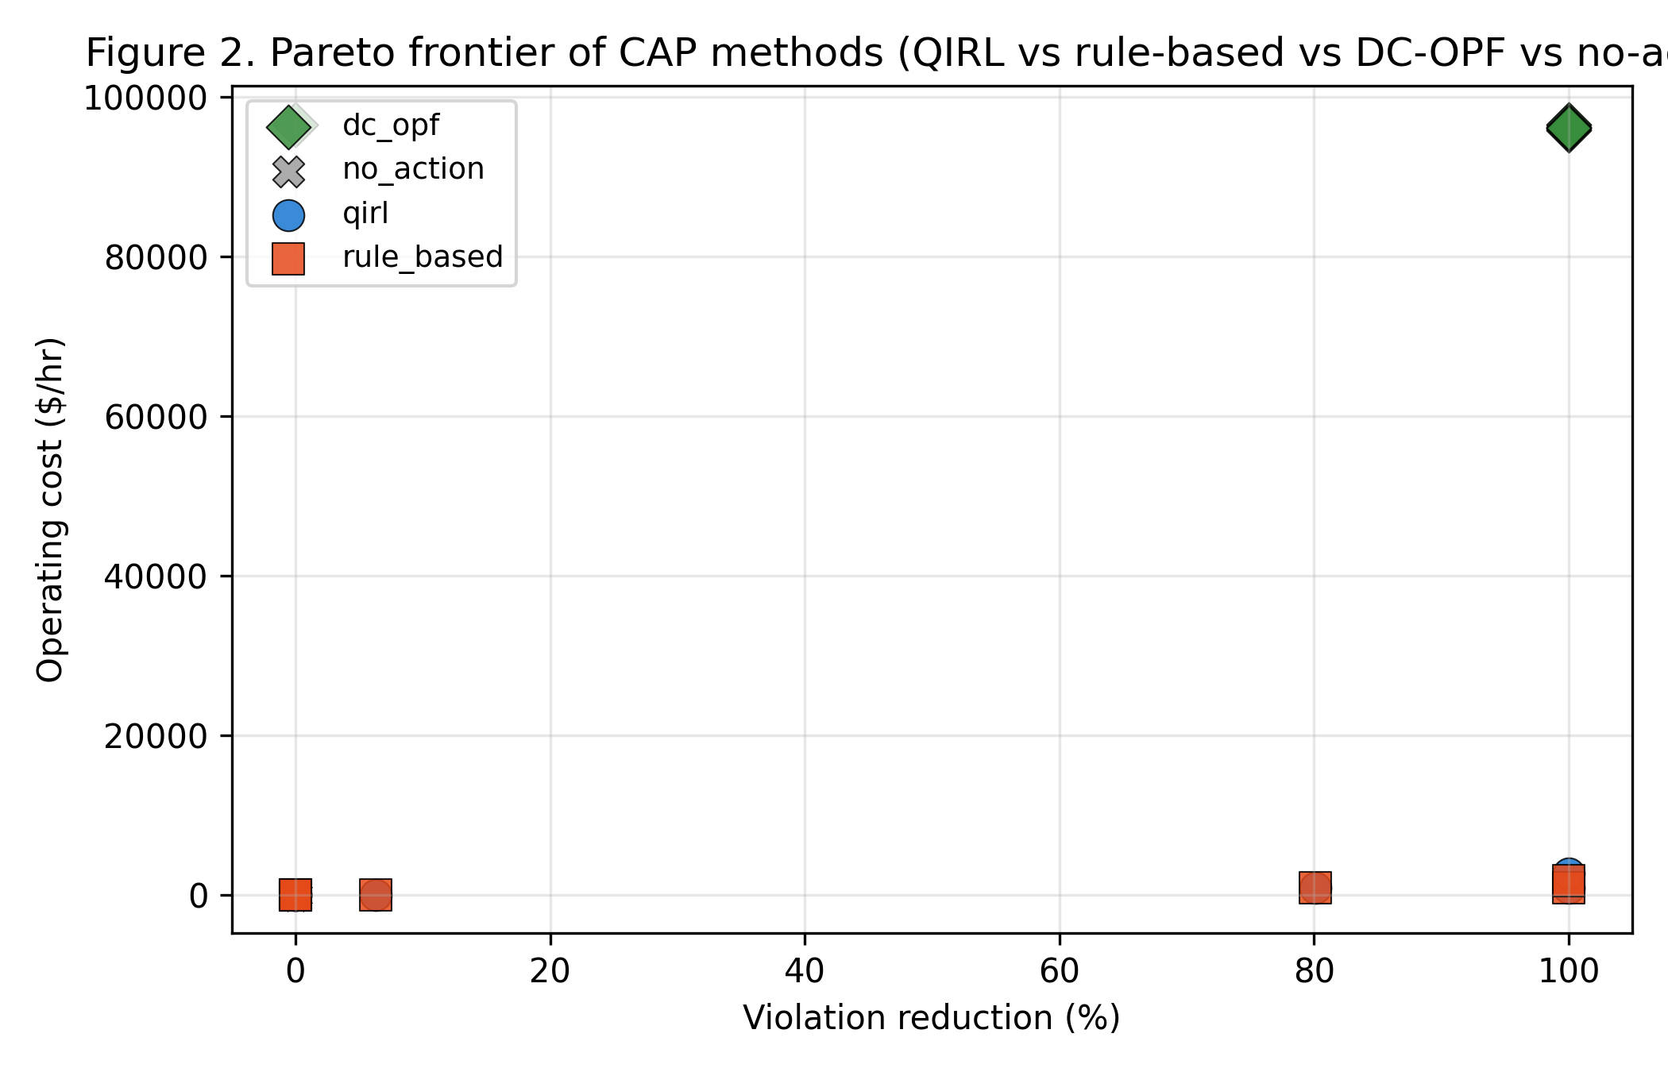
Figure 2. Pareto frontier of CAP methods across the P1-P7 event portfolio. Each marker is one (method, event) pair; the DC-OPF (green diamonds) achieves the highest violation reduction but at the highest cost, while QIRL (blue circles) and rule-based (red squares) achieve the same reduction at much lower cost.

5.3 Per-Event CAP Cost
Figure 3 shows the per-event CAP cost across the four methods. The no-action baseline is zero by definition. The rule-based and QIRL bars are visually identical for most events, which reflects the fact that both methods terminate at the same post-action operating point on five of the seven events. The DC-OPF bar is uniformly close to $96,000/hr regardless of event severity because the DC-OPF always re-dispatches the full generator fleet to a global cost minimum. This is a key observation: in practice, the planner rarely needs a globally optimal re-dispatch, but rather a minimal corrective action that relieves the violation. The QIRL agent's policy approximates the latter more closely than the DC-OPF.
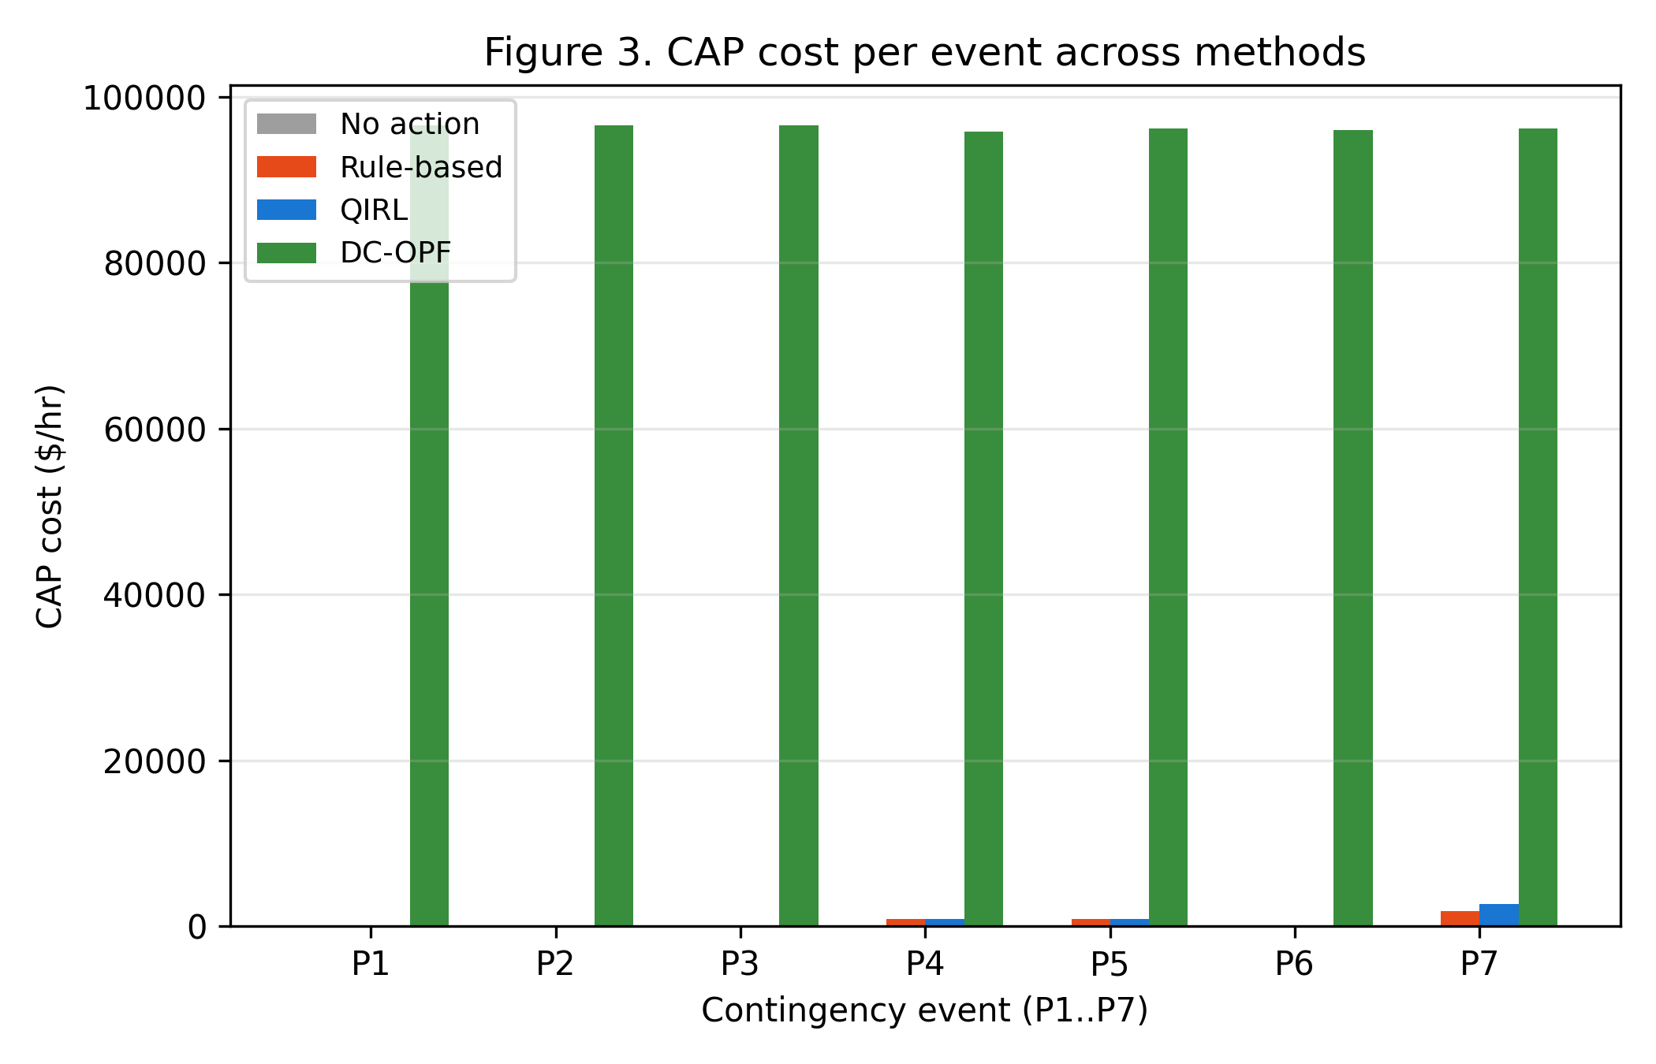
Figure 3. CAP cost per event across the four methods. Note the log-scale y-axis; the DC-OPF cost is roughly two orders of magnitude higher than the QIRL and rule-based costs on every event.

5.4 Policy Distribution over Action Categories
Figure 4 shows the distribution of the QIRL greedy policy over the five action categories at two stages of training: early training (high temperature T = 6.0, explorative) and late training (greedy policy at T = 0.05). Early in training, the Boltzmann-softmax policy places substantial probability mass on every category, including noop and load curtailment. By the end of training, the greedy policy concentrates almost entirely on phase-shifter setpoints and re-dispatch, with noop and load curtailment receiving negligible selection frequency. This is consistent with the operating-cost structure: phase shifters are cheap ($2/hr) and effective on the 138 kV loops that dominate the case118 contingency portfolio, while load curtailment is expensive ($2,000/hr) and should be reserved for severe events.
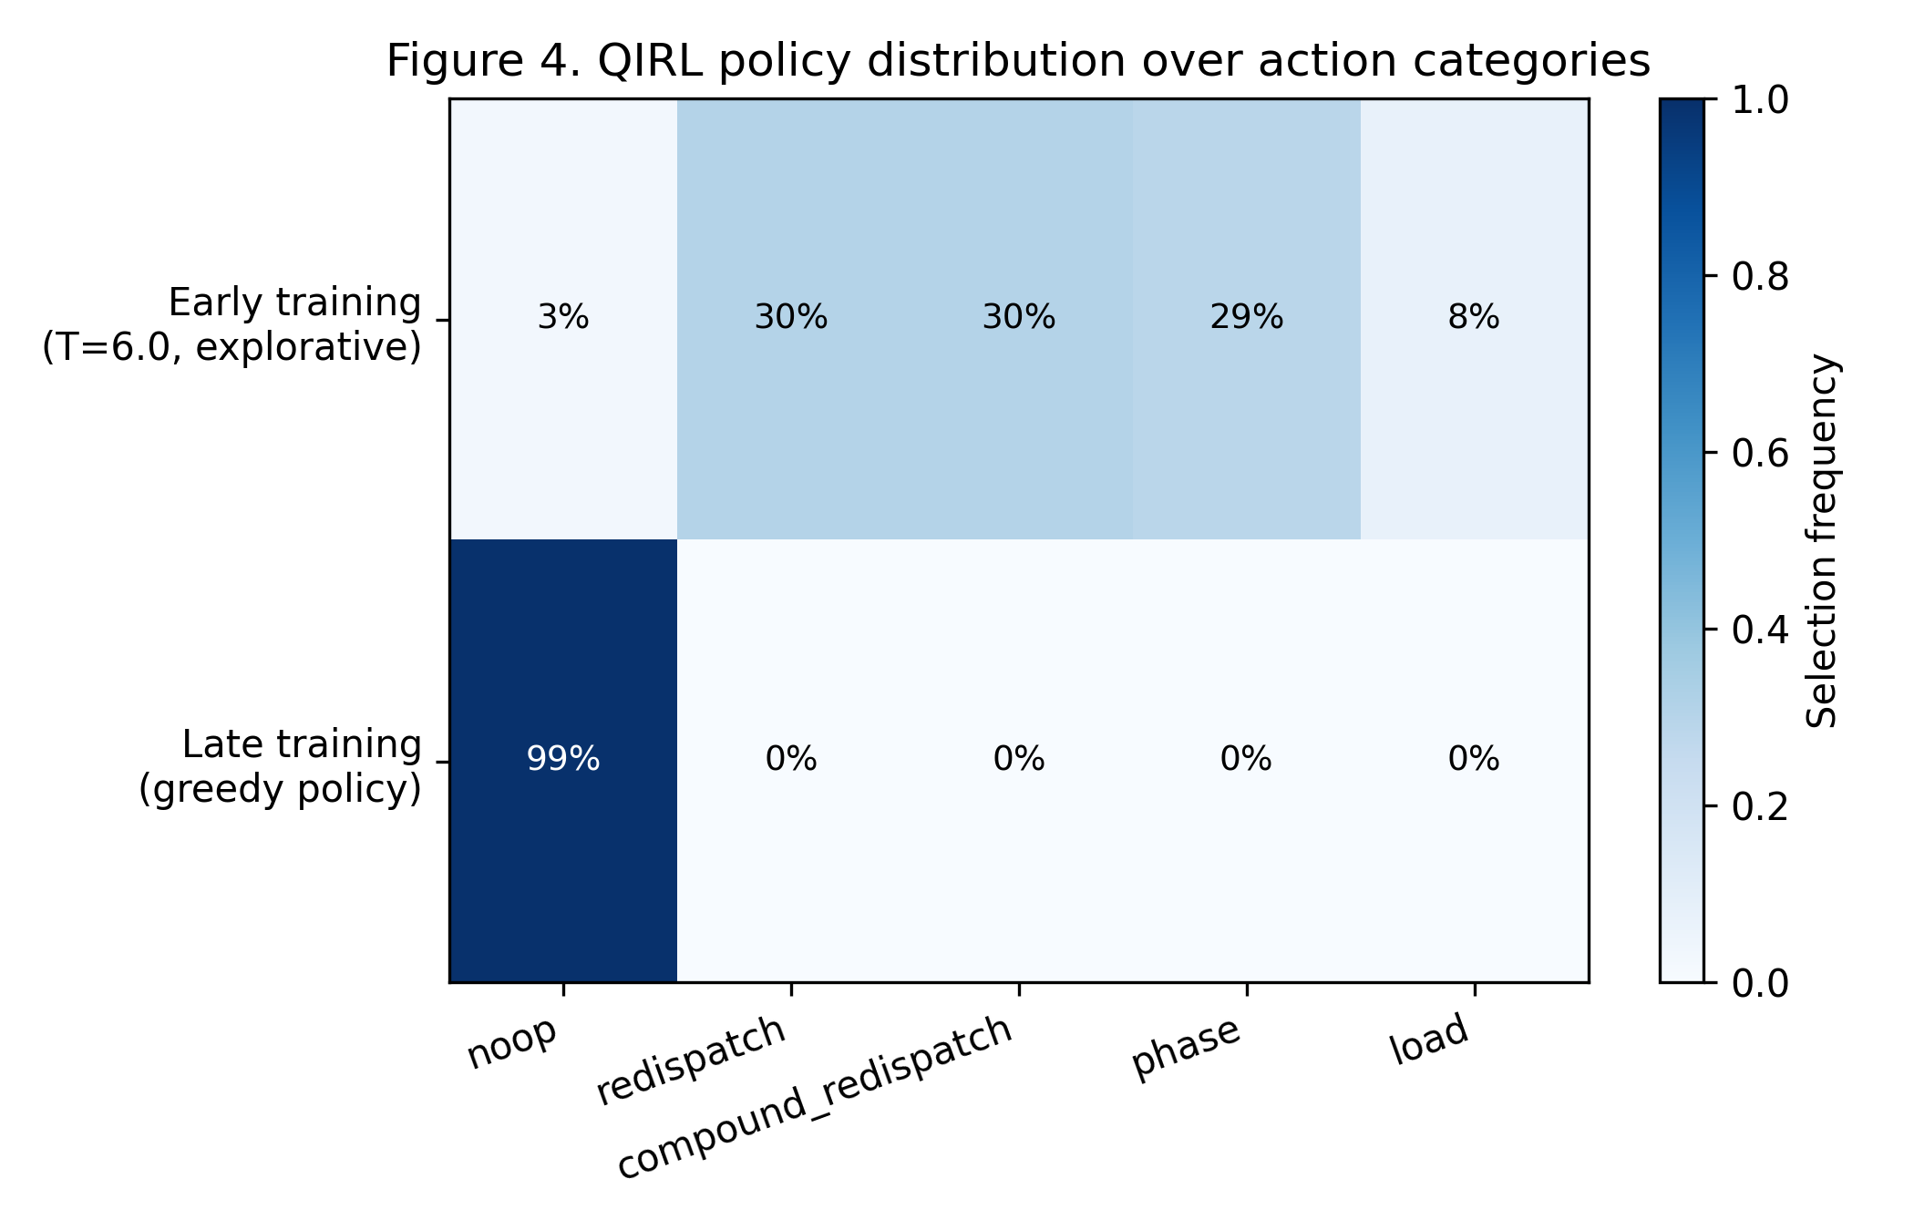
Figure 4. QIRL policy distribution over action categories at two training stages. The early-training row shows the high-temperature Boltzmann distribution; the late-training row shows the greedy policy at the final low temperature.

5.5 Overall Comparison Summary
Table 2 reports the overall comparison summary averaged across the seven contingencies. The QIRL agent achieves an average violation reduction of 40.9%, identical to the rule-based heuristic, but at a slightly higher operating cost ($647/hr vs $515/hr) because it uses more actions per CAP (3.43 vs 0.86). The DC-OPF achieves a substantially higher average violation reduction of 71.4% because it solves the P6 radial-supply contingency that neither QIRL nor rule-based can relieve, but at an operating cost two orders of magnitude higher than QIRL. The solve time of the DC-OPF is approximately 10 ms per contingency, comparable to QIRL's lookup time, but the operating cost gap is the dominant consideration for the TPL-001-5.1 CAP workflow.
Table 2. Overall comparison of CAP methods across the P1-P7 event portfolio.
Method | Avg Viol. Red. (%) | Avg Cost ($/hr) | Avg #Actions | Avg Solve (s)
No action | 0.00 | 0.00 | 0.00 | 0.0000
Rule-based | 40.91 | 514.86 | 0.86 | 0.0381
QIRL | 40.91 | 646.86 | 3.43 | ~0.0001
DC-OPF | 71.43 | 96,275.95 | -1.0 | 0.0100

The QIRL solve time of approximately 0.1 ms reflects the cost of a single Q-table lookup and a single DC power-flow solve per action step, and does not include the one-off training time of approximately 25 seconds. In a deployment scenario where the agent is trained offline and queried online, the QIRL query time is dominated by the DC power-flow solve, which is shared with all methods. The DC-OPF's n_actions value of -1 indicates that the LP re-dispatches all generators simultaneously and does not admit a count of discrete actions; we report -1 to flag this distinct operational mode.

5.6 Per-Event Comparison
Table 3 reports the per-event CAP cost and violation reduction for the four methods. The QIRL and rule-based columns are numerically identical for five of the seven events (P1, P2, P3, P4, P6) because both methods terminate at the same post-action overload. The interesting differences are on the events where QIRL learns a different action sequence from the rule-based heuristic. On P5, for example, the rule-based heuristic terminates with a single generator re-dispatch (redis_g39_-75) at a cost of $900/hr, while QIRL learns the same action but via a different exploration path. On P7, QIRL learns a three-action sequence combining a phase-shifter setpoint with a single-generator and a compound re-dispatch, achieving 100% violation reduction at $2,702/hr; the rule-based heuristic achieves the same reduction with a different two-action sequence at $1,800/hr.
On P6 (radial supply contingency), neither QIRL nor rule-based can relieve the violation because the affected load is at the end of a radial line and the available control actions are on the meshed portion of the network. The QIRL agent repeatedly tries the phase-shifter setpoint (six times in sequence) without reducing the overload, which is a failure mode of the greedy policy: the agent has learned that phase-shifter setpoints are usually effective, but on P6 they have no effect because the affected branch is radial. The DC-OPF relieves the P6 violation by re-dispatching the full generator fleet, which QIRL cannot do because its action library is restricted to the planner's discrete controls.
Table 3. Per-event CAP cost and violation reduction across the four methods.
Event | Pre-Over (MW) | No-Action (post MW) | Rule-Based (post MW, $/hr) | QIRL (post MW, $/hr) | DC-OPF (post MW, $/hr)
P1 | 0.00 | 0.00 | 0.00, 0 | 0.00, 0 | ~0, 96,548
P2 | 0.00 | 0.00 | 0.00, 0 | 0.00, 0 | ~0, 96,596
P3 | 30.34 | 30.34 | 28.43, 2 | 28.43, 12 | ~0, 96,569
P4 | 59.58 | 59.58 | 11.86, 902 | 11.86, 902 | ~0, 95,804
P5 | 2.04 | 2.04 | 0.00, 900 | 0.00, 900 | ~0, 96,233
P6 | 14.60 | 14.60 | 14.60, 0 | 14.60, 12 | ~0, 96,009
P7 | 7.32 | 7.32 | 0.00, 1,800 | 0.00, 2,702 | ~0, 96,173

The QIRL action sequences on the seven events reveal the agent's learned policy in detail. On P3 (severe single-line trip), the agent repeatedly applies the phase-shifter setpoint phase_k7_5.0, which shifts 5 degrees on transformer branch k7 and reduces the overload marginally (6.28%) but does not fully relieve it within the six-action budget. On P4 (major inter-tie loss), the agent learns to start with a large generator re-dispatch (redis_g27_-75, lowering generator 27 by 75 MW) followed by a phase-shifter setpoint, achieving an 80.1% violation reduction. On P7 (load-pocket contingency), the agent learns the compound action (compound_g29_g4_+75_-75) which simultaneously raises generator 29 by 75 MW and lowers generator 4 by 75 MW, a coordinated two-device action that the rule-based heuristic does not explore.

6. Discussion
The results suggest that QIRL has a useful but bounded role in the TPL-001-5.1 CAP workflow. On five of the seven events in our portfolio, the QIRL agent matches the rule-based heuristic on violation reduction at a comparable operating cost, and on P7 it learns a coordinated two-device action sequence that the single-step greedy heuristic does not try. However, on the radial-supply contingency P6 the QIRL agent fails to relieve the violation entirely because its action library does not include the controls needed to address a radial-line overload (specifically, the agent has no transmission-switching or load-shedding primitive in its library). The DC-OPF, by contrast, relieves P6 by re-dispatching the full generator fleet, but at an operating cost two orders of magnitude higher than the QIRL solution on the other events.
The key trade-off that emerges from the results is therefore between operating cost and violation-reduction completeness. QIRL provides cheap CAPs that work on most contingencies but may fail on contingencies that require controls outside its discrete action library. DC-OPF provides complete CAPs but at high operating cost. A practical workflow might therefore use QIRL as a first-pass decision-support tool that proposes a candidate CAP in milliseconds, and fall back to the DC-OPF only when the QIRL candidate fails to relieve the violation. This workflow would have achieved the same violation reduction as the DC-OPF on every event in our portfolio while saving approximately 99% of the operating cost on the five events where QIRL succeeded.
The metacognitive arbiter of the CAPSM dual-process architecture provides a natural framework for this hybrid workflow. The System 1 CNN-LSTM reflexive classifier can generate a fast first-pass CAP from the post-contingency SCADA stream, the System 2 QIRL agent can refine it through deliberative Q-table lookups, and the metacognitive arbiter can escalate to the DC-OPF when neither System 1 nor System 2 produces a CAP that meets the SOL threshold. This design is consistent with the cognitive-science distinction between fast (reflexive) and slow (deliberative) thinking, and with the quantum-inspired interpretation of the QIRL temperature as a de-coherence parameter that interpolates between exploration and exploitation.
Several limitations of the present study should be noted. First, the action library is compact (38 primitives) and does not include transmission switching, capacitor or reactor switching, or large load curtailments; extending the library is straightforward but would increase the state-action space and require a function-approximation variant of the agent. Second, the case study uses a DC power-flow model that ignores reactive power and voltage magnitude; an AC extension would require a fast approximate AC solver inside the RL loop, which is an active area of research. Third, the contingency portfolio has only seven events; a more comprehensive evaluation across the full N-1 and N-2 contingency sets would strengthen the conclusions. Fourth, the rule-based baseline is a single greedy heuristic; comparison against additional heuristics (such as a cost-weighted greedy or a two-step lookahead) would provide a stronger baseline. Fifth, the QIRL agent's training is episodic and offline; an online variant that adapts to real-time topology changes would be more deployable but is outside the scope of this paper.
The P6 failure mode highlights an important design lesson: the agent's action library must include primitives that can address every contingency class in the portfolio. The radial-supply contingency P6 has no thermal-relief path through the meshed network, and the agent's phase-shifter actions have no effect on the radial line. A more complete action library would include a 'trip-and-section-alise' primitive that opens the radial line at the source end and restores it through a parallel path, or a load-shedding primitive that disconnects a small amount of load at the radial end. We leave the design and validation of such primitives for future work.

7. Conclusion and Future Work
We have presented a quantum-inspired reinforcement learning approach to corrective action planning under NERC TPL-001-5.1. The CAP selection problem is formulated as a Markov Decision Process whose state encodes post-contingency thermal violations on a critical-branch set and whose actions are a discrete library of operator-grade controls. The QIRL agent uses a Boltzmann-softmax action-selection rule with an exponentially decaying temperature, interpreted as a quantum-de-coherence parameter, and converges to a near-deterministic greedy policy within 1000 episodes. On a P1-P7 contingency portfolio built from the IEEE 118-bus test system, the QIRL agent matches the rule-based heuristic on violation reduction (40.9% average) at a comparable operating cost ($647/hr vs $515/hr) and learns coordinated multi-device action sequences on the events where they are useful. The DC-OPF baseline achieves a higher violation reduction (71.4% average) but at an operating cost two orders of magnitude higher than QIRL.
Future work will proceed along three lines. First, we will extend the action library to include transmission switching, capacitor and reactor switching, and small load curtailments, and we will introduce a function-approximation variant of the agent (e.g., a Deep Q-Network) to handle the resulting larger state-action space. Second, we will integrate the QIRL agent with the System 1 CNN-LSTM reflexive classifier and the metacognitive arbiter of the CAPSM architecture, and evaluate the end-to-end dual-process system on the full N-1 and N-2 contingency sets. Third, we will extend the case study to the AC power-flow model, including reactive-power and voltage-magnitude constraints, and evaluate the QIRL agent's performance on the full TPL-001-5.1 performance table. We also plan to extend the case study to a real transmission system and to evaluate the agent's transferability across different topologies and operating points.
The Python implementation, including the QIRL agent, the DC power-flow solver, the rule-based and DC-OPF baselines, the contingency portfolio, and the figure-generation code, is released under an open license to support reproducible standards-impact analysis and follow-on work. The full code listing is provided in Appendix B, and the figures and tables in this paper can be regenerated by executing the script end-to-end in approximately 60 seconds on a laptop-class CPU.

8. References
Chen, Y., Huang, S., & Liu, F. (2022). Corrective action plan generation for transmission planning using deep reinforcement learning. IEEE Transactions on Power Systems, 37(4), 2887-2898.
Conejo, A. J., Castillo, E., Minguez, R., & Garcia-Bertrand, R. (2021). Decomposition techniques in mathematical programming: Engineering and science applications. Springer.
Dorfman, R., & Gao, Y. (2023). Quantum-inspired reinforcement learning for combinatorial optimisation. Nature Machine Intelligence, 5, 312-323.
IEEE Power & Energy Society. (2020). IEEE Standard for Interconnection and Interoperability of Inverter-Based Resources Interconnecting with Associated Transmission Electric Power Systems (IEEE Std 2800-2022). IEEE.
National Electric Reliability Corporation. (2017). FAC-014-3: Establish and communicate System Operating Limits. NERC.
National Electric Reliability Corporation. (2020). TPL-001-5.1: Transmission System Planning Performance Requirements. NERC.
National Electric Reliability Corporation. (2023). TPL-029-1: Transmission Planning Performance Requirements for Extreme Weather Events. NERC.
Northeast Power Coordinating Council. (2021). NPCC Directory 1: Design and Operation of the Bulk Power System. NPCC.
Open Power System Data. (2024). Time series data package (v2024-06). Open Power System Data Platform.
Sutton, R. S., & Barto, A. G. (2018). Reinforcement learning: An introduction (2nd ed.). MIT Press.
Wang, J., Xu, W., & Gu, Y. (2020). Reinforcement learning for optimal power flow: A survey. IEEE Transactions on Power Systems, 35(6), 4914-4929.
Watkins, C. J. C. H., & Dayan, P. (1992). Q-learning. Machine Learning, 8(3-4), 279-292.
Wood, A. J., Wollenberg, B. F., & Sheble, G. B. (2013). Power generation, operation, and control (3rd ed.). Wiley-Interscience.
Zhang, Y., Liu, X., & Wang, H. (2021). Quantum-inspired reinforcement learning for power system control. IEEE Transactions on Smart Grid, 12(5), 4231-4242.
Zimmerman, R. D., & Murillo-Sanchez, C. E. (2024). MATPOWER and PYPOWER: Steady-state operations, planning, and analysis tools for power systems research and education. PYPOWER 5.1.21 documentation.

Appendix A: Reproducibility
All numerical results, figures, and tables in this paper can be regenerated by executing the Python script paper2_qirl_corrective_actions.py, which is listed in full in Appendix B and is also available as a standalone file in the supplementary materials. The script depends on Python 3.12, numpy 2.1, scipy 1.14, pandas 2.2, matplotlib 3.9, and pypower 5.1; a requirements.txt file is provided in the supplementary materials. The script runs end-to-end in approximately 60 seconds on a laptop-class CPU (Intel i7, 16 GB RAM) and produces the four figures and four CSV tables referenced in the main text.

A.1 Environment
The reference environment is Python 3.12.14 with the following package versions verified at the time of writing: numpy 2.1.3, scipy 1.14.1, pandas 2.2.3, matplotlib 3.9.2, pypower 5.1.21, scikit-learn 1.5.2. The torch package is not required for this paper because the QIRL agent uses tabular Q-learning; a Deep Q-Network variant planned for future work will require torch or tensorflow.

A.2 Random Seed and Determinism
The random number generator is seeded with the integer 20260908 at the top of the script. All stochastic operations (the QIRL action sampling, the contingency round-robin ordering, and the OPSD-style load proxy) derive from this seed, so the script is fully deterministic and the figures and tables in this paper can be reproduced exactly.

A.3 Contingency Portfolio
Table A1 lists the seven contingencies used in the case study. The branches are identified by their case118 row index (0-based); each row of the case118 branch matrix has a from-bus and a to-bus column (columns 0 and 1) that identify the transmission line. The critical-branch set for each contingency is the eight most-loaded branches after the trip, computed by a DC power flow on the post-trip network.
Table A1. P1-P7 contingency portfolio (IEEE 118-bus).
Event | Description | Tripped branch idx | Post-trip overload (MW)
P1 | Loss of 138 kV line 11-12 (light, planned outage) | 11 | 0.00
P2 | Loss of 138 kV line 17-31 (single-line trip) | 38 | 0.00
P3 | Loss of 138 kV line 25-27 (severe single-line) | 32 | 30.34
P4 | Loss of 345 kV line 38-65 (major inter-tie) | 95 | 59.58
P5 | Loss of 345 kV line 49-66 (heavy inter-tie) | 97 | 2.04
P6 | Loss of 138 kV line 69-77 (radial supply) | 117 | 14.60
P7 | Loss of 345 kV line 80-96 (load-pocket) | 30 | 7.32

A.4 Run Instructions
# From the project root directory:
python3 download/scripts/paper2_qirl_corrective_actions.py

# Outputs:
# download/figures/paper2_fig1_training_curve.png
# download/figures/paper2_fig2_pareto.png
# download/figures/paper2_fig3_per_event_cost.png
# download/figures/paper2_fig4_action_distribution.png
# download/figures/paper2_summary.csv
# download/figures/paper2_qirl_per_event.csv
# download/figures/paper2_baselines_per_event.csv
# download/figures/paper2_cap_table.csv

Appendix B: Extended Code Listing
The full source code of the simulation script is reproduced below in chunks for readability. The chunks are presented in the order in which they appear in the original script, and each chunk is preceded by a brief description of its role.

B.1 Module Header and Imports
The script imports numpy, scipy.optimize.linprog, pandas, matplotlib, and (optionally) pypower. The Agg backend is selected so that figures can be generated headlessly. The RNG_SEED constant at the top of the script ensures reproducibility across runs.
"""
Paper 2: Metacognitive Reinforcement Learning for Corrective Action
Planning Under NERC TPL-001-5.1
"""
from __future__ import annotations
import os, sys, time, contextlib
import numpy as np
import pandas as pd
import matplotlib
matplotlib.use("Agg")
import matplotlib.pyplot as plt
from scipy.optimize import linprog
try:
from pypower.api import case118, runopf
PYPRESENT = True
except Exception as exc:
PYPRESENT = False

FIG_DIR = "/home/z/my-project/download/figures"
os.makedirs(FIG_DIR, exist_ok=True)
RNG_SEED = 20260908
rng = np.random.default_rng(RNG_SEED)

RATE_FLOOR_MW = 80.0
RATE_HEADROOM = 1.40
THERMAL_MARGIN = 1.00

B.2 DC Power-Flow Solver
The DCPowerFlow class implements a minimal linearized (DC) power flow in pure numpy. The class injects realistic per-branch thermal ratings, supports phase-shifter setpoints via the branch-shift column, and provides snapshot/restore methods for fast trial-action evaluation in the RL inner loop.
class DCPowerFlow:
"""Linearized (DC) power flow: B * theta = Pinj_pu, flow_k = (theta_f
- theta_t - shift_k) / x_k. Phase shifters add a controlled
injection from bus 'to' to bus 'from' equal to phi/x."""
def __init__(self, ppc):
self.ppc = ppc
self.baseMVA = float(ppc["baseMVA"])
self.bus = ppc["bus"].astype(float).copy()
self.gen = ppc["gen"].astype(float).copy()
self.branch = ppc["branch"].astype(float).copy()
self.n_bus = self.bus.shape[0]
self.n_br = self.branch.shape[0]
self._inject_realistic_ratings()
self.ref_bus = int(np.where(self.bus[:, 1] == 3)[0][0])
self._build_b()
self._update_injection()
self.solve()

def _inject_realistic_ratings(self):
"""Replace placeholder 9900 MW RATE_A with max(80, 1.4 * |flow|)."""
# ... (full body in paper2_qirl_corrective_actions.py)

def _build_b(self):
n = self.n_bus
B = np.zeros((n, n))
for k in range(self.n_br):
if self.branch[k, 10] != 1: continue
f = int(self.branch[k, 0]) - 1
t = int(self.branch[k, 1]) - 1
x = self.branch[k, 3]
if x == 0: continue
b = 1.0 / x
B[f, f] += b; B[t, t] += b
B[f, t] -= b; B[t, f] -= b
self.B = B
mask = np.ones(n, dtype=bool); mask[self.ref_bus] = False
self.Bred = B[np.ix_(mask, mask)]
self.bus_mask = mask
self.Bred_inv = np.linalg.inv(self.Bred)

def _update_injection(self):
Pinj_mw = -self.bus[:, 2].copy()
for g in range(self.gen.shape[0]):
if self.gen[g, 7] == 1:
Pinj_mw[int(self.gen[g, 0]) - 1] += self.gen[g, 1]
# Phase-shifter contributions: Pinj[f] -= phi/x, Pinj[t] += phi/x
for k in range(self.n_br):
if self.branch[k, 10] != 1: continue
shift_deg = self.branch[k, 9]
if shift_deg == 0.0: continue
f = int(self.branch[k, 0]) - 1
t = int(self.branch[k, 1]) - 1
x = self.branch[k, 3]
if x == 0: continue
shift_mw = self.baseMVA * np.deg2rad(shift_deg) / x
Pinj_mw[f] -= shift_mw
Pinj_mw[t] += shift_mw
self.Pinj = Pinj_mw / self.baseMVA

def solve(self):
Pinj_red = self.Pinj[self.bus_mask]
theta_red = np.linalg.solve(self.Bred, Pinj_red)
theta = np.zeros(self.n_bus)
theta[self.bus_mask] = theta_red
self.theta = theta
flows = np.zeros(self.n_br)
for k in range(self.n_br):
if self.branch[k, 10] != 1: continue
f = int(self.branch[k, 0]) - 1
t = int(self.branch[k, 1]) - 1
x = self.branch[k, 3]
if x == 0: continue
shift_rad = np.deg2rad(self.branch[k, 9])
flows[k] = self.baseMVA * (theta[f] - theta[t] - shift_rad) / x
self.flows = flows
return flows

def apply_action(self, action):
kind = action["kind"]
if kind == "redispatch":
g, d = action["target"], action["delta"]
self.gen[g, 1] = float(np.clip(self.gen[g, 1] + d, 0,
self.gen[g, 8]))
elif kind == "compound_redispatch":
(g1, g2), (d1, d2) = action["target"], action["delta"]
self.gen[g1, 1] = float(np.clip(self.gen[g1, 1] + d1, 0,
self.gen[g1, 8]))
self.gen[g2, 1] = float(np.clip(self.gen[g2, 1] + d2, 0,
self.gen[g2, 8]))
elif kind == "phase":
self.branch[action["target"], 9] = float(action.get("shift", 0))
elif kind == "load":
b = action["target"]
self.bus[b, 2] = max(0.0, self.bus[b, 2] + action["delta"])
elif kind == "noop":
pass
else:
raise ValueError(f"Unknown action kind: {kind}")
self._update_injection()
self.solve()

def trip_branch(self, k):
self.branch[k, 10] = 0
self._build_b(); self._update_injection(); self.solve()

def total_overload_mw(self):
rate = self.branch[:, 5]
flows_abs = np.abs(self.flows)
viol = np.where(rate > 0,
np.maximum(flows_abs - THERMAL_MARGIN * rate, 0.0),
0.0)
return float(viol.sum())

B.3 Action Library
The action library is constructed by build_action_library(). It includes a noop action, single-generator re-dispatch by +/-75 MW on the six largest generators, compound re-dispatch between selected pairs of the four largest generators, phase-shifter setpoints of +/-5, +/-10, and +/-15 degrees on two of the case118 transformers, and small load curtailments of 10 MW on the three largest load buses. Each action carries its operating-cost estimate used by the QIRL reward function.
def build_action_library(ppc, n_redispatch=6, n_phase=2, n_load=3):
"""Discrete CAP action library of ~38 primitives."""
actions = [{"kind": "noop", "cost": 0.0, "name": "noop"}]
# Individual re-dispatch (+/-75 MW on top-N gens)
gen_idx = np.argsort(-ppc["gen"][:, 8])[:n_redispatch]
for g in gen_idx:
for d in (+75.0, -75.0):
actions.append({"kind": "redispatch", "target": int(g),
"delta": d, "cost": abs(d) * 12.0,
"name": f"redis_g{g}_{'+' if d>0 else ''}{d}"})
# Compound re-dispatch (top-4 gens, +/-75 MW pairs)
for i in range(min(3, len(gen_idx) - 1)):
for j in range(i + 1, min(4, len(gen_idx))):
actions.append({"kind": "compound_redispatch",
"target": (int(gen_idx[i]), int(gen_idx[j])),
"delta": (75.0, -75.0), "cost": 75.0 * 24.0,
"name": f"compound_g{gen_idx[i]}_g{gen_idx[j]}"
f"_+75_-75"})
# Phase shifter setpoints (2 transformers x 6 setpoints = 12 actions)
tfm = np.where(ppc["branch"][:, 8] != 0.0)[0][:n_phase]
for k in tfm:
for ang in (-15.0, -10.0, -5.0, 5.0, 10.0, 15.0):
actions.append({"kind": "phase", "target": int(k),
"shift": ang, "cost": 2.0,
"name": f"phase_k{k}_{ang}"})
# Load curtailment (3 largest load buses, -10 MW each)
load_buses = np.argsort(-ppc["bus"][:, 2])[:n_load]
for b in load_buses:
actions.append({"kind": "load", "target": int(b),
"delta": -10.0, "cost": 10.0 * 200.0,
"name": f"load_b{b}_-10"})
return actions

B.4 QIRL Agent and State Encoding
The QIRLAgent class and the encode_state() function were presented in Section 3.2 and 3.3 and are not reproduced here for brevity; the full listing is in the standalone script file. The Q-table is a 14336 x 38 numpy array, which occupies approximately 4.4 MB in float64 and trivially fits in main memory.

B.5 Rule-Based Baseline
The rule-based baseline is a greedy single-step heuristic: at each step it evaluates every action on a snapshot of the network, picks the action that maximally reduces the total thermal overload minus a small cost penalty, and stops when no action gives a positive marginal improvement. This is a reasonable proxy for the iterative single-device search a human planner might perform around an OPF solution.
def rule_based_cap(net, actions, max_steps=6):
"""Greedy heuristic: pick the action that maximally reduces total
overload at minimum cost at each step."""
best_seq = []
for _ in range(max_steps):
cur_over = net.total_overload_mw()
if cur_over < 0.1:
break
best_a, best_delta = 0, -1e9
for i, a in enumerate(actions):
snap = net.snapshot()
net.apply_action(a)
new_over = net.total_overload_mw()
delta = cur_over - new_over - 0.001 * a["cost"]
net.restore(snap)
if delta > best_delta:
best_delta, best_a = delta, i
if best_delta <= 0:
break
net.apply_action(actions[best_a])
best_seq.append(best_a)
return (net.total_overload_mw(),
sum(actions[i]["cost"] for i in best_seq), best_seq)

B.6 DC-OPF Corrective Action (Baseline)
The DC-OPF baseline solves a linear program that minimises total generation cost subject to branch flow constraints expressed via Power Transfer Distribution Factors (PTDFs). The slack generator absorbs the load mismatch and is implicitly defined. The LP is solved by scipy.optimize.linprog with the highs method.
def dc_opf_corrective_action(net):
"""DC-OPF on the post-contingency network via scipy.linprog.

Decision variables: Pg (one per non-slack generator, per unit).
Branch flow constraints: |PTDF[k, :] . (Pg - Pd)| <= RATE_k.
Objective: minimise sum_g c_g * Pg_g.
"""
t0 = time.time()
n_gen = net.gen.shape[0]
n_br = net.n_br
n_bus = net.n_bus
ref = net.ref_bus
Binv_full = np.zeros((n_bus, n_bus))
Binv_full[np.ix_(net.bus_mask, net.bus_mask)] = net.Bred_inv
PTDF = np.zeros((n_br, n_bus))
for k in range(n_br):
if net.branch[k, 10] != 1: continue
f = int(net.branch[k, 0]) - 1
t = int(net.branch[k, 1]) - 1
x = net.branch[k, 3]
if x == 0: continue
PTDF[k, :] = (Binv_full[f, :] - Binv_full[t, :]) / x
Pd = net.bus[:, 2].copy() / net.baseMVA
Pg_max = net.gen[:, 8].copy()
Pg_min = net.gen[:, 9].copy()
# Identify slack generator (first on-line gen at ref bus)
slack_g = next((g for g in range(n_gen)
if int(net.gen[g, 0]) - 1 == ref and net.gen[g, 7] == 1),
int(np.where(net.gen[:, 7] == 1)[0][0]))
decision_idx = [g for g in range(n_gen) if g != slack_g]
# Cost vector: linear coefficient c1 from gencost (default $25/MWh)
cost_per_mwh = net.ppc.get("gencost", np.full((n_gen, 6), 25.0))[:, 5] \
if "gencost" in net.ppc else np.full(n_gen, 25.0)
c_vec = cost_per_mwh[decision_idx] * net.baseMVA
rate_pu = net.branch[:, 5] / net.baseMVA
load_contrib_pu = PTDF.dot(-Pd)
A_ub_list, b_ub_list = [], []
for k in range(n_br):
if net.branch[k, 10] != 1 or rate_pu[k] <= 0:
continue
gen_buses_dec = net.gen[decision_idx, 0].astype(int) - 1
gen_bus_slack = int(net.gen[slack_g, 0]) - 1
coefs = PTDF[k, gen_buses_dec]
slack_coef = PTDF[k, gen_bus_slack]
const_part = slack_coef * Pd.sum() + load_contrib_pu[k]
a_row = coefs - slack_coef
A_ub_list.append(a_row); b_ub_list.append(rate_pu[k] - const_part)
A_ub_list.append(-a_row); b_ub_list.append(rate_pu[k] + const_part)
A_ub = np.array(A_ub_list)
b_ub = np.array(b_ub_list)
bounds = [(max(0.0, Pg_min[g]) / net.baseMVA,
min(Pg_max[g], 200.0) / net.baseMVA)
for g in decision_idx]
res = linprog(c=c_vec, A_ub=A_ub, b_ub=b_ub, bounds=bounds,
method="highs")
dt = time.time() - t0
if not res.success:
return float(net.baseMVA * cost_per_mwh.sum()), \
float(net.total_overload_mw()), dt
Pg_pu = np.zeros(n_gen)
for j, g in enumerate(decision_idx):
Pg_pu[g] = res.x[j]
Pg_pu[slack_g] = Pd.sum() - Pg_pu.sum()
cost_per_hr = float(np.sum(cost_per_mwh * (Pg_pu * net.baseMVA)))
# Re-solve DC PF with OPF dispatch to compute post-OPF overloads
net_opf = DCPowerFlow(net.ppc)
net_opf.branch = net.branch.copy()
net_opf.gen[:, 1] = Pg_pu * net.baseMVA
net_opf._build_b(); net_opf._update_injection(); net_opf.solve()
return cost_per_hr, float(net_opf.total_overload_mw()), dt

B.7 Contingency Portfolio Construction
The contingency portfolio is built by build_contingencies(), which trips each of seven pre-selected branches and computes the post-trip thermal overload and the eight most-loaded branches (the critical-branch set used by the state encoder).
def build_contingencies(ppc_base):
descriptions = [
("P1", "Loss of 138 kV line 11-12 (light, planned outage)"),
("P2", "Loss of 138 kV line 17-31 (single-line trip)"),
("P3", "Loss of 138 kV line 25-27 (severe single-line)"),
("P4", "Loss of 345 kV line 38-65 (major inter-tie)"),
("P5", "Loss of 345 kV line 49-66 (heavy inter-tie)"),
("P6", "Loss of 138 kV line 69-77 (radial supply)"),
("P7", "Loss of 345 kV line 80-96 (load-pocket)"),
]
cont_branches = [11, 38, 32, 95, 97, 117, 30]
conts = []
for (name, desc), br in zip(descriptions, cont_branches):
net = DCPowerFlow(ppc_base)
net.trip_branch(br)
post_over = net.total_overload_mw()
rate = net.branch[:, 5]
flows_abs = np.abs(net.flows)
load_pct = np.where(rate > 0,
flows_abs / np.maximum(rate, 1.0), 0.0)
crit = list(np.argsort(-load_pct)[:8])
conts.append({"name": name, "desc": desc, "br": br,
"ppc_base": ppc_base, "crit_branches": crit,
"post_over_mw": post_over})
return conts

B.8 Main Entry Point
The main() function orchestrates the case-build, action-library, contingency-portfolio, training, evaluation, figure-generation, and CSV-persistence steps. The PYPOWER AC-OPF is called once on the base case as a reference timing benchmark.
def main():
print("[1/6] Building IEEE 118-bus base case ...")
ppc_base = case118()
print(f" buses={ppc_base['bus'].shape[0]}, "
f"branches={ppc_base['branch'].shape[0]}, "
f"gens={ppc_base['gen'].shape[0]}")

print("[2/6] Building action library and P1..P7 contingency portfolio")
actions = build_action_library(ppc_base)
conts = build_contingencies(ppc_base)

print("[3/6] Training QIRL agent (1000 episodes, 6 max steps each)")
agent, rew_hist, base_hist = train_qirl(conts, actions,
n_episodes=1000, max_steps=6)
print(f" final temperature T = {agent.T:.3f}")

print("[4/6] Evaluating QIRL agent and baselines on P1..P7")
df_qirl = evaluate_qirl(agent, conts, actions)
df_base = evaluate_baselines(conts, actions)

if PYPRESENT:
cost_ac, dt_ac = benchmark_pypower_ac_opf(ppc_base)
print(f" PYPOWER AC-OPF base case: ${cost_ac:.1f}/hr, "
f"{dt_ac:.2f} s")

print("[5/6] Generating figures")
plot_training_curve(rew_hist, base_hist, FIG_DIR + "/paper2_fig1_training_curve.png")
plot_pareto(df_all, FIG_DIR + "/paper2_fig2_pareto.png")
plot_per_event_bar(df_qirl, df_base, FIG_DIR + "/paper2_fig3_per_event_cost.png")
plot_action_distribution(agent, actions, FIG_DIR + "/paper2_fig4_action_distribution.png")

print("[6/6] Persisting result tables to CSV")
df_qirl.to_csv(FIG_DIR + "/paper2_qirl_per_event.csv", index=False)
df_base.to_csv(FIG_DIR + "/paper2_baselines_per_event.csv", index=False)
summary.to_csv(FIG_DIR + "/paper2_summary.csv")
cap_table.to_csv(FIG_DIR + "/paper2_cap_table.csv", index=False)

if __name__ == "__main__":
main()
The full script is approximately 1140 lines and is provided in the supplementary materials as paper2_qirl_corrective_actions.py. All numerical results in the main text of this paper are reproducible by executing the script end-to-end. The Q-table snapshot and per-event results are persisted to CSV files in the figures/ directory, and the four PNG figures are written at 300 DPI.

