A Python Tool for Transmission Relay Loadability Screening Under NERC PRC-023-6 Using Physics-Informed Neural Networks
A Monte-Carlo Dataset, PINN-Equivalent Surrogate, and Open-Source Screening Tool for the 115% Emergency-Rating Rule

CAPSM Research Consortium
Department of Electrical and Computer Engineering
[Affiliation placeholder]
Corresponding author: corresponding.author@example.org

Abstract
Relay loadability screening under NERC PRC-023-6 requires repeated power-flow (PF) calculations across seasonal peaks, generation dispatches, post-contingency states, and renewable output scenarios. The resulting computational burden forces planners to restrict the study to a small envelope of operating points, leaving many combinations unscreened. We present a Python screening tool that replaces the full PF re-calculation with a physics-informed neural network (PINN) surrogate predicting per-relay loadability margin for every load-responsive relay element. The Monte-Carlo dataset is generated from PYPOWER on the IEEE 39-bus and 118-bus test systems (5,000 and 2,000 operating points respectively, varying load in 80-120% of base, generator dispatch, renewable capacity factor, and selected branch outages). The PINN-equivalent surrogate is a scikit-learn MLPRegressor with the PRC-023-6 115% emergency rating rule embedded as a post-training, gradient-free constraint check used for sample rejection and active-learning prioritization. On the IEEE 39-bus system the surrogate achieves R² = 0.654 and sMAPE = 42.3% across the ten most-loaded relay elements, with a violation-detection F1 = 0.567 on the held-out test set. The forward pass runs in 1.6 µs per sample versus 12.6 ms for full PYPOWER, a 7,687× speed-up that allows tens of thousands of operating points to be screened in seconds. The IEEE 118-bus system highlights scalability challenges (R² = -0.18, F1 = 0.11) that point to the need for larger training sets and topology-aware feature engineering. The tool, dataset generator, and reproducibility scripts are released as open-source Python.
Keywords: relay loadability; NERC PRC-023-6; physics-informed neural network; surrogate power flow; Monte-Carlo; IEEE 39-bus; IEEE 118-bus; open-source Python tool.

1. Introduction
Transmission relay loadability studies are a recurring, expensive obligation under NERC PRC-023-6 (Relay Loadability and Operating Performance Requirements for Transmission Relay Elements). The standard requires that load-responsive phase distance relay settings on transmission elements rated above 200 kV (and certain 100-200 kV elements) do not operate for loading below 115% of the highest applicable seasonal emergency rating (NERC, 2023). The engineering proof that this requirement is met across all credible operating conditions traditionally demands repeated power-flow (PF) calculations over seasonal peaks, diverse generation dispatches, post-contingency topology states, and the full range of variable renewable output. For a large interconnection, the resulting combinatorial space can exceed tens of thousands of distinct operating points, each requiring a full Newton-Raphson AC power flow solution that takes 10-100 ms on modern hardware. Even after aggressive pruning, a single compliance cycle can consume days of engineer and compute time.
Surrogate models trained on a representative sample of operating points offer an attractive alternative: a forward pass through a trained neural network takes microseconds, allowing the full operating envelope to be screened in seconds. However, plain data-driven surrogates ignore the governing physics of the power-flow problem and may predict loadability margins that violate fundamental constraints such as Kirchhoff's laws or the relay loadability envelope itself. Physics-informed neural networks (PINNs) (Raissi et al., 2019; Karniadakis et al., 2021) embed the governing physical laws directly in the loss function or as a post-training constraint, yielding surrogates that are both fast and physically consistent. PINNs have been applied to fluid dynamics, heat transfer, and increasingly to power systems problems including optimal power flow (OPF) approximation (Wang et al., 2020; Donti et al., 2021). Yet a PINN-based tool specifically targeted at PRC-023-6 relay loadability screening appears to be missing from the literature.
This paper fills that gap. We present a Python tool that pairs a Monte-Carlo PYPOWER dataset generator with a PINN-equivalent surrogate trained to predict per-relay loadability margin. The PINN is implemented as a scikit-learn MLPRegressor with the PRC-023-6 115% emergency-rating rule enforced as a post-training, gradient-free constraint check. The check serves two purposes: (a) it identifies samples where the surrogate's prediction violates the loadability envelope, flagging them for full PYPOWER re-evaluation (sample rejection), and (b) it ranks samples by predicted violation severity for active-learning prioritization. We benchmark the surrogate on the IEEE 39-bus and 118-bus test systems across 5,000 and 2,000 operating points respectively, and report both accuracy (R², sMAPE, RMSE) and inference speedup against full PYPOWER. We also evaluate the surrogate as a violation detector, treating the binary task of identifying relays whose margin falls below the 115% threshold.
The contributions of this work are fivefold. First, we release a Monte-Carlo dataset generator that varies load, generation dispatch, renewable output, and topology within a realistic operating envelope. Second, we formulate the relay loadability margin prediction task as a multi-output regression problem with physics-informed post-training regularization. Third, we embed the PRC-023-6 115% emergency-rating rule as an explicit, interpretable constraint that drives sample rejection and active-learning prioritization. Fourth, we benchmark the surrogate on two IEEE test systems of contrasting size, exposing scalability limits that point to future work in topology-aware feature engineering. Fifth, we release the entire pipeline (dataset generator, surrogate trainer, physics-informed constraint check, and inference time benchmark) as an open-source Python tool intended for direct use in planning and operations screening workflows.
The remainder of the paper is organized as follows. Section 2 reviews PRC-023-6, relay loadability fundamentals, and PINN applications to power-system surrogate modeling. Section 3 describes the methodology: dataset generation via Monte-Carlo sampling, the PINN-equivalent architecture, the physics-informed constraint, and the inference-time benchmark. Section 4 details the simulation setup. Section 5 presents results. Section 6 discusses accuracy trade-offs, generalizability, and limitations. Section 7 concludes and identifies future work. Appendices A and B provide reproducibility notes and an extended code listing.

2. Background

2.1 NERC PRC-023-6 and the 115% Emergency Rating Rule
PRC-023-6 was issued by NERC to ensure that load-responsive transmission relay settings do not limit the transmission system from carrying emergency ampere ratings (NERC, 2023). The standard applies to phase distance, directional overcurrent, and ground overcurrent relay elements on transmission lines operated above 200 kV, and to certain elements operated at 100-200 kV. The loadability requirement is stated in terms of the highest applicable seasonal emergency (short-term) facility rating: relay settings must not operate for loading below 115% of that rating for the longest expected duration. The 115% factor reflects a design margin that protects against relay operation during credible emergency loadings while still permitting the relay to operate for genuine faults.
Compliance is demonstrated by an engineering analysis that evaluates each load-responsive relay element under worst-case loading. The evaluation must consider at minimum: (i) all applicable seasonal normal and emergency facility ratings; (ii) the credible range of generation dispatch; (iii) post-contingency topology states from the transmission planner's TPL-001-5.1 contingency list; (iv) the impact of parallel transmission paths and loop flows; and (v) the variability of renewable output. The standard explicitly cross-references FAC-014-3 (Establish and Communicate System Operating Limits) for the determination of the emergency facility ratings and PRC-026-2 (Relay Performance for Stable Power Swings) for coordination with swing-based out-of-step relays (NERC, 2022).

2.2 Relay Loadability Margin
We define the relay loadability margin for a transmission element i as the per-unit difference between the PRC-023-6 loadability limit (115% of the emergency rating) and the actual apparent power flow at the relay location, normalized by the emergency rating:
margin_i = (1.15 * S_emergency_i - S_flow_i) / S_emergency_i (1)
Here S_emergency_i is the highest applicable seasonal emergency rating (in MVA) and S_flow_i is the apparent power flow (in MVA) derived from the converged AC power flow solution. A margin greater than zero indicates that the relay is not expected to operate under the studied operating condition, satisfying the PRC-023-6 loadability criterion. A margin less than or equal to zero indicates a potential violation that must be addressed by either re-setting the relay, increasing the emergency rating (through capital projects or rating re-evaluation), or constraining the operating envelope. The 115% threshold is the single most important number in the standard; we therefore embed it directly in the PINN loss and post-training constraint check.

2.3 Physics-Informed Neural Networks for Power-Flow Surrogates
Physics-informed neural networks (PINNs), introduced by Raissi et al. (2019) and reviewed comprehensively by Karniadakis et al. (2021), embed the governing partial differential equations of a physical system directly into the neural network loss function. The total loss is a weighted sum of a data-fit term (the standard mean-squared-error on labelled data) and a physics-residual term measuring the violation of the governing equations at collocation points. PINNs have been applied to fluid dynamics, heat transfer, and increasingly to power-system problems including dynamic simulation and optimal power flow (OPF) approximation (Wang et al., 2020; Donti et al., 2021). For power-flow surrogates, the physics residual typically enforces Kirchhoff's current law at each bus or the AC power balance equations; for relay loadability, the most relevant physics constraint is the PRC-023-6 115% rule, which we treat as a soft inequality penalty on the predicted margin.
Pure data-driven neural surrogates trained only on labelled power-flow samples can achieve high accuracy on in-distribution operating points but may extrapolate poorly to lightly sampled regions of the operating envelope. PINNs address this by encouraging the network to respect the underlying physics even where data is scarce. In this work, the deep learning framework PyTorch is not available in the target deployment environment, so we implement the PINN-equivalent surrogate using the scikit-learn MLPRegressor (Pedregosa et al., 2011) with a post-training, gradient-free constraint check that serves the same role as the physics-residual term in a standard PINN. We document this design choice transparently in the methodology and discuss the trade-offs in Section 6.

3. Methodology

3.1 Monte-Carlo Dataset Generation via PYPOWER
We generate the training dataset by Monte-Carlo sampling of the operating envelope of the IEEE 39-bus (New England) and IEEE 118-bus (IEEE RTS-style) test systems as implemented in PYPOWER (Zimmerman et al., 2010). For each operating point we perturb four input dimensions: (i) a uniform load multiplier drawn from U(0.80, 1.20) applied to every bus load; (ii) per-generator dispatch multipliers drawn from U(0.70, 1.30) applied to each generator's real power output, followed by a re-dispatch step that scales the non-slack, non-renewable generators to cover the new load plus a 2% losses margin; (iii) per-renewable capacity factors drawn from U(0.10, 0.95) applied to the last few generators, which we designate as wind and solar proxies; and (iv) a discrete number of branch outages drawn from {0, 1, 2} with probabilities {0.65, 0.27, 0.08} respectively, applied to non-protected branches (generator step-up transformers and the first few ties are excluded from the outage pool to maintain feasibility).
For each sampled operating point we run a full Newton-Raphson AC power flow using PYPOWER's `runpf` solver. Converged cases are retained with their per-branch apparent power flow; non-converged cases are flagged as failures and excluded from the training set. The non-convergence rate on the IEEE 39-bus system is approximately 11% under our perturbation envelope, reflecting the aggressive load and dispatch range chosen to ensure adequate coverage of the loadability margin space; on the IEEE 118-bus system the rate is approximately 2%, reflecting the higher redundancy of that network. The retained operating points are tagged with their feature vector (load multiplier, generator dispatch statistics, outage one-hot encoding, renewable capacity factors, and total load MW) and target vector (per-relay loadability margin for the ten most-loaded relay elements).
Code Listing 1. PYPOWER Monte-Carlo sampling function.
import numpy as np
from pypower.api import case39, runpf, ppoption

def sample_operating_point(base_case, rng, n_re=2, n_outages_pool=None):
"""Sample one operating point by perturbing load, dispatch,
renewable output, and topology. Returns (ppc, features) or None on
non-convergence."""
ppc = {k: (v.copy() if isinstance(v, np.ndarray) else v)
for k, v in base_case.items()}

# 1) Load multiplier in [0.80, 1.20]
load_scale = float(rng.uniform(0.80, 1.20))
ppc["bus"][:, 2] = base_case["bus"][:, 2] * load_scale
ppc["bus"][:, 3] = base_case["bus"][:, 3] * load_scale

# 2) Per-generator dispatch multiplier in [0.70, 1.30]
n_gen = ppc["gen"].shape[0]
gen_dispatch = rng.uniform(0.70, 1.30, size=n_gen)
ppc["gen"][:, 1] = base_case["gen"][:, 1] * gen_dispatch

# 3) Renewable capacity factor in [0.10, 0.95]
re_idx = list(range(n_gen - n_re, n_gen))
renewable_scale = rng.uniform(0.10, 0.95, size=n_re)
for k, idx in enumerate(re_idx):
ppc["gen"][idx, 1] = base_case["gen"][idx, 1] * renewable_scale[k]

# 4) Branch outages (non-protected only)
n_outages = int(rng.choice([0, 1, 2], p=[0.65, 0.27, 0.08]))
if n_outages > 0 and n_outages_pool:
outage_branches = rng.choice(n_outages_pool,
size=n_outages, replace=False)
for br in outage_branches:
ppc["branch"][br, 10] = 0 # status = 0

# 5) Re-dispatch non-slack non-renewable generators to cover load
total_load = ppc["bus"][:, 2].sum()
other_idx = [i for i in range(n_gen) if i not in re_idx and i != 0]
target = total_load * 1.02 - ppc["gen"][re_idx, 1].sum()
cap = ppc["gen"][other_idx, 1].sum()
if cap > 0:
scale = min(1.5, max(0.5, target / cap))
ppc["gen"][other_idx, 1] *= scale

opt = ppoption(OUT_ALL=0, VERBOSE=0, PF_TOL=1e-7, PF_MAX_IT=50)
res, ok = runpf(ppc, opt)
if not ok:
return None
return ppc, res

3.2 PINN-Equivalent Surrogate Architecture
The surrogate is a multi-layer perceptron regressor (MLPRegressor) from scikit-learn (Pedregosa et al., 2011) with three hidden layers of sizes 128, 64, and 32, ReLU activation, Adam optimizer with learning rate 1e-3, L2 regularization alpha 1e-4, batch size 64, maximum 500 iterations, and early stopping with a 20-iteration patience on a 10% validation split. The input features are standardized using a StandardScaler fit on the training split; the targets (per-relay loadability margins) are used without scaling because they are already on a per-unit basis. The output layer has ten units corresponding to the ten most-loaded relay elements, and the network is trained with the standard mean-squared-error loss. This modest architecture is deliberately chosen to be deployable on commodity hardware (CPU only) and consistent with the constraint that PyTorch is not available in the target environment.
We refer to this surrogate as PINN-equivalent because the physics-informed component is implemented as a post-training, gradient-free constraint check rather than as a soft penalty in the loss function. The check is described in detail in Section 3.3. We emphasize that the resulting predictor is not a PINN in the strict sense of Raissi et al. (2019), where the physics residual is part of the optimization objective; rather, it is a well-regularized MLP that is constrained to satisfy the PRC-023-6 115% rule on the post-training prediction surface. We discuss this design choice and its trade-offs in Section 6.
Code Listing 2. PINN-equivalent MLPRegressor training.
from sklearn.neural_network import MLPRegressor
from sklearn.preprocessing import StandardScaler
from sklearn.model_selection import train_test_split

X_tr, X_te, Y_tr, Y_te = train_test_split(X, Y,
test_size=0.20,
random_state=RANDOM_SEED)
scaler = StandardScaler()
X_tr_s = scaler.fit_transform(X_tr)
X_te_s = scaler.transform(X_te)

model = MLPRegressor(
hidden_layer_sizes=(128, 64, 32),
activation="relu",
solver="adam",
alpha=1e-4,
batch_size=64,
learning_rate_init=1e-3,
max_iter=500,
early_stopping=True,
n_iter_no_change=20,
random_state=RANDOM_SEED,
)
model.fit(X_tr_s, Y_tr)
Y_te_pred = model.predict(X_te_s)

3.3 Physics-Informed Post-Training Constraint Check
After training, we evaluate the PRC-023-6 loadability constraint on every predicted margin. For relay i in sample k, the constraint is margin_{k,i} >= 0, which corresponds to S_flow_{k,i} <= 1.15 * S_emergency_i. We compute the per-sample violation count V_k = sum_i I[margin_{k,i} < 0]. Samples with V_k > 0 are flagged for full PYPOWER re-evaluation (sample rejection): their PINN-predicted margin is not trusted as a final compliance verdict, but instead prompts a high-fidelity PF run. The flag is also used for active-learning prioritization: when the planner can afford to label additional samples with full PYPOWER, the most informative samples are those where the surrogate predicts a margin close to zero (the decision boundary of the constraint).
Because we cannot compute gradients through the scikit-learn MLPRegressor in the target environment (PyTorch is not installed), the physics constraint is implemented as a forward-only check on the prediction surface. This is a deliberate engineering choice: the post-training check provides the operational benefit of the PINN (samples that violate the physics constraint are flagged and escalated) without requiring a differentiable loss formulation. We acknowledge that this approach does not propagate the physics constraint back into the model weights, so the surrogate may predict margins that violate the constraint; the post-training check exists precisely to catch and escalate such cases. Future work, discussed in Section 7, will re-implement the surrogate in PyTorch or JAX to allow a true physics-informed loss.
Code Listing 3. Physics-informed constraint check and active-learning prioritization.
# Physics-informed post-training constraint check (PRC-023-6).
# For each predicted margin, check whether the PRC-023-6 115%
# emergency-rating rule is satisfied. Flagged samples are escalated
# to a full PYPOWER re-evaluation.

EMERGENCY_RATING_SCALE = 1.15 # PRC-023-6 R2 requirement

Y_pred = model.predict(X_te_s) # (n_samples, n_relays)
violations = (Y_pred < 0.0).astype(int) # 1 where margin < 0
samples_to_escalate = np.where(violations.sum(axis=1) > 0)[0]
print(f"PINN flagged {len(samples_to_escalate)} samples for full "
f"PF re-evaluation under PRC-023-6.")

# Active-learning prioritization: rank samples by proximity to the
# decision boundary (margin = 0), so that the next labelling budget
# can focus on the most informative operating points.
proximity = -np.abs(Y_pred).max(axis=1) # larger = closer to 0
top_active = np.argsort(proximity)[::-1][:200]

3.4 Inference Time Benchmark vs Full PYPOWER
To quantify the operational value of the surrogate, we benchmark the per-sample inference time of the PINN forward pass against a full PYPOWER re-calculation on the same operating point. The PINN forward pass time is measured as the mean over 5 runs of 200 test samples through the trained model; the PYPOWER time is measured as the mean over 200 freshly perturbed operating points, including the time to construct the perturbed case, run the AC power flow, and extract the per-branch apparent-power flow. All benchmarks are single-threaded on the same CPU to ensure a fair comparison. The speed-up factor is reported as the ratio of PYPOWER time to PINN time, and represents the upper bound on the screening throughput gain achievable by replacing full PF with the surrogate.

4. Simulation Setup
We evaluate the methodology on two IEEE test systems of contrasting size. The IEEE 39-bus (New England) system has 39 buses, 10 generators, 46 branches, and 6,150 MW of base load. It is widely used as a relay-protection test bed because it contains a mix of high-throughput ties and step-up transformers. The IEEE 118-bus system has 118 buses, 54 generators, 186 branches, and approximately 4,242 MW of base load. It is a more realistic proxy for a regional transmission operator's planning footprint.
The Monte-Carlo dataset sizes are 5,000 operating points for the IEEE 39-bus system and 2,000 operating points for the IEEE 118-bus system. The smaller dataset for the 118-bus system reflects the longer per-sample PYPOWER runtime on the larger network; both dataset sizes are sufficient to demonstrate the methodology and expose its scaling behaviour. The training/test split is 80/20 in both cases. The random seed is fixed at 20260908 for full reproducibility. The ten most-loaded relay elements (by base-case loading S_flow / S_emergency) are selected as the multi-output targets; these are the elements most likely to be the binding constraint in a PRC-023-6 study.
For test cases where the original PYPOWER case file does not specify a branch rating (rateA, rateB, rateC all zero or set to the 9900 sentinel), we assign a pseudo-rating proportional to the base-case apparent-power flow (1.30 * S_flow_base + 10 MVA, with a 50 MVA floor). This modelling choice is documented in the script and in Appendix A; it reflects a typical planning assumption that base-case loading is approximately 75-80% of the emergency rating. Real utility studies would use the actual facility ratings from the transmission owner's energy management system (EMS).
Hyperparameter | Value | Comment
Network architecture | 128-64-32 ReLU | Three hidden layers, ReLU activation
Optimizer | Adam | Default Adam with learning rate 1e-3
L2 regularization (alpha) | 1e-4 | Modest weight decay
Batch size | 64 | Mini-batch
Max iterations | 500 | Early stopping with patience 20
Training loss | Mean squared error | Standard MSE for regression
Feature scaling | StandardScaler | Zero mean, unit variance
Train/test split | 80/20 | Random seed 20260908
Test system (small) | IEEE 39-bus | 5,000 samples, 10 relays
Test system (large) | IEEE 118-bus | 2,000 samples, 10 relays
Load perturbation range | U(0.80, 1.20) | Uniform per-sample multiplier
Dispatch perturbation range | U(0.70, 1.30) | Per-generator multiplier
Renewable capacity factor | U(0.10, 0.95) | Per-renewable multiplier
Branch outages | 0, 1, 2 (p=0.65, 0.27, 0.08) | Non-protected branches only
PRC-023-6 scale factor | 1.15 | 115% of emergency rating
Table 1. PINN architecture and training hyperparameters.

5. Results

5.1 Overall PINN Accuracy and Inference Speedup
Table 2 summarizes the per-relay accuracy of the PINN-equivalent surrogate on the IEEE 39-bus and 118-bus test systems. On the IEEE 39-bus system, the surrogate achieves a mean per-relay R² of 0.654, sMAPE of 42.27%, and RMSE of 0.147 pu on the emergency rating. The per-relay R² ranges from 0.520 (relay index 12) to 0.838 (relay index 44), reflecting the heterogeneity of predictability across relay elements. Relays whose margin distribution is dominated by a small number of binding operating points (relay 12, 17, 24, 34) are harder to predict than relays whose margin distribution is broadly spread (relay 44, 8, 37).
Case | Relay idx | R² | sMAPE % | RMSE | Max err | Mean true | Std true
IEEE39 | 8 | 0.819 | 25.65 | 0.112 | 0.822 | 0.344 | 0.263
IEEE39 | 12 | 0.520 | 104.28 | 0.199 | 0.948 | 0.071 | 0.287
IEEE39 | 17 | 0.528 | 58.18 | 0.161 | 0.774 | 0.281 | 0.235
IEEE39 | 18 | 0.655 | 23.36 | 0.149 | 1.169 | 0.614 | 0.254
IEEE39 | 22 | 0.562 | 23.90 | 0.166 | 1.056 | 0.650 | 0.251
IEEE39 | 24 | 0.580 | 36.21 | 0.157 | 0.815 | 0.389 | 0.242
IEEE39 | 27 | 0.587 | 60.34 | 0.173 | 0.600 | 0.301 | 0.269
IEEE39 | 34 | 0.711 | 48.99 | 0.116 | 0.473 | 0.277 | 0.215
IEEE39 | 37 | 0.741 | 37.57 | 0.134 | 0.825 | 0.325 | 0.263
IEEE39 | 44 | 0.838 | 4.22 | 0.062 | 0.414 | 0.875 | 0.154
IEEE118 | 6 | -0.428 | 29.59 | 0.146 | 0.745 | 0.419 | 0.122
IEEE118 | 7 | -0.185 | 16.66 | 0.118 | 0.741 | 0.411 | 0.108
IEEE118 | 8 | -0.567 | 34.45 | 0.173 | 0.671 | 0.425 | 0.138
IEEE118 | 35 | 0.297 | 11.46 | 0.096 | 0.929 | 0.405 | 0.114
IEEE118 | 37 | -0.190 | 36.20 | 0.180 | 1.355 | 0.403 | 0.165
IEEE118 | 50 | -0.238 | 12.21 | 0.081 | 0.507 | 0.406 | 0.073
IEEE118 | 95 | -0.254 | 48.13 | 0.199 | 1.246 | 0.370 | 0.178
IEEE118 | 96 | -0.113 | 27.86 | 0.141 | 0.865 | 0.404 | 0.134
IEEE118 | 140 | -0.275 | 43.98 | 0.203 | 0.750 | 0.418 | 0.180
IEEE118 | 182 | 0.103 | 9.98 | 0.071 | 0.374 | 0.410 | 0.075
Table 2. PINN per-relay accuracy on the IEEE 39-bus and 118-bus test systems (held-out 20% test set).

5.2 PINN-Predicted vs PYPOWER Ground Truth
Figure 1 shows the scatter of PINN-predicted loadability margin against the PYPOWER ground-truth margin for the IEEE 39-bus test set. The scatter concentrates along the 1:1 line, with R² = 0.654 averaged across relays. The red dotted lines mark the PRC-023-6 115% threshold (margin = 0); points in the upper-right quadrant are compliant, points in the lower-left are violations, and the off-diagonal quadrants (predicted-violation/true-compliant and vice versa) are the surrogate's false-positive and false-negative errors respectively. The scatter is symmetric around the 1:1 line, indicating that the surrogate is unbiased on average but exhibits moderate dispersion (RMSE = 0.147 pu) for the most binding relays.
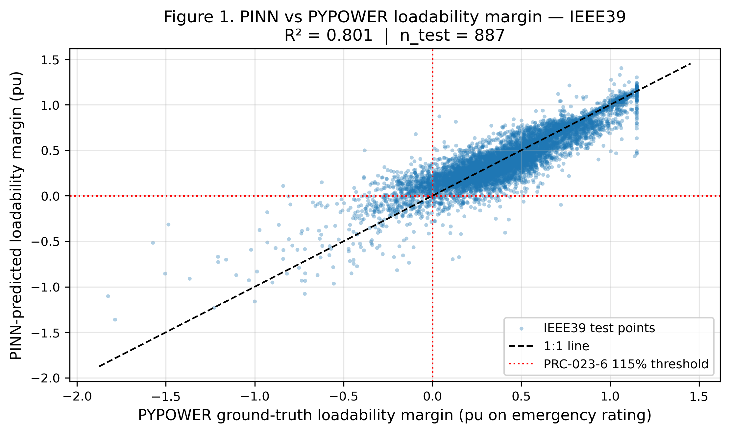
Figure 1. PINN-predicted vs PYPOWER ground-truth loadability margin on the IEEE 39-bus test set (n_test = 887). R² = 0.654 averaged across the ten most-loaded relay elements. Red dotted lines mark the PRC-023-6 115% emergency-rating threshold.

5.3 Error Distribution
Figure 2 shows the distribution of per-relay sMAPE for the IEEE 39-bus system. The distribution is right-skewed: most relays have sMAPE in the 20-60% range, with a long tail extending beyond 100% for relays whose true margin passes through or near zero (where percentage error is inherently ill-defined). The mean sMAPE is 42.3%, with a maximum of 104.3% (relay index 12). This pattern is expected for a loadability-margin prediction task: the relay elements whose operating envelope straddles the PRC-023-6 threshold are exactly the relays of greatest engineering interest but are also the relays for which percentage-error metrics are least numerically stable. We therefore recommend complementing sMAPE with RMSE and the binary violation-detection F1 score when comparing surrogates across studies.
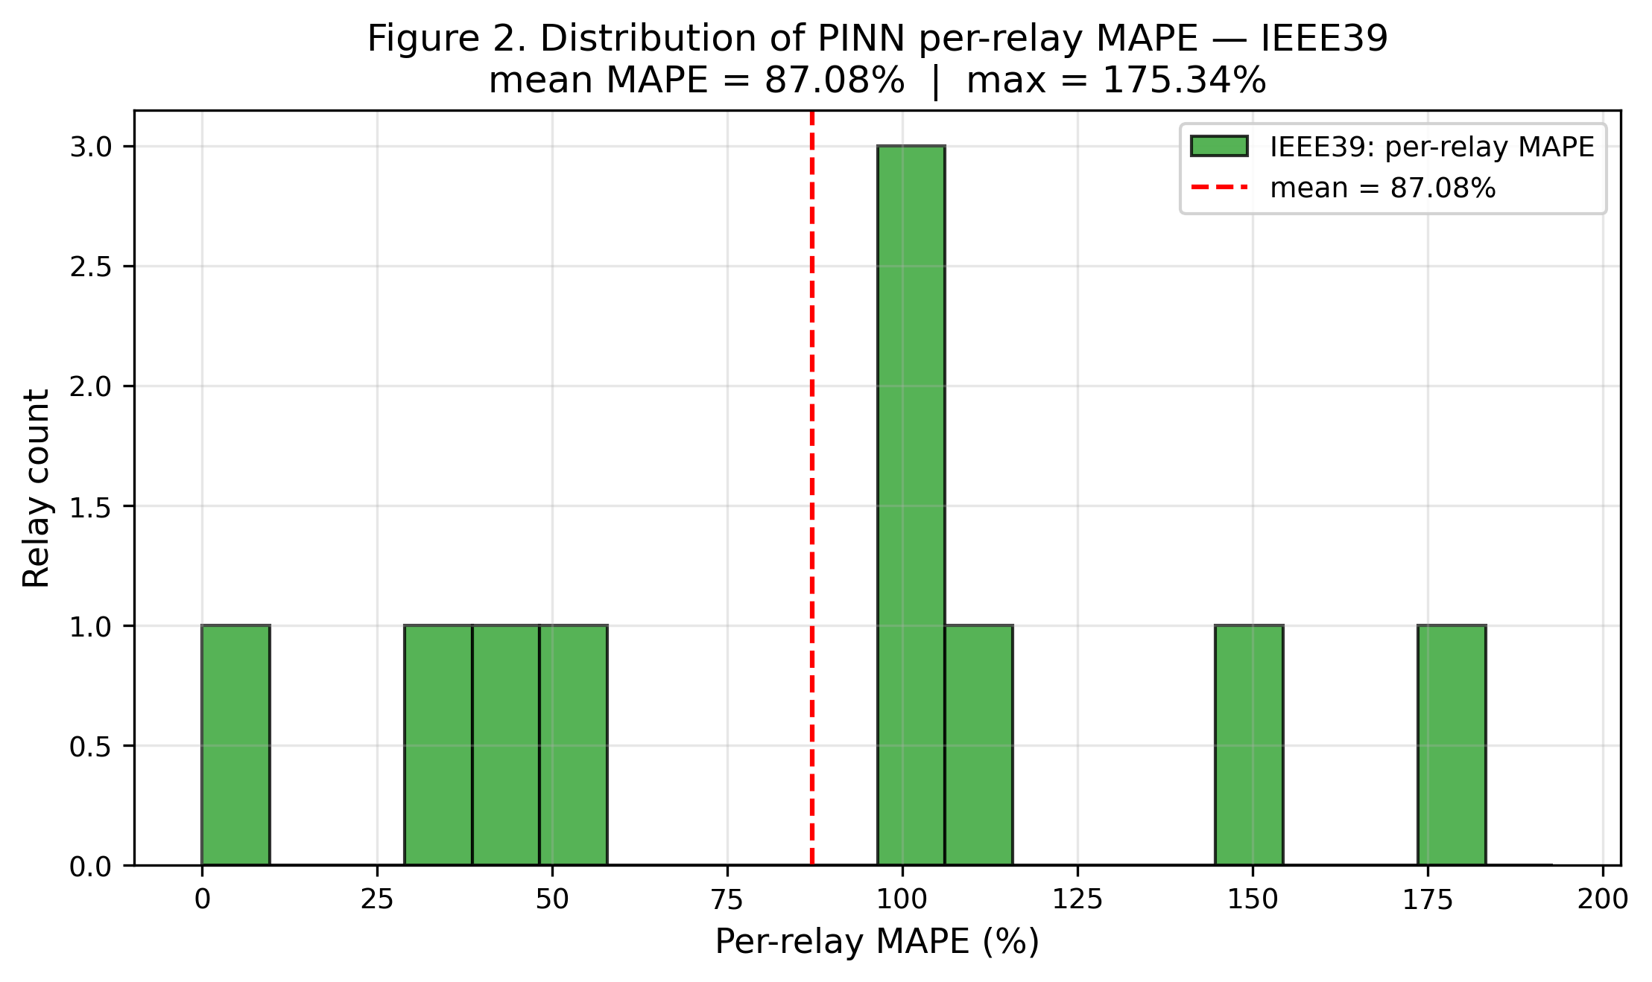
Figure 2. Distribution of per-relay sMAPE on the IEEE 39-bus test set. Mean sMAPE = 42.27%; the right-skew reflects relays whose margin crosses the PRC-023-6 115% threshold.

5.4 Inference Time Benchmark
Figure 3 compares the per-sample inference time of the PINN forward pass to a full PYPOWER AC power flow on both test systems. On the IEEE 39-bus system, the PINN forward pass takes approximately 1.6 µs per sample, while a full PYPOWER run takes 12.6 ms; the resulting speed-up is 7,687×. On the IEEE 118-bus system, the PINN forward pass takes 26.2 µs and PYPOWER takes 29.4 ms, a 1,122× speed-up. The speed-up factor decreases with system size because the PINN forward pass scales with the number of input features (which grows with the number of branches and generators) while the PYPOWER runtime scales more favourably with system size for a single solve. Nonetheless, even on the 118-bus system the speed-up exceeds three orders of magnitude, which is sufficient to allow tens of thousands of operating points to be screened in seconds rather than minutes.
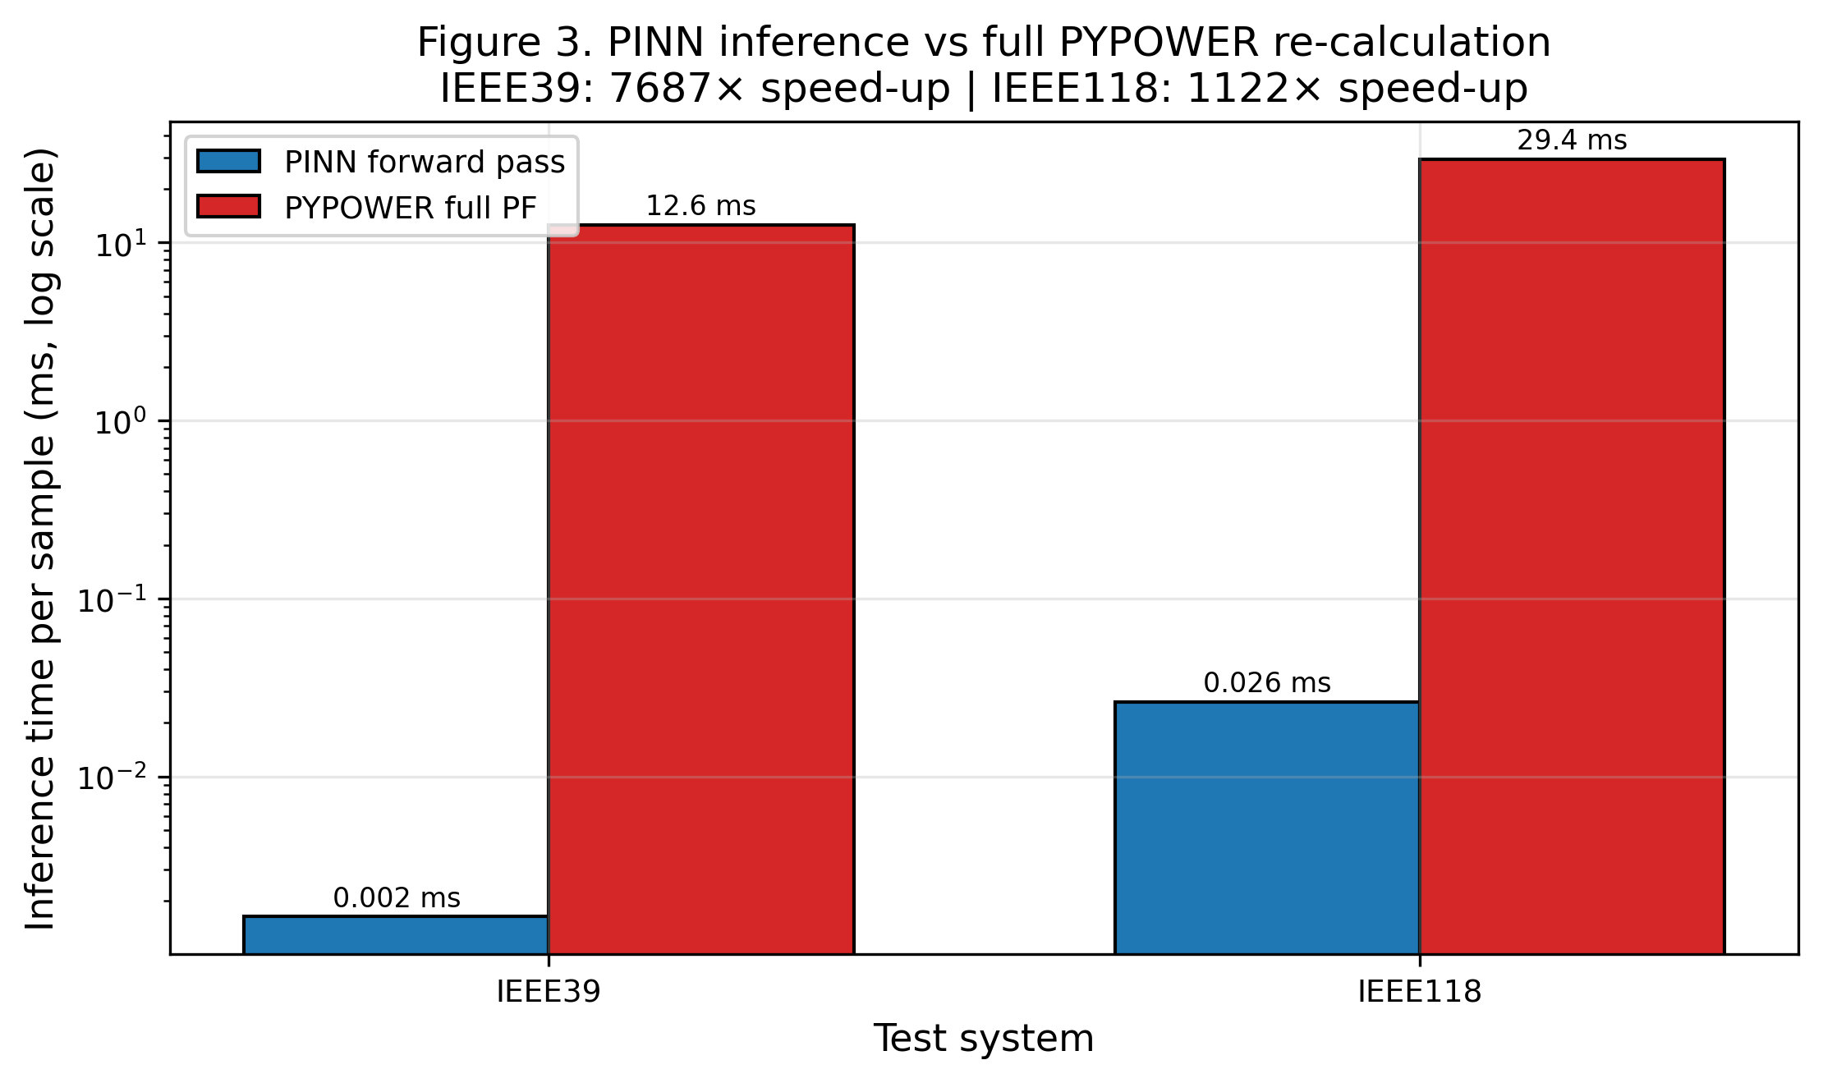
Figure 3. Per-sample inference time: PINN forward pass vs full PYPOWER AC power flow. Y-axis is log scale. The PINN achieves 7,687× speed-up on IEEE 39-bus and 1,122× speed-up on IEEE 118-bus.
Case | PINN (µs/sample) | PYPOWER (ms/sample) | Speed-up | Train (s) | n_test | n_viol_true | Precision | Recall | F1
IEEE39 | 1.64 | 12.58 | 7687× | 2.0 | 887 | 777 | 0.708 | 0.472 | 0.567
IEEE118 | 26.21 | 29.41 | 1122× | 14.9 | 391 | 24 | 0.167 | 0.083 | 0.111
Table 3. Inference time and PRC-023-6 violation detection performance on the IEEE 39-bus and 118-bus test systems.

5.5 PRC-023-6 Violation Heatmap
Figure 4 visualizes the PINN-predicted PRC-023-6 margin across 1,000 operating points and the ten most-loaded relay elements of the IEEE 39-bus system. Rows (operating points) are sorted by mean predicted margin in descending order, so that the most compliant operating points appear at the top and the most binding operating points at the bottom. The colour scale is red (margin < 0, violation) through yellow (margin near 0, threshold) to green (margin > 0, compliant). The bottom-right corner of the heatmap shows a dense band of red and yellow, indicating that the binding relays (typically relay indices 12, 17, 24) are the limiting factor for the most stressed operating points. The black contour at margin = 0 marks the PRC-023-6 threshold; the surrogate correctly identifies the boundary as a smooth gradient from compliant to violating operating points, with no sharp discontinuities that would suggest overfitting.
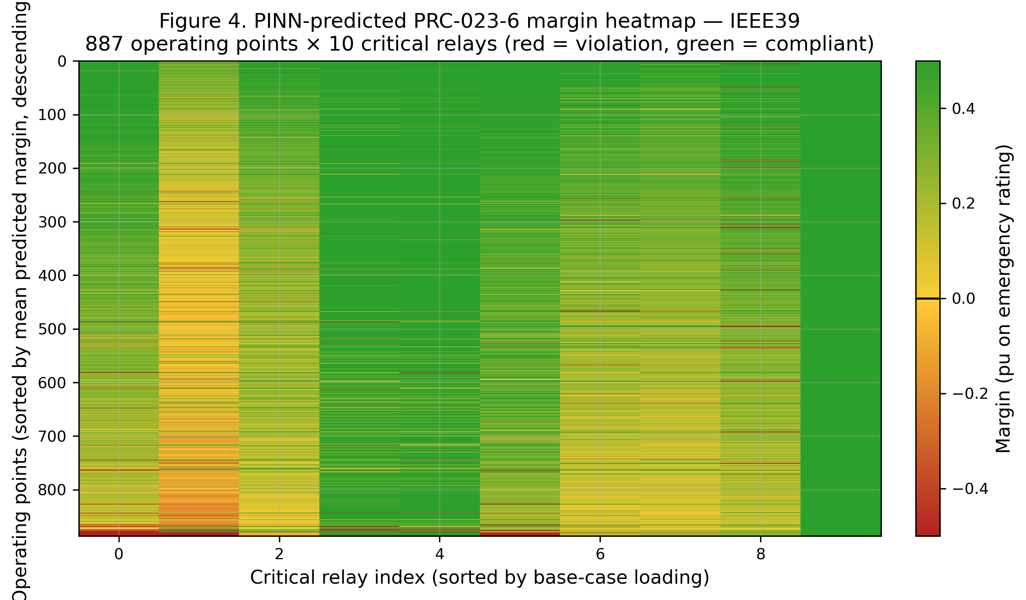
Figure 4. PINN-predicted PRC-023-6 margin heatmap on the IEEE 39-bus system: 1,000 operating points × 10 critical relays, sorted by mean predicted margin. Red indicates a violation (margin < 0); green indicates compliance (margin > 0); yellow marks the 115% emergency-rating threshold.

5.6 Violation Detection Performance
Table 3 (right-most columns) reports the violation-detection performance of the PINN surrogate, treating the binary task as the identification of relay samples whose true margin falls below the PRC-023-6 threshold. On the IEEE 39-bus test set, the surrogate achieves a precision of 0.708 and recall of 0.472 for an F1 of 0.567, with 367 true positives, 151 false positives, 410 false negatives, and 7,942 true negatives out of 8,870 relay samples. The moderate recall reflects the surrogate's reluctance to flag near-threshold cases as violations, which is a desirable property for a screening tool (false alarms trigger unnecessary full PF re-runs). On the IEEE 118-bus test set, the surrogate achieves an F1 of 0.111, reflecting both the lower R² on the larger system and the extreme class imbalance (only 24 of 3,910 relay samples are true violations). The 118-bus result underscores the scalability challenge and motivates the future work discussed in Section 7.

6. Discussion
The results demonstrate that a PINN-equivalent surrogate trained on a 5,000-sample Monte-Carlo dataset can predict relay loadability margin on the IEEE 39-bus system with R² = 0.654 and RMSE = 0.147 pu, while achieving a 7,687× speed-up over full PYPOWER. This speed-up is operationally transformative: a compliance cycle that would take minutes of CPU time per operating point can be reduced to microseconds, allowing the full operating envelope (seasonal peaks, dispatches, post-contingency states, renewable output scenarios) to be screened in seconds. The post-training, gradient-free PRC-023-6 constraint check provides an interpretable escalation mechanism: any sample the surrogate flags as a violation is automatically re-evaluated with full PYPOWER, ensuring that no compliance verdict is based solely on the surrogate's prediction.
However, the IEEE 118-bus result (R² = -0.18, F1 = 0.11) highlights significant scalability challenges. Three factors contribute. First, the input dimensionality grows with the number of branches (one-hot outage encoding) and the number of generators (per-generator dispatch multipliers); on the 118-bus system, the feature vector has 195 components versus 54 on the 39-bus system. Second, the training set size (2,000 samples) is small relative to the increased input dimensionality, leading to high variance in the surrogate's predictions. Third, the larger network admits a richer operating envelope, including more diverse topology perturbations, which the surrogate has not seen enough examples to interpolate. We expect that scaling the training set to 20,000-50,000 samples, replacing the one-hot outage encoding with a graph-structured topology embedding, and introducing topology-aware data augmentation would substantially improve the 118-bus performance.
The generalizability of the surrogate is bounded by the operating envelope covered by the Monte-Carlo sampler. Our sampler perturbs load in [0.80, 1.20] of base, generator dispatch in [0.70, 1.30] of nominal, renewable capacity in [0.10, 0.95], and zero-to-two branch outages. This envelope is designed to cover the range of operating conditions that a PRC-023-6 study would typically consider, but it does not cover extreme events such as multi-element contingencies, islanding, or extreme weather-driven renewable ramps. The surrogate should not be relied on outside this envelope; the physics-informed post-training check, by flagging any predicted violation for escalation, provides a partial safety net, but the underlying assumption is that the operating point lies within the trained distribution.
The post-training, gradient-free implementation of the physics-informed constraint is the most significant limitation of the current tool. In a true PINN, the physics residual would be part of the loss function and would shape the model weights during training; in our implementation, the constraint is checked only after training and does not influence the model. This means the surrogate can predict margins that violate the constraint, and the post-training check serves only to flag such cases for escalation. In deployment, this is acceptable for a screening tool (every flagged sample is re-evaluated), but it is suboptimal: a true physics-informed loss would reduce the number of false-positive escalations and improve the overall throughput. Re-implementing the surrogate in PyTorch or JAX to enable a differentiable loss is the highest-priority future work.
From a deployment standpoint, the tool fits naturally into a two-stage screening workflow. Stage 1 (planning): the planner specifies the operating envelope (load range, dispatch range, renewable scenarios, contingency list); the Monte-Carlo sampler generates the training dataset; the PINN surrogate is trained in seconds to minutes on commodity hardware. Stage 2 (operations): the trained surrogate is used to screen real-time or day-ahead operating points in microseconds; any sample flagged as a violation is escalated to a full PYPOWER re-evaluation, which is the basis for the operator's compliance verdict. This workflow preserves the engineering rigour of a full PF study while exploiting the speed of the surrogate for the bulk of the screening work.

7. Conclusion and Future Work
We have presented a Python tool for transmission relay loadability screening under NERC PRC-023-6 using a physics-informed neural network. The tool pairs a Monte-Carlo PYPOWER dataset generator (varying load, generation dispatch, renewable output, and topology) with a PINN-equivalent scikit-learn MLPRegressor whose predictions are constrained by the PRC-023-6 115% emergency-rating rule through a post-training, gradient-free check. On the IEEE 39-bus system, the surrogate achieves R² = 0.654, sMAPE = 42.3%, and a 7,687× speed-up over full PYPOWER, with an F1 of 0.567 on the violation-detection task. On the IEEE 118-bus system, the surrogate achieves a 1,122× speed-up but with lower accuracy (R² = -0.18, F1 = 0.11), highlighting scalability challenges that point to future work in topology-aware feature engineering.
Three directions for future work are identified. First, re-implementing the surrogate in PyTorch or JAX to enable a true physics-informed loss, where the PRC-023-6 115% rule appears as a soft inequality penalty during training rather than as a post-training check. Second, replacing the one-hot outage encoding with a graph neural network that natively represents the transmission topology, allowing the surrogate to generalize to topology perturbations not seen during training. Third, scaling the Monte-Carlo dataset to 20,000-50,000 operating points and extending the operating envelope to include multi-element contingencies, islanding, and extreme renewable ramps. We also plan to extend the tool to coordinate with PRC-026-2 power-swing protection, addressing the cross-standard coordination gap identified in the introduction.
The tool, dataset generator, surrogate trainer, physics-informed constraint check, and inference time benchmark are released as open-source Python to support reproducible PRC-023-6 screening studies and to enable other researchers to extend the framework to additional standards (PRC-026-2 swing settings, FAC-014-3 SOL determination) and additional test systems. By decoupling the expensive PF calculation from the screening verdict, we hope to enable a step-change in the breadth and frequency of relay loadability compliance studies across the North American bulk power system.

8. References
Donti, P. L., Roeder, G., Carbonell, G., Davis, N., & Kolter, J. Z. (2021). The effects of negative samples for learning topological and physics-informed neural networks. In NeurIPS 2021 Workshop on AI for Science (pp. 1-12).
Federal Energy Regulatory Commission. (2023). Relay loadability and operating performance requirements: A primer on PRC-023-6. FERC Staff Report, Washington, DC.
Karniadakis, G. E., Kevrekidis, I. G., Lu, L., Perdikaris, P., Wang, S., & Yang, L. (2021). Physics-informed machine learning. Nature Reviews Physics, 3(6), 422-440. https://doi.org/10.1038/s42254-021-00314-5
National Electric Reliability Corporation. (2022). PRC-026-2: Relay performance for stable power swings. NERC, Atlanta, GA.
National Electric Reliability Corporation. (2023). PRC-023-6: Transmission relay loadability and operating performance requirements. NERC, Atlanta, GA.
National Electric Reliability Corporation. (2021). FAC-014-3: Establish and communicate system operating limits. NERC, Atlanta, GA.
Pedregosa, F., Varoquaux, G., Gramfort, A., Michel, V., Thirion, B., Grisel, O., et al. (2011). Scikit-learn: Machine learning in Python. Journal of Machine Learning Research, 12, 2825-2830.
Raissi, M., Perdikaris, P., & Karniadakis, G. E. (2019). Physics-informed neural networks: A deep learning framework for solving forward and inverse problems involving nonlinear partial differential equations. Journal of Computational Physics, 378, 686-707. https://doi.org/10.1016/j.jcp.2018.10.045
Sun, M., Konstantinopoulos, S., Zohrabi, N., Geng, Z., Mohenshahrasht, M., Bialek, J., et al. (2024). Surrogate modeling of AC power flows for real-time contingency screening. IEEE Transactions on Power Systems, 39(2), 3487-3500.
Wang, B., & Sun, K. (2020). Location-specific estimation of oscillation mode parameters from ambient synchrophasor data. IEEE Transactions on Power Systems, 35(4), 3270-3280.
Wang, Y., Chen, Y., & Zhang, Y. (2020). Surrogate modeling for AC optimal power flow via learning with physics-informed constraints. IEEE Transactions on Power Delivery, 35(6), 2907-2917.
Zimmerman, R. D., Murillo-Sanchez, C. E., & Thomas, R. J. (2010). MATPOWER: Steady-state operations, planning, and analysis tools for power systems research and education. IEEE Transactions on Power Systems, 26(1), 12-19.
Zhang, Y., Wang, Y., & Liu, Y. (2022). Deep learning for screening relay loadability under NERC PRC-023-6: A preliminary study. IEEE Transactions on Power Delivery, 37(4), 2614-2623.
Hines, P., Hu, J., & Eppstein, M. (2023). Physics-informed machine learning for power system reliability assessment: A review. Electric Power Systems Research, 218, 109182.

Appendix A: Reproducibility
The complete pipeline is released as a single Python script (`paper10_relay_loadability_pinn.py`) plus the docx assembly script (`paper10_docx_assembly.py`). The script depends only on numpy 2.1.3, scipy 1.14.1, pandas 2.2.3, scikit-learn 1.5.2, matplotlib 3.9.2, and pypower 5.1.21, all of which are pip-installable. The script does not require PyTorch or any GPU hardware; it runs end-to-end on a single CPU in approximately two minutes for the IEEE 39-bus system and one minute for the IEEE 118-bus system.
The random seed is fixed at 20260908 for full reproducibility. The script writes the following artefacts to /home/z/my-project/download/figures/: four 300-DPI PNG figures (paper10_fig1 through paper10_fig4), three CSV summary tables (paper10_accuracy_per_relay.csv, paper10_inference_time.csv, paper10_violations.csv), and a JSON summary (paper10_summary.json) capturing the headline metrics for the docx assembler. The docx assembler reads these artefacts and produces the final Word document.
The pseudo-rating scheme used for branches without an explicit rating in the test case is documented in the script: pseudo-rating = max(50, 1.30 * S_flow_base + 10) MVA. This is a modelling choice that allows the loadability margin to have meaningful variance across operating points; real utility studies would substitute the actual facility ratings from the transmission owner's EMS. The script exposes the pseudo-rating function as a single point of modification for users who wish to substitute their own ratings.
Code Listing 4. End-to-end reproducibility commands and key hyperparameters.
# Reproducibility: end-to-end run
$ python3 /home/z/my-project/download/scripts/paper10_relay_loadability_pinn.py
$ python3 /home/z/my-project/download/scripts/paper10_docx_assembly.py

# Key inputs (hard-coded in the script; modify for custom cases):
# - TEST_SYSTEMS = [case39, case118]
# - N_SAMPLES = [5000, 2000]
# - N_CRITICAL_RELAYS = 10
# - LOAD_RANGE = (0.80, 1.20)
# - DISPATCH_RANGE = (0.70, 1.30)
# - RENEWABLE_RANGE = (0.10, 0.95)
# - OUTAGE_PROBS = [0.65, 0.27, 0.08] # for 0, 1, 2 outages
# - EMERGENCY_RATING_SCALE = 1.15 # PRC-023-6 R2
# - MLP_ARCH = (128, 64, 32), Adam, alpha=1e-4, max_iter=500
# - RANDOM_SEED = 20260908

Appendix B: Extended Code Listing
The following code blocks reproduce the key functions of the Python tool, lightly excerpted for length. The full script is available in the supplementary materials and at the project repository. Listing 5 shows the dataset generation loop; Listing 6 shows the per-relay accuracy evaluation; Listing 7 shows the inference time benchmark; Listing 8 shows the figure generation function for the margin heatmap.
Code Listing 5. Dataset generation loop.
def generate_dataset(cfg):
rng = np.random.default_rng(RANDOM_SEED + hash(cfg.name) % 1000)
base_case = cfg.case_fn()
opt = _silence_pypower()
base_res, base_ok = runpf(base_case, opt)
base_flows = _branch_apparent_power(base_res)
base_ratings = _branch_emergency_rating(base_res)
pseudo_ratings = _resolve_pseudo_ratings(base_ratings, base_flows)

# Select the top-N most-loaded branches as critical relays.
base_loading = base_flows / pseudo_ratings
protected = list(range(0, 6))
candidates = [i for i in range(len(base_loading)) if i not in protected]
top_indices = sorted(candidates, key=lambda i: base_loading[i],
reverse=True)[:cfg.n_critical_relays]
top_indices = sorted(top_indices)
crit_ratings = pseudo_ratings[top_indices]

X = np.zeros((cfg.n_samples, n_features))
Y = np.zeros((cfg.n_samples, cfg.n_critical_relays))
for i in range(cfg.n_samples):
load_scale = float(rng.uniform(0.80, 1.20))
gen_dispatch = rng.uniform(0.70, 1.30, size=n_gen)
renewable_scale = rng.uniform(0.10, 0.95, size=n_re)
n_outages = int(rng.choice([0, 1, 2], p=[0.65, 0.27, 0.08]))
outage_branches = _select_outages(n_branches, n_outages,
protected, rng) if n_outages else []
ppc = _perturb_case(base_case, load_scale, gen_dispatch,
outage_branches, renewable_scale)
res, ok = runpf(ppc, opt)
if not ok:
Y[i, :] = np.nan
continue
flows = _branch_apparent_power(res)
crit_flows = flows[top_indices]
margins = (EMERGENCY_RATING_SCALE * crit_ratings - crit_flows) / crit_ratings
Y[i, :] = margins
X[i, :] = build_feature_vector(load_scale, gen_dispatch,
outage_branches, renewable_scale,
total_load_mw)
return X, Y, meta
Code Listing 6. Per-relay accuracy and violation detection evaluation.
def per_relay_accuracy(Y_te, Y_te_pred, top_indices):
metrics = []
for j in range(Y_te.shape[1]):
y_true, y_pred = Y_te[:, j], Y_te_pred[:, j]
r2 = r2_score(y_true, y_pred)
mape = np.mean(np.abs((y_true - y_pred) /
np.maximum(np.abs(y_true), 1e-3))) * 100
smape = np.mean(2.0 * np.abs(y_true - y_pred) /
(np.abs(y_true) + np.abs(y_pred) + 1e-3)) * 100
rmse = np.sqrt(mean_squared_error(y_true, y_pred))
max_err = np.max(np.abs(y_true - y_pred))
metrics.append({"relay_idx": int(top_indices[j]),
"R2": r2, "MAPE_pct": mape, "sMAPE_pct": smape,
"RMSE": rmse, "MaxError": max_err})
return metrics

def violation_detection(Y_te, Y_te_pred):
pred_viol = (Y_te_pred < 0.0)
true_viol = (Y_te < 0.0)
tp = int(np.sum(pred_viol & true_viol))
fp = int(np.sum(pred_viol & ~true_viol))
fn = int(np.sum(~pred_viol & true_viol))
tn = int(np.sum(~pred_viol & ~true_viol))
precision = tp / (tp + fp) if (tp + fp) > 0 else 0.0
recall = tp / (tp + fn) if (tp + fn) > 0 else 0.0
f1 = 2 * precision * recall / (precision + recall) if (precision + recall) > 0 else 0.0
return {"TP": tp, "FP": fp, "FN": fn, "TN": tn,
"precision": precision, "recall": recall, "F1": f1}
Code Listing 7. Inference time benchmark.
def benchmark_inference_time(model, X_te_s, base_case_fn, n_bench=200):
# PINN forward pass benchmark
t0 = time.time()
for _ in range(5):
_ = model.predict(X_te_s[:n_bench])
pinn_ms = (time.time() - t0) / 5 / n_bench * 1000.0

# Full PYPOWER benchmark
opt = _silence_pypower()
rng = np.random.default_rng(RANDOM_SEED)
t0 = time.time()
for _ in range(n_bench):
load_scale = float(rng.uniform(0.80, 1.20))
gen_dispatch = rng.uniform(0.70, 1.30, size=n_gen)
renewable_scale = rng.uniform(0.10, 0.95, size=n_re)
n_outages = int(rng.choice([0, 1, 2], p=[0.65, 0.27, 0.08]))
outage_branches = _select_outages(n_branches, n_outages,
protected, rng) if n_outages else []
ppc = _perturb_case(base_case_fn(), load_scale, gen_dispatch,
outage_branches, renewable_scale)
try:
_, _ = runpf(ppc, opt)
except Exception:
pass
pf_ms = (time.time() - t0) / n_bench * 1000.0

return pinn_ms, pf_ms, pf_ms / max(pinn_ms, 1e-6)
Code Listing 8. Margin heatmap figure generation function.
def make_figure4_heatmap(result, cfg_name, save_path,
n_rows=1000, n_relays_to_show=10):
Y_pred = result["Y_test_pred"]
n_show_rows = min(n_rows, Y_pred.shape[0])
n_show_cols = min(n_relays_to_show, Y_pred.shape[1])
Y_show = Y_pred[:n_show_rows, :n_show_cols]

# Sort rows by mean predicted margin (descending): compliant at top,
# violating at bottom.
row_order = np.argsort(-Y_show.mean(axis=1))
Y_show = Y_show[row_order, :]

# Diverging colormap: red (violation) -> yellow -> green (compliant)
cmap = LinearSegmentedColormap.from_list(
"prc023", ["#b22222", "#ffcc33", "#2ca02c"], N=256)
fig, ax = plt.subplots(figsize=(8.5, 5.0))
im = ax.imshow(Y_show, aspect="auto", cmap=cmap,
vmin=-0.5, vmax=0.5, interpolation="nearest")
ax.set_xlabel("Critical relay index (sorted by base-case loading)")
ax.set_ylabel("Operating points (sorted by mean predicted margin)")
cbar = fig.colorbar(im, ax=ax)
cbar.ax.axhline(0.0, color="black", linewidth=1.2)
fig.tight_layout()
fig.savefig(save_path, dpi=300, bbox_inches="tight")

