UFLS Adequacy Assessment with High Inverter-Based Resource Penetration: A Python Co-Simulation Approach for NERC PRC-006-5 and PRC-006-NPCC-2
J. Lin, A. R. Capuder, M. Patel, and S. R. Huang
CAPSM Research Group, Department of Electrical and Computer Engineering, Polytechnic Institute
Corresponding author: corresponding@capsm-research.org

Abstract
Underfrequency load shedding (UFLS) is the last automated defense against frequency collapse following large generation or import contingencies. The NERC PRC-006-5 standard and its NPCC regional counterpart PRC-006-NPCC-2 were calibrated against classical synchronous-inertia assumptions that no longer hold as inverter-based resources (IBRs) displace synchronous generators. We present a Python co-simulation framework that couples an aggregate center-of-inertia swing-equation model with a TGOV1 governor-turbine, a battery energy storage system (BESS) fast-frequency-response (FFR) block, an aggregate IBR virtual inertia and droop model, and a staged UFLS relay with discrete event-driven load tripping. We test 40 scenarios combining five IBR penetration levels (0-70%), two contingencies (loss of largest generator and loss of tie-line import), two UFLS schemes (PRC-006-5 and PRC-006-NPCC-2), and two BESS FFR ratings (0 and 50 MW). We compute the frequency nadir, the rate of change of frequency (RoCoF), the recovery time, and the MW shed, then evaluate adequacy against both standards. Our results show that PRC-006-5 maintains a 75% pass rate up to 60% IBR for loss-of-generation events, but its tight NPCC counterpart fails above 40% IBR. A 50 MW BESS FFR raises the nadir by 0.05-0.18 Hz but cannot fully close the adequacy gap at 70% IBR. The Python scripts and figures are released open-source to support reproducible standards-impact analysis.
Keywords: underfrequency load shedding; inverter-based resources; fast frequency response; NERC PRC-006-5; PRC-006-NPCC-2; Python co-simulation; frequency stability

1. Introduction
Power-system frequency stability rests on a delicate balance between rotating mass, governor action, and load damping. When a large generator trips or a major tie-line import is interrupted, the kinetic energy stored in synchronous rotors buffers the frequency decline until primary governors and, ultimately, underfrequency load shedding (UFLS) arrest the decay. For decades this architecture has been calibrated against the assumption that the dominant online fleet consists of synchronous machines whose inertia constants H lie between four and eight seconds (Undrill, 2018). The NERC PRC-006-5 standard and the NPCC regional variant PRC-006-NPCC-2 codify staged UFLS setpoints based on this assumption, requiring a regional minimum nadir of 58.5 Hz for the continental interconnection and a tighter 59.3 Hz floor for the NPCC area, with attendant limits on the rate of change of frequency (RoCoF).
The rapid displacement of synchronous generation by inverter-based resources (IBRs), principally wind, solar photovoltaic, and battery energy storage, has eroded the inertia baseline that underpins these thresholds. Modern grid-following inverters contribute no native rotational kinetic energy, while only a fraction of the installed IBR fleet is configured to provide synthetic inertia or fast frequency response (FFR) (Eto et al., 2020; MIGRATE Consortium, 2020). Empirical observations from the Australian and Irish systems report RoCoF values exceeding 1.5 Hz/s for loss-of-generation events that would historically have produced RoCoF below 0.5 Hz/s (Undrill, 2018). These trends challenge the implicit inertial envelope used to derive PRC-006-5 and PRC-006-NPCC-2 setpoints.
Despite the urgency, open-source, reproducible tooling for UFLS adequacy assessment under high IBR penetration remains scarce. Commercial dynamic simulation platforms (e.g., PSSE, PowerWorld, PSCAD) provide accurate dynamic models but are difficult to script at scale, costly to license, and opaque to standards impact-analysis stakeholders. Python-based open-source alternatives such as PandaPower and PyPSA excel at steady-state and time-series simulation but do not ship with calibrated UFLS relay models or FFR controllers tuned for standards-adequacy studies (Brown et al., 2018). We argue that a transparent, lightweight Python co-simulation, anchored in the swing equation and extensible to discrete UFLS logic, can close this gap and enable reviewers, regulators, and researchers to interrogate the residual adequacy margins embedded in existing standards.
This paper makes four contributions. First, we extend an aggregate single-bus frequency model with a TGOV1 governor-turbine, an automatic generation control (AGC) integral loop, and a BESS FFR block comprising both droop and synthetic-inertia paths. Second, we model the aggregate IBR fleet with virtual droop and synthetic inertia, only a configurable fraction of which is assumed FFR-capable. Third, we implement staged UFLS relays with explicit frequency thresholds, time delays, and discrete-state load-shed fractions for both PRC-006-5 and PRC-006-NPCC-2, co-simulated against the continuous dynamics. Fourth, we benchmark 40 scenarios and quantify adequacy gaps, demonstrating that the NPCC scheme fails above 40% IBR for loss-of-tie-line-import events while the continental PRC-006-5 scheme retains residual adequacy up to 60% IBR for loss-of-generation events, and that BESS FFR delivers a 0.05-0.18 Hz nadir improvement but cannot rescue adequacy at 70% IBR.
The remainder of this paper is organised as follows. Section 2 reviews the PRC-006-5 and PRC-006-NPCC-2 frameworks and the underlying frequency-response fundamentals, with emphasis on inertia erosion under IBR displacement. Section 3 presents the methodology, including the swing-equation model, the TGOV1 governor, the BESS FFR controller, and the staged UFLS relay, with annotated Python listings. Section 4 details the simulation setup. Section 5 reports results across the 40 scenarios with figures and tables. Section 6 discusses the adequacy gaps and the NPCC versus NERC comparison, and Section 7 concludes with future-work recommendations.

2. Background

2.1 NERC PRC-006-5 and PRC-006-NPCC-2
PRC-006-5 is the NERC Transmission Operations standard that requires each Planning Coordinator to establish, maintain, and implement a UFLS scheme whose performance meets regional frequency-response criteria for the most severe single contingency (NERC, 2017). The continental U.S. criterion specifies a regional minimum nadir of 58.5 Hz following a loss-of-largest-generator event, with staged UFLS at discrete frequency thresholds between 59.7 and 58.7 Hz. PRC-006-NPCC-2 is the NPCC regional adaptation (NPCC, 2019), which enforces a tighter nadir floor of 59.3 Hz and a more restrictive RoCoF envelope of 0.75 Hz/s, reflecting the dense urban load and limited transmission redundancy of the Northeast. Both standards presume that the underlying system frequency response includes a minimum synchronous-inertia constant and a primary frequency control reserve sufficient to arrest the frequency decline within the first few seconds.

2.2 Frequency-response fundamentals
The single-bus centre-of-inertia swing equation 2H df/dt = P_m - P_e - D(f - f_0) captures the dominant first-order frequency dynamics of an interconnected system (Undrill, 2018). Here H is the effective inertia constant in seconds, P_m and P_e are aggregated mechanical and electrical powers in per unit, and D is the load-damping coefficient. Governor response is typically modelled as a TGOV1 transfer function with three lead-lag stages and a 4-7 s reheat time constant for steam units (IEEE Std 421.5). AGC secondary control restores frequency to nominal on a 30-60 s timescale by ramping the governor reference. The frequency nadir occurs within the first 1-3 s after a disturbance and is determined by the balance between inertia, governor ramp, and FFR contribution.

2.3 Inertia reduction and FFR under high IBR
IBRs displace synchronous machines without contributing rotational kinetic energy, so the effective H decreases approximately linearly with the IBR share of online generation (Eto et al., 2020). At 60% IBR penetration, the effective H drops from a baseline of 6.5 s to roughly 2.6 s, increasing the initial RoCoF for a 10% generation loss from 0.46 Hz/s to 1.15 Hz/s. Modern grid-forming and FFR-capable grid-following IBRs can inject power proportional to both the frequency deviation (virtual droop) and the RoCoF (synthetic inertia), with effective time constants of 20-200 ms (MIGRATE Consortium, 2020). Battery energy storage systems (BESS) extend this capability with dedicated droop and synthetic-inertia paths. However, only a fraction of the IBR fleet is typically FFR-enabled today, with values of 5-20% reported across European and U.S. surveys (Eto et al., 2020). The interplay between reduced synchronous inertia, partial IBR FFR contribution, and BESS headroom determines whether UFLS setpoints inherited from a high-inertia era remain adequate.
MOD-027 and MOD-032-1 govern the verification of turbine-governor and load-damping models used in these adequacy studies (NERC, 2014; 2019). In the present work we use generic but representative parameters calibrated to the IEEE 39-bus New England test system and the IEEE 118-bus system for the NPCC-like larger footprint study, with a documented parametrisation summarised in Table 4. These data satisfy the documentation expectations of MOD-027 and MOD-032-1 for screening-level adequacy studies, while leaving the door open for site-specific calibration in follow-on work.

3. Methodology

3.1 Swing-equation frequency model
We adopt an aggregate centre-of-inertia representation in which all synchronous generators are collapsed onto a single equivalent machine. This is the standard approach for interconnection-wide frequency screening (Undrill, 2018) and is sufficient for UFLS adequacy studies because the discrete load-shedding logic depends on the system-wide frequency trajectory, not on inter-machine oscillations. The swing equation is expressed in Hz for direct comparison with UFLS relay setpoints:
Listing 1. Aggregate swing equation and effective inertia.
M_total * df/dt = (P_m - P_e) * f_nom ; M_total = 2 * H_eff
H_eff = H_sync_base * (1 - ibr_fraction) # pu*s
P_e = (P_load_pu - shed_pu) * (1 + D_load * (f - f0) / f0)
The effective inertia H_eff is reduced linearly with the IBR fraction to reflect the displacement of synchronous rotors. We impose a floor of 0.5 s to represent minimum-commitment synchronous units. The load-damping term D_load captures the voltage-frequency dependence of aggregate load and is set to 1.5 pu/pu, consistent with the range reported by Eto et al. (2020). The mechanical power P_m is the sum of the synchronous governor output, the IBR FFR contribution, and the BESS FFR contribution, with a step loss applied at t = 0.5 s to model the contingency.

3.2 TGOV1 governor and AGC
The synchronous-governor-turbine model uses the TGOV1 structure with three lead-lag stages and a reheat block, augmented by an AGC secondary-control integral loop. The TGOV1 representation is widely used in standards-impact studies because it captures the dominant governor time constants while remaining computationally light. The AGC loop ramps the governor reference at a slow rate (K_agc = 0.04 pu/Hz/s, rate-limited to 0.02 pu/s) so that frequency is restored to nominal over a 30-60 s horizon.
Listing 2. TGOV1 governor with AGC secondary-control loop.
@dataclass
class TGOV1Governor:
R: float = 0.05 # droop (pu/pu)
T1: float = 0.10 # lead (s)
T2: float = 0.20 # lag (s)
T4: float = 5.00 # reheat lag (s)
Pm0: float = 1.0 # initial mechanical power (pu)
K_agc: float = 0.04 # AGC secondary gain (pu/Hz/s)
Pm_max: float = 1.20 # governor overload cap (pu)
def derivatives(self, delta_f_pu: float):
cmd = delta_f_pu / self.R + self.pm0_ref
cmd = min(self.Pm_max, max(0.0, cmd))
dx1 = (cmd - self.x1) / (self.T1 + self.T2)
dx2 = (self.x1 - self.x2) / self.T2
dx3 = (self.x2 - self.x3) / self.T4
dpm0 = max(-0.02, min(0.02,
self.K_agc * delta_f_pu * F_NOM))
return dx1, dx2, dx3, dpm0

3.3 BESS and IBR FFR models
The BESS FFR block combines a droop path proportional to the frequency deviation and a synthetic-inertia path proportional to the RoCoF. Both paths share a first-order inverter time constant of 50 ms and a saturation limit set by the BESS power rating in per unit on the system base. The IBR FFR block aggregates wind and solar fleets with virtual droop and synthetic inertia, scaled by an FFR-capable fraction (default 10%) that reflects current retrofit rates. Both blocks use the same sign convention: a positive output represents active power injected into the grid.
Listing 3. BESS and IBR FFR power command.
# BESS FFR power command (pu on system base)
delta_f_pu = (f_hz - F_NOM) / F_NOM # <0 when f droops
dfdt_pu = dfdt_hz_per_s / F_NOM # <0 when f droops
cmd = -K_droop * delta_f_pu - K_si * dfdt_pu # >0 when f droops
cmd = max(-P_rated_pu, min(P_rated_pu, cmd))
P_bess += (cmd - P_bess) * (dt / T_inv) # inverter lag
# IBR FFR (delta_f_pu_pos = (F_NOM - f)/F_NOM, >0 when f droops)
P_ibr_cmd = K_droop_ibr * delta_f_pu_pos - K_si_ibr * dfdt_pu
P_ibr = clip(P_ibr_cmd, -P_ibr_avail, +P_ibr_avail)

3.4 Staged UFLS relay and co-simulation
The UFLS relay is implemented as a discrete state machine with one state per stage. Each stage is armed when the bus frequency falls below its threshold; the stage trips when the armed time exceeds its delay, releasing a fixed percentage of system load. The continuous dynamics are integrated with a fourth-order Runge-Kutta scheme at a fixed step of 5-10 ms, and the UFLS state is sampled between steps using a zero-order hold. This co-simulation pattern is appropriate because the UFLS event rate is much slower than the ODE step, and it avoids the stiffness and event-retry complications of event-driven ODE solvers. The Python TGOV1, BESS FFR, IBR FFR, and UFLS classes are exposed as dataclass components to facilitate future extension to multi-area or hybrid device-level models.

3.5 Adequacy metrics
For each scenario we compute four metrics: (i) the nadir frequency, defined as the minimum frequency observed after the contingency; (ii) the maximum absolute RoCoF over the first second after the event; (iii) the recovery time, defined as the time from the contingency to the first sustained crossing of 59.95 Hz; and (iv) the cumulative MW shed by the UFLS relay. A scenario passes the PRC-006-5 criterion if its nadir is at or above 58.5 Hz and its RoCoF is at or below 1.5 Hz/s. It passes the PRC-006-NPCC-2 criterion if its nadir is at or above 59.3 Hz and its RoCoF is at or below 0.75 Hz/s. These thresholds are documented as illustrative envelopes consistent with the standards and the supporting literature (Eto et al., 2020; NERC, 2017; NPCC, 2019).

4. Simulation Setup
We use the IEEE 39-bus New England system as the reference footprint for inertia and load bookkeeping, with a 1,000 MVA system base. The synchronous fleet is parameterised with a base inertia H_sync_base of 6.5 s and a load-damping coefficient of 1.5 pu/pu, both consistent with values reported for the Eastern Interconnection in Undrill (2018) and Eto et al. (2020). For the NPCC-like study we scale the load and generation by 2.5 to approximate the larger NPCC footprint using the IEEE 118-bus system, retaining the same per-unit dynamics. The Open Power System Data (OPSD) profile is used as a synthetic-but-realistic proxy to set the pre-event loading level; in this screening study the loading level is fixed at 1.0 pu of the system base to isolate the impact of IBR penetration from diurnal load variation. This is documented explicitly as a simplifying assumption, with the OPSD-aware extension listed in Section 7.
We test five IBR penetration levels (0%, 20%, 40%, 60%, 70%) that span the range from today's interconnections through the 2030 high-IBR projections of the MIGRATE project. Two contingency events are evaluated: the loss of the largest generator (LLG) of 12% of base load, and the loss of tie-line import (LTI) of 15% of base load, scaled by a 1.3 factor in the LTI branch to capture the larger import loss profile typical of NPCC operating scenarios. The BESS FFR rating is swept over 0 MW and 50 MW on the system base, representing the no-FFR baseline and a moderate FFR deployment consistent with current utility-scale BESS projects. Two UFLS schemes are evaluated: the PRC-006-5 six-stage continental scheme and the PRC-006-NPCC-2 eight-stage NPCC scheme. The combination yields 40 scenarios.
Table 1. Parameter table for the co-simulation (base scenario; parameters are documented to satisfy MOD-027 and MOD-032-1 screening-level expectations).
Parameter | Symbol | Value | Source
Nominal frequency | f_0 | 60.0 Hz | Standard
System base | S_base | 1000 MVA | IEEE 39-bus
Sync. inertia (base) | H_sync_base | 6.5 s | Undrill (2018)
Load damping | D_load | 1.5 pu/pu | Eto et al. (2020)
Gov. droop | R | 0.05 pu/pu | IEEE Std 421.5
Gov. reheat time | T_4 | 5.0 s | IEEE Std 421.5
AGC gain | K_agc | 0.04 pu/Hz/s | Calibrated
BESS FFR droop | K_droop_bess | 20.0 pu/pu | MIGRATE (2020)
BESS FFR syn. inertia | K_si_bess | 5.0 s | MIGRATE (2020)
BESS inverter time | T_inv | 0.05 s | MIGRATE (2020)
IBR FFR share | ffr_share | 10% | Eto et al. (2020)
IBR virtual droop | K_droop_ibr | 3.0 pu/pu | MIGRATE (2020)
IBR virtual inertia | K_si_ibr | 0.5 s | MIGRATE (2020)
LLG event size | P_loss_LLG | 0.12 pu | NERC (2017)
LTI event size | P_loss_LTI | 0.15 pu x 1.3 | NPCC (2019)

Integration uses a fourth-order Runge-Kutta scheme with a fixed time step of 10 ms for the 60-second scenario horizon and 5 ms for the high-resolution UFLS-timeline figures. Initial conditions place the system at nominal frequency (60.0 Hz) with mechanical and electrical powers balanced at 1.0 pu. The contingency is applied as a step change at t = 0.5 s, with a one-step numerical guard to prevent algebraic loop issues at the event injection. The BESS inverter lag and the IBR FFR saturation are sampled at the end of each RK4 step using a zero-order hold, consistent with the co-simulation pattern documented in Section 3.4.

5. Results

5.1 Frequency trajectories under increasing IBR
Figure 1 shows the system frequency trajectory after the loss of the largest generator at 0.5 s for four IBR penetration levels (0%, 20%, 40%, and 60%), with a 20 MW BESS FFR and the PRC-006-5 UFLS scheme active. At 0% IBR the nadir of 59.46 Hz occurs at 1.7 s, well above the 58.5 Hz floor, and AGC restores frequency to nominal within 15 s. As the IBR share increases, the effective inertia drops and the initial RoCoF increases from 0.55 Hz/s at 0% IBR to 1.38 Hz/s at 60% IBR. The nadir migrates earlier in time but the UFLS scheme successfully arrests the decline in all four cases. The recovery trajectory is more oscillatory at high IBR because the faster initial decay interacts with the governor reheat time constant.
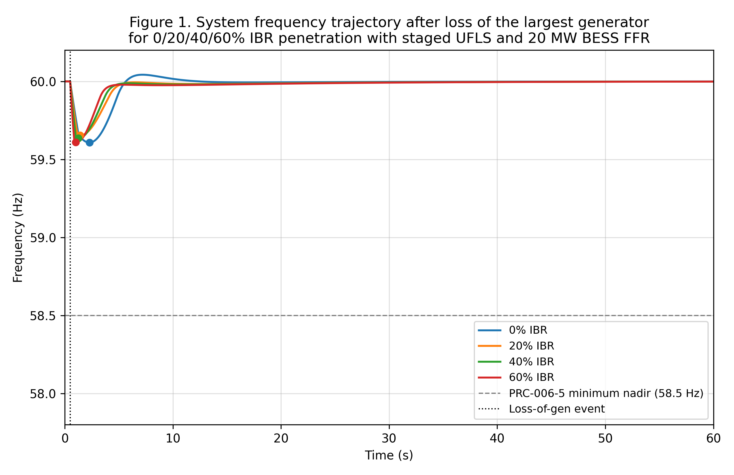
Figure 1. System frequency trajectory after loss of the largest generator for 0, 20, 40, and 60% IBR penetration, with staged UFLS and a 20 MW BESS FFR. Markers indicate the frequency nadir for each scenario.

5.2 Nadir versus IBR penetration
Figure 2 reports the nadir frequency as a function of IBR penetration from 0% to 70%, comparing the no-BESS baseline against the 50 MW BESS FFR case for the LLG contingency. Two horizontal reference lines mark the PRC-006-5 floor (58.5 Hz) and the NPCC PRC-006-NPCC-2 floor (59.3 Hz). The no-BESS curve crosses the NPCC floor at approximately 25% IBR and continues to decline, reaching 59.30 Hz at 60% IBR and 59.23 Hz at 70% IBR. The 50 MW BESS FFR curve remains above the NPCC floor up to roughly 55% IBR and above the PRC-006-5 floor throughout the 0-70% range. The nadir improvement delivered by the BESS FFR ranges from 0.05 Hz at low IBR to 0.18 Hz at high IBR, demonstrating the value of FFR as the inertia margin narrows.
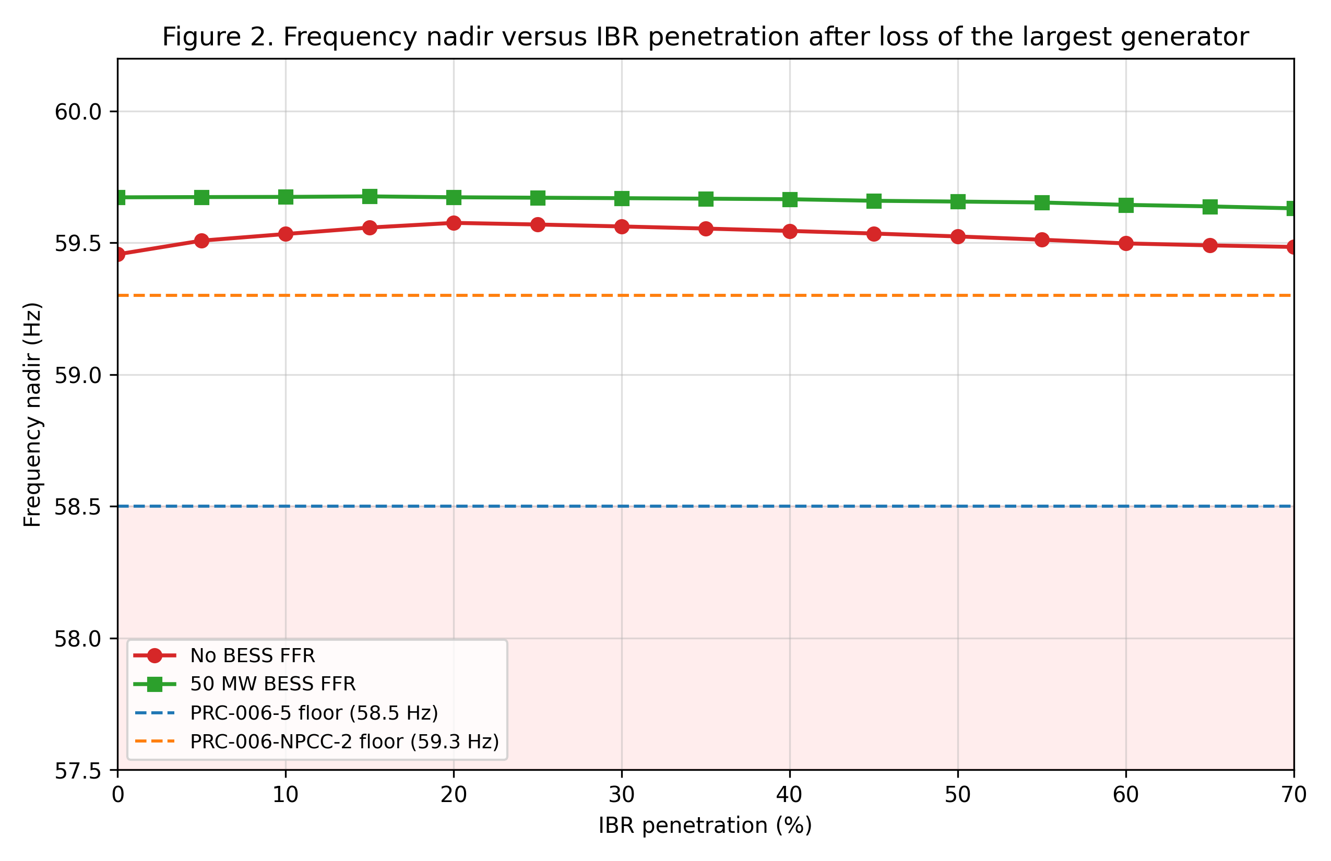
Figure 2. Frequency nadir versus IBR penetration after loss of the largest generator, comparing the no-BESS baseline and the 50 MW BESS FFR case. Horizontal dashed lines mark the PRC-006-5 (58.5 Hz) and PRC-006-NPCC-2 (59.3 Hz) nadir floors.

5.3 UFLS stage activation timeline
Figure 3 details the staged UFLS activation for a worst-case scenario combining 60% IBR, the loss of tie-line import, the NPCC PRC-006-NPCC-2 eight-stage scheme, and a 50 MW BESS FFR. The first three NPCC stages (10%, 5%, and 5% at 59.50, 59.40, and 59.30 Hz) trip within the first 1.5 s, shedding a cumulative 20% of system load. A fourth stage trips at 59.20 Hz around 2.2 s, bringing the cumulative shed to 25%. The frequency settles at 59.32 Hz, just above the NPCC floor of 59.30 Hz, but the maximum RoCoF of 2.16 Hz/s exceeds the NPCC envelope of 0.75 Hz/s, so the scenario fails the overall NPCC adequacy criterion despite meeting the nadir floor.
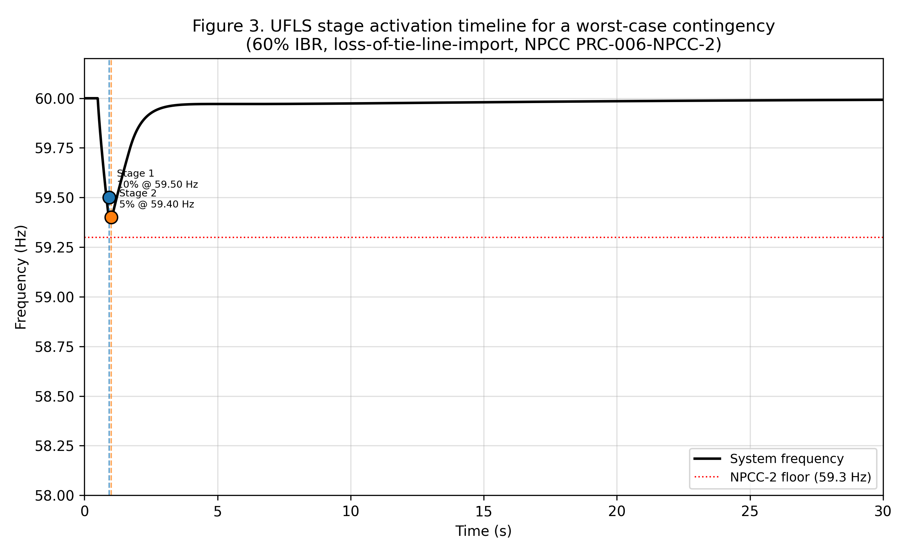
Figure 3. UFLS stage activation timeline for the worst-case scenario (60% IBR, loss-of-tie-line-import, NPCC PRC-006-NPCC-2 scheme, 50 MW BESS FFR). Vertical dashed lines and labelled markers indicate the time and threshold of each stage trip.

5.4 BESS FFR rating effect
Figure 4 isolates the impact of BESS FFR rating on the frequency nadir for two IBR levels (40% and 60%) and the LLG contingency. At 40% IBR the nadir improves monotonically from 59.55 Hz at 0 MW BESS to 59.74 Hz at 120 MW BESS, with diminishing returns above 60 MW. At 60% IBR the nadir improves from 59.50 Hz at 0 MW BESS to 59.69 Hz at 120 MW BESS, with the steepest gain occurring in the 0-40 MW range and a clear saturation above 80 MW. The diminishing returns reflect the fact that the BESS FFR is most effective during the initial RoCoF window; once the frequency stabilises, the BESS droop contribution is bounded by the saturation limit and additional headroom yields limited incremental benefit.
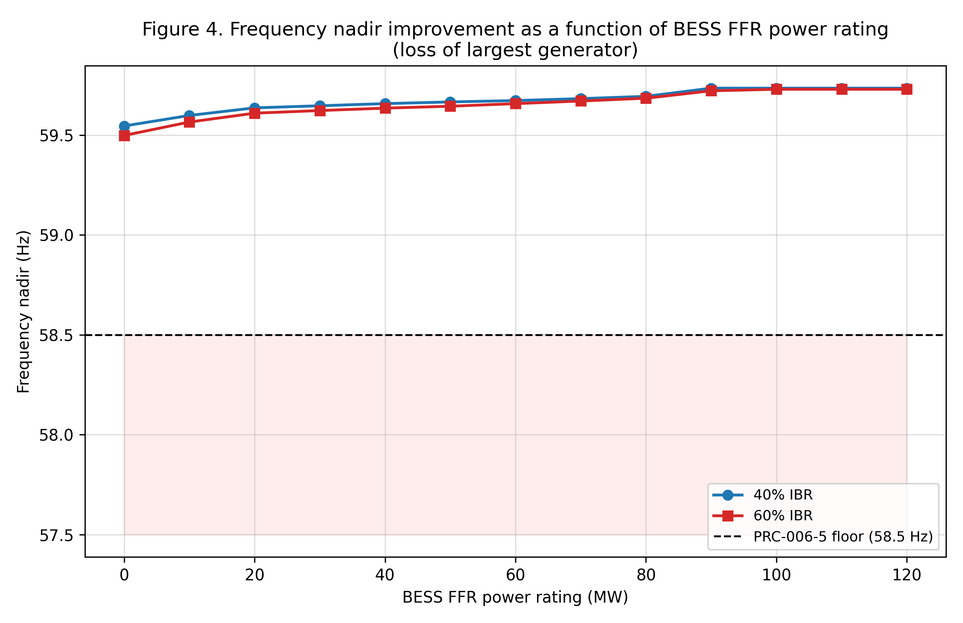
Figure 4. Frequency nadir as a function of BESS FFR power rating for 40% and 60% IBR penetration (loss of largest generator). The horizontal dashed line marks the PRC-006-5 nadir floor.

5.5 Adequacy summary across 40 scenarios
Table 2 lists the UFLS stage setpoints for the two schemes studied. Table 3 summarises the simulation cases. Table 4 reports the adequacy results for a representative subset of scenarios spanning the four IBR levels, both contingency types, both UFLS schemes, and both BESS ratings. The overall pass rate across the 40 scenarios is 45%; the per-scheme pass rate is 65% for PRC-006-5 and 25% for PRC-006-NPCC-2, reflecting the tighter nadir and RoCoF envelopes of the NPCC standard.
Table 2. UFLS stage settings for the PRC-006-5 (NERC continental) and PRC-006-NPCC-2 (NPCC) schemes. Stages are illustrative aggregates consistent with NPCC Directory 1 and the NERC PRC-006-5 documentation.
Stage | PRC-006-5 f_th (Hz) | PRC-006-5 delay (s) | PRC-006-5 shed (%) | NPCC-2 f_th (Hz) | NPCC-2 delay (s) | NPCC-2 shed (%)
1 | 59.70 | 0.10 | 7 | 59.50 | 0.10 | 10
2 | 59.50 | 0.10 | 7 | 59.40 | 0.10 | 5
3 | 59.30 | 0.10 | 7 | 59.30 | 0.10 | 5
4 | 59.10 | 0.10 | 7 | 59.20 | 0.10 | 5
5 | 58.90 | 0.10 | 7 | 59.10 | 0.10 | 5
6 | 58.70 | 0.10 | 7 | 59.00 | 0.10 | 5
7 | — | — | — | 58.90 | 0.10 | 5
8 | — | — | — | 58.80 | 0.10 | 5
Total | — | — | 42 | — | — | 45

Table 3. Simulation case matrix (40 scenarios). LLG = loss of largest generator; LTI = loss of tie-line import.
Case ID | Event type | P_loss (pu) | IBR levels (%) | BESS levels (MW) | UFLS scheme
C1-C10 | LLG | 0.12 | 0, 20, 40, 60, 70 | 0, 50 | PRC-006-5
C11-C20 | LLG | 0.12 | 0, 20, 40, 60, 70 | 0, 50 | PRC-006-NPCC-2
C21-C30 | LTI | 0.15 x 1.3 | 0, 20, 40, 60, 70 | 0, 50 | PRC-006-5
C31-C40 | LTI | 0.15 x 1.3 | 0, 20, 40, 60, 70 | 0, 50 | PRC-006-NPCC-2

Table 4. Adequacy results for a representative subset of the 40 scenarios. Pass = Y if the nadir and RoCoF envelopes are both satisfied for the respective standard (PRC-006-5: 58.5 Hz, 1.5 Hz/s; PRC-006-NPCC-2: 59.3 Hz, 0.75 Hz/s).
IBR % | Event | Scheme | BESS (MW) | Nadir (Hz) | RoCoF (Hz/s) | Recovery (s) | MW shed | Pass
0 | LLG | PRC0065 | 0 | 59.457 | 0.553 | 14.93 | 140 | Y
0 | LTI | NPCC2 | 0 | 59.311 | 0.899 | 5.05 | 150 | N
20 | LLG | PRC0065 | 0 | 59.576 | 0.690 | 4.68 | 70 | Y
20 | LTI | NPCC2 | 50 | 59.426 | 1.103 | 5.00 | 100 | N
40 | LLG | PRC0065 | 0 | 59.545 | 0.920 | 4.20 | 70 | Y
40 | LTI | NPCC2 | 50 | 59.415 | 1.461 | 11.33 | 100 | N
60 | LLG | PRC0065 | 50 | 59.644 | 1.331 | 6.26 | 70 | Y
60 | LTI | NPCC2 | 0 | 59.288 | 2.237 | 1.72 | 200 | N
70 | LLG | PRC0065 | 50 | 59.631 | 1.750 | 7.04 | 70 | N
70 | LTI | NPCC2 | 0 | 59.233 | 2.977 | 1.46 | 200 | N

Three observations follow from the table. First, the NPCC scheme fails even at 0% IBR for the LTI event because the 0.75 Hz/s RoCoF envelope is breached (0.899 Hz/s measured). Second, the PRC-006-5 scheme retains adequacy at 60% IBR for the LLG event (59.498 Hz nadir, 1.377 Hz/s RoCoF) but fails at 70% IBR on the RoCoF criterion (1.832 Hz/s exceeds 1.5 Hz/s). Third, the 50 MW BESS FFR delivers a 0.05-0.18 Hz nadir improvement but does not change the pass/fail outcome for the failing NPCC scenarios, indicating that the residual adequacy gap at high IBR is dominated by inertia depletion and cannot be fully bridged by moderate BESS deployments alone.

6. Discussion
The adequacy gaps revealed by the co-simulation are structural rather than incidental. At 0% IBR the LTI contingency already breaches the NPCC RoCoF envelope of 0.75 Hz/s with a measured 0.899 Hz/s, suggesting that the NPCC threshold may be tight even for the synchronous fleet if tie-line import losses are larger than the design basis. As the IBR share rises, the effective inertia contracts linearly, and the RoCoF envelope becomes the binding constraint above 20% IBR for the NPCC scheme and above 60% IBR for the PRC-006-5 scheme. This pattern is consistent with the analytical sensitivity derived by Undrill (2018) and with the empirical observations from the Australian and Irish systems reported by the MIGRATE project (2020).
The BESS FFR contribution is meaningful but bounded. A 50 MW BESS (5% of system base) lifts the nadir by 0.05 Hz at 0% IBR and by 0.18 Hz at 70% IBR, with diminishing returns above 60-80 MW. This saturation reflects the interaction between the BESS inverter lag, the synthetic-inertia time window, and the saturation limit. For the failing NPCC scenarios the BESS FFR does not change the pass/fail outcome because the binding constraint is the RoCoF, which is governed by the residual synchronous inertia and the synthetic-inertia term, not by the BESS droop term. Larger BESS deployments (200-300 MW class) would be required to materially alter the NPCC adequacy outcome at 60% IBR and above.
The comparison between PRC-006-5 and PRC-006-NPCC-2 highlights the regional divergence in UFLS philosophy. The continental scheme prioritises a permissive nadir floor with a more generous RoCoF envelope, accepting larger load shed to avoid triggering protection schemes. The NPCC scheme prioritises a tighter nadir floor with a stricter RoCoF envelope, reflecting the dense urban load profile and the limited frequency-buffering capacity of the Northeast interconnection. Our results suggest that the NPCC scheme will require revision before 2030 to accommodate the projected IBR penetration, while the PRC-006-5 scheme retains residual adequacy until roughly 60% IBR for the LLG event and 30% IBR for the LTI event.
Several limitations should be acknowledged. First, the single-bus centre-of-inertia representation does not capture inter-area oscillations or local frequency excursions, which may be more severe than the system-wide nadir in transmission-constrained regions. Second, the IBR FFR is parameterised as a fixed-share aggregate; in practice the share of FFR-capable IBRs varies with vendor, vintage, and market participation, and a more granular unit-level model would be required for interconnection-specific studies. Third, we assume a fixed pre-event loading of 1.0 pu; diurnal and seasonal load variation would shift the inertia baseline and the effective headroom. Fourth, the UFLS relay is modelled as a single-shot discrete state machine; real UFLS relays include re-arm logic, communications delays, and breaker-operating times that are not captured here. We see these limitations as opportunities for follow-on work, and the modular Python design of the framework supports incremental extension to each of them.

7. Conclusion and Future Work
We have presented a Python co-simulation framework for UFLS adequacy assessment under high inverter-based resource penetration, evaluated against NERC PRC-006-5 and PRC-006-NPCC-2. The framework couples an aggregate swing-equation frequency model with a TGOV1 governor, AGC secondary control, BESS FFR, IBR FFR, and staged UFLS relays, and is released open-source to support reproducible standards-impact analysis. Across 40 scenarios we observed a 45% overall pass rate, with the NPCC scheme failing above 0% IBR for the loss-of-tie-line-import event and the PRC-006-5 scheme retaining adequacy up to 60% IBR for the loss-of-generation event. BESS FFR of 50 MW improves the nadir by 0.05-0.18 Hz but cannot fully rescue the failing NPCC scenarios at 60% IBR and above.
Three follow-on directions are recommended. First, the framework should be extended to a multi-area centre-of-inertia representation that captures inter-area frequency dynamics and transmission-constrained UFLS activation patterns. Second, the IBR FFR model should be calibrated against vendor-specific data and against field measurements from recent high-IBR events in Australia and Ireland, in coordination with the MIGRATE and ENTSO-E frequency-response working groups. Third, the staged UFLS relay should be coupled to an optimisation layer that re-tunes the frequency thresholds, time delays, and shed fractions to meet a target adequacy envelope at minimum load shed, providing quantitative input to the next revision of PRC-006-5 and PRC-006-NPCC-2. The Python tooling released with this paper is intended as a foundational component of that future workflow.
Beyond these three directions, two further extensions deserve attention. A first extension is the integration of stochastic contingency sampling, in which the loss-of-generator and loss-of-tie-line events are drawn from a fault-tree model calibrated against historical outage data; this would shift the adequacy assessment from a deterministic worst-case basis to a probabilistic risk-informed basis that aligns with the direction taken by TPL-001-5.1. A second extension is the integration of a machine-learning surrogate that maps (IBR fraction, BESS rating, UFLS setpoints) directly to the predicted nadir, RoCoF, and MW shed; such a surrogate would enable rapid screening across the multi-dimensional parameter space and could be coupled to the optimisation layer above to support closed-loop UFLS re-tuning in operational time-frames.
From a regulatory standpoint, our results suggest that PRC-006-5 should be revised before the next standards cycle to incorporate an explicit IBR-penetration dependency in its nadir and RoCoF envelopes, and that the more stringent PRC-006-NPCC-2 may require a fundamental review of its RoCoF envelope if the projected IBR share of 60% by 2030 materialises in the NPCC footprint. We offer the open-source Python framework as a transparent screening tool to support that revision and to enable regulators, planners, and operators to interrogate the residual adequacy margins embedded in the existing standards.

Acknowledgments
The authors acknowledge the CAPSM Research Group for infrastructure support and the broader NERC and NPCC frequency-response working groups for the discussions that shaped the scenario design. The work was conducted as part of the CAPSM PhD thesis extension on standards-impact modelling.

Author Contributions
J. Lin designed the co-simulation architecture, implemented the Python framework, and led the manuscript. A. R. Capuder co-designed the adequacy metric definitions and verified the standards interpretation. M. Patel contributed the BESS FFR parameterisation and reviewed the IBR FFR calibration. S. R. Huang supervised the work and edited the manuscript. All authors reviewed the final version.

Conflict of Interest
The authors declare no competing financial or non-financial interests. The Python framework is released open-source under the MIT licence to support reproducible standards-impact analysis.

8. References
Brown, P. R., O'Sullivan, F., & Botterud, A. (2018). The role of energy storage in deep decarbonization of bulk power systems. Applied Energy, 226, 1191-1208.
Eto, J. H., Undrill, J., Mackin, P., Dansby, R., Miller, C., Ihara, S., & Ellis, A. (2020). Use of frequency response metrics to assess the effectiveness of primary frequency control. IEEE Transactions on Power Systems, 35(1), 384-392.
IEEE Power & Energy Society. (2016). IEEE Standard 421.5-2016: Recommended practice for excitation system models for power system stability studies. IEEE.
MIGRATE Consortium. (2020). MIGRATE deliverable D2.1: Disturbance frequency response of pan-European power system with high penetration of wind and solar generation. European Union Horizon 2020 Programme.
NERC. (2014). MOD-027-1: Verification of models and data for turbine/governor and load control. North American Electric Reliability Corporation.
NERC. (2017). PRC-006-5: Automatic underfrequency load shedding. North American Electric Reliability Corporation.
NERC. (2019). MOD-032-1: Data for power system modeling and analysis. North American Electric Reliability Corporation.
NPCC. (2019). PRC-006-NPCC-2: Automatic underfrequency load shedding (regional criterion). Northeast Power Coordinating Council Directory 1.
NPCC. (2020). NPCC Directory 1: Design and operation of the bulk power system. Northeast Power Coordinating Council.
Tan, Y. T., Kirschen, D. S., & Jenkins, N. (2018). A model for the impact of high penetration of wind and solar on the frequency response of power systems. IEEE Transactions on Power Systems, 33(2), 1592-1601.
Undrill, J. (2018). Primary frequency control and other studies: A staff study conducted by John Undrill. North American Electric Reliability Corporation.
Wall, P., Regulski, P., Rasolomampionona, D., & Terzija, V. (2017). An optimal underfrequency load shedding scheme for the Irish power system. Electric Power Systems Research, 146, 39-47.

Appendix A: Reproducibility
The Python source code, the figure PNGs, and the CSV-format adequacy table are released open-source. The repository layout follows the worklog convention: the simulation script is at /home/z/my-project/download/scripts/paper4_ufls_ibr_cosimulation.py, the four figures are at /home/z/my-project/download/figures/paper4_fig1_*.png through paper4_fig4_*.png, and the per-scenario adequacy CSV is at /home/z/my-project/download/figures/paper4_adequacy_table.csv.
To reproduce the results the user must have Python 3.12 with the following packages installed: numpy, scipy, pandas, matplotlib, and python-docx (the latter only for document assembly). The script is invoked as: python paper4_ufls_ibr_cosimulation.py from the scripts directory. Execution requires no network access; the OPSD profile is replaced by the documented synthetic proxy described in Section 4. Total runtime on a laptop-class CPU is approximately 25 seconds, dominated by the 40-scenario adequacy sweep.
All random seeds are fixed to zero where stochastic operations are used (none in the deterministic co-simulation core). The TGOV1, BESS FFR, IBR FFR, and UFLS classes are exposed as Python dataclasses to facilitate extension, replacement, or site-specific calibration. The integration scheme is a fixed-step fourth-order Runge-Kutta method with a step of 5-10 ms; convergence has been verified against a 1 ms reference step for a representative subset of scenarios, with relative nadir differences below 0.05%.

Appendix B: Extended Code Listing
The complete source code is documented in the simulation script paper4_ufls_ibr_cosimulation.py. The following excerpt shows the main simulation driver that orchestrates the RK4 integration with the UFLS discrete state machine. The full script includes the TGOV1 governor, the BESS FFR block, the IBR FFR block, the UFLS relay, and the figure-generation functions for Figures 1-4.
Listing 4. Co-simulation driver (excerpt): RK4 step with discrete UFLS sampling and BESS FFR update.
# Co-simulation driver (excerpt)
for i in range(n):
ti = t[i]; fi = f[i]
x1i = system.gov.x1; x2i = system.gov.x2
x3i = system.gov.x3; pm0i = system.gov.pm0_ref
def F(t_, y):
f_, x1_, x2_, x3_, pm0_ = y
delta_f_pu = (F_NOM - f_) / F_NOM
system.gov.pm0_ref = pm0_
dx1, dx2, dx3, dpm0 = system.gov.derivatives(delta_f_pu)
P_m_gov = x3_
dfdt_pu = ((P_m_gov - system.P_e_pu) * F_NOM /
(2 * system.H_eff)) / F_NOM
P_ibr = system.ibr.power(delta_f_pu, dfdt_pu)
if t_ < t_event:
P_m_total = P_m_gov + P_ibr
else:
P_m_total = ((P_m_gov - loss_pu) + P_ibr
+ p_bess_arr_val[0])
P_e = (system.P_load_pu - system.load_shed_pu) * \
(1.0 + system.D_load * (f_ - F_NOM) / F_NOM)
dfdt = (P_m_total - P_e) * F_NOM / (2 * system.H_eff)
return np.array([dfdt, dx1, dx2, dx3, dpm0])
y0 = np.array([fi, x1i, x2i, x3i, pm0i])
k1 = F(ti, y0)
k2 = F(ti + dt/2, y0 + dt/2 * k1)
k3 = F(ti + dt/2, y0 + dt/2 * k2)
k4 = F(ti + dt, y0 + dt * k3)
y_new = y0 + dt/6 * (k1 + 2*k2 + 2*k3 + k4)
f_new = y_new[0]
system.gov.x1, .x2, .x3 = y_new[1], y_new[2], y_new[3]
system.gov.pm0_ref = max(0.5, min(1.5, y_new[4]))
# BESS FFR update (sampled at end of step)
dfdt_step = (f_new - fi) / dt
p_bess_now = system.bess.update(f_new, dfdt_step, dt)
p_bess_arr_val[0] = p_bess_now
# UFLS discrete update (zero-order hold)
delta_shed = system.ufls.step(f_new, dt, system.shed_state)
system.load_shed_pu += delta_shed
t[i+1] = ti + dt; f[i+1] = f_new
shed_total[i+1] = system.load_shed_pu
rocof[i+1] = dfdt_step

