title: “Visualizations”
author: “The Energy Generators”
date: “2022-11-20”
output: word_document

A visualization of each column in your data set. Choose an appropriate visualization based on the type of data in each column. If your data set has more than 10 columns, you can limit yourself to visualizing the 10 columns that you are most interested in.
##view(visualizationData)
ggplot(visualizationData, aes(y= reorder(YEAR, YEAR, length))) +
geom_bar()
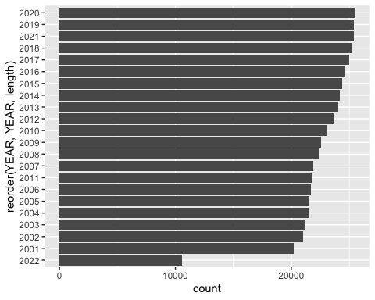
ggplot(visualizationData, aes(y=reorder(MONTH, MONTH, length))) +
geom_bar()
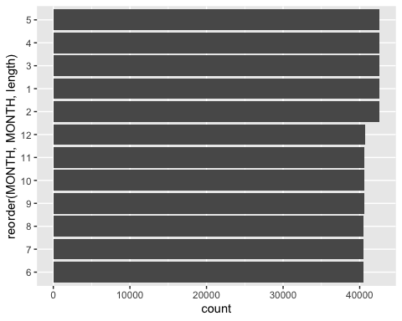
ggplot(visualizationData, aes(y=reorder(STATE, STATE, length))) +
geom_bar()
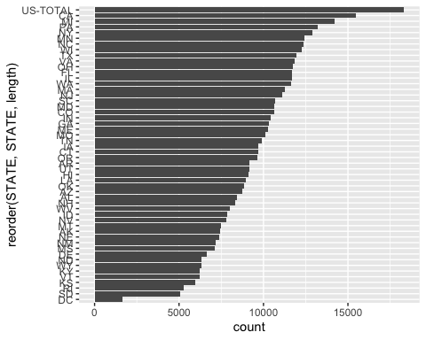
ggplot(visualizationData, aes(y=reorder(TYPE_OF_PRODUCER, TYPE_OF_PRODUCER, length))) +
geom_bar()
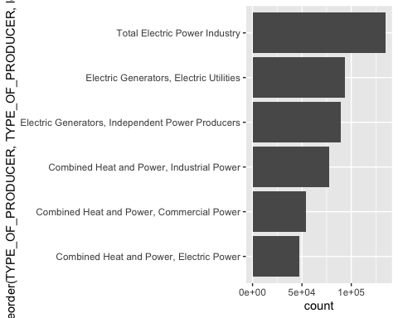
ggplot(visualizationData, aes(y=reorder(ENERGY_SOURCE, ENERGY_SOURCE, length))) +
geom_bar()
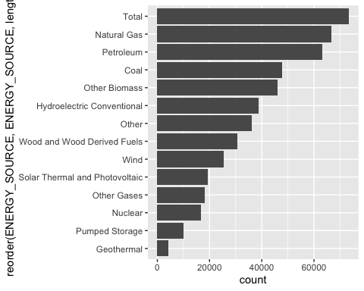
ggplot(visualizationData, aes(x=GENERATION_Megawatthours)) +
geom_histogram(bins = 2.2 )
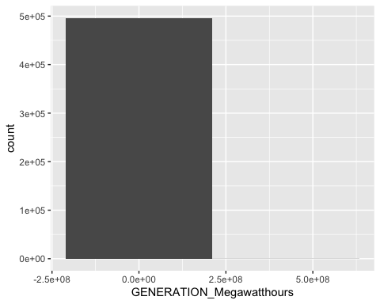

At least 5 visualizations that show the relationships between pairs of columns in your data set. You can choose whichever 5 (or more) pairs of columns you are interested in.
- TYPE_OF_PRODUCER vs GENERATION_Megawatthours
ProdVsGen <- visualizationData
##ProdVsGen
##Sum up enegry Generation by producer
totalByMonth <- ProdVsGen %>% group_by(TYPE_OF_PRODUCER) %>%
summarize(totalProduction = sum(GENERATION_Megawatthours))
##totalBySource
## create bar graph for total production
ggplot(data = totalByMonth) +
geom_bar(aes(y = reorder(TYPE_OF_PRODUCER, totalProduction), x = totalProduction), stat = "identity") +
labs(title = "Total GENERATION_Megawatthours by PRODUCER",
x = "GENERATION_Megawatthours",
y = "Type of Producer")
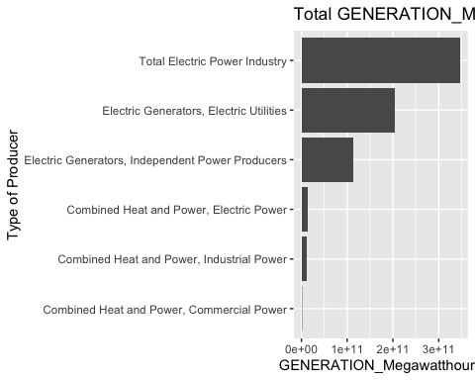
- MONTH vs GENERATION_Megawatthours
MonthVsGen <- visualizationData
##MonthVsGen
##Sum up enegry Generation by month
totalByMonth <- MonthVsGen %>% group_by(MONTH) %>%
summarize(totalProduction = sum(GENERATION_Megawatthours))
##totalBySource
## create bar graph for total production
ggplot(data = totalByMonth) +
geom_bar(aes(y = reorder(MONTH, totalProduction), x = totalProduction), stat = "identity") +
labs(title = "Total GENERATION_Megawatthours by MONTH",
x = "GENERATION_Megawatthours",
y = "MONTH (Numeric)")
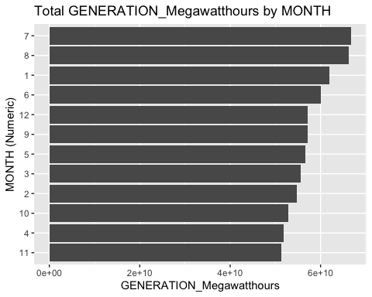
- YEAR vs GENERATION_Megawatthours
YearVsGen <- visualizationData
##YearVsGen
##Sum up enegry Generation by year
totalByYear <- YearVsGen %>% group_by(YEAR) %>%
summarize(totalProduction = sum(GENERATION_Megawatthours))
##totalBySYear
## create bar graph for total production
ggplot(data = totalByYear) +
geom_bar(aes(y = reorder(YEAR, totalProduction), x = totalProduction), stat = "identity") +
labs(title = "Total GENERATION_Megawatthours by Year",
x = "GENERATION_Megawatthours",
y = "YEAR")
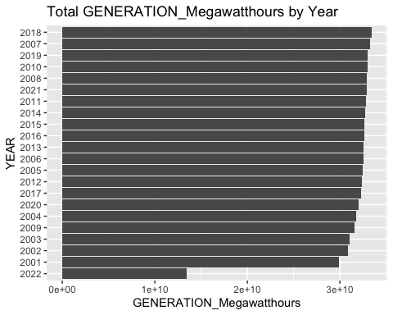 4. STATE VS GENERATION_Megawatthours
stateVsGen <- visualizationData
##stateVsGen
##Sum up enegry Generation by state
totalByState <- stateVsGen %>% group_by(STATE) %>%
summarize(totalProduction = sum(GENERATION_Megawatthours)) %>%
filter(!STATE=="US-TOTAL") ## remove Total category
##totalBySource
## create bar graph for total production
ggplot(data = totalByState) +
geom_bar(aes(y = reorder(STATE, totalProduction), x = totalProduction), stat = "identity") +
labs(title = "Total GENERATION_Megawatthours by STATE",
x = "GENERATION_Megawatthours",
y = "STATE")
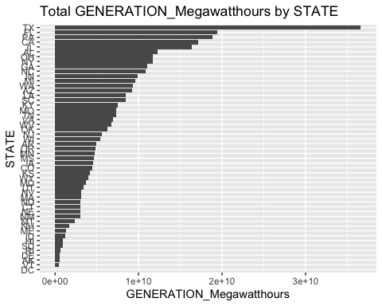 5. ENERGY_SOURCE vs GENERATION_Megawatthours
sourceVsGen <- visualizationData
##stateVsGen
##Sum up enegry Generation by source
totalBySource <- sourceVsGen %>% group_by(ENERGY_SOURCE) %>%
summarize(totalProduction = sum(GENERATION_Megawatthours)) %>%
filter(!ENERGY_SOURCE=="Total") ## remove Total category
##totalBySource
## create bar graph for total production
ggplot(data = totalBySource) +
geom_bar(aes(y = reorder(ENERGY_SOURCE, totalProduction), x = totalProduction), stat = "identity") +
labs(title = "Total GENERATION_Megawatthours by ENERGY_SOURCE",
x = "GENERATION_Megawatthours",
y = "ENERGY_SOURCE")
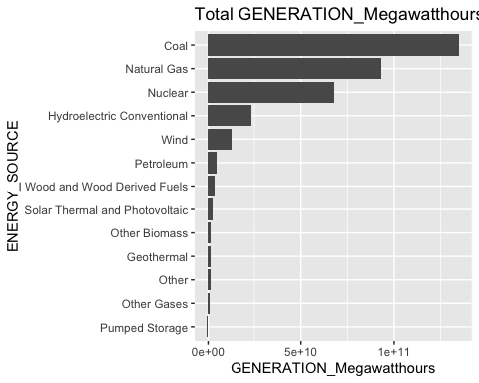

A brief discussion (one or two sentences) of each visualization. In your discussion, interpret the visualization and highlight any interesting patterns or relationships that the visualization reveals.
- TYPE_OF_PRODUCER vs GENERATION_Megawatthours Graphing the TYPE_OF_PRODUCER by GENERATION shows that electric produces the most for the country, Total Electric Power Industry being the leader.
- MONTH vs GENERATION_Megawatthours Graphing the MONTH by GENERATION shows that the months July and August produce the most amount of energy. These are the summer months and weather changes could have increased demand for energy.
- YEAR vs GENERATION_Megawatthours Graphing YEAR vs GENERATION shows that 2018 procduced the greatest total amount of energy for all states.
- STATE VS GENERATION_Megawatthours
Graphing STATE vs GENERATION shows Texas is by far the largest energy producer in the country. FL, PA, CA and IL also produce much more energy than other states. Since there are so many states, we will likely need to focus our anaylsis on key states.
- ENERGY_SOURCE vs GENERATION_Megawatthours
Graphing the ENERGY_SOURCE by GENERATION shows that there are 5 main energy sources in the US. This will inform which energy sources we want to evelaute in the final report. Unless something interesting is occuring in those 8 categories - it probably isn’t worth including in our analysis.

