Lab 1 AM Modulation & Demodulation
Prepared by :
Tadala Mitumbili

Due date :
21 May 2026
Partner : Yauvana Naidoo

Introduction

Mathematical description
In this lab we will be investigating the use of DSB-LC and DSB-SC modulation and demodulation. Running DSB-SC and DSB-LC modulation and demodulation in Julia to examine waveforms and frequency spectra. We will use these simulations as a benchmark. In a practical circuit, we expect the waveform to resemble the simulation waveforms somewhat. We will also lok at these practical waveforms using the FFT.
For DSB-SC, the modulated signal φ(t) is formed as the product of a message signal x(t) and a sinusoidal carrier:
φ(t) = x(t) · cos(ω_c · t)
where ω_c = 2π·20,000 rad/s is the carrier angular frequency. For a sinusoidal message x(t) = cos(ω_m·t) with ω_m = 2π·1,000 rad/s, expanding using the product-to-sum identity gives:
φ(t) = ½·cos[(ω_c + ω_m)t] + ½·cos[(ω_c − ω_m)t]
This shows that the DSB-SC spectrum consists of two tones at 21 kHz (upper sideband, USB) and 19 kHz (lower sideband, LSB), with no carrier at 20 kHz.
For DSB-LC, a DC offset A is added to the message prior to multiplication:
φ_DSB-LC(t) = [x(t) + A] · cos(ω_c · t)
The modulation index m characterises the degree of amplitude variation and is defined as:
m = max{|x(t)|} / A
For sinusoidal modulation with x(t) = k·cos(ω_m·t), m = k/A. When m ≤ 1 the envelope of the signal never crosses zero and straightforward envelope detection is possible. When m > 1 (over-modulation), the envelope crosses zero and the recovered signal is distorted.

Demodulation techniques
DSB-SC demodulation is achieved by multiplying the received signal by a locally generated copy of the carrier (synchronous detection) and low-pass filtering the result:
φ(t)·cos(ω_c·t) = ½·x(t) + ½·x(t)·cos(2ω_c·t) →[LPF]→ ½·x(t)
The LPF removes the high-frequency term centred at 2ω_c = 40 kHz, recovering a scaled replica of the message. This method is phase-sensitive: if the local carrier has a phase error θ, the output amplitude is scaled by cos(θ), falling to zero at θ = 90°.
DSB-LC demodulation uses a diode envelope detector, which follows the positive peaks of the modulated waveform through a charging and discharging RC network. The time constant τ = RC must be chosen to track the envelope dynamics without being so slow that it clips the downward slope. For sinusoidal modulation the optimal condition is:

RC = 1 / (m · ω_m)

Methods

Equipment
Before coming to the lab we were required to complete the pre lab simulation in Julia In the lab we used the UCT amplitude modulation board which is shown in figure 1.
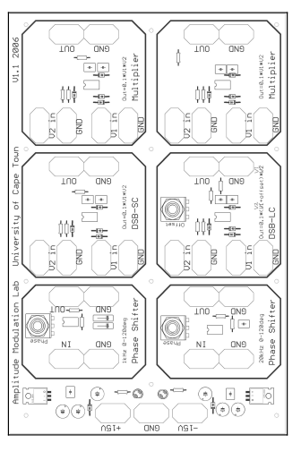
Figure 1 UCT amplitude modulation board

These board were used through the remainder of the practical to simulate DSB-LC and DSB-SC modulation and demodulation. The boards contain AD633JN analogue multipliers two phas shifters and asocited passive components. Aside from the provided assembled boards we also make use of a breadboard, a 15/-15V supply, an oscilloscope, as well as various passive components and a function generator.

Setup
To start, we want to connect the -15/+15V supply, which can be done by connecting 1 DC supply positive to +15V of the board and the negative to ground and connecting another DC supply negative to -15V terminal and the positive to ground. We will then be making use of the signal generators to generate a 20 kHz carrier signal and a 1 kHz modulating signal.
Ensuring the peak to peak of the 1 kHz is set to 4V_{pp} with an offset of 0V and the signal generator is set for high impedance load. Want to test oscilloscope probes to ensure they are working .Then want connect the two probes of the oscilloscope setting one to the modulating signal throughout the majority of the practical. We may need to adjust the trigger threshold of the oscilloscope to ensure a proper output wave on the screen. We would want it to trigger of the modulating wave which will remain constant through the practical this will be use as a sort of reference for the remainder of the practical. Want to set the trigger threshold to a rising edge with 0v threshold. Important to ensure both probes are set to x1. We connect channel 2 to the 1kHz modulating signal and use channel 2 to configure the trigger. This provides a more slow stable trigger rather than the high frequency carrier which . Channel 1 is then used to probe the 20kHz carieer signal.

2.3 DSB-SC Modulation
We generate DSB-SC form the product of the modulating waveform x(t) and carrier wave. Making used of the AD633 multiplier circuit which also provides amplification. We connect x(t) from generated 1kHz signal to V1-in input of the DSB-SC multiplier module. Carrier signal is connected to V2-in input. We can then observe the output of the multiplier
The AD633 multiplier transfer function is:
W = (X1 − X2)(Y1 − Y2) / 10 + Z
With X1 = x(t), X2 = 0, Y1 = cos(ω_c·t), Y2 = 0, Z = 0, this gives W = x(t)·cos(ω_c·t)/10. The factor of 0.1 is inherent to the AD633 device and is present in all multiplier outputs on the board. An additional series output resistance of 1 kΩ (R₁₆ on the circuit board) is present at each multiplier output. Then capture waveform for
- Nominal sine wave
- Modulating frequency varied
- Square wave modulating signal
- Square wave carrier

2.4 DSB-SC Demodulation – Synchronous Detection
The output of the DSB-SC module is then connected to V1-IN of the second multiplier module which effects serve as a demodulator.
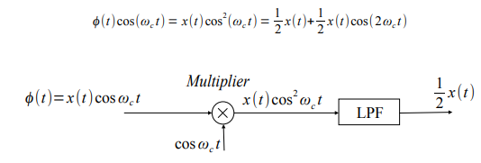
Figure 2 demodulation logic
As the carrier signal is also connected to V2-IN of both the modulator and demodulator to ensure the correct cos is used. We then pass output of the demodulator through a first order RC LPF. The filter is designed such that the 3dB frequency is above highest frequency component in the modulating signal.
$$x=\frac{1}{2πRC}$$
Worth noting that w ecan expect a phase shift of approximately 45 dgeree. As part of the board there is already a 1kΩ resistor present . Then observe the waveform in to the LPF in both time and frequency domain and the amplitude and waveshape of the out put of the LPF.

Then want to investigate the effect of phase error where by rather than demodulating by the correct cos(ω_ct) w einstead have cos(ω_ct+θ) where θ is the phase error. We can add this phase shift by passing the carrier signal throught the phase shifter which is capable of introducing phase shift from 0-120, before feeding it to the demodulation circuit.

2.5 DSB-LC Modulation
The DSB-LC AM signal can be attained by adding an offset to modulating signal
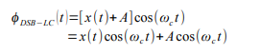
We take negative voltage pin X2 of the AD633 and add an offset A to modulating signal before multiplication. We can then control the offset by means of a potentiometer. We can connect the DSB-LC module inputs in the same manner as with the DSB-SC . the degree of amplitude fluctuation is characterized by the parameter known as the modulation index m
We want to then observe the following three cases:
- m<1 (modulation)
- m = 1 (maximum modulation)
- m > 1 (over modulation )

2.6 DSB-LC Demodulation – Envelope detector

For DSB-LC we make use of asynchronous detection, this form of detection does not require a multiplication with sinusoid signal that is synchronized with the carrier wave. Instead it makes use of an envelope detector which will need to be constructed. It consists of amplifier , envelope detector stage, LPF and HPF. The envelope detector should be tested in stages.
Output of the AD633 multiplier may be too small so we need to pass it through an amplifier. A TL071 or LF351 amplifier is used. The amplifier is configured as inverting amplifier with a gain of x7.9 using 27kΩ feedback resistor and 3.9kΩ input resistor. The envelope is then made by putting a 1N4148 silicon diode in series with the amplifier output to make a half wave rectifier. A parallel RC network is then added across the load to form the envelope detector.
The RC time constant should be cg=hosen to track the dynamics of the envelope
$$RC= \frac{1}{mω_{m}}$$
For modulation index 0.7 and frequency 1kHz
RC = 1 / (m·ω_m) = 1 / (0.7 × 2π × 1000) ≈ 0.227 ms

Values of R = 2.2kΩ and C 100nF were chosen. Giving a time constant of 0.22ms meaning the values selected are sufficient. Then test the rectifier is working. The LPF is the cascaded on to this after the envelope detector. Let R of LPF be 10kΩ with cutoff frequency of 2kHz let C = 10nF and for the high pass R = 100kΩ and cutoff frequency 500Hz and let C = 3.3nF. the series combination of these stages form a bandpass filter.

3 Experimental results ,observations and explanations

3.1 DSB-SC modulation
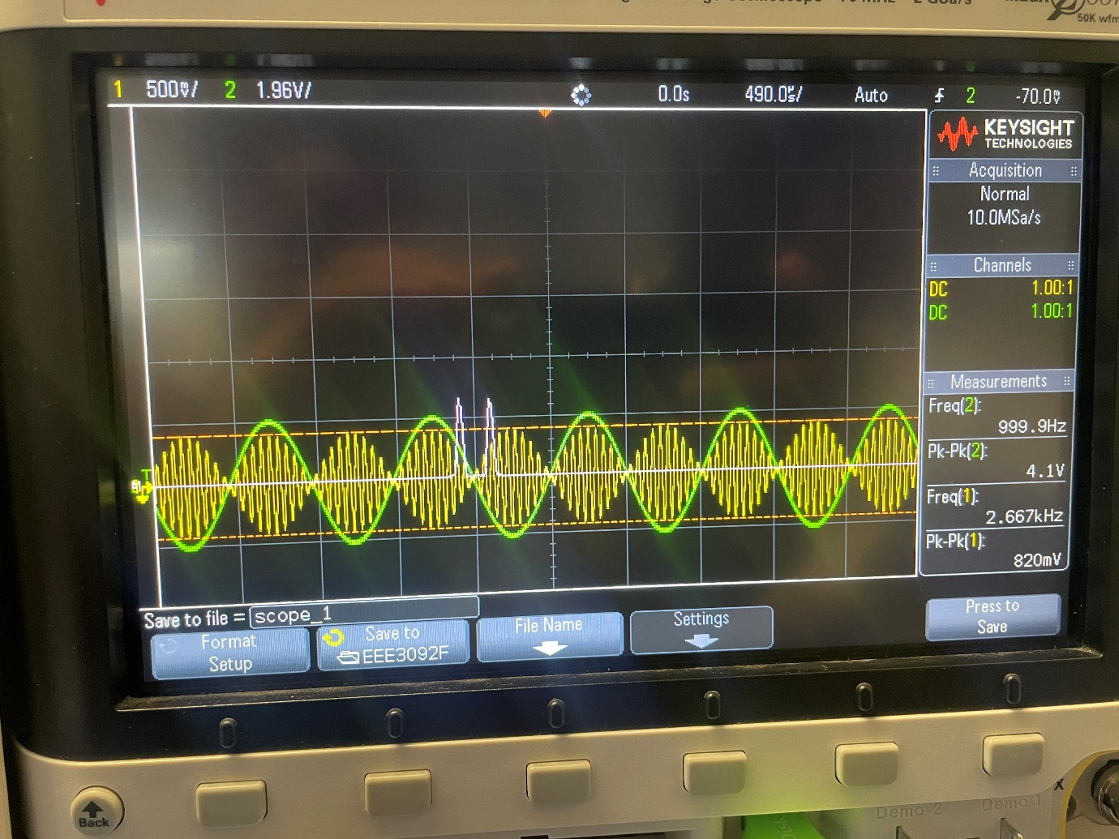
Figure 3 DSB-Sc modulated waveform along with the FFT
We have DSB-SC modulated waveform which is at the output of the AD633 multiplier. Channel one(yellow) is the carrier while channel 2(green) is modulating signal. A deifinig characteristic of this modulation technique is the carrier phase inverts by 180 degree when the message envelope crosses the zero axis. Additionally we can also see the FFT, the two spectral lines. No component of the carrier frequency is seen confirming that the carrier has been supressed. We see rather than a dirac delta function the spectral line shave a finite width, this is due to the FFT recording window duration. So rather than infinitely narrow pulse we get a sharp sinusoidal shape. In order to reduce sidebands w eusually applyb window function.
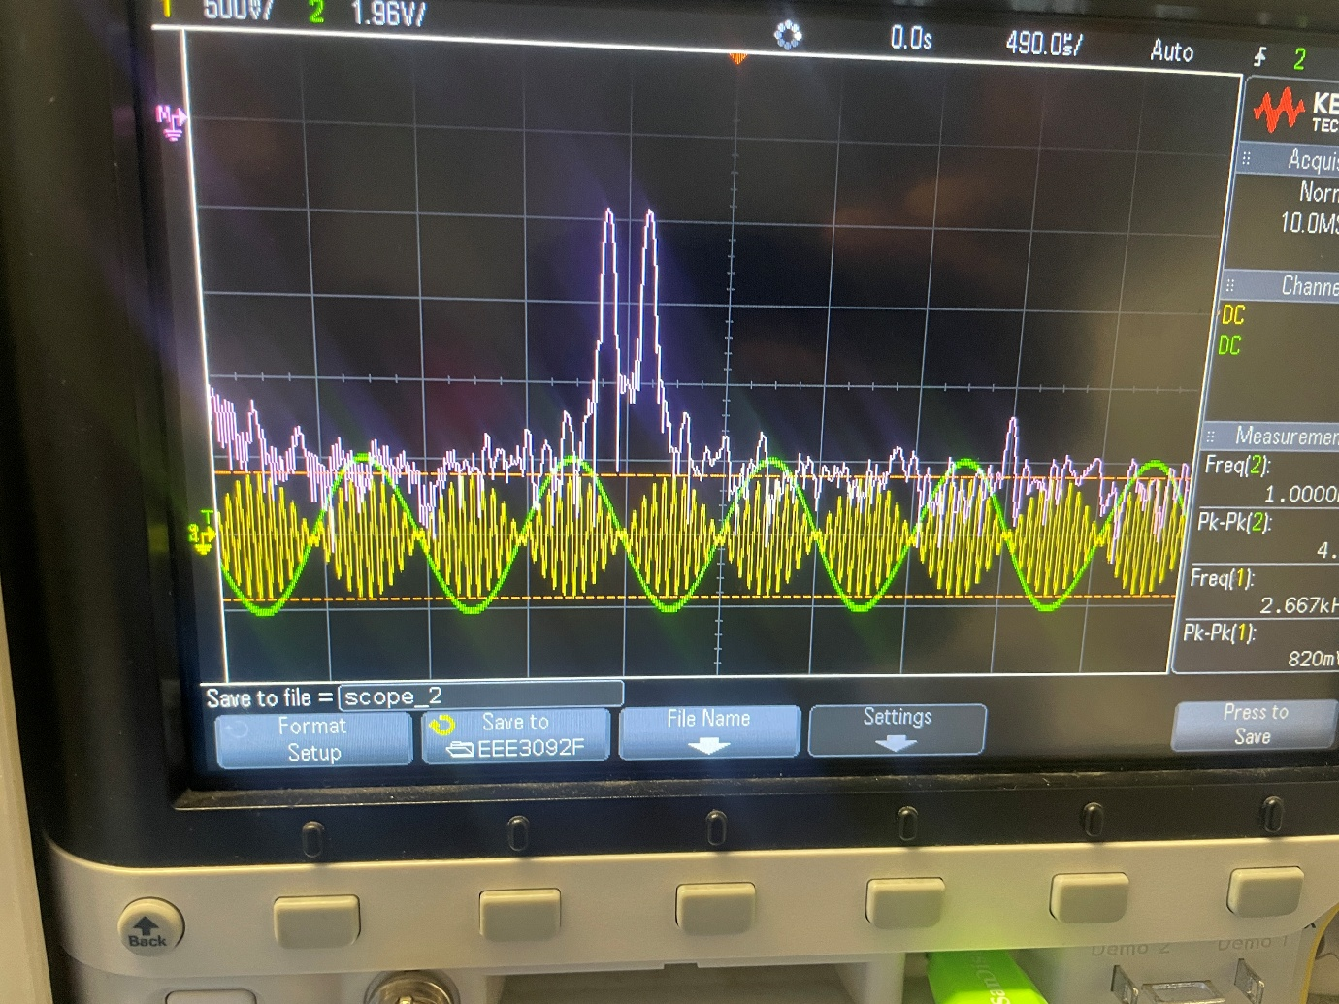
Figure 4 modulated DSB-SC waveform with FFt in decibels
In figure 4 we have the same signal but b=now we have the FFT in decibels rather than a linear scale. Viewing in dB allows us to see a larger range.
In terms of varying frequency sidebands move closer to or further from fc.
- Lower fm → sidebands closer together (LSB and USB closer to 20 kHz)
- Higher fm → sidebands spread further apart
The carrier remains suppressed regardless of fm.
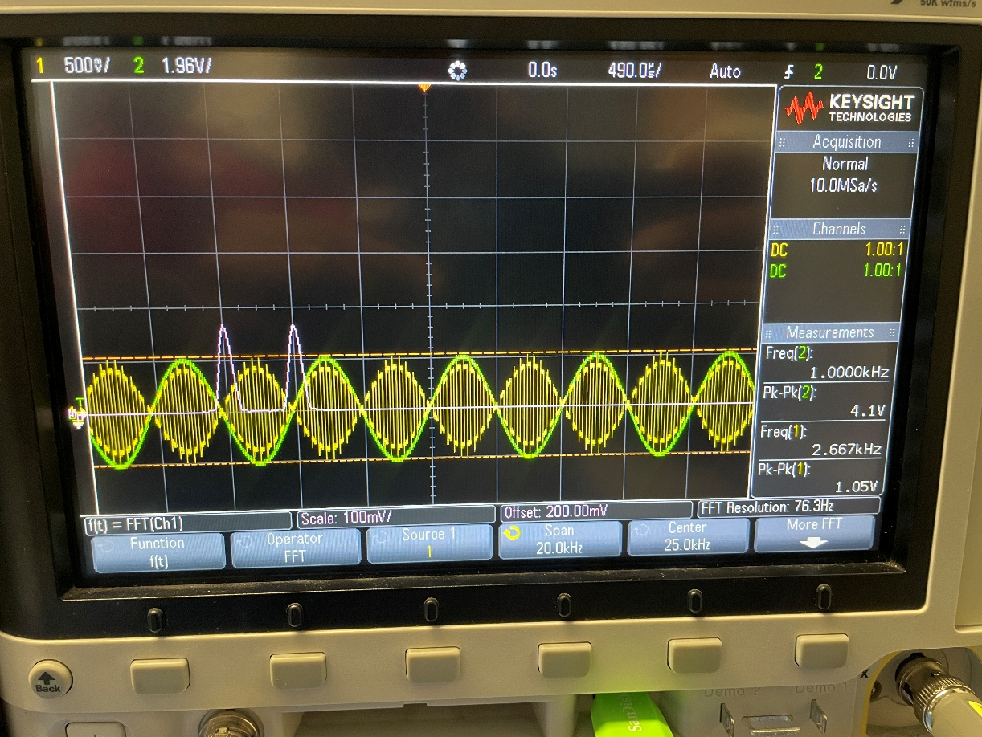
Figure 5 varied frequency high fm

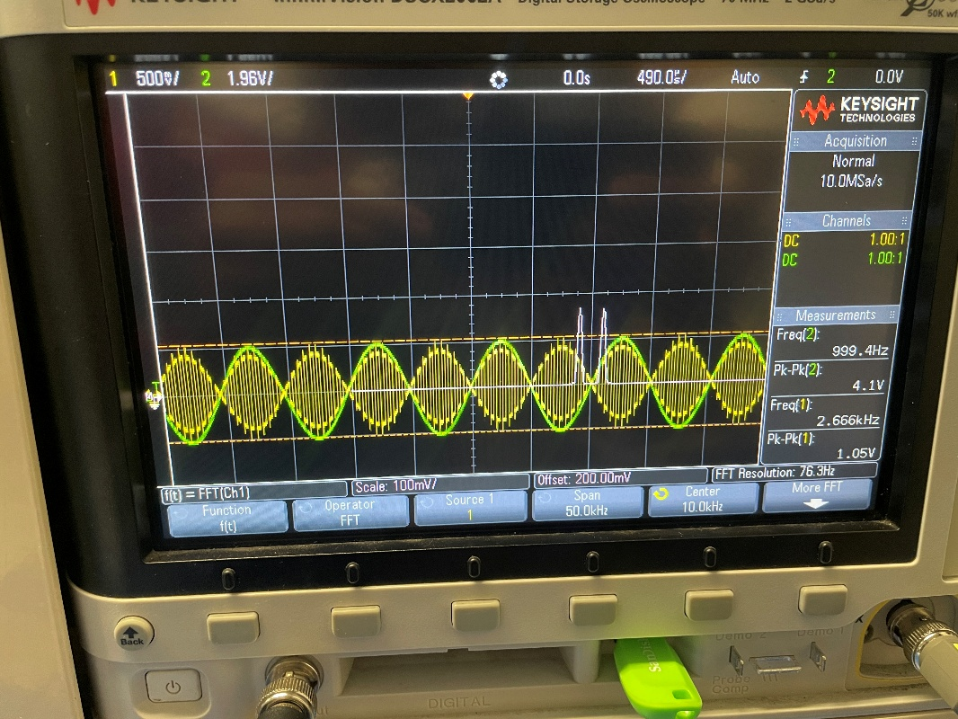
Figure 6varied frequency lower fm
If we are to use a square wave for our modulating signal rather than a Sine wave we get the signal in figure 7

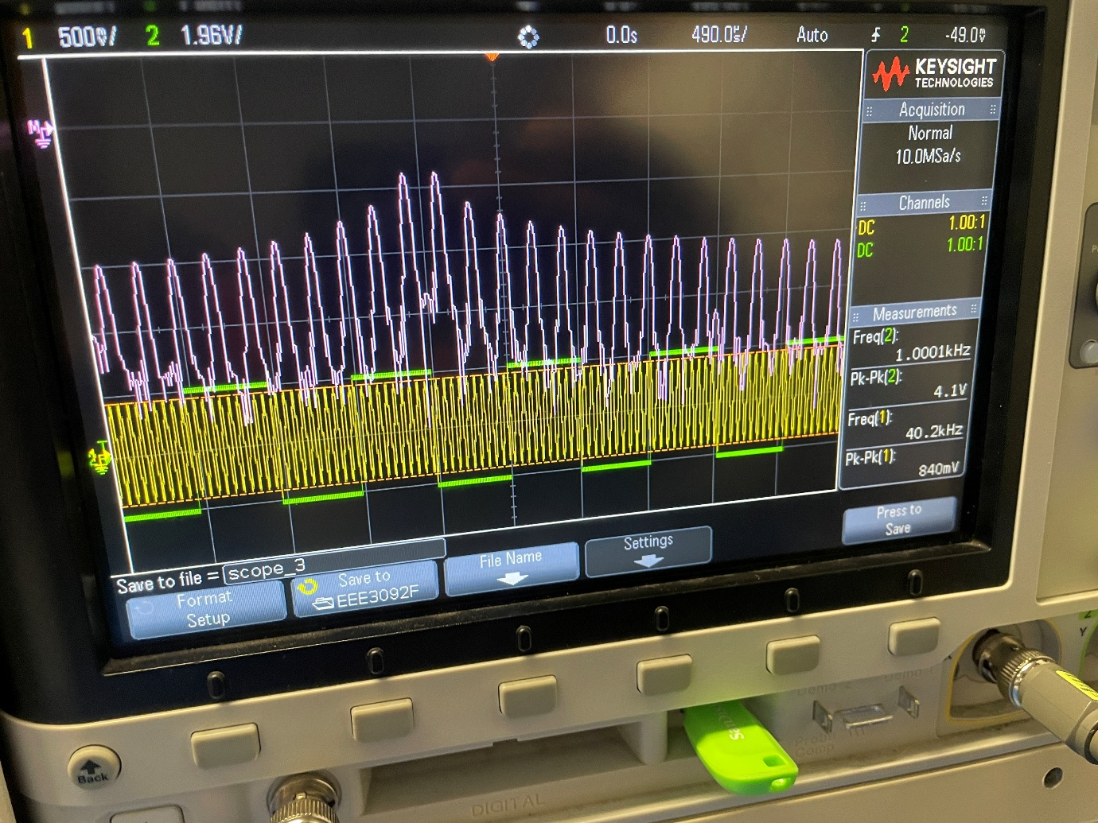
Figure 7 Sqaure modulating signal
As the 1kHz is made up of a multitude of odd harmonics each of these harmonics modulate the 29kHz this creates the outward spreading sideband pairs.

