# Neighborhoods and Breweries in Denver, CO, USA Presentation

## Business Problem

Many people consider Denver as a major hub for North American craft brewers. There are a couple hundred active breweries in the direct area, and the economy seems to support it, so this is a good assumption for the purposes of this project.

So, craft beer is a popular item in Denver that has proven it can sell...

But has the market reached its saturation point?

Based on research, the answer to this is most likely no, the market has not reached saturation for the entire city.

Would a new brewery fail just because there are too many in walking distance in a given neighborhood already?

In fact, many neighborhoods lack any nearby breweries in a city that likes to spend money on local beer.

What neighborhoods have the most/fewest close to their center?

The distribution is scattered. Two quick visuals support the concept of these business problems for an aspiring new brewery owner.

## Map

This map is the first visual that shows uneven distribution of breweries in Denver neighborhoods. Neighborhoods are big blue dots, and breweries are small green dots.

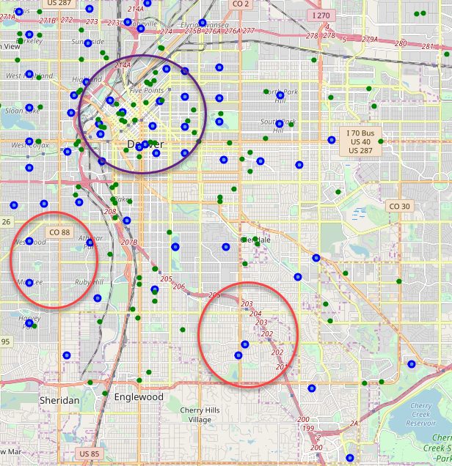

Breweries are clustered downtown and north (purple circle) while we can find multiple neighborhoods to the south and west (red circles for examples) with no nearby breweries.

All of these neighborhoods are within Denver proper, which means that they all have a significant population. There are no ‘rural’ areas on the map if you will, so a neighborhood missing a brewery might be missing a key market place for, say, after work patrons.

## Distribution number

Next is this simple histogram. Distribution is all over the place with some areas having zero in the cutoff distance, then some having a few, and only a handful of neighborhoods downtown having a lot.

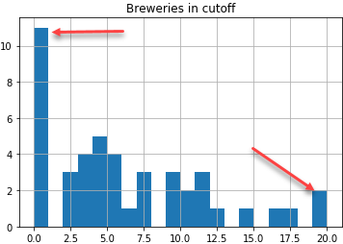

The top four neighborhoods with nearby breweries are near downtown, no surprise there:

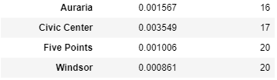

But I was surprised to find 11 neighborhoods with no nearby breweries. Not all of these neighborhoods are on the edge of the city when you look at the map either.

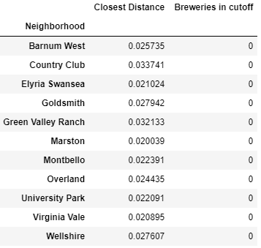

Based on this report, it looks like there is still opportunity in many areas of an already big market. This shows a good starting point that the market is not even, and if you make a good product in a good location (less brewing competition, but restaurants nearby?) then there is a solid chance of success here.

## Conclusion

My conclusion is there are several neighborhoods with communities of people that might enjoy a local brewery. The Goldsmith neighborhood and Overland might be the best starting spots to look as ‘cold’ areas that are still well accessible by many other neighborhoods (and suburbs) of Denver. It looks like further research and potential investment is warranted here!