**Lab 4 – Navigation and app architecture**

**Name: Nguyễn Quỳnh Mai Thanh - ID: ITITIU20309**

**Github repository:** [**https://github.com/mtnguyenquynh/MobileLabPractice.git**](https://github.com/mtnguyenquynh/MobileLabPractice.git)

**Pathway 1: Architecture Components**

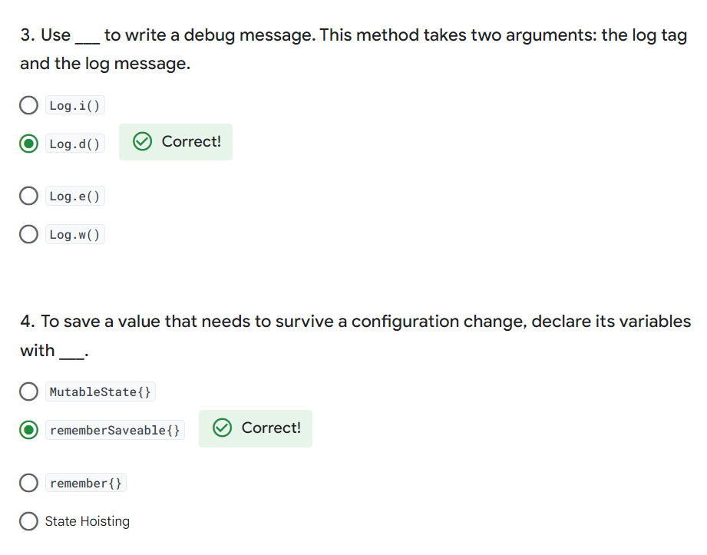

**Pathway 2: Navigation in Jetpack Compose**

**Pathway 3: Adaptive Layout**

**Badge Earned**

