**Engineering Full Stack Apps in the Cloud**

<http://image-filter-starter-code-metin-dev-dev.us-east-1.elasticbeanstalk.com/filteredimage?image_url=https://www.google.com/images/branding/googlelogo/2x/googlelogo_color_272x92dp.png>

**GITHUB**

<https://github.com/mtnylmz/cloud-developer>

<https://github.com/mtnylmz/cloud-developer/tree/master/course-02/project/image-filter-starter-code>

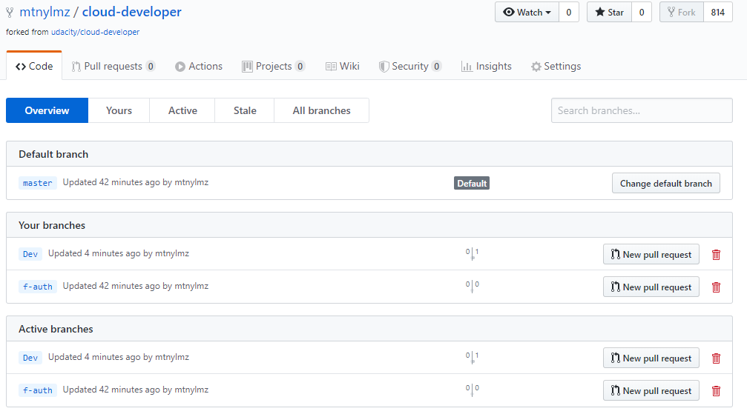

**DEVELOPMENT SERVER**

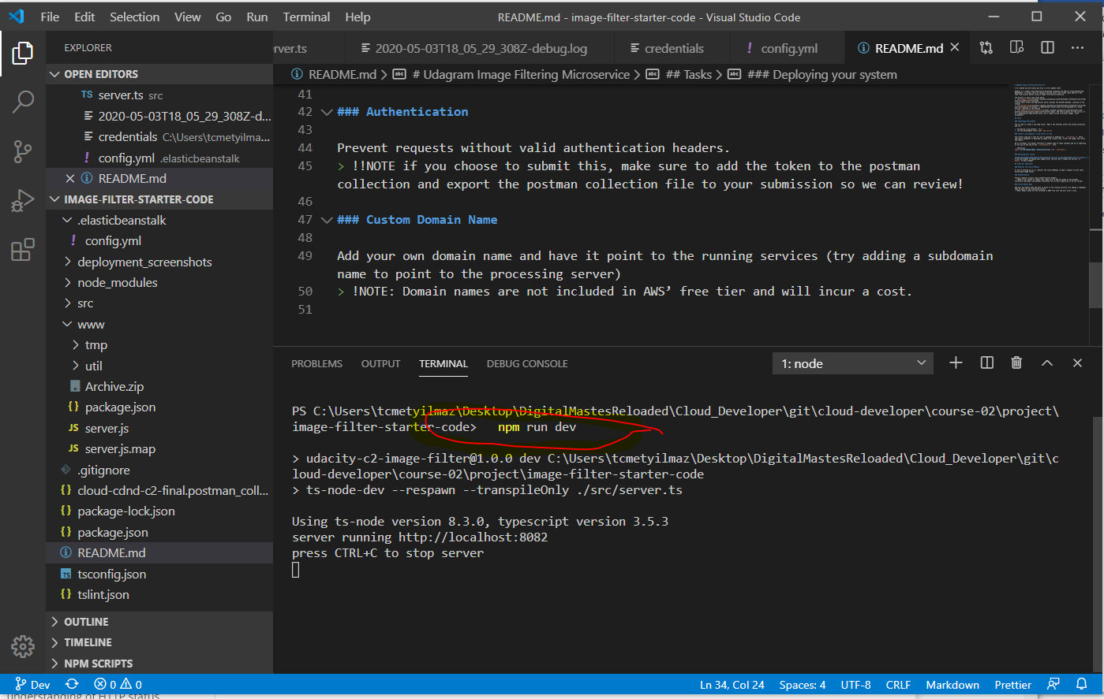

<https://github.com/mtnylmz/cloud-developer/blob/master/course-02/project/image-filter-starter-code/src/server.ts>

[https://timedotcom.files.wordpress.com/2019/03/kitten-report.jpg](http://localhost:%7b%7bPORT%7d%7d/filteredimage?image_url=https://timedotcom.files.wordpress.com/2019/03/kitten-report.jpg) image was not there anymore I’ve something else…

http://localhost:8082/filteredimage?image_url=https://www.google.com/images/branding/googlelogo/2x/googlelogo_color_272x92dp.png

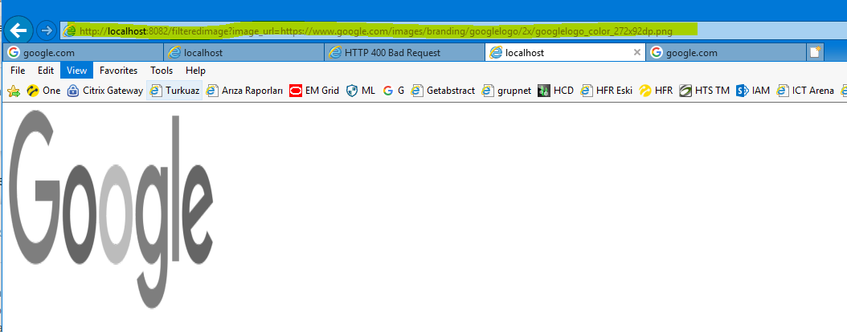

**Elastic Beanstalk Deployment**

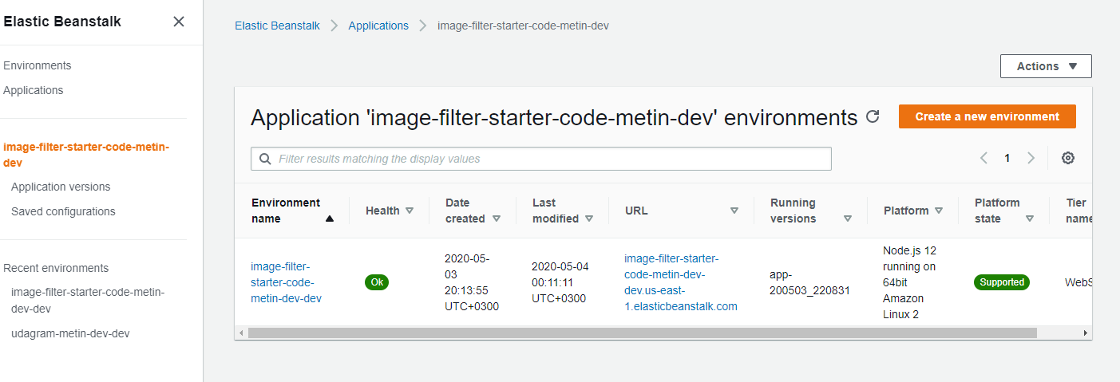

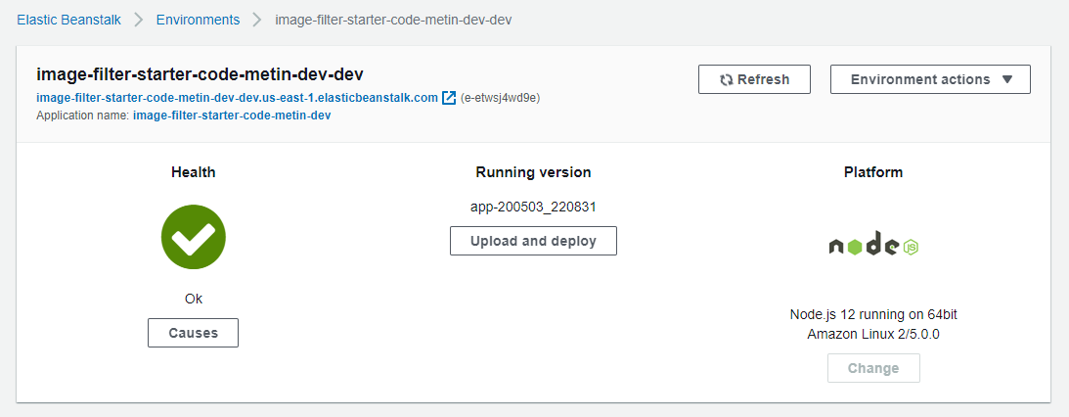

<http://image-filter-starter-code-metin-dev-dev.us-east-1.elasticbeanstalk.com/filteredimage?image_url=https://www.google.com/images/branding/googlelogo/2x/googlelogo_color_272x92dp.png>

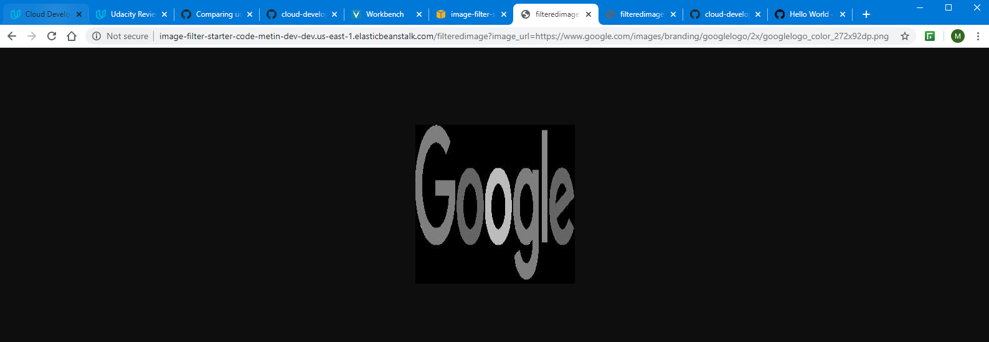

[http://image-filter-starter-code-metin-dev-dev.us-east-1.elasticbeanstalk.com/filteredimage?image_url=https://timedotcom.files.wordpress.com/2019/03/kitten-report.jpg](http://image-filter-starter-code-metin-dev-dev.us-east-1.elasticbeanstalk.com/filteredimage?image_url=https://timedotcom.files.wordpress.com/2019/03/kitten-report.jpg%20)