EVIDENCE PACK
Published Framework, Hypotheses, Variables, and Questionnaire Evidence
Direct-model replication source pack

Min Thiha Oo
August 2026

1. Decision
Pass under the strict source-fidelity rule. One published article supplies the actual model, all 13 hypotheses, all 11 constructs, the 40 coded construct items, the seven-point scale, and the PLS-SEM procedure. The Thai population and IT micro-credential badge context are disclosed replication changes.

Primary source: Steenkamp, N., Fisher, R., and Nesbit, T. (2024), Understanding accounting students' intentions to use digital badges to showcase employability skills, Accounting Education, 33(6), 906-934. DOI: 10.1080/09639284.2023.2276200.

2. Strict Source Audit
Table 2.1: Pass/fail audit
Required component | Published location | Status | Current use
Actual framework | Figure 1, article p. 10 | Direct | Complete figure reproduced; no redrawing or path selection.
Variables | Figure 1, Appendix, Table 2 | Direct | All 11 source constructs and codes retained.
Hypotheses | H1-H13, article pp. 11-13 | Direct | All paths and directions reproduced.
Questionnaire | Appendix, article pp. 28-29 | Direct | All 40 coded source items transcribed.
Scale | Appendix note, article p. 29 | Direct | Seven-point agreement scale retained.
Analysis | Method/results, article pp. 13-17 | Direct-method guide | Reflective PLS-SEM and 5,000 bootstrap samples.

3. Actual Published Framework
The image below is a direct crop from the source PDF. It is not a reconstruction. The source boxes, labels, arrows, and caption are unchanged.
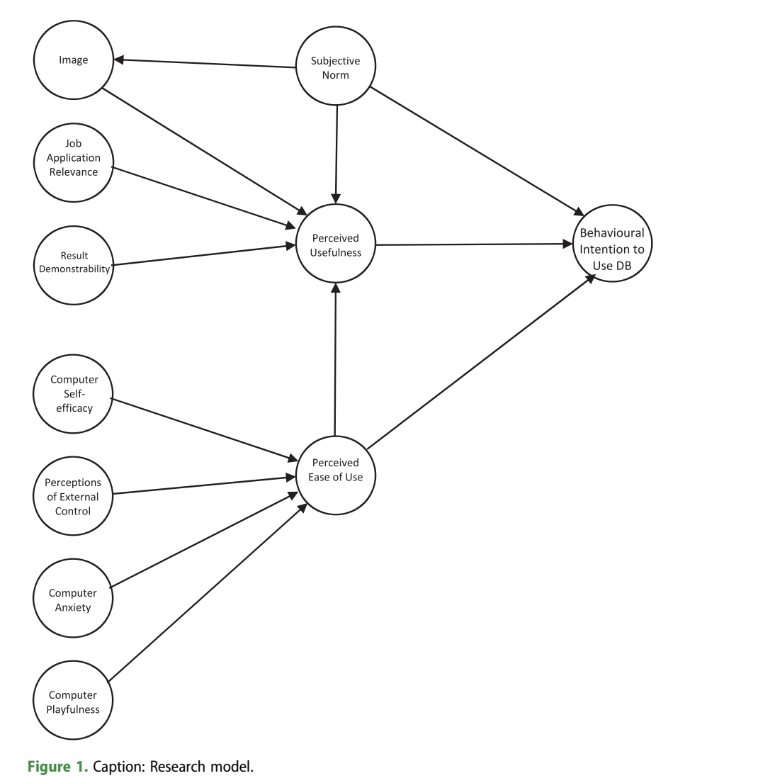
Figure 3.1: Direct source reproduction of Steenkamp et al. (2024, Figure 1, article p. 10).

4. Exact Published Hypotheses
The statements below reproduce the source hypotheses. H11's grammar is retained to avoid silently rewriting the published statement.
H1: Perceived usefulness has a positive direct effect on students' intention to use digital badges in applying for jobs.
H2: Perceived ease of use has a positive direct effect on students' intention to use digital badges in applying for jobs.
H3: Perceived ease of use has a positive direct effect on students' perceived usefulness of digital badges in applying for jobs.
H4: Subjective norm has a positive direct effect on students' intention to use digital badges in applying for jobs.
H5: Subjective norm has a positive direct effect on students' perceived usefulness of digital badges in applying for jobs.
H6: Subjective norm has a positive direct effect on image.
H7: Image has a positive direct effect on perceived usefulness of digital badges in applying for jobs.
H8: Job application relevance has a positive direct effect on perceived usefulness of digital badges in applying for jobs.
H9: Result demonstrability has a positive direct effect on perceived usefulness of digital badges in applying for jobs.
H10: Computer self-efficacy has a positive direct effect on perceived ease of use of digital badges in applying for jobs.
H11: Perceptions of external control has a positive direct effect on perceived ease of use of digital badges in applying for jobs.
H12: Computer anxiety has a negative direct effect on perceived ease of use of digital badges in applying for jobs.
H13: Computer playfulness has a positive direct effect on perceived ease of use of digital badges in applying for jobs.

5. Exact Variable and Item-Count Match
Table 5.1: Construct and item-count audit
Published construct | Code | Published codes | Count | Thesis match
Perceived Usefulness | PU | PU1-PU4 | 4 | Exact
Perceived Ease of Use | PEOU | PEOU1-PEOU4 | 4 | Exact
Computer Self-Efficacy | CSE | CSE1-CSE3 | 3 | Exact
Perceptions of External Control | PEC | PEC1-PEC4 | 4 | Exact
Computer Playfulness | CPLAY | CPLAY1-CPLAY4 | 4 | Exact
Computer Anxiety | CANX | CANX1-CANX4 | 4 | Exact
Subjective Norm | SN | SN1-SN4 | 4 | Exact
Image | IMG | IMG1-IMG3 | 3 | Exact
Job Application Relevance | REL | REL1-REL3 | 3 | Exact
Result Demonstrability | RES | RES1-RES4 | 4 | Exact
Behavioural Intention to Use DB | BI | BI1-BI3 | 3 | Exact
Total |  |  | 40 | Exact

6. Actual Published Questionnaire Appendix
The next two images are direct crops of the source Appendix pages. They show the item codes, wording, prior sources identified by Steenkamp et al., and seven-point response scale.
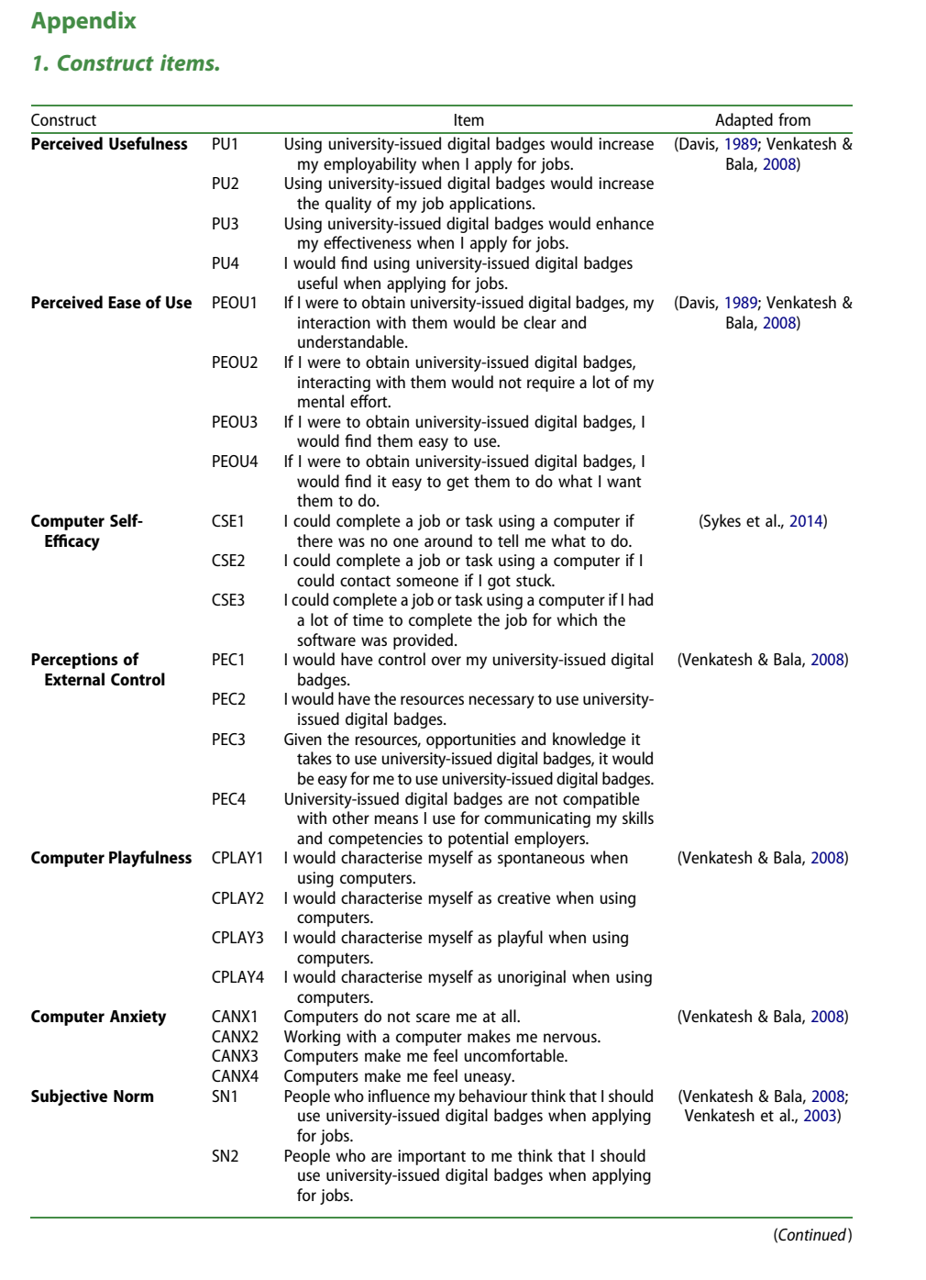
Figure 6.1: Direct source reproduction of the first construct-item Appendix page, Steenkamp et al. (2024, article p. 28).

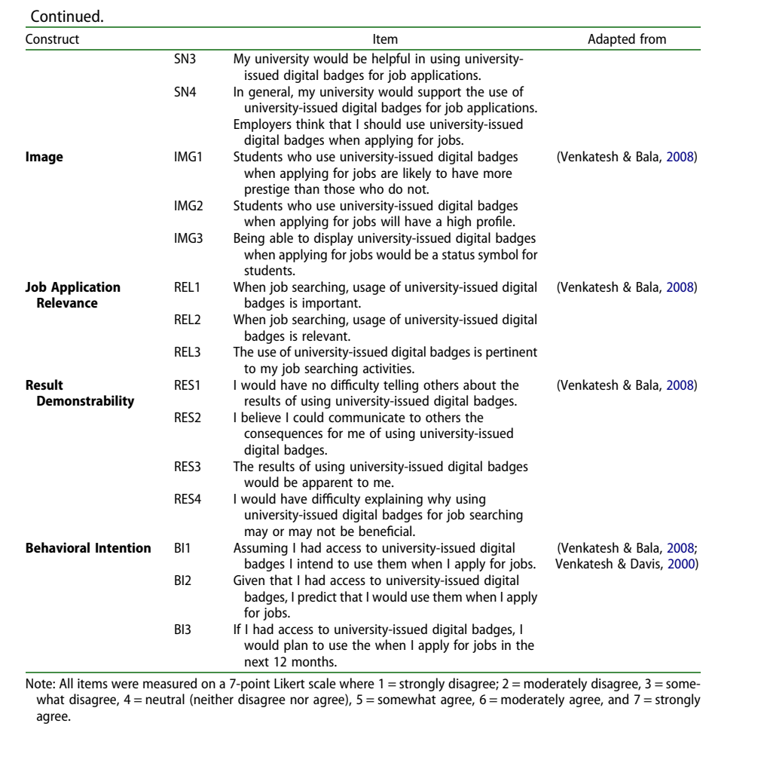
Figure 6.2: Direct source reproduction of the second construct-item Appendix page, Steenkamp et al. (2024, article p. 29).

7. Item-Level Provenance
All 40 coded statements below are verbatim from the source Appendix, including BI3's apparent typo; any correction requires approval before fielding.
Table 7.1: Forty-item direct provenance matrix
Code | Construct | Exact source wording | Master status
PU1 | Perceived Usefulness | Using university-issued digital badges would increase my employability when I apply for jobs. | Exact
PU2 | Perceived Usefulness | Using university-issued digital badges would increase the quality of my job applications. | Exact
PU3 | Perceived Usefulness | Using university-issued digital badges would enhance my effectiveness when I apply for jobs. | Exact
PU4 | Perceived Usefulness | I would find using university-issued digital badges useful when applying for jobs. | Exact
PEOU1 | Perceived Ease of Use | If I were to obtain university-issued digital badges, my interaction with them would be clear and understandable. | Exact
PEOU2 | Perceived Ease of Use | If I were to obtain university-issued digital badges, interacting with them would not require a lot of my mental effort. | Exact
PEOU3 | Perceived Ease of Use | If I were to obtain university-issued digital badges, I would find them easy to use. | Exact
PEOU4 | Perceived Ease of Use | If I were to obtain university-issued digital badges, I would find it easy to get them to do what I want them to do. | Exact
CSE1 | Computer Self-Efficacy | I could complete a job or task using a computer if there was no one around to tell me what to do. | Exact
CSE2 | Computer Self-Efficacy | I could complete a job or task using a computer if I could contact someone if I got stuck. | Exact
CSE3 | Computer Self-Efficacy | I could complete a job or task using a computer if I had a lot of time to complete the job for which the software was provided. | Exact
PEC1 | Perceptions of External Control | I would have control over my university-issued digital badges. | Exact
PEC2 | Perceptions of External Control | I would have the resources necessary to use university-issued digital badges. | Exact
PEC3 | Perceptions of External Control | Given the resources, opportunities and knowledge it takes to use university-issued digital badges, it would be easy for me to use university-issued digital badges. | Exact
PEC4 | Perceptions of External Control | University-issued digital badges are not compatible with other means I use for communicating my skills and competencies to potential employers. | Exact
CPLAY1 | Computer Playfulness | I would characterise myself as spontaneous when using computers. | Exact
CPLAY2 | Computer Playfulness | I would characterise myself as creative when using computers. | Exact
CPLAY3 | Computer Playfulness | I would characterise myself as playful when using computers. | Exact
CPLAY4 | Computer Playfulness | I would characterise myself as unoriginal when using computers. | Exact
CANX1 | Computer Anxiety | Computers do not scare me at all. | Exact
CANX2 | Computer Anxiety | Working with a computer makes me nervous. | Exact
CANX3 | Computer Anxiety | Computers make me feel uncomfortable. | Exact
CANX4 | Computer Anxiety | Computers make me feel uneasy. | Exact
SN1 | Subjective Norm | People who influence my behaviour think that I should use university-issued digital badges when applying for jobs. | Exact
SN2 | Subjective Norm | People who are important to me think that I should use university-issued digital badges when applying for jobs. | Exact
SN3 | Subjective Norm | My university would be helpful in using university-issued digital badges for job applications. | Exact
SN4 | Subjective Norm | In general, my university would support the use of university-issued digital badges for job applications. | Exact
IMG1 | Image | Students who use university-issued digital badges when applying for jobs are likely to have more prestige than those who do not. | Exact
IMG2 | Image | Students who use university-issued digital badges when applying for jobs will have a high profile. | Exact
IMG3 | Image | Being able to display university-issued digital badges when applying for jobs would be a status symbol for students. | Exact
REL1 | Job Application Relevance | When job searching, usage of university-issued digital badges is important. | Exact
REL2 | Job Application Relevance | When job searching, usage of university-issued digital badges is relevant. | Exact
REL3 | Job Application Relevance | The use of university-issued digital badges is pertinent to my job searching activities. | Exact
RES1 | Result Demonstrability | I would have no difficulty telling others about the results of using university-issued digital badges. | Exact
RES2 | Result Demonstrability | I believe I could communicate to others the consequences for me of using university-issued digital badges. | Exact
RES3 | Result Demonstrability | The results of using university-issued digital badges would be apparent to me. | Exact
RES4 | Result Demonstrability | I would have difficulty explaining why using university-issued digital badges for job searching may or may not be beneficial. | Exact
BI1 | Behavioral Intention | Assuming I had access to university-issued digital badges I intend to use them when I apply for jobs. | Exact
BI2 | Behavioral Intention | Given that I had access to university-issued digital badges, I predict that I would use them when I apply for jobs. | Exact
BI3 | Behavioral Intention | If I had access to university-issued digital badges, I would plan to use the when I apply for jobs in the next 12 months. | Exact; typo noted

8. Source Anomalies and Decisions
Table 8.1: No-hidden-decisions register
Source detail | Evidence | Decision
Unnumbered employer sentence after SN4 | The methods state 40 items; the Appendix has 40 coded items; Table 2 reports SN1-SN4 only. | Do not invent SN5 or score the unnumbered sentence.
PEC4, CPLAY4, RES4 removed in source analysis | Source measurement-model section reports outer loadings below .40. | Administer all 40 source items; make any Thai-sample deletion from Thai data and report it.
BI3 source typo | Appendix prints 'use the when'. | Preserve source wording in evidence; seek approval for the field correction 'them'.
Behavioural/Behavioral label variation | Figure and Appendix use different English spelling/label length. | Retain the figure label in the model and the Appendix label in the item evidence; treat both as BI.

9. What Changes and What Does Not
Table 9.1: Replication boundary
Element | Source study | Thai study | Classification
Population | Accounting students at one New Zealand university | Students in IT-related programs in Thailand | Disclosed context change
Badge context | University-issued badges for employability skills | University-issued badges representing IT micro-credentials for employability skills | Disclosed context specification
Model, constructs, paths | Figure 1; 11 constructs; 13 paths | Same complete model | No change
Construct items | 40 coded Appendix items | Same English source master | No conceptual change
Response scale | Seven-point agreement | Same | No change
Language | English | English audit master plus approved Thai translation | Necessary cross-language procedure
Pilot | Not reported as a separate pilot | Required local pilot of 40 | Local process requirement

10. References
Brislin, R. W. (1970). Back-translation for cross-cultural research. Journal of Cross-Cultural Psychology, 1(3), 185-216. https://doi.org/10.1177/135910457000100301
Council of the European Union. (2022). Council Recommendation of 16 June 2022 on a European approach to micro-credentials for lifelong learning and employability (2022/C 243/02). Official Journal of the European Union, C 243, 10-25.
Davis, F. D. (1989). Perceived usefulness, perceived ease of use, and user acceptance of information technology. MIS Quarterly, 13(3), 319-340. https://doi.org/10.2307/249008
Hair, J. F., Hult, G. T. M., Ringle, C. M., and Sarstedt, M. (2022). A primer on partial least squares structural equation modeling (PLS-SEM) (3rd ed.). Sage.
Hertzog, M. A. (2008). Considerations in determining sample size for pilot studies. Research in Nursing & Health, 31(2), 180-191. https://doi.org/10.1002/nur.20247
Johanson, G. A., and Brooks, G. P. (2010). Initial scale development: Sample size for pilot studies. Educational and Psychological Measurement, 70(3), 394-400. https://doi.org/10.1177/0013164409355692
Kiiskila, P., Kukkonen, A., and Pirkkalainen, H. (2023). Are micro-credentials valuable for students? Perspective on verifiable digital credentials. SN Computer Science, 4, Article 366. https://doi.org/10.1007/s42979-023-01797-y
Krejcie, R. V., and Morgan, D. W. (1970). Determining sample size for research activities. Educational and Psychological Measurement, 30(3), 607-610. https://doi.org/10.1177/001316447003000308
Miao, M., Ahmed, M., Ahsan, N., and Qamar, B. (2024). Intention to use technology for micro-credential programs: Evidence from technology acceptance and self-determination model. International Journal of Educational Management, 38(4), 948-977. https://doi.org/10.1108/IJEM-02-2023-0066
Steenkamp, N., Fisher, R., and Nesbit, T. (2024). Understanding accounting students' intentions to use digital badges to showcase employability skills. Accounting Education, 33(6), 906-934. https://doi.org/10.1080/09639284.2023.2276200
Sykes, T. A., Venkatesh, V., and Johnson, J. L. (2014). Enterprise system implementation and employee job performance: Understanding the role of advice networks. MIS Quarterly, 38(1), 51-72. https://doi.org/10.25300/MISQ/2014/38.1.03
UNESCO. (2022). Towards a common definition of micro-credentials. UNESCO. https://unesdoc.unesco.org/ark:/48223/pf0000381668
Venkatesh, V. (2000). Determinants of perceived ease of use: Integrating control, intrinsic motivation, and emotion into the technology acceptance model. Information Systems Research, 11(4), 342-365. https://doi.org/10.1287/isre.11.4.342.11872
Venkatesh, V., and Bala, H. (2008). Technology acceptance model 3 and a research agenda on interventions. Decision Sciences, 39(2), 273-315. https://doi.org/10.1111/j.1540-5915.2008.00192.x
Venkatesh, V., and Davis, F. D. (2000). A theoretical extension of the technology acceptance model: Four longitudinal field studies. Management Science, 46(2), 186-204. https://doi.org/10.1287/mnsc.46.2.186.11926
Venkatesh, V., Morris, M. G., Davis, G. B., and Davis, F. D. (2003). User acceptance of information technology: Toward a unified view. MIS Quarterly, 27(3), 425-478. https://doi.org/10.2307/30036540

