PUBLISHED FRAMEWORK AND QUESTIONNAIRE EVIDENCE PACK

Min Thiha Oo
August 2026

1. Purpose of This Pack
This pack shows, in one place, the actual published framework borrowed for the study, the exact transfer of its variable names into the conceptual framework, the published questionnaire sources, every proposed adapted item, and the evidence supporting each hypothesis. It accompanies the chaptered thesis draft and is not a separate theoretical model.
Main correction: the previous recognition, stackability, industry-endorsement, trust, and perceived-value experiment has been removed. Those labels did not appear together as variables in any borrowed published framework. The replacement uses four exact labels from one same-field published model.

2. Source Integrity: What Is Original and What Is Adapted
Table 2.1: Source audit
Visual or table | Status | How it was produced
Kiiskilä et al. (2023), Figure 1 | Direct source reproduction | Cropped directly from page 366 of the original Springer PDF. No boxes, labels, or arrows were generated or redrawn. CC BY 4.0.
Conceptual framework for this thesis | Author-created adaptation | New diagram selecting three direct paths from the source. Exact variable labels retained; H1-H3 added; straight arrows used.
Questionnaire wording | Documented adaptation | Item structures borrowed from published scales; the referent is changed to digital credentials issued for IT micro-credentials.

3. Actual Published Framework Borrowed
Primary source: Kiiskilä, P., Kukkonen, A., and Pirkkalainen, H. (2023), Are Micro-Credentials Valuable for Students? Perspective on Verifiable Digital Credentials, SN Computer Science, 4, Article 366. DOI: 10.1007/s42979-023-01797-y.
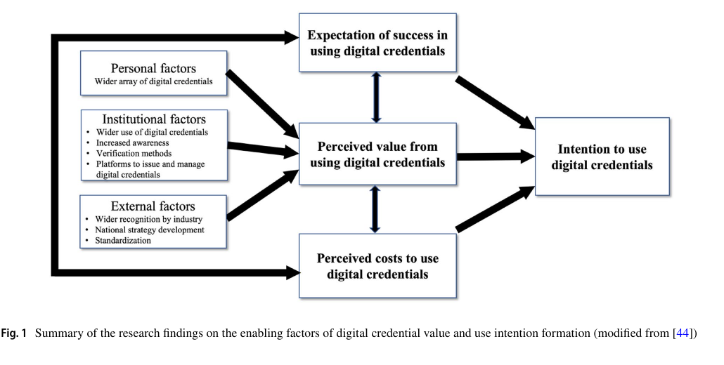
Figure 3.1: Direct crop of the source's Figure 1 on p. 366. This is the published diagram, not a recreation. Source: Kiiskilä et al. (2023), CC BY 4.0.
Why it fits: the source is peer-reviewed, open access, situated in higher education, and specifically concerns verifiable digital credentials associated with micro-credentials. The authors use EVC as their theoretical framework, state that their questions were based on surveys including Kosovich et al. (2015), and publish the same four core variables used in the new conceptual framework.
Table 3.1: Exact constructs and selected source paths
Source construct, copied exactly | Direct source path selected | Hypothesis
Expectation of success in using digital credentials | To intention to use digital credentials | H1 positive
Perceived value from using digital credentials | To intention to use digital credentials | H2 positive
Perceived costs to use digital credentials | To intention to use digital credentials | H3 negative
Intention to use digital credentials | Dependent variable receiving all three paths | DV

4. Conceptual Framework Used in the Thesis
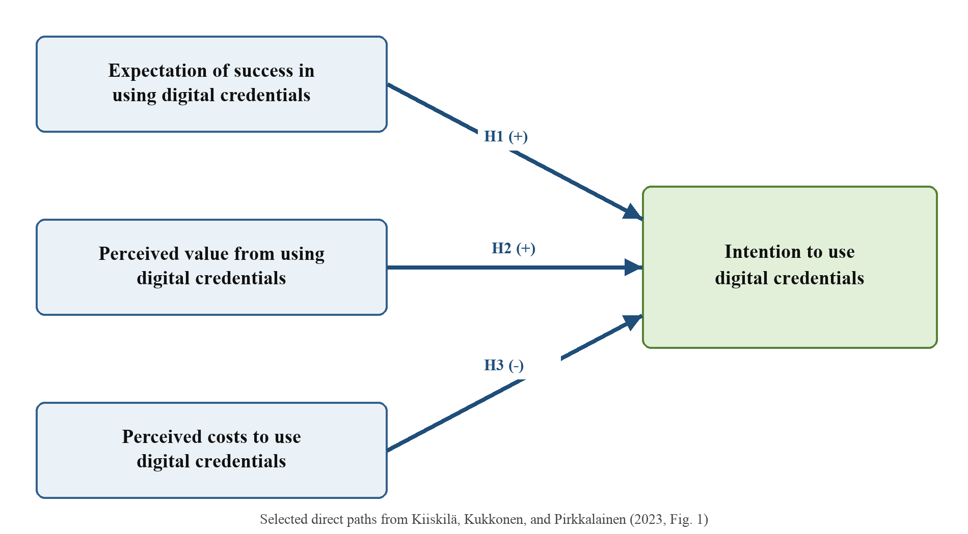
Figure 4.1: Author-created conceptual framework. It selects three straight direct paths from Kiiskilä et al. (2023, Figure 1); it does not rename the variables.
Table 4.1: Variable-name comparison
Published source wording | Thesis wording | Match
Expectation of success in using digital credentials | Expectation of success in using digital credentials | Exact
Perceived value from using digital credentials | Perceived value from using digital credentials | Exact
Perceived costs to use digital credentials | Perceived costs to use digital credentials | Exact
Intention to use digital credentials | Intention to use digital credentials | Exact

5. Questionnaire Evidence

5.1 Expectancy-Value-Cost Items
Kosovich et al. (2015) published a brief 10-item EVC Scale: three expectancy items (E1-E3), three value items (V1-V3), and four cost items (C1-C4). The Appendix uses a six-point scale from Strongly disagree to Strongly agree. Confirmatory factor analysis supported separate expectancy, value, and cost factors, and the paper reports good omega reliability. The published Appendix is available at DOI 10.1177/0272431614556890.
The adaptation is narrow: the source's math/science-class referent is replaced with digital credentials issued for IT micro-credentials. The sentence purpose and item order remain traceable through E1-E3, V1-V3, and C1-C4. Kiiskilä et al. (2023) independently support this move because they state that their digital-credential questions were adapted from EVC surveys including Kosovich et al.

5.2 Intention Items
Venkatesh et al. (2003) publish three behavioral-intention items (BI1-BI3) built around intention, prediction, and planning to use a system in the future. The present items change the system referent to digital credentials issued for IT micro-credentials and use 'in the future' as the common time referent. The source article is available through the AIS eLibrary and DOI 10.2307/30036540. Miao et al. (2024) provide field-specific corroboration: their micro-credential study used three behavioral-intention items and reported alpha = .870, composite reliability = .920, and AVE = .794. Miao et al. identify the number, source, and measurement performance but do not print the full wording, so they are used as contextual evidence rather than as the wording source.

5.3 Full Proposed Questionnaire Items
Table 5.1: Final English items ready for Thai translation and pilot
Code | Exact construct | Proposed item | Source mapping
EOS1 | Expectation of success in using digital credentials | I know I can learn how to use digital credentials issued for IT micro-credentials. | Kosovich et al. (2015), E1; adapted referent
EOS2 | Expectation of success in using digital credentials | I believe I can be successful in using digital credentials issued for IT micro-credentials. | Kosovich et al. (2015), E2; adapted referent
EOS3 | Expectation of success in using digital credentials | I am confident that I can understand how to use digital credentials issued for IT micro-credentials. | Kosovich et al. (2015), E3; adapted referent
PV1 | Perceived value from using digital credentials | I think using digital credentials issued for IT micro-credentials is important. | Kosovich et al. (2015), V1; adapted referent
PV2 | Perceived value from using digital credentials | I value using digital credentials issued for IT micro-credentials. | Kosovich et al. (2015), V2; adapted referent
PV3 | Perceived value from using digital credentials | I think using digital credentials issued for IT micro-credentials is useful. | Kosovich et al. (2015), V3; adapted referent
PC1 | Perceived costs to use digital credentials | Using digital credentials issued for IT micro-credentials would require too much of my time. | Kosovich et al. (2015), C1; adapted referent
PC2 | Perceived costs to use digital credentials | Because of other things that I do, I would not have enough time to use digital credentials issued for IT micro-credentials. | Kosovich et al. (2015), C2; adapted referent
PC3 | Perceived costs to use digital credentials | I would be unable to put in the time needed to use digital credentials issued for IT micro-credentials effectively. | Kosovich et al. (2015), C3; adapted referent
PC4 | Perceived costs to use digital credentials | I would have to give up too much to use digital credentials issued for IT micro-credentials. | Kosovich et al. (2015), C4; adapted referent
INT1 | Intention to use digital credentials | I intend to use digital credentials issued for IT micro-credentials in the future. | Venkatesh et al. (2003), BI1; adapted system and time referent
INT2 | Intention to use digital credentials | I predict that I will use digital credentials issued for IT micro-credentials in the future. | Venkatesh et al. (2003), BI2; adapted system and time referent
INT3 | Intention to use digital credentials | I plan to use digital credentials issued for IT micro-credentials in the future. | Venkatesh et al. (2003), BI3; adapted system and time referent

Response scale for every construct item: 1 = Strongly disagree; 2 = Disagree; 3 = Slightly disagree; 4 = Slightly agree; 5 = Agree; 6 = Strongly agree. No interviews and no open-ended questions are proposed.

6. Evidence for Each Hypothesis
Table 6.1: Relationship-evidence matrix
Hypothesis | Direct framework evidence | Additional relationship evidence
H1: Expectation of success -> intention (+) | Kiiskilä et al. (2023), Figure 1 and discussion | Eccles et al. (1983); Wigfield & Eccles (2000); Durik et al. (2006); Kosovich et al. (2015)
H2: Perceived value -> intention (+) | Kiiskilä et al. (2023), Figure 1 and discussion | Eccles et al. (1983); Eccles & Wigfield (2002); Durik et al. (2006); Shang & Lyv (2022)
H3: Perceived costs -> intention (-) | Kiiskilä et al. (2023), Figure 1 and discussion | Barron & Hulleman (2015); Flake et al. (2015); Kosovich et al. (2015); Perez et al. (2019)

7. Definition Evidence Required for Chapter 2
Table 7.1: Variable-definition evidence
Exact variable | Four or more definition sources | Study definition
Expectation of success in using digital credentials | Eccles et al. (1983); Wigfield & Eccles (2000); Eccles & Wigfield (2002); Kosovich et al. (2015); Kiiskilä et al. (2023) | Belief that the student can learn, understand, and successfully use digital credentials issued for IT micro-credentials.
Perceived value from using digital credentials | Eccles et al. (1983); Eccles & Wigfield (2002); Kosovich et al. (2015); Oliver (2021); Kiiskilä et al. (2023) | Judgment that using the digital credential is important, valuable, and useful.
Perceived costs to use digital credentials | Eccles (2005); Eccles & Wigfield (2002); Flake et al. (2015); Kosovich et al. (2015); Kiiskilä et al. (2023) | Perceived time, competing obligations, and sacrifice involved in use.
Intention to use digital credentials | Fishbein & Ajzen (1975); Ajzen (1991); Venkatesh et al. (2003); Kiiskilä et al. (2023); Miao et al. (2024) | Stated intention, prediction, and plan to use the digital credential in the future.

8. Pilot and Analysis Evidence
Table 8.1: Method decisions and evidence
Decision | Planned treatment | Evidence
Pilot | 40 eligible Thai IT students; excluded from main sample | Hertzog (2008) evaluates pilot samples up to 40; Johanson & Brooks (2010) recommend 30 representative participants as a reasonable minimum.
Main sample | Minimum 384 usable; target 400 | Krejcie & Morgan (1970) large-population table under conventional 95%/5% assumptions.
Response scale | Six-point agreement for all 13 construct items | Preserves Kosovich et al. (2015) EVC response format.
Primary analysis | Multiple linear regression in Jamovi | One continuous DV and three continuous IV composite scores.
Claim boundary | Associations and prediction, not causal effects or actual employment outcomes | Cross-sectional observational design.

9. Source Access List
Table 9.1: Quick source-location guide
Purpose | Source | Where the evidence appears
Exact published framework | Kiiskilä et al. (2023) | Figure 1, p. 366; research framework and discussion; DOI 10.1007/s42979-023-01797-y
EVC questionnaire | Kosovich et al. (2015) | Published Appendix, E1-E3, V1-V3, C1-C4; DOI 10.1177/0272431614556890
Intention questionnaire | Venkatesh et al. (2003) | Behavioral intention items BI1-BI3, p. 460; DOI 10.2307/30036540
Micro-credential intention context | Miao et al. (2024) | Table 1 source mapping and Table 3 reliability; DOI 10.1108/IJEM-02-2023-0066
Pilot-size evidence | Hertzog (2008); Johanson & Brooks (2010) | Aim-specific pilot guidance and a 30-participant reasonable minimum; DOIs 10.1002/nur.20247 and 10.1177/0013164409355692

References
Ajzen, I. (1991). The theory of planned behavior. Organizational Behavior and Human Decision Processes, 50(2), 179-211. https://doi.org/10.1016/0749-5978(91)90020-T
Barron, K. E., & Hulleman, C. S. (2015). Expectancy-value-cost model of motivation. In J. D. Wright (Ed.), International encyclopedia of the social & behavioral sciences (2nd ed., Vol. 8, pp. 503-509). Elsevier. https://doi.org/10.1016/B978-0-08-097086-8.26099-6
Brislin, R. W. (1970). Back-translation for cross-cultural research. Journal of Cross-Cultural Psychology, 1(3), 185-216. https://doi.org/10.1177/135910457000100301
Council of the European Union. (2022). Council Recommendation of 16 June 2022 on a European approach to micro-credentials for lifelong learning and employability (2022/C 243/02). Official Journal of the European Union, C 243, 10-25. https://eur-lex.europa.eu/eli/C/2022/243/oj
Durik, A. M., Vida, M., & Eccles, J. S. (2006). Task values and ability beliefs as predictors of high school literacy choices: A developmental analysis. Journal of Educational Psychology, 98(2), 382-393. https://doi.org/10.1037/0022-0663.98.2.382
Eccles, J. S. (2005). Subjective task value and the Eccles et al. model of achievement-related choices. In A. J. Elliot & C. S. Dweck (Eds.), Handbook of competence and motivation (pp. 105-121). Guilford Press.
Eccles, J. S., Adler, T. F., Futterman, R., Goff, S. B., Kaczala, C. M., Meece, J. L., & Midgley, C. (1983). Expectancies, values, and academic behaviors. In J. T. Spence (Ed.), Achievement and achievement motives (pp. 75-146). W. H. Freeman.
Eccles, J. S., & Wigfield, A. (2002). Motivational beliefs, values, and goals. Annual Review of Psychology, 53, 109-132. https://doi.org/10.1146/annurev.psych.53.100901.135153
Fishbein, M., & Ajzen, I. (1975). Belief, attitude, intention and behavior: An introduction to theory and research. Addison-Wesley.
Flake, J. K., Barron, K. E., Hulleman, C. S., McCoach, D. B., & Welsh, M. E. (2015). Measuring cost: The forgotten component of expectancy-value theory. Contemporary Educational Psychology, 41, 232-244. https://doi.org/10.1016/j.cedpsych.2015.03.002
Hertzog, M. A. (2008). Considerations in determining sample size for pilot studies. Research in Nursing & Health, 31(2), 180-191. https://doi.org/10.1002/nur.20247
Hulleman, C. S., Barron, K. E., Kosovich, J. J., & Lazowski, R. A. (2016). Student motivation: Current theories, constructs, and interventions within an expectancy-value framework. In A. A. Lipnevich, F. Preckel, & R. D. Roberts (Eds.), Psychosocial skills and school systems in the 21st century (pp. 241-278). Springer. https://doi.org/10.1007/978-3-319-28606-8_10
Johanson, G. A., & Brooks, G. P. (2010). Initial scale development: Sample size for pilot studies. Educational and Psychological Measurement, 70(3), 394-400. https://doi.org/10.1177/0013164409355692
Kato, S., Galán-Muros, V., & Weko, T. (2020). The emergence of alternative credentials (OECD Education Working Papers No. 216). OECD Publishing. https://doi.org/10.1787/b741f39e-en
Kiiskilä, P., Kukkonen, A., & Pirkkalainen, H. (2023). Are micro-credentials valuable for students? Perspective on verifiable digital credentials. SN Computer Science, 4, Article 366. https://doi.org/10.1007/s42979-023-01797-y
Kosovich, J. J., Hulleman, C. S., Barron, K. E., & Getty, S. (2015). A practical measure of student motivation: Establishing validity evidence for the expectancy-value-cost scale in middle school. The Journal of Early Adolescence, 35(5-6), 790-816. https://doi.org/10.1177/0272431614556890
Krejcie, R. V., & Morgan, D. W. (1970). Determining sample size for research activities. Educational and Psychological Measurement, 30(3), 607-610. https://doi.org/10.1177/001316447003000308
Miao, M., Ahmed, F., Ahsan, M., & Qamar, B. (2024). Intention to use technology for micro-credential programs: Evidence from technology acceptance and self-determination model. International Journal of Educational Management, 38(4), 948-977. https://doi.org/10.1108/IJEM-02-2023-0066
Ministry of Higher Education, Science, Research and Innovation. (2022). Micro-credentials in Thai higher education: Opportunities, challenges and outlooks from ASEAN and Europe. https://www.mhesi.go.th/index.php/en/news-and-announce-all/news-all/executive-ps-news/7614-micro-credentials-in-thai-higher-education-opportunities-challenges-and-outlooks-from-asean-and-europe.html
Ministry of Higher Education, Science, Research and Innovation. (2023). Regional policy seminar on micro-credentials in ASEAN higher education. https://www.mhesi.go.th/index.php/en/news-and-announce-all/news-all/executive-ps-news/9589-unesco-bangkok-korean-educational-development-institute-kedi-micro-credentials.html
Oliver, B. (2021). Micro-credentials: A learner value framework: Provocation. Journal of Teaching and Learning for Graduate Employability, 12(1), 48-51. https://doi.org/10.21153/jtlge2021vol12no1art1456
Perez, T., Wormington, S. V., Barger, M. M., Schwartz-Bloom, R. D., Lee, Y. K., & Linnenbrink-Garcia, L. (2019). Science expectancy, value, and cost profiles and their proximal and distal relations to undergraduate science, technology, engineering, and math persistence. Science Education, 103(2), 264-286. https://doi.org/10.1002/sce.21490
Shang, S., & Lyv, W. (2022). Understanding the impact of quality elements on MOOCs continuance intention. Education and Information Technologies, 27, 10949-10976. https://doi.org/10.1007/s10639-022-11063-y
UNESCO. (2022). Towards a common definition of micro-credentials. UNESCO. https://unesdoc.unesco.org/ark:/48223/pf0000381668
Venkatesh, V., Morris, M. G., Davis, G. B., & Davis, F. D. (2003). User acceptance of information technology: Toward a unified view. MIS Quarterly, 27(3), 425-478. https://doi.org/10.2307/30036540
Wigfield, A., & Eccles, J. S. (2000). Expectancy-value theory of achievement motivation. Contemporary Educational Psychology, 25(1), 68-81. https://doi.org/10.1006/ceps.1999.1015

