ASSUMPTION UNIVERSITY OF THAILAND
Graduate School of Business and Advanced Technology Management

Framework, Hypotheses, Variables, and Questionnaire Evidence
Source Record for the Author-Constructed Digital-Badge Model

BY
MR. MIN THIHA OO

ITM7000 INDEPENDENT STUDY
Submitted in Partial Fulfillment of the Requirements for the Degree of
Master of Information Technology Management

AUGUST 2026

1. Purpose
This document records the published frameworks used to construct the study model, the direct source of every variable and relationship, and the original questionnaire source. It accompanies the chaptered thesis manuscript.
The study does not reproduce Steenkamp et al.'s complete model. It selects five exact constructs and four supported paths from that published model, adds no new construct, and uses only the 18 printed questionnaire items belonging to those constructs.

2. Published Frameworks

2.1 Technology Acceptance Model 3
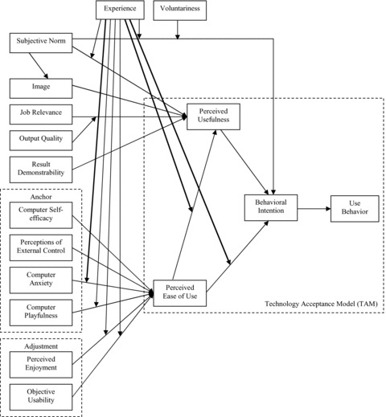
Figure 2.1: Technology Acceptance Model 3
Source: Venkatesh and Bala (2008, Figure 2).

2.2 Micro-Credential Technology-Acceptance Framework
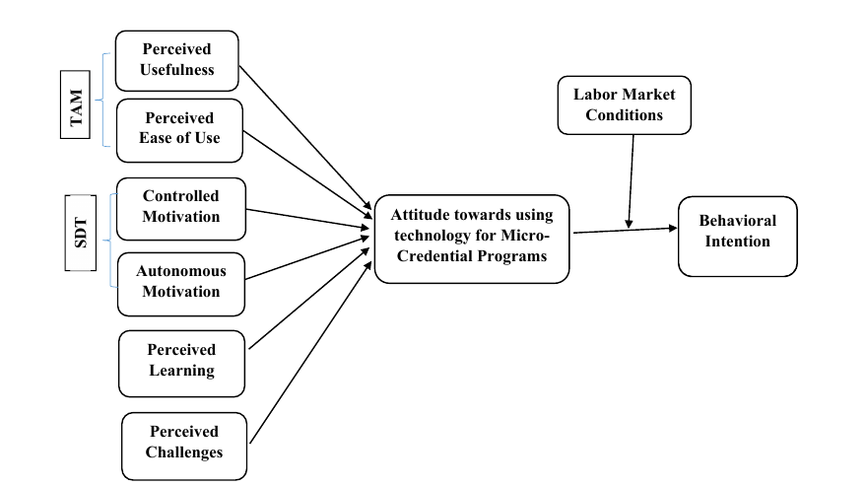
Figure 2.2: Technology use for micro-credential programmes
Source: Miao et al. (2024, Figure 1, p. 956).

2.3 Digital-Badge Acceptance Framework
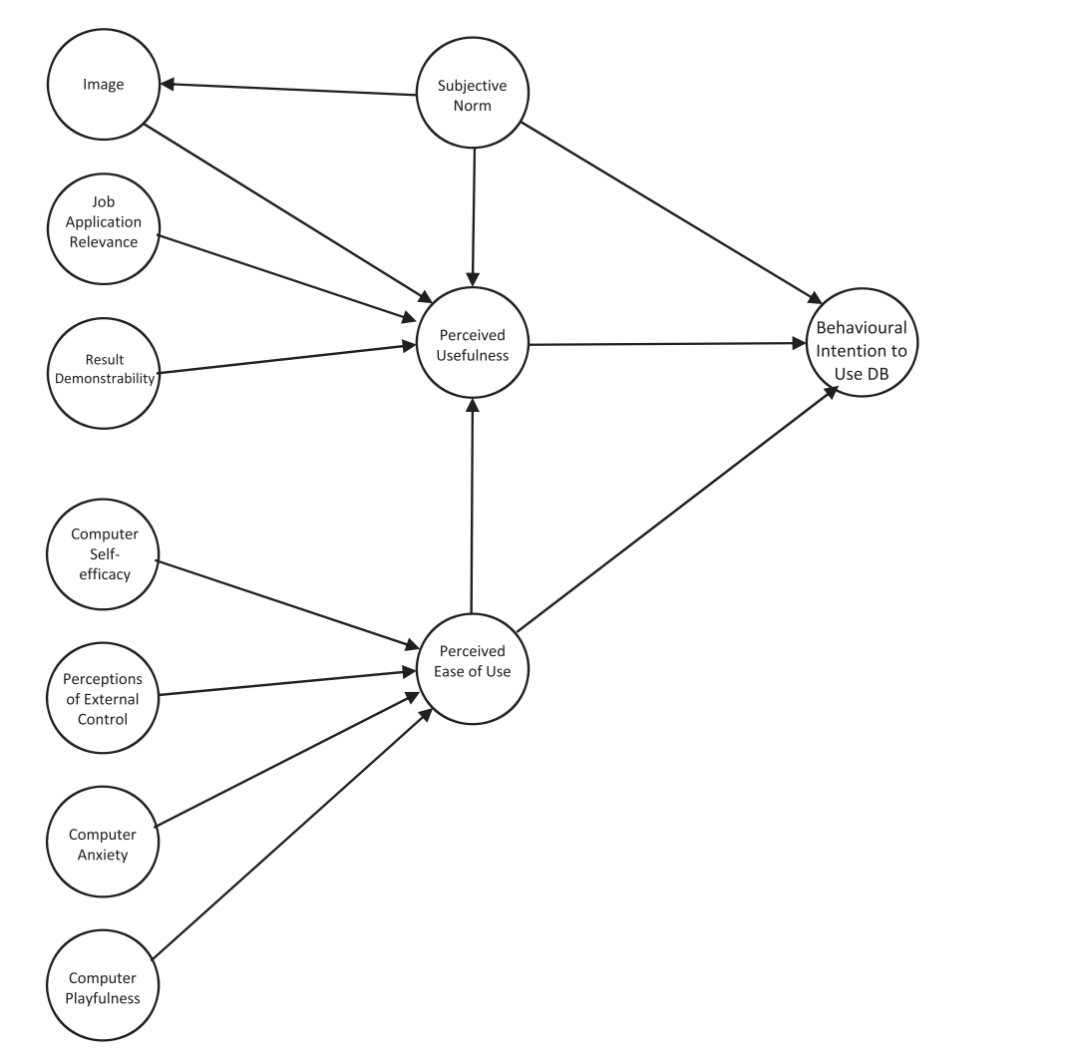
Figure 2.3: Published digital-badge research model
Source: Steenkamp, Fisher, and Nesbit (2024, Figure 1, p. 10).

3. Conceptual Framework Used in the Study
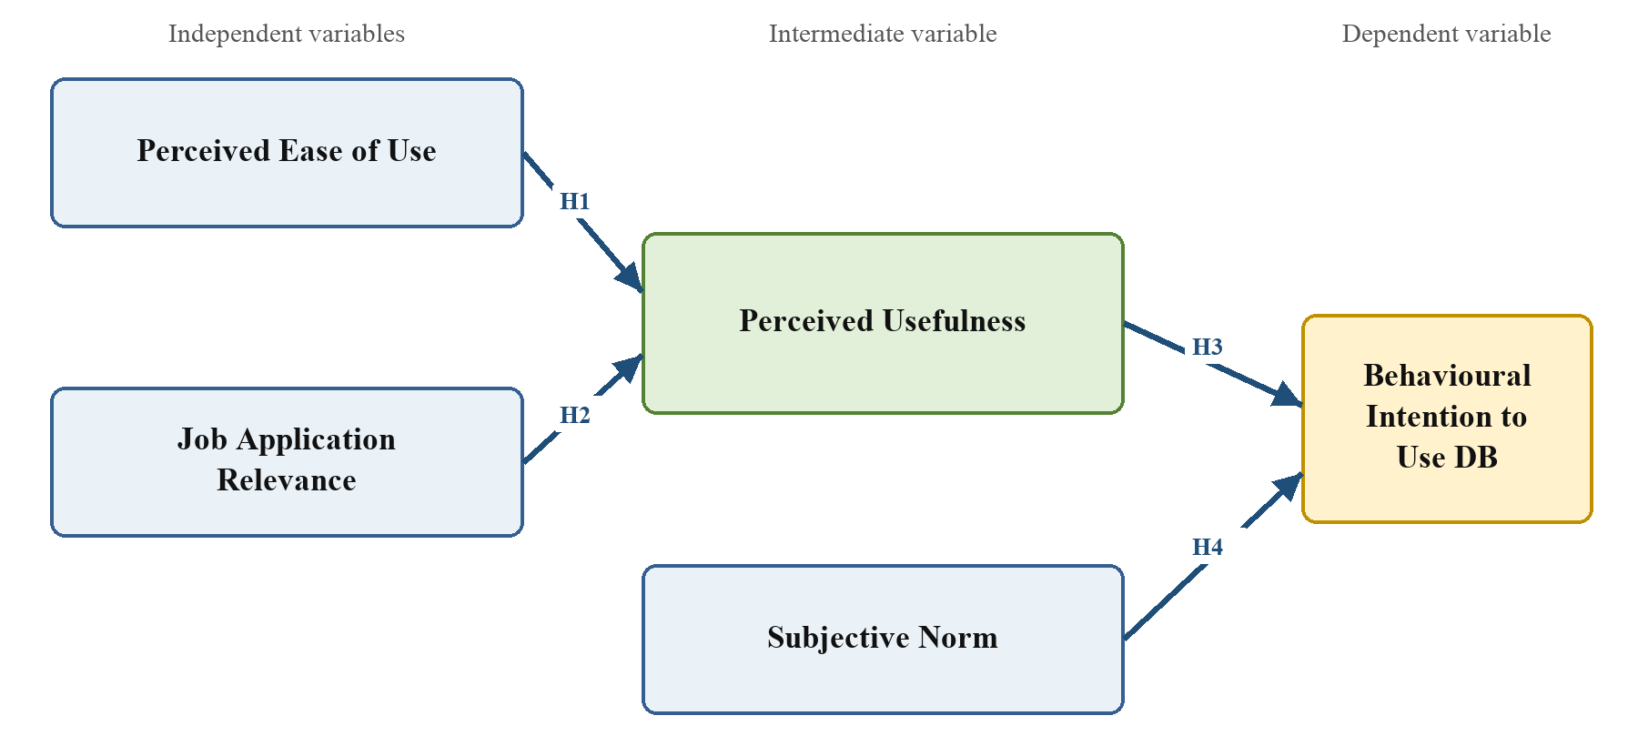
Figure 3.1: Conceptual framework of the study
Source: Constructed by the author based on Venkatesh and Bala (2008), Miao et al. (2024), and Steenkamp et al. (2024).
Table 3.1: Direct path provenance
Study hypothesis | Exact path | Direct published source | Published result
H1 | Perceived Ease of Use -> Perceived Usefulness | Steenkamp et al. (2024), source H3 | Supported (beta = .671, p < .001)
H2 | Job Application Relevance -> Perceived Usefulness | Steenkamp et al. (2024), source H8 | Supported (beta = .229, p = .047)
H3 | Perceived Usefulness -> Behavioural Intention to Use DB | Steenkamp et al. (2024), source H1 | Supported (beta = .403, p = .010)
H4 | Subjective Norm -> Behavioural Intention to Use DB | Steenkamp et al. (2024), source H4 | Supported (beta = .593, p < .001)

H1: Perceived ease of use has a positive direct effect on students' perceived usefulness of university-issued digital badges in job applications.
H2: Job application relevance has a positive direct effect on students' perceived usefulness of university-issued digital badges in job applications.
H3: Perceived usefulness has a positive direct effect on students' behavioural intention to use university-issued digital badges in job applications.
H4: Subjective norm has a positive direct effect on students' behavioural intention to use university-issued digital badges in job applications.

4. Exact Variable Provenance
Table 4.1: Exact-label audit
Study variable | Exact source label | Published framework location | Questionnaire codes
Perceived Ease of Use | Perceived Ease of Use | Steenkamp et al. (2024), Figure 1 | PEOU1-PEOU4
Job Application Relevance | Job Application Relevance | Steenkamp et al. (2024), Figure 1 | REL1-REL3
Perceived Usefulness | Perceived Usefulness | Steenkamp et al. (2024), Figure 1 | PU1-PU4
Subjective Norm | Subjective Norm | Steenkamp et al. (2024), Figure 1 | SN1-SN4
Behavioural Intention to Use DB | Behavioural Intention to Use DB | Steenkamp et al. (2024), Figure 1 | BI1-BI3

5. Published Questionnaire Evidence
Steenkamp et al. (2024, Appendix, pp. 28-29) printed all construct codes, questionnaire statements, prior measurement sources, and the seven-point agreement scale. The two images below are direct crops of those Appendix pages.
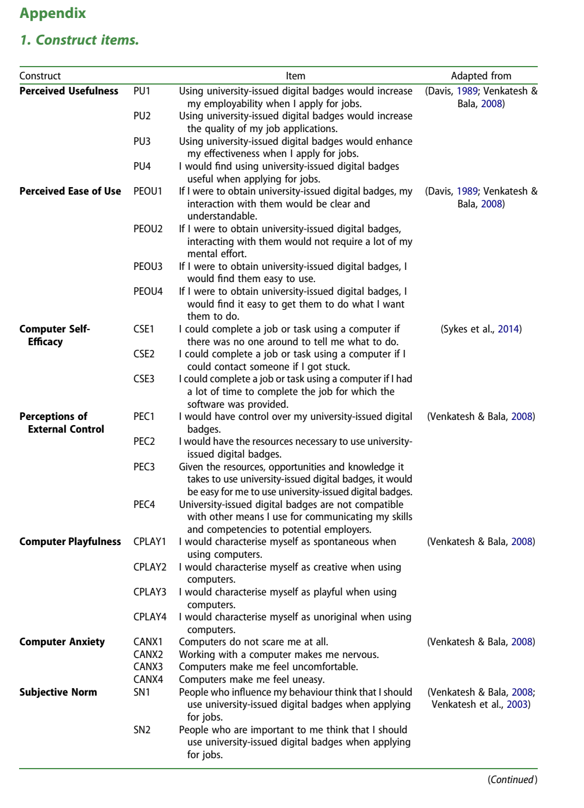
Figure 5.1: Published questionnaire Appendix, first page
Source: Steenkamp et al. (2024, Appendix, p. 28).

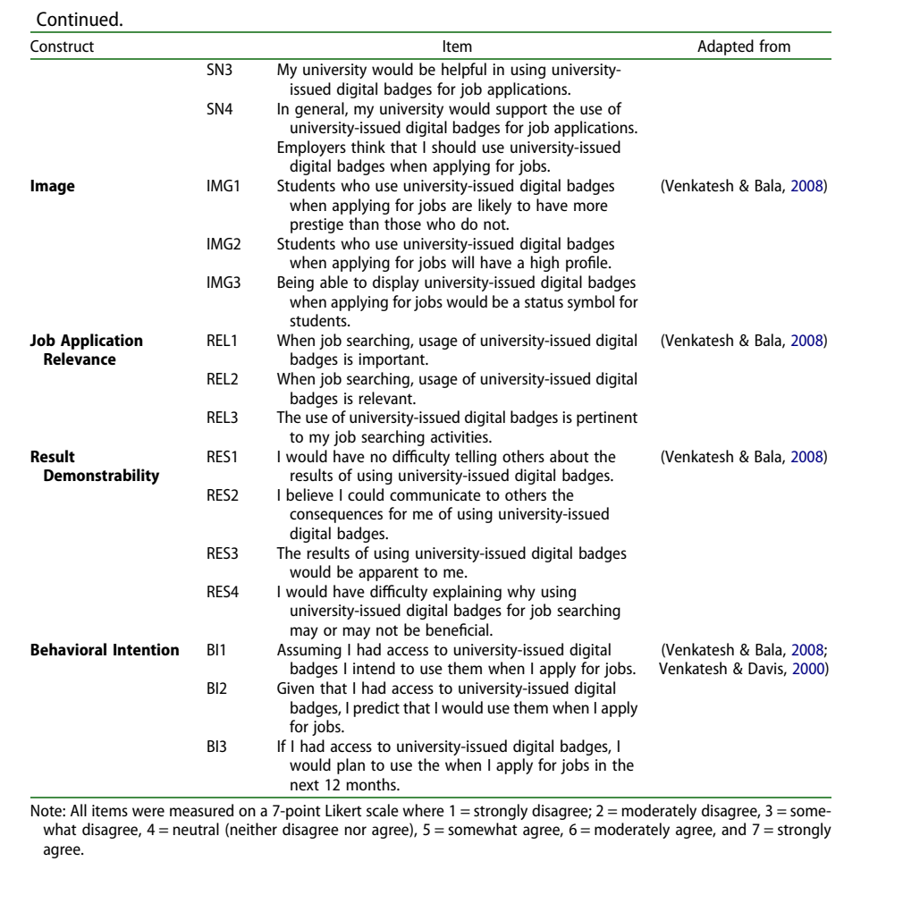
Figure 5.2: Published questionnaire Appendix, second page
Source: Steenkamp et al. (2024, Appendix, p. 29).
Table 5.1: Eighteen-item provenance matrix
Code | Exact construct | Published wording | Field wording/status
PU1 | Perceived Usefulness | Using university-issued digital badges would increase my employability when I apply for jobs. | Exact wording
PU2 | Perceived Usefulness | Using university-issued digital badges would increase the quality of my job applications. | Exact wording
PU3 | Perceived Usefulness | Using university-issued digital badges would enhance my effectiveness when I apply for jobs. | Exact wording
PU4 | Perceived Usefulness | I would find using university-issued digital badges useful when applying for jobs. | Exact wording
PEOU1 | Perceived Ease of Use | If I were to obtain university-issued digital badges, my interaction with them would be clear and understandable. | Exact wording
PEOU2 | Perceived Ease of Use | If I were to obtain university-issued digital badges, interacting with them would not require a lot of my mental effort. | Exact wording
PEOU3 | Perceived Ease of Use | If I were to obtain university-issued digital badges, I would find them easy to use. | Exact wording
PEOU4 | Perceived Ease of Use | If I were to obtain university-issued digital badges, I would find it easy to get them to do what I want them to do. | Exact wording
SN1 | Subjective Norm | People who influence my behaviour think that I should use university-issued digital badges when applying for jobs. | Exact wording
SN2 | Subjective Norm | People who are important to me think that I should use university-issued digital badges when applying for jobs. | Exact wording
SN3 | Subjective Norm | My university would be helpful in using university-issued digital badges for job applications. | Exact wording
SN4 | Subjective Norm | In general, my university would support the use of university-issued digital badges for job applications. | Exact wording
REL1 | Job Application Relevance | When job searching, usage of university-issued digital badges is important. | Exact wording
REL2 | Job Application Relevance | When job searching, usage of university-issued digital badges is relevant. | Exact wording
REL3 | Job Application Relevance | The use of university-issued digital badges is pertinent to my job searching activities. | Exact wording
BI1 | Behavioral Intention | Assuming I had access to university-issued digital badges I intend to use them when I apply for jobs. | Exact wording
BI2 | Behavioral Intention | Given that I had access to university-issued digital badges, I predict that I would use them when I apply for jobs. | Exact wording
BI3 | Behavioral Intention | If I had access to university-issued digital badges, I would plan to use the when I apply for jobs in the next 12 months. | Typographical correction only: If I had access to university-issued digital badges, I would plan to use them when I apply for jobs in the next 12 months.

Response scale: 1 = Strongly disagree, 2 = Moderately disagree, 3 = Somewhat disagree, 4 = Neutral, 5 = Somewhat agree, 6 = Moderately agree, and 7 = Strongly agree.

6. Requirement Check
Table 6.1: Supervisor-requirement check
Professor's requested component | Where it is provided | Status
Actual frameworks borrowed from previous studies | Figures 2.1-2.3 and thesis Section 3.1 | Provided as published source images
Author's conceptual framework | Figure 3.1 and thesis Figure 3.4 | Constructed from cited frameworks
Variables with exact names | Table 4.1 and thesis Table 3.1 | All exact Steenkamp labels
Hypotheses supported by previous studies | Table 3.1 and thesis Sections 2.4 and 3.3 | Four direct published paths
Borrowed questionnaire | Figures 5.1-5.2 and Table 5.1 | All 18 items directly traceable
Operationalization | Thesis Table 3.2 | Full definitions, item wording, scale, and source
Pilot | Thesis Section 4.4 | Forty eligible pilot participants

7. References
Abdullah, F., and Ward, R. (2016). Developing a general extended technology acceptance model for e-learning (GETAMEL) by analysing commonly used external factors. Computers in Human Behavior, 56, 238-256. https://doi.org/10.1016/j.chb.2015.11.036
Abdullah, F., Ward, R., and Ahmed, E. (2016). Investigating the influence of the most commonly used external variables of TAM on students' perceived ease of use and perceived usefulness of e-portfolios. Computers in Human Behavior, 63, 75-90. https://doi.org/10.1016/j.chb.2016.05.014
Ajzen, I. (1991). The theory of planned behavior. Organizational Behavior and Human Decision Processes, 50(2), 179-211. https://doi.org/10.1016/0749-5978(91)90020-T
Brislin, R. W. (1970). Back-translation for cross-cultural research. Journal of Cross-Cultural Psychology, 1(3), 185-216. https://doi.org/10.1177/135910457000100301
Council of the European Union. (2022). Council Recommendation of 16 June 2022 on a European approach to micro-credentials for lifelong learning and employability (2022/C 243/02). Official Journal of the European Union, C 243, 10-25.
Davis, F. D. (1989). Perceived usefulness, perceived ease of use, and user acceptance of information technology. MIS Quarterly, 13(3), 319-340. https://doi.org/10.2307/249008
Fishbein, M., and Ajzen, I. (1975). Belief, attitude, intention and behavior: An introduction to theory and research. Addison-Wesley.
Granic, A., and Marangunic, N. (2019). Technology acceptance model in educational context: A systematic literature review. British Journal of Educational Technology, 50(5), 2572-2593. https://doi.org/10.1111/bjet.12864
Hair, J. F., Hult, G. T. M., Ringle, C. M., and Sarstedt, M. (2022). A primer on partial least squares structural equation modeling (PLS-SEM) (3rd ed.). Sage.
Hertzog, M. A. (2008). Considerations in determining sample size for pilot studies. Research in Nursing & Health, 31(2), 180-191. https://doi.org/10.1002/nur.20247
Johanson, G. A., and Brooks, G. P. (2010). Initial scale development: Sample size for pilot studies. Educational and Psychological Measurement, 70(3), 394-400. https://doi.org/10.1177/0013164409355692
Kiiskila, P., Kukkonen, A., and Pirkkalainen, H. (2023). Are micro-credentials valuable for students? Perspective on verifiable digital credentials. SN Computer Science, 4, Article 366. https://doi.org/10.1007/s42979-023-01797-y
Krejcie, R. V., and Morgan, D. W. (1970). Determining sample size for research activities. Educational and Psychological Measurement, 30(3), 607-610. https://doi.org/10.1177/001316447003000308
Miao, M., Ahmed, M., Ahsan, N., and Qamar, B. (2024). Intention to use technology for micro-credential programs: Evidence from technology acceptance and self-determination model. International Journal of Educational Management, 38(4), 948-977. https://doi.org/10.1108/IJEM-02-2023-0066
Moore, G. C., and Benbasat, I. (1991). Development of an instrument to measure the perceptions of adopting an information technology innovation. Information Systems Research, 2(3), 192-222. https://doi.org/10.1287/isre.2.3.192
Schepers, J., and Wetzels, M. (2007). A meta-analysis of the technology acceptance model: Investigating subjective norm and moderation effects. Information & Management, 44(1), 90-103. https://doi.org/10.1016/j.im.2006.10.007
Steenkamp, N., Fisher, R., and Nesbit, T. (2024). Understanding accounting students' intentions to use digital badges to showcase employability skills. Accounting Education, 33(6), 906-934. https://doi.org/10.1080/09639284.2023.2276200
Sykes, T. A., Venkatesh, V., and Johnson, J. L. (2014). Enterprise system implementation and employee job performance: Understanding the role of advice networks. MIS Quarterly, 38(1), 51-72. https://doi.org/10.25300/MISQ/2014/38.1.03
Taylor, S., and Todd, P. A. (1995). Understanding information technology usage: A test of competing models. Information Systems Research, 6(2), 144-176. https://doi.org/10.1287/isre.6.2.144
UNESCO. (2022). Towards a common definition of micro-credentials. UNESCO. https://unesdoc.unesco.org/ark:/48223/pf0000381668
Ursavas, O. F., Yalcin, Y., and Bakir, E. (2019). The effect of subjective norms on preservice and in-service teachers' behavioural intentions to use technology: A multigroup multimodel study. British Journal of Educational Technology, 50(5), 2501-2519. https://doi.org/10.1111/bjet.12834
Venkatesh, V. (2000). Determinants of perceived ease of use: Integrating control, intrinsic motivation, and emotion into the technology acceptance model. Information Systems Research, 11(4), 342-365. https://doi.org/10.1287/isre.11.4.342.11872
Venkatesh, V., and Bala, H. (2008). Technology acceptance model 3 and a research agenda on interventions. Decision Sciences, 39(2), 273-315. https://doi.org/10.1111/j.1540-5915.2008.00192.x
Venkatesh, V., and Davis, F. D. (2000). A theoretical extension of the technology acceptance model: Four longitudinal field studies. Management Science, 46(2), 186-204. https://doi.org/10.1287/mnsc.46.2.186.11926
Venkatesh, V., Morris, M. G., Davis, G. B., and Davis, F. D. (2003). User acceptance of information technology: Toward a unified view. MIS Quarterly, 27(3), 425-478. https://doi.org/10.2307/30036540

