ASSUMPTION UNIVERSITY OF THAILAND
Graduate School of Business and Advanced Technology Management

Factors Influencing Thai IT Students' Intentions to Use University-Issued Digital Badges for IT Micro-Credentials in Job Applications
A Quantitative Study of Usefulness, Job Relevance, Ease of Use, and Social Influence

BY
MR. MIN THIHA OO

ITM7000 INDEPENDENT STUDY
Submitted in Partial Fulfillment of the Requirements for the Degree of
Master of Information Technology Management

AUGUST 2026

Abstract
University-issued digital badges provide students with a portable way to present learning achievements from IT micro-credentials in job applications. Their value depends partly on whether students regard them as useful and intend to use them. This proposed study examines four published relationships explaining Thai IT students' behavioural intention to use university-issued digital badges in job applications. The conceptual framework draws on the Technology Acceptance Model, Technology Acceptance Model 3, research on technology use for micro-credential programmes, and the digital-badge framework tested by Steenkamp, Fisher, and Nesbit (2024). The framework contains five constructs: Perceived Ease of Use, Job Application Relevance, Perceived Usefulness, Subjective Norm, and Behavioural Intention to Use DB. A quantitative cross-sectional questionnaire survey will be conducted with students aged 18 years or older who are enrolled in IT-related university programmes in Thailand. The questionnaire contains 18 seven-point Likert-scale items taken from Steenkamp et al. (2024). After a pilot test with 40 eligible students, at least 384 usable responses will be collected and analysed using partial least squares structural equation modelling. The study is intended to identify the beliefs most closely associated with students' intended use of digital badges and to inform university micro-credential and career-support practices.
Keywords: digital badges, micro-credentials, perceived usefulness, subjective norm, behavioural intention, Thai IT students

Table of Contents
CHAPTER 1: INTRODUCTION 4
CHAPTER 2: LITERATURE REVIEW 8
CHAPTER 3: RESEARCH FRAMEWORK 13
CHAPTER 4: RESEARCH METHODOLOGY 18
References 23

CHAPTER 1: INTRODUCTION

1.1 Background of the Study
Micro-credentials certify learning outcomes acquired through a comparatively small volume of learning and are intended to support flexible learning, upskilling, and employability (Council of the European Union, 2022; UNESCO, 2022). A digital badge is a visual and potentially verifiable representation of an achievement. It may contain information about the issuer, recipient, learning outcomes, and assessment criteria (Kiiskila et al., 2023; Steenkamp et al., 2024). In the present study, the micro-credential is the learning achievement and the university-issued digital badge is the electronic representation that a student can store and present.
Digital badges may be especially relevant to students in IT-related programmes because technical skills and tools change rapidly and students may complete focused learning in areas such as data analytics, cybersecurity, cloud computing, and software development. A badge can give students an additional way to present this learning in online profiles and job applications. The availability of a badge, however, does not ensure that students will use it. Intended use may depend on whether the badge is easy to use, relevant to applying for jobs, useful for strengthening an application, and supported by people and institutions that matter to the student.
The Technology Acceptance Model (TAM) explains technology use through Perceived Usefulness and Perceived Ease of Use (Davis, 1989). TAM2 and TAM3 added social influence and task-relevance processes, including Subjective Norm and Job Relevance (Venkatesh & Davis, 2000; Venkatesh & Bala, 2008). These models have been applied widely in educational technology research (Abdullah & Ward, 2016; Granic & Marangunic, 2019). Miao et al. (2024) used TAM-related variables to study students' technology acceptance for micro-credential programmes, while Steenkamp et al. (2024) applied TAM3 constructs directly to university-issued digital badges used in job applications.
The present study uses these published foundations to examine a smaller model suited to a master's thesis. It retains exact construct names and four relationships shown and tested by Steenkamp et al. (2024). Perceived Ease of Use and Job Application Relevance are proposed to influence Perceived Usefulness. Perceived Usefulness and Subjective Norm are proposed to influence Behavioural Intention to Use DB. The model is examined among Thai students in IT-related university programmes.

1.2 Statement of the Problem
Universities may introduce IT micro-credentials and digital-badge systems without knowing whether students will use the badges when seeking employment. If students do not see the badges as relevant to job applications, useful for presenting their skills, easy to use, or supported by important people and their university, the badges may remain unused even when the underlying learning is valuable. Universities therefore need evidence about the beliefs associated with students' intended use before investing further in badge communication, platforms, and career-support activities.
Existing studies provide useful but geographically limited evidence. Steenkamp et al. (2024) examined accounting students at one New Zealand university, while Miao et al. (2024) examined technology use for micro-credential programmes among private-university students in Pakistan. Evidence remains limited for Thai university students in IT-related programmes and for the specific use of university-issued badges in job applications. This study addresses that contextual gap by testing a focused set of previously published relationships and measures among Thai IT students.

1.3 Research Objectives
- To examine the effect of Perceived Ease of Use on Perceived Usefulness of university-issued digital badges among Thai IT students.
- To examine the effect of Job Application Relevance on Perceived Usefulness of university-issued digital badges among Thai IT students.
- To examine the effect of Perceived Usefulness on Behavioural Intention to Use DB among Thai IT students.
- To examine the effect of Subjective Norm on Behavioural Intention to Use DB among Thai IT students.

1.4 Research Questions
- How does Perceived Ease of Use affect Perceived Usefulness of university-issued digital badges among Thai IT students?
- How does Job Application Relevance affect Perceived Usefulness of university-issued digital badges among Thai IT students?
- How does Perceived Usefulness affect Behavioural Intention to Use DB among Thai IT students?
- How does Subjective Norm affect Behavioural Intention to Use DB among Thai IT students?

1.5 Scope of the Research
The study focuses on students aged 18 years or older who are enrolled in undergraduate or postgraduate IT-related programmes at universities in Thailand. The focal object is a university-issued digital badge representing successful completion of an IT micro-credential and capable of being presented in a job application. The model contains five constructs and four hypothesised relationships. Data will be collected using an 18-item, seven-point Likert-scale online questionnaire, followed by PLS-SEM analysis. The study concerns students' perceptions and intended use; it does not measure employers' evaluations, actual employment outcomes, or actual badge use.

1.6 Research Limitations
First, the cross-sectional design measures variables at one point in time and cannot establish causality. Second, convenience and snowball recruitment may limit the representativeness of the sample. Third, self-reported intention may not lead to actual badge use in future job applications. Fourth, some respondents may have limited experience with digital badges; a neutral definition will therefore be provided before the measurement items. These limits will be considered when the results are interpreted.

1.7 Significance of the Study
The study contributes to technology-acceptance and digital-credential research by testing a focused set of published TAM3 relationships in a Thai higher-education and IT-student setting. It also examines whether relationships supported in Steenkamp et al.'s (2024) New Zealand digital-badge study are observed in a different discipline and national context. The study does not propose new constructs; its contribution is the contextual test and the focused combination of established constructs in one model.
The findings may help universities identify where practical support is most useful. Evidence about Perceived Ease of Use can guide platform instructions and student support. Evidence about Job Application Relevance and Perceived Usefulness can guide how badges are connected to employability and career services. Evidence about Subjective Norm can guide communication by lecturers, career advisers, and universities. Students may benefit from clearer information about how badges can be stored and presented, while credential providers and policymakers may gain evidence about the conditions associated with learner acceptance.

1.8 Definition of Key Terms
Table 1.1: Definitions of key terms
Term | Definition used in this study
Behavioural Intention to Use DB | A student's stated intention or plan to use university-issued digital badges when applying for jobs. (Steenkamp et al., 2024).
Digital badge | A visual and potentially verifiable electronic representation of an achievement, including information about the issuer, recipient, criteria, and learning outcome (Kiiskila et al., 2023; Steenkamp et al., 2024).
Job Application Relevance | The extent to which a student believes that digital badges are applicable and pertinent to job-search and job-application activities. (Steenkamp et al., 2024).
Micro-credential | A record of learning outcomes acquired through a small volume of learning (Council of the European Union, 2022; UNESCO, 2022).
Perceived Ease of Use | The extent to which a student believes that using a university-issued digital badge will be clear, understandable, and free of effort. (Davis, 1989; Steenkamp et al., 2024).
Perceived Usefulness | The extent to which a student believes that using a university-issued digital badge will improve the effectiveness and quality of a job application. (Davis, 1989; Steenkamp et al., 2024).
Subjective Norm | The extent to which a student perceives that important people and the university expect or support the use of digital badges in job applications. (Venkatesh & Davis, 2000; Steenkamp et al., 2024).
University-issued digital badge | A digital badge issued by a university to represent successful completion of an IT micro-credential and capable of being presented in a job application.

CHAPTER 2: LITERATURE REVIEW

2.1 Applied Theory

2.1.1 Technology Acceptance Model
Davis (1989) developed the Technology Acceptance Model to explain why individuals accept or reject information technology. TAM proposed that Perceived Usefulness and Perceived Ease of Use shape attitudes and intentions toward use. Perceived Usefulness concerns expected performance benefits, whereas Perceived Ease of Use concerns expected effort. The model was tested through scale development and empirical studies of computer systems and became one of the most widely applied models of technology acceptance. Reviews show that TAM and its extensions have continued to explain the use of learning systems, e-portfolios, and other educational technologies (Abdullah & Ward, 2016; Granic & Marangunic, 2019).

2.1.2 TAM2 and TAM3
Venkatesh and Davis (2000) extended TAM to TAM2 by adding social-influence processes and cognitive instrumental processes. Subjective Norm represented perceived expectations from important others, while Job Relevance concerned the applicability of a system to the user's task. Venkatesh and Bala (2008) later combined TAM2 with determinants of Perceived Ease of Use to produce TAM3. TAM3 retained the central paths to Behavioural Intention and organised the antecedents of Perceived Usefulness and Perceived Ease of Use in one integrated framework. The model was examined using longitudinal data from organisational technology implementations and was intended to provide more practical guidance than the original, more general TAM.

2.1.3 Suitability for the Present Study
TAM3 is suitable because the present study concerns students' intention to use a digital tool for a specific task. The selected constructs cover the practical effort of using a badge, its relevance and usefulness for job applications, and the influence of important people and the university. Miao et al. (2024) demonstrated the relevance of TAM variables to technology used for micro-credential programmes. More directly, Steenkamp et al. (2024) applied TAM3 constructs and questionnaire items to students' use of university-issued digital badges for employability. These studies provide both the theoretical and same-field basis for the present framework.

2.2 Micro-Credentials and University-Issued Digital Badges
Micro-credentials are smaller units of assessed learning that can support flexible education and lifelong learning (Council of the European Union, 2022; UNESCO, 2022). Their digital representation can make achievement information more portable and verifiable. Kiiskila et al. (2023) found that students and university administrators associated digital credentials with the ability to present skills, maintain records of learning, and share evidence with employers, while also identifying implementation and recognition concerns. These findings indicate that the value of a digital credential depends partly on how learners expect to use it.
In the present study, the badge is limited to one clear purpose: representing completion of an IT micro-credential and being available for use in a job application. This common referent reduces the risk that respondents imagine unrelated badge types. The study measures perceptions of the badge and intention to use it rather than claiming that the badge is already recognised by employers or that it produces employment outcomes.

2.3 Variable Definitions

2.3.1 Perceived Ease of Use
Davis (1989) defined perceived ease of use as the belief that using a particular system would require little effort. Venkatesh and Davis (2000) retained it as a central technology-acceptance belief that can also increase perceived usefulness. Venkatesh and Bala (2008) incorporated the construct into TAM3 and examined the conditions that form ease-of-use judgements. In a micro-credential setting, Miao et al. (2024) treated perceived ease of use as the accessibility, adaptability, usability, and effortlessness of the supporting technology. Steenkamp et al. (2024) applied the same construct to university-issued digital badges. In this study, perceived ease of use means the extent to which a student believes that using a university-issued digital badge will be clear, understandable, and free of effort.

2.3.2 Job Application Relevance
Venkatesh and Davis (2000) described job relevance as the extent to which a target system is applicable to a person's work. Venkatesh and Bala (2008) positioned job relevance as a cognitive instrumental determinant of perceived usefulness. Abdullah and Ward (2016) identified job relevance as a commonly studied external factor in educational technology acceptance, and Abdullah et al. (2016) examined the relevance of technology to students' learning tasks in an e-portfolio setting. Steenkamp et al. (2024) used the exact contextual label Job Application Relevance for digital badges. In this study, job application relevance means the extent to which a student believes that using university-issued digital badges is important, relevant, and pertinent to job-search and job-application activities.

2.3.3 Perceived Usefulness
Davis (1989) defined perceived usefulness as the belief that using a system will improve task or job performance. Venkatesh and Davis (2000) treated it as a direct determinant of behavioural intention, while Venkatesh and Bala (2008) retained this role in TAM3. Miao et al. (2024) applied perceived usefulness to technology used for micro-credential programmes and related it to improved learning performance and efficiency. Steenkamp et al. (2024) measured usefulness in terms of employability, job-application quality, effectiveness, and practical utility. In this study, perceived usefulness means the extent to which a student believes that using a university-issued digital badge will improve the effectiveness and quality of a job application.

2.3.4 Subjective Norm
Fishbein and Ajzen (1975) introduced subjective norm as perceived social pressure from important others regarding a behaviour. Taylor and Todd (1995) applied the construct to information-technology use, and Venkatesh and Davis (2000) incorporated it into TAM2 as a social-influence process. Venkatesh and Bala (2008) retained subjective norm in TAM3, while Steenkamp et al. (2024) applied it to encouragement and support for using digital badges in job applications. In this study, subjective norm means the extent to which a student perceives that important people and the university expect or support the use of university-issued digital badges in job applications.

2.3.5 Behavioural Intention to Use DB
Fishbein and Ajzen (1975) treated behavioural intention as a person's readiness or plan to perform a behaviour, and Ajzen (1991) retained intention as the closest antecedent of planned behaviour. Davis (1989) used intention to explain future system use, while Venkatesh and Davis (2000) and Venkatesh and Bala (2008) positioned it as the principal outcome of the technology-acceptance process. Steenkamp et al. (2024) specified the construct as Behavioural Intention to Use DB. In this study, it means a student's stated intention, prediction, and plan to use university-issued digital badges when applying for jobs.

2.4 Relationships Between Variables

2.4.1 Perceived Ease of Use and Perceived Usefulness
The original TAM proposed that a system that is easier to use can be judged as more useful because less effort is required to obtain its benefits (Davis, 1989). Venkatesh and Davis (2000) and Venkatesh and Bala (2008) retained the positive perceived-ease-of-use to perceived-usefulness path in TAM2 and TAM3. Reviews of educational technology acceptance also report this relationship across e-learning settings (Abdullah & Ward, 2016; Granic & Marangunic, 2019). In the digital-badge study, Steenkamp et al. (2024) found a positive and significant effect (beta = .671, p < .001). Therefore, H1 proposes a positive effect of Perceived Ease of Use on Perceived Usefulness.

2.4.2 Job Application Relevance and Perceived Usefulness
TAM2 proposes that a technology is more useful when it is directly applicable to the task for which it is being considered (Venkatesh & Davis, 2000). TAM3 retained Job Relevance as a determinant of Perceived Usefulness (Venkatesh & Bala, 2008). Educational technology studies have likewise treated task or job relevance as an external factor shaping usefulness judgements (Abdullah & Ward, 2016; Abdullah et al., 2016). Steenkamp et al. (2024) contextualised the construct as Job Application Relevance and found a positive significant effect on Perceived Usefulness (beta = .229, p = .047). Therefore, H2 proposes a positive effect of Job Application Relevance on Perceived Usefulness.

2.4.3 Perceived Usefulness and Behavioural Intention to Use DB
Perceived Usefulness is a central predictor of Behavioural Intention in the original TAM (Davis, 1989), TAM2 (Venkatesh & Davis, 2000), and TAM3 (Venkatesh & Bala, 2008). Systematic reviews support the continued relevance of this relationship in educational technologies (Abdullah & Ward, 2016; Granic & Marangunic, 2019). Miao et al. (2024) also found usefulness to be important in students' acceptance of technology for micro-credential programmes. In the closest digital-badge study, Steenkamp et al. (2024) reported a positive significant effect on intention (beta = .403, p = .010). Therefore, H3 proposes a positive effect of Perceived Usefulness on Behavioural Intention to Use DB.

2.4.4 Subjective Norm and Behavioural Intention to Use DB
Subjective Norm represents the influence of people or institutions that matter to the potential user. Taylor and Todd (1995) found that social influence contributed to technology-use intention. A meta-analysis by Schepers and Wetzels (2007) confirmed a significant relationship between Subjective Norm and Behavioural Intention, and Ursavas et al. (2019) found the relationship among pre-service and in-service teachers. Steenkamp et al. (2024) found a positive significant effect of Subjective Norm on Behavioural Intention to Use DB (beta = .593, p < .001). Therefore, H4 proposes a positive effect of Subjective Norm on Behavioural Intention to Use DB.

2.5 Summary of Previous Studies
Table 2.1: Summary of previous studies
Study | Context and method | Framework or finding | Use in this study
Davis (1989) | Technology-acceptance scale development and empirical validation. | Established Perceived Usefulness, Perceived Ease of Use, and intention. | Core theory and original PU/PEOU measures.
Venkatesh and Davis (2000) | Four longitudinal field studies of technology adoption. | TAM2 added Subjective Norm and Job Relevance as determinants of acceptance. | Theory for SN, job relevance, PU, and BI relationships.
Venkatesh and Bala (2008) | Longitudinal organisational studies; integrated TAM3. | Combined the determinants of usefulness and ease of use in one framework. | Foundational framework and original scales.
Abdullah and Ward (2016) | Meta-analytic model of e-learning acceptance factors. | Confirmed recurring external determinants of PU and PEOU in education. | Educational-technology relationship evidence.
Kiiskila et al. (2023) | Interviews with students and university administrators about verifiable credentials. | Identified value and use-intention factors for digital credentials. | Micro-credential and digital-credential context.
Miao et al. (2024) | Survey of 474 private-university students in Pakistan; PLS-SEM. | Used TAM and self-determination variables to explain technology acceptance for micro-credential programmes. | Same-field framework and student context.
Steenkamp et al. (2024) | Online survey of 57 accounting students in New Zealand; PLS-SEM. | Tested 11 constructs and 13 paths for using university-issued digital badges in job applications. | Exact labels, four selected paths, and all 18 questionnaire items.

CHAPTER 3: RESEARCH FRAMEWORK

3.1 Theoretical Frameworks from Previous Studies
The conceptual framework was developed from three published frameworks. The first provides the general TAM3 structure, the second applies technology-acceptance variables to micro-credential programmes, and the third applies the variables and questionnaire directly to university-issued digital badges. The original published diagrams are presented before the framework used in this study.

3.1.1 Technology Acceptance Model 3
Venkatesh and Bala (2008) combined TAM2 and the determinants of Perceived Ease of Use to develop TAM3. They tested the integrated model using longitudinal survey observations from organisational technology implementations. The model included Subjective Norm and Job Relevance as determinants of Perceived Usefulness and retained Perceived Usefulness and Behavioural Intention as central acceptance constructs. Figure 3.1 reproduces the authors' published TAM3 model.
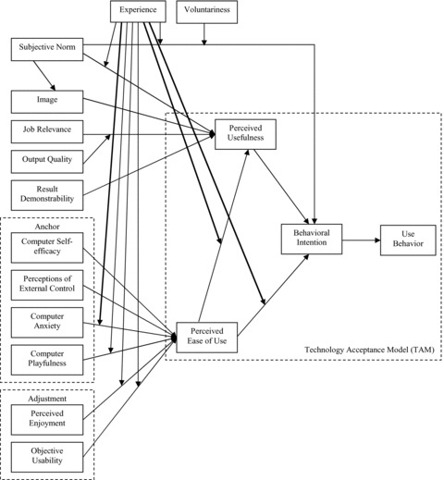
Figure 3.1: Technology Acceptance Model 3
Source: Venkatesh and Bala (2008, Figure 2).

3.1.2 Technology Use for Micro-Credential Programmes
Miao et al. (2024) combined TAM and self-determination theory to study technology used for micro-credential programmes. They collected questionnaire data from 474 private-university students in Karachi using convenience sampling and analysed the model with PLS-SEM. Perceived Usefulness significantly influenced Attitude towards using technology for Micro-Credential Programs. Perceived Ease of Use was reported as supported at p = .051, and attitude significantly influenced Behavioral Intention. The proposed labour-market moderation was not significant. Figure 3.2 reproduces their published conceptual framework.
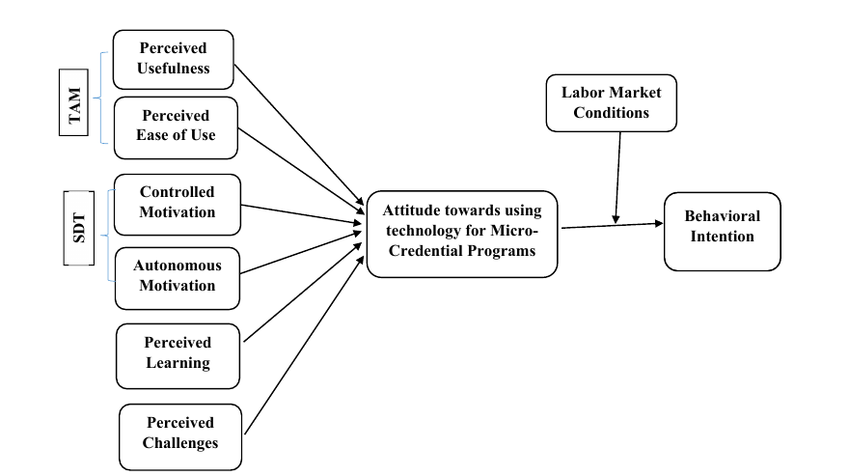
Figure 3.2: Conceptual framework for technology use in micro-credential programmes
Source: Miao et al. (2024, Figure 1, p. 956).

3.1.3 Digital-Badge Acceptance Framework
Steenkamp et al. (2024) developed an extended TAM3 framework for students' intention to use university-issued digital badges in job applications. They collected online questionnaire data from 57 accounting students at a New Zealand university and analysed 11 reflective constructs with PLS-SEM. Six of 13 hypothesised paths were supported. The four paths selected for the present study were all significant: Perceived Ease of Use to Perceived Usefulness, Job Application Relevance to Perceived Usefulness, Perceived Usefulness to Behavioural Intention to Use DB, and Subjective Norm to Behavioural Intention to Use DB. Figure 3.3 is a direct reproduction of their published model.
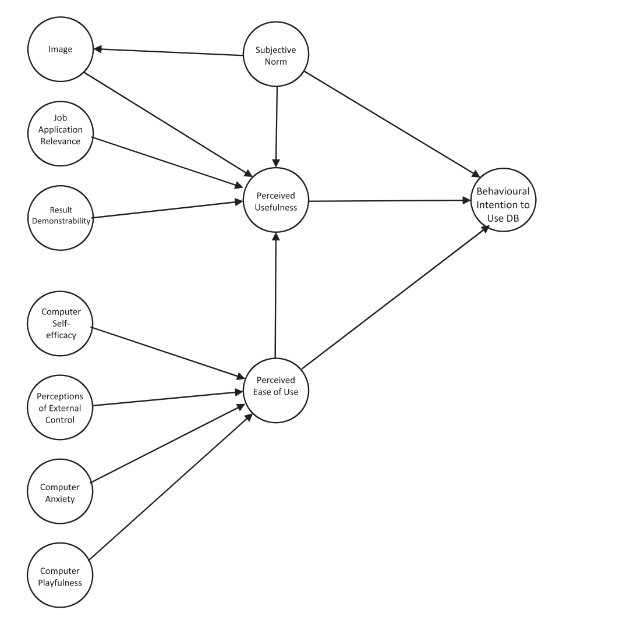
Figure 3.3: Research model for students' intention to use digital badges
Source: Steenkamp, Fisher, and Nesbit (2024, Figure 1, p. 10).

3.2 Conceptual Framework of the Study
The conceptual framework in Figure 3.4 was constructed for this study by selecting five exact constructs and four previously tested paths from Steenkamp et al. (2024). TAM3 provides the underlying theoretical structure, and Miao et al. (2024) provides additional evidence that Perceived Ease of Use, Perceived Usefulness, and Behavioral Intention are relevant in a micro-credential technology context. No construct in the final framework has been renamed from Steenkamp et al.'s published digital-badge framework.
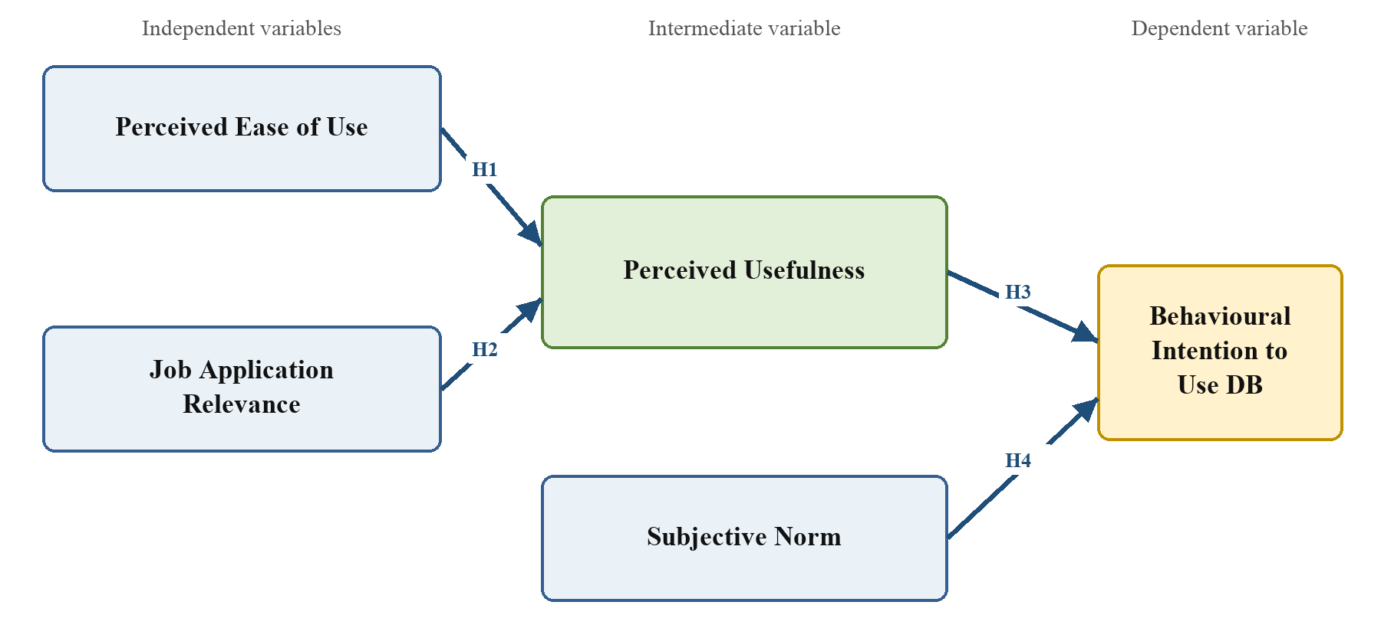
Figure 3.4: Conceptual framework of the study
Source: Constructed by the author based on Venkatesh and Bala (2008), Miao et al. (2024), and Steenkamp et al. (2024).
Table 3.1: Framework provenance
Study construct | Exact-label source | Selected published path | Additional framework support
Perceived Ease of Use | Steenkamp et al. (2024), Figure 1 | PEOU -> PU (source H3) | Venkatesh & Bala (2008); Miao et al. (2024)
Job Application Relevance | Steenkamp et al. (2024), Figure 1 | REL -> PU (source H8) | Job Relevance in Venkatesh & Bala (2008)
Perceived Usefulness | Steenkamp et al. (2024), Figure 1 | PU -> BI (source H1) | Venkatesh & Bala (2008); Miao et al. (2024)
Subjective Norm | Steenkamp et al. (2024), Figure 1 | SN -> BI (source H4) | Venkatesh & Bala (2008)
Behavioural Intention to Use DB | Steenkamp et al. (2024), Figure 1 | Dependent construct | Behavioral Intention in Venkatesh & Bala (2008) and Miao et al. (2024)

3.3 Research Hypotheses
The following hypotheses correspond directly to the four arrows in Figure 3.4. The numbering is specific to the present study; Table 3.1 identifies the original Steenkamp et al. (2024) hypothesis number for each selected path.
H1: Perceived ease of use has a positive direct effect on students' perceived usefulness of university-issued digital badges in job applications.
H2: Job application relevance has a positive direct effect on students' perceived usefulness of university-issued digital badges in job applications.
H3: Perceived usefulness has a positive direct effect on students' behavioural intention to use university-issued digital badges in job applications.
H4: Subjective norm has a positive direct effect on students' behavioural intention to use university-issued digital badges in job applications.

3.4 Operationalization of the Variables
Table 3.2: Operationalization and full measurement items
Variable and operational definition | Code | Measurement statement | Scale | Source
Perceived Usefulness: The extent to which a student believes that using a university-issued digital badge will improve the effectiveness and quality of a job application. | PU1 | Using university-issued digital badges would increase my employability when I apply for jobs. | 7-point Likert | Steenkamp et al. (2024)
 | PU2 | Using university-issued digital badges would increase the quality of my job applications. | 7-point Likert | Steenkamp et al. (2024)
 | PU3 | Using university-issued digital badges would enhance my effectiveness when I apply for jobs. | 7-point Likert | Steenkamp et al. (2024)
 | PU4 | I would find using university-issued digital badges useful when applying for jobs. | 7-point Likert | Steenkamp et al. (2024)
Perceived Ease of Use: The extent to which a student believes that using a university-issued digital badge will be clear, understandable, and free of effort. | PEOU1 | If I were to obtain university-issued digital badges, my interaction with them would be clear and understandable. | 7-point Likert | Steenkamp et al. (2024)
 | PEOU2 | If I were to obtain university-issued digital badges, interacting with them would not require a lot of my mental effort. | 7-point Likert | Steenkamp et al. (2024)
 | PEOU3 | If I were to obtain university-issued digital badges, I would find them easy to use. | 7-point Likert | Steenkamp et al. (2024)
 | PEOU4 | If I were to obtain university-issued digital badges, I would find it easy to get them to do what I want them to do. | 7-point Likert | Steenkamp et al. (2024)
Subjective Norm: The extent to which a student perceives that important people and the university expect or support the use of digital badges in job applications. | SN1 | People who influence my behaviour think that I should use university-issued digital badges when applying for jobs. | 7-point Likert | Steenkamp et al. (2024)
 | SN2 | People who are important to me think that I should use university-issued digital badges when applying for jobs. | 7-point Likert | Steenkamp et al. (2024)
 | SN3 | My university would be helpful in using university-issued digital badges for job applications. | 7-point Likert | Steenkamp et al. (2024)
 | SN4 | In general, my university would support the use of university-issued digital badges for job applications. | 7-point Likert | Steenkamp et al. (2024)
Job Application Relevance: The extent to which a student believes that digital badges are applicable and pertinent to job-search and job-application activities. | REL1 | When job searching, usage of university-issued digital badges is important. | 7-point Likert | Steenkamp et al. (2024)
 | REL2 | When job searching, usage of university-issued digital badges is relevant. | 7-point Likert | Steenkamp et al. (2024)
 | REL3 | The use of university-issued digital badges is pertinent to my job searching activities. | 7-point Likert | Steenkamp et al. (2024)
Behavioural Intention to Use DB: A student's stated intention or plan to use university-issued digital badges when applying for jobs. | BI1 | Assuming I had access to university-issued digital badges I intend to use them when I apply for jobs. | 7-point Likert | Steenkamp et al. (2024)
 | BI2 | Given that I had access to university-issued digital badges, I predict that I would use them when I apply for jobs. | 7-point Likert | Steenkamp et al. (2024)
 | BI3 | If I had access to university-issued digital badges, I would plan to use them when I apply for jobs in the next 12 months. | 7-point Likert | Steenkamp et al. (2024)

BI3 corrects the source Appendix's apparent typographical phrase 'use the when' to 'use them when'; no construct meaning or timeframe is changed.

CHAPTER 4: RESEARCH METHODOLOGY

4.1 Research Design
The study will use a quantitative, explanatory, cross-sectional survey design. This design is appropriate for measuring student perceptions and estimating the four hypothesised relationships at one point in time. The five constructs will be measured reflectively, consistent with Steenkamp et al. (2024), and the measurement and structural models will be assessed using PLS-SEM. The design can identify associations and predictive relationships but cannot establish causal effects.

4.2 Sampling Procedure

4.2.1 Target Population
The target population consists of students aged 18 years or older who are currently enrolled in an IT-related undergraduate or postgraduate programme at a university in Thailand. Relevant fields include information technology, computer science, software engineering, information systems, data science, cybersecurity, computer engineering, and closely related programmes.

4.2.2 Sampling Method and Sample Size
Convenience and snowball sampling will be used because a complete national sampling frame of Thai IT students is not available. The questionnaire will be distributed through university programmes, student groups, and academic networks. The Krejcie and Morgan (1970) table provides 384 as a conventional benchmark for a large population under probability-sampling assumptions. The present non-probability sample cannot claim the corresponding margin of error, but 384 is retained as a conservative minimum and exceeds the sample normally required for this five-construct PLS-SEM model (Hair et al., 2022). The recruitment target will be 400 usable responses.

4.2.3 Inclusion and Exclusion Criteria
Respondents will be included if they provide informed consent, are at least 18 years old, are currently enrolled in an IT-related university programme in Thailand, and complete the construct measures. Records will be excluded for failed eligibility screening, duplicate submission, substantial missing data, or implausibly short completion time. Pilot participants will not be included in the main-study dataset.

4.3 Research Instrument and Questionnaire Design
Data will be collected through a structured online questionnaire. The 18 construct items are the items printed by Steenkamp et al. (2024, Appendix, pp. 28-29) for the five exact constructs retained in the conceptual framework. Their wording already refers to university-issued digital badges and job applications, so no contextual replacement is required. BI3 contains only the grammatical correction described in Section 3.4.
Table 4.1: Structure of the questionnaire
Section | Content | Purpose
A | Participant information, consent, age, enrolment status, and field | Confirm consent and eligibility
B | Neutral definition of an IT micro-credential and university-issued digital badge | Provide a common referent
C | Age group, gender, study level, field, year, institution type, and prior badge awareness or use | Describe the sample
D | Eighteen statements measuring five model constructs | Test the measurement and structural models

All construct items will use the seven-point agreement scale employed by Steenkamp et al. (2024), ranging from 1 (strongly disagree) to 7 (strongly agree). The complete English measurement instrument is presented below.
Table 4.2: Seven-point agreement scale
1 | 2 | 3 | 4 | 5 | 6 | 7
Strongly disagree | Moderately disagree | Somewhat disagree | Neutral | Somewhat agree | Moderately agree | Strongly agree

Perceived Usefulness
Table 4.3: Perceived Usefulness measurement items
Code | Questionnaire statement | Measurement source
PU1 | Using university-issued digital badges would increase my employability when I apply for jobs. | Steenkamp et al. (2024); Davis (1989); Venkatesh & Bala (2008)
PU2 | Using university-issued digital badges would increase the quality of my job applications. | Steenkamp et al. (2024); Davis (1989); Venkatesh & Bala (2008)
PU3 | Using university-issued digital badges would enhance my effectiveness when I apply for jobs. | Steenkamp et al. (2024); Davis (1989); Venkatesh & Bala (2008)
PU4 | I would find using university-issued digital badges useful when applying for jobs. | Steenkamp et al. (2024); Davis (1989); Venkatesh & Bala (2008)

Perceived Ease of Use
Table 4.4: Perceived Ease of Use measurement items
Code | Questionnaire statement | Measurement source
PEOU1 | If I were to obtain university-issued digital badges, my interaction with them would be clear and understandable. | Steenkamp et al. (2024); Davis (1989); Venkatesh & Bala (2008)
PEOU2 | If I were to obtain university-issued digital badges, interacting with them would not require a lot of my mental effort. | Steenkamp et al. (2024); Davis (1989); Venkatesh & Bala (2008)
PEOU3 | If I were to obtain university-issued digital badges, I would find them easy to use. | Steenkamp et al. (2024); Davis (1989); Venkatesh & Bala (2008)
PEOU4 | If I were to obtain university-issued digital badges, I would find it easy to get them to do what I want them to do. | Steenkamp et al. (2024); Davis (1989); Venkatesh & Bala (2008)

Subjective Norm
Table 4.5: Subjective Norm measurement items
Code | Questionnaire statement | Measurement source
SN1 | People who influence my behaviour think that I should use university-issued digital badges when applying for jobs. | Steenkamp et al. (2024); Venkatesh & Bala (2008); Venkatesh et al. (2003)
SN2 | People who are important to me think that I should use university-issued digital badges when applying for jobs. | Steenkamp et al. (2024); Venkatesh & Bala (2008); Venkatesh et al. (2003)
SN3 | My university would be helpful in using university-issued digital badges for job applications. | Steenkamp et al. (2024); Venkatesh & Bala (2008); Venkatesh et al. (2003)
SN4 | In general, my university would support the use of university-issued digital badges for job applications. | Steenkamp et al. (2024); Venkatesh & Bala (2008); Venkatesh et al. (2003)

Job Application Relevance
Table 4.6: Job Application Relevance measurement items
Code | Questionnaire statement | Measurement source
REL1 | When job searching, usage of university-issued digital badges is important. | Steenkamp et al. (2024); Venkatesh & Bala (2008)
REL2 | When job searching, usage of university-issued digital badges is relevant. | Steenkamp et al. (2024); Venkatesh & Bala (2008)
REL3 | The use of university-issued digital badges is pertinent to my job searching activities. | Steenkamp et al. (2024); Venkatesh & Bala (2008)

Behavioural Intention
Table 4.7: Behavioural Intention measurement items
Code | Questionnaire statement | Measurement source
BI1 | Assuming I had access to university-issued digital badges I intend to use them when I apply for jobs. | Steenkamp et al. (2024); Venkatesh & Bala (2008); Venkatesh & Davis (2000)
BI2 | Given that I had access to university-issued digital badges, I predict that I would use them when I apply for jobs. | Steenkamp et al. (2024); Venkatesh & Bala (2008); Venkatesh & Davis (2000)
BI3 | If I had access to university-issued digital badges, I would plan to use them when I apply for jobs in the next 12 months. | Steenkamp et al. (2024); Venkatesh & Bala (2008); Venkatesh & Davis (2000)

4.4 Translation and Pilot Testing
The approved English questionnaire will be translated into Thai and independently back-translated into English. Differences will be reconciled to preserve each construct's intended meaning (Brislin, 1970). Before the main survey, the Thai questionnaire will be pilot tested with 40 eligible Thai IT students, consistent with the programme examples and published pilot-study guidance (Hertzog, 2008; Johanson & Brooks, 2010). The pilot will assess screening logic, instructions, item comprehension, completion time, missing responses, and preliminary internal consistency. Pilot participants will be excluded from the main study.

4.5 Data Collection
After academic and ethical approval, an online survey link will be distributed through the selected university and student channels. The first page will provide participant information and request informed consent. Participation will be voluntary. Respondents may leave before submitting the questionnaire, and no directly identifying information will be required. Survey records will be stored securely and used only for the stated academic purpose.

4.6 Statistical Treatment of Data
- Screen records for consent, eligibility, duplicate submissions, missing data, completion quality, and coding errors.
- Describe respondent characteristics using frequencies and percentages and summarize item and construct responses using means and standard deviations.
- Assess the reflective measurement model using indicator loadings, Cronbach's alpha, composite reliability, average variance extracted, and heterotrait-monotrait ratios.
- Assess structural-model collinearity using variance inflation factors and report R-squared values for Perceived Usefulness and Behavioural Intention to Use DB.
- Estimate H1-H4 in SmartPLS using 5,000 bootstrap samples and report path coefficients, confidence intervals, p-values, and effect sizes (Hair et al., 2022).
- Determine support for each hypothesis at the 5% significance level and compare the resulting pattern with Steenkamp et al. (2024) and the literature reviewed in Chapter 2.

4.7 Ethical Considerations
The study will follow the university's research-ethics requirements. The consent page will explain the study purpose, eligibility requirements, voluntary participation, foreseeable risks, confidentiality, data use, and withdrawal before submission. Only respondents who provide consent will continue. Findings will be reported in aggregate form and will not be presented as evidence of actual employment outcomes or employer acceptance.

References
Abdullah, F., and Ward, R. (2016). Developing a general extended technology acceptance model for e-learning (GETAMEL) by analysing commonly used external factors. Computers in Human Behavior, 56, 238-256. https://doi.org/10.1016/j.chb.2015.11.036
Abdullah, F., Ward, R., and Ahmed, E. (2016). Investigating the influence of the most commonly used external variables of TAM on students' perceived ease of use and perceived usefulness of e-portfolios. Computers in Human Behavior, 63, 75-90. https://doi.org/10.1016/j.chb.2016.05.014
Ajzen, I. (1991). The theory of planned behavior. Organizational Behavior and Human Decision Processes, 50(2), 179-211. https://doi.org/10.1016/0749-5978(91)90020-T
Brislin, R. W. (1970). Back-translation for cross-cultural research. Journal of Cross-Cultural Psychology, 1(3), 185-216. https://doi.org/10.1177/135910457000100301
Council of the European Union. (2022). Council Recommendation of 16 June 2022 on a European approach to micro-credentials for lifelong learning and employability (2022/C 243/02). Official Journal of the European Union, C 243, 10-25.
Davis, F. D. (1989). Perceived usefulness, perceived ease of use, and user acceptance of information technology. MIS Quarterly, 13(3), 319-340. https://doi.org/10.2307/249008
Fishbein, M., and Ajzen, I. (1975). Belief, attitude, intention and behavior: An introduction to theory and research. Addison-Wesley.
Granic, A., and Marangunic, N. (2019). Technology acceptance model in educational context: A systematic literature review. British Journal of Educational Technology, 50(5), 2572-2593. https://doi.org/10.1111/bjet.12864
Hair, J. F., Hult, G. T. M., Ringle, C. M., and Sarstedt, M. (2022). A primer on partial least squares structural equation modeling (PLS-SEM) (3rd ed.). Sage.
Hertzog, M. A. (2008). Considerations in determining sample size for pilot studies. Research in Nursing & Health, 31(2), 180-191. https://doi.org/10.1002/nur.20247
Johanson, G. A., and Brooks, G. P. (2010). Initial scale development: Sample size for pilot studies. Educational and Psychological Measurement, 70(3), 394-400. https://doi.org/10.1177/0013164409355692
Kiiskila, P., Kukkonen, A., and Pirkkalainen, H. (2023). Are micro-credentials valuable for students? Perspective on verifiable digital credentials. SN Computer Science, 4, Article 366. https://doi.org/10.1007/s42979-023-01797-y
Krejcie, R. V., and Morgan, D. W. (1970). Determining sample size for research activities. Educational and Psychological Measurement, 30(3), 607-610. https://doi.org/10.1177/001316447003000308
Miao, M., Ahmed, M., Ahsan, N., and Qamar, B. (2024). Intention to use technology for micro-credential programs: Evidence from technology acceptance and self-determination model. International Journal of Educational Management, 38(4), 948-977. https://doi.org/10.1108/IJEM-02-2023-0066
Moore, G. C., and Benbasat, I. (1991). Development of an instrument to measure the perceptions of adopting an information technology innovation. Information Systems Research, 2(3), 192-222. https://doi.org/10.1287/isre.2.3.192
Schepers, J., and Wetzels, M. (2007). A meta-analysis of the technology acceptance model: Investigating subjective norm and moderation effects. Information & Management, 44(1), 90-103. https://doi.org/10.1016/j.im.2006.10.007
Steenkamp, N., Fisher, R., and Nesbit, T. (2024). Understanding accounting students' intentions to use digital badges to showcase employability skills. Accounting Education, 33(6), 906-934. https://doi.org/10.1080/09639284.2023.2276200
Sykes, T. A., Venkatesh, V., and Johnson, J. L. (2014). Enterprise system implementation and employee job performance: Understanding the role of advice networks. MIS Quarterly, 38(1), 51-72. https://doi.org/10.25300/MISQ/2014/38.1.03
Taylor, S., and Todd, P. A. (1995). Understanding information technology usage: A test of competing models. Information Systems Research, 6(2), 144-176. https://doi.org/10.1287/isre.6.2.144
UNESCO. (2022). Towards a common definition of micro-credentials. UNESCO. https://unesdoc.unesco.org/ark:/48223/pf0000381668
Ursavas, O. F., Yalcin, Y., and Bakir, E. (2019). The effect of subjective norms on preservice and in-service teachers' behavioural intentions to use technology: A multigroup multimodel study. British Journal of Educational Technology, 50(5), 2501-2519. https://doi.org/10.1111/bjet.12834
Venkatesh, V. (2000). Determinants of perceived ease of use: Integrating control, intrinsic motivation, and emotion into the technology acceptance model. Information Systems Research, 11(4), 342-365. https://doi.org/10.1287/isre.11.4.342.11872
Venkatesh, V., and Bala, H. (2008). Technology acceptance model 3 and a research agenda on interventions. Decision Sciences, 39(2), 273-315. https://doi.org/10.1111/j.1540-5915.2008.00192.x
Venkatesh, V., and Davis, F. D. (2000). A theoretical extension of the technology acceptance model: Four longitudinal field studies. Management Science, 46(2), 186-204. https://doi.org/10.1287/mnsc.46.2.186.11926
Venkatesh, V., Morris, M. G., Davis, G. B., and Davis, F. D. (2003). User acceptance of information technology: Toward a unified view. MIS Quarterly, 27(3), 425-478. https://doi.org/10.2307/30036540

