**Exploring the Nexus: Comparing and Aligning**

**Planetary Health, One Health, and EcoHealth**

Byomkesh Talukder1*, Nilanjana Ganguli2, Eunice Choi2, Mohammadali Tofighi2

1. Department of Global Health, Florida International University, USA.
2. Dahdaleh Institute for Global Health Research, York University, Canada.

* [byomkesh.talukder@gmail.com](mailto:byomkesh.talukder@gmail.com)

**Abstract**

The interconnectedness between humans and ecosystems highlights the need to protect ecosystems for the well-being of humans and the environment. This has led to the emergence of holistic and interdisciplinary concepts like Planetary Health, One Health, and EcoHealth. There is a growing interest about the differences and implementation of these concepts, including their founders, fundamental questions answered, focus, global distribution of studies, and alignment. This study aims to address these issues to facilitate coordinated health interventions for people and ecosystems. Using electronic databases (Web of Science, PubMed, and ProQuest) and conducting a systematic literature review using the Preferred Reporting Items for Systematic Reviews and Meta-Analyses (PRISMA), this paper compares the concepts of Planetary Health, One Health, and EcoHealth, providing a comprehensive overview of the findings and insights by examining each field’s advocacy, conceptual application, and implementation levels and exploring the contributions of influential individuals and organizations. The results highlight the global interest in and applicability of each concept and point out challenges and opportunities for further advancement. The study concludes by emphasizing the shared goals and interconnections among these fields in addressing complex health issues at the nexus of human health, environmental health, and ecosystem well-being.

**Keywords:** Planetary Health, One Health, EcoHealth, Advocacy, Distinctions, Resemblances

1. **Introduction**

Humans and ecosystems are connected [1,2,3]. Exploiting ecosystems for survival has shaped and influenced human societies and ecosystems and continues to impact both humans and ecosystems today. Many religions and indigenous communities recognize the importance of protecting ecosystems and advocate for the judicious use of resources [4,5,6]. Humans and ecosystems are interconnected in a complex adaptive system. Ecosystems provide various services to humans, including regulatory services such as pollination, water purification, climate regulation, and so forth, and provisional services such as food, raw materials, medicinal resources, and so on [7,8,9,10,11]. These services are crucial for human health and influence the social determinants of health [12].

Human reliance on ecosystems for survival and health has increased alongside the growth of the global population [13,14]. Achievements in human development, such as longer life expectancies and poverty reduction, have been facilitated by resource usage, including fossil fuels, increased energy consumption, and modified agricultural practices. However, these advances have resulted in detrimental consequences like escalating CO2 emissions, deforestation, water scarcity, and other environmental damages [14]. As the world’s population is projected to reach 9.6 billion by 2050, the demand for food and water will intensify, further straining available resources and exacerbating greenhouse gas emissions, environmental degradation, and the vulnerability of Earth’s systems [14].

Regrettably, this exploitation has endangered ecosystem functioning. The industrial revolution in the nineteenth century triggered significant pollution, environmental degradation, and public health concerns through changes in production and manufacturing processes [15]. Presently, 14 out of 18 categories of nature’s contributions to human life are experiencing decline, reflecting the strain on ecosystems and their reduced capacity to sustain human civilization, leading to adverse health impacts (see Fig. 1). For instance, air and water pollution have been linked to health issues like cancer and respiratory disorders, and pesticides and improper waste disposal have poisoned millions and contaminated water sources, contributing to the spread of waterborne diseases [16].

Top of Form

Fig. 1. Global 50-year trends in the capacity of nature to sustain contributions to a good quality of life, showing a decline in 14 of the 18 categories of nature’s contributions to people [16].

These issues are not new; environmental degradation has been attributed as a contributing factor to the destruction of numerous past societies, such as the collapse of the [Indus Valley](https://www.worldhistory.org/Indus_Valley_Civilization/) [Civilization](https://www.worldhistory.org/civilization/) (7000 to 600 BCE) [17]. The need to address the unsustainable use of natural resources and mitigate harmful impacts on ecosystems and human health is urgent as well as evident [18]. Environmental movements gained momentum in the twentieth century, leading to the establishment of national and international environmental laws and regulations [19]. Scientific research in the latter part of the twentieth century established the link between environmental factors and specific health outcomes, including cancer and respiratory diseases. Accordingly, policies and practices have been developed to reduce exposure to environmental pollutants and minimize their impact on human health [20,21,22]. Concurrently, the concepts of Planetary Health, One Health and EcoHealth have emerged to address impacts of ecological degradation on human health.

Planetary Health “is the achievement of the highest attainable standard of health, well-being, and equity worldwide through judicious attention to the human systems—political, economic, and social—that shape the future of humanity and the Earth’s natural systems that define the safe environmental limits within which humanity can flourish” [14, p.1978]. One Health “is an approach to designing and implementing programs, policies, legislation, and research in which multiple sectors communicate and work together to achieve better public health outcomes. The areas of work may include zoonotic diseases, antimicrobial resistance, food safety, and emergency preparedness, among others” [23, p.1]. EcoHealth “is an approach that integrates natural and social sciences to understand and manage ecosystems and the interactions among human, animal, and environmental health” [24, n. d., p. 1].

Fig. 2 presents a graphical illustration of these concepts. Planetary Health, One Health, and EcoHealth principles are frequently used at the local and regional levels to increase awareness, engage communities, and promote policies and practices that enhance sustainable and resilient health systems of both people and the ecosystems (for Planetary Health see [25,26,27]; for One Health see [28,29,30,31,32]; for EcoHealth see [33,34,35,36]. However, different groups of experts and global platforms emphasize these concepts differently, leading to various concerns. These include: (i) how they differ in advocacy, conceptual application, and implementation; (ii) who the experts are in the global South and North and how they are using/applying these concepts; (iii) where the studies of these concepts are concentrated. Other concerns are: (i) who the founders and organizations are that are working to advance the concept; (ii) what fundamental questions are answered by these concepts; (iii) how they differ in terms of focus and scope, emphases, and critical considerations; and (iv) how the studies differ in distinction, resemblance, and alignment. Finding the answers to these questions in order to successfully design coordinated interventions to address human and ecosystem health is the objective of this study.

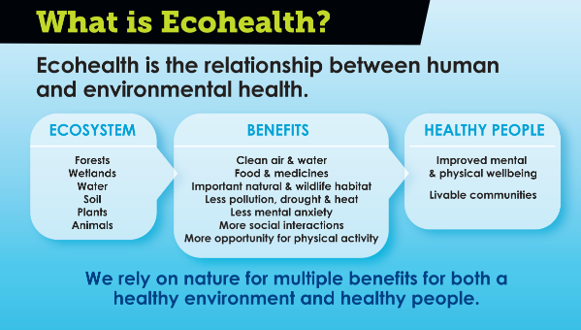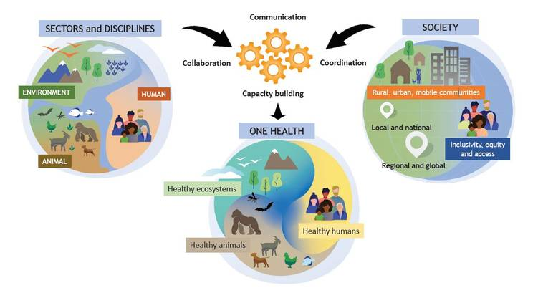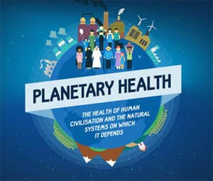

Fig. 2. Graphical illustrations of [A] Planetary Health, [B] One Health and [C] EcoHealth concepts.

1. **Methodology**

To fulfill the objective of the study, data were gathered and visualized by the following steps.

***2.1 Identify and Sort Articles***

Following the guidelines of PRISMA (Preferred Reporting Items for Systematic Reviews and Meta-Analyses [37], a rigorous literature search was conducted by combining keywords like “Planetary Health”, “One Health”, “EcoHealth” using the Boolean operators “AND/OR” in three electronic data sources: Web of Science, PubMed, and ProQuest (see Table 1). The search mainly focused on peer-reviewed articles written in English and published between January 2015 and June 2021 onwards. The year 2015 was selected as the starting point to align with the official launch year of “Planetary Health,” which is the newest among the three concepts [14]. This approach ensured fairness in the search results, aiming for an equal number of articles per concept. Later, a few other articles from 2022 were also included by hand search.

Table 1. Database and Keywords used for Identifying Articles

|  |  |  |
| --- | --- | --- |
| **Concept** | **Source** | **Keywords** |
| Planetary Health | *WOS* | TITLE: (“Planetary Health”) AND TOPIC: (concept* OR approach*) |
| AB = (“Planetary Health”) AND TS = (approach* OR concept*) |
| *PubMed* | (“Planetary Health” [Title/Abstract]) AND (concept* OR approach*) |
| *ProQuest* | ti (“Planetary Health”) AND (concept* OR approach*) |
| ab (“Planetary Health”) AND noft (concept* OR approach*) |
| One Health | *WOS* | TITLE: (“One Health”) AND TOPIC: (concept* OR approach*) |
| AB = (“One Health”) AND TS = (approach* OR concept*) |
| *PubMed* | (“One Health” [Title/Abstract]) AND (concept* OR approach*) |
| *ProQuest* | ti (“One Health”) AND (concept* OR approach*) |
| ab (“One Health”) AND noft (concept* OR approach*) |
| EcoHealth | *WOS* | TITLE: (“ecohealth ” OR” EcoHealth”) AND TOPIC: (concept* OR approach*) |
| AB = (“EcoHealth” OR “ecohealth”) AND TS = (approach* OR concept*) |
| *PubMed* | (“EcoHealth”[Title] OR “EcoHealth”[Title/Abstract]) AND (concept*[Title] OR approach*[Title]) |
| *ProQuest* | ti (“EcoHealth” OR “EcoHealth”) AND noft (concept* OR approach*) |
| ab (“EcoHealth” OR “EcoHealth”) AND noft (concept* OR approach*) |

A predefined research protocol with clearly defined inclusion and exclusion criteria for identification, screening, eligibility, and inclusion (see Fig. 3) was developed by the authors based on PRISMA principles [37]. The predefined protocol was verified by running pilot searches and further adjusted to keep the size of the dataset manageable yet highly representative of the three concepts.

The first step of the screening process was to export the articles (with full records) from all three databases to Zotero software and merge the results per concept and store them in three separate folders (one for each concept). Duplicates were eliminated, which brought the sample size to 2169 articles for One Health, 170 articles for EcoHealth, and 183 articles for Planetary Health.

To fulfill the objective of the study, mainly both review papers and empirical research were included in the search results. A few book chapters and reports and website information were also included.

The research protocol required adjustment after the pilot searches were run. This was mainly due to the high number of hits for One Health, which has gained a lot of momentum. In order to keep the sample size manageable, a special exclusion criterion of “less than 10 citations” was applied only to the One Health results.

The last sorting phase was based on title and abstracts and consisted of a few inclusion and exclusion criteria: (i) only articles focussed on either advocating or applying one or more of the three concepts were included; (ii) theoretical papers on the three concepts were excluded; (iii) articles comparing the three concepts or bibliometric analysis of the three concepts were excluded from the results/analysis (but authors have used a few to add robustness to the discussion); (iv) articles in which the concepts were only mentioned and were not the focus of the article were excluded; (v) articles that considered “Planetary Health”, “One Health” and “EcoHealth” not as concepts but in the general sense to refer to the health of the planet, a health problem, or the health of the ecosystem were excluded; (vi) articles that were linked to the same project especially in the case of One Health and EcoHealth, were excluded; and (vii) articles were excluded if there was no access to the full article.

Step - 1

Identification

Total articles identified:

PH (*n* = 391)

OH (*n* = 4748)

EH (*n* = 324)

Excluded articles:

PH (*n* = 178)

OH (*n* = 379)

EH (*n* = 125)

Identified eligible articles:

PH (*n* = 51)

OH (*n* = 228)

EH (*n* = 47)

Reviewed articles: PH (*n* = 51)

OH (*n* = 228)

EH (*n* = 47)

Step - 2

Screening

Step - 3

Eligibility

Step - 4

Included

Fig 3. Steps of systematic literature review Note: PH = Planetary Health; One Health = One Health; EH = EcoHealth

As depicted in Fig. 3, at the end of the final screening phase, 228 articles for One Health, 47 articles for EcoHealth, and 52 articles for Planetary Health were deemed to find the answer of (i) how Planetary Health, One Health, and EcoHealth differ in advocacy, conceptual application, and implementation; (ii) who the experts are in the global South and North and how they are using/applying these concepts; (iii) where the studies of these concepts are concentrated.

***2.2 Data Extraction and Compilation***

Included articles were exported in Excel sheets to create a database from the articles about “advocacy,” “conceptual application,” and “implemented” based on the following predefined criteria, as shown in Table 2.

Table 2. Criteria for “Advocacy,” “Conceptual Application,” and “Implemented.”

|  |  |
| --- | --- |
| **Category** | **Criteria** |
| Advocacy | Articles advocating one of the concepts for a defined local, regional, or global issue. For example, “One Health for Antimicrobial Resistance (AMR) surveillance in the global context.” |
| Conceptual Application | Articles that explicitly discuss the conceptual application of the concepts in the investigation or intervention of a defined local, regional, or global health issue. Applications range from conceptual models, application of theoretical frameworks, technological solutions, and educational workshops to vaccination programs/projects. For example, “Labelling plant-based meat as an intervention to promote the Planetary Health diet.” |
| Implemented | Articles based on research-to-action projects, or, in other words, a concept funded and implemented, whether field-based or virtual (think-tank), to solve a local, regional, or global health issue. For example, “The Lawa project to control Opisthorchiasis in northeast Thailand (“EcoHealth” project).” |

Following the sorting of the articles per category, key variables identified were publication year, journal name, title of study, authors’ names, authors’ disciplines, authors’ locations, study location (for implemented), type of health issue (communicable or non-communicable disease; type of communicable disease (zoonotic, vector-borne, infectious, parasitic); NGO or government involvement (in funding or research team member); type of study (investigation or intervention): top-down (no community involvement) or bottom-up (community involvement in data collection, implementation and reporting) approach; and single discipline, multidisciplinary (2 disciplines) or transdisciplinary (2 or more disciplines). The articles were coded by authors’ locations and authors’ disciplines for Global North and South collaboration and single discipline (1 discipline), interdisciplinary (2 disciplines), or transdisciplinary (3 or more disciplines), respectively.

Besides 52 articles other articles were hand searched to identify (i) the founders and organizations working to advance the concepts; (ii) fundamental questions addressed by the concepts; and (iii) focus and scope, emphasis, and critical considerations, and (v) distinctions, resemblances, and alignment of the concepts.

***2.3 Data Presentation***

Using Microsoft Excel’s Analyze Data option, multiple visual charts and maps were developed (as discussed in the results) to compare the three concepts based on the level of interdisciplinary collaboration, Global North-South collaboration, popularity (number of studies, disciplines, location), stage (advocacy, conceptual application, or implemented), main health issue, location of the project (for implemented), policy potential (NGO or government involvement) and methodology approach (expert level or community-level participation).

**3.0 Results**

The results were based on the final included articles of the systematic literature review.

***3.1 Advocacy, Conceptual Application, and Implemented***

There was a significant hike in academic interest in Planetary Health in 2019-2020 due to the pandemic (Fig. 4[A]). One Health and Planetary Health are very close in the percentage of articles that focussed on advocacy (49% and 50%, respectively), with EcoHealth lagging considerably behind with only 13%. However, the reverse was true for implemented, with EcoHealth leading significantly (Fig. 4[B]). Advocacy dominated throughout the study period, with a rise in 2019-2020 and a steady decrease in articles on application within the same period (Fig. 4[C]). This decrease could be related to limitations due to travel restrictions caused by COVID-19.

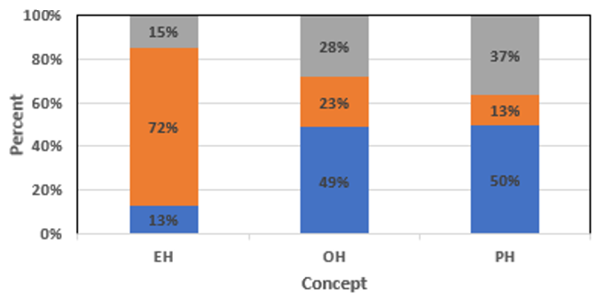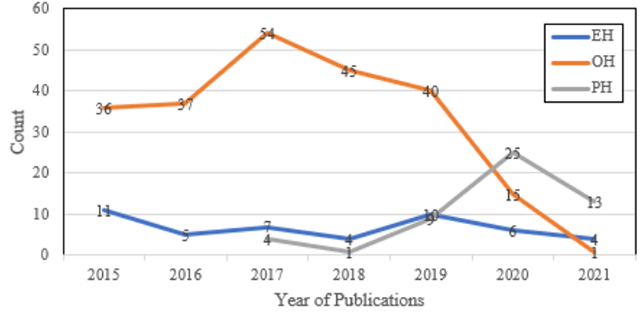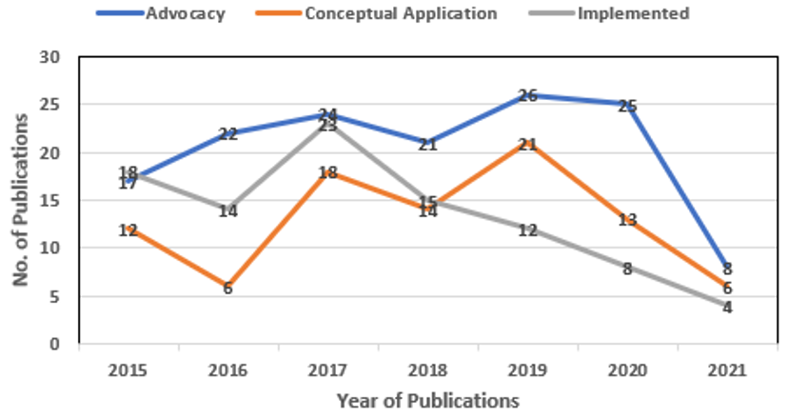

**[A]**

**[B]**

**[C]**

Fig. 4. [A] Number of publications per concept in 2015-2021, [B] Percentage of articles by category per concept, [C] Number of articles per category by publication year.

***3.2 Involvement of Experts from the Global South and North***

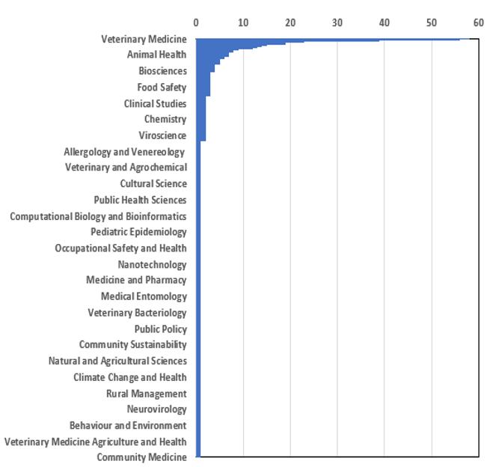In terms of author’s expertise, veterinary medicine is the most frequently occurring academic expertise in the sample, which could be associated with the significantly high number of articles about One Health versus EcoHealth and Planetary Health (Fig. 5). There was a considerable amount of transdisciplinary collaboration in the articles on all three concepts, but it is essential to draw attention to the disciplines that are in partnership and to discover if there are any gaps. For example, 35% of articles featured collaborations between authors from the Global North and South, with most of the cooperation in One Health (Fig. 6[A]), and a sharp difference in the percentage of studies led independently by global North versus global South (Fig. 6[B]). Fig. 7[A] and 7[B] show the geographical locations of the authors; it is encouraging to see the broad global reach of the three concepts.

Fig. 5. Number of publications per disciplines of the authors

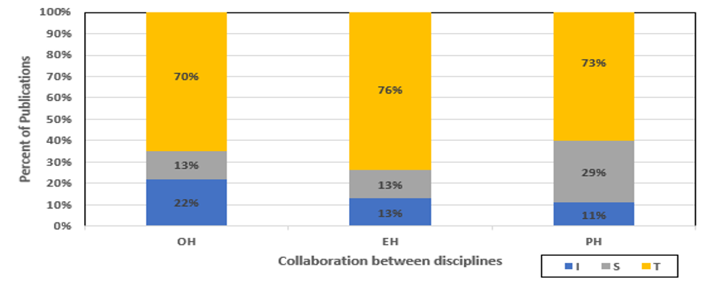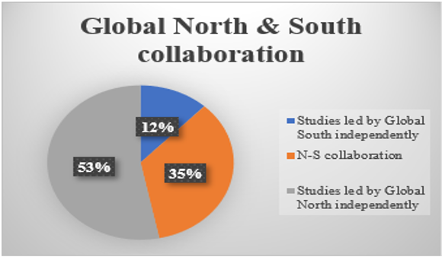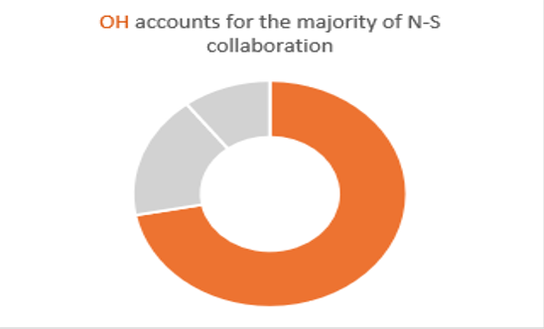

**[A]**

**[B]**

**[C]**

Fig. 4. [A] Percentage of publications collaborate between disciplines from 2015-2021, [B] Percentage of articles collaborate in Global North and South, [C] Dominance of One Health in Global North and South collaboration

Fig. 7 [A]. Overall locations of authors

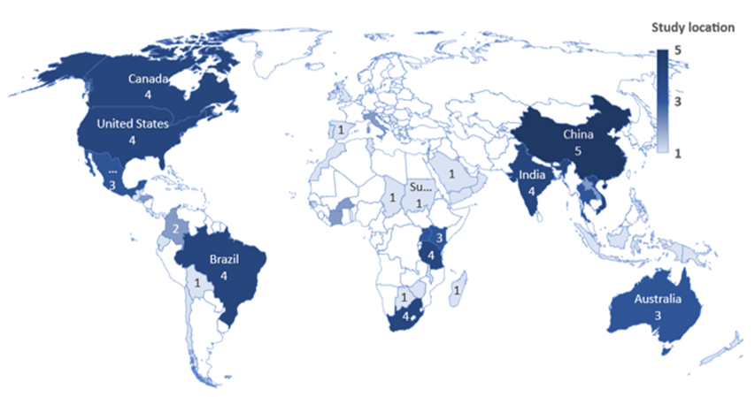

Fig 7[B]. Study location (only for implemented of the concepts)

***3.3 Founders and Organizations Working to Advance the Concepts***

Planetary Health is a multidisciplinary field that draws on expertise from various disciplines. It has been advanced by Dr. Samuel Myers and supported by the Rockefeller Foundation (. Several organizations and UN agencies such as World Health Organization (WHO), United Nations Environment Programme (UNEP), Food and Agriculture Organization (FAO), United Nations Development Programme (UNDP), United Nations Framework Convention on Climate Change (UNFCCC), United Nations Educational, Scientific and Cultural Organization (UNESCO) and United Nations Human Settlements Programme (UN-Habitat) work together to promote Planetary Health through research, policy development, and international collaboration.

One Health is a collaborative and interdisciplinary concept that has significantly advanced by the role of Dr. Calvin Schwabe, a veterinarian and epidemiologist, Dr. Roger M. K. M. Hoekstra, a veterinary pathologist, and Dr. Laura H. Kahn, a physician. The One Health Commission, One Health Initiative, and Centers for Disease Control and Prevention (CDC) are significantly promoting One Health concepts. International organizations such as the WHO, FAO, UNEP, UNDP, and World Organization for Animal Health (OIE) also advocate this concept to address animal and human health.

While it is difficult to attribute the founding of EcoHealth to specific individuals, several key figures have made significant contributions to its development, including Dr. Bruce Wilcox, an environmental scientist, and Dr. Margaret Chan, former WHO Director-General. Several organizations and initiatives are dedicated to promoting and advancing the field, such as the International Association for Ecology and Health (IAEH), Consortium for Ecosystem Health Sciences (CEHS), and EcoHealth Alliance. Several UN organizations contribute to the principles of EcoHealth through their respective mandates and activities, including UNEP, WHO, FAO, UNDP, and UNESCO.

***3.4 Fundamental Questions Addressed by the Concepts***

The fundamental questions addressed by these concepts provide a framework for research, policy development, and practice. They guide efforts to understand, analyze, and address the complex issues at the intersection of human health, environmental health, and ecosystem well-being. By addressing these questions, we can gain insights, develop evidence-based solutions, and promote collaboration to create a healthier and more sustainable future for both people and the planet. Table 3 presents the fundamental questions addressed by each concept and some representative articles that pose these questions.

Table 3. Fundamental Questions Addressed by Planetary Health, One Health, and EcoHealth Concepts.

|  |  |  |
| --- | --- | --- |
| **Concepts** | **Fundamental Questions** | **References** |
| Planetary Health | How do environmental changes affect human health? | [38] |
| What are the underlying drivers of environmental change and their impact on health? | [39] |
| How can we address health disparities and promote equity within the context of Planetary Health? | [40] |
| How can we transition to sustainable and resilient systems that promote both human health and environmental well-being? | [41] |
| One Health | How do zoonotic diseases emerge and spread, and how can we prevent and control them? | [42] |
| What is the impact of antimicrobial resistance (AMR), and how can we combat it? | [43] |
| How can the health of ecosystems and biodiversity conservation contribute to human and animal health? | [44] |
| How can interdisciplinary collaboration improve public health outcomes? | [45] |
| EcoHealth | How do ecosystem changes and disruptions affect human health? | [46] |
| How can traditional ecological knowledge be integrated with scientific research to inform EcoHealth interventions? | [47] |
| What are the social, economic, and political factors shaping people’s interactions with the environment and health? | [48] |
| How can EcoHealth contribute to sustainable development and improved health outcomes? | [49] |

***3.5 Focus and Scope, Emphases, and Critical Considerations***

The focus and scope, emphases, and critical considerations of these concepts vary, as shown in Table 4. Understanding them enables a more holistic approach to addressing the interconnections between human health, environmental health, and ecosystem well-being.

Table 4. Focus and Scope, Emphases, and Critical Considerations of Planetary Health, One Health and EcoHealth

|  |  |  |  |
| --- | --- | --- | --- |
| **Concepts** | **Focus and Scope** | **Emphases** | **Critical Considerations** |
| Planetary Health | Explores the health of human civilization and its interdependent relationship with the planet [50] | Global perspective, sustainability [51] | Interconnectedness between human well-being and the health of the planet, climate change mitigation and adaptation, biodiversity conservation, environmental sustainability, social justice, and equity, systemic approach to address global health challenges [14] |
| One Health | Recognizes the interconnectedness of human, animal, and environmental health [44] | Collaboration across multiple disciplines [45] | Zoonotic disease prevention and control, shared health threats between humans and animals, multisectoral collaboration and integration (e.g., human health, veterinary medicine, environmental science), integrated surveillance and research [52] |
| EcoHealth | Considers the ecological, social, and economic aspects of health [48] | Ecosystem and community well-being [53] | Complex interactions between ecological, social, and economic systems, understanding health as a product of interactions among humans, animals, and the environment, focus on community involvement and participation, local context, and systems thinking [54] |

***3.6 Distinctions, Resemblances, and Alignment***

The distinctions, resemblances, and alignment of Planetary Health, One Health and EcoHealth are presented in Table 5. Distinctions are variations or divisions within a concept, involving understanding unique qualities that differentiate its components. Resemblances refer to similarities between different facets of a concept, understanding shared traits that distinguish its elements. Alignment is the process of ensuring consistency and coherence between various parts of a concept, integrating them to achieve a common objective. Exploring distinctions, resemblances, and alignment aspects individually promotes clarity, collaboration, and synergy. The identification of these factors enables effective resource allocation, facilitates interdisciplinary cooperation, and informs policy development and holistic decision-making processes for addressing complex health and environmental issues.

Table 5. Distinctions, Resemblances, and Alignment of Planetary Health, One Health and EcoHealth.

|  |  |  |  |
| --- | --- | --- | --- |
| Criteria | Concepts | | |
| Planetary Health | One Health | EcoHealth |
| Distinctions | It focuses on the interdependent health of human civilization and the natural systems that support it [14] | Recognizes the interconnectedness of human, animal, and environmental health [55] | Considers the complex interactions between ecological, social, and economic systems concerning human and ecosystem health [56] |
| Emphasizes the role of climate change, biodiversity loss, and environmental degradation on human health [57] | Promotes collaboration among multiple disciplines [58] | It focuses on understanding health as a product of interactions among humans, animals, and the environment [59] |
| Calls for a systemic approach to address global health challenges [60] | Emphasizes integrated surveillance, research, and policy to address shared health threats between humans and animals [44] | Highlights the importance of the local context, community involvement, and systems thinking in EH research and practice [61] |
| Resemblances | Recognizes the interconnectedness of human, animal, and environmental health [62] | Shares the emphasis on the importance of ecological interactions and zoonotic disease prevention and control [63] | Emphasizes community involvement and participation in understanding and managing health [48] |
| Alignment | Aligns with One Health and EcoHealth in acknowledging the importance of ecosystems, climate change, and sustainability [62,64] | Aligns with Planetary Health and EcoHealth in acknowledging the interconnectedness of health and ecosystems [62, 65] | Aligns with Planetary Health and One Health in recognizing the importance of ecological and social determinants of health [66] |

**4.0 Discussion**

It is interesting to observe that One Health and Planetary Health show similar levels of advocacy, at 49% and 50%, respectively. This suggests that One Health and Planetary Health have received significant attention and support in raising awareness and promoting their importance in academic discourse. On the other hand, EcoHealth is far behind, with only 13% of articles featuring some kind of advocacy. There was a noticeable rise in academic interest in public health during the 2019-2020 academic year, which can be related to the widespread effects of the COVID-19 pandemic. This shows that the pandemic sparked a greater understanding of the linkages between human health and the planet’s health.

There are significant implementation efforts in the EcoHealth articles. This means that EcoHealth has better-applied principles in the real world, demonstrating a higher level of practical applicability. One Health and Planetary Health are behind in implementation, suggesting that there may be a disconnect between advocacy and actual action in these domains. Advocacy has constantly dominated the study period, rising in 2019-2020, but in that same period, fewer articles were published that focused on how to apply these ideas. This decrease may be linked to travel bans during the epidemic that might have hampered fieldwork and valuable research efforts. In addition, the number of articles primarily focusing on application may have decreased because researchers were limited to conducting studies from their homes or offices.

Dr. Samuel Myers has substantially contributed to the advancement of Planetary Health, which is regarded as a multidisciplinary field that draws on knowledge from numerous disciplines. Drs. Calvin Schwabe, Roger M. K. M. Hoekstra, and Laura H. Kahn are credited with substantially contributing to One Health, which is regarded as a collaborative and interdisciplinary idea. Despite not having a clear founder, influential people including Drs. Bruce Wilcox and Margaret Chan have pushed EcoHealth. Through research, the creation of policies, and international cooperation, numerous UN agencies, including WHO, UNEP, FAO, UNDP, UNFCCC, UNESCO, and UN-Habitat, are playing significant roles in advancing each of these health concepts.

The fundamental questions that Planetary Health, One Health, and EcoHealth address differ slightly. Planetary Health investigates the state of civilization as a whole and how interdependent it is on the environment. It adopts a global viewpoint with a focus on sustainability. Recognizing relationship of human health and biodiversity loss, climate change, sea level rise, melting of glaciers, desertification, increase of temperature, addressing climate change through mitigation and adaptation strategies, promoting biodiversity conservation, ensuring SDGs, promoting social justice and equity, and taking a systemic approach to addressing global health challenges are some of the critical aspects in Planetary health. On the other hand, One Health acknowledges how linked environmental, animal, and human health are and focuses on interdisciplinary cooperation. Preventing and controlling zoonotic diseases, understanding the shared health risks posed by humans and animals, encouraging multisectoral collaboration, and integrating the study of human health, veterinary medicine, and environmental science are some of the crucial aspects of One Health. To better understand and address health concerns at the interface of humans, animals, and the environment, One Health also emphasizes integrated monitoring and research initiatives. Finally, EcoHealth considers the ecological, social, and financial facets of health, emphasizing the health of the ecosystem and the community. Understanding the intricate relationships between ecological, social, and economic systems and realizing that interactions between people, animals, and the environment produce health are crucial aspects of environmental health. EcoHealth strongly emphasizes the value of participating in the community, considering the local context, and using systems thinking techniques. Considering these factors will enhance health outcomes, accomplish sustainable development, and promote the health of communities and ecosystems. The answers to the fundamental questions of each area provide a context for each field’s research, policymaking, and practice, offering perceptions and evidence-based remedies and encouraging cooperation to address complex problems at the nexus of human health, environmental health, and ecosystem well-being.

Veterinary medicine is the most frequently occurring academic specialty among the sampled articles, which is consistent with the higher number of One Health articles compared to EcoHealth and Planetary Health articles. Veterinary medical knowledge and the focus of One Health on zoonotic disease prevention and control are related. However, it is crucial to note that all three approaches featured a great deal of cross-disciplinary cooperation. This shows that scientists working across different sectors actively interact and advance knowledge in these areas.

Only 35% of worldwide collaborations included researchers from the Global North and South, with One Health showing the highest level of cooperation. To promote a more balanced and inclusive approach to solving global health concerns, more collaboration between academics from various geographic locations is needed, especially between researchers from the global North and South. The proportion of studies independently led by the Global North as opposed to the Global South also differed noticeably. This disparity raises the possibility of an imbalance in research and underscores the need for more participation and leadership from the Global South in setting the research agenda and addressing regional health issues. All three concepts showed evidence of cooperation. This indicates that researchers from diverse disciplines are actively collaborating and contributing to the understanding and advancement of these fields.

It is exciting to see the broad global applicability of the three concepts, as reflected by the authors’ localities. This result indicates that researchers and practitioners from various world regions are actively advancing One Health, EcoHealth, and Planetary Health knowledge and practice. These ideas are applicable in various situations due to their worldwide reach, which also emphasizes the joint efforts being made to address the intricate relationships between human health, environmental health, and ecosystem well-being.

Planetary Health is distinguished by its focus on the interdependent health of human civilization and the natural systems that support it. It emphasizes the role of climate change, biodiversity loss, and environmental degradation on human health, calling for a systemic approach to address global health challenges. One Health recognizes the interconnectedness of human, animal, and ecological health and promotes collaboration among multiple disciplines with a focus on integrated surveillance, research, and policy to address shared health threats between humans and animals. On the other hand, EcoHealth considers the complex interactions between ecological, social, and economic systems concerning human and ecosystem health. It focuses on understanding health as a product of interactions among humans, animals, and the environment, highlighting the importance of the local context, community involvement, and systems thinking.

Despite their distinctions, there are resemblances and alignments among the concepts. They all recognize the interconnectedness of human, animal, and environmental health and emphasize the importance of ecological interactions and zoonotic disease prevention and control. They also highlight the importance of community involvement and participation in understanding and managing health.

Planetary Health aligns with One Health and EcoHealth in acknowledging the importance of ecosystems, climate change, and sustainability. One Health aligns with Planetary Health and EcoHealth in acknowledging the interconnectedness of health and ecosystems. EcoHealth aligns with Planetary Health and One Health in recognizing the importance of ecological and social determinants of health.

**5.0 Conclusion**

Planetary Health highlights sustainability and addresses global health issues by offering solutions for reducing climate change, conserving biodiversity, and promoting social justice. It also focuses on the interconnection of human civilization and the environment. One Health encourages interdisciplinary collaboration to combat zoonotic illnesses and shared animal and human health hazards because it recognizes the connections between the environment, animal health, and human health. In order to improve health outcomes and advance sustainable development, EcoHealth takes into account the ecological, social, and economic elements of health, with special emphasis on community involvement and systems thinking.

The findings of this study reveal interesting insights into the Planetary Health, One Health and EcoHealth concepts. While One Health and Planetary Health have gotten a lot of attention and support in academic debate, EcoHealth is behind in support. The COVID-19 epidemic has sharply raised scholarly interest in public health and brought attention to the connections between human health and the health of the environment. In the research on One Health and Planetary Health, however, there appears to be a gap between advocacy and implementation, indicating a need for closer coordination between the two. Reputable UN organisations like WHO, UNEP, FAO, UNDP, UNFCCC, UNESCO, and UN-Habitat actively advance these subjects through research, policy development, and international collaboration. All three approaches demonstrate cross-disciplinary collaboration, showcasing active communication and knowledge expansion among researchers from other fields.

To address global health issues more inclusively and balance the research agenda, there has to be increased collaboration between the global North and South. Furthermore, it is good to note that Planetary Health, One Health, and EcoHealth are applicable globally as represented by active contributions from scholars and practitioners around the world. Despite their differences, the three concepts have a lot in common when it comes to understanding how intertwined human, animal, and environmental health are. In order to understand and manage health, each strongly emphasizes ecological relationships, zoonotic disease prevention, and the value of community involvement. They also concur that it is essential to understand the roles of ecosystems, climate change, and socioeconomic determinants of health in the wellbeing of Earth and its people.

The similarities between Planetary Health, One Health, and EcoHealth can create confusion, highlighting the need to clarify the relative focus of each. However, their alignments highlight the scope of collaboration rather than competition among experts. The concepts complement each other in terms of scientific research and converting research findings into policies and programmes.

**References**

[1] MEA (Millennium Ecosystem Assessment). (2005). *Ecosystems and human well-being* (Vol. 5, p. 563). Washington, DC: Island press.

[2] Pausas, J. G., & Keeley, J. E. (2009). A burning story: the role of fire in the history of life. BioScience, 59(7), 593-601.

[3] McNeill, J. R., & Engelke, P. (2016). *The great acceleration: An environmental history of the Anthropocene since 1945*. Harvard University Press.

[4] Negi, C. S. (2005). Religion and biodiversity conservation: not a mere analogy. *The International Journal of Biodiversity Science and Management*, *1*(2), 85-96.

[5] Dudley, N., Higgins‐Zogib, L., & Mansourian, S. (2009). The links between protected areas, faiths, and sacred natural sites. *Conservation Biology*, *23*(3), 568-577.

[6] Pascua, P. A., McMillen, H., Ticktin, T., Vaughan, M., & Winter, K. B. (2017). Beyond services: A process and framework to incorporate cultural, genealogical, place-based, and indigenous relationships in ecosystem service assessments. Ecosystem Services, 26, 465-475.

[7] Daily, G. C., & Matson, P. A. (2008). Ecosystem services: From theory to implementation. *Proceedings of the national academy of sciences*, *105*(28), 9455-9456.

[8] Bennett, E. M., Peterson, G. D., & Gordon, L. J. (2009). Understanding relationships among multiple ecosystem services. *Ecology letters*, *12*(12), 1394-1404.

[9] Carpenter, S. R., Mooney, H. A., Agard, J., Capistrano, D., DeFries, R. S., Díaz, S., ... & Whyte, A. (2009). Science for managing ecosystem services: Beyond the Millennium Ecosystem Assessment. *Proceedings of the National Academy of Sciences*, *106*(5), 1305-1312.

[10] Lee, M., & Diop, S. (2009). Millennium ecosystem assessment. *An Assessment of Assessments: Findings of the Group of Experts Pursuant to UNGA Resolution 60/30*, *1*, 361.

[11] Perrings, C., Naeem, S., Ahrestani, F., Bunker, D. E., Burkill, P., Canziani, G., ... & Weisser, W. (2010). Ecosystem services for 2020. Science, 330(6002), 323-324.

[12] Hancock, T., Spady, D. W., & Soskolne, C. L. (2016). *Global change and public health: addressing the ecological determinants of health*. Ottawa, ON, Canada: Canadian Public Health Association.

[13] Corvalan, C., Hales, S., McMichael, A. J., & Butler, C. (2005). *Ecosystems and human well-being: health synthesis* (Vol. 1). World Health Organization.

[14] Whitmee, S., Haines, A., Beyrer, C., Boltz, F., Capon, A. G., de Souza Dias, B. F., ... & Yach, D. (2015). Safeguarding human health in the Anthropocene epoch: report of The Rockefeller Foundation–Lancet Commission on planetary health. *The lancet*, *386*(10007), 1973-2028.

[15] McMichael, A. J. (2000). The urban environment and health in a world of increasing globalization: issues for developing countries. *Bulletin of the world Health Organization*, *78*, 1117-1126.

[16] Watson, R., Baste, I., Larigauderie, A., Leadley, P., Pascual, U., Baptiste, B., ... & Mooney, H. (2019). Summary for policymakers of the global assessment report on biodiversity and ecosystem services of the Intergovernmental Science-Policy Platform on Biodiversity and Ecosystem Services. *IPBES Secretariat: Bonn, Germany*, 22-47.

[17] Diamond, J. (2011). Collapse: how societies choose to fail or succeed: revised edition. Penguin.

[18] UNEP (United Nations Environment Programme). (2011). International Resource Panel, United Nations Environment Programme. Sustainable Consumption, & Production Branch. *Decoupling natural resource use and environmental impacts from economic growth*. UNEP/Earthprint.

[19] Rootes, C. (2004). Environmental movements. *The Blackwell companion to social movements*, 608-640.

[20] Smith, G. D., Hart, C., Blane, D., & Hole, D. (2003). Adverse socioeconomic conditions in childhood and cause-specific adult mortality: prospective observational study. In *Health inequalities* (pp. 191-204). Policy Press.

[21] Doll, R., Peto, R., Boreham, J., & Sutherland, I. (2004). Mortality in relation to smoking: 50 years' observations on male British doctors. *Bmj*, *328*(7455), 1519.

[22] Chapman, K. R., Mannino, D. M., Soriano, J. B., Vermeire, P. A., Buist, A. S., Thun, M. J., ... & Beasley, R. (2006). Epidemiology and costs of chronic obstructive pulmonary disease. *European Respiratory Journal*, *27*(1), 188-207.

[23] WHO (World Health Organization). (2020). One Health. Retrieved from <https://www.who.int/news-room/q-a-detail/one-health>

[24] International Association for Ecology and Health (IAEH). (n.d.). What is EcoHealth? Retrieved from <https://ecohealth.net/what-is-ecohealth/>

[25] WHO (World Health Organization). (2019). Ten threats to global health in 2019. Retrieved from <https://www.who.int/emergencies/ten-threats-to-global-health-in-2019>

[26] GLFF (Global Alliance for the Future of Food). (2020). Statement on the Planetary Health Emergency. Retrieved from <https://futureoffood.org/statement-on-the-planetary-health-emergency/>

[27] LPHC (The Lancet Planetary Health Commission). (2021). Safeguarding human health in the Anthropocene epoch: Report of The Lancet Planetary Health Commission. The Lancet, 397(10292), 1573-1628.

[28] WB (World Bank Group). (2021). Health, Nutrition, and Population. Retrieved from <https://www.worldbank.org/en/topic/health>

[29] UN (United Nations). (2021). Sustainable Development Goals. Retrieved from <https://sdgs.un.org/goals>

[30] WOAH (World Organization for Animal Health). (2021). One Health. Retrieved from <https://www.oie.int/en/for-the-media/onehealth/>

[31] GHSA (Global Health Security Agenda). (2021). About GHSA. Retrieved from <https://www.ghsagenda.org/about/>

[32] FAO (Food and Agriculture Organization of the United Nations). (2021). Antimicrobial resistance (AMR). Retrieved from <http://www.fao.org/antimicrobial-resistance/en/>

[33] IPES-Food. (2016). From Uniformity to Diversity: A Paradigm Shift from Industrial Agriculture to Diversified Agroecological Systems. International Panel of Experts on Sustainable Food Systems. Retrieved from <https://www.ipes-food.org/pages/UniformityDiversityReport>

[34] UNEP (United Nations Environment Programme). (2018). Environment and health. Retrieved from <https://www.unep.org/explore-topics/health>

[35] Landrigan, P. J., Fuller, R., Acosta, N. J., Adeyi, O., Arnold, R., Baldé, A. B., ... & Zhong, M. (2018). The Lancet Commission on pollution and health. *The lancet*, *391*(10119), 462-512.

[36] GEO (Global Environment Outlook). (2019). Global Environment Outlook - GEO-6: Healthy Planet, Healthy People. Retrieved from <https://www.unep.org/resources/global-environment-outlook-geo-6-healthy-planet-healthy-people>

[37] Moher, D., Liberati, A., Tetzlaff, J., Altman, D. G., & Prisma Group. (2009). Reprint—preferred reporting items for systematic reviews and meta-analyses: the PRISMA statement. *Physical therapy*, *89*(9), 873-880.

[38] Myers, S. S. (2017). Planetary health: protecting human health on a rapidly changing planet. *The Lancet*, *390*(10114), 2860-2868.

[39] Pathak, N., & McKinney, A. (2021). Planetary health, climate change, and lifestyle medicine: threats and opportunities. *American Journal of Lifestyle Medicine*, *15*(5), 541-552.

[40] Valentine, N., Ajuebor, O., Fisher, J., Bodenmann, P., Baum, F., & Rasanathan, K. (2022). Planetary health benefits from strengthening health workforce education on the social determinants of health. *Health Promotion International*, *37*(3), daac086.

[41] Iyer, H. S., DeVille, N. V., Stoddard, O., Cole, J., Myers, S. S., Li, H., ... & Golden, C. D. (2021). Sustaining planetary health through systems thinking: Public health's critical role. SSM-Population Health, 15, 100844.

[42] Berthe, F. C. J., Bali, S. R., & Batmanian, G. J. (2022). Putting Pandemics Behind Us: Investing in One Health to Reduce Risks of Emerging Infectious Diseases. World Bank. <https://openknowledge.worldbank.org/server/api/core/bitstreams/956a58be-ddd8-572f-8aac-df5ab453d7b2/content>

[43] McEwen, S. A., & Collignon, P. J. (2018). Antimicrobial resistance: a one health perspective. *Antimicrobial resistance in bacteria from livestock and companion animals*, 521-547.

[44] Mackenzie, J. S., & Jeggo, M. (2019). The One Health approach—Why is it so important?. *Tropical medicine and infectious disease*, *4*(2), 88.

[45] Errecaborde, K. M., Macy, K. W., Pekol, A., Perez, S., O’Brien, M. K., Allen, I., ... & Pelican, K. (2019). Factors that enable effective One Health collaborations-A scoping review of the literature. *PLoS One*, *14*(12), e0224660.

[46] Bayles, B. R., Brauman, K. A., Adkins, J. N., Allan, B. F., Ellis, A. M., Goldberg, T. L., ... & Ristaino, J. B. (2016). Ecosystem services connect environmental change to human health outcomes. *EcoHealth*, *13*, 443-449.

[47] Finn, S., Herne, M., & Castille, D. (2017). The value of traditional ecological knowledge for the environmental health sciences and biomedical research. *Environmental health perspectives*, *125*(8), 085006.

[48] Lisitza, A., & Wolbring, G. (2018). EcoHealth and the determinants of health: Perspectives of a small subset of Canadian academics in the EcoHealth community. *International Journal of Environmental Research and Public Health*, *15*(8), 1688.

[49] Lisitza, A., & Wolbring, G. (2016). Sustainability within the Academic EcoHealth Literature: Existing Engagement and Future Prospects. *Sustainability*, *8*(3), 202.

[50] Horton, R., & Lo, S. (2015). Planetary health: a new science for exceptional action. *The Lancet*, *386*(10007), 1921-1922.

[51] Pongsiri, M. J., Bickersteth, S., Colón, C., DeFries, R., Dhaliwal, M., Georgeson, L., ... & Ungvari, J. (2019). Planetary health: from concept to decisive action. *The Lancet Planetary Health*, *3*(10), e402-e404.

[52] Ghai, R. R., Wallace, R. M., Kile, J. C., Shoemaker, T. R., Vieira, A. R., Negron, M. E., ... & Barton Behravesh, C. (2022). A generalizable one health framework for the control of zoonotic diseases. *Scientific Reports*, *12*(1), 8588.

[53] Bunch, M. J. (2016). Ecosystem approaches to health and well‐being: Navigating complexity, promoting health in social–ecological systems. *Systems research and behavioral science*, *33*(5), 614-632.

[54] Webb, J., Raez-Villanueva, S., Carrière, P. D., Beauchamp, A. A., Bell, I., Day, A., ... & Vaillancourt, C. (2023). Transformative learning for a sustainable and healthy future through ecosystem approaches to health: insights from 15 years of co-designed ecohealth teaching and learning experiences. *The Lancet Planetary Health*, *7*(1), e86-e96.

[55] Zinsstag, J., Schelling, E., Crump, L., Whittaker, M., Tanner, M., & Stephen, C. (Eds.). (2020). *One Health: the theory and practice of integrated health approaches*. CABI.

[56] Harrison, S., Kivuti-Bitok, L., Macmillan, A., & Priest, P. (2019). EcoHealth and One Health: A theory-focused review in response to calls for convergence. *Environment international*, *132*, 105058.

[57] Halonen, J. I., Erhola, M., Furman, E., Haahtela, T., Jousilahti, P., Barouki, R., ... & Antó, J. M. (2021). A call for urgent action to safeguard our planet and our health in line with the Helsinki declaration. *Environmental research*, *193*, 110600.

[58] Destoumieux-Garzón, D., Mavingui, P., Boetsch, G., Boissier, J., Darriet, F., Duboz, P., ... & Voituron, Y. (2018). The one health concept: 10 years old and a long road ahead. *Frontiers in veterinary science*, 14.

[59] Bergquist, R., Brattig, N. W., Chimbari, M. J., Zinsstag, J., & Utzinger, J. (2017). Ecohealth research in Africa: Where from—Where to?. *Acta tropica*, *175*, 1-8.

[60] de Paula, N. (2021). Planetary health diplomacy: a call to action. *The Lancet Planetary Health*, *5*(1), e8-e9.

[61] Duboz, R., Echaubard, P., Promburom, P., Kilvington, M., Ross, H., Allen, W., ... & Binot, A. (2018). Systems thinking in practice: participatory modeling as a foundation for integrated approaches to health. *Frontiers in veterinary science*, *5*, 303.

[62] de Castañeda, R. R., Villers, J., Guzmán, C. A. F., Eslanloo, T., de Paula, N., Machalaba, C., ... & Bolon, I. (2023). One Health and planetary health research: leveraging differences to grow together. *The Lancet Planetary Health*, *7*(2), e109-e111.

[63] UNEP and ILRI (United Nations Environment Programme and International Livestock Research Institute) (2020). Preventing the Next Pandemic: Zoonotic diseases and how to break the chain of transmission. Nairobi, Kenya.

[64] Lerner, H., & Berg, C. (2017). A comparison of three holistic approaches to health: one health, ecohealth, and planetary health. *Frontiers in veterinary science*, *4*, 163.

[65] Roger, F., Caron, A., Morand, S., Pedrono, M., Garine-Wichatitsky, M. D., Chevalier, V., ... & Binot, A. (2016). One Health and EcoHealth: the same wine in different bottles?. *Infection Ecology & Epidemiology*, *6*(1), 30978.

[66] Morand, S., Guégan, J.-F., Laurans, Y. (2020). From One Health to Ecohealth, mapping the incomplete integration of human, animal and environmental health. Iddri, Issue Brief N°04/20.