Revisiting the importance of guard cell cross-sectional geometry for stomatal opening: the air mattress effect.

Abstract:

Introduction:

Stomata are microscopic pores located on the plant epidermis that are essential for regulating gas exchange and controlling water loss via transpiration. These pores are flanked by a pair of guard cells whose turgor pressure changes, driven by ion fluxes (notably of potassium and chloride), lead to stomatal opening and closing. Environmental factors such as light intensity, CO₂ concentration, and water availability, along with internal signals, like the stress hormones abscisic acid (ABA) and biotic stresses including pathogen attacks, modulate these ion fluxes. Under favourable conditions, the accumulation of solutes in guard cells increases osmotic potential and turgor pressure, resulting in stomatal opening. Conversely, during stress, solute efflux leads to reduced turgor and stomatal closure, thus helping the plant conserve water. The majority of plant families have stomata comprising two kidney-shaped guard cells, with the exception being the grasses, which have dumbbell-shaped guard cells flanked by lateral subsidiary cells.

The inflation and deflation of the guard cells is essentially a mechanical process (Woolfenden et al., 2018). Therefore, much research has been carried out to determine the cell wall properties and guard cell geometries of greatest importance for stomatal efficiency. Earlier studies focussed more on observation, mathematical models, and even studies using physical models, such as balloons. In more recent years, focus has moved to the use of Finite Element Method (FEM) modelling. However, the rapid increase in computing power and imaging technology over the last twenty years has allowed for detailed modelling studies, using geometries extracted from 3D images of guard cells. This has allowed researchers to investigate the relative influence of cell wall materials, such as stiffness, and guard cell geometries on stomatal opening. Such an approach has demonstrated the importance of starting cell wall geometries for grass stomata (Durney et al., 2023).

Early hypotheses for kidney-shaped stomatal opening focussed on the importance of geometrical properties such as cross-section (Cooke et al., 1976), changes in wall thickness (Sharpe & Wu, 1978), and anisotropic stiffness resulting from the presence of radially arranged cellulose microfibrils (Aylor et al., 1973). More recent studies have highlighted the role played by cell wall properties, such as anisotropic stiffness and strain-stiffening (Woolfenden et al., 2017), and polar pinning (Carter et al., 2017). A full review of the mechanisms surrounding stomatal opening, and the models used to investigate them can be found in (Woolfenden et al., 2018). The main result however, is that the change in aperture is mainly achieved by the elongation of the guard cells (Meckel et al., 2007; Woolfenden et al., 2017).

Here, we use meshes created from 3D confocal images of onion stomatal to revisit previous observations of the importance of guard cell geometry for stomatal function. We show that taking account of realistic guard cell geometry allows for guard cell inflation to open the stomatal pores, even in the absence of constraints such as cell wall anisotropic stiffness, contrary to previous studies (Sharpe & Wu, 1978; Woolfenden et al., 2017). We choose onions for our study because, as they are monocots like grasses, they share fundamental characteristics, despite belonging to different evolutionary lineages. An overarching aim of our study is to determine the differences between the underlying mechanisms of kidney-shaped and dumbbell-shaped stomatal opening, and how their unique geometries contribute to these differences. We find that, as for the grass stomata, geometry plays an essential part in the opening of onion stomata, in particular, the cross-sectional aspect ratio, and the thinner walls at the poles. This leads to the intriguing hypothesis that the underlying mechanisms for the onion stomata could be the same as for the grass stomata, hinting at a possible evolutionary pathway between kidney-shaped and dumbbell-shaped guard cells.

Results

The ability to run FEM models on meshes derived from confocal images allows us to simulate more closely the stomata opening and closing. However, the complex shape of the guard cells makes the development of general hypotheses linking specific geometries with opening efficiency difficult. We therefore need to create simplified meshes, based on the stomatal shapes.

Fig 1: Simplified meshes can be used to test the impact of guard cell geometry on stomatal opening. Here, both the confocal image derived mesh (left), and the idealised mesh (right) have comparable lengths, widths, and pore areas. The pore areas are 44.7 um² and 44.8 um² for the confocal and idealised mesh, respectively.

Both models were initialised with the same mechanical and material properties (see Table 1), and inflated to the same pressure (2MPa). The only point of difference between them was their starting geometry. At the end of the simulation, the confocal mesh had an increased pore area of 63.5 um², whereas the pore area of the idealised mesh model had decreased to 36.5 um². This is consistent with previous studies (refs), who found that in the absence of anisotropy, models using idealised meshes would close, rather than open. However, as the model using the confocal mesh did show a significant increase in pore area upon inflation, this suggested that the idealised mesh was not capturing the essential geometrical features for stomatal opening.

One noticeable difference between the confocal mesh and the idealised mesh is the cross section. Whilst the idealised mesh has a circular cross section, the confocal images obtained from the onion stomata had aspect ratios (long axis / short axis) of 1.2-1.7 (median = 1.4, n=13) at the midpoint of the cell. We therefore amended our idealised mesh, so that its cross section matched that of the confocal mesh, although we kept the cross section constant throughout the guard cell.

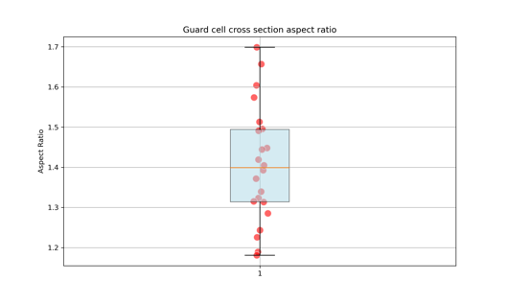 | 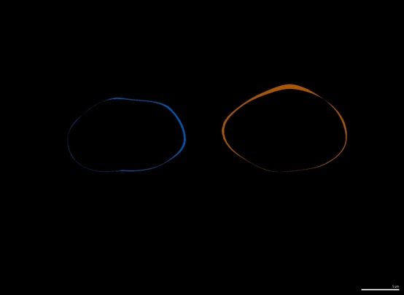

Fig 2: Onion guard cells have oval cross sections at their midpoint.

Increasing the cross-sectional aspect ratio of the idealised meshes allowed them to open upon inflation. The pore area increased from 44.8 um² to 49.3 um². Whilst not as great an increase as the confocal image derived meshes, this increase in pore area suggests that the cross-sectional aspect ratio could play an important role in guard cell opening dynamics.

Whilst the aspect ratio made a significant difference to the stomatal opening, the discrepancy between the confocal image derived mesh model and the idealised mesh model made it apparent that some important geometrical characteristic was still missing from the idealised mesh. One clear difference between the side views of the confocal mesh and idealised mesh is the rounded ends of the confocal mesh. Further investigation revealed that whilst the cross-sectional aspect ratios at the midpoint of the onion guard cells are oval, towards the tips, this cross section becomes more circular.

Fig 3: Onion guard cell cross-section aspect ratio becomes circular towards the tips of the cells. We added this characteristic to the idealised mesh.

The cross section in the idealised mesh now transitioned from oval at the midpoint, to circular at the tips, with the transition taking place close to the tips, and the cross-sectional area being maintained throughout. When this mesh was used with the FEM model, the pore area increased to 59.2 um², upon inflation to 2MPa. This simplified shape was therefore able to capture similar pore opening to the confocal image derived mesh.

Do we want to investigate how much anisotropy it would take to achieve a) flattened only and b) flattened with bulging tips?

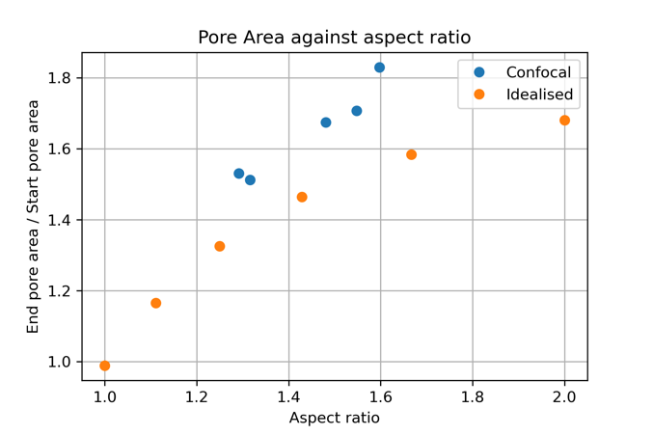 | 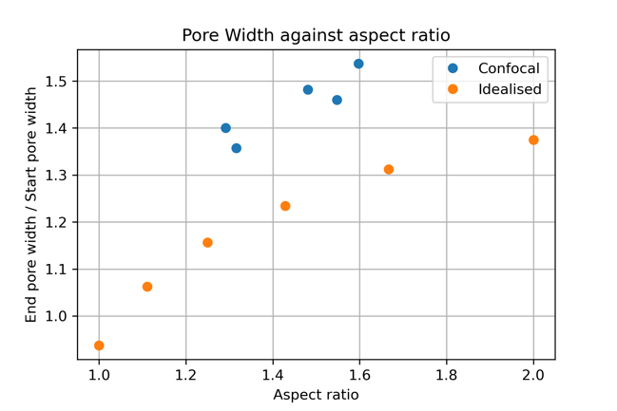

Figure 2: The front (a) and side (b) view of the mesh created from the confocal images. The front (c) and side (d) view of the idealised mesh. The change in pore area (a) and the change in pore width (b) are a function of the aspect ratio in both the idealised meshes (orange) and the meshes created from confocal images (blue).

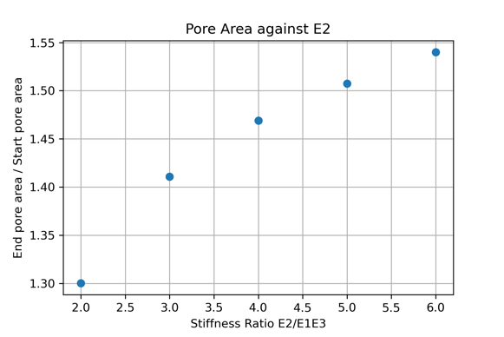 | 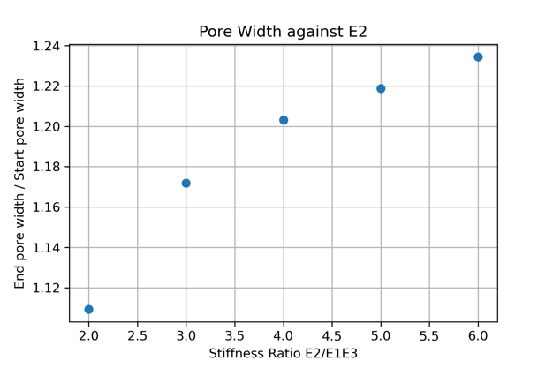
Figure 3: Simulations run with the idealised mesh suggest that an increase of stiffness in the E2 direction would give comparable opening enhancement to an aspect ratio of around 1.6 (the largest aspect ratio seen in our confocal meshes).

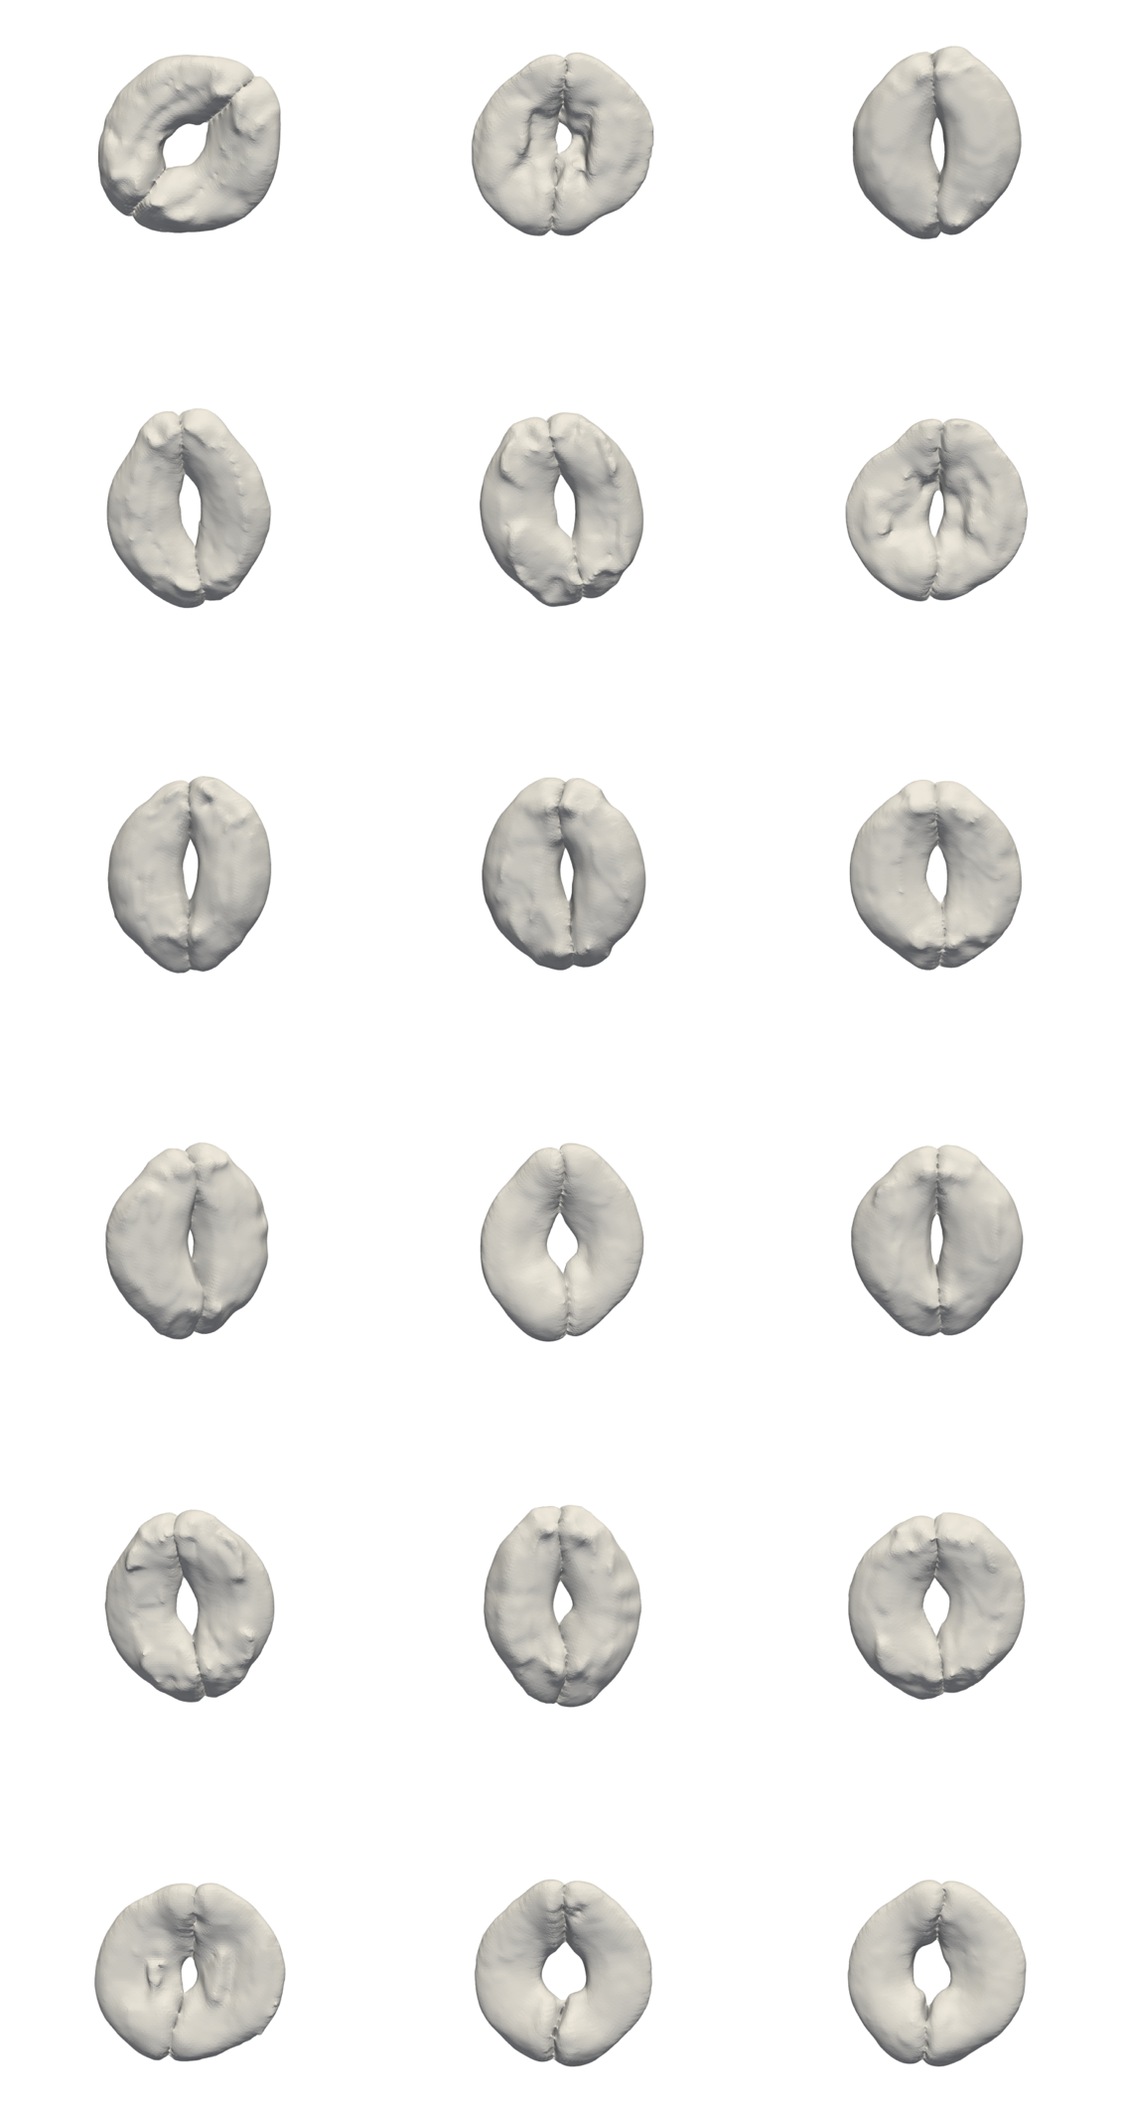
Discussion

Previous models of kidney-shaped stomata, such as can be found in onion, have highlighted the importance of anisotropic stiffness for their opening. Here, we show that significant stomatal opening can be seen in isotropic kidney-shaped stomatal models, if important geometrical features are correctly captures. The most important of these is the oval cross section, with opening being increased with the additional of circular cross section near the tips, resulting in bulbous guard cell ends. Through careful integration of confocal microscopy with FEM modelling, we have demonstrate the importance of geometry for kidney-shaped stomatal opening.

Interestingly, our conclusions align well with historic observations and predictions of the link between stomatal shape and function. The importance of the cross-sectional geometry was highlighted by (Cooke et al., 1976), who used an FEM to show that initial configurations of cross-sections that were circular would rely on the cell wall stretching, rather than the shape changing, as the turgor pressure increased.

Furthermore, the greater volume expansion at the tips of guard cells was observed by Tliirdiy, Rasehke & Dickerson (1973), who reported that the walls near the polar regions of the guard cell are relatively thin, and therefore expand proportionally more than the rest of the cell. Here, we were not looking at the cell wall thickness, although it is possible that the increased bulging at the ends of the onion guard cells could be due to thinner walls at these locations. Future studies could focus on how variability in wall thickness affects stomatal opening.

It is important to stress, however, that these results do not preclude the presence of anisotropic stiffness in guard cells. Evidence suggests that the microfibrils are oriented in a direction that would result in circumferential stiffness (refs), and previous studies have suggested that the guard cells lengthen when the turgor pressure increases (Meckel, refs).

Finally, an interesting observation is the similarity of bulbous ends of the guard cells to the shapes seen in grass-type plants, where the

In line with previous observations regarding stomatal structure, we observed thinner walls near the poles, which could contribute to greater volume and therefore greater opening in these areas. We further hypothesise that the thicker cell wall in the mid-section could constrain expansion in these areas, which would further enhance this effect. This type of opening is similar to the mechanism seen in grasses, where the bulbous ends of the dumbbell shaped guard cells have been shown to be important for stomatal opening (Clinton grasses).

Current hypotheses for how kidney-shaped stomata open

The pore aperture depends upon the pressure difference between the guard cells and the subsidiary cells
Aylor et al (1973): Stomatal opening requires the presence of radially arranged cellulose microfibrils, and their model depends upon constraints on the length of the stomatal system
Proper stomata dynamics are built on two key properties of the cell wall: anisotropy in the form of hoop reinforcement, and strain stiffening. Importantly, we find that for an isotropic cell wall, the pore does not open with increasing turgor, but actually closes. (Wolfenden et al, 2017). However, it should be obvious that expanding the guard cell volume by itself only closes the pore more tightly (Sharpe and Wu)

Stomata open pores in response to low CO₂ and light to facilitate CO₂ access for photosynthesis, and they close the pore in the dark, under drought stress, and in the presence of the water-stress hormone abscisic acid to minimise water loss through transpiration. Stomatal function important for transpiration and water use efficiency. For the guard cell, the most relevant homeostatic variables comprise cell volume, cell osmolality, water potential and turgor, membrane potential, cytosolic and vacuolar K+ Cl- and to lesser extents, total and free Ca2+ contents and concentrations, pH, unidirectional and net fluxes of all ionic or neutral solutes through each transporter, water permeability, and flux.(onGuard). Stomata close their pores in response to pathogen attacks (Small holes, big impact: Stomata in plant–pathogen–climate epic trifecta, Hou, Shuguo et al.Molecular Plant, Volume 17, Issue 1, 26 - 49)

Early models of kidney-shaped stomata used balloons or rubber tubes to investigate how changes to guard cells material properties impact pore opening dynamics. For example, Aylor et al. (1973) used a combination of balloons and masking tape to demonstrate the importance of the radial orientation of the microfibrils, and the constraint of the stomatal length to the pore opening.
The use of FEM models to investigate those properties of kidney-shaped guard cells important for the opening of stomatal cells have resulted in a number of hypotheses. Most studies represent the pairs of guard cells as an elliptical torus, with its behaviour based on either a linear, or non-linear elastic model.
Unlike previously studied plants (Arabidopsis and bean), onions use Cl- rather than malate2- for counter ions for opening stomatal pores. This is likely a more straightforward and faster opening mechanism, although it is reliant on Cl- availability in the soil. In contrast, plants utilising malate2- have a more metabolically complex mechanism, independent from external chloride ion levels, but one that requires more energy and metabolic regulation.

Onion, as a monocot, more closely related to the grasses (which we have previously modelled). Another good reason to use them?

List previous hypotheses surrounding stomatal opening, and for which species they were applied.

We’ve previously shown that, unlike studies using Arabidopsis / broad bean, the geometry of four cell stomatal models, such as found in grasses, holds more importance for stomatal opening than material properties such as strain-stiffening, or anisotropy. We therefore investigated onions, as these are monocots, and therefore more closely related to the grasses.

Estimates of open pore apertures: Maximum apertures ranged between 12-17um under growth chamber conditions and between 7-12 um under greenhouse conditions (Amodeo, G., Talbott, L. D., & Zeiger, E. (1996). Use of potassium and sucrose by onion guard cells during a daily cycle of osmoregulation. Plant and Cell Physiology, 37(5), 575-579.)

Despite these large changes in turgor pressure, the guard cell volume is only modified by 20%9 in Vicia faba. (Vacuolar control of stomatal opening revealed by 3D imaging of the guard cells)

Meckel found that “While the major volume change is caused by a slight increase in the cross section of the cells, an elongation of the guard cells achieves the main aperture change.”

