1. A Boolean value is a value that is either True or False. Thus, A Boolean expression is an expression that evaluates to produce a result which is a Boolean value.

3 examples of expressions that can yield a Boolean values:

5 == 6

6 == 3 \* 2

x == y

1. A flowchart is the visual form of the codes we write in Python. It represents an algorithm, workflow or process, showing the steps as boxes of various kinds, and their order by connecting them with arrows.

For example:

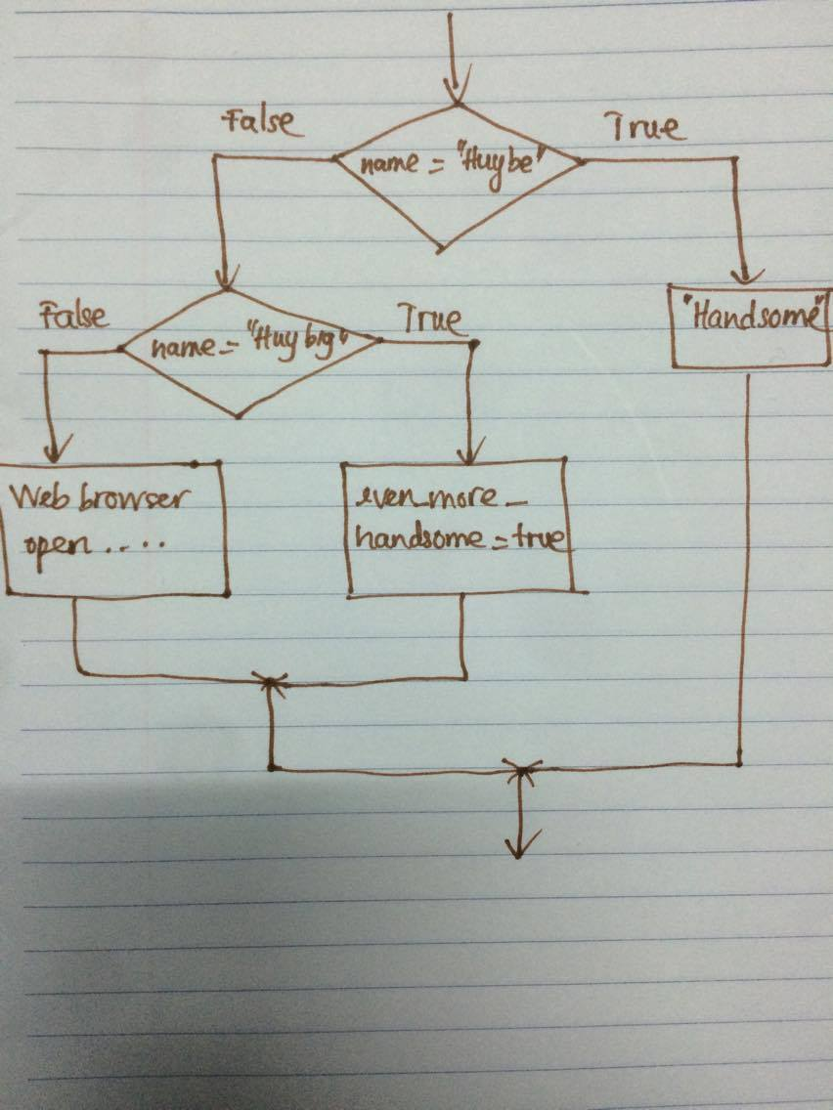

1. Nested conditional is one conditional (if-else statement) nested within another.

For example:

if x == y:

print(“x equals y”)

else:

if x > y:

print(“x is bigger than y”)

else:

print(“x is smaller than y”)

The indented part is the nested conditional, since it lies inside another conditional.