- Голосование. Вывод вопроса и вариантов ответа. Голосование и просмотр результатов голосования по данному вопросу. Вывод статистики по датам подачи голосов. Управление пользователями и ролями. Управления списком вопросов.
Роли: админ и пользователь
Рубрики
Число ответов – более 2-х
Выбор числа ответов (один или несколько ответов) – задается при создании вопроса

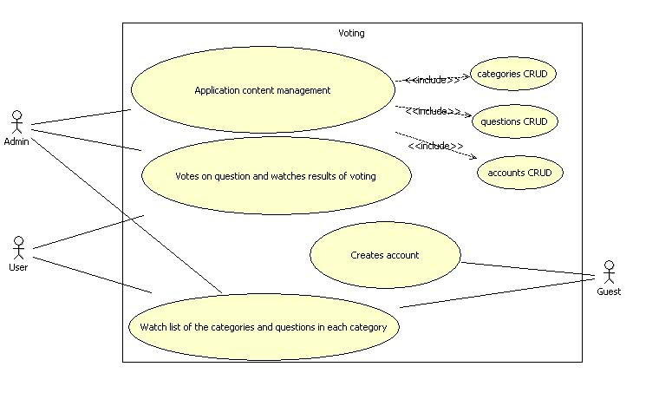

Features:
- Easy deployment:
Just copy voting.war in webapps folder and enjoy. The only parameters which you should change are database connection options in \WEB-INF\classes\META-INF\spring\database.properties file, located in war archive. The first registered user in the system will be admin.
- Interface
  - AJAX check for username and email existence on account registration; pagination, tiles.
  - Multilanguage support
  - Dynamic javascript reports using highcharts library with ability to export results in popular graphic formats.
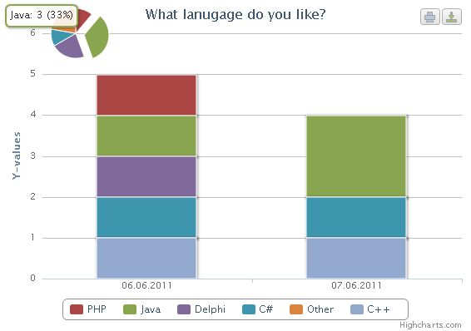
- Security
- Using simplecaptcha to protect your site from autoregistration
- Using jasypt to protect your passwords(encoding and decoding)
- Using spring security to protect pages from illegal access and duplicate votes.
- Logging users activity with different priorities(user’s attempts to vote more than 1 time or attemts to watch results without voting).
- Backend technologies and architecture

Architecture:

Models: Account, (has some SystemRole and Gender), Answer, Category, Question, Vote.

Controllers: Account controller(operations with accounts), Category controller(operations with categories), Question controller(operations with questions, votes, answers)

Technologies:

Spring core(transactions, autowiring) +hibernate(customization using jpa annotations) - for model

Spring mvc(annotations driven), spring security - for controllers

Spring convertion service for autoconverting data from views to entities.

Easy add your favourite SpringSource technology with the help Spring Roo.
- Automated testing

  - Backend
model layer testing using high quality junit tests, generated with the help of Spring roo
- Frontend
Testing typical and untypical admins, users, guest activities in different brausers using Selenium RC
- Dependies management
Build project with all the dependies with the help of Maven.

