Kingdom of Saudi Arabia
Ministry of Education
Prince Sattam Bin Abdulaziz University
College of Computer Engineering and Sciences
Department of Software Engineering
TerraGuavd
UAV-Based Landmine Detection System
Graduation Project Report
A UAV-based software platform for mission monitoring, sensor-data processing,
detection management, and field visualization.
Submitted by
Abdulmajeed Theeb Alqahtani — 445050242
Mnsour Mohammad Aldossari — 445050244
Osama Abdulmohsen bin Julayyil — 445050009
Omar Saeed Alghamdi — 444050891
Bachelor’s Degree in Software Engineering
Supervised by
Dr. Mawal Ali Abdo Mohammad
September 2026

DECLARATION
I hereby declare that this project report entitled “UAV-Based Landmine Detection System” is our own work and has not been submitted previously, in whole or in part, for any degree or professional qualification. All sources used in this report have been properly acknowledged and referenced.

APPROVAL FOR SUBMISSION
This project report entitled “UAV-Based Landmine Detection System” has been reviewed and approved for submission.
Supervisor Name: Mawal Ali Abdo Mohammad Signature: Date:

ACKNOWLEDGEMENTS
The project team would like to express sincere appreciation to our supervisor, Dr. Mawal Ali Abdo Mohammad, for his guidance, feedback, and support throughout this graduation project. We also thank the Department of Software Engineering and the College of Computer Engineering and Sciences at Prince Sattam Bin Abdulaziz University for providing the academic environment and resources needed to develop the project. We are also grateful to everyone who supported the project through advice, feedback, or technical assistance.

ABSTRACT
[Provide a concise summary of the project, including the context/problem, proposed solution, methodology, major results or expected outcomes, and main contribution. Keep the abstract focused and self-contained.]
Keywords: [Keyword 1], [Keyword 2], [Keyword 3], [Keyword 4], [Keyword 5]

صلختسملا
تاجرخملا وأ جئاتنلا مهأو ،ةيجهنملاو ،حرتقملا لحلاو ،قايسلا وأ ةلكشملا نمضتي عورشملل ازًجوم اًيبرع اًصخلم لخدأ، .ةيسيئرلا ةمهاسملاو.
الكلمات الدلالية: [الكلمة ]1، [الكلمة ]2، [الكلمة ]3، [الكلمة ]4، [الكلمة ]5

TABLE OF CONTENTS
DECLARATION 2
APPROVAL FOR SUBMISSION 2
ACKNOWLEDGEMENTS 3
ABSTRACT 4
المستخلص 5
LIST OF TABLES 8
LIST OF FIGURES 9
LIST OF ABBREVIATIONS 10
Chapter 1: Introduction 12
1.1 Project Overview 12
1.2 Problem Description 13
1.3 Proposed Solution 15
1.4 Aim and Objectives 16
1.5 Project Timeline and Management 17
1.6 Report Organization 17
Chapter 2: Literature Review 19
2.1 Overview 19
2.2 Existing Solutions 19
2.2.1 mav_findmine 19
2.2.2 Xensor 19
2.2.3 Skyfront Landmine, IED and UXO Detection 20
2.2.4 Safe Pro Group 20
2.2.5 UMag Solutions 20
2.2.6 Mine Kafon Drone System 21
2.2.7 cosine / Φ-lab Hyperspectral Detection 21
2.2.8 MineGuard 21
2.4 Advantages of the Proposed Solution 22
2.4.1 Integrated System Architecture 22
2.4.2 Adaptive Detection and Classification 22
2.4.3 Simulation-Based Development and Evaluation 23

TABLE OF CONTENTS (continued)
Chapter 3: System Analysis 25
3.1 System Requirements 25
3.1.1 Requirements Elicitation 25
3.1.2 Functional Requirements 25
3.1.3 Non-Functional Requirements 26
3.1.4 System Constraints 27
3.1.5 Engineering Standards 27
3.2 Requirements Modeling 29
3.2.1 UML Modeling 29
Chapter 4: System Design 38
4.1 System Design 38
4.2 Software System Architecture 39
4.3 User Interfaces 40
4.3.1 System Administrator Interface 41
4.3.2 Supervisor Interface 48
4.3.3 Mission Operator Interface 52
4.3.4 Detection Analyst Interface 59
4.3.5 Field Personnel Interface 63
4.4 Database Design 66
4.5 Testing and Evaluation Plan 75
Chapter 5: Conclusion 77
5.1 Main Contributions 77
5.2 Limitations and Future Work 77
References 78
Appendices (Optional) 79

LIST OF TABLES
Table 1.Main Problems and Challenges 14
Table 2. Problem-Solution Analysis 16
Table 3.Project Timeline & Milestones 17
Table 4. Comparative Analysis of Existing Solutions 22
Table 5. System functional requirements 26
Table 6.System non-functional requirements 26
Table 7.System constraints 27
Table 8. users Attributes. 67
Table 9. auth_sessions Attributes. 67
Table 10. survey_area_assignments Attributes. 67
Table 11. survey_area_events Attributes. 68
Table 12. missions Attributes. 68
Table 13. mission_events Attributes. 69
Table 14. observations Attributes. 70
Table 15. detections Attributes. 70
Table 16. analyst_reviews Attributes. 71
Table 17. survey_attempts Attributes. 71
Table 18. vehicle_leases Attributes. 72
Table 19. audit_events Attributes. 72
Table 20. uav_types Attributes. 73
Table 21. uavs Attributes. 73
Table 22. Planned Testing and Evaluation. 75

LIST OF FIGURES
Figure 1.TerraGuavd actors and use cases 29
Figure 2.Mission Creation and Approval 30
Figure 3.Explicit mission execution sequence 31
Figure 4.Potential detection review sequence 32
Figure 5.Survey area assignment activity 33
Figure 6.Mission planning and execution activity 34
Figure 7.Potential Detection Analysis activity 35
Figure 8.Principal persisted entities and relationships 36
Figure 4.1: TerraGuavd Client–Server Architecture. 39
Figure 4.2: Shared Login Interface. 40
Figure 4.3: Administration Dashboard. 41
Figure 4.4: User Management Interface. 42
Figure 4.5: Roles and Permissions Interface. 43
Figure 4.6: System Monitoring Interface. 44
Figure 4.7: Audit Log Interface. 45
Figure 4.8: UAV Management and Fleet Overview. 46
Figure 4.9: UAV Information. 47
Figure 4.10: Survey Area Creation and Assignment. 48
Figure 4.11: Survey Progress Interface. 49
Figure 4.12: Area Editing and Reassignment. 50
Figure 4.13: Survey and Assignment History. 51
Figure 4.14: Mission Control Dashboard. 52
Figure 4.15: Mission Planning Interface. 53
Figure 4.16: Mission Configuration and Draft Saving. 54
Figure 4.17: Mission Execution Controls. 55
Figure 4.18: Map and Telemetry Monitoring. 56
Figure 4.19: Gazebo World Visualization. 57
Figure 4.20: Mission Reports and Survey History. 58
Figure 4.21: Potential Detection Review. 59
Figure 4.22: Target Details and Analyst Assessment. 60
Figure 4.23: Sensor Data Interface. 61
Figure 4.24: Geographic Results Interface. 62
Figure 4.25: Assigned Missions and Field Monitoring. 63
Figure 4.26: Potential Detections and Mission History. 64
Figure 4.27: Alerts and Stop Requests. 65
Figure 4.28. TerraGuavd Database Entity Relationship Diagram. 66

LIST OF ABBREVIATIONS
Abbreviation | Full Form
UAV | Unmanned Aerial Vehicle
GPR | Ground-Penetrating Radar
IP | Intellectual Property
GPS | Global Positioning System
UML | Unified Modeling Language

Chapter 1
Introduction

Chapter 1: Introduction

Project Overview
TerraGuavd integrates UAV mission planning, fleet registration, geographic monitoring, experimental detection-data processing and centralized survey records. It links each mission to a registered UAV and assigned geographic sector, allowing authorized personnel to plan operations, monitor progress and review potential detection locations.
The prototype provides a FastAPI application backend, a React/TypeScript web dashboard and a Flutter field client source. The interfaces provide mission management, monitoring, geographic results and historical records through backend-enforced permissions, while Field Personnel access assigned mission information and potential detection locations.
During a mission, the system records UAV information such as position, altitude, movement, battery status, mission progress, and timestamps. Detection data from the available sensors is also collected and associated with the relevant mission and geographic location.
A key component is the adaptive detection and classification component. Instead of relying on one fixed detection rule, it considers available sensor responses and relevant information such as estimated depth, object characteristics, and surrounding ground conditions when available. The system identifies potential detections but does not treat them as confirmed landmines; final verification is performed by trained personnel.
The system stores mission and detection records in a central database, allowing authorized users to review previous missions, detection locations, and mission progress. A working prototype will be developed and tested using controlled conditions and available or simulated data. The project also includes a patent application focused on making the detection and classification approach adaptive to changing detection conditions.
The project addresses challenges such as different landmine characteristics, low-metal or non-metallic targets, harmless buried objects, and natural ground structures that can produce confusing sensor responses. Therefore, the system focuses on collecting, processing, classifying, locating, and presenting detection data through digital mapping and centralized records.
The implemented simulation prototype demonstrates mission management, UAV monitoring, experimental detection-data processing, digital mapping, and role-aware web and field interfaces. It now supports a registered UAV fleet, multiple survey sectors within an assigned area, and independent simulated mission execution.
A Supervisor defines and assigns a large survey area. The assigned Mission Operator draws smaller sectors, selects one registered UAV for each mission, and previews a generated survey route before saving. Rectangle, circle and free-shape tools, editable boundaries, and retained sector drafts support this workflow. Current sensing uses explicitly selected synthetic features; proposed adaptive physical classification remains a research objective.

Problem Description
Surveying an area that may contain landmines can expose personnel to dangerous conditions and requires careful organization of the information collected during a mission. The problem is not limited to identifying a possible detection. Personnel also need to know the UAV position, mission progress, covered area, collected data, and locations of potential detections. Without an integrated system, these activities may be handled through separate tools or manual processes, making monitoring and follow-up more difficult.
Another problem is the amount and variety of information generated during a UAV mission. Mission information can include UAV position, altitude, movement, battery status, mission progress, timestamps, and detection records. Detection data may contain sensor measurements and information about possible objects. These data need to be collected, organized, stored, and linked to the correct mission and location.
Detection results also cannot be treated as direct confirmation of a landmine. A sensor response may be caused by a harmless metallic object, a natural ground structure, or another buried object. Different sensing methods can provide different types of information, and their results may need to be considered together. Detection conditions can also affect the results. These issues create a need for an organized and adaptive method of processing and presenting potential detections.
There is also a monitoring and accessibility requirement. Field personnel may need quick access to current mission information and potential detection locations, while supervisors or other authorized users may need a wider view of missions, UAV status, maps, historical records, and system information. A web dashboard and mobile application can provide access to the same central system data according to the user's needs.
Finally, potential detections need to be linked to geographic locations and preserved as part of the mission history. If detection records are not properly associated with locations and mission information, reviewing and verifying potential targets becomes more difficult. These challenges create the need for an integrated system that connects mission management, UAV monitoring, detection-data management, adaptive processing and classification, mapping, alerts, and historical records in one environment.
A major technical problem is low and uncertain detection accuracy. A sensor response does not directly identify the type of buried object. A metallic response may be caused by harmless buried metal rather than a landmine, while subsurface responses may also be affected by rocks, soil layers, ground structures, and other natural or man-made objects. This creates a classification problem in which different sources can produce similar or overlapping detection patterns.

The problem can also change with the physical conditions surrounding a buried object. Detection responses may vary with object depth, object characteristics, soil conditions, and the position of the sensing equipment relative to the target. Low-metal-content and non-metallic mines can present additional detection difficulties because their characteristics may differ from objects with stronger metallic signatures.
Another challenge is the interpretation of multiple types of sensor data. Different sensors can provide different information about the same subsurface area, so the system needs to process the available measurements together. Without suitable processing and classification, individual readings may produce false alarms or may not provide enough information for useful analysis.
There is also a spatial data-management challenge. Detection measurements need to be associated with geographic locations so that potential targets can be identified and reviewed later. Inconsistent data collection, incorrect location association, or poor organization of measurements can reduce the usefulness of the results. The system therefore needs to maintain consistent links between missions, UAV data, sensor data, detection results, and locations.
These challenges create a need for a structured system that can manage mission information, process detection data, adapt its classification according to available data and detection conditions, reduce unnecessary alerts, and present potential detection locations in a clear form. The final classification is intended to support subsequent verification by trained personnel rather than replace that verification.
Table 1.Main Problems and Challenges
Problem | Description
Human Safety | Direct surveying can expose personnel to potentially dangerous areas.
Large-Area Surveying | Manual inspection can be difficult and time-consuming over large areas.
Lack of Integrated Monitoring | UAV mission information, detection data, and mission status may not be available through one integrated system.
Limited Field Accessibility | Personnel in the field need quick access to mission status, UAV information, maps, and potential detection locations.
Difficult Mission Management | Managing UAV missions, mission progress, locations, and collected data can become difficult without a centralized system.
Low and Uncertain Detection Accuracy | Sensor responses do not directly identify buried objects and may produce uncertain results.
Lack of Centralized Records | Previous missions, detection locations, and collected information may be difficult to review without a centralized database.
Spatial Data Management | Detection results need to be associated with accurate geographic locations.

Proposed Solution
The proposed solution is an integrated UAV-based system that connects the UAV mission, available detection sensors, a central system program, a database, a web-based monitoring dashboard, and a mobile monitoring application. The system provides one environment for managing missions, receiving UAV and detection information, processing and classifying detection data, displaying potential detection locations, generating relevant alerts, and reviewing previous mission records.
The system will begin with mission planning. An authorized user will be able to create a mission, define the target area and scanning path, and provide the required mission information. During the mission, the system will receive available UAV information such as location, altitude, movement, battery status, mission progress, and timestamps. Detection data from the available sensing equipment will also be collected and associated with the relevant mission and location.
The main system program will manage incoming information and coordinate communication between the UAV data, detection data, database, web dashboard, and mobile application. It will store mission information and detection records and provide processed information to the monitoring interfaces. The central database will maintain relationships between missions, UAV information, detection records, locations, users, and historical results.
The system will include an adaptive detection and classification component to address uncertain or low-accuracy detection results. The component will not rely on one fixed rule. Instead, it will use available sensor responses and relevant detection information, such as estimated object depth when available, object characteristics, and surrounding ground conditions, to adjust the analysis according to the available data and detection conditions. The component will organize results into potential detection categories and identify locations that require further verification. This approach is intended to reduce unnecessary alerts and improve the usefulness of the available sensor information without claiming to physically improve the sensors themselves.
The web dashboard will provide an interface for authorized users to view active missions, UAV status, maps, detection locations, mission history, alerts, and recorded results. The mobile application will provide field users with essential mission information, current UAV information, maps, alerts, and potential detection locations while they are working in the field. Both interfaces will use the same central system data so that information remains consistent.
The system will also provide digital mapping and location recording. Potential detection locations will be displayed on a map together with relevant mission information. This allows users to review where detections occurred and provides organized information for later verification by trained personnel. Mission and detection records will remain available for later review and reporting.
The proposed system will be developed as a prototype and evaluated using controlled test conditions with available or simulated UAV and detection data. Testing will examine mission management, data collection and organization, adaptive processing and classification, location recording, mapping, alerts, web and mobile interfaces, and consistency of stored mission

records. The project also includes a patent application focused on making the detection and classification approach adaptive.
Problem | Proposed Solution
Human Safety | The UAV-based system supports surveying and monitoring while reducing the need for personnel to enter potentially dangerous areas.
Large-Area Surveying | The system supports mission planning by allowing authorized users to define the target area and scanning path and monitor mission progress.
Lack of Integrated Monitoring | The system connects the UAV mission, detection sensors, central system program, database, web dashboard, and mobile application in one environment.
Limited Field Accessibility | The mobile application provides field users with mission information, UAV information, maps, alerts, and potential detection locations.
Difficult Mission Management | The main system program manages mission information, UAV data, detection data, and communication between the system components, while the database stores the related records.
Low and Uncertain Detection Accuracy | The adaptive detection and classification component analyzes available sensor responses and relevant detection information to organize potential detections and reduce unnecessary alerts.
Lack of Centralized Records | The central database stores mission information, detection records, locations, users, and historical results for later review and reporting.
Spatial Data Management | The system associates detection data with the relevant mission and location and displays potential detection locations through digital mapping.
Table 2. Problem-Solution Analysis

Aim and Objectives
The overall aim of the project is to develop an integrated UAV-based system for mission management, monitoring, detection-data processing, adaptive classification, location recording, alerts, and visualization through a web dashboard and mobile application, supporting the organized surveying of areas containing potential landmines and other buried objects.
- Design the overall system architecture that integrates UAV mission data, available detection sensors, the central system program, database, web dashboard, and mobile application.
- Develop mission-management and monitoring functions for assigning geographic survey areas, planning multiple UAV-specific sectors, previewing survey routes, tracking independent mission states, and preserving mission and survey history.
- Implement an adaptive detection-data processing and classification component that analyzes available sensor data and relevant detection conditions, organizes potential detections, and identifies locations for further verification.
- Develop web and mobile interfaces that display mission information, UAV status, maps, alerts, potential detection locations, and historical records to authorized users.
- Test and evaluate the integrated system under controlled conditions using available or simulated UAV and sensor data to assess data management, monitoring, adaptive classification, mapping, alerts, and interface functions.

Project Timeline and Management
The project will be managed through a milestone-based approach in which each chapter represents a major stage of the project. The chapters will be used to organize the work, monitor progress, and ensure that the system is developed in a structured sequence.
Chapter 1 establishes the project scope, system context, problem, proposed solution, aim, objectives, and management plan. Chapter 2 examines existing systems and related technologies relevant to UAV mission monitoring, detection-data processing, adaptive classification, mapping, and web and mobile interfaces, and identifies the project gap. Chapter
- defines the system requirements, users, constraints, data requirements, and models. Chapter
- translates these requirements into the system architecture and detailed design, including the main system program, database, web dashboard, mobile application, data flow, and interfaces. Chapter 5 documents the implementation and testing outcomes, summarizes the completed system and its contributions, and discusses limitations and future improvements.
The project team will divide responsibilities according to the work required for each chapter and system component. Regular progress reviews will be used to monitor milestones, identify problems, and adjust the work plan when necessary. The supervisor will provide guidance and review the project at the major milestones. This approach keeps the work focused on developing, integrating, and evaluating the proposed system.
Table 3.Project Timeline & Milestones
Phase | Main Activities | Timeline | Milestone / Deliverable | Responsible
Phase 1 | Planning / Proposal | Semester 1 / Weeks  1–3 | Approved proposal and  project plan | Project Team
Phase 2 | Project Overview and Context | Semester 1 / Weeks  3–4 | Chapter 1 | Project Team
Phase 3 | Research and Project Gap | Semester 1 / Weeks 5-7 | Chapter 2 | Project Team
Phase 4 | Requirements Analysis and Modeling | Semester 1 / Weeks  8-11 | Chapter 3 | Project Team
Phase 5 | System Architecture and Design | Semester 1/ Weeks  12–15 | Chapter 4 | Project Team
Phase 6 | Project Outcomes and Evaluation | Semester 1/ Weeks  15–16 | Chapter 5 | Project Team

Report Organization
[Briefly describe the purpose and contents of each chapter.] The remainder of this report is organized as follows:
Chapter 2 reviews .. .. Chapter 3 defines .. .. Chapter 4 describes .. ..
Chapter 5 presents the conclusion of the project, summarizing the main outcomes, contributions, limitations, and possible directions for future work.

Chapter 2
Literature Review

Chapter 2: Literature Review

Overview
This chapter reviews existing systems, research studies, and technical approaches related to UAV-based landmine and buried-object detection. The review is organized around three areas that directly support the proposed project: UAV mission and survey systems, sensor integration and detection classification, and adaptive processing, mapping, and monitoring. The purpose of the review is to understand what has already been developed, identify relevant strengths and limitations, and establish the project gap that motivates the proposed system.
The literature shows that UAVs can be used to collect detection data while reducing the need for people to enter a survey area. It also shows that GPR, metal detectors, magnetometers, cameras, and other sensing methods can provide complementary information. Existing work has investigated sensor fusion, machine learning, adaptive sensing, mission planning, and geographic visualization. Therefore, this project does not claim that UAV-based landmine detection or sensor fusion is a new concept. Instead, the project focuses on integrating these functions into a structured, simulation-based system with mission management, centralized data storage, adaptive detection and classification, web monitoring, mobile access, and digital mapping.

Existing Solutions
The reviewed solutions use different combinations of UAV platforms, sensors, automated processing, mapping, and operational software. Some are specialized field systems, while others focus on imagery analysis, magnetic detection, mapping, or software prototypes. The following solutions are reviewed because their capabilities are relevant to the proposed system.


mav_findmine
[1]
Description: A UAV platform for automatic radar and camera surveys. It includes mission planning, trajectory execution, sensor monitoring, and survey logging through a ROS-based robotics workflow.
Relevance: Relevant as a reference for mission management, UAV telemetry, sensor collection, and survey workflow.
Limitation / Focus: The project is a specialized robotics platform rather than an integrated web/mobile monitoring system.

Xensor
[2]
Description: A drone-based mine-detection approach using complementary sensing such as magnetometer, ground radar, optical, infrared, and thermal information, with AI-assisted analysis and mapping.

Relevance: Provides a strong reference for multi-sensor detection, data fusion, threat assessment, and mapping.
Limitation / Focus: The solution is oriented toward operational sensing and detection rather than a university-scale software architecture with multiple user interfaces.

Skyfront Landmine, IED and UXO Detection

[3]
Description: A UAV-based solution for geolocating anti-tank mines, anti-personnel mines, IEDs, and UXO using magnetometers and other sensors, supported by long-endurance flight, terrain following, RTK positioning, and magnetic-noise reduction.
Relevance: Relevant to remote surveying, telemetry, geolocation, terrain-aware missions, and large-area coverage.
Limitation / Focus: Its emphasis is on specialized UAV and sensor capabilities and field operation.

Safe Pro Group
[4]
Description: An AI-based drone-imagery solution that detects and maps explosive threats using computer vision, GPS-tagged imagery, and cloud or edge processing.
Relevance: Provides a reference for automated detection, geospatial tagging, mapping, and software-based analysis of drone imagery.
Limitation / Focus: It primarily analyzes visible drone imagery and does not represent a multi-sensor buried-object processing workflow.

UMag Solutions
[5]
Description: A drone magnetic-sensing solution for land and naval mines and other subsurface explosive hazards. Its UMagMission software supports mission operation, real-time data handling, and target analysis.
Relevance: Relevant to mission software, real-time sensor data, target analysis, and geographic reporting.
Limitation / Focus: The approach is strongly centered on magnetic sensing rather than a broader multi-sensor software workflow.

Mine Kafon Drone System
[6]
Description: A remote mine-detection concept that combines aerial mapping/surveillance and detection functions using dedicated drone systems and sensors.
Relevance: Relevant to remote mapping, detection, mission information collection, and reducing the need for personnel to enter hazardous areas.
Limitation / Focus: It is a specialized operational concept rather than the proposed integrated software architecture.

cosine / Φ-lab Hyperspectral Detection
[7]
Description: A drone-based approach that combines hyperspectral and thermal sensing for landmine detection, identification, and mapping.
Relevance: Demonstrates how advanced sensor data can be connected to detection and geographic mapping.
Limitation / Focus: Its focus is advanced optical sensing and field evaluation rather than a complete mission-management and multi-interface software system.

MineGuard
[8]
Description: A software-oriented prototype combining RGB, thermal, and metal-detection information with neural-network models, real-time monitoring, and an interactive map.
Relevance: It is closely related to the proposed project because it combines multi-sensor processing, classification, monitoring, and mapping.
Limitation / Focus: The proposed project additionally emphasizes integrated mission management, centralized records, web/mobile access, and an adaptive classification workflow within one Software Engineering system.
Existing Solution | Pricing / Cost | Detection Technology | Difference from Proposed Solution
mav_findmine | Open-source | Radar + Camera | Focuses on a UAV/ROS detection platform, while our project focuses on an integrated software system with adaptive classification, centralized data, mapping, and Web + Mobile  monitoring.
Xensor | Commercial / Quote | Magnetometer, GPR, Optical, IR/Thermal | Provides an operational multi-sensor detection solution, while our project focuses on a university-scale software platform that integrates mission management, adaptive classification, and  centralized monitoring.
Skyfront | Commercial / Quote | Magnetometer, LiDAR,  Thermal | Focuses on specialized UAV hardware, long-endurance surveying, and geolocation, while our project focuses on software-based mission management and detection-data  processing.
Safe Pro Group | Commercial / Contract | Drone imagery  / AI | Primarily focuses on AI analysis of drone imagery and surface threats, while our project focuses on sensor data, buried-object  detection, mission management, and adaptive classification.

Existing Solution | Pricing / Cost | Detection Technology | Difference from Proposed Solution
UMag Solutions | Commercial / Quote | Magnetic sensing | Specializes in magnetic detection and mission software, while our project combines multiple available sensor data with adaptive classification, centralized records, and Web + Mobile  monitoring.
Mine Kafon | Low-cost / Open-source approach | Mapping + Detection Sensors | Uses dedicated drones for mapping and detection, while our project focuses on the software workflow connecting mission management, sensor processing, classification, mapping, and  monitoring.
cosine / Φ-lab | Research / Project-based | Hyperspectral + Thermal | Focuses on hyperspectral and thermal sensing for detection, while our project focuses on an integrated software architecture capable of processing available multi-sensor data and managing  the complete mission workflow.
MineGuard | Prototype / Open-source | RGB + Thermal  + Metal Detection | Uses neural networks for multi-sensor detection, while our project additionally integrates mission management, centralized database storage, digital mapping, and Web + Mobile  monitoring.
Table 4. Comparative Analysis of Existing Solutions

Advantages of the Proposed Solution
The proposed system does not claim that UAV detection, sensor fusion, adaptive processing, or digital mapping are individually new technologies. Its advantages are based on the way these functions are combined into a single Software Engineering prototype and evaluated as one workflow. The main advantages are described below.

Integrated System Architecture
The system provides a single architecture connecting the UAV data source, available detection sensors, main system program, database, adaptive detection component, web dashboard, and mobile application. Mission information, UAV telemetry, sensor readings, detection results, and geographic locations can therefore be managed as related data. This reduces the need to treat mission monitoring, detection processing, and result visualization as separate activities.
The architecture also provides a common source of information for the web and mobile interfaces. Authorized users can view the information relevant to their role while the underlying mission and detection records remain centralized. This supports consistent data handling and provides a clear basis for later analysis and reporting.

Adaptive Detection and Classification
Adaptive detection and classification is a central software component of the proposed system. Instead of applying one fixed rule to every sensor reading, the component will consider available sensor responses and relevant detection information such as estimated depth, object characteristics, and surrounding conditions when available. The purpose is to organize uncertain results, distinguish different categories of potential detections, and reduce unnecessary alerts.
The adaptive component will be evaluated using controlled or simulated data under different detection conditions. This allows the team to examine how changes in the input data affect

classification results and to improve the processing approach during development. The project does not claim that this software component physically increases sensor sensitivity or confirms the presence of a landmine. Its role is to improve the organization and interpretation of available detection data.

Simulation-Based Development and Evaluation
The proposed system can be developed and evaluated using simulated UAV telemetry and controlled or simulated sensor data. This provides repeatable test conditions for mission management, data collection, adaptive processing, classification, mapping, database operations, alerts, and web and mobile interfaces. It also allows the project team to test different scenarios without requiring the physical detection equipment to be available for every development and testing activity.
Simulation also supports systematic evaluation. For example, the team can create scenarios with different UAV paths, sensor responses, object characteristics, locations, and detection conditions. The resulting records can then be compared to the expected outcomes. This provides a practical way to demonstrate the complete system workflow within the available graduation-project scope.

Chapter 3
System Analysis

Chapter 3: System Analysis
This chapter defines the requirements and behavioral models of TerraGuavd, a software platform for planning and monitoring UAV surveys, managing potential detections, and retaining geographic survey history. The analysis connects the five user roles to the shared backend, spatial database and isolated simulation runtime. It establishes the conditions under which actions are permitted and the evidence required to report survey progress.

System Requirements

Requirements Elicitation
To develop a UAV-based landmine detection system that meets user needs and operational requirements, the following requirement-gathering techniques were considered:
- Questionnaires & Surveys: Questionnaires designed for potential users, including UAV operators, field personnel, and supervisors, to identify their expectations regarding mission monitoring, landmine detection, and system usability.
- Interviews: Proposed interviews with UAV operators and personnel involved in landmine detection to identify challenges related to mission planning, detection accuracy, data management, and field operations.
- Observation & Benchmarking: Existing UAV-based landmine detection solutions, including Skyfront, Safe Pro Group, UMag Solutions, and Mine Kafon, were reviewed to identify useful features, technical approaches, and limitations.
- Prototyping: Initial interface designs and system models were developed to explore the main functions, including mission planning, UAV monitoring, detection visualization, and survey area management.

Functional Requirements
Table 3.1 defines the functional requirements of the connected prototype. Each requirement identifies observable behavior and its principal acceptance condition.
ID | Description
FR-01 | The system shall allow authorized users to securely log in and access features according to their assigned roles.
FR-02 | The System Administrator shall be able to create, update, deactivate, and manage user accounts and assign user  roles.
FR-03 | The System Administrator shall be able to register and manage UAV information and system configurations.
FR-04 | The Supervisor shall be able to define large geographic survey areas by drawing polygons on an interactive map.
FR-05 | The Supervisor shall be able to assign geographic survey areas to Mission Operators and monitor assignment progress.
FR-06 | The Mission Operator shall be able to divide assigned survey areas into smaller sections and create multiple survey  missions within the assigned boundaries.
FR-07 | The Mission Operator shall be able to create and configure survey missions by defining geographic boundaries,  flight paths, and mission parameters.
FR-08 | The system shall allow Mission Operators to request Supervisor approval before starting missions outside their assigned survey areas.
FR-09 | The system shall allow authorized Mission Operators to start, monitor, and terminate UAV survey missions.
FR-10 | The system shall integrate with PX4 and Gazebo to simulate UAV flight and mission execution.
FR-11 | The system shall receive and display UAV telemetry, including position, altitude, speed, battery level, and mission  status.
FR-12 | The system shall collect and process available Ground-Penetrating Radar (GPR) and metal detector readings  during survey missions.
FR-13 | The system shall use an adaptive detection and classification component to analyze sensor readings and identify  potential buried objects.

ID | Description
FR-14 | The system shall classify potential detections using available sensor responses and relevant characteristics, such as  estimated depth and ground conditions.
FR-15 | The system shall record the geographic coordinates, timestamps, and relevant sensor information associated with  each potential detection.
FR-16 | The system shall display potential landmine detection locations on an interactive geographic map.
FR-17 | The system shall track surveyed, partially surveyed, and remaining geographic areas based on validated survey  coverage.
FR-18 | The system shall record the date, time, and mission associated with each surveyed area and preserve its survey  history.
FR-19 | The Detection Analyst shall be able to review potential detections, examine available sensor information, and  record analysis results.
FR-20 | The system shall generate alerts for potential detections and important mission events.
FR-21 | The system shall provide Field Personnel with a mobile interface for viewing assigned mission information, UAV  status, maps, and potential detection locations.
FR-22 | The system shall store mission information, UAV telemetry, sensor readings, detection results, and survey records  in a centralized database.
FR-23 | The system shall allow authorized users to review previous missions, survey results, and detection history.
FR-24 | The system shall generate mission and detection reports containing relevant survey information and potential  detection locations.
FR-25 | The system shall allow Supervisors to review mission outcomes, survey progress, and reports.
FR-26 | The system shall support automatic selection of light or dark interface themes according to the user's device  settings, with a manual override option.
Table 5. System functional requirements

Non-Functional Requirements
The quality requirements in Table 3.2 define evaluation criteria. They describe required properties rather than asserting that all production or cross-platform validation has already been completed.
ID | Category | Requirement and evaluation criterion
NFR01 | Security | Use Argon2 password hashing, hashed session tokens, active-account checks and server-side authorization. Reject unauthorized and out-of-scope operations in automated tests.
NFR02 | Integrity | Persist identity, missions and geographic records in PostgreSQL/PostGIS through versioned Alembic migrations. Use transactions, revision checks and consistent lock order for assignment mutations.
NFR03 | Reliability | Persist terminal outcomes and recover interrupted execution without automatic restart. Record runtime failures clearly and avoid duplicate vehicle reservations.
NFR04 | Usability | Support desktop and mobile web layouts, readable labels, keyboard-accessible controls and consistent Ivory/Evergreen themes. Do not communicate evidence status through color alone.
NFR05 | Responsivenes s | Provide live mission updates with polling fallback. Evaluate update delay and rendering with recorded observations; no unmeasured latency or throughput guarantee is claimed.
NFR06 | Maintainability | Keep web, backend, detection, simulation, mobile and infrastructure modules separate. Maintain typed API contracts, automated checks and shared reusable UI components.
NFR07 | Performance | The system shall process telemetry, calculate survey coverage, and retrieve mission records efficiently under the expected prototype workload. Evaluate processing time, API response time, and resource usage using representative mission data and document the measured results.
NFR08 | Traceability | Retain UTC timestamps, account attribution, assignment revisions, analyst reviews and processing versions. Exclude passwords and tokens from audit records.
NFR09 | Testability | Cover identity, permissions, state transitions, containment, provenance and spatial coverage with unit and integration tests. Report skipped or unavailable environments explicitly.
Table 6.System non-functional requirements

System Constraints
ID | Constraint | Description
SC-01 | Simulation-Based  Development | The initial prototype shall be developed and evaluated primarily using PX4 and  Gazebo simulation rather than relying on a physical UAV.
SC-02 | Sensor  Availability | GPR and metal detector readings may be simulated or generated from controlled  datasets when physical sensing equipment is unavailable.
SC-03 | Hardware Compatibility | The system shall account for differences between AMD64 and ARM64  platforms, particularly when deploying PX4, Gazebo, ROS 2, and Docker-based components.
SC-04 | Detection  Limitations | The system shall treat classification outputs as potential detections because  sensor responses cannot independently confirm the presence of landmines.
SC-05 | Environmental  Factors | Detection performance may be affected by soil conditions, object depth, object  characteristics, and sensor limitations.
SC-06 | Network Dependency | Real-time telemetry and remote monitoring require an operational communication connection between the relevant system components.
SC-07 | Geographic Data | Geographic boundaries, UAV positions, and detection locations shall follow  consistent coordinate conventions to support accurate mapping and data storage.
SC-08 | Development  Resources | Implementation and evaluation shall remain within the available graduation  project timeframe, team resources, and computing capabilities.
SC-09 | User Authorization | Mission execution, survey assignments, and detection analysis shall be restricted  according to the permissions associated with each user role.
SC-10 | Safety and  Verification | The system shall not classify surveyed areas as safe or mine-free without  independent verification by qualified personnel.
SC-11 | External Software Dependencies | UAV simulation and communication depend on compatible versions and  configurations of PX4, Gazebo, MAVSDK/MAVLink, and any ROS 2 components used.
Table 7.System constraints

Engineering Standards
- ISO/IEC Standards
TerraGuavd follows relevant ISO/IEC software quality and security principles to ensure the system is reliable, secure, and maintainable. These principles support effective UAV mission management, detection-data processing, and system usability.
- UML 2.0 (OMG Standard)
UML diagrams, including use case, sequence, activity, and class diagrams, are used to represent system requirements, workflows, interactions, and relationships. They provide consistent visual communication and a shared understanding among the development team.
- Coding Standards
Clean code practices, including meaningful naming conventions, consistent formatting, modular design, and clear documentation, are applied to improve code readability, maintainability, and future system development.
- Geographic Data Standards
TerraGuavd uses the GeoJSON format defined in RFC 7946 to represent survey boundaries, detection locations, and coverage areas. Geographic data follows the WGS 84 reference system, identified as EPSG:4326, with coordinates expressed in longitude–latitude order. These conventions support consistent geographic storage, exchange, and visualization.

- API Interface Standards
TerraGuavd uses the OpenAPI 3.1 specification to describe system interfaces, including available operations, request structures, and responses. A shared interface contract supports consistent communication between system components and reduces integration errors.
- Date and Time Standards
TerraGuavd uses ISO 8601 and RFC 3339 timestamp conventions to represent dates and times consistently. Backend records are maintained in Coordinated Universal Time (UTC), supporting the accurate ordering and comparison of mission events, sensor observations, alerts, and survey history.

Requirements Modeling

UML Modeling
Unified Modeling Language (UML) diagrams are used to visually represent the structure and behavior of the TerraGuavd UAV-Based Landmine Detection System. These diagrams help clarify how different system components interact and ensure that the proposed design aligns with the functional and non-functional requirements. The following section presents UML models, including Use Case Diagrams, Class Diagrams, Activity Diagrams, and Sequence Diagrams, to describe user interactions, data relationships, mission workflows, and system communication processes. These visual representations support better understanding, effective communication, and improved development planning throughout the system lifecycle.
      - Use Case Diagram
The Use Case Diagram illustrates the interactions between the five TerraGuavd roles. Administrator responsibilities include UAV type and vehicle management; the Supervisor defines assignments and retains the authorization responsibility required by the specification; the assigned Mission Operator plans sectors, selects UAVs and requests execution. Backend permissions remain authoritative.
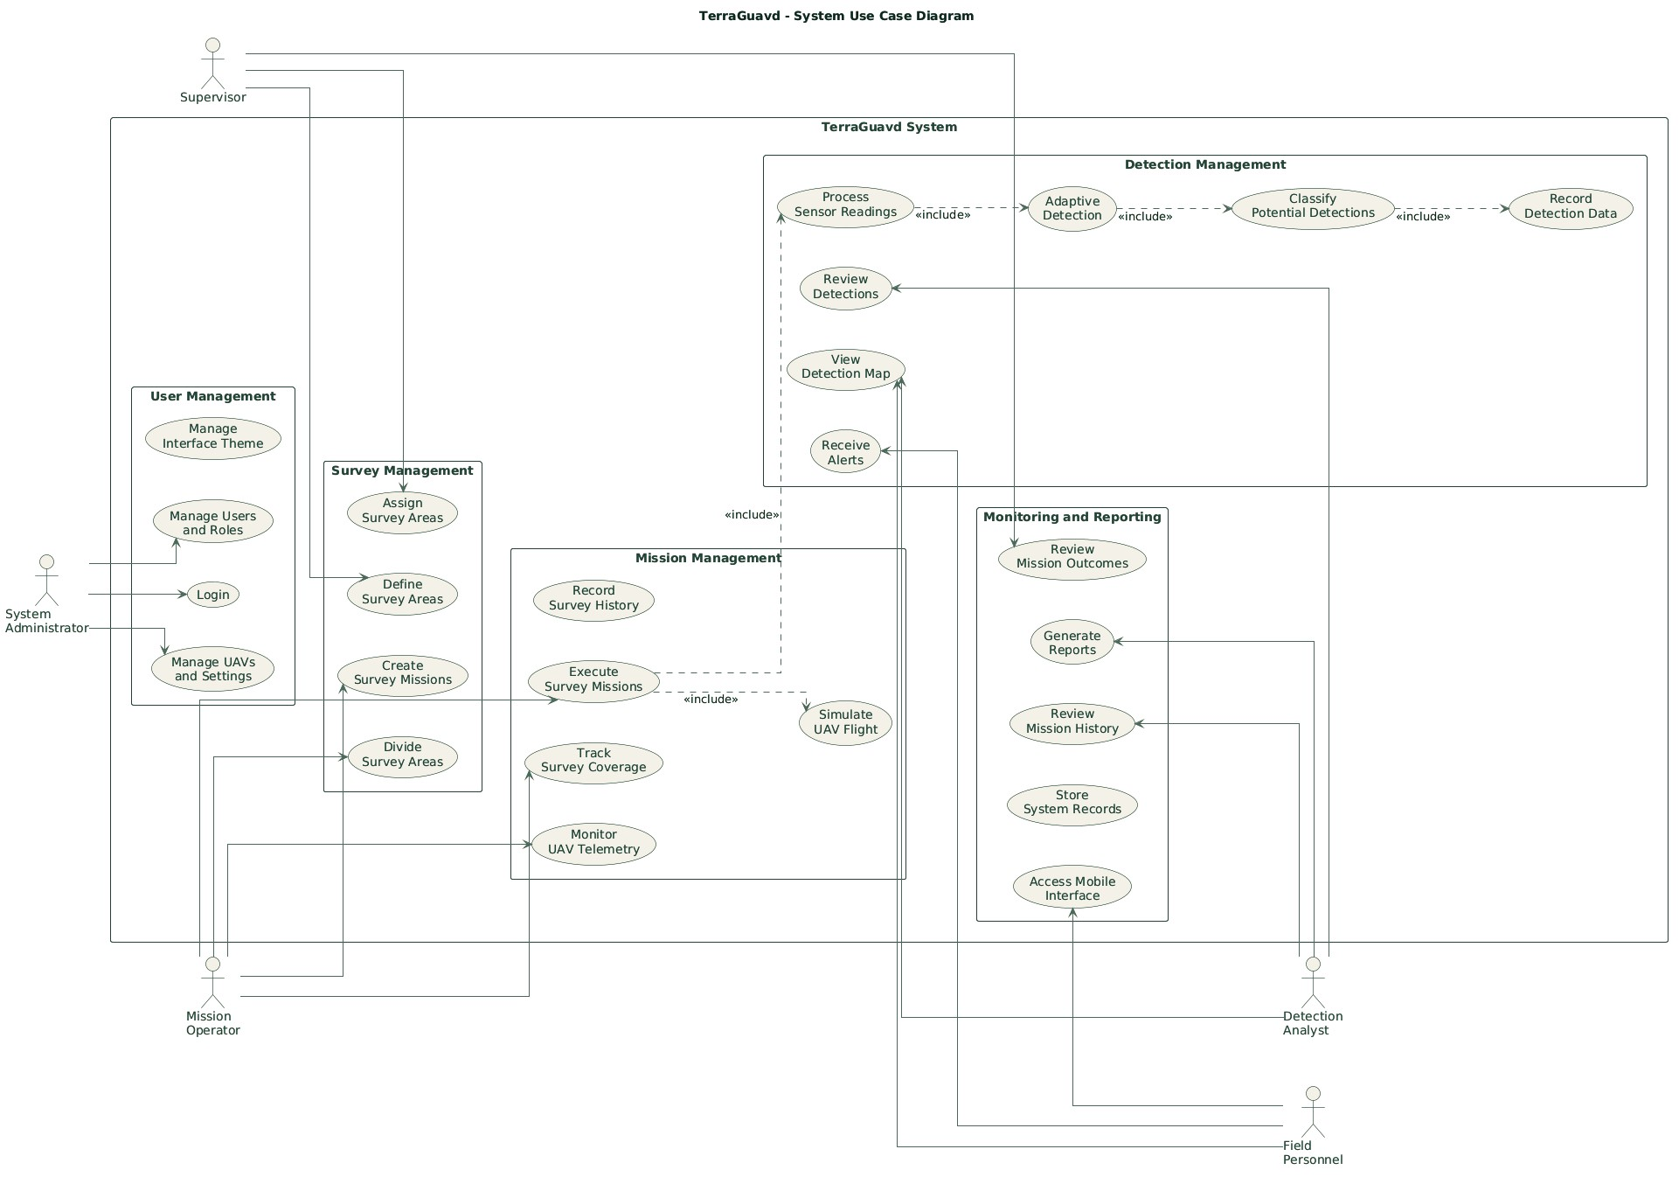
Figure 1.TerraGuavd actors and use cases

      - Sequence Diagrams
Sequence diagrams illustrate how actors and system components communicate over time to perform specific operations. The following three diagrams describe the main interactions involved in survey area assignment, UAV mission execution, and potential detection review.
        - Survey Area Assignment
Related Requirements: FR-06, FR-07, FR-08, FR-26.
The planning model begins with a Supervisor-owned area assignment. The Mission Operator selects the assignment and UAV, draws or edits a sector, and previews the generated route before saving. Supervisor authorization for out-of-assignment exceptions remains part of the requirements; Supervisor authorization is enforced before an exceptional plan can be validated or executed; routine lane previews remain within the assigned area.
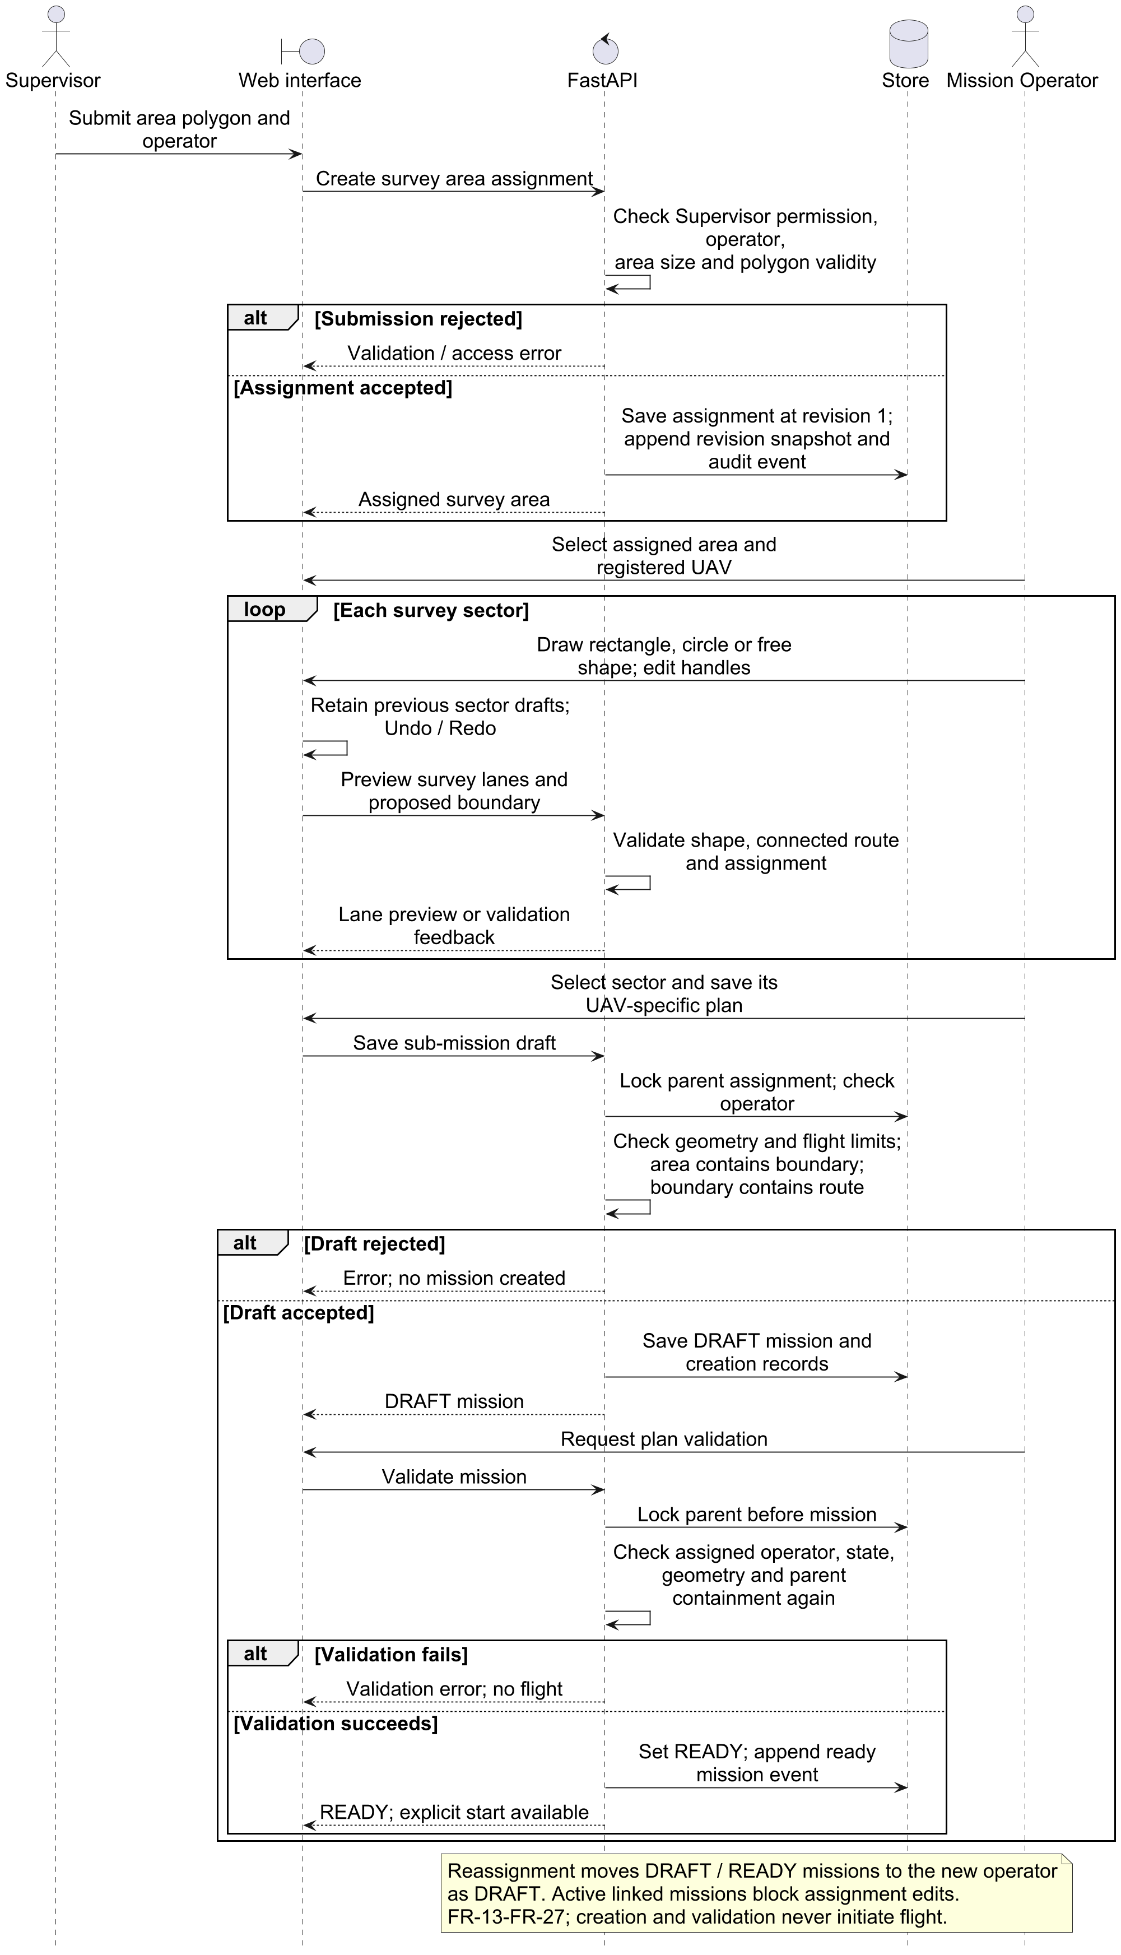
Figure 2.Mission Creation and Approval

        - Explicit Simulated Mission Execution
Related Requirements: FR-06 through FR-17, FR-19, FR-21
This diagram describes explicit execution of a UAV-specific survey mission. The backend rechecks assignment and permissions, reserves the selected UAV, configures its isolated PX4/Gazebo world near the first waypoint, waits for actual telemetry and pre-arm checks, and then uploads and starts the mission. Telemetry and experimental synthetic sensing retain their own provenance.
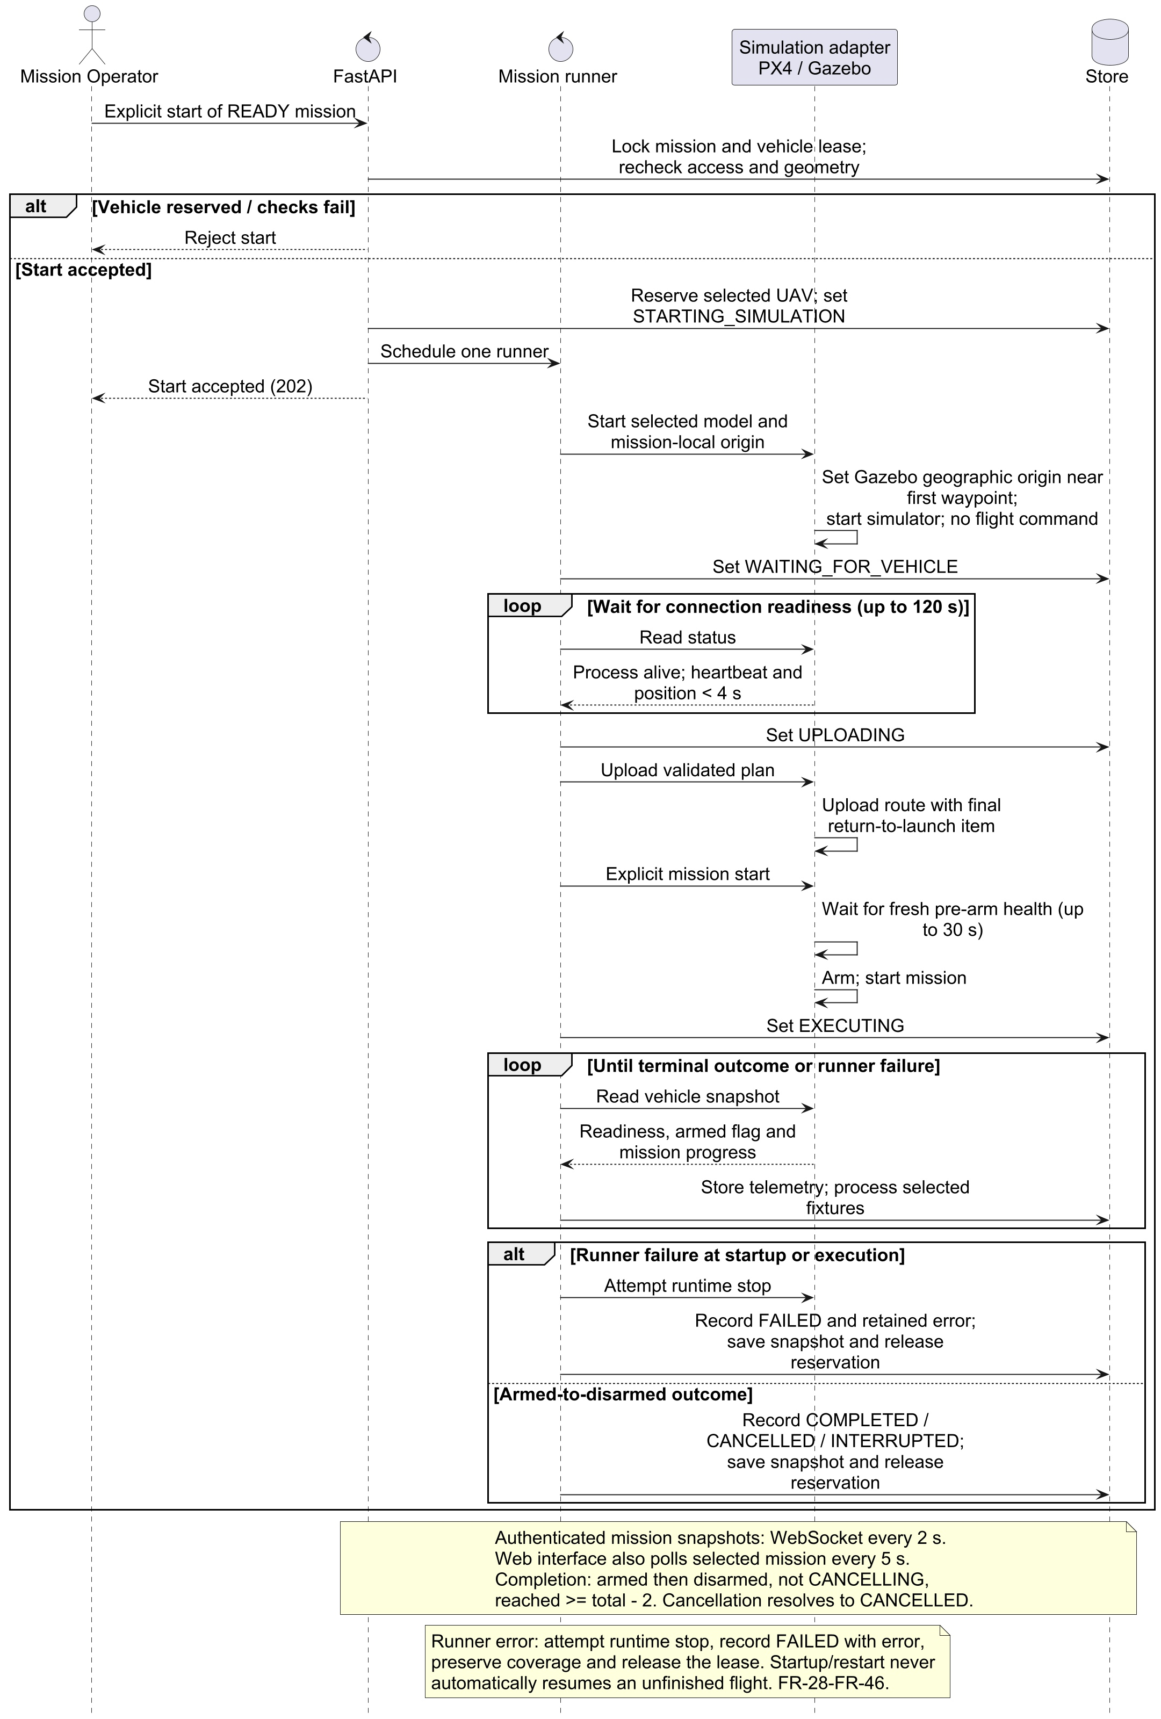
Figure 3.Explicit mission execution sequence

        - Potential Detection Review
Related Requirements: FR-14, FR-15, FR-18, FR-19, FR-21, FR-22
This diagram illustrates how a Detection Analyst reviews potential landmine detections recorded during a survey mission. The analyst retrieves detection details, examines the available sensor data, and records an assessment. The system stores the review and updates the detection status for authorized users.
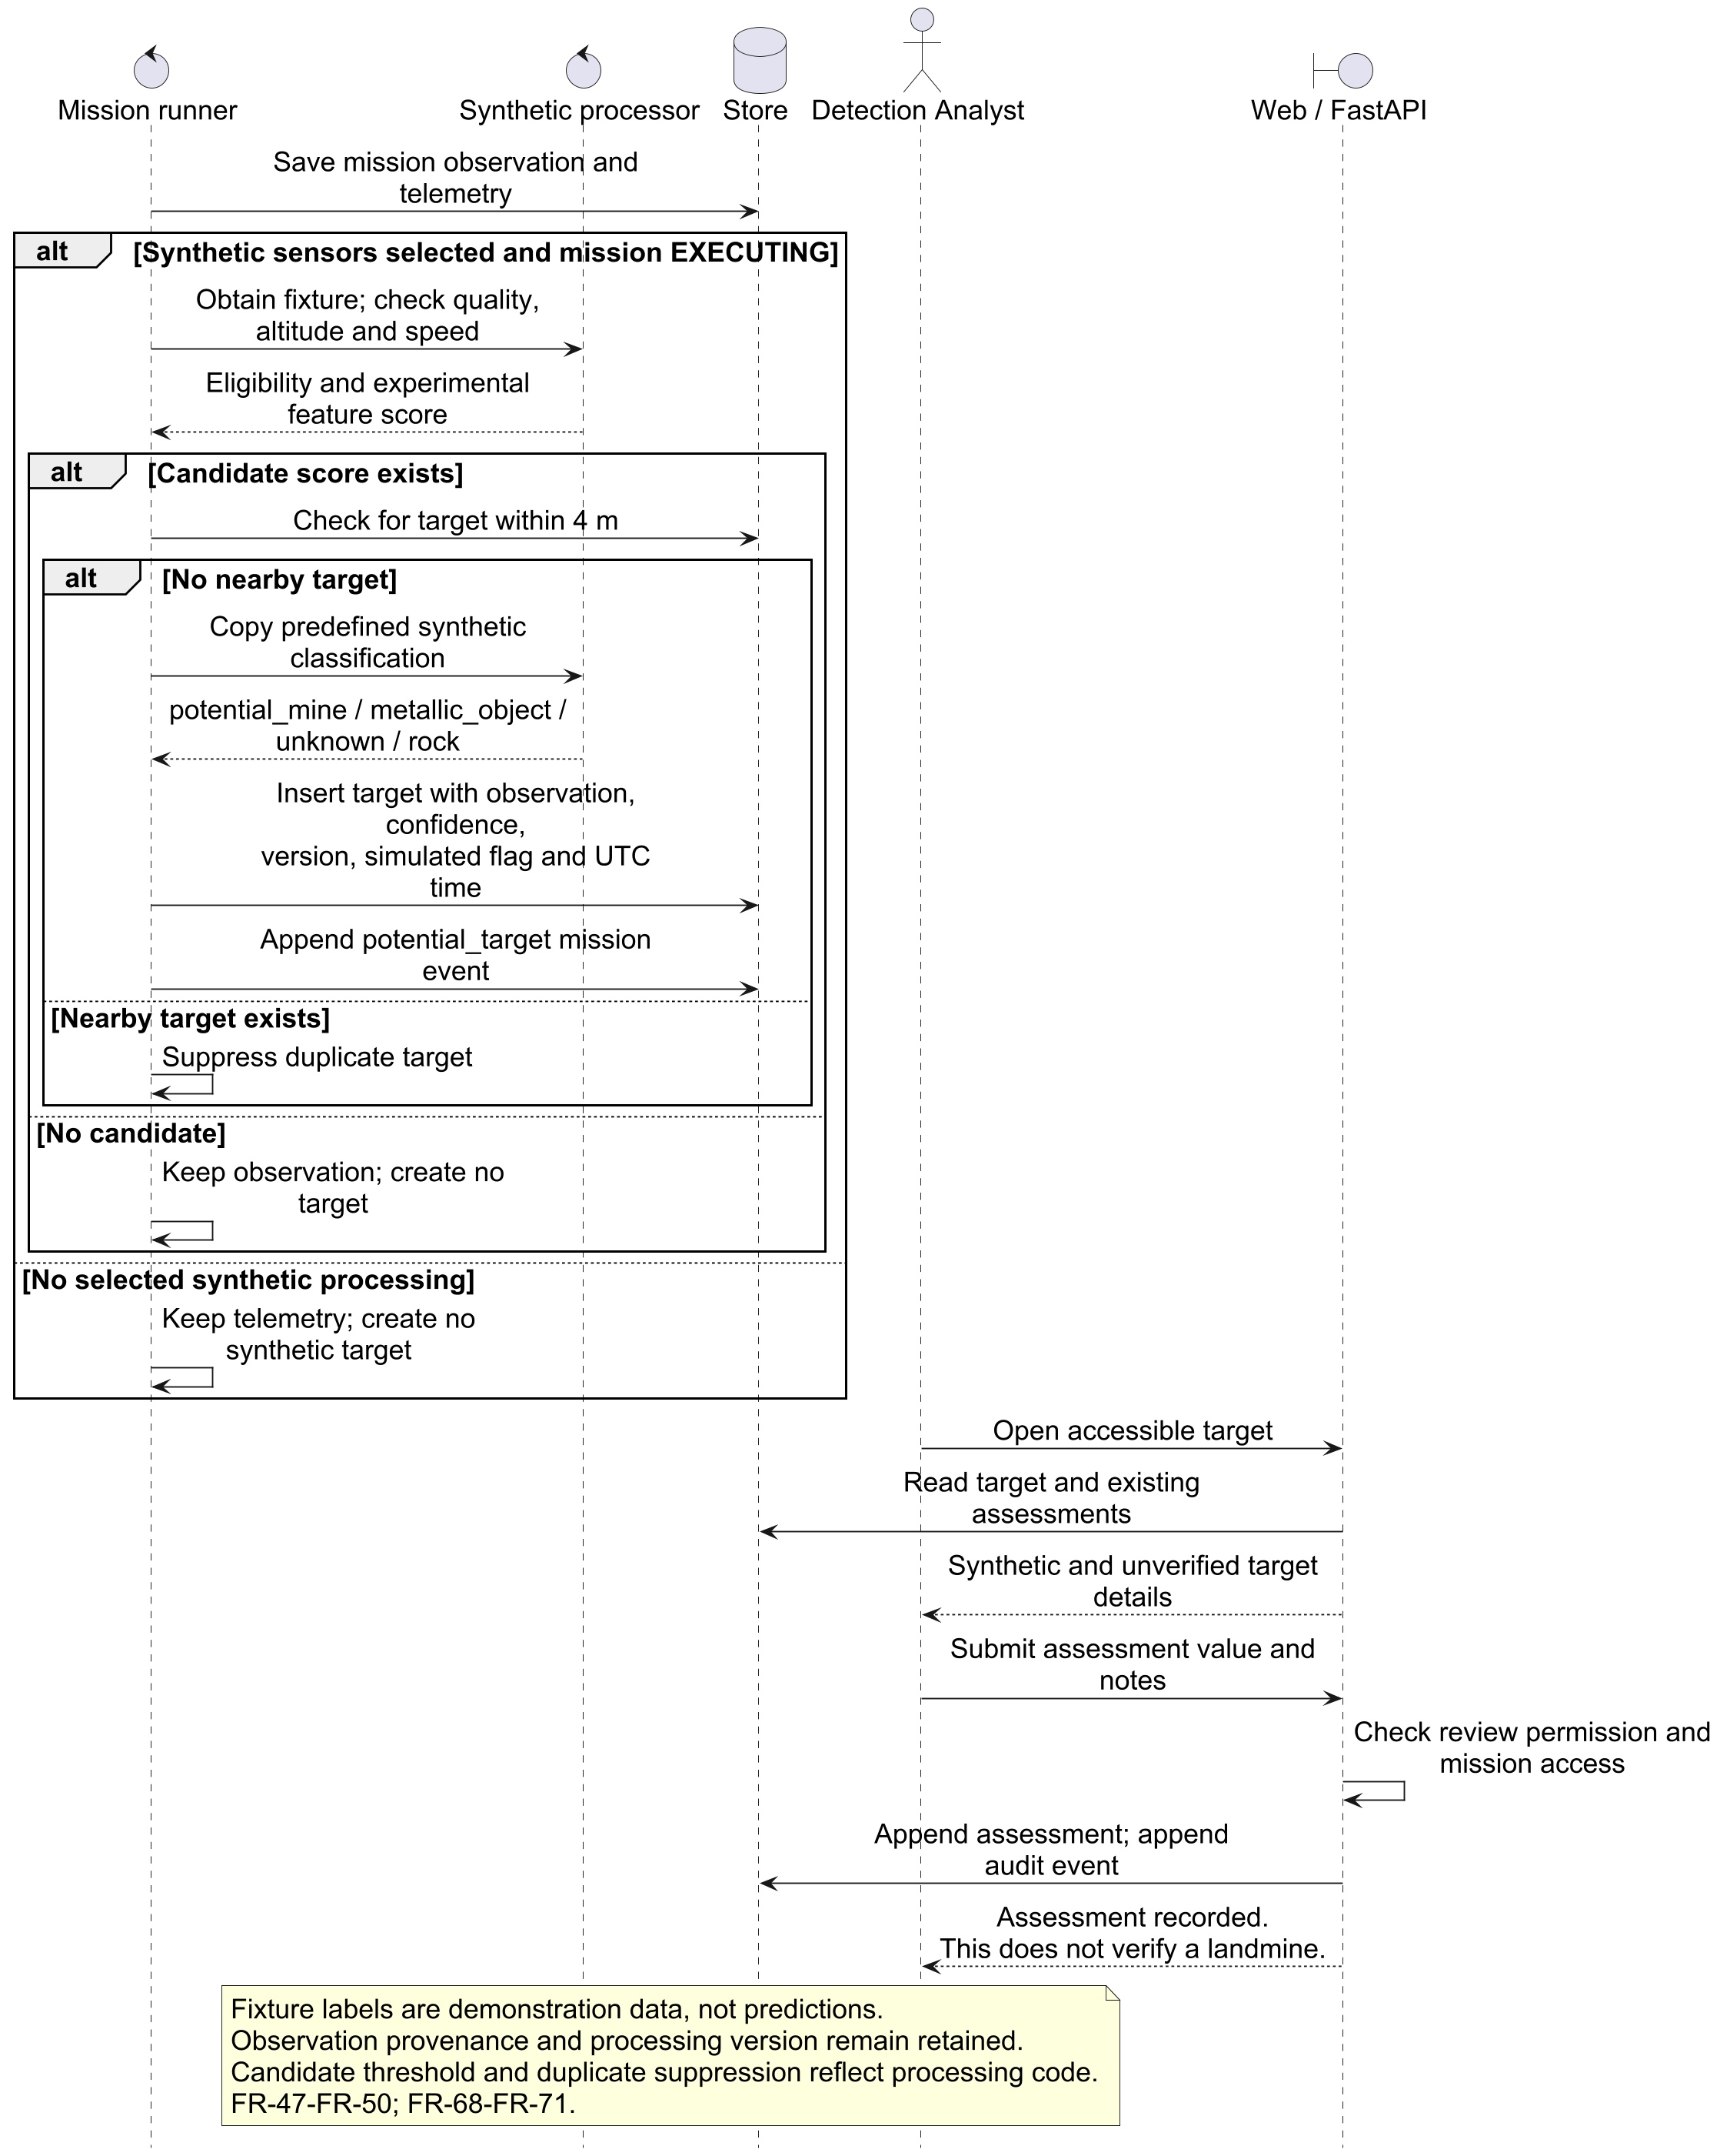
Figure 4.Potential detection review sequence

      - Activity Diagrams
Activity diagrams illustrate the workflows, decisions, and actions involved in the system's main processes. The following three diagrams describe survey area assignment, UAV mission execution, and detection analysis.
        - Survey Area Assignment Workflow
Related Requirements: FR-04, FR-05, FR-06
This diagram illustrates the process of defining and assigning a geographic survey area. The Supervisor selects the survey boundary and assigns it to a Mission Operator. The system validates the area and assignment before making it available for mission planning.
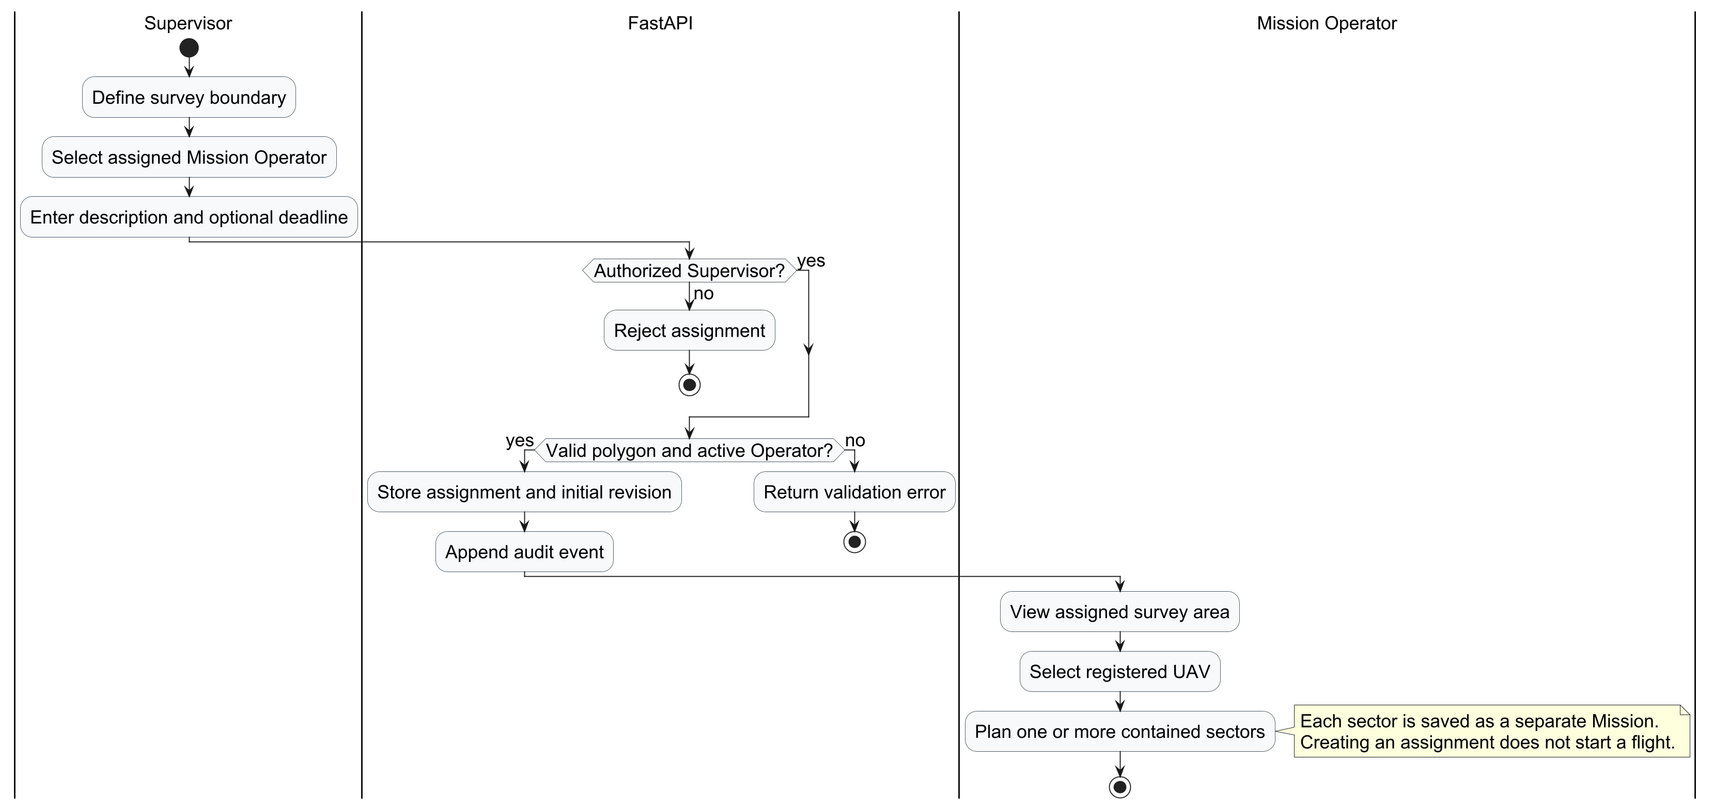
Figure 5.Survey area assignment activity

        - Mission Planning and Execution Workflow
Related Requirements: FR-07 through FR-17, FR-19, FR-21
This diagram describes the main UAV survey workflow, beginning with mission creation and validation. The Mission Operator starts the mission, after which the system initializes PX4/Gazebo, processes telemetry and sensor readings, updates geographic coverage, and records potential detections. The process ends when the mission is completed or terminated.
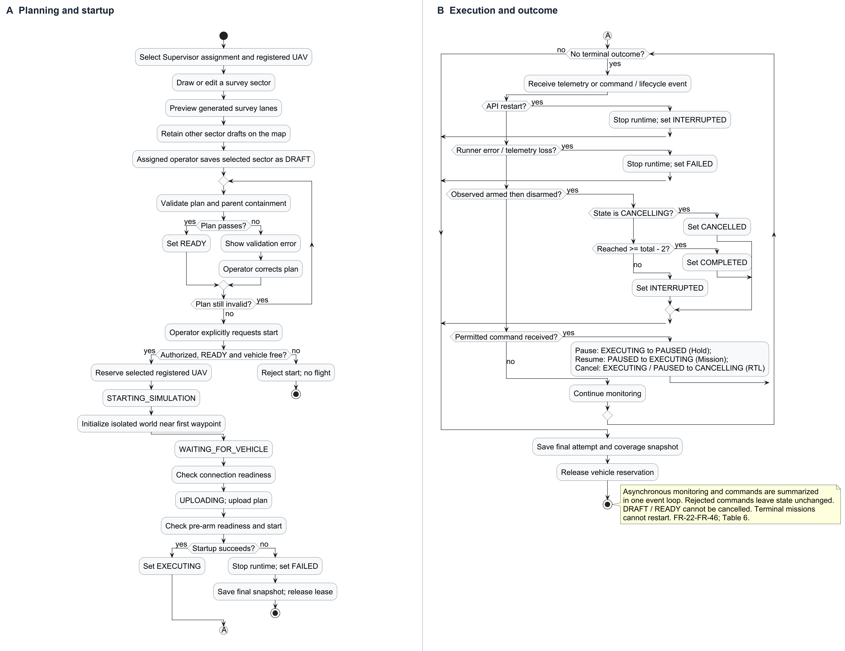
Figure 6.Mission planning and execution activity

        - Potential Detection Analysis Workflow
Related Requirements: FR-14, FR-15, FR-18, FR-21, FR-22
This diagram illustrates the process used by the Detection Analyst to examine potential detections. The analyst selects a recorded detection, reviews sensor information and geographic data, and submits an assessment. The system validates and stores the review, making the updated information available for future reference.
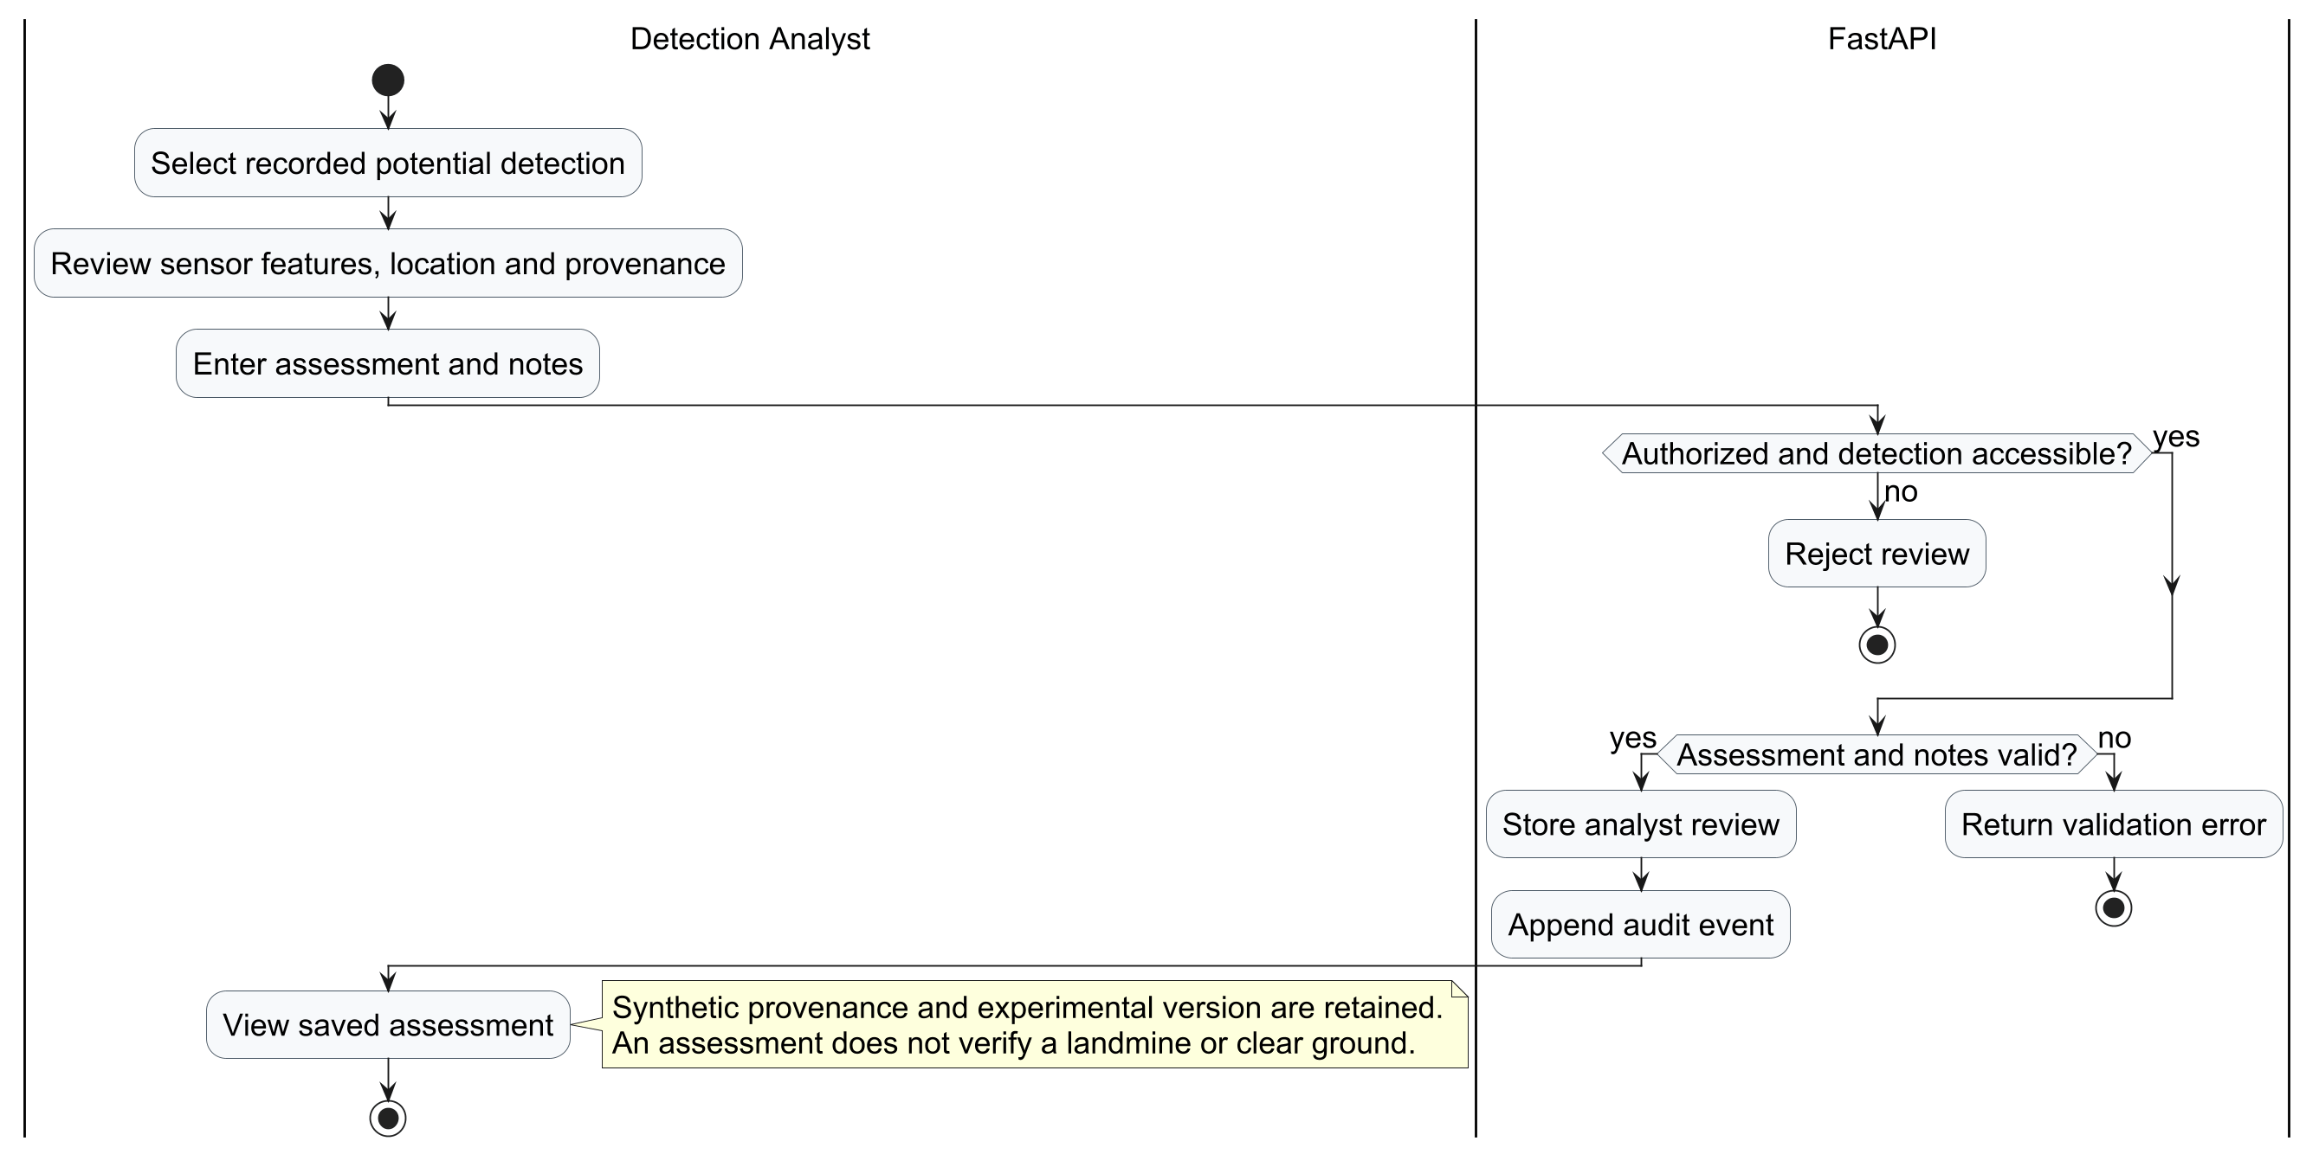
Figure 7.Potential Detection Analysis activity

      - Class Diagram
The Class Diagram represents the main domain objects and their relationships, including users, assigned survey areas, UAV types, individual UAVs, missions, observations, potential targets and retained survey attempts. Each mission selects one registered UAV, while one survey assignment may contain multiple missions using different UAVs.
The diagram shows Supervisor ownership and Operator assignment, the type-to-vehicle relationship, and the links from missions to telemetry, potential targets and final attempt snapshots. Planning drafts stored in the browser are separate from persisted mission records.
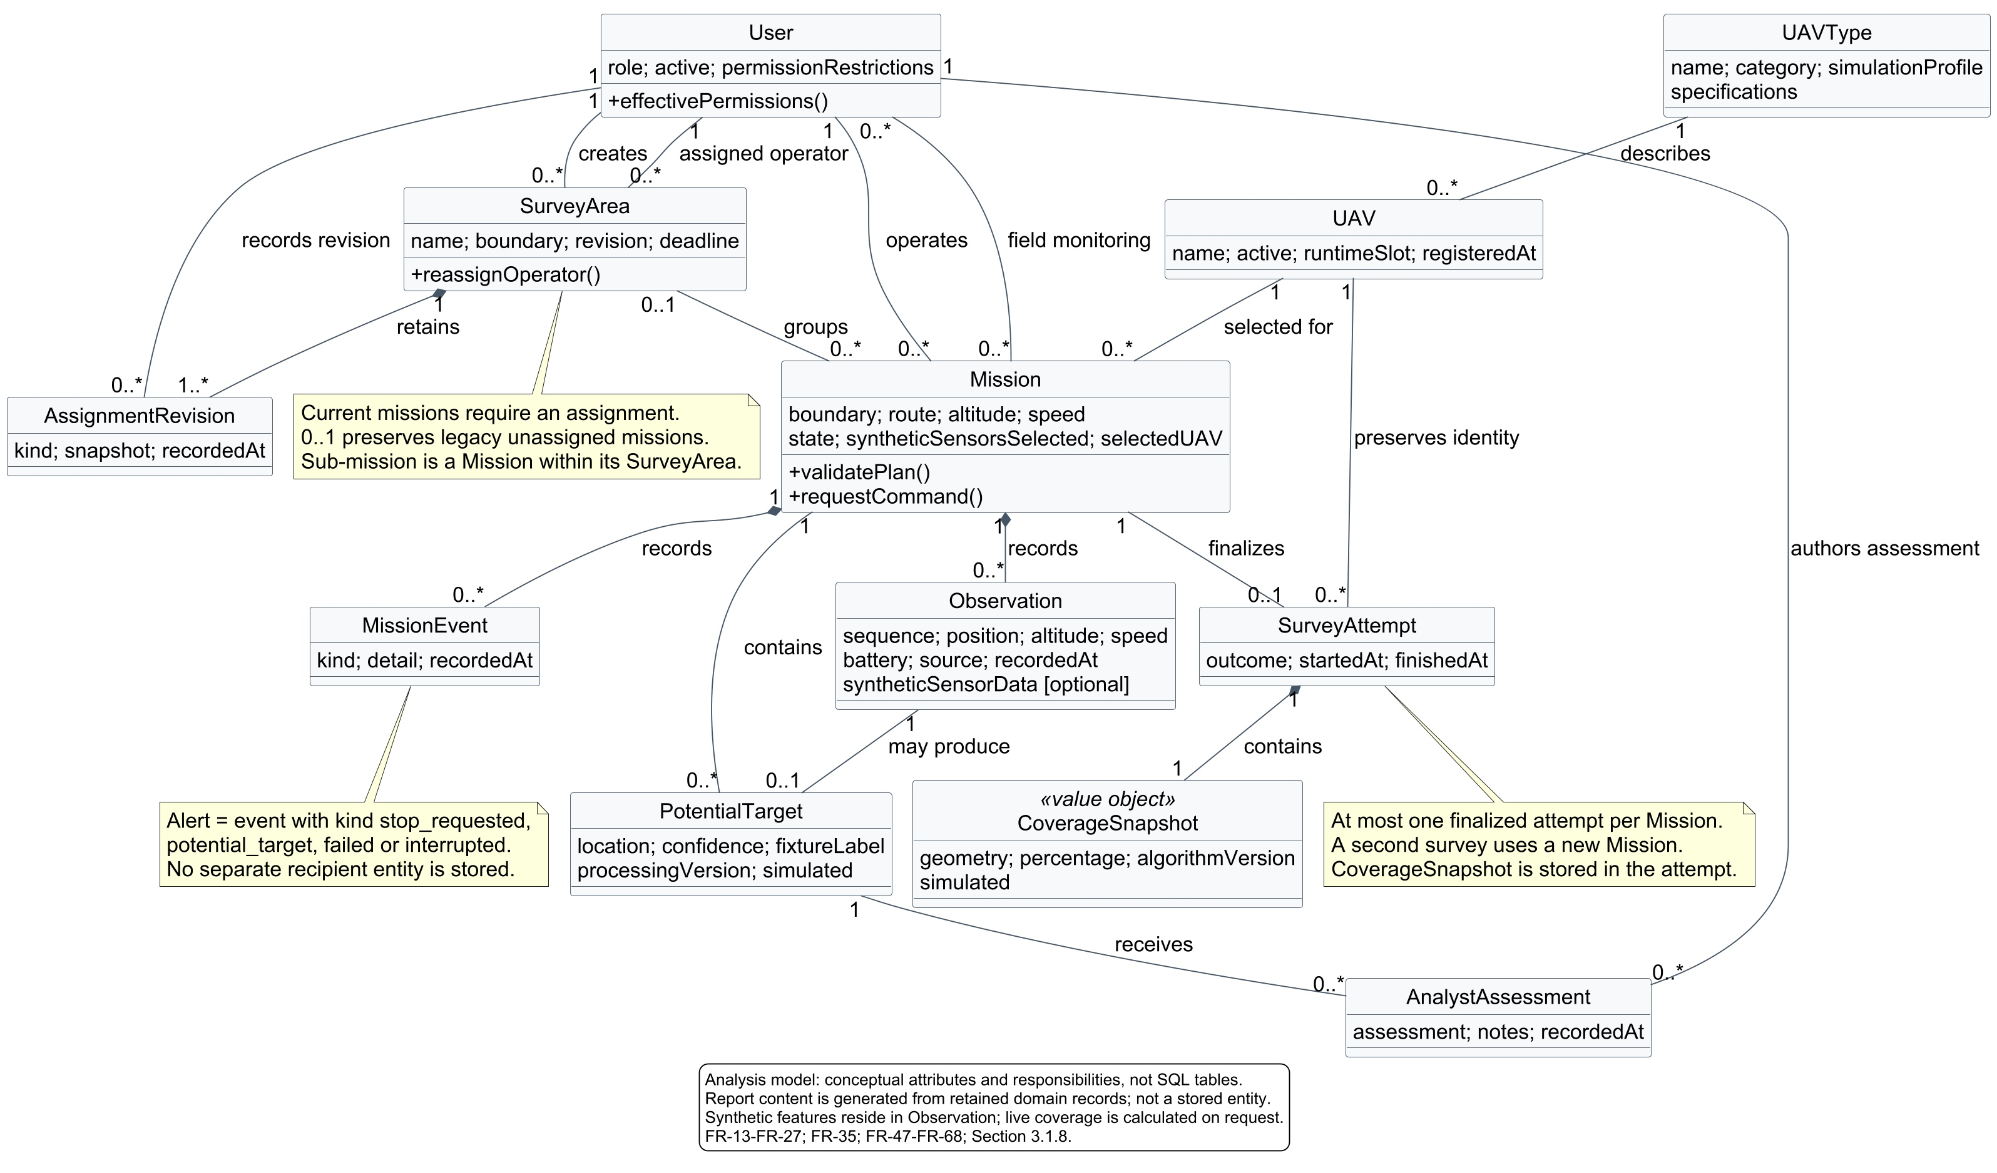
Figure 8.Principal persisted entities and relationships

Chapter 4
System Design

Chapter 4: System Design
This chapter presents the design of TerraGuavd, translating the requirements and system models developed in Chapter 3 into an organized software structure. It explains how the system components, user interfaces, and database work together to support survey planning, mission monitoring, detection review, and reporting.

4.1 System Design
TerraGuavd follows a layered client–server architecture that supports survey assignments, fleet management, sector planning, mission monitoring, detection review, and reporting. The presentation layer provides role-aware web and field interfaces; FastAPI manages authentication, permissions, planning and mission workflows; PostgreSQL/PostGIS stores operational and geographic records. The UAV adapter resolves each mission’s selected vehicle and isolated runtime. Supervisor authorization remains a system requirement, while current prototype commands enforce the implemented assignment and permission checks.

4.2 Software System Architecture
TerraGuavd connects its user interfaces, backend services, database, and UAV integration component through a client–server architecture, as illustrated in Figure 4.1. Users interact with a React and TypeScript web application that provides workspaces for administrators, supervisors, mission operators, detection analysts, and field personnel. A Flutter field client is also provided, although native device builds remain unverified. Client requests are sent through REST APIs to the FastAPI backend, which handles authentication, authorization, survey assignments, mission management, detection processing, and reporting.
The backend stores operational and spatial records in PostgreSQL/PostGIS. A UAV integration adapter resolves the selected registered vehicle and its independent reservation, then communicates with one of three isolated PX4 SITL/Gazebo runtimes through MAVLink using pymavlink. On explicit mission start, the isolated world is initialized near the first survey waypoint; actual MAVLink position remains authoritative. Authenticated WebSocket updates use polling as a fallback. Current execution supports x500 and its camera-free downward-LiDAR variant; other registered categories remain catalog-only. Sensor features are synthetic and experimental, and neither detections nor coverage verify mines or ground clearance.
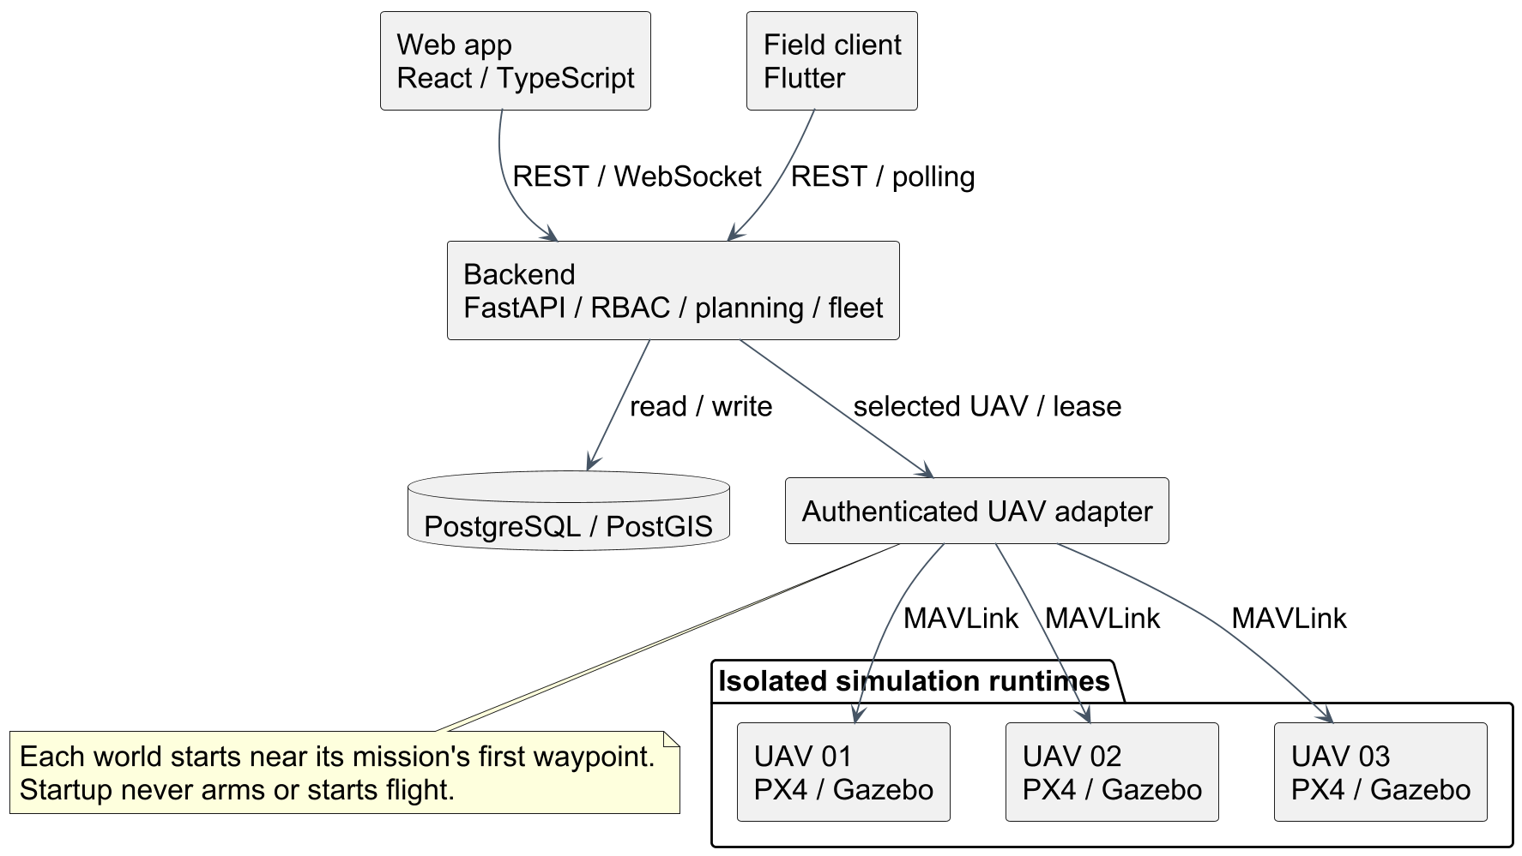
Figure 4.1: TerraGuavd Client–Server Architecture.

4.3 User Interfaces

Shared Login Interface
The following interfaces are illustrated using the original screenshots supplied in Light theme.pdf. They are organized by user role and key function. The examples retain their documentation-fixture labels; displayed sensor results are synthetic and unverified. Field Personnel images show the responsive web interface.
- Account Login: Users enter their provisioned username and password to access the system.
- Role-aware Access: The application opens the workspace associated with the authenticated account. The backend enforces permissions independently.
- Evidence Labels: Simulation and unverified-result notices remain visible throughout the interface.
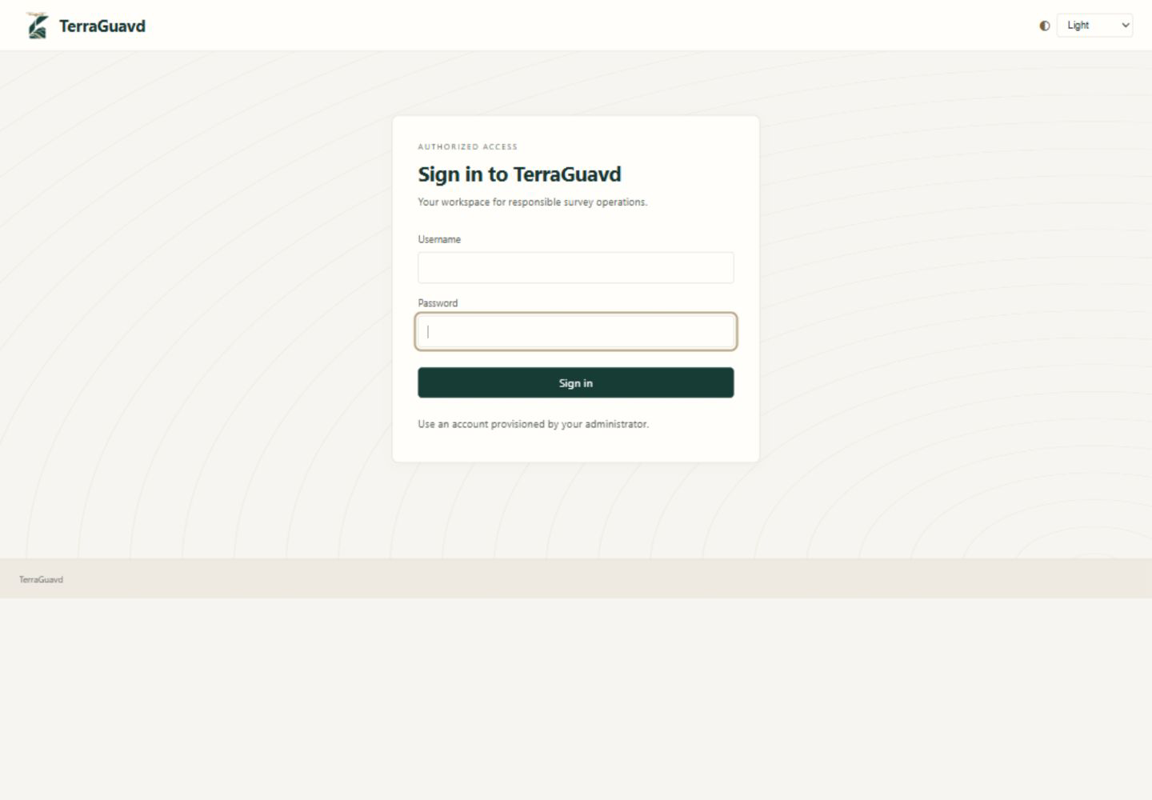
Figure 4.2: Shared Login Interface.

4.3.1 System Administrator Interface

4.3.1.1 Administration Dashboard
The dashboard provides an overview of the platform and access to administrative functions.
- Operational Summary: Displays recorded mission, potential-detection and survey-attempt counts.
- Service Health: Provides access to backend, database and simulator-service checks.
- User Directory: Lists provisioned accounts and their role-based permissions.
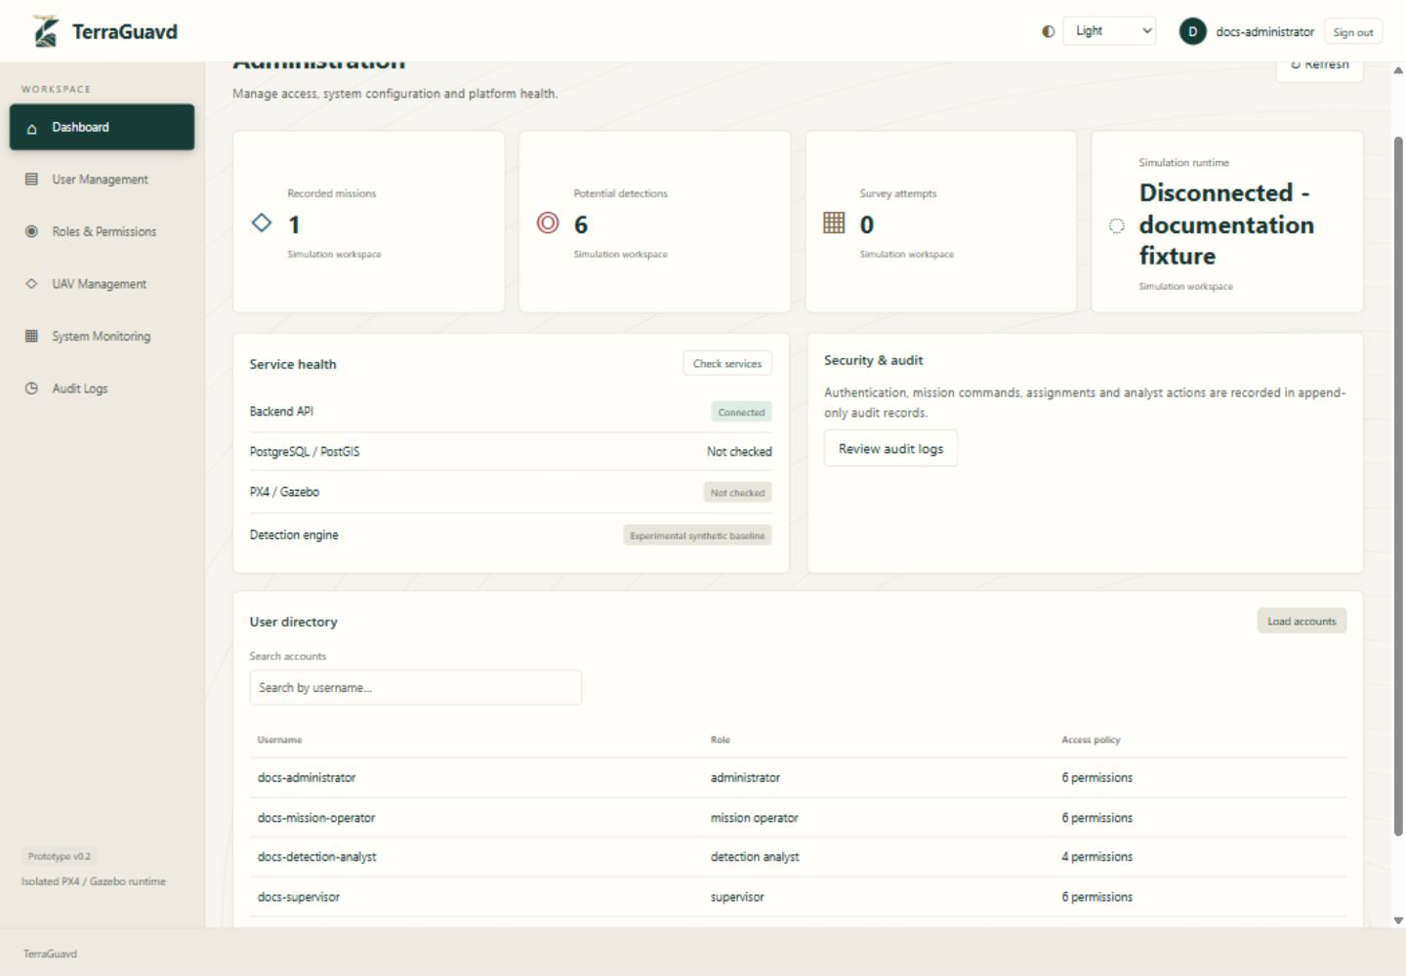
Figure 4.3: Administration Dashboard.

4.3.1.2 User Management Interface
The account list allows the Administrator to inspect existing users and select an account for access management.
- Account Directory: Displays usernames, assigned roles and account status.
- Edit Access: Opens access settings for a selected account.
- Account Protection: The current Administrator cannot change their own access through this interface.
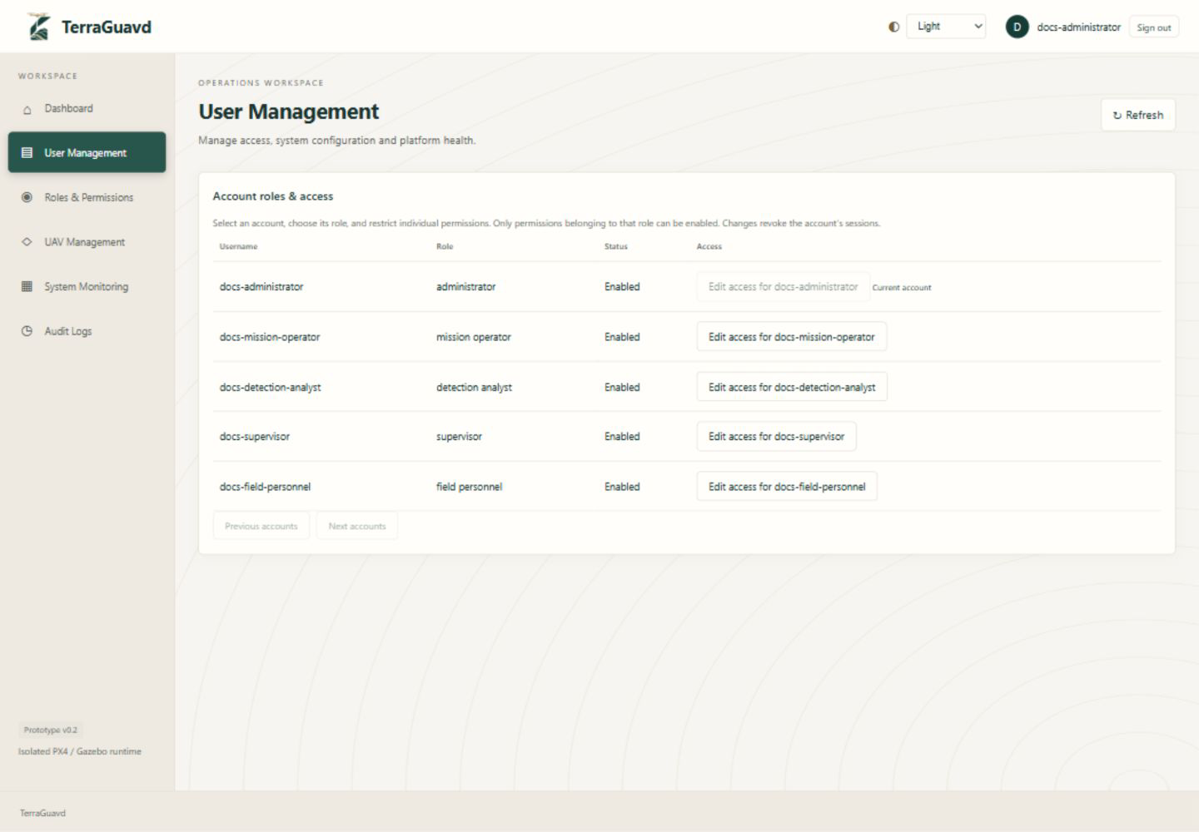
Figure 4.4: User Management Interface.

4.3.1.3 Roles and Permissions Interface
The access editor controls an existing account within the permission limits of its selected role.
- Role Selection: Assigns the appropriate role to the selected account.
- Account Status: Enables or disables account access.
- Permission Restrictions: Removes selected permissions within the role. Saving access changes revokes the affected account sessions.
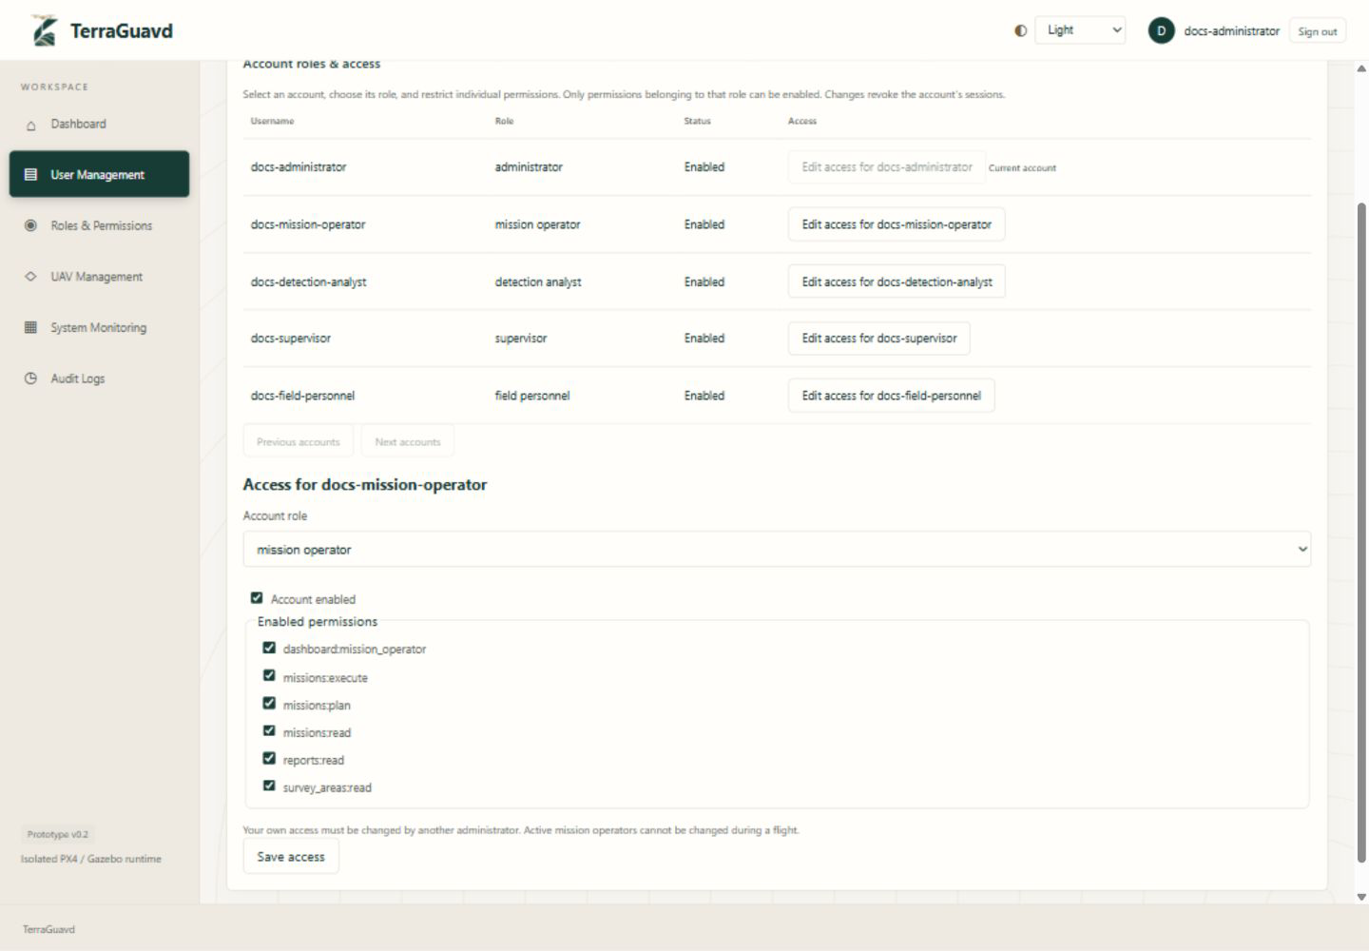
Figure 4.5: Roles and Permissions Interface.

4.3.1.4 System Monitoring Interface
The monitoring screen presents the availability of the services used by the prototype.
- Backend and Database: Checks API connectivity and PostgreSQL/PostGIS readiness.
- Simulation Runtime: Reports service availability and whether the simulator is running.
- Security Overview: Provides access to the recorded audit events.
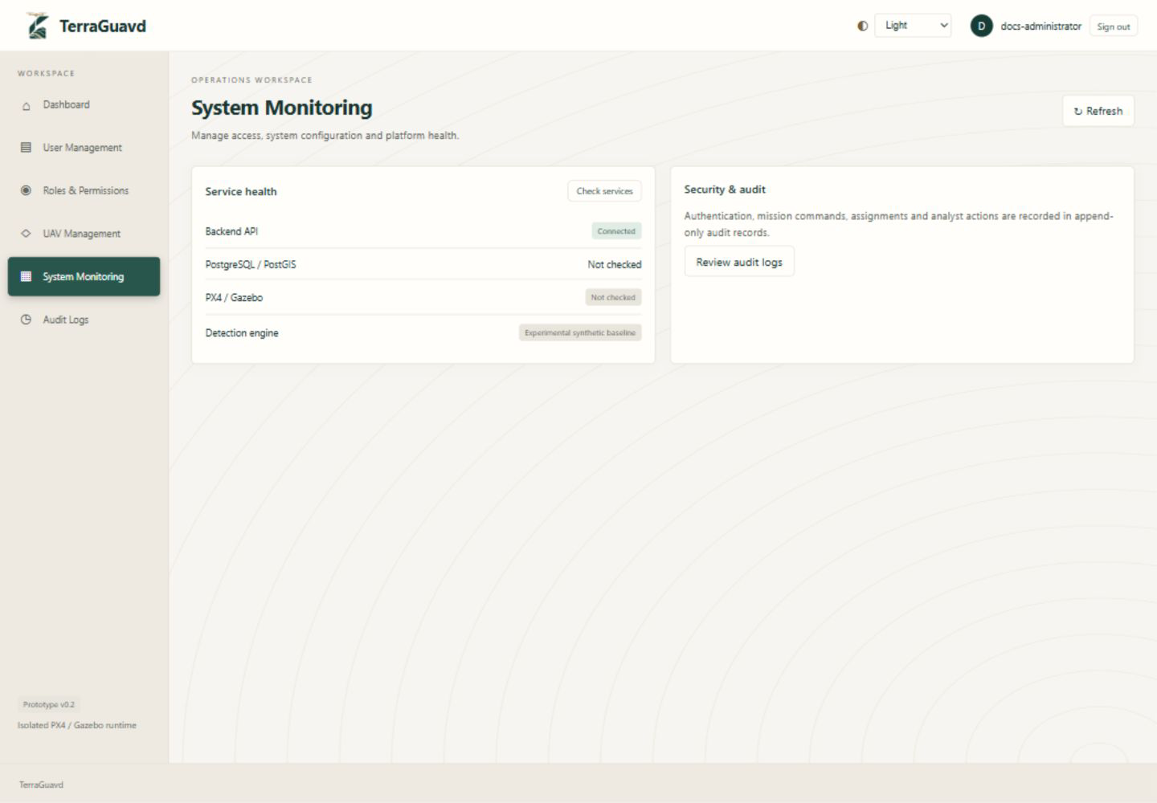
Figure 4.6: System Monitoring Interface.

4.3.1.5 Audit Log Interface
The audit screen allows the Administrator to review recent recorded security and operational actions.
- Recorded Actions: Displays action names, account attribution and timestamps.
- Recent Records: Loads the latest audit records from the backend.
- Read-only Review: Supports inspection without providing an interface to edit or delete audit events.
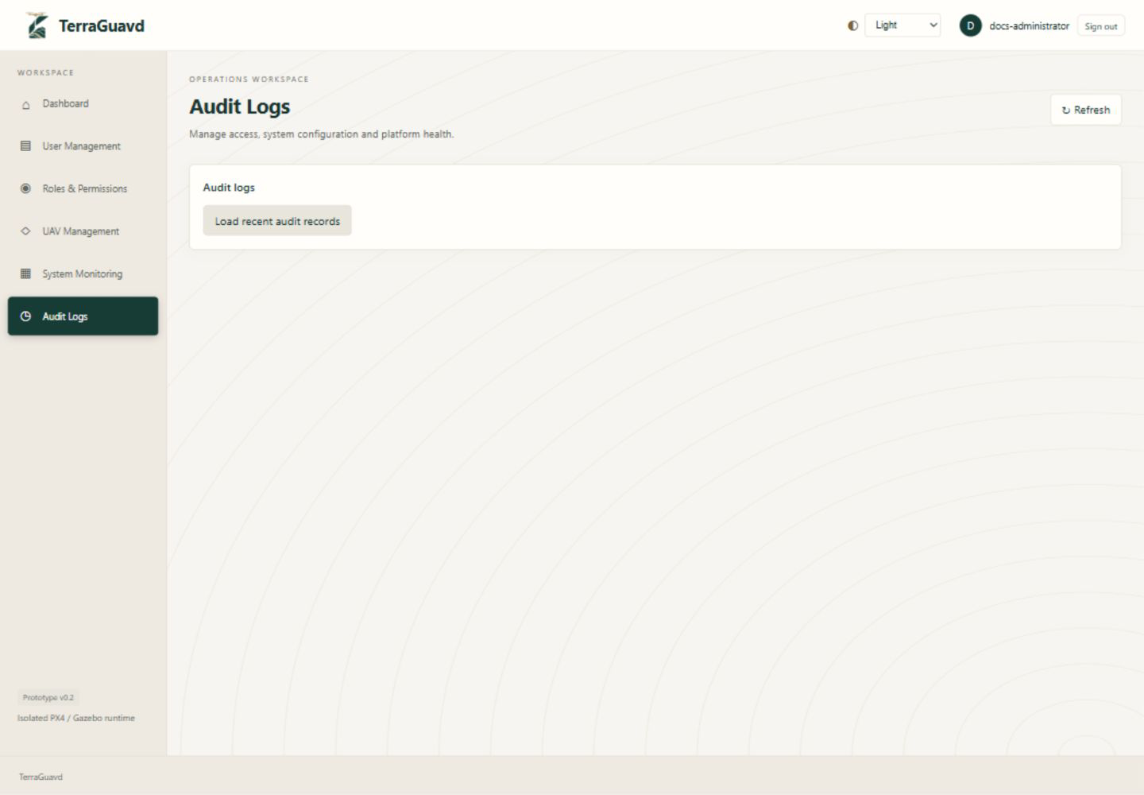
Figure 4.7: Audit Log Interface.

4.3.1.6 UAV Management and Fleet Overview
The Administrator registers UAV types and individual vehicles in separate collapsible forms. Type selection, name/ID search and availability filters organize the fleet; text and colored indicators distinguish available, in-use, disabled and catalog-only vehicles.
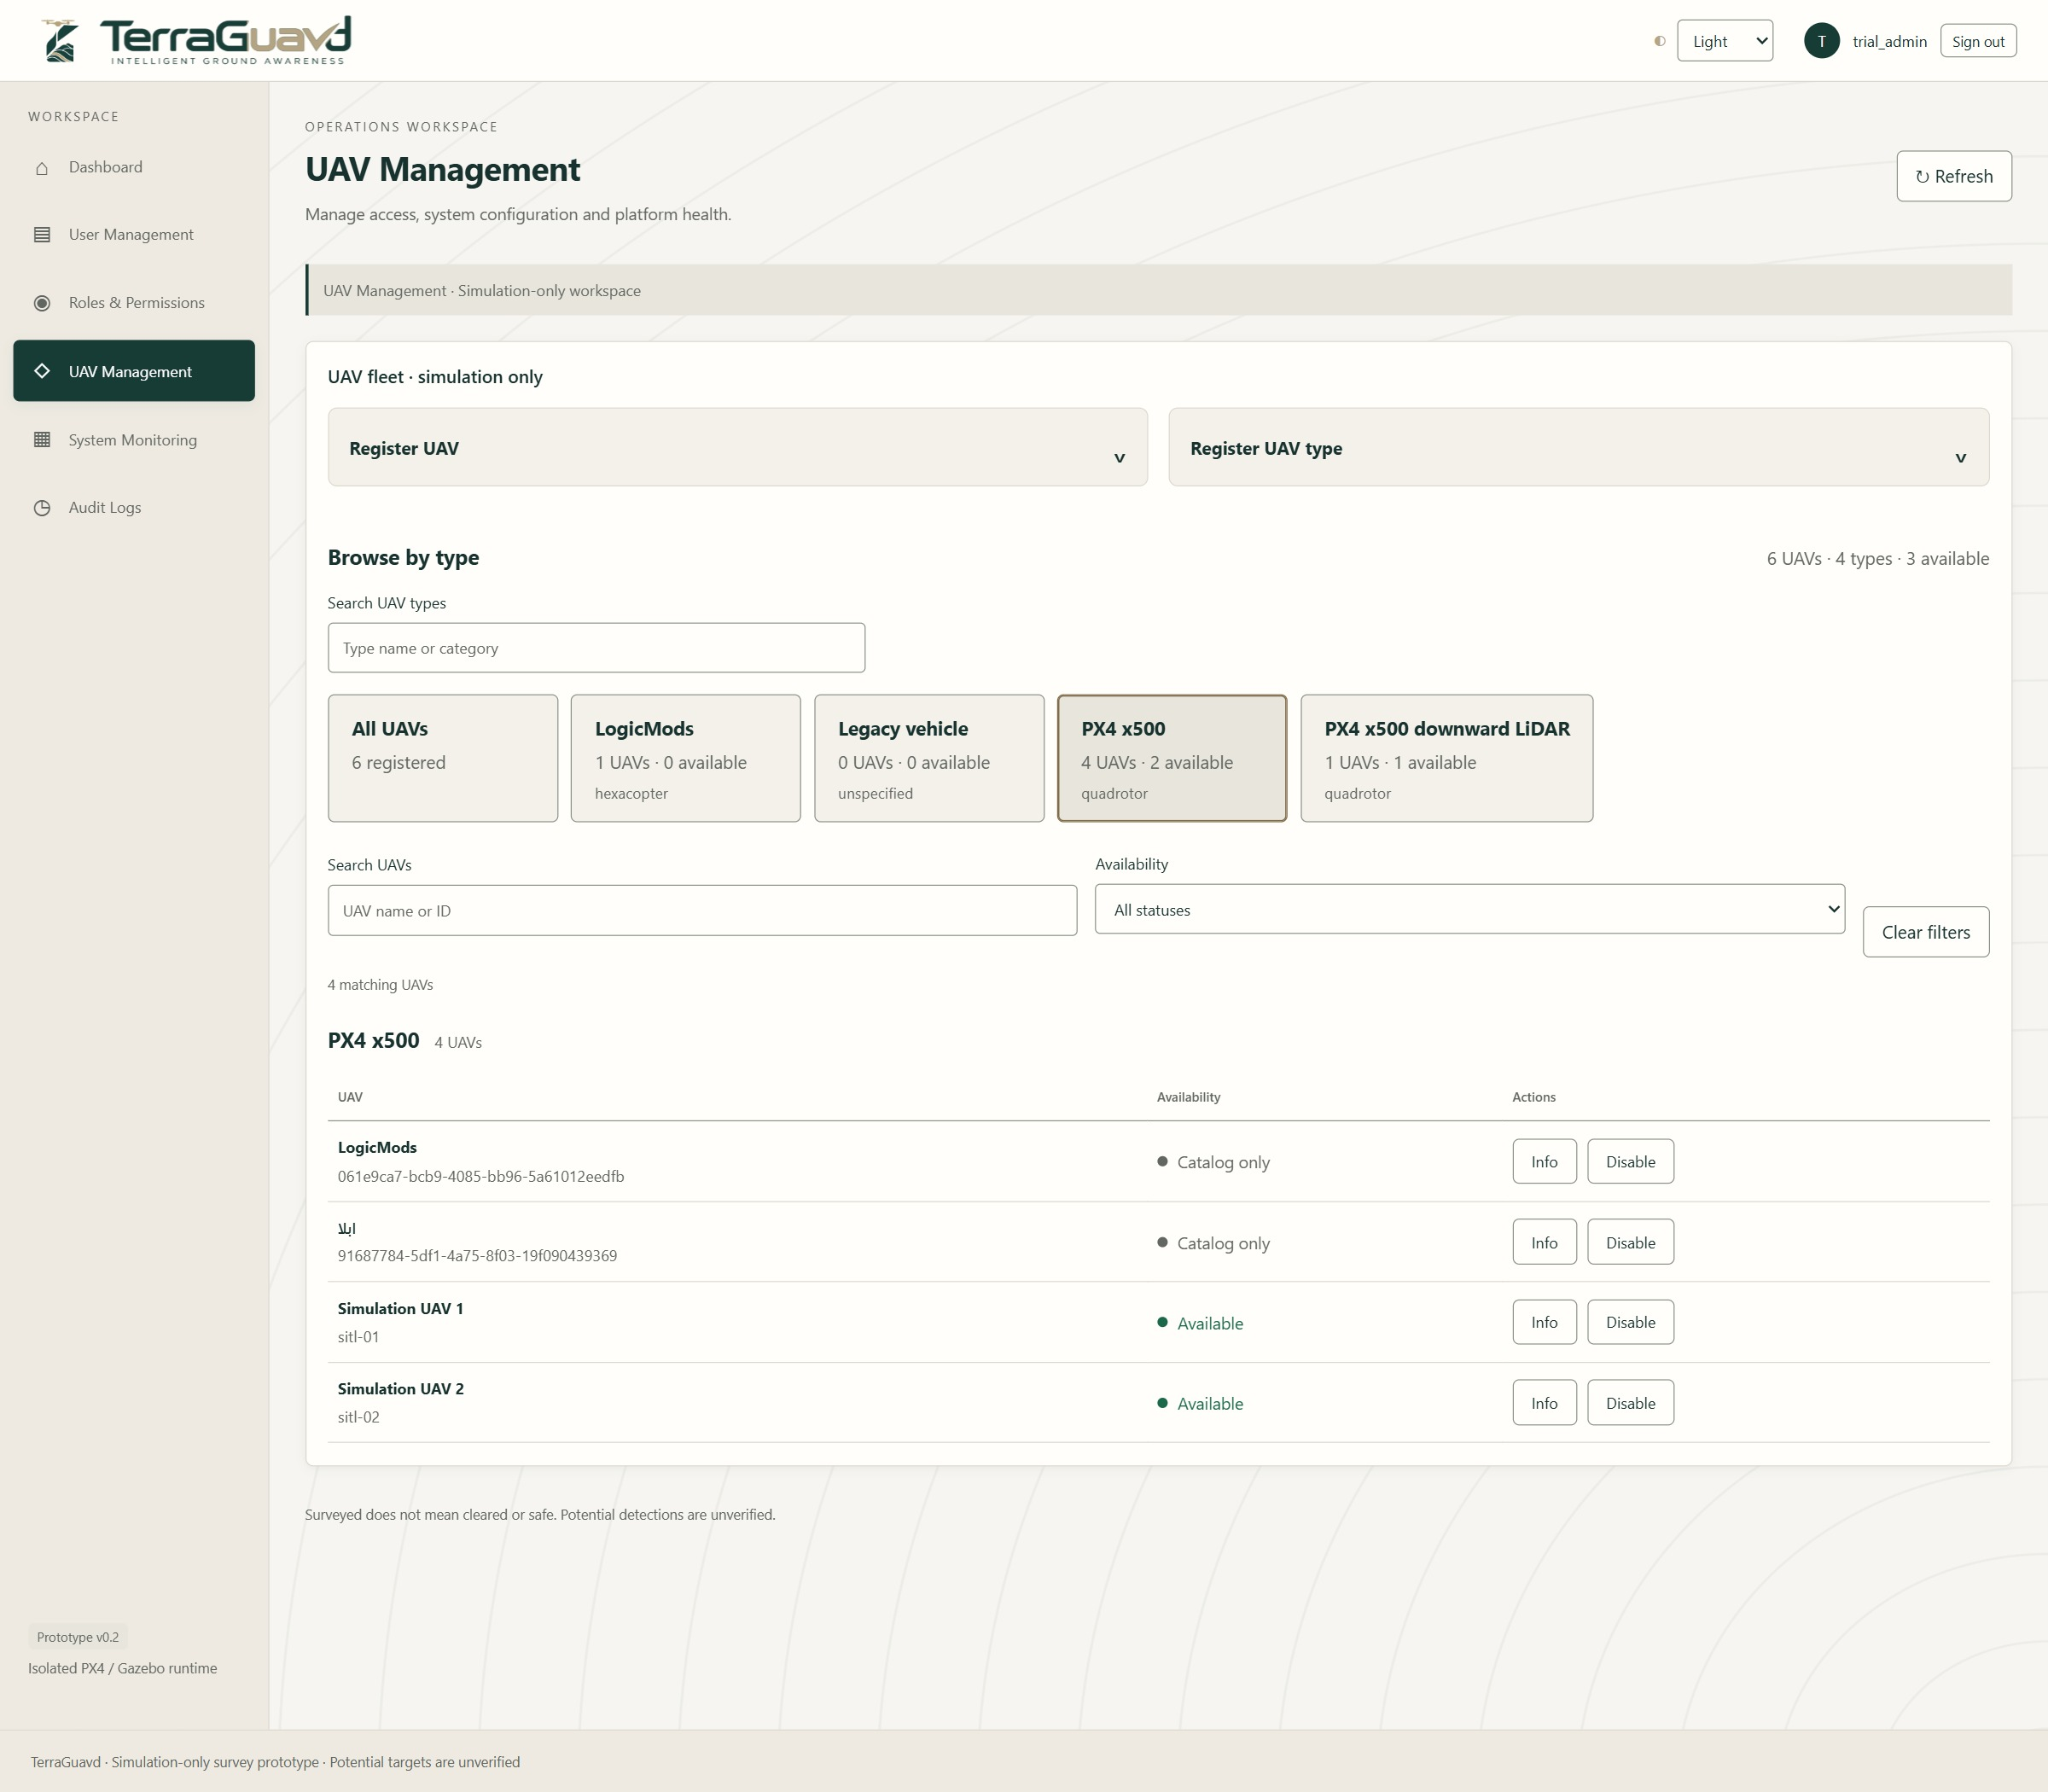
Figure 4.8: UAV Management and Fleet Overview.

4.3.1.7 UAV Information
The information window displays a selected UAV’s type, category, registration timestamp, runtime binding and recorded mission-use statistics. Registration date is not manufacture date, and physical age or maintenance history is not inferred.
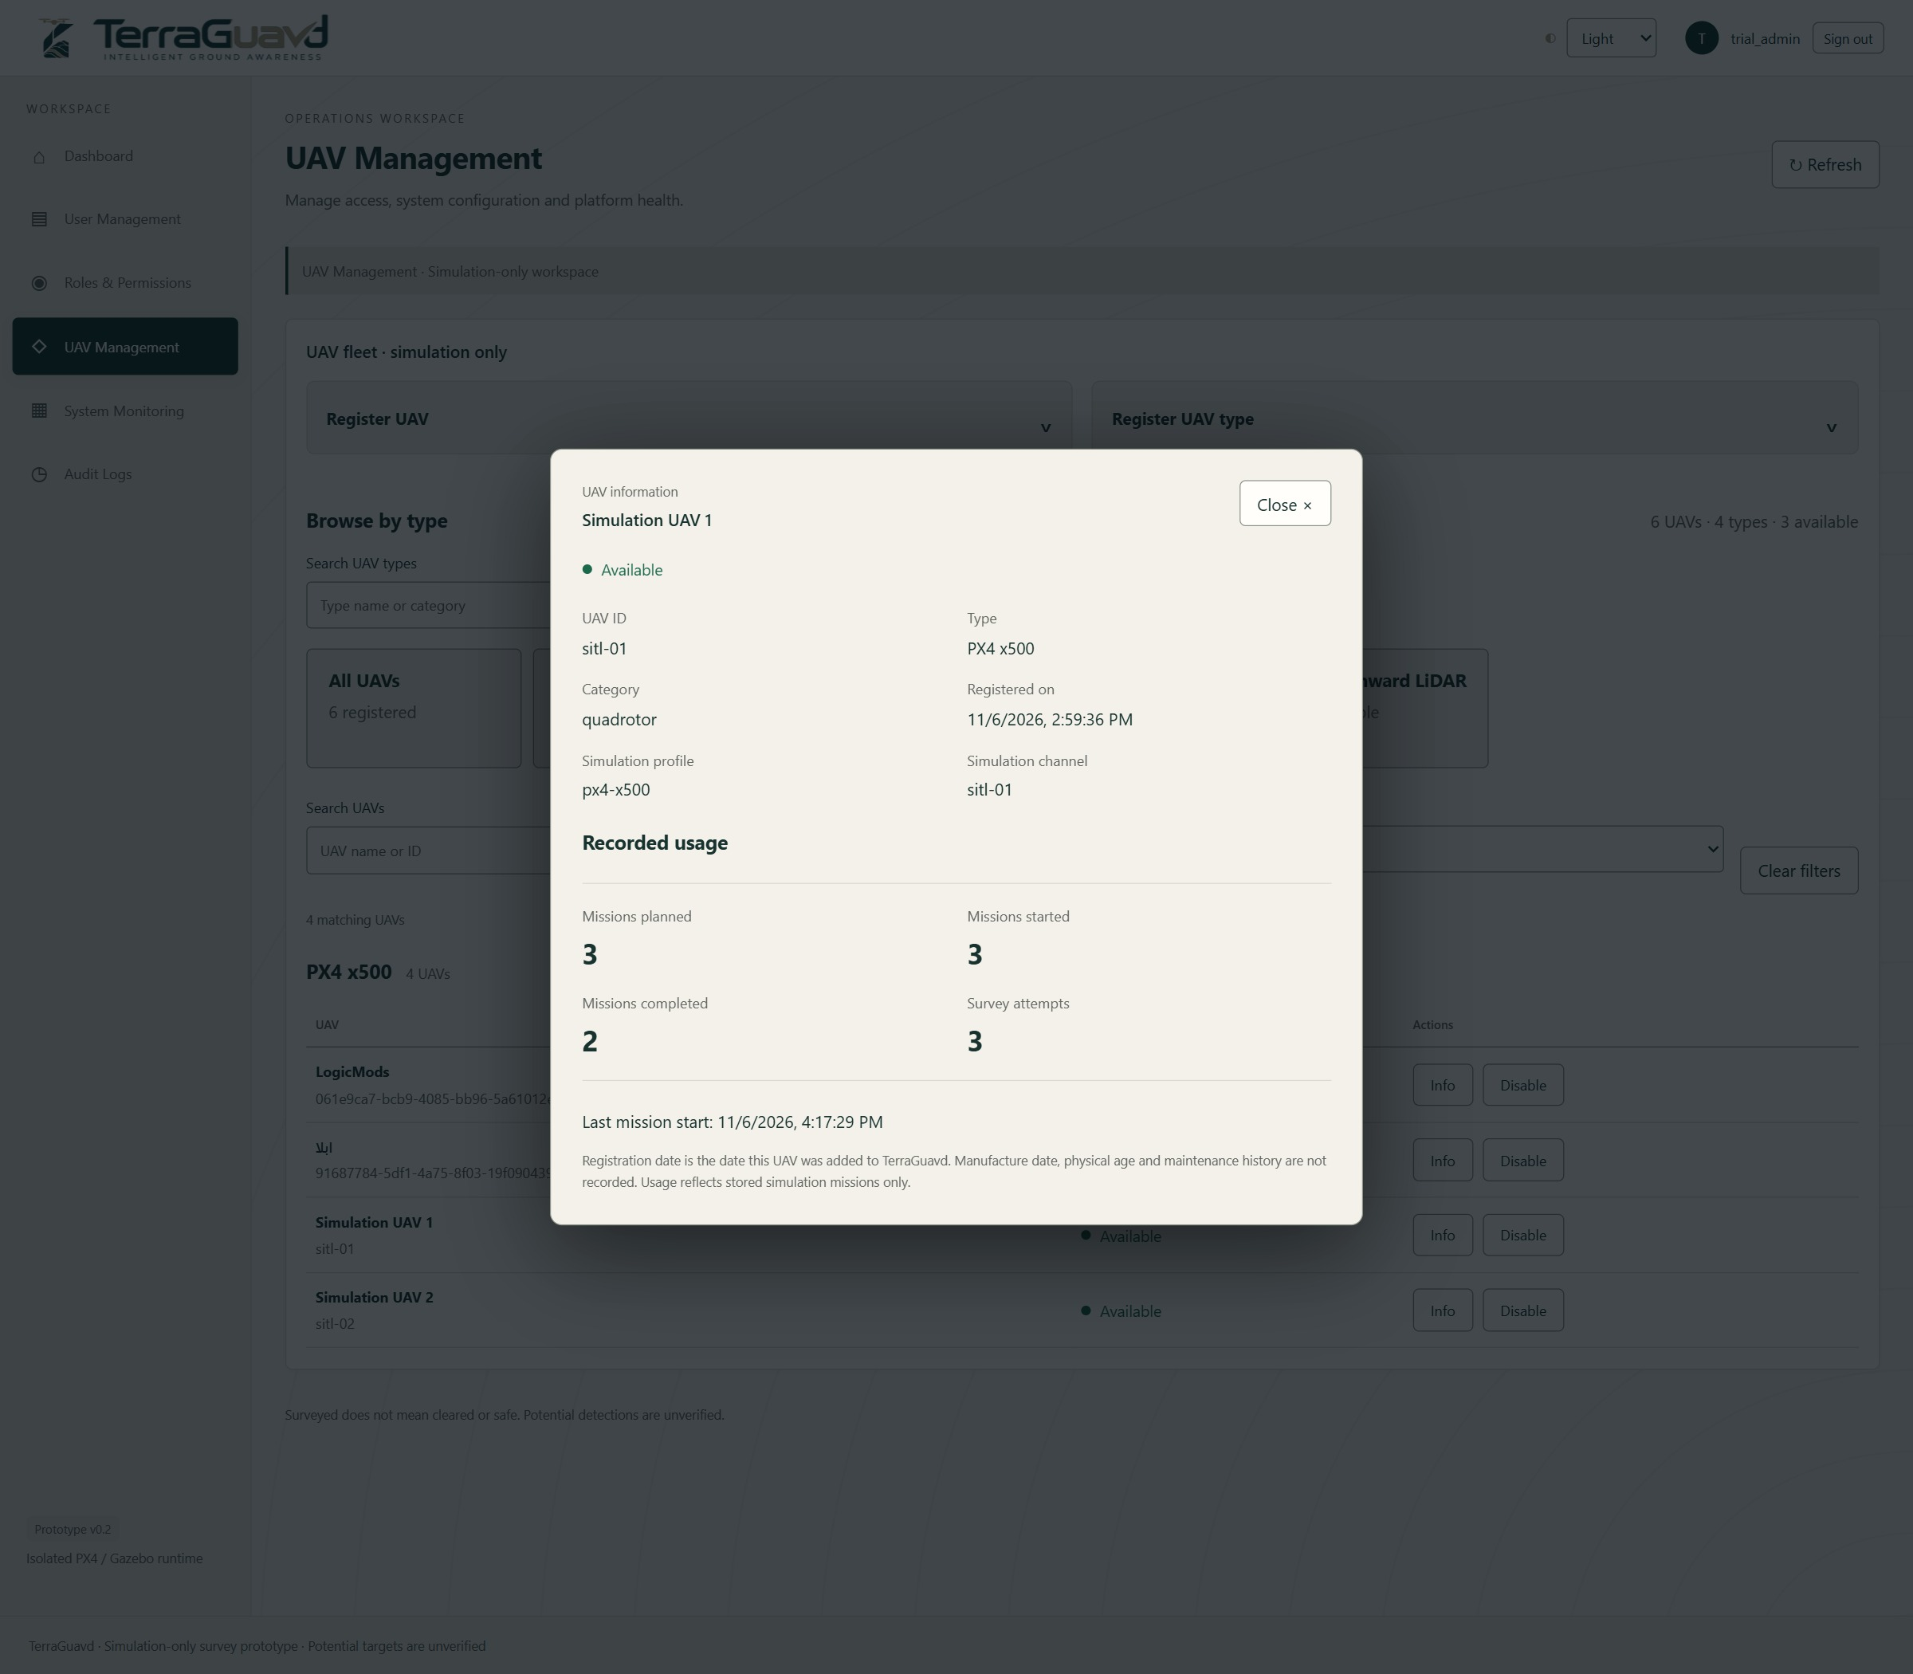
Figure 4.9: UAV Information.

4.3.2 Supervisor Interface

4.3.2.1 Survey Area Creation and Assignment
The Supervisor defines a large survey area using the same editable rectangle, circle or free-shape drawing tools and assigns a responsible Mission Operator.
- Area Drawing: Provides draggable handles, measurements and Undo/Redo.
- Operator Assignment: Associates the area with its responsible Mission Operator and optional deadline.
- Assignment Saving: Stores the assignment and revision history without initiating a flight.
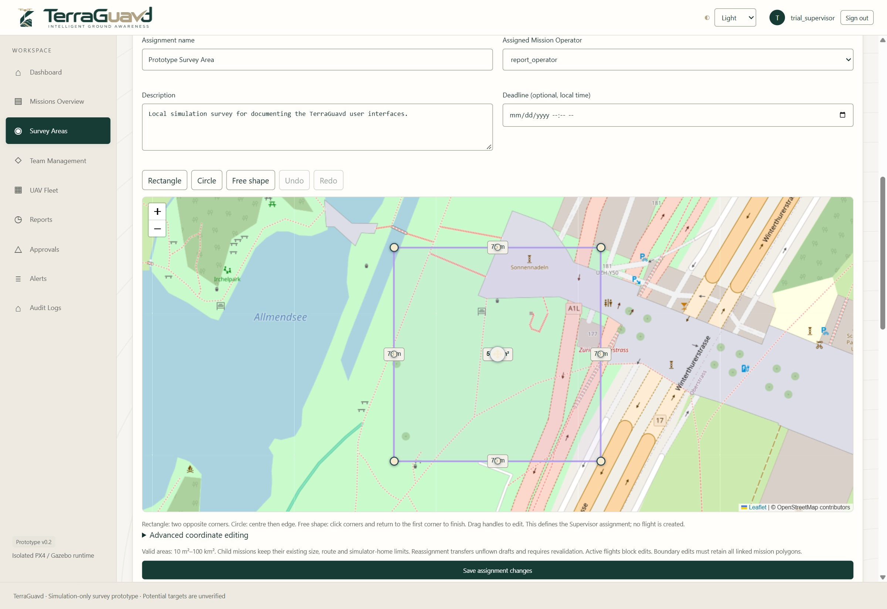
Figure 4.10: Survey Area Creation and Assignment.

4.3.2.2 Survey Progress Interface
The area details screen combines assignment information with geographic progress layers.
- Assignment Details: Displays the operator, assignment status and current revision.
- Coverage Layers: Separates completed experimental coverage, live footprints and remaining ground.
- Geographic Progress: Counts the union of eligible completed coverage rather than completed mission counts.
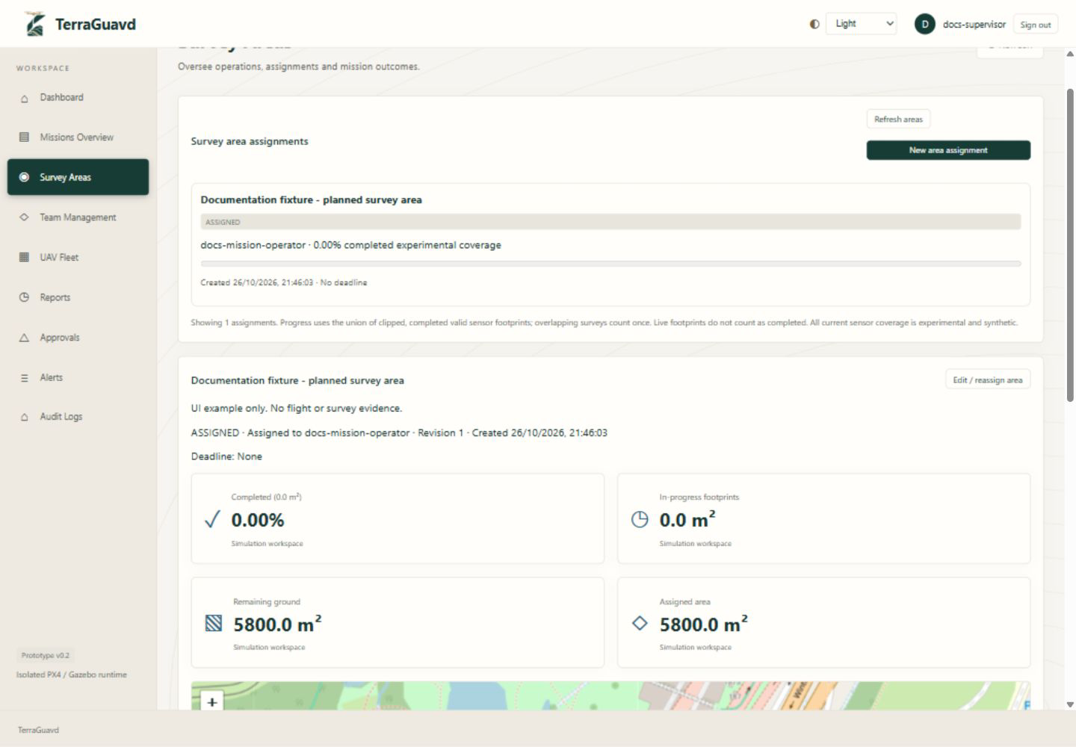
Figure 4.11: Survey Progress Interface.

4.3.2.3 Area Editing and Reassignment
The edit screen allows the Supervisor to revise an existing assignment.
- Assignment Updates: Edits the name, description, deadline and boundary.
- Operator Reassignment: Selects a different responsible operator when permitted.
- Consistency Checks: Active missions block changes, and edited boundaries must retain linked mission polygons.
Figure 4.12: Area Editing and Reassignment.

4.3.2.4 Survey and Assignment History
The history sections preserve the relationship between an assigned area, its sub-missions and its revisions.
- Sub-mission History: Lists linked missions and their recorded outcomes.
- Survey Evidence: Retains finalized attempts and their experimental coverage.
- Assignment Changes: Shows recorded assignment changes and revision history.
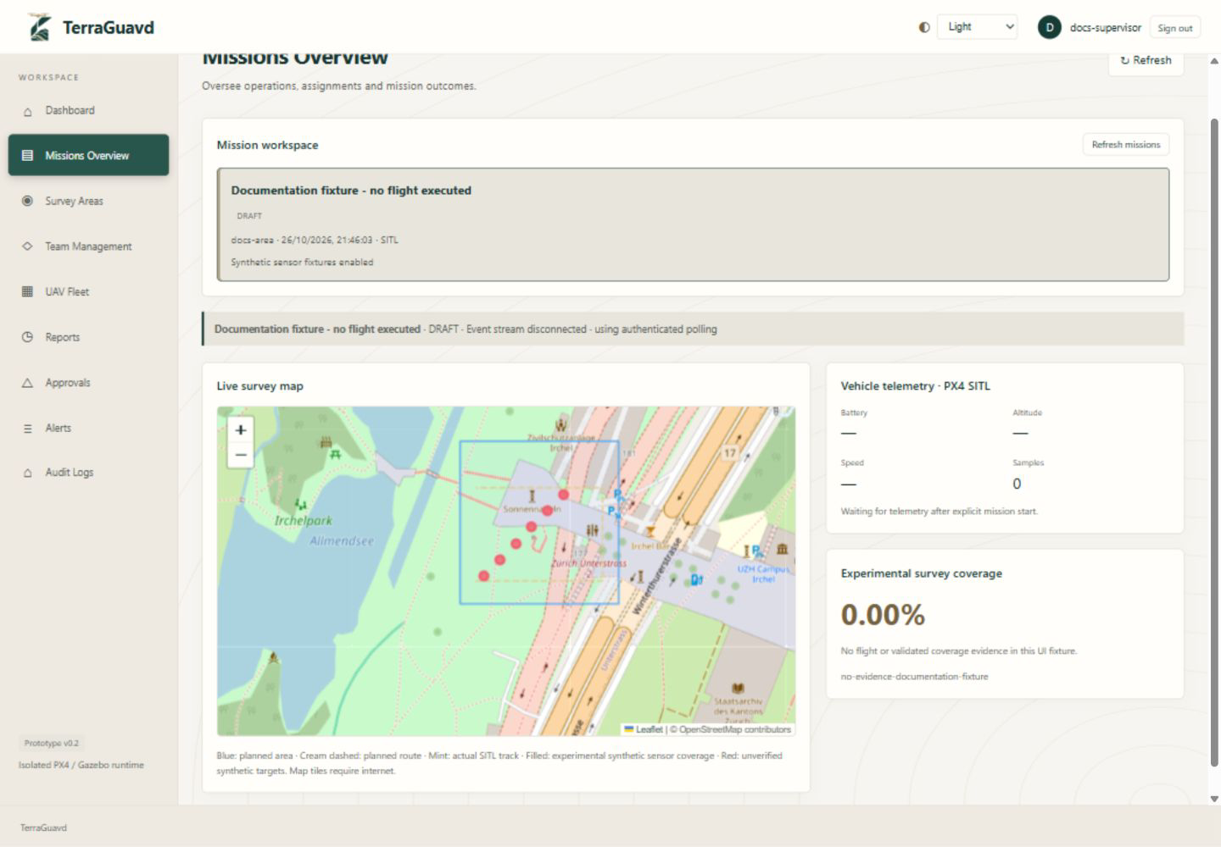
Figure 4.13: Survey and Assignment History.

4.3.3 Mission Operator Interface

4.3.3.1 Mission Control Dashboard
The operator workspace provides access to assigned survey areas and available mission records.
- Assigned Areas: Displays areas assigned by a Supervisor.
- Mission Selection: Opens a selected mission for monitoring and review.
- Sub-mission Planning: Starts planning a smaller mission inside an assigned parent area.
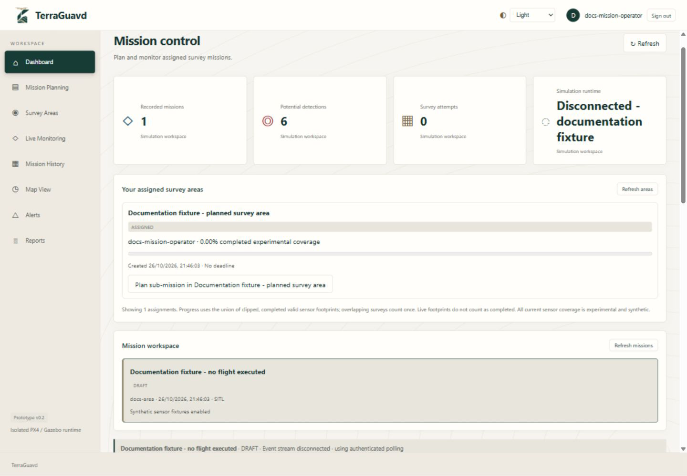
Figure 4.14: Mission Control Dashboard.

4.3.3.2 Mission Planning Interface
The Mission Operator selects a Supervisor-assigned area and a registered UAV, then defines the sector using rectangle, circle or free-shape tools.
- Interactive Editing: Drag handles resize or move the outline; Undo and Redo retain finished edits.
- Route Preview: Displays generated survey lanes and validates the connected route inside the sector and assigned area.
- Retained Sectors: Adding a sector keeps previous drafts visible with their UAV identities.
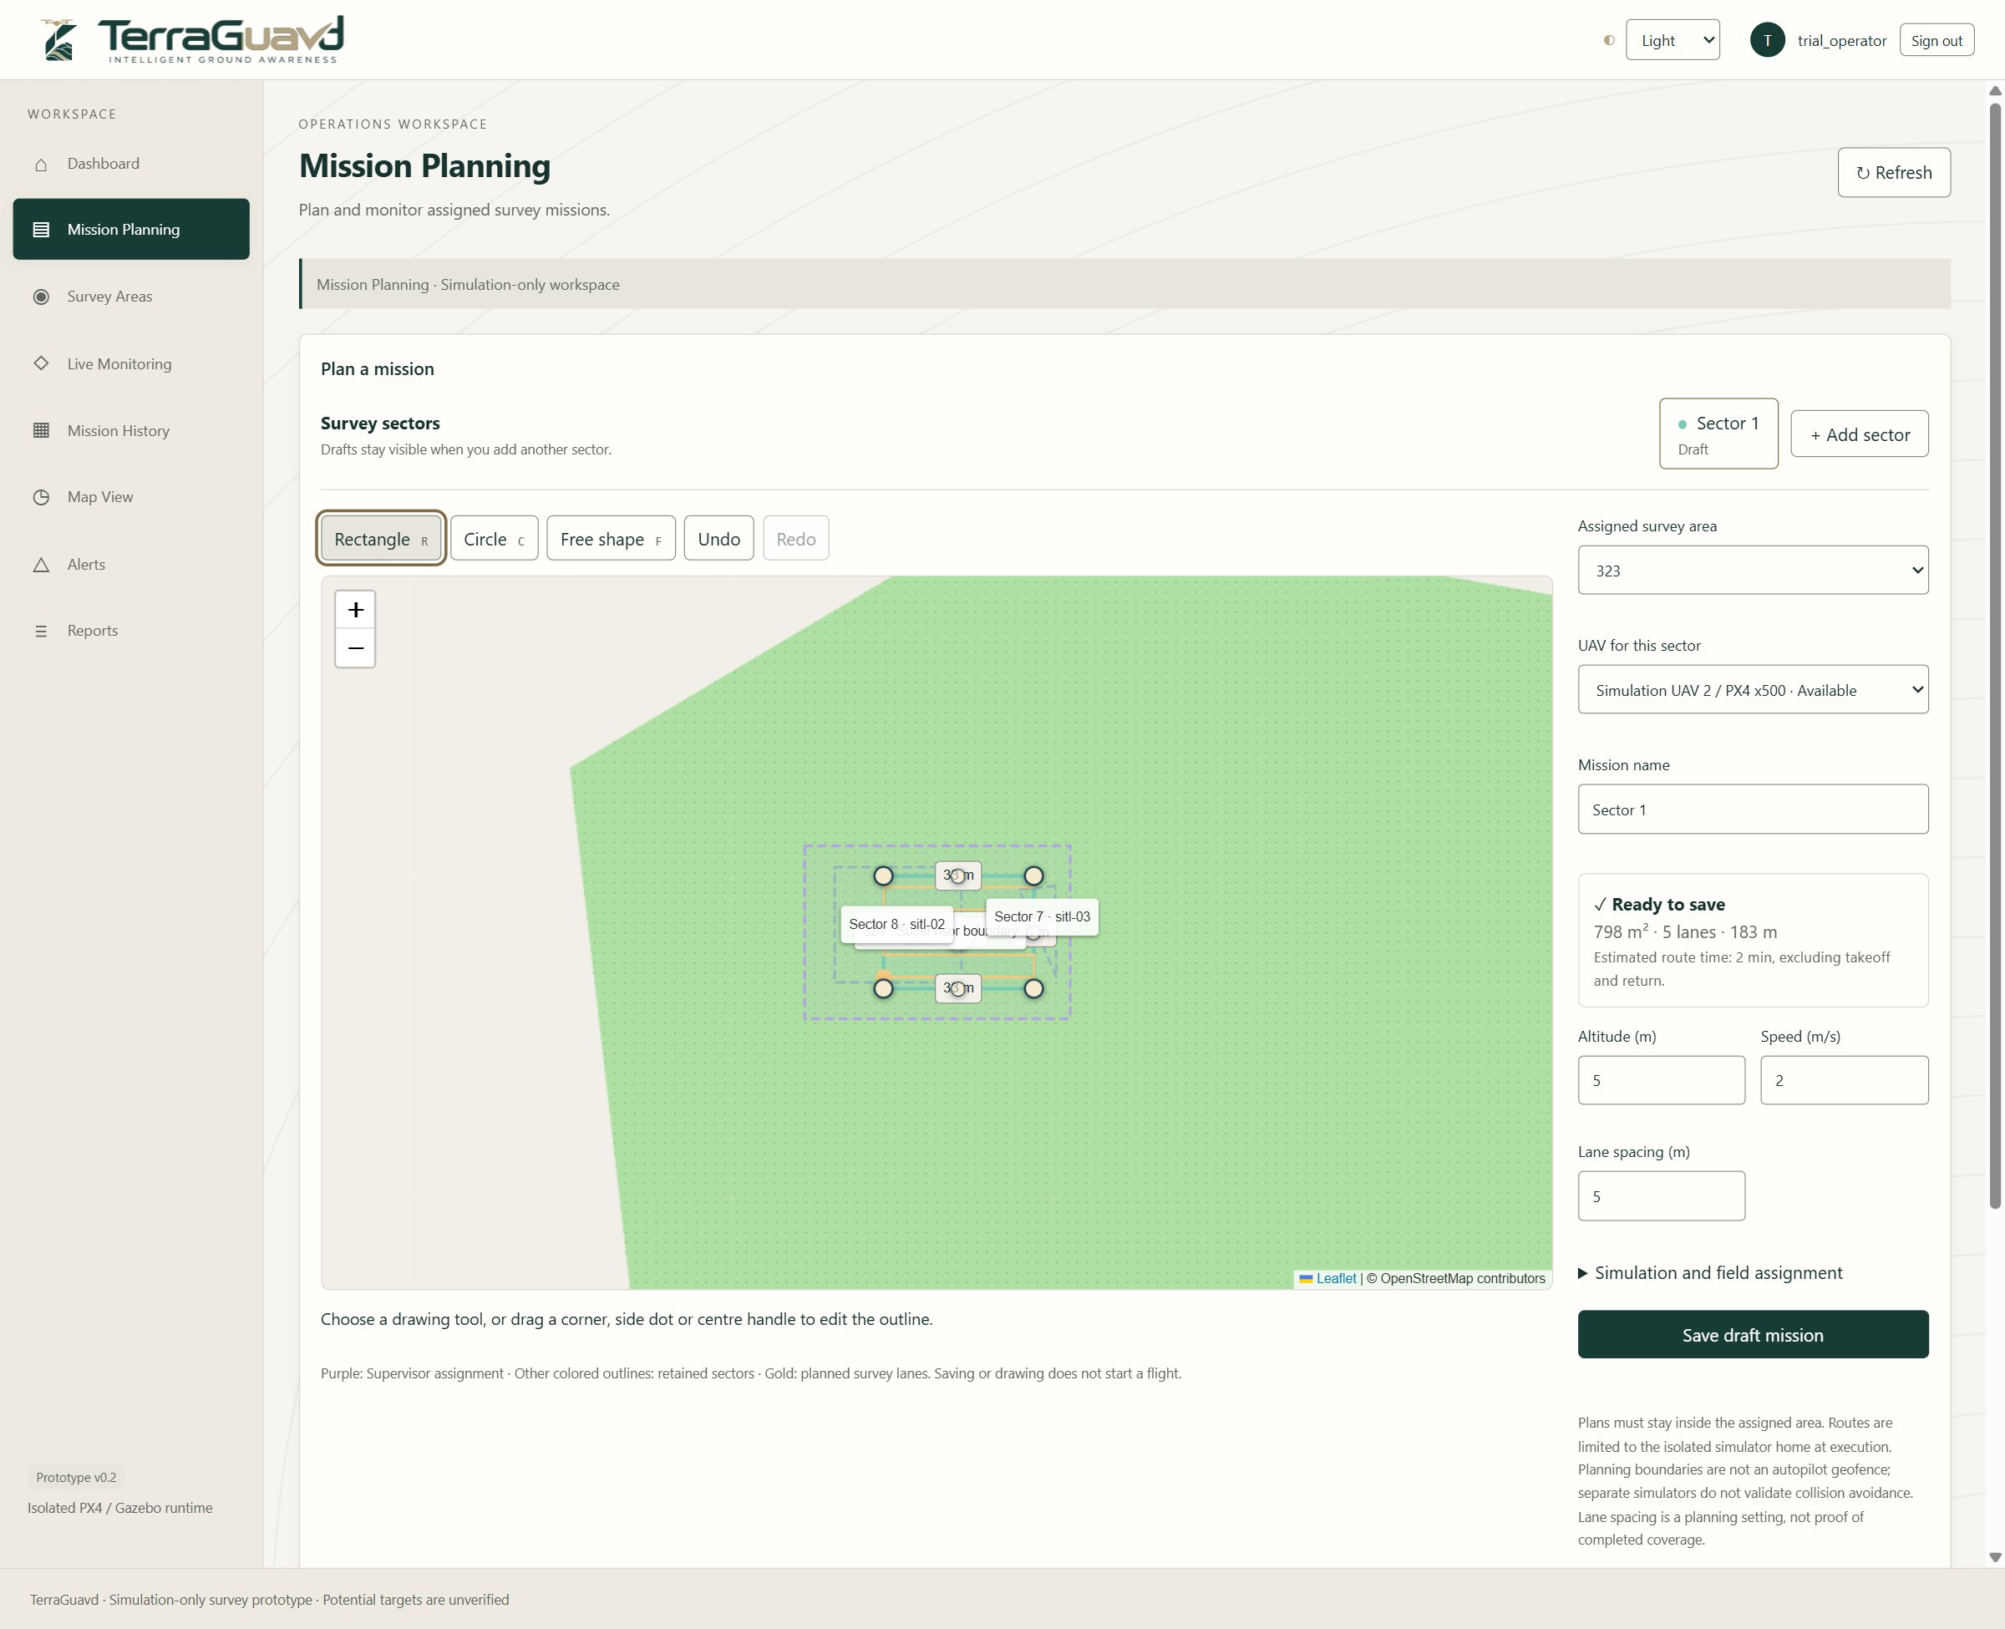
Figure 4.15: Mission Planning Interface.

4.3.3.3 Mission Configuration and Draft Saving
Each sector keeps its own UAV, mission name, altitude, speed and lane spacing. Unpersisted drafts are retained within the same browser-tab session.
- Planning Parameters: Updates the route preview without starting the simulator or reserving a UAV.
- Draft Saving: Creates a persisted mission while retaining its outline; a saved sector can be copied to a new draft for another attempt.
- Field Assignment: Selects Field Personnel and explicitly labels synthetic sensor fixtures. Validation and flight start remain separate actions.
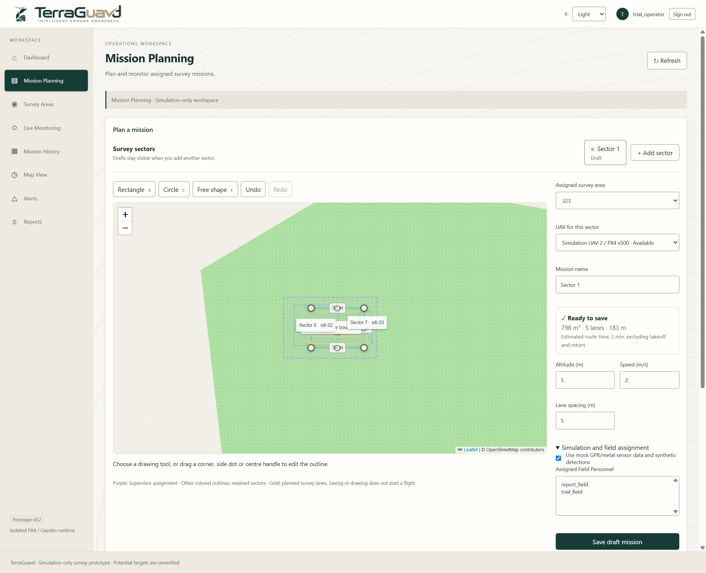
Figure 4.16: Mission Configuration and Draft Saving.

4.3.3.4 Mission Execution Controls
The command panel provides state-dependent actions for the assigned Mission Operator.
- Validate and Start: Validates the draft before accepting an explicit mission-start request.
- Pause and Resume: Changes the execution state when supported by the current mission state.
- Cancel and Return: Requests cancellation and return through the authorized simulation adapter.
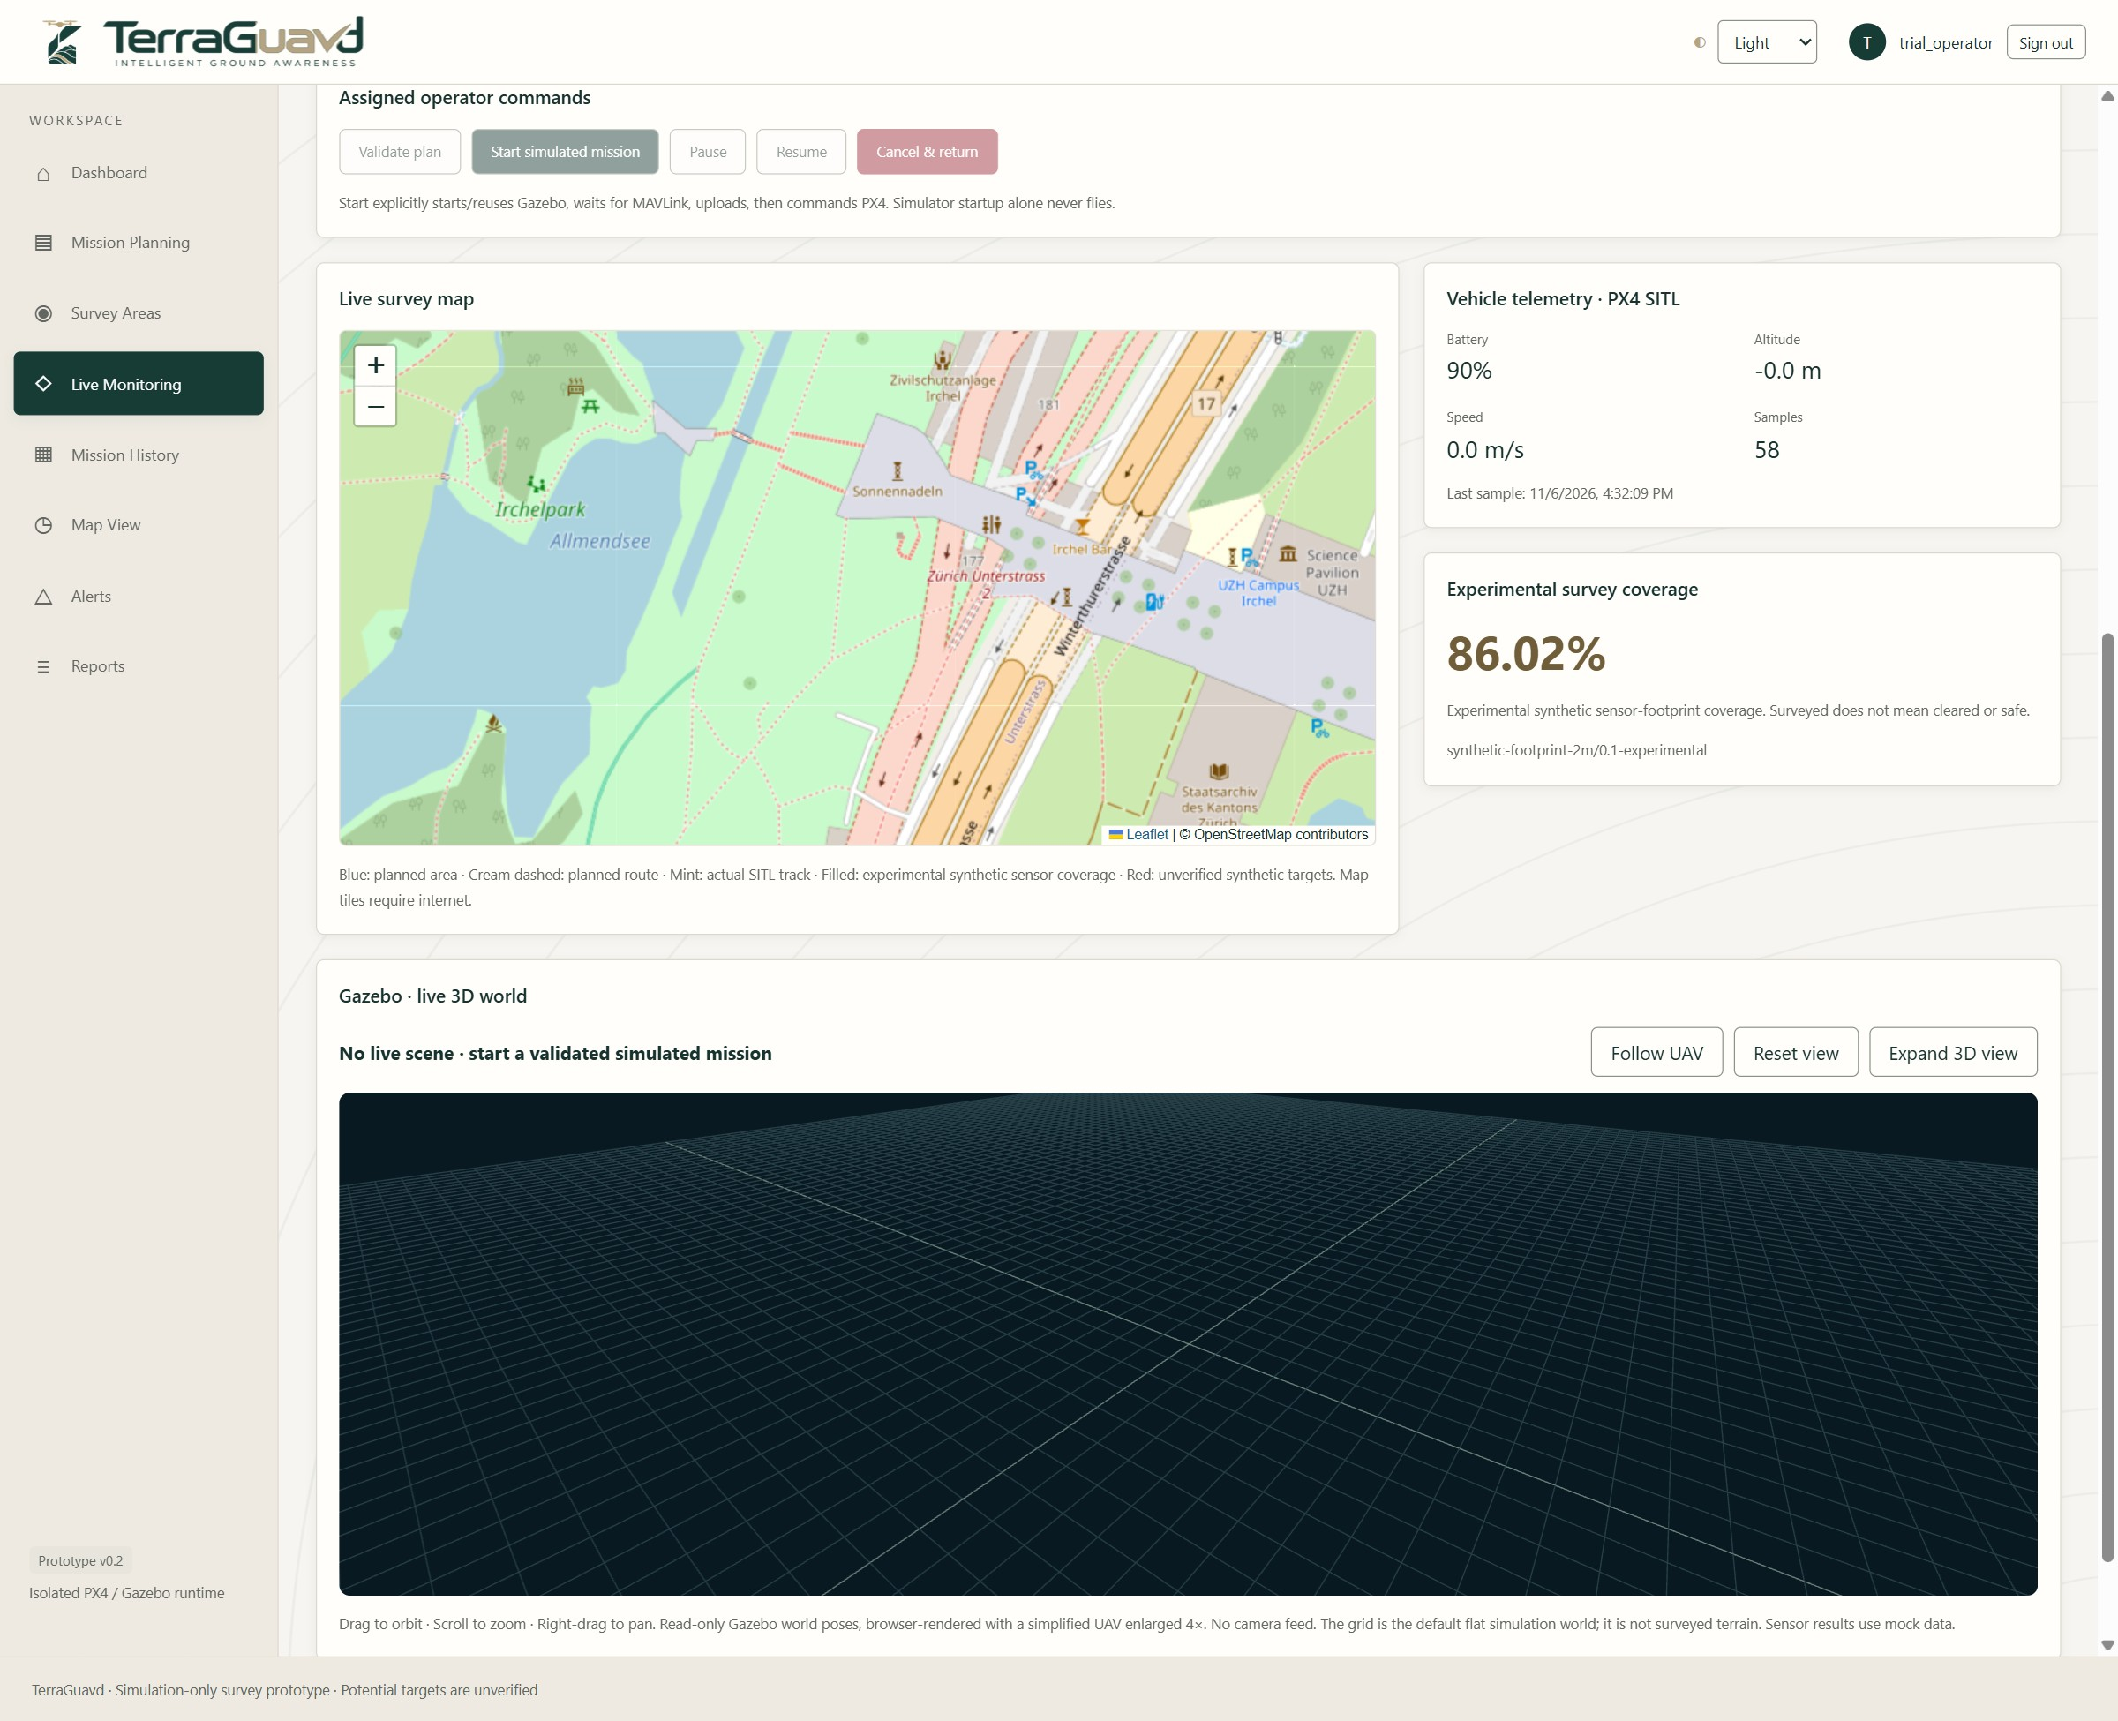
Figure 4.17: Mission Execution Controls.

4.3.3.5 Map and Telemetry Monitoring
The monitoring view combines the planned survey, recorded flight information and experimental coverage.
- Survey Map: Displays mission boundaries, the planned route, recorded track and potential targets.
- Vehicle Telemetry: Shows recorded battery, altitude, speed and sample information.
- Coverage Summary: Displays experimental sensor-footprint coverage independently of flight completion.
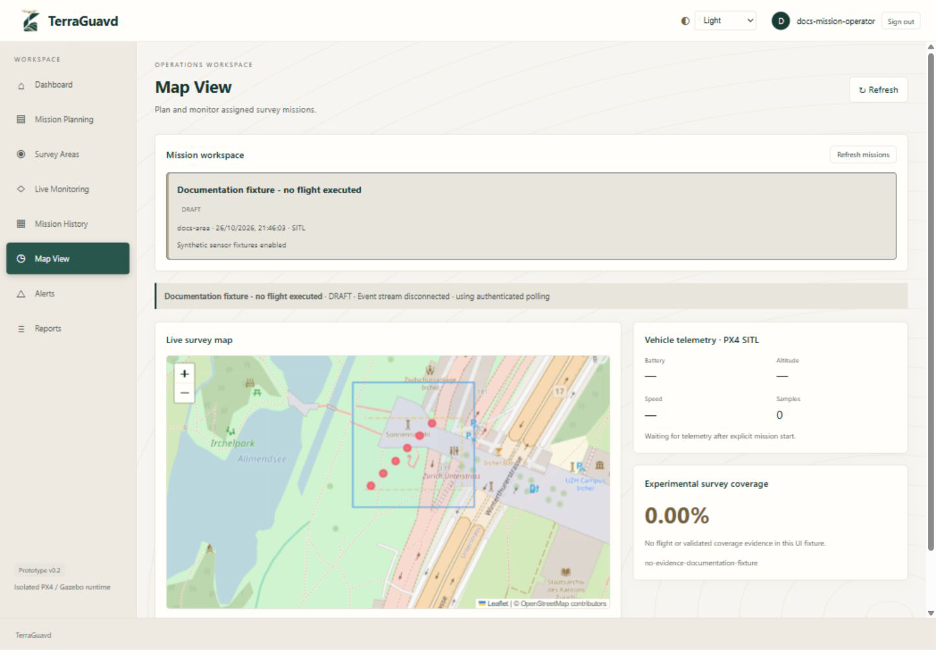
Figure 4.18: Map and Telemetry Monitoring.

4.3.3.6 Gazebo World Visualization
The Gazebo panel provides a read-only 3D viewing area and navigation controls. The supplied screenshot shows an inactive scene; it does not demonstrate a live flight.
- World View: Provides a grid-based scene area for the UAV visualization when a live pose is available.
- View Controls: Supports orbiting, zooming, following the UAV and resetting the view.
- Visualization Boundary: The panel is not a camera feed or the native Gazebo desktop interface.
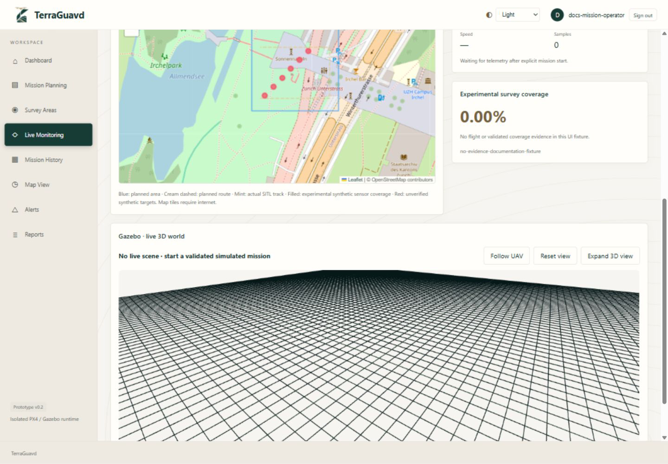
Figure 4.19: Gazebo World Visualization.

4.3.3.7 Mission Reports and Survey History
The reports view provides mission-report controls and a section for finalized survey attempts. The supplied documentation fixture has no finalized attempt.
- Survey History: Displays the recorded outcome, date and experimental coverage of an attempt.
- Data Reports: Provides authorized JSON and CSV downloads.
- Printable Report: Supports browser printing or saving as PDF while retaining provenance and interpretation notices.
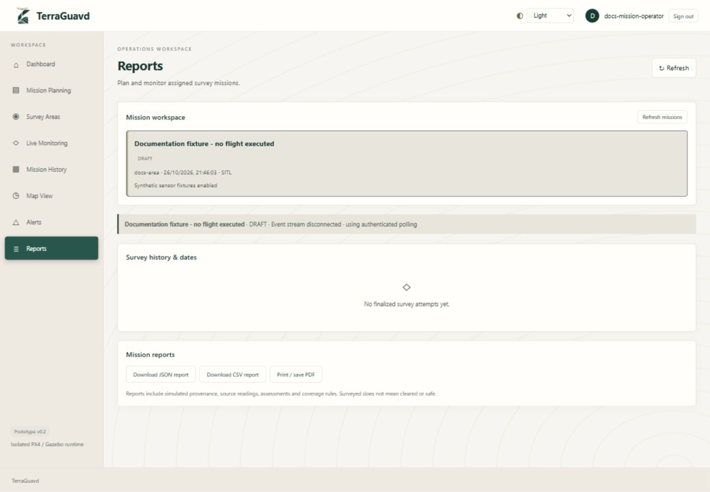
Figure 4.20: Mission Reports and Survey History.

4.3.4 Detection Analyst Interface

4.3.4.1 Potential Detection Review
The analyst selects a mission and reviews its stored potential-target records.
- Detection Cards: Display stored labels, experimental scores and geographic coordinates.
- Target Selection: Opens the details of an individual record.
- Synthetic Provenance: Clearly identifies the displayed examples as synthetic and unverified.
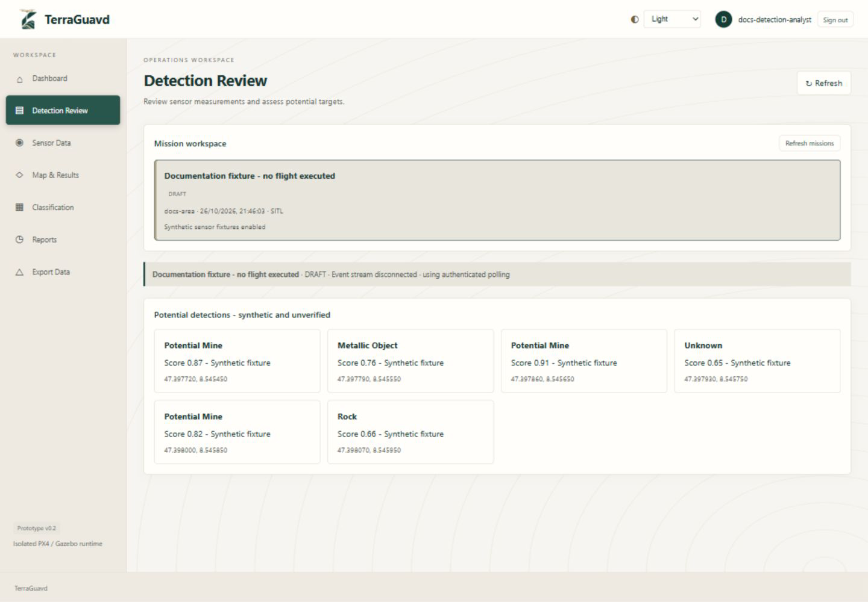
Figure 4.21: Potential Detection Review.

4.3.4.2 Target Details and Analyst Assessment
The target details screen connects a potential detection to its source observation and allows an analyst assessment.
- Record Details: Displays the detection identifier, processing version and source observation.
- Assessment Options: Provides Needs Investigation, Likely False Positive and Inconclusive outcomes.
- Analyst Notes: Records an explanatory assessment without confirming the presence of a landmine.
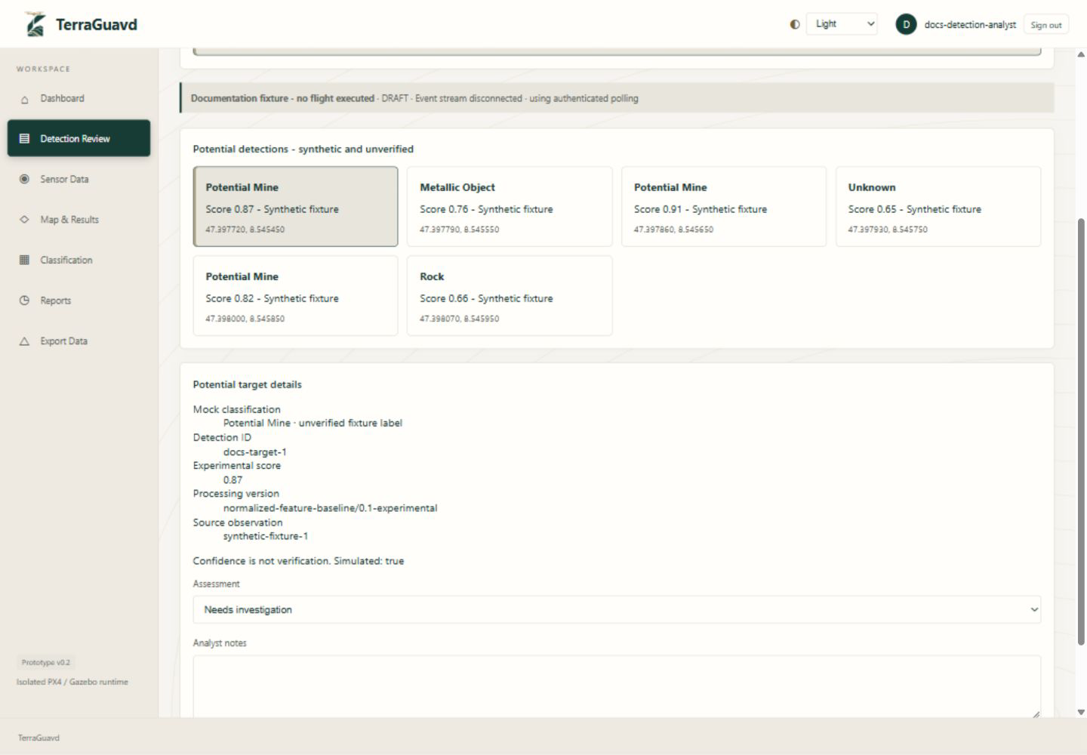
Figure 4.22: Target Details and Analyst Assessment.

4.3.4.3 Sensor Data Interface
The sensor table presents the observations associated with the selected mission.
- Observation Review: Shows recorded coordinates, altitude, speed and feature values.
- Feature Interpretation: Displays synthetic normalized GPR and metal responses used by the prototype.
- Traceability: Retains the relationship between observations and the mission being reviewed.
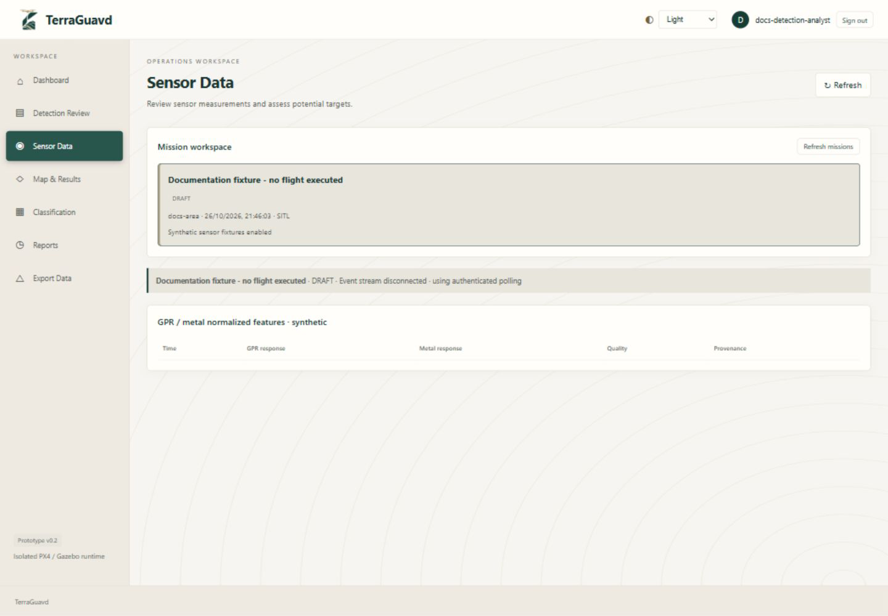
Figure 4.23: Sensor Data Interface.

4.3.4.4 Geographic Results Interface
The map view allows the analyst to inspect potential-target locations alongside the mission track and coverage.
- Spatial Context: Places potential detections within the recorded mission geography.
- Separate Layers: Distinguishes the planned boundary, flight track and experimental coverage.
- Recorded Telemetry: Provides supporting vehicle information for reviewing the selected mission.
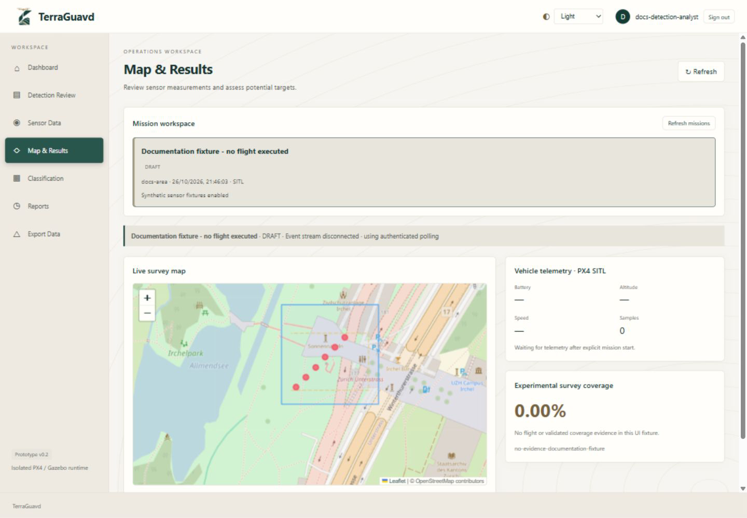
Figure 4.24: Geographic Results Interface.

4.3.5 Field Personnel Interface

4.3.5.1 Assigned Missions and Field Monitoring
The responsive Field Personnel workspace provides assigned-mission access, geographic context and account information.
- Mission Access: Shows the missions assigned to the authenticated field account.
- Field Map: Displays the recorded UAV position, route, coverage and potential targets.
- Account and Navigation: Shows the account permissions and navigation available to Field Personnel.
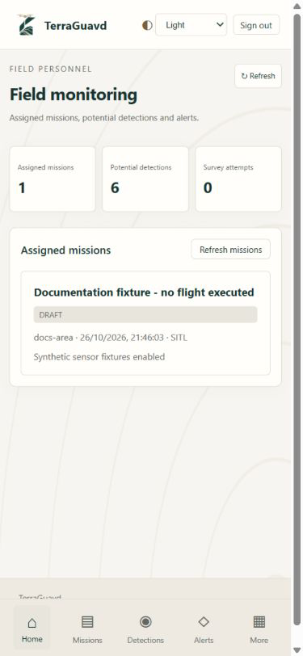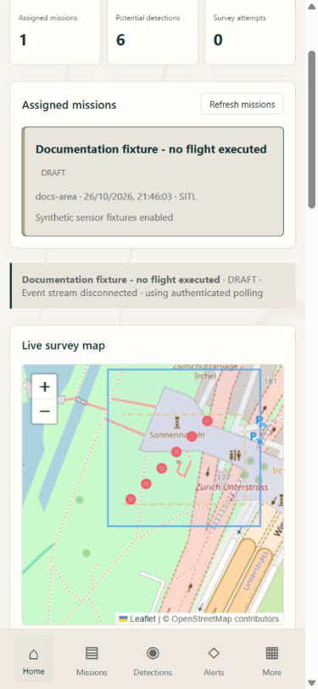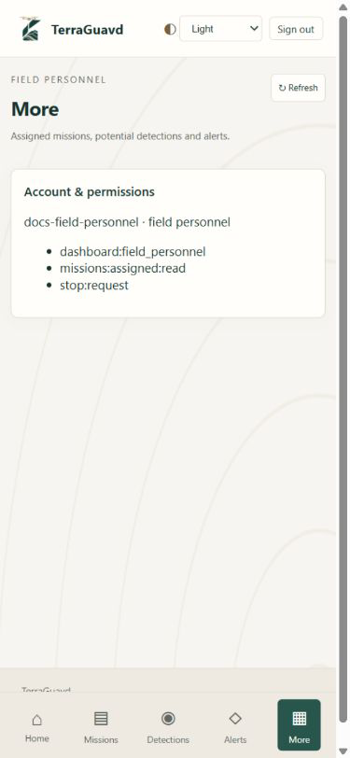
Figure 4.25: Assigned Missions and Field Monitoring.

4.3.5.2 Potential Detections and Mission History
Field Personnel can inspect potential detections and access the assigned-mission history section. The supplied fixture has no finalized survey attempt.
- Potential Targets: Displays synthetic target cards and their recorded scores.
- Read-only Monitoring: Provides field access without granting direct flight-control permissions.
- Survey History: Displays finalized attempt dates, status and experimental coverage.
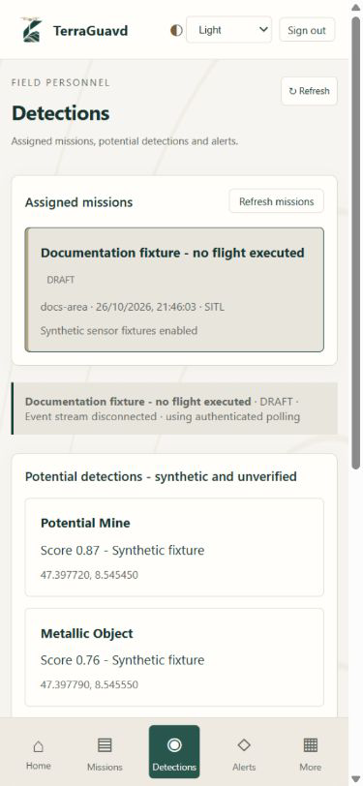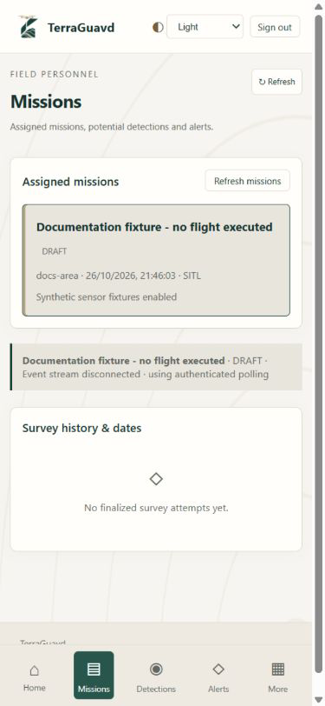
Figure 4.26: Potential Detections and Mission History.

4.3.5.3 Alerts and Stop Requests
The alerts view provides a mission-event area and a stop-request form. The supplied draft fixture shows the request control disabled.
- Mission Alerts: Displays recorded detection, execution and stop-request events.
- Stop Request: Accepts a reason and records an operator notification during an active assigned mission.
- State-dependent Access: A request requires an active assigned mission. The disabled control shown here does not directly command PX4.
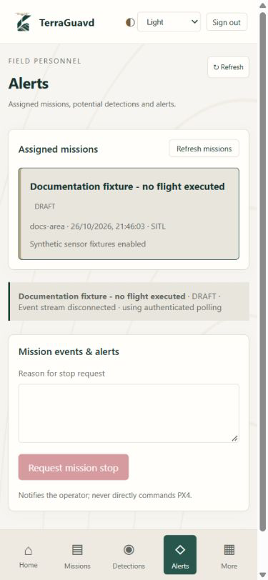
Figure 4.27: Alerts and Stop Requests.

4.4 Database Design
TerraGuavd uses PostgreSQL with the PostGIS extension to store application and geospatial data. PostgreSQL was selected for its support for relational tables, primary and foreign keys, integrity constraints, and schema evolution through versioned migrations. Relational constraints support consistent links between records, while PostGIS provides spatial indexing and operations for survey boundaries, positions, footprints, and coverage. The database stores user accounts, authentication sessions, survey assignments, missions, observations, potential detections, analyst reviews, and operational history.
Entity Relationship Diagram
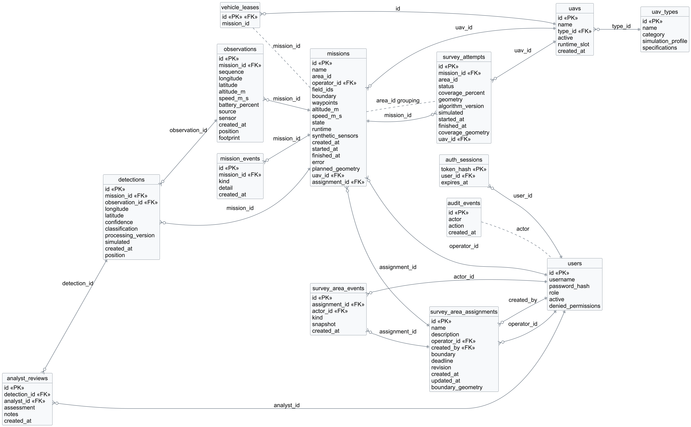
Figure 4.28. TerraGuavd Database Entity Relationship Diagram.
The ERD links UAV types to registered vehicles, and vehicles to missions, survey attempts and leases. Solid links denote declared foreign keys; dashed links denote application-managed associations. Each mission retains at most one survey_attempts record.

Entity Attributes
The following tables describe the 14 application entities. Types follow the PostgreSQL schema defined by the database migrations. PK denotes a primary key; FK denotes a declared foreign key. Nullable fields are identified in their descriptions.
The Class Diagram presents the domain object model, while the ERD represents persisted tables. UAVType and UAV now have database representations in uav_types and uavs; reports remain generated outputs rather than a separate report table.
Table 8. users Attributes.
Attribute | Type | Description
id | VARCHAR(36) | PK; unique user identifier.
username | VARCHAR(80) | Unique account login name.
password_hash | TEXT | Argon2 password hash; no plaintext password is stored.
role | VARCHAR(40) | Single account role; constrained to the five supported role names.
active | BOOLEAN | Whether the account is enabled.
denied_permissions | JSON | JSON list of permissions removed from the account role; defaults to [].
Relationships: One users record can have many auth_sessions, missions, survey_area_assignments, analyst_reviews, and survey_area_events records through their declared foreign keys.
Table 9. auth_sessions Attributes.
Attribute | Type | Description
token_hash | VARCHAR(64) | PK; SHA-256 hash of the opaque session token.
user_id | VARCHAR(36) | FK → users.id; account owning the session.
expires_at | TIMESTAMP WITH TIME ZONE | Absolute session expiry timestamp in UTC.
Relationships: Each auth_sessions record belongs to one users record; one user may have multiple sessions.
Table 10. survey_area_assignments Attributes.
Attribute | Type | Description
id | VARCHAR(36) | PK; unique survey assignment identifier.
name | VARCHAR(100) | Survey area name.
description | TEXT | Description of the assigned survey area.
operator_id | VARCHAR(36) | FK → users.id; assigned Mission Operator.
created_by | VARCHAR(36) | FK → users.id; supervisor who created the assignment.
boundary | JSON | Assigned survey boundary as GeoJSON.
deadline | TIMESTAMP WITH TIME ZONE | Optional deadline in UTC.
revision | INTEGER | Revision used to reject stale updates; database default is 1.
created_at | TIMESTAMP WITH TIME ZONE | Record creation timestamp in UTC.
updated_at | TIMESTAMP WITH TIME ZONE | Most recent assignment update timestamp in UTC.
boundary_geometry | geometry(Polygon,4326) | Stored generated Polygon derived from boundary; SRID 4326, spatially indexed, and checked for validity and non-emptiness. Nullable.
Relationships: Each assignment references one operator and one creator in users; it may contain many missions and survey_area_events records.
Table 11. survey_area_events Attributes.
Attribute | Type | Description
id | VARCHAR(36) | PK; unique assignment-history event identifier.
assignment_id | VARCHAR(36) | FK → survey_area_assignments.id; assignment whose history is recorded.
actor_id | VARCHAR(36) | FK → users.id; user who performed the change.
kind | VARCHAR(40) | Type of assignment change.
snapshot | JSON | JSON snapshot retained for the assignment change.
created_at | TIMESTAMP WITH TIME ZONE | Record creation timestamp in UTC.
Relationships: Each event references one survey_area_assignments record and one acting users record; history is append-only.
Table 12. missions Attributes.
Attribute | Type | Description
id | VARCHAR(36) | PK; unique mission identifier.
name | VARCHAR(100) | Mission name.
area_id | VARCHAR(80) | Survey-history grouping label; not a foreign key to survey_area_assignments.
operator_id | VARCHAR(36) | FK → users.id; assigned Mission Operator.
field_ids | JSON | JSON list of assigned Field Personnel user IDs; validated by the application, with no FK constraint.
boundary | JSON | Planned mission boundary as GeoJSON.
waypoints | JSON | Ordered waypoint coordinates stored as JSON.
altitude_m | FLOAT | Planned flight altitude in metres.
speed_m_s | FLOAT | Planned flight speed in metres per second.
state | VARCHAR(32) | Persisted mission lifecycle state.
runtime | VARCHAR(32) | Simulation runtime identifier.
synthetic_sensors | BOOLEAN | Whether synthetic sensor fixtures were explicitly enabled for the mission.
created_at | TIMESTAMP WITH TIME ZONE | Record creation timestamp in UTC.
started_at | TIMESTAMP WITH TIME ZONE | Start timestamp in UTC. Nullable.
finished_at | TIMESTAMP WITH TIME ZONE | Finish timestamp in UTC. Nullable.
error | TEXT | Optional stored mission error message.
planned_geometry | geometry(Polygon,4326) | PostGIS Polygon for the planned boundary; SRID 4326 and spatially indexed. Nullable.
uav_id | VARCHAR(40) | FK → uavs.id; registered UAV selected for this mission or preserved survey attempt.
assignment_id | VARCHAR(36) | FK → survey_area_assignments.id; parent survey assignment; nullable for legacy missions, required by the API for new missions.
Relationships: Each mission references one operator and zero or one survey assignment; it may have many mission_events, observations, and detections, and zero or one survey_attempts record.
Table 13. mission_events Attributes.
Attribute | Type | Description
id | VARCHAR(36) | PK; unique mission event identifier.
mission_id | VARCHAR(36) | FK → missions.id; related mission.
kind | VARCHAR(40) | Event type.
detail | TEXT | Text describing the mission event.
created_at | TIMESTAMP WITH TIME ZONE | Record creation timestamp in UTC.
Relationships: Each event belongs to one missions record; a mission may have multiple events.
Table 14. observations Attributes.
Attribute | Type | Description
id | VARCHAR(36) | PK; unique observation identifier.
mission_id | VARCHAR(36) | FK → missions.id; related mission.
sequence | INTEGER | Observation sequence; unique together with mission_id.
longitude | FLOAT | Longitude in decimal degrees.
latitude | FLOAT | Latitude in decimal degrees.
altitude_m | FLOAT | Relative altitude in metres.
speed_m_s | FLOAT | Speed in metres per second.
battery_percent | FLOAT | Optional reported battery percentage.
source | VARCHAR(40) | Observation source identifier.
sensor | JSON | Optional JSON sensor features, including synthetic provenance when fixtures are enabled.
created_at | TIMESTAMP WITH TIME ZONE | Observation receipt timestamp in UTC.
position | geometry(Point,4326) | PostGIS Point populated from the observation coordinates; SRID 4326. Nullable.
footprint | geometry(Geometry,4326) | Optional valid sensor footprint; SRID 4326 and spatially indexed.
Relationships: Each observation belongs to one missions record and may be referenced by multiple detections records.
Table 15. detections Attributes.
Attribute | Type | Description
id | VARCHAR(36) | PK; unique potential detection identifier.
mission_id | VARCHAR(36) | FK → missions.id; related mission.
observation_id | VARCHAR(36) | FK → observations.id; source observation used to produce the record.
longitude | FLOAT | Longitude in decimal degrees.
latitude | FLOAT | Latitude in decimal degrees.
confidence | FLOAT | Stored experimental feature score; not a calibrated probability or confirmation of a mine.
classification | VARCHAR(40) | Stored potential-target classification label.
processing_version | VARCHAR(80) | Version identifier of the processing algorithm or fixture output.
simulated | BOOLEAN | Records simulated provenance; does not indicate verified physical evidence.
created_at | TIMESTAMP WITH TIME ZONE | Record creation timestamp in UTC.
position | geometry(Point,4326) | Stored generated Point derived from longitude and latitude; SRID 4326 and spatially indexed. Nullable.
Relationships: Each detection references one missions record and one observations record; it may have multiple analyst_reviews records.
Table 16. analyst_reviews Attributes.
Attribute | Type | Description
id | VARCHAR(36) | PK; unique analyst review identifier.
detection_id | VARCHAR(36) | FK → detections.id; potential detection being reviewed.
analyst_id | VARCHAR(36) | FK → users.id; detection Analyst who recorded the review.
assessment | VARCHAR(40) | Analyst assessment label.
notes | TEXT | Analyst review notes.
created_at | TIMESTAMP WITH TIME ZONE | Record creation timestamp in UTC.
Relationships: Each review references one detections record and one users record; reviews are append-only.
Table 17. survey_attempts Attributes.
Attribute | Type | Description
id | VARCHAR(36) | PK; unique preserved survey snapshot identifier.
mission_id | VARCHAR(36) | FK → missions.id; related mission; unique, allowing at most one final snapshot per mission.
area_id | VARCHAR(80) | Survey-history grouping label; no FK constraint.
status | VARCHAR(32) | Mission outcome recorded when the final snapshot is stored.
coverage_percent | FLOAT | Experimental valid sensor-footprint coverage percentage.
geometry | JSON | Final coverage snapshot as GeoJSON.
algorithm_version | VARCHAR(80) | Version of the coverage algorithm used for the snapshot.
simulated | BOOLEAN | Records simulated provenance; does not indicate verified physical evidence.
started_at | TIMESTAMP WITH TIME ZONE | Start timestamp in UTC.
finished_at | TIMESTAMP WITH TIME ZONE | Finish timestamp in UTC.
coverage_geometry | geometry(Geometry,4326) | PostGIS coverage geometry populated from geometry by a BEFORE INSERT trigger; SRID 4326 and spatially indexed. Nullable.
uav_id | VARCHAR(40) | FK → uavs.id; registered UAV selected for this mission or preserved survey attempt.
Relationships: Each snapshot references exactly one missions record; UNIQUE(mission_id) limits a mission to zero or one snapshot. Snapshots are append-only.
Table 18. vehicle_leases Attributes.
Attribute | Type | Description
id | VARCHAR(40) | PK; FK → uavs.id; registered vehicle whose reservation is tracked.
mission_id | VARCHAR(36) | Optional mission currently holding the vehicle lease; no FK or UNIQUE constraint.
Relationships: mission_id is an application-managed link to missions; the schema declares no foreign-key relationship.
Table 19. audit_events Attributes.
Attribute | Type | Description
id | VARCHAR(36) | PK; unique audit event identifier.
actor | VARCHAR(36) | Optional actor identifier; stored without a FK constraint.
action | VARCHAR(80) | Security or administrative action recorded by the backend.
created_at | TIMESTAMP WITH TIME ZONE | Record creation timestamp in UTC.
Relationships: actor is an application-recorded user identifier without a foreign-key relationship; audit records are append-only.
Table 20. uav_types Attributes.
Attribute | Type | Description
id | VARCHAR(36) | PK; unique UAV type identifier.
name | VARCHAR(80) | Unique registered type name.
category | VARCHAR(40) | Vehicle category; category alone does not establish execution support.
simulation_profile | VARCHAR(40) | Allowlisted simulation profile or catalog-only.
specifications | JSON | Structured registered type metadata.
Relationships: One uav_types record may describe multiple uavs.
Table 21. uavs Attributes.
Attribute | Type | Description
id | VARCHAR(40) | PK; unique registered UAV identifier.
name | VARCHAR(100) | Display name of the individual UAV.
type_id | VARCHAR(36) | FK → uav_types.id; registered vehicle type.
active | BOOLEAN | Whether this vehicle is enabled in the registry.
runtime_slot | VARCHAR(16) | Nullable; unique isolated runtime binding: sitl-01, sitl-02 or sitl-03.
created_at | TIMESTAMP WITH TIME ZONE | UTC registration timestamp; not manufacture date.
Relationships: Each UAV belongs to one type and may be referenced by missions and survey attempts; vehicle_leases.id also references uavs.id.
Data Management Approach
- Storage and schema evolution: PostgreSQL data is retained in the postgres_data Docker volume, and versioned Alembic migrations define the schema. JSON stores structured payloads alongside PostGIS geometry columns in SRID 4326, with GiST indexes supporting spatial queries.
- Integrity and consistency: Primary keys, declared foreign keys, NOT NULL constraints, uniqueness and geometry checks protect stored data. Transactions, consistent row locks, assignment revisions, unique runtime bindings and per-UAV leases coordinate updates and prevent conflicting reservations.
- Access control: FastAPI checks authenticated, active users, applies role permissions minus denied_permissions, and enforces assignment checks for mission access and commands. Permissions are enforced by the application rather than PostgreSQL row-level security.
- Credential protection: Passwords are hashed with Argon2, and only SHA-256 hashes of opaque session tokens are stored. Sessions expire after 30 minutes and are deleted on logout or account-access changes; database credentials are supplied through environment configuration.
- History and provenance: Database triggers reject updates and deletions to audit_events, analyst_reviews, survey_attempts, and survey_area_events. UTC timestamps, algorithm versions, source fields, and simulated provenance preserve traceability while planned boundaries, positions, footprints, and final coverage snapshots remain distinct; simulated results do not verify mines or ground clearance.
- Backup and recovery: No automated database backup process is currently implemented. Data persistence relies on the postgres_data Docker volume.

4.5 Testing and Evaluation Plan
[Describe the testing strategy, test levels, evaluation criteria, datasets/test cases, metrics, and expected validation activities.]
Test ID | Requirement /  Feature | Test Case | Expected  Result | Status
Table 22. Planned Testing and Evaluation.

Chapter 5
Conclusion

Chapter 5: Conclusion
[Summarize the project, the problem addressed, the proposed solution, the major outcomes, and the extent to which the objectives were achieved.]

Main Contributions
[Summarize the key technical, academic, or practical contributions of the project.]

Limitations and Future Work
[Discuss important limitations, assumptions, scope boundaries, or unresolved issues.][Describe realistic extensions, improvements, or future research directions.]

References
- ETH Zurich Autonomous Systems Lab, “mav_findmine: A UAV for Landmine Detection,” 2021.
- Xensor GmbH, “Drone-Based Mine Detection,” 2026.
- Skyfront, “Landmine, IED and Unexploded Ordnance Detection with Drones,” 2026.
- Safe Pro Group, “AI Software: Drone Imagery Analysis and Mapping for Explosive Threat Detection,” 2026.
- UMag Solutions ApS, “Defense Solutions: Drone Magnetic Solutions for Subsurface Threat Detection,” 2026.
- Mine Kafon, “Vento – Mine Kafon Drone,” 2026.
- cosine Remote Sensing and Phi-lab, “From Space to Safety on Earth: cosine and Phi-lab Advance Drone-Based Landmine Detection Using Hyperspectral Imaging,” 2026.
- MarkHmnv, “MineGuard: Software and Neural Network Model for Drone-Based Remote Landmine Detection,” 2026.

Appendices (Optional)
Include supplementary materials that support the project but are too detailed to be included in the main chapters. Examples include additional screenshots, questionnaires, additional diagrams, test cases, or supporting documents.
Appendix A: [Title]
[Insert appendix content here.]
Appendix B: [Title]
[Insert appendix content here.]

