Name | [YOUR NAME]
Student ID | [STUDENT ID]
Studio Session | [STUDIO SESSION]

Part A: URL of the Visualisation

Paste your visualisation URL in the empty space below.
Tip: Test your URL in incognito mode to ensure it is a working URL
https://mtra0098.github.io/FIT2179-repo/

Part B: Domain Description

Describe your domain chosen for DV II
This visualisation examines the patterns of bushfires in Australia from 1950 to 2024. Bushfire is an integral part of the Australian landscape; the eucalypts have evolved to depend upon it and the Indigenous Australians have lived with fire on this continent for sixty thousand years. The modern Bureau of Meteorology and Geoscience Australia record of 70 years of fire seasons reveals a greater intensity of fire. The land burned by the continent was double that burned over the last half century, up to 2000. The domain is the nexus of climate, geography and disaster, and it's a tale of how the seasons which the nation has planned for are changing in silent ways beneath all our feet.

Describe the Why and Who aspects of your DV II
How: plant fires burn and spread, killing people, destroying houses and altering ecosystems for many years. The news cycle focuses on each catastrophic season as it occurs, but the trend of increased size, frequency and concentration of fires in a few dry years is more difficult to discern. A national long-term perspective on fire is required to help readers to understand the context of any one season. In fact, the Black Summer of 2019 to 2020 seems more like a normal occurrence as the climate evidence is now being printed. What: the average Australian adult, particularly those who have experienced evacuation protocols, witnessed the sky turn orange from smoke or watched footage from a distance. The visualisation does not require any knowledge of statistics, but simply that the reader is interested in the place where they live and the changes taking place in it.

Describe the “What” aspect of your DV II
The visualisation is based on two main datasets. The first is the ArcGIS REST Feature Service (AGRFs) Historical Bushfire Boundaries dataset (version 2) published by Geoscience Australia (GA). It includes all known fire perimeters from 1950 to 2024 and has a variety of attributes such as cause of ignition (where known), season, burnt area (in hectares), and state. The second is monthly rainfall and temperature anomaly data from the Bureau of Meteorology Climate Data Online service, to match fire intensity with seasonal climate anomalies and to compare years with the 1961-1990 period. Both are publicly available, government-sponsored sources. Black Summer impact figures (lives lost, homes destroyed, area burnt) from the Royal Commission into National Natural Disaster Arrangements (2020) and Borchers Arriagada et al. in Medical Journal of Australia (2020). We used pandas to process the raw data in a Python pipeline. The steps involved in the processing of this data were: convert hectares to square kilometres, aggregate by year, state, decade and month; bucket the ignition causes into three groups, the smallest, the largest and unknown; calculate rainfall anomalies for winter and spring. The result is fourteen clean CSV files that do not exceed 100K in size, and thus do not fail the size constraint of the data.

Describe the “How” aspect of your DV II
Vega-Lite visualisations are presented as a scrollable data essay of 11 visualisations. The story then progresses from where (choropleth map of cumulative burnt area by state) to when (time series of annual burnt area 1950-2024), to why (radial chart of monthly distribution and donut chart and stacked area chart of ignition causes and scatter graph of summer temperature vs fire counts). A small multiples panel allows the national trend to be broken out by state, using independent y-scales, so that smaller states are not 'swamped' by Western Australia. The most custom-built element is a bivariate choropleth which encodes fire frequency as well as summer temperature anomaly in a 3x3 colour matrix, uncovering compound risk in one map. A ranked bar chart lists the top 10 largest fires by individuals. A calendar heatmap then zooms in on Black Summer day-by-day, with cards of annotation showing the Mallacoota evacuation on New Year's Eve 2019, the worst day on 4 January 2020, and the rainfall that finally broke the season on 10 February. Finally, a connected scatter plot ties together the theme of the essay by making a correlation between annual rainfall and burnt area; all of the catastrophic years have been grouped on the "dry" side of the scatter plot. The bivariate legend is constructed as a custom HTML element for more control over the layout than the Vega-Lite legend supports. Interactive tooltips are used on all charts, and a KPI strip pops up with four headline numbers: total area burnt; fires recorded; homes destroyed; lives lost, these are taken from the data.

Part C: Sketch
A URL to a PDF document with an image of your sketch on your GitHub account.
Tip: Test your URL in incognito mode to ensure it is a working URL
https://github.com/mtra0098/FIT2179-repo/blob/master/sketchs/sketches.pdf

Paste a screenshot of your sketch for your DV II.
Note: Use the entire page here for the screenshot and ensure that it is clearly legible and visible
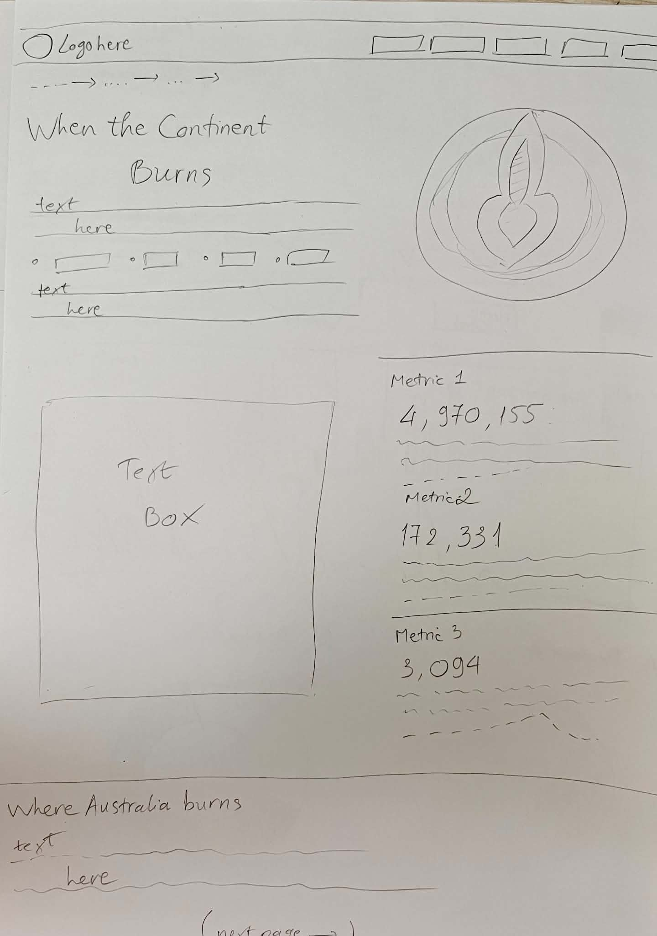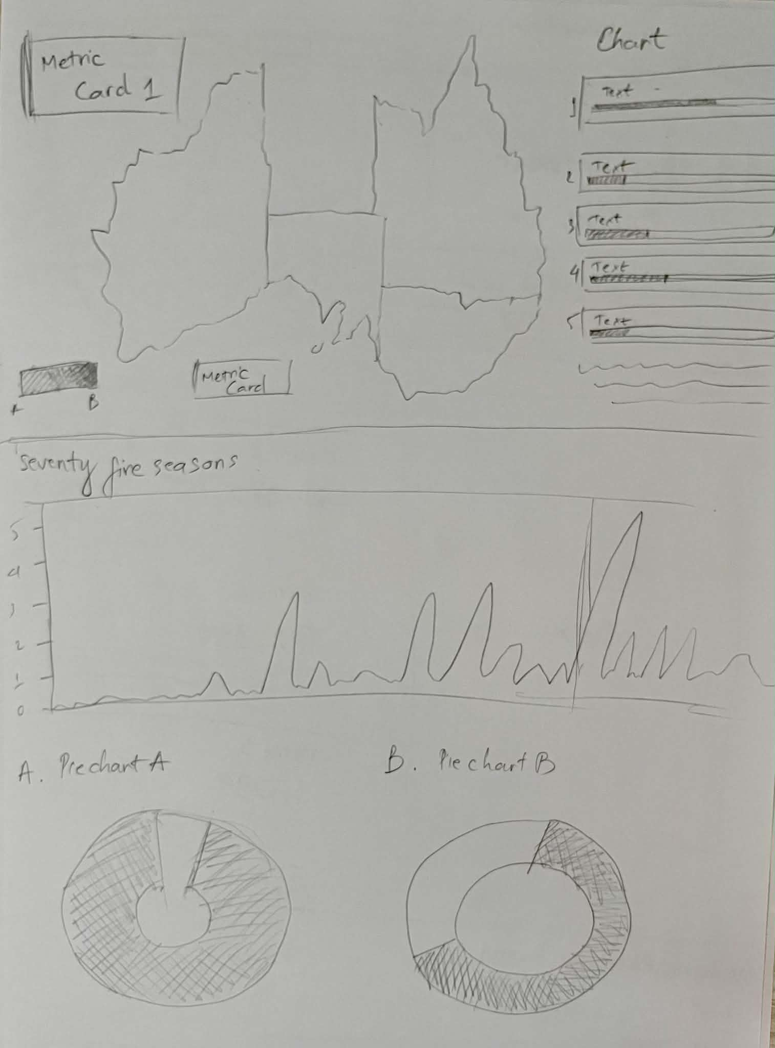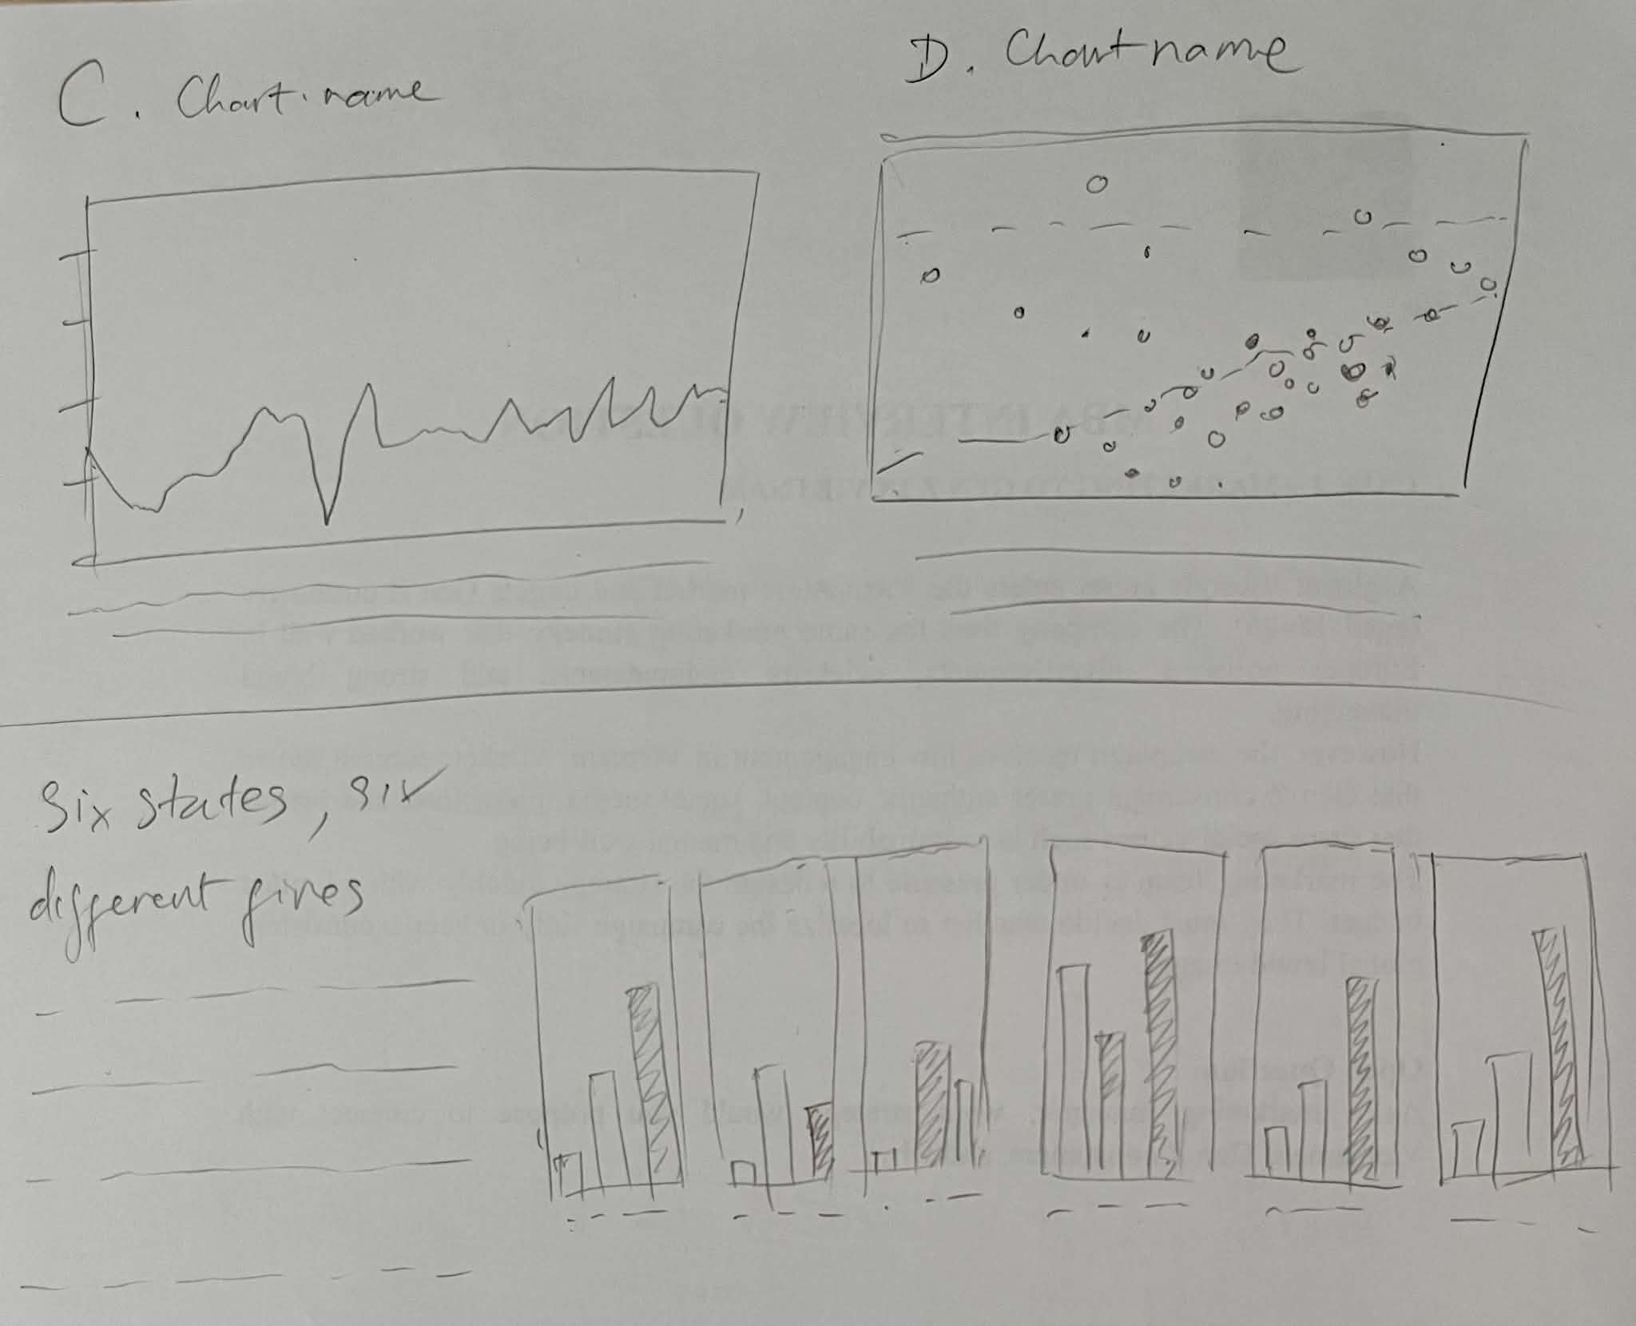

Part D: Full-size screenshot of your DV II
Paste a full-size screenshot of your DV II assignment from the URL here
