API Challenge

WeatherPy Part 1: Three trends based on the your findings

For this challenge, I analyzed weather data all across the world using and the Open Weather Map API. I pulled a random sample of cities and captured the Max Temperature, Humidity, Cloudiness, and Wind Speed. Using the cities latitude, I plotted the data and analyzed to see if there is any correlation between theses variables. Here are three trends I found.

1. Max temperature has the strongest correlation with latitude. Cities further away from the equator have a lower max temperature. The r-squared value for the northern hemisphere = .74 and the r-squared value for the southern hemisphere = .41.
2. Cloudiness has no correlation to latitude. The r-squared value for the northern hemisphere = .02 and the r-squared value for the southern hemisphere = 6.9e-05.
3. Humidity does not have a strong correlation to latitude. The r-squared value for the northern hemisphere = .15 and the r-squared value for the southern hemisphere = .001. It was interesting to find that the northern hemisphere has a stronger correlation to humidity than the southern hemisphere where there is no correlation.

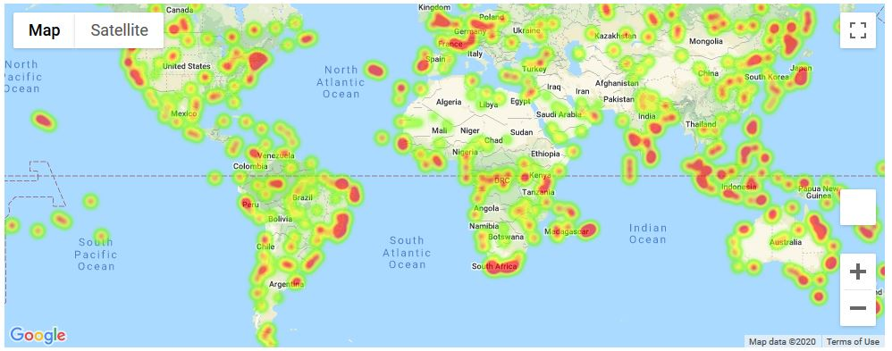VacationPy Part 2: Include a screenshot of the heatmap

