* 1. **System Description**

Xingze Guo               xig480

Rongli Han              roh919

Xianming Luo            xil430

Spencer Ondrusek    spo798

Matt Triff                  mdt879

Our Warehouse Management System software allows employees within a retail warehouse better manage their inventory and reduce errors in their business. The system does this by storing all stock information on an item, including details such as price, name, attributes, and physical location within the warehouse.

The software will provide Receivers with a simple and easy interface for adding incoming products to their inventory, Shippers with the ability to remove products for outgoing shipments, and Stock Handlers with an interface to locate and manage inventory within the warehouse. The system will have the ability to print and format reports for management, detailing internal metrics and stock within the warehouse.

By meeting the needs of each type of employee in the warehouse, this software system will be central to the efficient and successful operation of a retail warehouse.

* 1. **Business Case**

The modern warehouse of today is run in much the same way that is was twenty years ago, predominantly on paper documents that are handled by a wide variety of actors. This currently results in lost product, missed shipments, confusion and low efficiency. Some workers are constantly working hard every day, while others take advantage of the current situation and partake in leisure activities on the job. As warehouses remain central to brick-and-mortar stores, the meteoric rise of online sales has only increased the stress and demand on the warehousing industry. It is time to develop a new and innovative way to run the world’s warehouses, and disrupt their current offerings with the power of technology.

The main purpose of our electronic Warehouse Management System is to help management and staff to monitor, track, and improve efficiency with the power of data. Tools to track worker speed, stock turnover speed, and interactive stock tracking features all will allow management to better improve the efficiency of their organization, allowing them to reduce manpower and cut expenses.

This software provides functionality to integrate and organize the tasks of all members of the warehouse organization, by providing a graphical user interface to easily navigate and perform tasks. Along with the management features mentioned above, Stock Handlers will receive optimize routes for gathering products for shipment, Shippers will be able to simply track and manage all outgoing shipments, receivers will be able to autonomously record new stock and determine on the fly if a the warehouse has the capacity for a new shipment.

Our Warehouse Management System provides an easy to use program to assist all members of a warehouse organization make once complicated tasks simple.

* 1. **User-Level Goals for the System**

We have set the following user-level goals for the system. The goals have been divided into four separate categories to match the four types of users for the system.

**Manager**

The main expectations and requirements that a Manager has for the Management and Reporting System functionality of our system is to be able to:

* View information on the products in the warehouse, including name, description, item number, category, price, quantities, and location within warehouse.
* Display the shipping reports for outgoing products for a given time period (past, present or future), including date ordered, status (pending, gathered, shipped), tracking information if available, weight, destination, and product manifest.
* Display the purchase order report for incoming products for a given time period (past, present or future), including date ordered, tracking information if available, order cost, and product manifest.
* Display statistics and metrics reports, listing the fastest selling products, slowest moving products, and the percentage of the warehouse space currently being used.
* Display an employee status report, showing either one or more employee’s information such as name, title, and employee speed (i.e. orders gathered per hour, average time to ship a shipment, average time to receive a shipment).
* Create, modify and delete shipment orders made to the warehouse.
* Create, modify and delete purchase orders made by the warehouse.

**Shipper**

The main expectations and requirements that a Shipper has for the Shipping System functionality of our system is to be able to:

* View a listing of all upcoming shipments.
* Assign upcoming shipments to a Stock Handler.
* Record outgoing shipment information such as tracking number and date shipped.

**Receiver**

The main expectations and requirements that a Receiver has for the Receiving System functionality of our system is to be able to:

* Update stock information according to received purchase orders.
* Input information of new incoming products.
* Assess if there is capacity in the warehouse for a given purchase order.
* Analyze which shipments will need to be shipped before the warehouse has enough capacity for an incoming purchase order.

**Stock Handler**

The main expectations and requirements that a Stock Handler has for the Stock Picking System functionality of our system is to be able to:

* Print out a list of items required to be gathered to fulfill upcoming orders.
* Record the time of finishing each cart as well as any inconsistencies stock levels, product location or product information.
  1. **User Scenarios**

**Use Case Name**: Statistics Reporting

**Level**: Summary

**Actors**: Manager

**Goal**: Provide a high level view of warehouse operations, to drive efficiency gaining decision making

**Activities**: Analyze staff efficiency for promotion and layoffs, view turnover speed of specific products to guide purchase order and discount sales decisions, gauge warehouse stock level

**Quality**: high quality, fast, accurate, and reliable

**Use Case Name**: Stock Reporting

**Level**: Summary

**Actors**: Manager

**Goal**: Provide in depth view of information on the warehouse stock

**Activities**: View stock information for all products currently or previously contained in the warehouse, monitor stock levels

**Quality**: high quality, fast, accurate, and reliable

**Use Case Name**: Routing Stocking Tasks

**Level**: Summary

**Actors**: Stock Handler

**Goal**: Increase efficiency of navigating the warehouse for stocking tasks

**Activities**: Putting away stock that has been received, gathering stock for an upcoming shipment, building pallets correctly

**Quality**: high quality, accurate, reliable, and effective

**Use Case Name**: Receive Purchase Order

**Level**: Summary

**Actors**: Receiver, Stock Handler

**Goal**: Add new stock items to the system,

**Activities**: Recording information on newly received stock, increasing warehouse stock level to correspond to received shipments, assign Stock Handler to store the product

**Quality**: high quality, accurate, high ease of use, reliable, flexible

**Use Case Name**: Send Shipments

**Level**: Summary

**Actors**: Shipper, Stock Handler

**Goal**: Send the items ordered for shipment from the warehouse

**Activities**: Remove stock from the warehouse, track pallet contents, record progress of Stock Handlers in gathering items required for shipment.

**Quality**: high quality, accurate, high ease of use, reliable, flexible

**Use Case Name**: Locating Stock

**Level**: Summary

**Actors**: Manager, Stock Handler

**Goal**: Find the location of stock within the warehouse

**Activities**: Locate stock for shipment, locate old stock location to place recently received stock of the same item, view map of warehouse to find location of the stock

**Quality**: high quality, reliable, efficient

* 1. **Scope Document**

The Warehouse Management System will provide all the tools necessary to run a basic, retail-scale warehouse. The following functionality will be available for each type of user:

**Stock Handler**

* Create printable day plans for stock to be gathered for shipment
* Figuring out the most efficient routes that the Stock Handler should take to gather all products in a matter that will build a sturdy pallet
* Recording and monitoring of inconsistencies in stock levels
* Recording and moving items with inconsistencies in stock locations
* Track speed of each of the workers at performing tasks

**Manager**

* Display product information report for a set of items within the warehouse (showing from one item to all items in the warehouse) such as description, item number, category, price, quantities, location within warehouse
* Display statistics reports, listing the fastest selling products, slowest moving products, the percentage of the warehouse space currently being used
* Display shipping report for a given time period (past, present or future), including date ordered, status (pending, gathered, shipped), tracking information if available, weight, destination, product and manifest
* Display purchase order report for a given time period (past, present or future), including date ordered, tracking information if available, cost, and product manifest
* Display employee status report (showing from one employee’s information, to all employee’s information) such as name, title, employee speed (i.e. orders gathered per hour, average time to ship a shipment, average time to receive a shipment)
* Create, modify and delete orders made to the warehouse
* Create, modify and delete purchase orders made by the warehouse
* Configure the GUI warehouse map to mimic the warehouse floor plan

**Shipper**

* Check upcoming shipments
* Assign upcoming shipments to a Stock Handler
* Record outgoing shipment information
* Track pallet contents

**Receiver**

* Input information of incoming products
* Check if there is capacity in the warehouse for a given purchase order
* Check which shipments will need to be shipped before the warehouse has enough capacity for a new shipment

Only the above functionality will be able to be accomplished by our system unless some key functionality is determined by test users to be required.

The estimated work time required for this project is 60 hours of planning and programming for the work unit for each team member. An additional 30 hours for each team member will be required for meetings, testing, and user interviews.

* 1. **Project Plan/Rough Estimates**

The following are our current rough estimates for completing our required functionality for this project. Note that these are rough estimates for the initial creation of each piece of functionality, additional iterations will certainly be required to iterate and refine, based on user feedback. Due to the unknown nature of user suggestions, we are unable to estimate their completion time, however, it is estimated that for total completion of the coding for the project will take 60 hours per team member.

|  |  |  |
| --- | --- | --- |
| **Task** | **Assigned To** | **Rough Estimate for Completion (hours)** |
| **Stock Handler** | - | - |
| Create printable day plans for stock to be gathered for shipment | Spencer |  |
| Figure out most efficient routes to take to gather all products for shipment | Matt | 3 |
| Recording and monitoring of inconsistencies in stock levels | Spencer |  |
| Recording and moving items with inconsistencies in stock locations | Spencer |  |
| Track speed of each of the workers at performing tasks | Spencer |  |
| **Manager** | - | - |
| Create and display product information report | Han |  |
| Create and display statistics reports | Han/Matt | 2 |
| Create and display shipping report | Han |  |
| Create and display purchase order report | Han |  |
| Create and display employee report | Han |  |
| Create, modify and delete purchase orders | Han |  |
| Create, modify and delete shipment orders | Han |  |
| **Shipper** | - | - |
| Check upcoming shipments | Xingze | 4 |
| Assign upcoming shipments to Stock Handler | Xingze | 4 |
| Record outgoing shipment information | Xingze | 4 |
| Track pallet contents | Xingze | 4 |
| **Receiver** | - | - |
| Input information for incoming products | Xingze | 5 |
| Check warehouse capacity for incoming purchase order | Xingze | 5 |
| Check shipments to be shipped to create space for incoming shipments | Xingze | 5 |
| **Graphical User Interface** | - | - |
| Create toy prototype | Sam | 5 |
| Configure GUI warehouse map | Sam | - |
| Move items from one section of the warehouse to another | Sam | - |
| Display current usage levels for each section | Sam | - |
| Refine user interface and menus | Sam | - |
| **Database/Backend** | - | - |
| Set up MySQL database to record warehouse information | Matt | 1.5 |
| Create dummy data to fill MySQL database | Matt | 1 |
| Set up Neo4j Graph Database to record warehouse layout | Matt | 7 |
| Create accessors objects to access data securely within the MySQL database | Matt | 8 |
| Create mutator objects to manipulate data in a concurrent manner | Matt | 8 |
| Set up and manage Ant build management system | Matt | 10 |
| Set up JUnit testing suite | Matt | 2 |

* 1. **User Involvement Plan**

We will involve users throughout the project to ensure that our software is easy to use, error free, and most importantly, what the customer wants. This will give us the opportunity to receive feedback of which features users would like to see implemented and which features are unnecessary.

We have already involved users in the initial milestones for this project. Thanks to the prior experience of two of our team members, one of them with a vast range of experience in both retail and mining warehouses, the other with retail warehouse experience, we have been identifying their feedback as we outlined the project scope and initial requirements. We have used three hours of their time for this project so far, and they will continue to use their experience through the development cycle.

Beyond our internal users, we will start by only involving management and will need 30 minutes of their time. We will begin our user interaction with our toy prototype and demonstration of the features we plan to implement. This will simply be a discussion of features in their abstract phase. We will discuss with the user if they see any problems with the system at a high level and restructure our program accordingly. At this phase nothing is implemented so changes can easily be made to the functionality of our system. Any change arising from these discussions will not consume very many resources.

After collecting initial input from the user we will implement our functions with continual contact with the previously interviewed management to address if a specific design decision is acceptable. Each of these communications should take under 10 minutes, and will allow us to further refine our system to ensure that our implementation does not deviate from the customer’s needs.

For greatest use of time of the employees we will enlist a single member of each type of employee (Shipper, Receiver, Stock Handler, and Manager) to maintain continual contact. Once the functionality for a phase is completed we will consult that group’s user. We will have the user navigate and use the completed functionality, while we observe their behavior. A short, informal, interview will take place after the usage of the functionality to determine what issues or confusion they encountered in using the product. We will use the spiral method for prototyping and iteration until all desired functionality is addressed. The amount of time and resources required for this user involvement will range depending on the initial quality of each prototype, however, each session with the user should take approximately 30 minutes.

When all functionality is discussed and addressed to the satisfactory of our sample subject we will beta test our program with a new inexperienced member of that group. This will be to ensure ease of use for many different operators and is likely to require two iterations (or spiral twice). This stage is likely to require user involvement for 45 minutes in total. At the final stage, management will be consulted for any remaining finishing touches, estimated to require 15 minutes of their time.

Each time a user is involved in consulting it will require one of the developers on our team to be present with latest release of our software, in an area similar to the environment the software would be used in, to observe and interview the user in a realistic use case scenario.

* 1. **Low Fidelity Prototypes**

Our low fidelity prototypes were primarily drawn on paper, and can be viewed in the images below:

**Main Page**

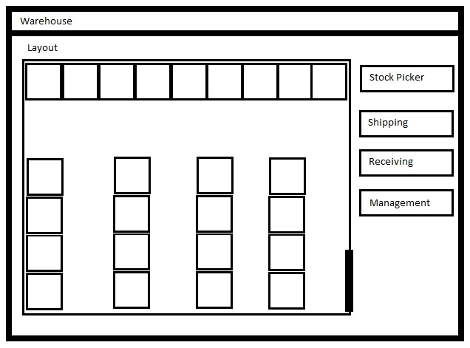

Provides an interactive map of the layout of the warehouse, navigation buttons on the right allow access to each of the individual users functionalities.

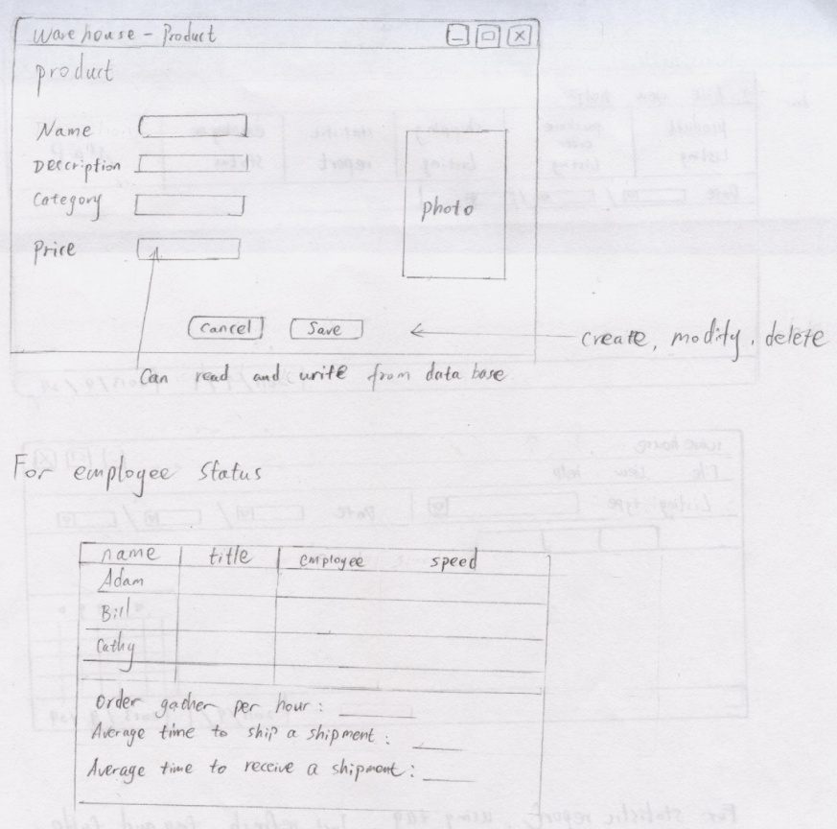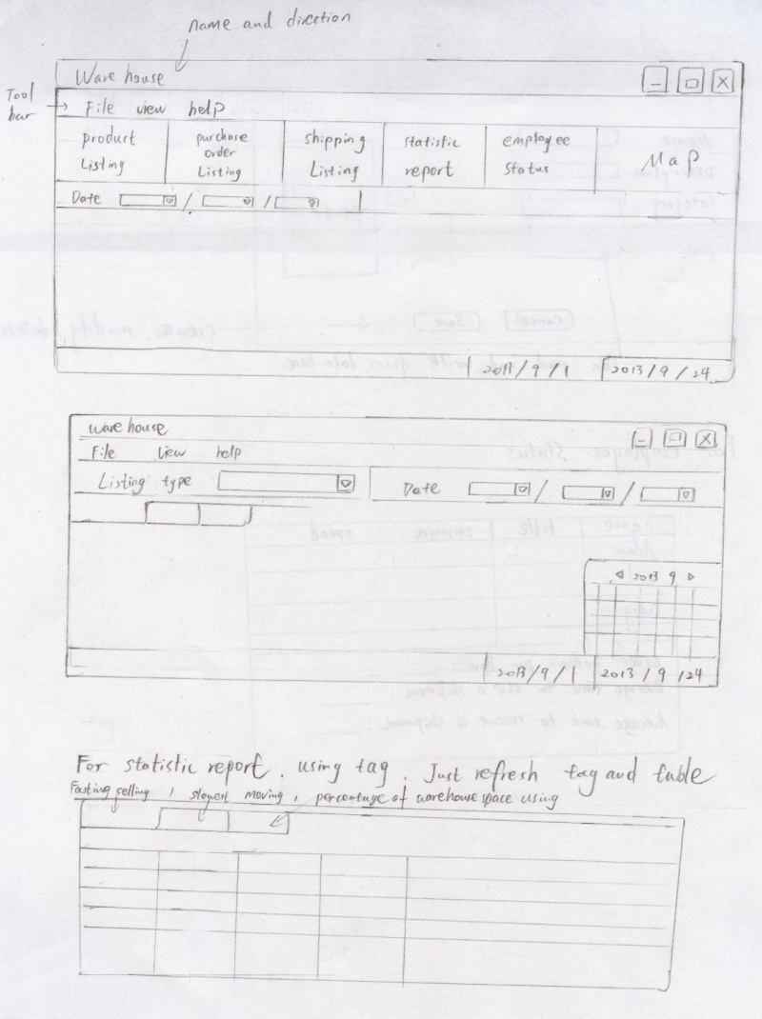**Management System**

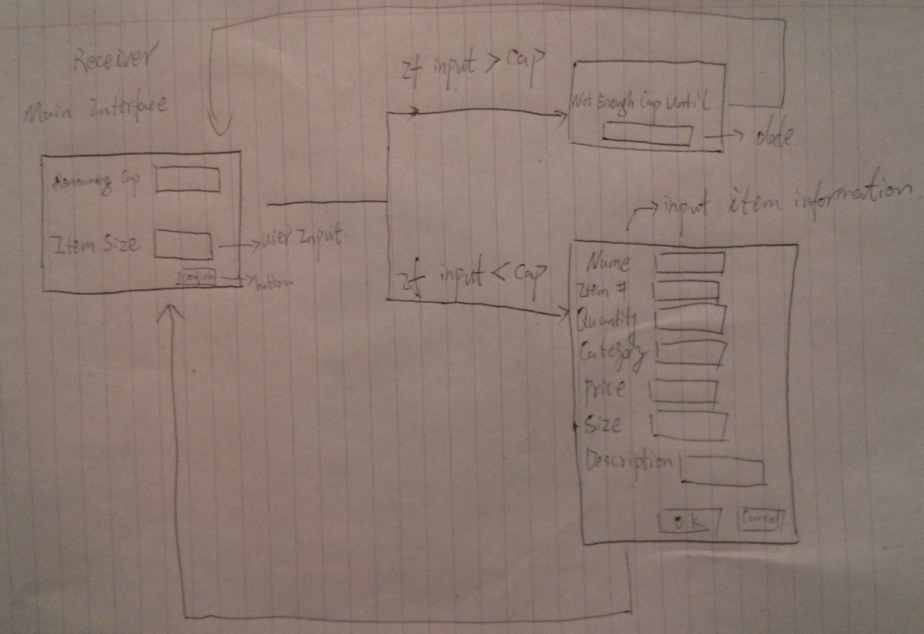**Receiving System**

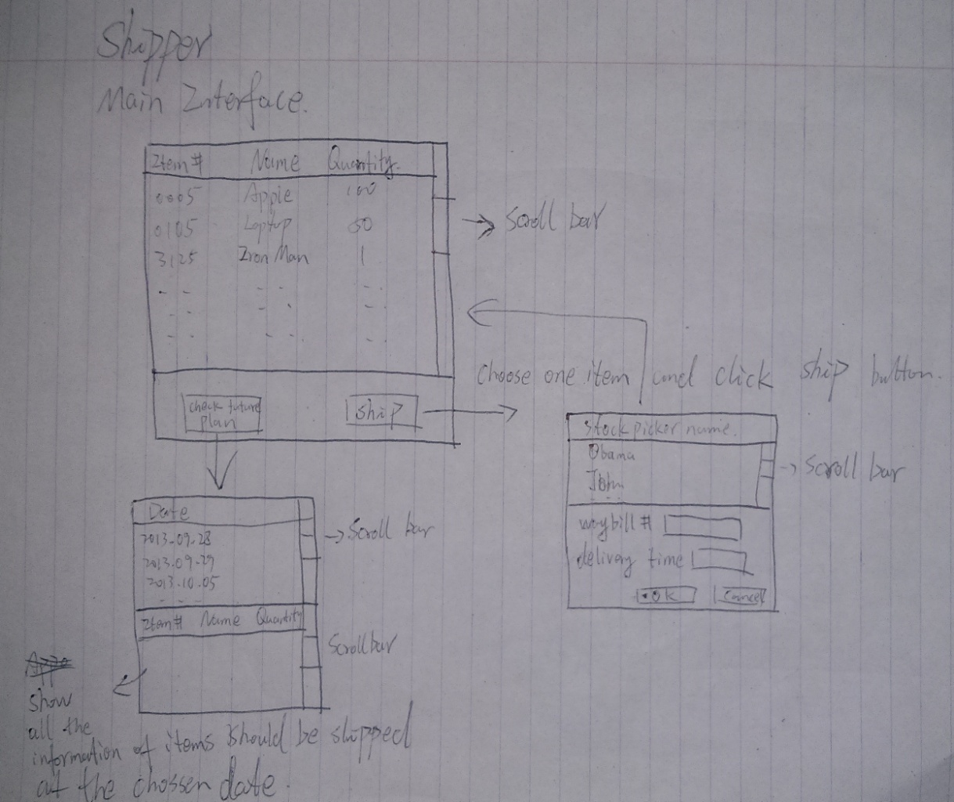**Shipping System**

* 1. **Project Management Report**

<< TO DO: INCLUDE TABLE FROM GOOGLE DOC SPREADSHEET>>

The risks associated with this project include feature creep (addition of unnecessary features), and efficient planning and coordination. Due to the integrated nature of the project, certain tasks to be done by one team member are required for another team member to proceed, as such, due care and attention will need to be made in planning out the sequence of tasks to ensure consistent progress.

* 1. **Project Plan**

The following table contains all tasks that have been completed thus far, as well as all tasks that will need to be completed for the next milestone.

<<TO DO: INCLUDE TABLE FROM GOOGLE DOC SPREADSHEET>>

|  |  |  |  |
| --- | --- | --- | --- |
| **Task** | **Assigned To** | **Rough Estimate for Completion (hours)** | **Status** |
| Meet to discuss presentation of project | All | 1.5 | Not Started |
| Create presentation | All | 6 | Not Started |
| Meet to discuss Milestone 4 tasks | All | 1.5 | Not Started |
| Complete requirements gathering | Unassigned | 5 | Not Started |
| Move use cases to “User Goal” level | Unassigned | 4 | Not Started |
| Preliminary Software Design | All | 4 | Not Started |

* 1. **Toy Prototype**

<<TO DO: INCLUDE INSTRUCTIONS ON HOW TO RUN TOY PROTOTYPE JAR FILE>>

<<TO DO: INCLUDE SCREENSHOTS FROM TOY PROTOTYPE>>

* 1. **Glossary**

Pallet – A wooden platform for placing products on, commonly used in a warehouse to bundle products for shipment and moving the products using a forklift

Shipment – A pallet that will be sent via truck to it’s destination

Product Order – A pallet containing products that have been ordered by the warehouse