INTERVIEW PREPARATION
Mihir AI Chatbot

Interview Study Guide and Quick Reference
Everything you need to explain this project confidently, in about fifteen minutes of reading. For depth and verification, use the Complete Guide.
Purpose | Fast pre-interview refresher — read it the night before, skim it in the taxi
Reading time | Approximately 10–15 minutes
Companion | Mihir_AI_Chatbot_Complete_Guide.docx
Source of truth | docs/MIHIR_AI_INTERVIEW_CHEATSHEET.md, MIHIR_AI_COMPLETE_GUIDE.md,  MIHIR_AI_GLOSSARY.md, docs/diagrams/*.mmd

CURRENT LIMITATION
Three things not to say. The groundedness check is not a safety gate — it is log-only; the hard gate is citation-ID validation. The frontend does not display citations, even though the backend sends them. Deployment is not automated — there is no CI/CD in either repository. Getting caught overstating any of these costs more credibility than the feature would have earned.

1 · The Project in One Sentence
SAY IT LIKE THIS
“It's an AI chatbot on my portfolio site that answers recruiter questions about my background using retrieval-augmented generation over my own profile content, running on a Cloudflare Worker with full session, CSRF, rate-limit and bot security — and every citation it produces is validated server-side before it reaches the user.”

2 · The 30-Second Explanation
SAY IT LIKE THIS
“I built an AI chatbot for my portfolio that answers recruiter questions about my background. The frontend's a static site with a vanilla JS widget; the backend's a Cloudflare Worker handling security — sessions, CSRF, rate limiting, bot protection — then retrieval-augmented generation: hybrid vector-plus-keyword search over my profile content, a Llama model answering from the top passages, and citation validation before anything reaches the user. It also detects hiring intent and captures leads with email notifications.”

3 · The 60-Second Explanation
SAY IT LIKE THIS
“It's two repos. Portfolio_001 is a static, no-build-step site on GitHub Pages with a self-contained chat widget — vanilla JS, talks to my backend over fetch, keeps its session in sessionStorage, no cookies. mihir-ai-worker is a Cloudflare Worker in TypeScript with zero runtime npm dependencies, using D1 for relational data and KV for rate limits.
Every mutating request needs a CSRF token signed with HMAC at session creation. Rate limits run in KV with time-bucketed keys. Cloudflare Turnstile kicks in after five messages. Every message hits a regex injection filter before the model is ever called.
The AI itself is RAG: my profile is five Markdown files chunked into 21 passages, embedded and stored as vectors in D1. A question triggers hybrid vector-plus-keyword search, fused with Reciprocal Rank Fusion, reranked by the LLM, and the top five passages go into the prompt with a rule that every claim must cite its source — citations are then validated server-side, and anything invented gets stripped and logged. There's a golden evaluation set with measured recall and MRR, all behind a feature flag for safe rollout.”

4 · The 90-Second Architecture Explanation
SAY IT LIKE THIS
“Request enters src/index.ts, which wraps every response — even errors — with CORS headers, then router.ts does plain path/method matching to one of five handlers, no framework. /api/chat is the core one: it looks up the session in D1, verifies the CSRF token in constant time, checks a D1-based hard message cap, runs two KV rate limits (global and per-IP), requires Turnstile once the session's crossed five messages, and runs the message past a static regex injection filter — all before touching the AI model.
Then, if the RAG_ENABLED flag is on, it calls retrieve(): embed the question, run exact vector search and FTS5 keyword search in parallel, fuse with Reciprocal Rank Fusion, optionally rerank with the LLM, and hand the top five chunks to the generation call. The model's citations are checked against what was actually retrieved before the response goes out, and both messages get persisted to D1.
Nothing in the pipeline lets the model trigger a side effect directly — email, D1 writes and external calls are all coded explicitly in route handlers, never invoked by model output.”

TECHNICAL DETAIL
The one-line version of the ordering argument: every cheap check runs before every expensive one, and every security check runs before the model is called. Validation costs nothing, rate limits cost a KV read, Turnstile costs an external call, inference costs real money — so they run in exactly that order.

5 · High-Level Architecture
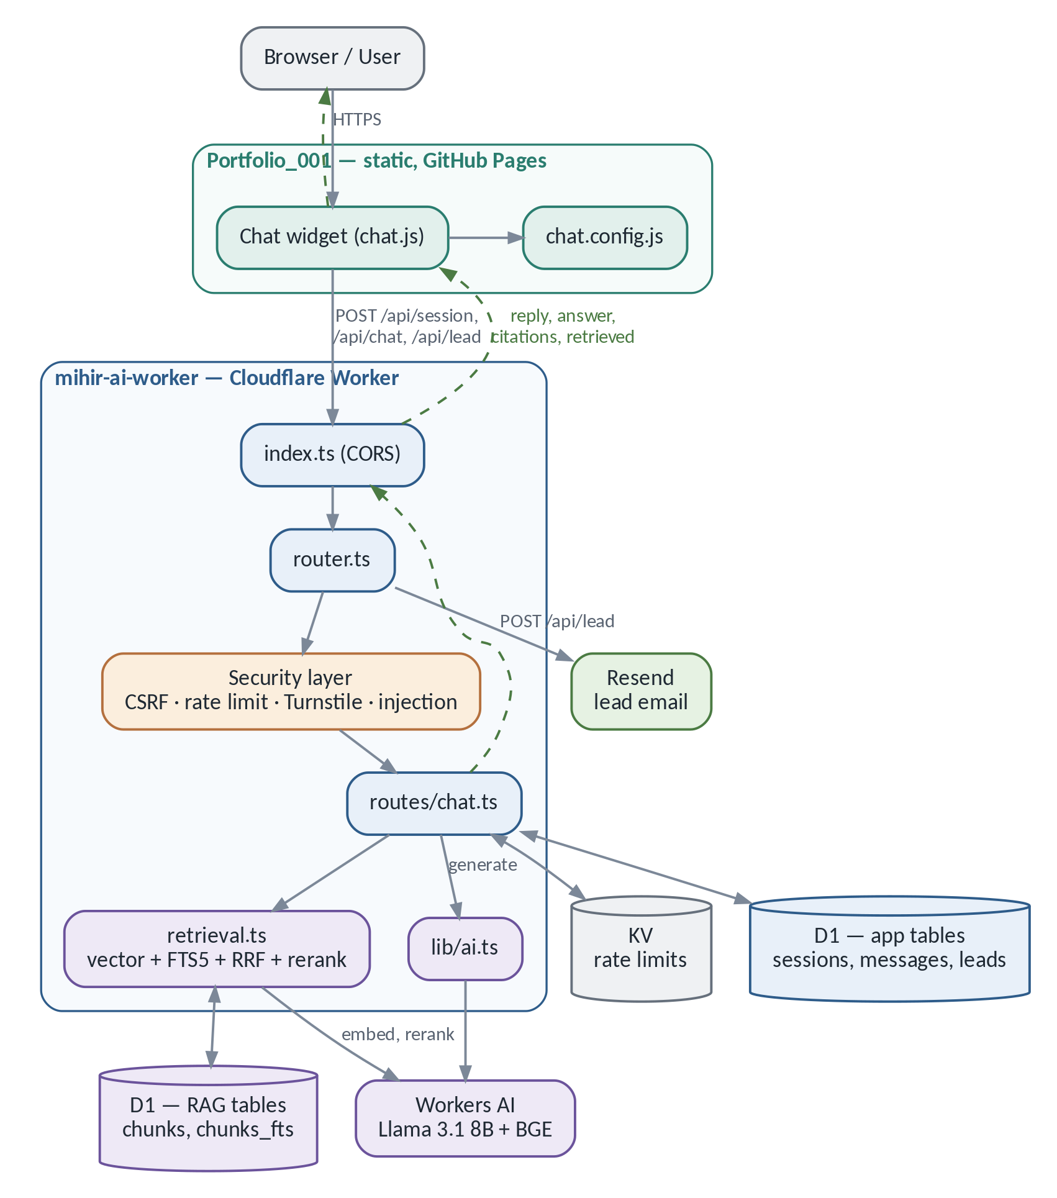
Figure A — System architecture (simplified). Source: docs/diagrams/system-architecture.mmd
The browser only ever talks to the Worker. The Worker talks to D1 (one database holding both the application tables and the RAG tables), KV (rate-limit counters only), Workers AI (embeddings, reranking and generation) and Resend (lead email, from the lead route only).

6 · Frontend Responsibilities
Does | Does not
Injects the widget DOM and handles all chat UI | No retrieval and no model logic — those are server-side only
Creates a session and stores session_id / csrf_token in sessionStorage | Holds no secrets; chat.config.js has only the public Turnstile site key
POSTs /api/session, /api/chat, /api/lead over fetch | Never talks to D1, KV or Workers AI directly
Handles 429, 401 and Turnstile-shaped 403 distinctly | Does not render citations — citations and retrieved arrive but are unused
Lazy-loads Turnstile only when it is first needed | No framework, no bundler, no build step

7 · Backend Responsibilities
Concern | Where | What it does
Entry and CORS | src/index.ts | Wraps every response — success or error — with the right CORS headers
Routing | src/router.ts | Plain pathname/method matching to five handlers; no framework
Chat orchestration | src/routes/chat.ts | Session, CSRF, caps, rate limits, Turnstile, injection filter, retrieval, generation, citation validation, persistence
Retrieval | src/retrieval.ts | retrieve, vectorSearch, keywordSearch, rrfFuse, rerank
Generation | src/lib/ai.ts | getAiReply — builds the prompt and calls Workers AI
Grounding | src/lib/grounding.ts | assessGrounding — lexical overlap check, log-only
Security primitives | src/lib/crypto.ts, kv.ts, turnstile.ts, prompts.ts | HMAC, IP hashing, rate limits, bot verification, injection patterns
Lead capture | src/routes/lead.ts, src/lib/email.ts | Validates and stores a lead, then notifies via Resend; email failure never fails the response

8 · Why Cloudflare
SAY IT LIKE THIS
“I chose Cloudflare because Workers, D1, KV and Workers AI are all first-party products behind one CLI and one credential set — no separate signups or cross-cloud latency to stitch together for a small project. Workers run in a V8 isolate rather than a container, so there's no cold start, and it's serverless — I never provision anything. D1 is hosted SQLite, and it happens to ship FTS5, so my keyword search lives in the same database as my application data with zero extra infrastructure. Workers AI gives me both the chat model and the embedding model without a separate API key or external network hop.
The honest tradeoff is vendor coupling — I had to use the Web Crypto API instead of Node's crypto module because Workers don't expose Node's standard library — and D1 is younger than a managed Postgres, fine at my scale but not a given choice for high write volume or complex relations.”

Product | Used for | The alternative I did not need
Workers | The entire API, at the edge | A traditional host plus a deploy pipeline
Workers AI | Generation and embeddings, no API key | An external LLM API and billing
D1 | Sessions, messages, leads, RAG chunks | A separate hosted database
KV | Rate-limit counters with TTL | Redis and its connection management
Turnstile | Bot check after 5 messages | A third-party CAPTCHA
Wrangler | Dev, secrets, deploy | Custom scripts per service

9 · End-to-End Chat Flow
Fifteen steps. If you can recite these in order, you can answer almost any follow-up.
- Frontend trims the text and blocks the send if one is already in flight.
- Worker validates the JSON body — types, lengths, 2,000-character cap on message.
- getSession() looks up D1; missing or ended → 401.
- CSRF token recomputed from the session secret, compared in constant time; mismatch → 403.
- D1 hard cap checked (message_count >= 50) — no network call needed.
- KV rate limit: 5,000/day globally.
- KV rate limit: 30 per 10 minutes per IP; either → 429 with Retry-After.
- If the post-turn count reaches 5+, Turnstile is verified server-side; failure → 403.
- Message tested against INJECTION_PATTERNS; a match returns a canned refusal and the model is never called.
- Last 6 history messages fetched for context.
- If RAG_ENABLED, retrieve() runs the hybrid pipeline and returns the top 5 chunks.
- getAiReply() builds the prompt and calls Workers AI.
- Citations extracted and filtered to IDs actually retrieved; the rest are logged as rag_hallucinated_citation and dropped.
- assessGrounding() runs and logs — it does not block.
- Both messages persisted; JSON response returned and rendered.

If this fails… | The visitor gets…
Malformed body | 400
Unknown or ended session | 401
Bad CSRF token | 403
Missing or invalid Turnstile | 403
Rate limit or 50-message cap | 429
Injection pattern matched | 200 with a safe refusal — the model is never invoked
RAG retrieval throws | 200 “not enough information” — never an ungrounded answer
Workers AI throws | 200 generic fallback reply
Model invents a citation | The answer, with that citation stripped and logged

10 · RAG in Plain English
IN PLAIN ENGLISH
A plain language model is a closed-book exam — it knows nothing about me specifically. RAG makes it open-book: search a small knowledge base first, then answer only from what was found, with citations.

SAY IT LIKE THIS
“My profile is five Markdown files split by heading into 21 chunks, each embedded with a Cloudflare BGE model into a 768-dimension vector, normalized and stored as a BLOB in D1.
At query time I run two searches in parallel: exact vector search — a dot product against all 21 chunks, since 21 is small enough that a linear scan is sub-millisecond — and SQLite FTS5 keyword search with BM25 ranking, which catches exact terms vector search can miss, like a certification code. I fuse the two ranked lists with Reciprocal Rank Fusion rather than averaging scores, because vector and BM25 scores live on incomparable scales — RRF only needs each list's rank order. The fused top candidates go through one more pass: the LLM itself reranks them, which measurably improved my ranking quality — MRR from 0.958 to 0.982 in my evaluation. The final five chunks go into the prompt with a rule that every claim needs a bracketed citation ID, and after generation I regex-extract every citation and drop anything that wasn't actually in the retrieved set — logged as a hallucination, never shown to the user.”

11 · RAG Indexing Flow (Offline)
Runs manually on Mihir's machine whenever content/*.md changes — never per request, because embedding costs time and money and the corpus barely moves.
Step | What happens
1 · Source | 5 Markdown files: experience, skills, projects, education, certifications
2 · Frontmatter | Parse doc_id, source, title
3 · Chunk | Split on ## headings (scripts/chunk.js); oversized sections split at paragraph boundaries with ~15% trailing overlap → 21 chunks
4 · Prefix | embed_text gets a [Title > Heading] prefix so the embedding carries topic context
5 · Hash | SHA-256 of the complete embed_text; a cache hit skips re-embedding
6 · Embed | @cf/baai/bge-base-en-v1.5 → 768 dimensions
7 · Normalize | L2-normalize so a dot product equals cosine similarity
8 · Serialize | Little-endian Float32 BLOB — 3,072 bytes per vector
9 · Write | data/seed.sql + data/index.json, applied to D1 chunks and chunks_fts

TECHNICAL DETAIL
Two numbers worth having exact: 768 is the output size of the BGE model, not a tuning choice, and 3,072 bytes is simply 768 × 4-byte floats — verified against the remote D1 database in the merged pull request.

12 · RAG Retrieval Flow (Per Request)
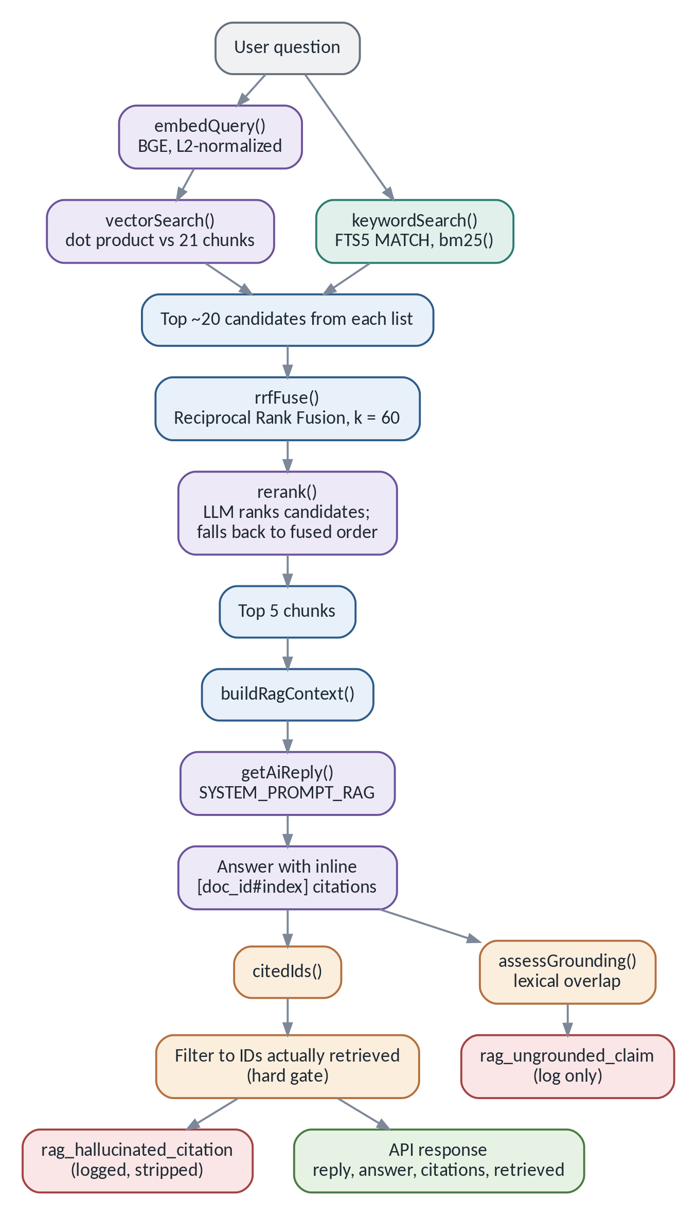
Figure B — Retrieval, generation and citation validation. Source: docs/diagrams/rag-query-flow.mmd
The seven steps are genuinely different operations. Do not describe them as one.
Step | What it is | What it is not
Vector retrieval | Dot product over 21 normalized embeddings | Not keyword matching — can miss an exact rare term
Keyword retrieval | FTS5 MATCH ranked by BM25 | Not semantic — misses paraphrases
Hybrid + RRF | Fusing the two rank orders, k = 60 | Not averaging scores — the scales are incomparable
Reranking | One LLM call re-ordering ~20 candidates to 5 | Not a new search — cannot recover what retrieval missed
Generation | One LLM call writing the answer from 5 chunks | Not retrieval — the model sees only what it was handed
Citation validation | Server-side set membership on extracted IDs — the hard gate | Not a truth check — a real ID can still front a wrong claim
Grounding assessment | Lexical overlap between sentence and cited chunk | Not enforcement — it logs and nothing else

SAY IT LIKE THIS
“If the reranker call fails or comes back unparseable, it falls back to the RRF-fused order — the request never fails because of reranking. And if retrieval itself throws, the answer degrades to 'not enough information' rather than an ungrounded guess.”

13 · Security Architecture
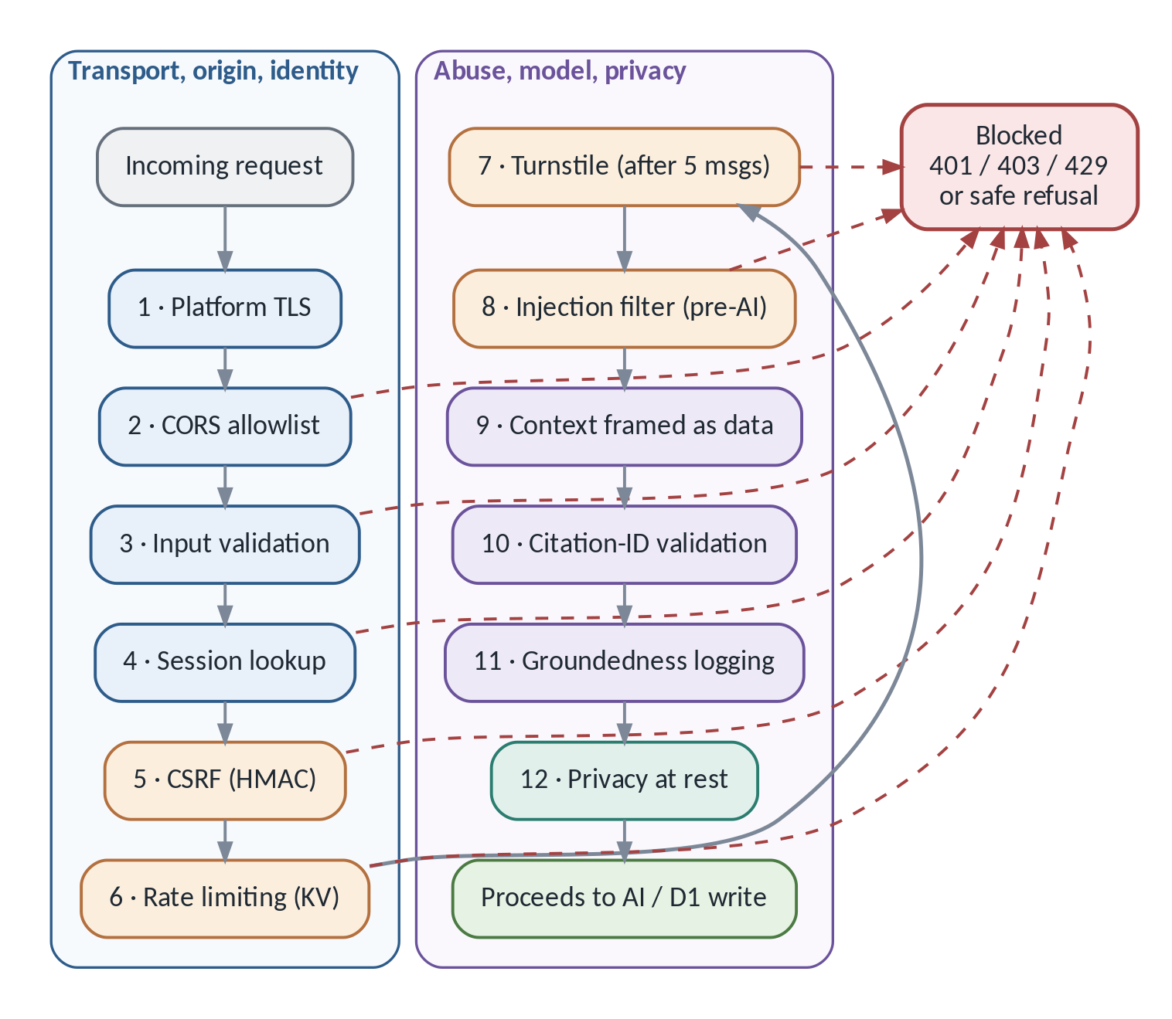
Figure C — Twelve security layers in request order. Source: docs/diagrams/security-layers.mmd
SAY IT LIKE THIS
“Security is layered and each layer defends against a different attacker. CORS restricts which origins can even call the API. CSRF is an HMAC token signed at session creation and checked in constant time before any write — it proves the request came from a client that legitimately has the session's secret. Rate limiting uses time-bucketed KV keys so each window gets its own expiring counter. Turnstile blocks scripted bots once a session looks automated, after five messages. A static regex filter catches direct prompt-injection attempts before the model is ever called — the model never has to police itself.
For RAG specifically, retrieved content is explicitly framed in the system prompt as reference material, never instructions, and every citation in the model's answer is checked against what was actually retrieved — anything invented is stripped and logged, not shown. I'm upfront that one piece — a lexical-overlap groundedness check — is currently observability-only, not a hard gate; that's a documented limitation, not something I'm hiding.”

13.1 Six concerns that are not the same thing
Concern | Question it answers | In Mihir AI
Authentication | Who is this visitor? | Does not exist — sessions are anonymous, there is no login
Authorization | What may they do? | Moot — every session has identical permissions
CSRF | Did this session's own frontend send this? | HMAC token, constant-time verified before any write
Bot protection | Is a human driving? | Turnstile after 5 messages
Prompt-injection protection | Is this text trying to hijack instructions? | Regex filter pre-model, plus context framing
Data grounding | Is the claim backed by a source? | Citation-ID validation (hard gate) + log-only lexical check

SECURITY CONSIDERATION
Fail-open versus fail-closed. Rate limiting fails open — if KV is unavailable the request proceeds, because blocking every visitor over a counter outage is worse than the abuse risk. Turnstile fails closed. Knowing which of your controls does which, and why, is a strong signal in an interview.

14 · Evaluation Metrics
A 35-question golden dataset with expected source chunks, plus refusal and prompt-injection cases. eval/run.js runs the real retrieval code against a real (Miniflare) D1 and live Workers AI — not a mock — across four modes.
Metric | Result
Recall@5 (all four retrieval modes) | 1.0000
MRR — vector-only | 0.9643
MRR — keyword-only | 0.8988
MRR — hybrid, no rerank | 0.9583
MRR — hybrid + rerank | 0.9821 (best of four)
Refusal pass rate | 1.0000
Prompt-injection pass rate | 1.0000
Retrieved-context-injection pass rate | 1.0000 (2/2 fixtures)
Corpus size | 5 documents / 21 chunks / 768-dimension embeddings

Source: PR #2, “fix: complete RAG evaluation and production rollout” — a live run against production Workers AI.

SAY IT LIKE THIS
“All four hit perfect Recall@5; reranking gave the best MRR at 0.982. I'm careful to say this doesn't prove real-world performance at scale — it's 21 chunks about one person's résumé, with test questions written by the same person who wrote the content. It's a controlled proof of the pattern, not a generalisation claim.”

TECHNICAL DETAIL
Recall@5, MRR, citation-ID validity and the grounding check are all deterministic — no LLM makes the pass/fail call anywhere. Only generation varies run to run, and the reranker adds roughly ±1–2 points of MRR variance. Nothing uses an LLM as a judge.

15 · Major Design Decisions
Decision | Why | When I would change it
Two separate repositories | Different deploy targets and secrets; backend secrets cannot leak via a frontend commit | If a monorepo-wide typed SDK were needed
Cloudflare Worker backend | No cold start; first-party D1/KV/AI bindings behind one CLI | If scale outgrew Cloudflare's product boundaries
Static Markdown corpus | Trivial to hand-edit; headings give human-curated chunk boundaries | If content volume or the number of editors grew
Exact (linear-scan) vector search | Simplest correct approach; sub-millisecond at 21 chunks, no approximation error | Past roughly a few thousand chunks → Vectorize
SQLite FTS5 for keyword search | Ships inside D1; zero extra infrastructure | If fuzzy or synonym search were needed
Hybrid retrieval with RRF | Vector and keyword fail differently; RRF fuses ranks, not incomparable scores | Rarely — hybrid is close to strictly better here
LLM reranking with fallback | Measurably improved MRR (0.9583 → 0.9821); falls back to fused order on failure | If latency became a hard constraint
RAG_ENABLED feature flag | Reversible rollout — flip to false and redeploy, no data migration | Once the legacy path is dead code
reply kept identical to answer | Backward compatibility; RAG shipped without a synced frontend deploy | Once the frontend adopts answer/citations
Log-only groundedness | A lexical heuristic cannot reliably separate true from false claims | If a more reliable check were validated

16 · Tradeoffs
TRADEOFF
Vendor coupling. Web Crypto instead of Node's crypto; D1's SQLite dialect. Portability was traded for one dashboard and one credential set.
Exact search does not scale. O(n) over every chunk is right at 21 and wrong at 10,000.
RRF discards magnitude. A near-tie and a landslide look identical, so per-query confidence is not recoverable downstream.
KV rate limiting is not atomic. Two concurrent requests can read the same pre-increment count — accepted for a low-traffic portfolio bot, unacceptable for anything billing-critical.
Manual re-indexing. Content edits require npm run chunk, npm run index and a wrangler d1 execute; nothing re-indexes on deploy.
Reranking costs a round trip. One extra Workers AI call per question, in exchange for measurably better ordering.

17 · Hardest Problems Solved

The flaky-retrieval bug
chat.ts and retrieval.ts were bundled as two separate esbuild entry points, each carrying its own inlined module-scope cache. The test's cache-clearing helper cleared one copy while the code under test read the other, so newly seeded test chunks were sometimes invisible. Fixed by bundling both through a single shared entry point. Evidence: PR #2 body.

Making “grounded” mean something
Instructing a model to cite sources is easy and unverifiable. The fix was to make it a server-side check: extract every [doc_id#index] after generation and drop anything outside the retrieved set, then test it adversarially by planting a fabricated citation and confirming it is stripped and logged.

Rate limiting without a perpetual window
The naive approach — one key, reset its TTL on every write — restarts the window forever and never actually limits anything. The fix was time-bucketed keys: {prefix}:{bucketNumber} where bucket = floor(now/windowMs), each with a TTL equal to the remaining window.

Shipping a large change to a live endpoint
RAG was a substantial rewrite of the answer path. The RAG_ENABLED flag, with string-safe parsing and a legacy path that never touches the RAG tables, meant rollback was one variable and a redeploy — no data migration and no coordinated frontend release.

18 · Current Limitations
CURRENT LIMITATION
Frontend does not render citations — citations and retrieved are returned and validated, but chat.js reads only reply.
Groundedness is log-only — the hard gate is citation-ID validity, nothing else.
Corpus is tiny — 5 documents, 21 chunks; the eval is a controlled proof, not evidence at scale.
Re-indexing is manual — nothing re-indexes on deploy.
RAG tables are not in migrations/0001_init.sql — they come from data/seed.sql.
KV rate limiting is non-atomic.
No CI/CD — no GitHub Actions in either repository; deploys are a manual wrangler deploy.
summaries, analytics_events, daily_metrics are schema-only — their helpers throw "TODO".
CSRF tokens are not rotated mid-session.
Retrieved-context injection defence assumes a single trusted author — it resists planted instructions and fake citation IDs, not a false “fact” phrased in matching vocabulary inside a real chunk.

19 · Future Improvements
None of these are built. Do not describe them as features.
FUTURE IMPROVEMENT
A larger corpus to stress-test retrieval beyond the current 35-question set.
Automatic re-indexing (a Cron Trigger or CI step) to remove the manual chunk/index step.
A dedicated vector store (Vectorize) once a linear scan stops being sub-millisecond.
Stricter groundedness enforcement — acting on assessGrounding()'s signal rather than only logging it.
A citation UI in Portfolio_001 — pure frontend work; the backend contract already exists.
Better observability — the two RAG warnings are only console.logs today.
Evaluation expansion — multi-hop questions and adversarial paraphrases.
Model upgrades — AI_MODEL is a single constant, already swapped once after a Cloudflare deprecation.
Streaming responses and cost/latency monitoring — both in BACKLOG.md, neither built.
Multi-tenant isolation — not applicable today, but real work if the project were repurposed.

20 · Twenty Likely Interview Questions
Spoken answers, not written ones — read them aloud once and they will come out naturally. Each has the keywords a technical interviewer is listening for, the follow-up most likely to come next, and where the evidence lives.

20.1 Walk me through this project.
SAY IT LIKE THIS
“It's a chatbot on my portfolio that answers recruiter questions about my background. Two repos: a static frontend on GitHub Pages with a vanilla-JS widget, and a Cloudflare Worker backend that owns sessions, security and the AI. The interesting half is the backend — every request passes CSRF, rate limits, Turnstile and an injection filter before the model is touched, and then the answer is built by retrieval-augmented generation over my own profile with server-side citation validation. It also detects hiring intent and captures leads.”

Keywords | Likely follow-up | Evidence
two-repo · Workers · RAG · D1 · CSRF · Turnstile · citation validation | “Which part was hardest?” or “Why not just call OpenAI?” | src/routes/chat.ts

20.2 Why did you choose Cloudflare?
SAY IT LIKE THIS
“One vendor bundles edge compute, a SQL database, KV and hosted LLM inference behind one CLI and one credential set. Workers run in a V8 isolate rather than a container, so there's no cold start. And D1 happens to ship FTS5, so my keyword search lives in the same database as my application data with no extra infrastructure.”

Keywords | Likely follow-up | Evidence
edge · serverless · V8 isolate · bindings · first-party integration | “What's the downside?” — answer: vendor coupling, Web Crypto instead of Node crypto. | wrangler.toml

20.3 Why did you implement RAG?
SAY IT LIKE THIS
“The pre-RAG version literally pasted a fixed profile into every prompt — that code is still there as the legacy path. RAG gave me three things that version couldn't: answers that cite a source, a design that scales if the profile grows, and retrieval quality I can actually measure.”

Keywords | Likely follow-up | Evidence
grounding · citations · measurable retrieval · legacy path | “How do you know retrieval is better?” — go straight to Recall@5 and MRR. | ADR-010 versus current chat.ts

20.4 How does hybrid retrieval work?
SAY IT LIKE THIS
“Two searches run in parallel over the same 21 chunks: vector search for meaning, and FTS5 with BM25 for exact terms. I fuse their ranked lists with Reciprocal Rank Fusion, then optionally rerank the fused candidates with the LLM before the top five go into the prompt.”

Keywords | Likely follow-up | Evidence
parallel search · RRF · BM25 · rerank | “Why fuse instead of picking one?” | src/retrieval.ts: retrieve()

20.5 Why use vector and keyword search together?
SAY IT LIKE THIS
“They fail differently. Vector search finds paraphrases but can under-weight an exact rare token — a certification code, a product name. Keyword search nails those but misses anything phrased differently. Running both and fusing gets the union of their strengths for one extra query.”

Keywords | Likely follow-up | Evidence
complementary failure modes · recall · exact tokens | “Did hybrid actually beat either alone in your eval?” — be honest: recall was already perfect for all modes; reranking is what moved MRR. | Chapter 16 metrics table

20.6 How do embeddings work?
SAY IT LIKE THIS
“An embedding turns text into coordinates in a space where similar meanings land near each other. I use Cloudflare's BGE model, which outputs 768 numbers per passage. I L2-normalize every vector so that comparing two of them is just a dot product — at unit length, the dot product is cosine similarity.”

Keywords | Likely follow-up | Evidence
768 dimensions · BGE · L2 normalization · dot product = cosine | “Why normalize?” — because it removes the magnitude division from every comparison. | embedQuery(), normalize()

20.7 Why exact vector search rather than a vector database?
SAY IT LIKE THIS
“At 21 chunks a linear scan is sub-millisecond and has zero approximation error. An ANN index is a performance optimisation that costs recall and adds infrastructure — there's nothing here to optimise. I'd reach for Vectorize past a few thousand chunks, and I know that's where the line is.”

Keywords | Likely follow-up | Evidence
O(n) linear scan · ANN tradeoff · knowing the threshold | “At what size does that break?” — hundreds to low thousands of chunks. | vectorSearch()

20.8 What does Reciprocal Rank Fusion actually do?
SAY IT LIKE THIS
“It combines ranked lists using positions instead of scores. Each chunk gets the sum of 1/(k + rank + 1) across every list it appears in, with k = 60. I use it because a cosine-like score and an unbounded BM25 score aren't on the same scale — averaging them would be meaningless — but 'ranked second' means the same thing in both lists.”

Keywords | Likely follow-up | Evidence
rank fusion · k = 60 · incomparable scales · deterministic ties | “Where does k = 60 come from?” — a conventional IR-literature constant, not tuned to this corpus. | rrfFuse()

20.9 Why use reranking at all?
SAY IT LIKE THIS
“It's the cheap-then-precise pattern: a fast, broad first pass, then a smaller, more expensive second pass over the survivors. It measurably improved my ranking quality — MRR went from 0.958 to 0.982. And if the rerank call fails or comes back unparseable, it falls back to the fused order rather than failing the request.”

Keywords | Likely follow-up | Evidence
cheap-then-precise · MRR gain · graceful fallback | “Same model as generation?” — yes, different prompt and token budget (128 versus 512). | rerank(), PR #2

20.10 How do you reduce hallucinations?
SAY IT LIKE THIS
“Three layers. The model only sees the five retrieved passages, and the system prompt says to cite every claim and to refuse if the context is insufficient. Then, after generation, my code extracts every citation ID and drops anything that wasn't actually retrieved — that's a hard server-side gate, not a request to the model. Separately, a lexical-overlap check flags claims that look unsupported by their cited chunk, but I'll be clear that one is log-only today.”

Keywords | Likely follow-up | Evidence
constrained context · citation validation · log-only grounding | “What can still get through?” — a wrong claim wearing a valid citation ID. | citedIds(), grounding.ts

20.11 How did you evaluate retrieval?
SAY IT LIKE THIS
“A 35-question golden dataset with expected chunk IDs, plus refusal and injection cases. eval/run.js runs the real retrieval code against a real Miniflare D1 seeded from my actual seed file, calling live Workers AI — nothing mocked — across four modes. All four hit Recall@5 of 1.0; hybrid plus rerank had the best MRR at 0.982.”

Keywords | Likely follow-up | Evidence
golden dataset · Recall@5 · MRR · four modes · deterministic scoring | “Is that a fair test?” — volunteer the caveat before it's asked. | eval/golden.jsonl, PR #2

20.12 How do you protect against prompt injection?
SAY IT LIKE THIS
“Two different defences for two different attack vectors. Direct injection — the user typing 'ignore your instructions' — is caught by a static regex filter that runs before the model is ever called, so the model never has to police itself. Indirect injection, where hostile text is hiding inside retrieved content, is handled by framing retrieved chunks in the system prompt as reference material rather than instructions. I have two test fixtures for that second case, an override attempt and a fake-citation attempt, and both were resisted.”

Keywords | Likely follow-up | Evidence
direct versus indirect · pre-model filter · context framing | “What if a regex misses one?” — then the model's instructions are the only defence, which is why the framing exists. | INJECTION_PATTERNS, tests/chat-rag.test.js

20.13 How does the frontend communicate with the backend?
SAY IT LIKE THIS
“Plain fetch calls to five REST endpoints, JSON in and out, no cookies. The session ID and CSRF token live in sessionStorage and are sent explicitly in the body. Every response comes back through a CORS wrapper in index.ts, including error responses — which matters, because a CORS-less error is invisible to the browser.”

Keywords | Likely follow-up | Evidence
REST · fetch · sessionStorage · explicit tokens · CORS on errors | “Why not cookies?” — no login, no cross-site cookie complexity, and CSRF is handled explicitly. | chat.js: sendChat(), src/index.ts

20.14 How do D1 and KV differ, and why use both?
SAY IT LIKE THIS
“D1 is hosted SQLite — relational, queryable, durable. That's where sessions, messages, leads and the RAG chunks live. KV is an eventually-consistent key-value store with TTL support, and I use it for exactly one thing: rate-limit counters, which need a fast write and automatic expiry, not a schema. Using D1 for counters would mean a database round trip on every request for data that's disposable.”

Keywords | Likely follow-up | Evidence
relational versus KV · TTL · eventual consistency · fit-for-purpose | “What does eventual consistency cost you?” — non-atomic increments; concurrent requests can both read a stale count. | src/lib/d1.ts, src/lib/kv.ts

20.15 What happens if retrieval or reranking fails?
SAY IT LIKE THIS
“Reranking failing is a non-event — it falls back to the RRF-fused order. Retrieval failing is caught around retrieve() and returns a safe 'not enough information' response rather than letting the model answer ungrounded. A Workers AI failure during generation returns a generic fallback reply with a 200. None of those paths return a raw 500 to the visitor.”

Keywords | Likely follow-up | Evidence
graceful degradation · fail-safe defaults · never ungrounded | “Why 200 and not 500?” — the endpoint is still healthy; the answer just isn't available. | chat.ts catch blocks

20.16 How would this application scale?
SAY IT LIKE THIS
“The first thing to break is exact vector search — it's O(n) per query, so past a few thousand chunks I'd move to Vectorize. The second is KV rate limiting, which isn't atomic; at real traffic I'd need Durable Objects or a counter that can't be raced. Workers, D1 reads and the model calls themselves scale horizontally without me doing anything, which is the main reason the platform choice holds up.”

Keywords | Likely follow-up | Evidence
O(n) bottleneck · ANN index · atomic counters · horizontal scale | “What about the model cost?” — that's the real ceiling; rate limits exist to bound it. | Chapters 4 and 18

20.17 What would you improve next?
SAY IT LIKE THIS
“Two things, in order. First, make groundedness an actual gate instead of a log line — that's the honest weak point in the pipeline. Second, build the citation UI in the frontend, because the backend already returns validated citations and nothing consumes them. The second one is pure frontend work with no backend change at all.”

Keywords | Likely follow-up | Evidence
enforcement · citation UI · backend contract already exists | “Why hasn't the UI shipped?” — the RAG rollout was deliberately kept backend-only and reviewable. | Chapter 19

20.18 What was the hardest bug?
SAY IT LIKE THIS
“A test-harness problem that looked like flaky retrieval. chat.ts and retrieval.ts were bundled as two separate esbuild entry points, and each bundle carried its own inlined copy of a module-scope cache. My test helper cleared one copy while the code under test read the other, so newly seeded chunks were sometimes invisible. The fix was bundling both through one shared entry point — but the diagnosis was the hard part, because the symptom looked like a retrieval bug, not a build one.”

Keywords | Likely follow-up | Evidence
module-scope cache · bundling · test isolation · symptom versus cause | “How did you find it?” — by noticing the cache was cleared and still stale, which pointed at duplication rather than logic. | PR #2 body

20.19 What are the limitations?
SAY IT LIKE THIS
“I'd name four before you ask. The frontend doesn't show citations even though the backend sends them. The groundedness check is observability-only, not a gate. The corpus is 21 chunks, so my perfect recall numbers are a controlled result, not a generalisation. And there's no CI/CD — deploys are a manual wrangler deploy.”

Keywords | Likely follow-up | Evidence
citation UI · log-only grounding · small corpus · manual deploys | “Which one bothers you most?” — the grounding gate, because it's the one that sounds stronger than it is. | Chapter 19

20.20 What are you most proud of?
SAY IT LIKE THIS
“The citation-validation gate. It's almost embarrassingly small — a Set membership filter — but it's what turns 'grounded' from a marketing word into something I can demonstrate. I tested it by planting a fabricated citation and confirming it gets stripped and logged. Most of what makes this project more than an API wrapper is that kind of check.”

Keywords | Likely follow-up | Evidence
verifiable grounding · adversarial fixture · small but load-bearing | “Show me the test.” — tests/chat-rag.test.js. | citedIds() in chat.ts

21 · Key Terminology

Architecture
Cloudflare Workers · edge computing · serverless · V8 isolate · D1 (SQLite) · KV · Workers AI · Turnstile · Wrangler · bindings · CORS · two-repo separation · no framework, no build step · feature flag (RAG_ENABLED)

RAG
chunking · frontmatter · embedding (768-dimension, BGE) · L2 normalization · Float32 BLOB · exact / linear-scan vector search · dot product = cosine similarity at unit length · FTS5 · BM25 · Reciprocal Rank Fusion (k = 60) · reranking · citation validation · hallucinated citation · log-only groundedness · golden dataset · Recall@5 · MRR

Security
CSRF (HMAC-SHA256, constant-time compare) · rate limiting (time-bucketed KV) · Turnstile · prompt-injection filter (regex, pre-model) · indirect / retrieved-context injection · IP hashing (SHA-256 + salt) · CORS (environment-aware) · secrets via wrangler secret put · fail-open (rate limits) versus fail-closed (Turnstile)

Term | One-line definition
Chunk | A retrievable passage — one ## section, identified like experience#0
Embedding | A 768-number vector representing a passage's meaning
L2 normalization | Scaling a vector to length 1 so a dot product equals cosine similarity
BM25 | A keyword-ranking formula rewarding rare, exact term matches
RRF | Fusing ranked lists by position rather than by score
Reranking | Re-ordering candidates with a more precise, slower pass
Recall@5 | Fraction of correct chunks appearing in the top five
MRR | How close to rank 1 the first correct chunk lands, averaged
Citation validation | Server-side check that a cited ID was actually retrieved — the hard gate
Grounding | Checking a claim is textually supported by its citation — log-only here
CSRF | An attack forging a request from a victim's active session; blocked by an HMAC token
Turnstile | Cloudflare's CAPTCHA alternative; required after 5 messages
Binding | How a Worker reaches a Cloudflare resource without credentials in code

22 · Important Files and Commands
Concern | File
Entry point and CORS | src/index.ts
Routing | src/router.ts
Chat orchestration | src/routes/chat.ts
Retrieval pipeline | src/retrieval.ts
LLM generation | src/lib/ai.ts
Groundedness heuristic | src/lib/grounding.ts
Prompts and injection patterns | src/lib/prompts.ts
CSRF, HMAC, IP hashing | src/lib/crypto.ts
Rate limiting | src/lib/kv.ts
Database schema | migrations/0001_init.sql
RAG content source | content/*.md (5 files)
Chunking and indexing | scripts/chunk.js, scripts/index.js
Golden eval set | eval/golden.jsonl (35 cases)
Frontend widget | Portfolio_001/chat/chat.js

npm run typecheck # tsc --noEmit
npm test # tests/*.test.js via node:test
npm run chunk -- --dry-run # sanity-check corpus chunking
npm run index # regenerate data/seed.sql (needs CF credentials)
npm run eval # live retrieval + safety eval (needs CF credentials)
npx wrangler dev --remote # local dev with real Workers AI
npx wrangler deploy # manual production deploy

wrangler d1 execute mihir_ai --remote --file data/seed.sql # apply new chunks

TECHNICAL DETAIL
Worth remembering as a pair: npm test is deterministic and free; npm run eval costs real inference and is not. That is exactly why they are separate commands and why only one of them could ever gate a commit.

23 · Final One-Page Interview Checklist

Numbers to have exact
Corpus | 5 Markdown documents · 21 chunks
Embeddings | @cf/baai/bge-base-en-v1.5 · 768 dimensions · L2-normalized · 3,072-byte Float32 BLOB
Retrieval | Exact vector search + FTS5/BM25 · RRF with k = 60 · LLM rerank · top 5 chunks
Eval | 35 golden questions · Recall@5 = 1.0000 (all 4 modes) · best MRR = 0.9821 (hybrid + rerank)
Safety | Refusal 1.0000 · injection 1.0000 · retrieved-context injection 1.0000 (2/2)
Limits | 30 messages / 10 min / IP · 5,000 / day global · 50 messages / session · Turnstile after 5
Model | @cf/meta/llama-3.1-8b-instruct-fp8 · 512 max tokens generating, 128 reranking

Five sentences worth memorising
SAY IT LIKE THIS
1. “The injection filter runs before the model is ever called — the model isn't policing itself.”
2. “Every citation is checked against what was actually retrieved; invented ones are stripped and logged.”
3. “RRF fuses rank order, not raw scores, because vector and BM25 aren't on the same scale.”
4. “My eval numbers are real — a live run against production Workers AI, recorded in the merge PR.”
5. “The groundedness check is honestly log-only today — that's a documented next step, not a hidden gap.”

Mistakes to avoid
CURRENT LIMITATION
Don't call the groundedness check a hard safety gate — it is observability-only. The actual gate is citation-ID validation. Overstating this is the single easiest thing to get caught on.
Don't claim the frontend shows citations — it doesn't, even though the backend sends them.
Don't present Recall@5 = 1.0 as proof the system works perfectly — it is a small, hand-curated, single-author corpus. Say so before being asked.
Don't say there is a login or authentication system — there isn't. Sessions are anonymous, and CSRF protection is not authentication.
Don't say deployment is automated — there is no CI/CD in either repository.
Don't confuse the injection filter (blocks user messages) with the retrieved-context framing (protects against a poisoned chunk) — two defences, two attack vectors.

The thirty seconds before you walk in
- One sentence: portfolio chatbot, Cloudflare Worker, hybrid RAG over my own profile, validated citations.
- One number: 21 chunks, 768 dimensions, MRR 0.9821.
- One thing you're proud of: the citation gate.
- One limitation you'll volunteer: grounding is log-only.
- One thing you'd do next: make it a real gate, then ship the citation UI.

