Week 1: Useful Excel Features

# Terminology

An Excel file is called a **workbook.**

Workbooks are comprised of **worksheets**, sometimes referred colloquially as “tabs.”

A worksheet contains **cells**.

Cells are referenced by column letter, then row number, eg “E9”

# Cell Selection

To select a single cell, click on the cell.

To select an entire column, click on the column letter.

To select an entire row, click on the row number.

To select all the entire table, use Ctrl+A or click on the grey cell in the upper left:  
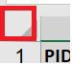

To select a range of cells that are adjacent to each other, click the first cell, hold Shift, then click the cell at the end of the range.

Or, click cell, hold Shift, then use arrow key to navigate to the cell at the end of that range.

To select non-adjacent cells, click the first cell, hold Ctrl, and select all the remaining cells.

# Cell Navigation

You can navigate to the cell by using the keyboard arrow keys or Tab/Enter:

|  |  |
| --- | --- |
| **To go** | **Use** |
| Right | 🡪 OR Tab |
| Left | 🡨 OR Shift + Tab |
| Down | 🡫 OR Enter |
| Up | 🡩 OR Shift + Enter |

Ctrl+Arrow will take you to the furthest cell in that direction. Note: This only works if there are no breaks in columns or rows.

To edit the cell’s contents:

* Double-click the cell, or
* Select cell then press F2, or
* Select cell then click the Formula bar:  
  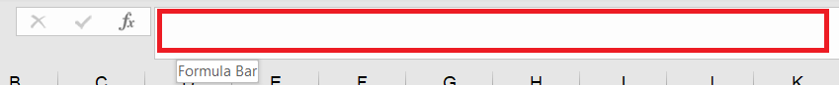

To exit edit mode:

* Enter key to commit changes, or
* Esc key to cancel changes

# Summary Statistics

1. Use the “Study Participants” worksheet.
2. Select the first five cells in the Age column (L2 through L6)  
   Table

   Description automatically generated
3. In the status bar, Excel gives you quick statistics for what it assumes you may want. Since this column contains numbers, it assumes you may be interested in the Sum of the data within the selected cells, the number (Count) of cells selected, and the Average of the data within the cells.  
   

Note: In some versions of Excel, it doesn’t show multiple statistics in the status bar. It will show you one, and you will need to click on it to view additional statistics.

# Freeze/Split Pane

## Freeze pane

Under **View** > **Freeze Panes**, you’ll see that there are three options. We will go through each of these options.  
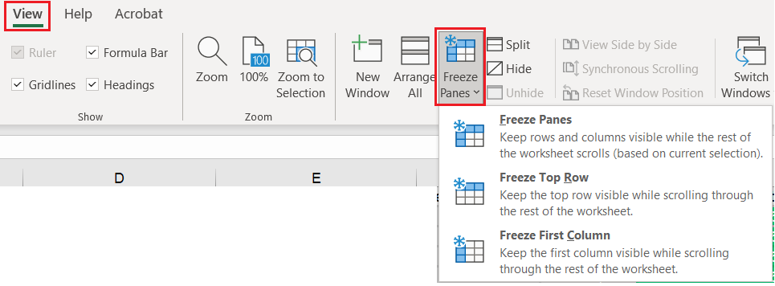

Use the “Study Participants” worksheet for these examples.

1. **Freeze Top Row**This will freeze the first row. As you scroll down, the first row will remain at the top. This is useful if your first row of data is the header row; it helps you keep track of the which columns are which while you’re scrolling down.
2. **Freeze First Column**This will freeze the first column. As you scroll to the right, the first column will remain at the far-left.
3. **Unfreeze Panes**If you’ve frozen any rows or columns, you can remove the freeze by clicking “Unfreeze Panes”  
   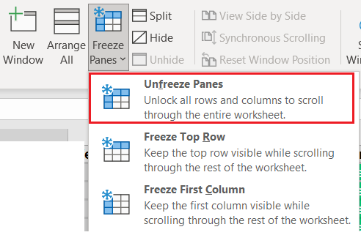
4. **Freeze Panes**This option allows us to freeze multiple rows and/or columns simultaneously.   
     
   Select the cell to the right of the column you want to freeze, and/or below the row you want to freeze.  
     
   Let’s freeze the header row, and the first four columns. Select the cell E2, then select “Freeze Panes”  
   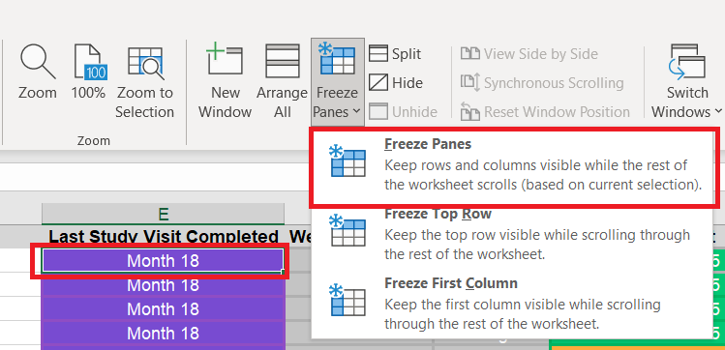

## Split pane

*To split a single worksheet:*

Similar to the “Freeze Panes” option, select the cell to the right of and/or below the area you want to split.

In this example, I want to have two scrollable panes side-by-side (left and right).

Click E1 then Split button.  
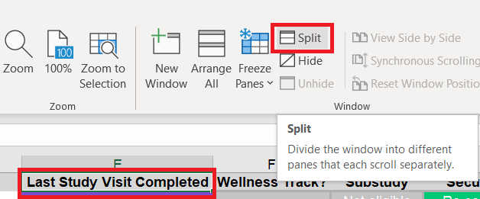

You can drag the divider to adjust the size of the panes.

When you’re done with this view, click the “Split” button again to disable the split.

*To view multiple worksheets simultaneously from the same workbook*

If you’ve tried to open the same workbook in different windows, you will usually get an error that you can’t open two workbooks with the same file name (even if it’s not actually the same file).

Instead, we can utilize a built-in feature.

In the **View** menu, click **New Window**.  
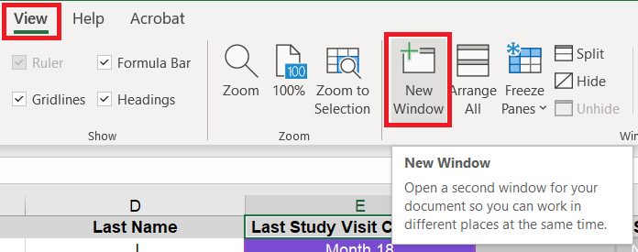

This creates something like a mirror of your file in a new window. Notice it says “ - 2” at the end of the file name in the title bar.   


You can switch between the windows using **Switch Windows**. This will display all your open workbooks. In this case, we have the same workbook in two windows.

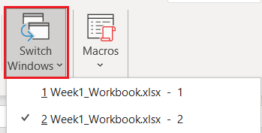

In this example, we’ll arrange the windows side-by-side. Click **Arrange All**, and select the **Vertical** option. Check the box for “Windows of active workbook” so that it will only arrange the current workbook instead of all Excel files you have open.  
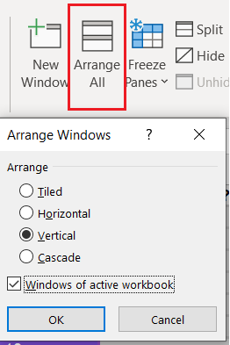s

Now, we can view one worksheet in one window, and select a different one in a second window. Since these are mirrors of one another, any changes you make in one window will be reflected in the second window.

When done, close out any of the windows, and your file name will revert back to its name without any numbers at the end.

# Sorting

## Quick sort

Under the **Data** menu, there are two icons for Quick Sort.   
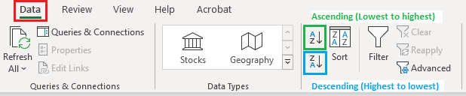

1. Select a single cell in the column you want to sort.
2. Click Sort A to Z to perform an ascending sort (A to Z or smallest number to largest).
3. Click Sort Z to A to perform a descending sort (Z to A or largest number to smallest).

## Advanced sort

For more advanced sorting options, click on **Sort**.  
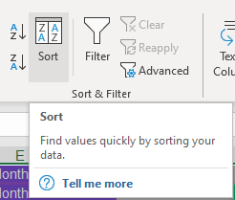

For example, we can sort alphabetically by CRC, then by PID ascending.

1. Sort by **CRC** in **A to Z** order  
   Graphical user interface, text, application

   Description automatically generated
2. Click **Add level**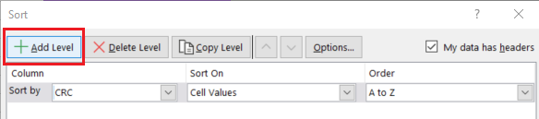
3. Then by **PID** in **Smallest to Largest** order  
   Graphical user interface, application

   Description automatically generated
4. Click **OK** to apply the sort  
   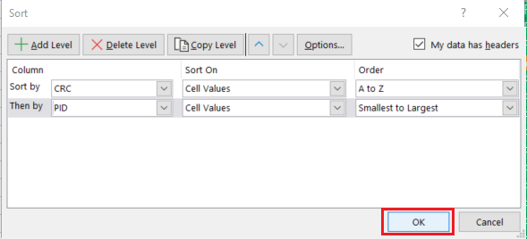

# Filtering

You can quickly apply filters to every column by clicking the **Filter** button.  
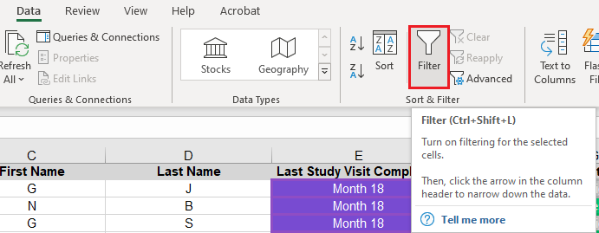

Or, you can apply filters to individual columns by selecting the column(s) before clicking the Filter button.

From the filter dropdown, you can:

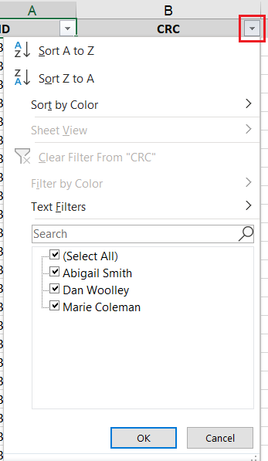

* Sort the column
* Filter before sorting
* Just filter

To remove the filters, click the **Filter** button again.

# Conditional Formatting

Example 1: Indicate if there are duplicate values in the PID column. Bonus points for sorting them to the top for visibility.

1. Select the PID column  
   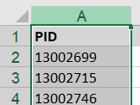
2. Under the **Home** menu, click **Conditional Formatting**, hover over **Highlight Cell Rules**, then select **Duplicate Values**  
   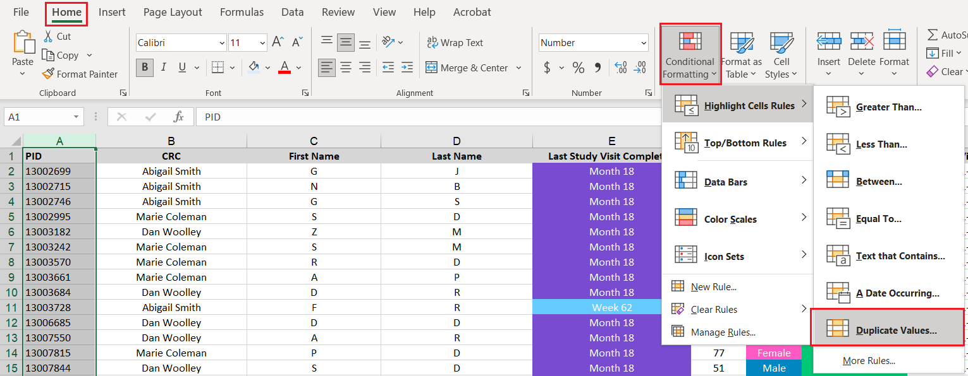
3. Click **OK** to proceed with the default condition and formatting  
   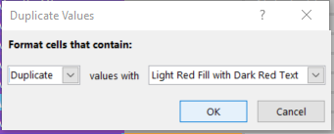
4. If you scroll down, you will notice that the duplicate values have a different format applied to the cells  
   Text, application

   Description automatically generated
5. Under the **Data** menu, click **Sort** to enter the dialog. Apply these sort settings and click **OK**  
   Graphical user interface, application

   Description automatically generated
6. The rows with duplicate PIDs have now been sorted to the top  
   Table

   Description automatically generated

Example 2: Identify participants who are between 40 and 64 years of age (inclusive).

1. Select the Age column  
   A picture containing timeline

   Description automatically generated
2. Under the **Home** menu, click **Conditional Formatting**, hover over **Highlight Cell Rules**, then select **Between...**  
   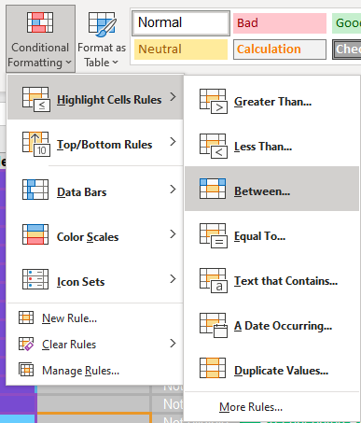
3. Update the age range values, and click **OK**  
   Graphical user interface, application, Teams

   Description automatically generated
4. The format will be applied to the cells  
   Table

   Description automatically generated

To view/edit/delete rules that have been applied, click the **Conditional Formatting** button and select **Manage Rules**  
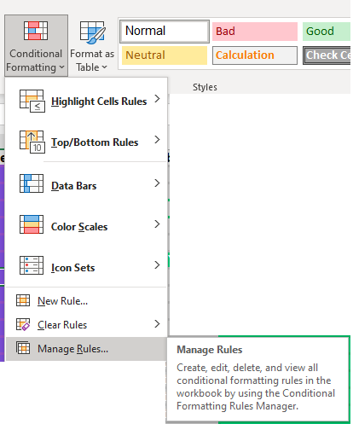

The dialog displays the conditional formatting rules along with order in which rules are applied

To clear all rules, click on the **Conditional Formatting** button, hover over **Clear Rules**, then select one of the options.  
