Week 2: Introduction to Formulas and Functions

# Terminology

A **formula** is an expression which calculates the value of a cell.  
- You let Excel know that you want to calculate something by typing an **=** (equals sign)  
- Formulas can contain cell references, ranges of cell references, operators, and constants.

### Exercise: In Sheet1, add A2 and B2, and put the result in C2

1. Click on C2
2. Enter formula: =A2+B2
3. Press *Enter* to calculate.

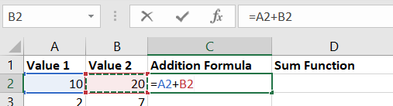

- A formula can contain a function

**Functions** are pre-defined formulas available in Excel.

Under the *Formulas* tab under Functions Library, you should be able to find every function you need.

If for some reason it doesn’t fit your need, know that you can also create custom functions (not covered in this workshop).

# Using Formulas

Here’s an example of using the function SUM. The values within the parenthesis are called **arguments**.

### Exercise: In Sheet1, use the SUM function to sum values A2 through B2, and put the result in D2

1. Click on D2
2. Input the equals sign.  
   As you start typing a function name, Excel will launch Intellisense, which will list all of the functions starting with the letters you type.  
   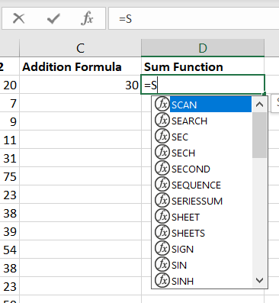
3. Use the up/down arrow keys to navigate to the function you want.  
   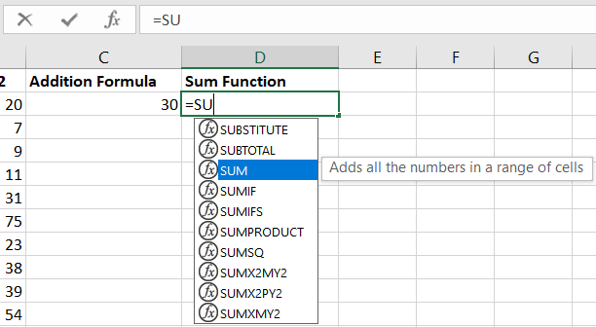
4. When you press *Tab*, Excel will automatically finish the function name and enter the opening parenthesis for you. It will also display the optional and required arguments. Optional arguments in square brackets.  
   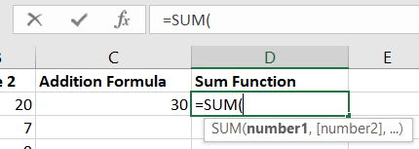
5. Use the cursor to select A2 through B2 or type in *A2:B2*. Then add the close parenthesis.  
   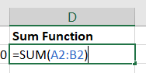
6. Press *Enter* to calculate.  
   Graphical user interface

   Description automatically generated
7. Note: In this case, you didn’t need to manually add the close parenthesis. If you pressed *Enter* after entering the arguments, Excel would have added the parenthesis for you. However, it’s good practice to add the close parenthesis because when we get to Nested Functions in a later workshop, it will be important to close your parentheses.
8. We selected a range of cells to SUM. The colon denotes we used a range, and not a list of arguments.  
   Graphical user interface, text, application, chat or text message

   Description automatically generated

# Auto Fill Formulas

### Exercise: In Sheet1, use the Fill Handle to copy formula from C2 to C3

1. Click on C2.
2. Hover over the lower-righthand corner of C2, and your cursor should turn into the Fill Handle (solid plus sign).  
   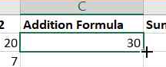
3. Click and drag to the bottom of C3.  
   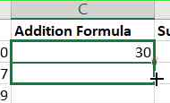
4. Release the Fill Handle.  
   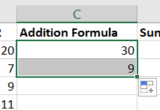

### Exercise: Use the Fill Handle to copy formula from D2 to D3

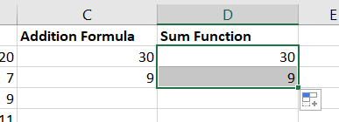

You can also copy multiple cells at the same time.

### Exercise: Use the Fill Handle to copy formulas from C3 and D3 to C4 and D4 simultaneously

1. Select C3 and D3.  
   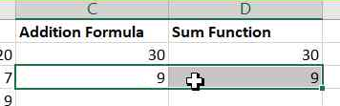
2. Find the Fill Handle at the bottom-right corner of D3.  
   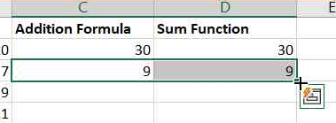
3. Drag the Fill Handle down one row.  
   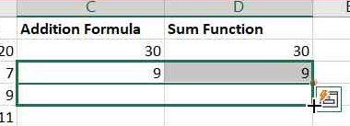
4. Release the Fill Handle.  
   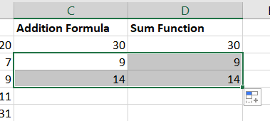

You can Auto Fill down a column by double-clicking the Fill Handle.

### Exercise: Double-click the Fill Handle to copy down C4 and D4 simultaneously

1. Select C4 and D4.  
   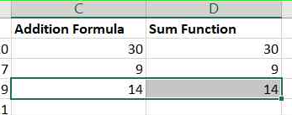
2. Find the Fill Handle at the bottom-right corner of D4.  
   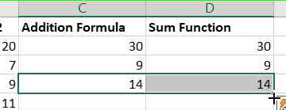
3. Double-click the Fill Handle, and the remainder of the cells will be populated.  
   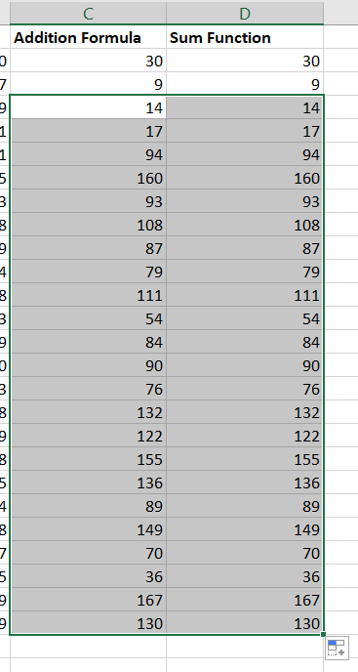

# Auto Fill Data

Auto Fill can also be used to fill in data. Use Sheet2 for the following exercises.

### Exercise: In Column A, use Auto Fill to add the same number

1. Type in a number into A3.  
   Table

   Description automatically generated
2. Drag the Auto Fill handle to fill in the next 10 or so cells in the same column.  
   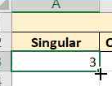  
     
   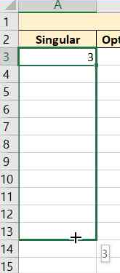
3. All cells should have the same number.  
   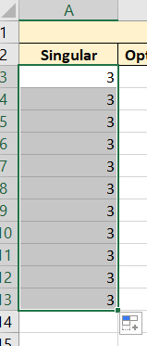

### Exercise: In Column B, use Auto Fill options to add the sequential numbers

1. Type in a number into B3.  
   Diagram

   Description automatically generated with medium confidence
2. Drag the Auto Fill handle to fill in the next 10 or so cells in the same column.  
   Table

   Description automatically generated  
     
   Table

   Description automatically generated
3. After releasing the Fill Handle, an Auto Fill Option menu should appear.  
   Table, Excel

   Description automatically generated
4. Click the dropdown icon and select Fill Series.  
   Graphical user interface, application, table, Excel

   Description automatically generated
5. Instead of copying the same number, you should now have a sequential series of numbers.   
   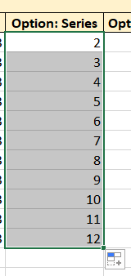

### Exercise: In Column C, use Auto Fill to fill in sequential numbers, then change to duplicating set of numbers

1. Type two sequential numbers into C3 and C4.   
   Graphical user interface, application, table, Excel

   Description automatically generated
2. Drag the Auto Fill handle to fill in the next 10 or so cells in the same column.  
   Application, table, Excel

   Description automatically generated
3. Because we typed in two numbers, Auto Fill continues filling in cells as sequential numbers.  
   Table

   Description automatically generated with low confidence
4. We can use the “Copy Cells” option in the Auto Fill Options menu to repeatedly duplicate the numbers instead.  
   Graphical user interface, application, table, Excel

   Description automatically generated  
     
   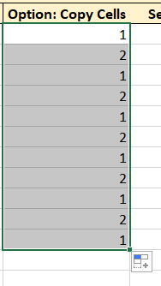

### Exercise: In Column D, use Auto Fill to fill in sequential numbers

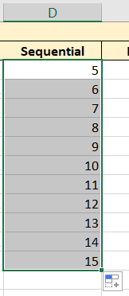

### Exercise: In Column E, use Auto Fill to fill in pattern series of numbers

Excel can auto fill numbers based on patterns, such as odd, even, or multiples of 5. We’ll use odd numbers for this exercise, but feel free to try other patterns.

1. Type in 1 and 3 into cells E3 and E4 respectively.  
   Graphical user interface, table

   Description automatically generated
2. Drag the Auto Fill handle to fill in the next 10 or so cells in the same column.  
   Table

   Description automatically generated  
     
     
   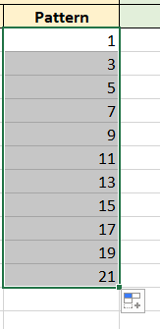

### Exercise: In Column F, use Auto Fill to fill in duplicate sets of text

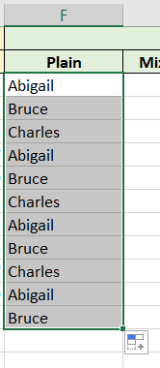

### Exercise: In Column G, use Auto Fill to fill in sequential text mixed with numbers

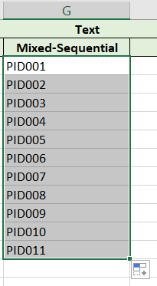

### Exercise: In Column H, use Auto Fill to fill in patterned text mixed with numbers

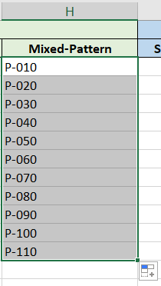

### Exercise: In Column I, use Auto Fill to fill in sequential dates

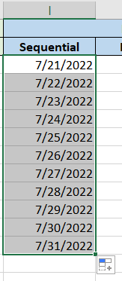

### Exercise: In Column J, use Auto Fill to fill in pattern series of dates

Excel can also auto fill dates based on patterns, similar to patterns for numbers. We’ll use increments of 7 (weekly) for this exercise, but feel free to try other patterns.

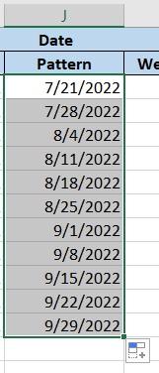

### Exercise: In Column K, use Auto Fill to fill in pattern weekdays using the Auto Fill Options menu

1. Type a date into K3.  
   Table

   Description automatically generated
2. Use the Fill Handle to fill in more dates.  
   Graphical user interface, application, table, Excel

   Description automatically generated
3. Select the “Fill Weekdays” option under the Auto Fill Options menu.  
   Graphical user interface, application, table, Excel

   Description automatically generated
4. This will replace the filled cells with dates of weekdays. Note that it doesn’t check if the dates you inputted are weekdays, only the cells Auto Fill has filled in.  
   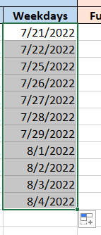

### Exercise: In Column L, use Auto Fill to fill in full calendar month names

1. Type the full name of a calendar month into L3.   
   A picture containing diagram

   Description automatically generated
2. Use Auto Fill to continue the sequence.  
   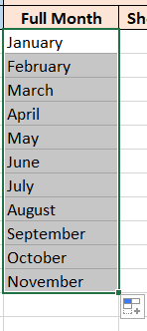

### Exercise: In Column M, use Auto Fill to fill in shortened calendar month names

1. Type the shortened name of a calendar month into M3.   
   Diagram

   Description automatically generated
2. Use Auto Fill to continue the sequence.  
   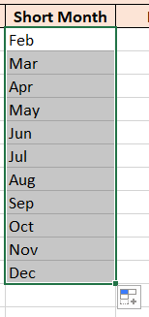

You can also do the same with day of week.

### Exercise: In Column N, use Auto Fill to fill in ranks

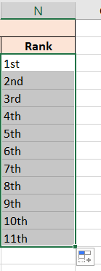

# References

Types of cell references:

1. The default cell reference is **relative** to the cell you’ve selected.
2. **Absolute** cell references do not change.
3. A cell reference can also be **mixed**, if one part of the reference (column name or row number) is absolute while the other is relative.

You can also refer to a cell in another worksheet, but we will not cover this in this workshop.

Additional reading: https://support.microsoft.com/en-us/office/switch-between-relative-absolute-and-mixed-references-dfec08cd-ae65-4f56-839e-5f0d8d0baca9

Use Sheet3 for the following exercises.

### Exercise: Calculate the subtotals (Column D) for all the products

1. In D4, enter formula to multiple B4 by C4.  
   Graphical user interface, application, table, Excel

   Description automatically generated   
     
   B4 and C4 are **relative** cell references. While we understand we are looking at the values in cells “B4” and “C4,” Excel understands the instructions as “2 cells to the left” and “1 cell to the left,” respectively.
2. Press *Enter* to calculate the value. When your cursor turns into the Fill Handle, double-click to fill in the rest of the cells.  
   Table, calendar

   Description automatically generated
3. D4 through D7 should look like this:   
   Table

   Description automatically generated
4. Notice how the copied formula has changed for each cell:  
   Graphical user interface, application, table, Excel

   Description automatically generated

As we move down in column D, the cell references update correspondingly to look for values “2 cells to the left” and “1 cell to the left.”

### Exercise: Include the sales tax (B1) to calculate the totals (Column E) for all the products

1. In E4, enter the formula to include sales tax.   
   Graphical user interface, application, table, Excel

   Description automatically generated
2. Add the close parenthesis and press *Enter* to calculate.  
   Graphical user interface, application, table, Excel

   Description automatically generated
3. Double-click the Fill Handle to auto fill the remaining cells.  
   Table

   Description automatically generated
4. Hm. This doesn’t look right. As you can see in E5, the formula is referring to B2, which is empty. This is because both cell references in the formula are relative.  
   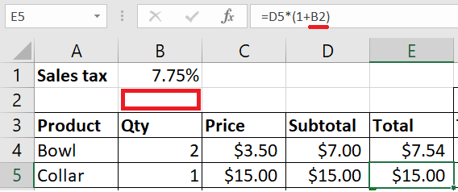
5. In order to instruct Excel to use an absolute reference, we put a **$** (dollar sign) in front of the column letter or row number we want to “freeze.” In this case, we want to always refer to the cell B1 for sales tax. Therefore, we need to update the formula for E4 to use an absolute reference to B1 by including $ in front of B and 1.  
   Graphical user interface, application, table, Excel

   Description automatically generated
6. Now when we double-click the fill handle, the totals are correct.  
   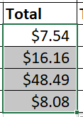
7. Check the formulas in each of the cells in E. The reference for the Subtotal updates, but the reference for sales tax does not.  
   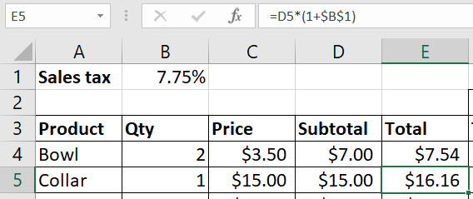

### Exercise: Use one formula to calculate the commission amounts across all tiers

1. Our sales reps earn commission on the post-tax amounts. In F4, enter the formula to multiply the total by the commission rate.   
   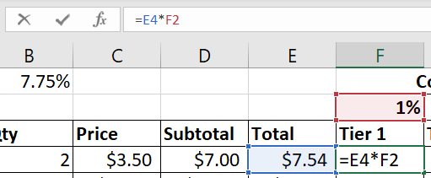
2. As we saw in the previous exercise, there will be issues if we try to apply this formula to all the commission cells. Since the first cell reference should always use column E for the total, we need to add a $ in front of “E”.  
   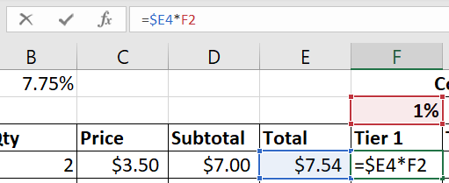
3. Since the second cell reference should always use row 2 for the commission percentages, we need to add a $ in front of “2”.  
   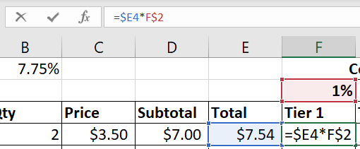
4. Press *Enter* to calculate the value.   
   Table

   Description automatically generated with medium confidence
5. Select cells F4 through H7.  
   Table, Excel

   Description automatically generated
6. Use shortcut Ctrl+D to auto fill the formula down the selected area.  
   Table, Excel

   Description automatically generated
7. Use shortcut Ctrl+R to auto fill the formula across the selected area.  
   Graphical user interface, application, table, Excel

   Description automatically generated
8. You could have also dragged the Fill Handle to auto fill all the cells, but this exercise was demonstrating the fourth method listed on Slide 4.  
   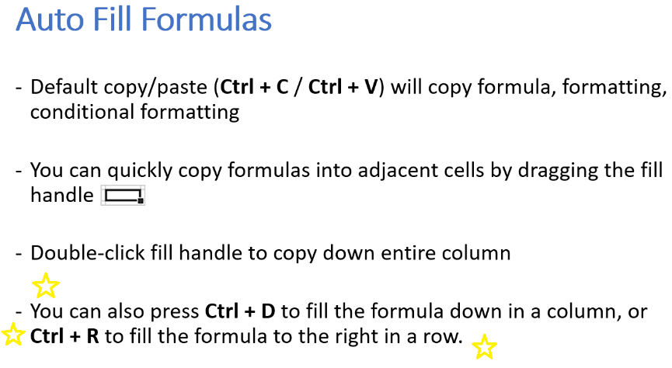
9. The two cell references in the formula are examples of **mixed** references: the column OR row is “frozen” but not both.

### Exercise: Change the sales tax rate (B1)

1. Change the sales tax rate to that of Los Angeles’: 9.5%  
   Graphical user interface, application, table

   Description automatically generated
2. The amounts in E4 through H7 have all updated to reflect this change in sales tax rate, without having to manually update any formulas.  
   Table, Excel

   Description automatically generated

## “X-Ray Vision”

Use Ctrl + ` (backtick) enter and exit the Formula Mode (or, as I call it, “X-ray vision,” which enables you to view all formulas in a worksheet.

