Week 4: Conditional Functions and Data Validation

I know that most people use Google Sheets for use at home. I wanted to note that almost everything we go over can also be applied to Google Sheets.

# Conditional Functions

**Conditional functions** let you sum, average, or count a range based on a given condition, or criteria you specify.

**COUNTIF** takes two arguments:  
- range to look in  
- value to look for within the range

Use the “Grocery list” worksheet for the following exercises.

### Exercise: In Column H, count number items for each grocery category in Column G

1. In H2, enter formula listed on Slide 3, then hit *Enter* to calculate.  
   Table

   Description automatically generated with medium confidence
2. Use the Fill Handle to copy the formula down  
   Application, table

   Description automatically generated
3. Since this was a relative reference, the range updated as the formula was copied down.  
   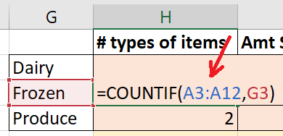
4. Instead, we need to use an absolute reference. Then copy the new formula down.  
   A picture containing table

   Description automatically generated
5. We can easily sum up the number of items using the Autosum feature.  
   Click on H5.  
   Under the **Formulas** tab, click on the **Autosum** button.  
   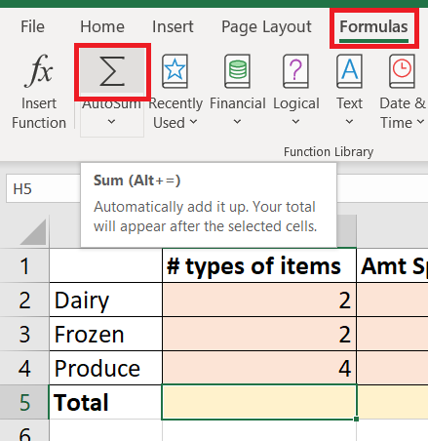
6. Autosum tries to sum up numbers it finds above the cell you selected.  
   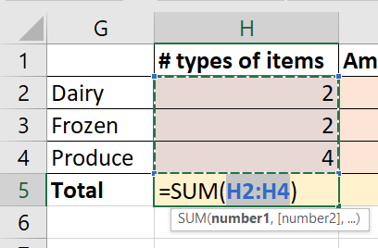
7. Confirm the range is correct, then press *Enter*.  
   Table

   Description automatically generated

**SUMIF** takes three arguments:  
- range to look in  
- value to look for within the range  
- optional: range to sum if value is found

### Exercise: In Column I, sum amount spent for each grocery category in Column G

1. First, we’ll need to calculate the totals in Column E.  
   Click on E2 and enter the formula to calculate the total.  
   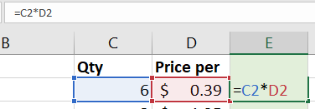  
     
   Then use Auto Fill to copy the formula down.  
   Table

   Description automatically generated
2. Use Autosum in E12 to get a total of $42.02  
   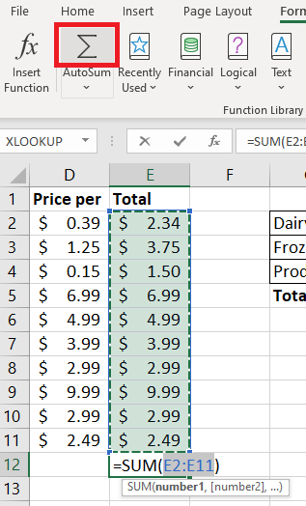
3. In I2, enter formula listed on Slide 4, then hit *Enter* to calculate.  
   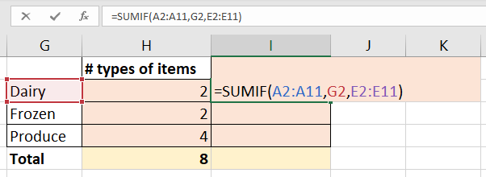
4. Similar to the last exercise, we will need to use an absolute reference for *both* ranges.  
   Table

   Description automatically generated
5. Use Auto Fill to copy the formula down.  
   Table

   Description automatically generated
6. Use Autosum in I5  
   Table, Excel

   Description automatically generated

# Data Validation

Having the totals in two places (E12 and I5) is a simple way to crosscheck your work. As you may have noticed, these totals don’t match. This is because there are more categories in Column A than we looked for in Column G.

Tip: Use **data validation** when possible. Watch the video in the link on Slide 5 for a brief overview of data validation.

There are many ways you can use data validation. For this workshop, we’ll focus on using dropdown lists.

### Exercise: Apply data validation to A2:A11 based on the categories in Column G.

1. Select A2:A11
2. Under the **Data** tab, click on **Data Validation**.  
   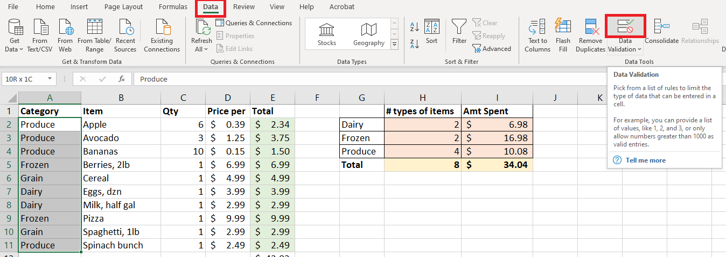
3. Under the **Allow** dropdown, select **List**.  
   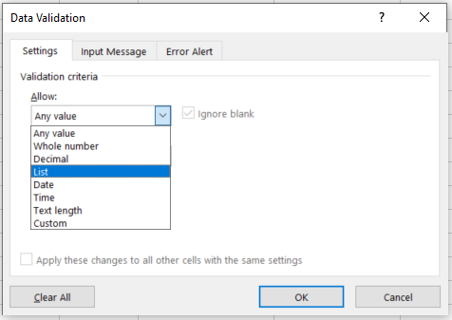
4. Click the **Source** button.  
   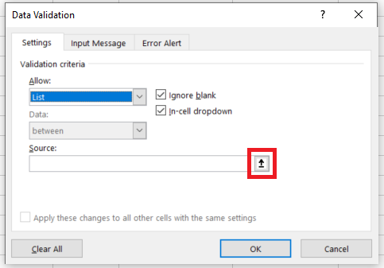
5. The dialog will allow you to type in a source range, or select it manually.  
   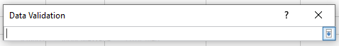
6. Select G2:G4, and it will populate the input for you.  
   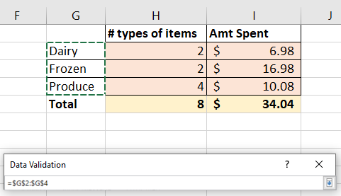
7. Press *Enter* then click **OK**.  
   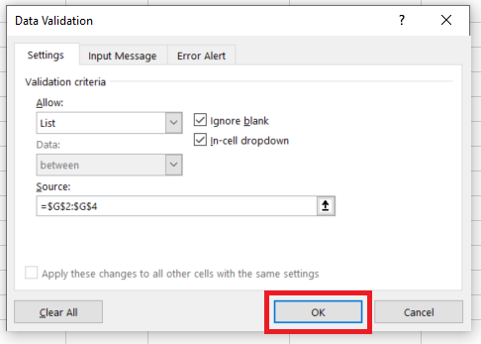
8. Your cells in A2:A11 should now have a dropdown option if you click on the cell.  
   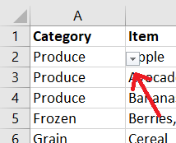  
     
   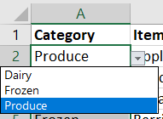

Since the data validation was applied after the values were inputted, the data validation isn’t able to catch values that aren’t in Column G.

### Exercise: Use Data Validation to find invalid data

1. Click on the dropdown list next to **Data Validation** and select the option **Circle Invalid Data**  
   Table

   Description automatically generated

### Exercise: Add “Grain” to categories in Column G

1. I prefer to keep lists alphabetized, so we will insert “Grain” before “Produce” in Column G.  
   Select G4:I5  
   Table

   Description automatically generated
2. It’s fastest to copy and paste. Ctrl+C to copy.  
   Click G5 and Ctrl+V to paste.  
   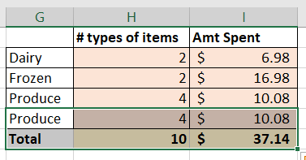
3. Change the value of G4 to “Grain” then press *Enter*.  
   Table

   Description automatically generated
4. Use Autosum to update the totals in H6 and I6.  
   Table

   Description automatically generated

The totals in E12 and I6 now match, but we still need to update the dropdown list source.  
*Note: It is best practice to use Excel tables because you wouldn’t have to update the references if your table grows. However, we will cover Excel tables in a different workshop. Knowing how to update your source data manually is useful because Excel tables don’t exist in Google Sheets.*

### Exercise: Update data validation dropdown list for A2:A11

1. Select A2:A11. Under the **Data** tab, click **Data Validation**.
2. You can manually change the source, or repeat the steps in the exercise above to select the cells for the source. Here, I’ve manually changed the “4” to “5”. Click **OK**.  
   Graphical user interface, application

   Description automatically generated
3. The data validation circles are now gone  
   Table

   Description automatically generated

# VLOOKUP

**VLOOKUP** is a powerful function to look up and return a value based on a match.

Use the “Twilight” worksheet for the next exercise.

Exercise: Use VLOOKUP in G2 to find the type for the character selected in E2

1. Select cell G2 and enter the formula from Slide 7. Press *Enter*.  
   A picture containing table

   Description automatically generated
2. You can now use the dropdown list in E2 to select a character to change the output in G2.  
   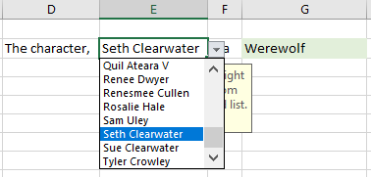

Slide 8 has the basic rules for using VLOOKUP.

Use the “Bulk order” worksheet for the next exercise. This worksheet has been set up to use a VLOOKUP with an approximate match (range_lookup=TRUE)

Exercise: See how the range_lookup argument is used in B8 for the quantity entered in A8

1. The value for B8 is #N/A, an error, because there is nothing entered in A8.  
   Table

   Description automatically generated
2. Enter “100” into A8. The discount the customer would receive is 1%.  
   Table

   Description automatically generated
3. If we enter “250” into A8, the discount is 2%. What if the customer orders 200 pieces? The customer should only receive a 1% discount because they had not reached the minimum quantity of 250 to receive the 2% discount.  
   Table

   Description automatically generated

Since we set the final argument range_lookup to TRUE, VLOOKUP returns the closest number smaller than the value we’re looking for. In this case, 100<200, and it returns the discount for quantity 100. Remember that when setting the argument range_lookup to TRUE, the range (column A here) must be sorted from smallest to largest.

Exercise: Import a table of US state names and abbreviations. Use VLOOKUP in “Registrants” worksheet to return the value of the state abbreviations.

Note: You need Excel 2019 or later for this exercise.

1. Under the **Data** tab, click on **From Web**  
   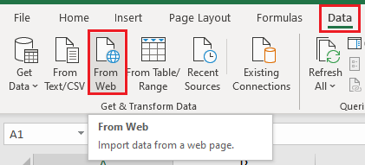
2. Enter the URL from Slide 9 then click **OK**  
   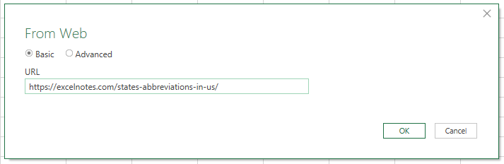
3. Select **Table 0** then click **Load**  
   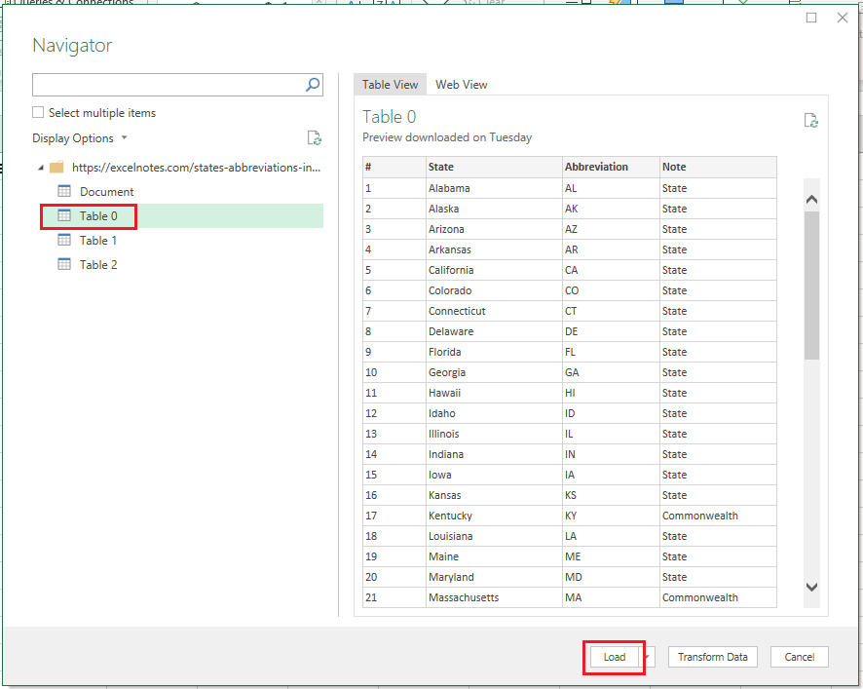
4. Since we didn’t specify a worksheet, the table will be added to a new worksheet  
   Table

   Description automatically generated with medium confidence
5. On the “Registrants” worksheet, click on C2 and enter formula  
   Graphical user interface, text

   Description automatically generated
6. Since the cell reference of the lookup is an Excel Table, we don’t need to use absolute references. Use Autofill to copy down the formula.  
   Table

   Description automatically generated

# Example: Simple budget

This example demonstrates using different concepts reviewed in Workshops 1 – 4.

Remember you can use Ctrl + ` to toggle viewing all the formulas on a worksheet.

“Income breakdown” worksheet

Categories for different expenditures are in Column A.

In Column D, we can break down the categories further to make it easier to identify expected expenditures.

Column B uses SUMIF to add up the budgeted amount from Column E.

“July Expenditures” worksheet

We can use this worksheet to add our expenditures for July as they come in.

Column D uses a data validated dropdown with the categories in “Income breakdown” Column A.

As expenditures are added, the amounts will be added in Column J using SUMIF.

Column H has a “Base Budget” uses VLOOKUP to find your budget amounts from the “Income breakdown” worksheet.

Column I references the values in Column H, but you can adjust the month’s budget if you are expecting a change. For example, if your pet has their annual vet visit, you can increase the budgeted amount for “Pet” for the month.

Column K uses nested IF statements to show different statuses after comparing the values between Columns I and J. Conditional formatting has been added to make it easier to identify whether you are approaching or over your specified budget.

Duplicating the worksheet

You can duplicate the worksheet for each new month.

1. Right-click “July expenditures” and select **Move or Copy…**  
   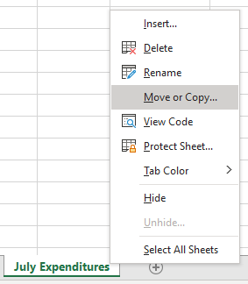
2. Choose where you want the copy. In this case we will use “(move to end)”. Check “Create a copy” then click **OK**.  
   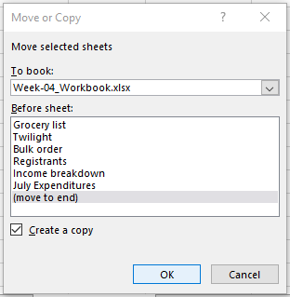
3. Right-click the duplicated worksheet and select **Rename**.  
   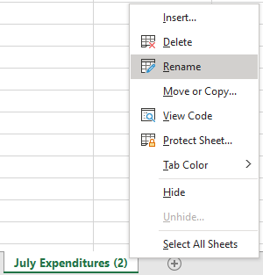
4. Rename to “August Expenditures”  
   
5. Assuming you pay rent (or mortgage) monthly, select A3 through D18.  
   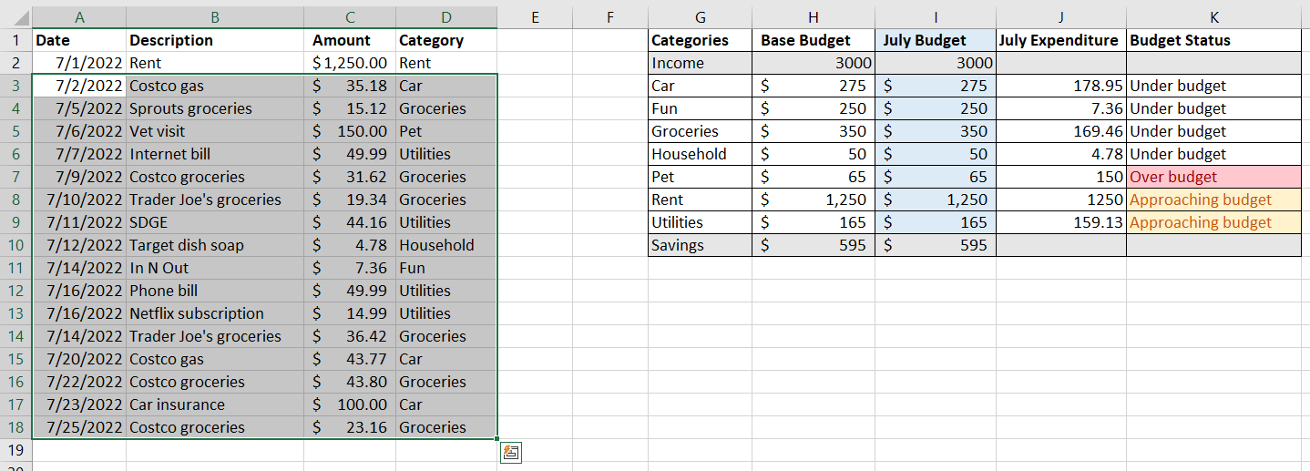
6. Press *Delete* to delete the values in the cells.  
   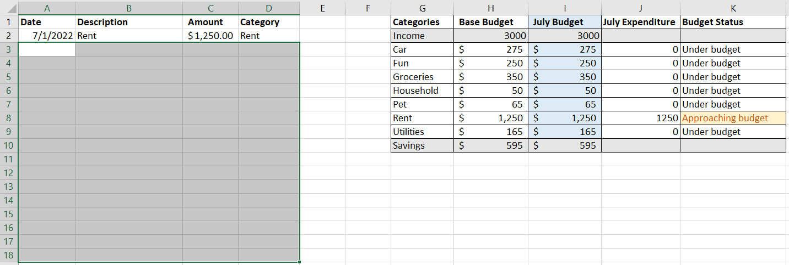
7. Update A2, I1, and J1 to current month.  
   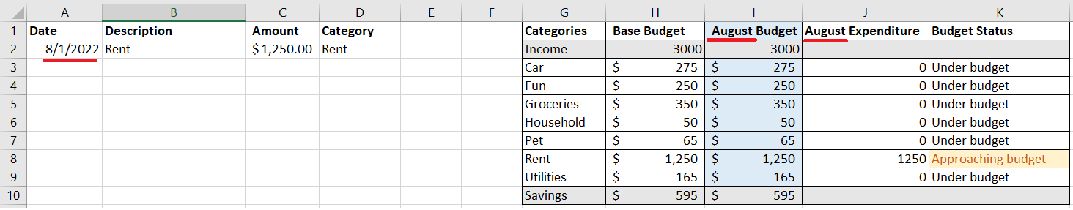

# LOOKUP Family

There are three functions in the LOOKUP family:

* **VLOOKUP**, used to search vertically in a range.
* **HLOOKUP**, used to search horizontal in a range.
* **XLOOKUP**, which can be used in both directions. Note: this is only available in the newest version of Excel (365).