Alternative method for input text on a mobile device with iOS system

Marek Truszkowski
Warsaw University of Technology

Warsaw, Poland

Abstract—Gesture keyboard application gave possibility to input text on mobile device operated under control of iOS Apple Inc. operating system. Software implement receive taps and swipe gesture and provide appropriate string of chars. System respond for single touch. Letter composition include normal keyboard layout and frequency of use in English language.
Keywords—keyboard; gesture; iOS; Apple; swift; touches; swipe;

Introduction
In the last years world of mobile devices grow and evaluate very fast. Electronics components are getting smaller and more efficient at the same time. Devices from few years back, size of shoes box now we can put in the pocket or even wear on the wrist. Companies year by year introduces us more and more personal devices. This matter has big influence for people who become more “mobile”.
Personal computers used lately to most of the things like mail, news, organization, work, design, communication, education, internet, social media or even writing; now are replaced by smart devices such as tablets, smartphones or watches. Those devices are smaller and the user - device communication is different. Smartphones don’t have mouse and keyboard like we used to have in our laptops, they even don’t have almost any buttons. That communication is solved in some others ways. One of that is voice command, what is intensively developed right now by most of the leading companies. Another is touch screen on which we focus on.
Touch screen features like tap or moving give as a lot of capabilities like pointing, scrolling or selection to interact with device.
The basic way to sending information from us to device is type it in the keyboard. Standard keyboard looks like normal keyboard and we can input letters by touching the screen on the place where letter is displayed. But what when our fingers are much bigger than letter on the screen? The mishit is common problem on that type of keyboard. What if the screen is a size of a arm watch? Now we don’t have good solution for that.
Normal “QWERTY” keyboard was designed for typing by ten fingers. But on our smartphones most of us use only one finger. Combining this observation with the growing smartphone using to input information, one concludes – from computer science point of view – that the best way to succeed is build a keyboard that will be easy to use and capable to fit in small area.

Goal
The goal of the keyboard is to input text in easy way using gestures, taps and swipes. Keyboard also provide functionalities like backspace, capitalization, return, typing numbers and most used special characters or separators from around of the touching area. Letter scheme will be loaded from properly formatted file, what gives an easy and code error less system to customize the heart of a project. To prevent mishit or other mistake during the typing there are real – time feedback solutions that will be show to the user currently character to send to system proxy. Other function forced upon Apple is “Next keyboard button” what allowed to change keyboard whenever it is needed.

Operating system iOS
B iOS is a mobile operating system created and developed by Apple and distributed exclusively for Apple hardware like iPhone, iPod touch, iPad or Apple TV. Before seventh of June 2010 known by iPhone OS. System base on the operating system Mac OS X 10.5 and kernel Darwin.
Darwin is evaluation of connection Mach kernel v 3.0 (1985 – 1994 researched on Carnegie – Mellon University) and tools and services from systems FreeBSD and NetBSD which both have sources in 4.4BSD, which means the Darwin roots reach for historic Unix. Darwin source code is freely available under license APLS (Apple Public Source License).
Current release, iOS 9.2 was released on December 8, 2015. System is divided for four abstraction layers: Core OS (hardware software interaction), Core Service (based libraries to handle network, applications, data bases etc.), Media (audio, video, graphic) and Cocoa Touch (user interface and user interaction).
Since iOS is designed to be simple and easy to use, it does not include several features found in a traditional operating system. For example, user cannot mange files and folders like on Windows, Mac or Linux. There is also limited access to system settings.
iOS SDK firstly released sixth of march 2008 to developers for free, but for publication applications in App Store is needed paid version of developer program. Apple also takes 30% od profit from application. All applications are individually checking and authorized by Apple and distributed by iTunes with digital signature. This model of distribution allows prevent from propagation malicious software and enables central control of actualizations and withdrawal an app. Which let to ensure high standard of safety and quality for users.

Extension Keyboard
A Release of iOS 8 bring some new feature, one of those is the addition of 3rd Party Keyboard as App Extensions.
“A custom keyboard replaces the system keyboard for users who want capabilities such as a novel text input method or the ability to enter text in a language not otherwise supported in iOS. The essential function of a custom keyboard is simple: Respond to taps, gestures, or other input events and provide text, in the form of an unattributed NSString object, at the text insertion point of the current text input object.” [1]
Custom keyboard that once set by user in one app will be opened in every single other app. For this reason, Apple Inc. require that product must at minimum provide certain base futures, most important is the keyboard must allow the user to switch to another keyboard.
Apple Inc. in documentation also give us a clue to understand user expectations for keyboard, giving us an example of its own, system keyboard. It’s fast, responsive and capable. And it never interrupts the user with information or requests. By features that user also expects they mean things as:
• Picking from among a set of top – level domain suffixes,
• Automatic capitalization,
• Auto correction and suggestion,
• Caps lock support,
• Automatic period upon double space,
• Appropriate layout and features based on keyboard type trait
• Keycap artwork
• Multistage input for ideographic languages
But there is not permitted and developer can decide whether implement such features or not.
There also some features in system keyboard unavailable to custom keyboard such as:
• Does not have access to keyboard settings in Settings App (Auto – Capitalization, Enable Caps Lock, Reset Keyboard Dictionary)
• Text input objects that keyboard is not eligible to type into like secure text input objects (system temporally change keyboard when user need is focused on secure text input object)
• Text input to type in phone number like in Contacts
• Apps that developers turn on option always system keyboard like banking apps
• Cannot offer inline auto correction controls near the insertion point
• Has no access to device microphone, so dictation is not possible
• It is not possible to display key artwork above the top edge

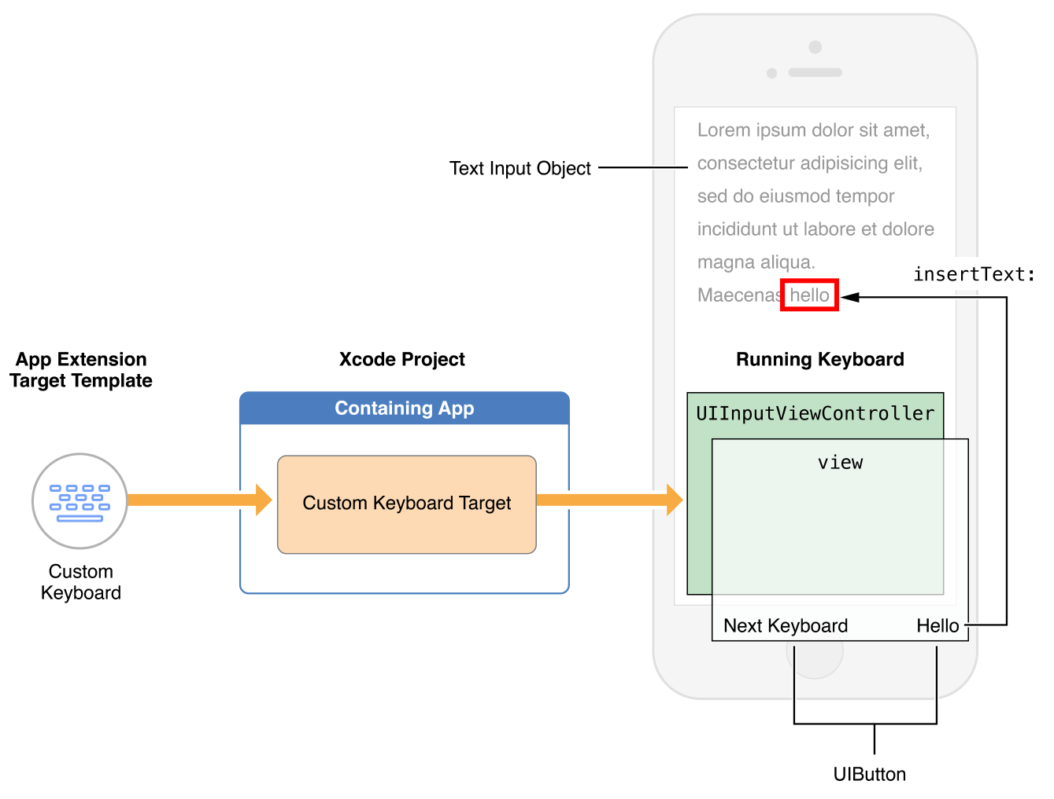

- Basic structure of a custom keyboard (source: https://developer.apple.com/library/ios/documentation/General/Conceptual/ExtensibilityPG/Keyboard.html)
Figure 1 presents structure of custom keyboard. As we can observe, keyboard app is limited to the view in down part of the screen.

System design

The Keyboard is build from 8 triangular fields with one circle on the middle, which are on rectangular area called touchView in class representation. Around that area are some buttons to input characters like numbers or often used special characters. Buttons responds to simple tap gesture. Letters are placed in the middle of triangle fields. Placed in way to show direction of movement causes chose that letter.
Composition letters in touches area is relevant to normal keyboard layout. Arrangement of letter in triangles is caused frequency of use that letter in English language. Letter are only from English alphabet and there are no other characters. (Fig. 2)
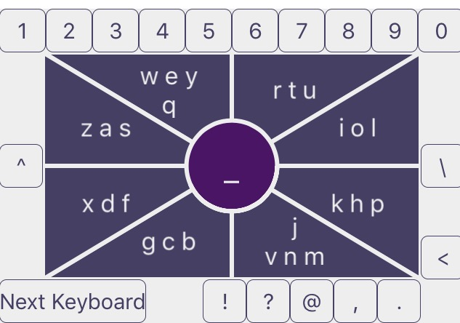
- Print screeen of keyboard design
On the middle of keyboard there is a circle. Circle is the crucial element of the keyboard. It has many roles such as receive tap events but also show feedback immediately. Circle show character that will be send to operating system after accept by release finger. It is also starting point to create more complicate movements.
Letter and fields are pre set on XML file. It gives possibility to quickly change the letter set, and set more than one keyboard for test. It will be also very useful in future improvements. XML file is parsing when the keyboard start working and views are draw after that base on parsed objects.
There is also visible on print screens “Next Keyboard” button. That button is required by Apple to give the user possibility to quick change the keyboard.

How to use

Keyboard are created in way, that respond on single taps but also on more complicated moves. Also it give fast feedback to better control of typing.

Taps
When user press on the triangle field, the respond circle show immediately letter that is on the middle of letters on current pressed triangle. Triangle while is being pressed change color to show that is selected (Fig. 3). When user release finger from screen, letter that is showed in middle circle is sending to operating system, and circle return to normal state.
After tap middle circle the character to send is space. Taps on other buttons around touch view send character showed on that button, there are also shift/caps lock, enter and backspace buttons.
By single tap is not possible to enter every letter.

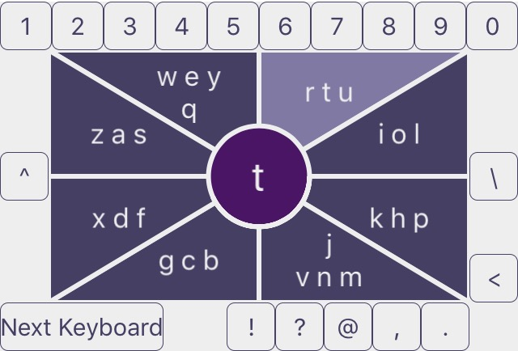
- Print Screen triangle is beeing pressed

Swipe

The other method to input text is swipe. When user press triangle and move finger to another field and cross the border the letter on middle circle change to letter show on the filed was pressed before that border. Letter placed in side of direction that follow move. After release the finger letter will be send to operating system. When movement finish on middle circle, the letter that will be send is the current showed letter with space after. There are two places where are four letters. To chose additional letter users need to move finger two border away in direction that letter is showing.

Complicate movements

Last option is create complicate movements to create strings of characters. The rule is simple, user need to:
- Start movement from middle circle
- Then go to filed with letter to chose
- Go back to chose middle letter or go to other field to border letter and go back to circle
- Without release the finger go from circle to another field and repeat choosing letter algorithm.
Release finger send string to operation system.

Conclusions
The Keyboard meets the project foundation. Give possibility to input words with double same letter and other challenges words.

- iOS Developer Library, Custom Keyboard https://developer.apple.com/library/ios/documentation/General/Conceptual/ExtensibilityPG/Keyboard.html

