**Flowgorithm exercises**

**Flowgorithm** is a graphical [authoring tool](https://en.wikipedia.org/wiki/Authoring_tool) which allows users to write and execute programs using [flowcharts](https://en.wikipedia.org/wiki/Flowchart). The approach is designed to emphasize the algorithm rather than the syntax of a specific programming language. The flowchart can be converted to several major programming languages. This application is free and its helps to create a programs using flowcharts, flowgorithm codes can use shape to represent the different actions that you want program perform and if you create a algorithm make sure the codes you will use is correct and appropriate because flowgorithms runs only if the shapes codes is correct.

M1 – Adding Two Numbers

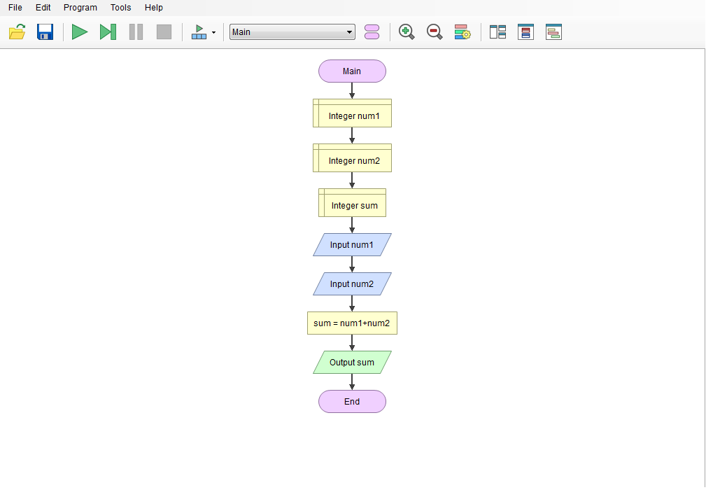

M2 – Getting the Area of a Circle using Radius and Diameter

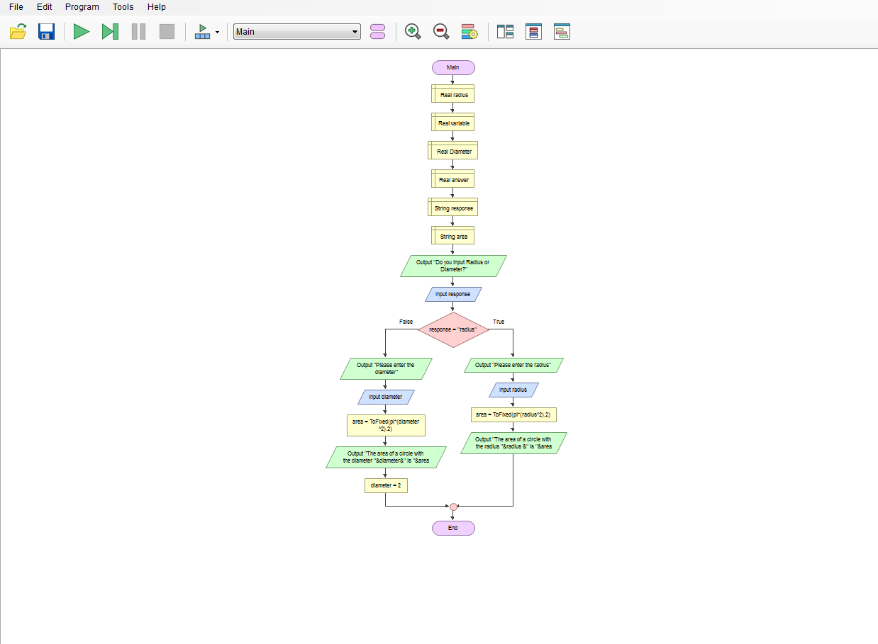

M3 – Odd and Even number Identifier

