Dancing Machaut’s Chansons baladées: Unfixed Forms and Mensural Missteps
Social dancing was an integral part of both courtly and country life in Medieval France and beyond. Indeed, “dance was ever-present in the lives of western Europeans from the late Medieval period to the middle of the eighteenth century” (Nevile 2008a, 2). The carole was the simplest and most common type of dance, well established in France by the mid-twelfth century (Mullally 1986, 224). Medieval French writings on a wide range of topics mention this dance and illuminated romances provide numerous depictions of the carole, such as that of Example 1. From these kinds of evidence, modern scholars have reconstructed the basic movement of the carole. What remains is to attempt matching those dance steps to music we know to have been danced and, in turn, to speculate about how musical structure encoded dance conventions. Alas, no European dance manuals or treatises exist before the fifteenth century (Nevile 2008a, 7). While securely matching fourteenth-century music to dance may remain elusive, this essay takes an initial step of identifying some norms as well as some complications ars nova mensuration can impose upon bipedal dancers and explores how the formal repeats of formes fixes lyrics can dislocate a dance’s regularity. Finally, I extend dance-step notation as a tool for the analysis of metrical grouping in fourteenth-century song more broadly. In whole, this study aims to foster a heightened awareness among modern interpreters of the dance roots of a considerable body of medieval French song and example how those roots can continue to shape our reading and performance today.

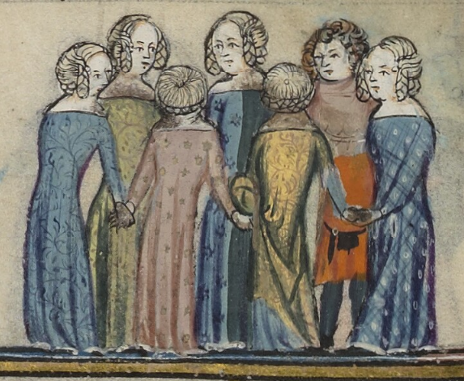
Example 1. dancing the carole; detail from MS Bodley 264, f. 172v (1338-44)
Unfortunately for scholars today, the carole was so simple that its proponents left very scant record of how to do it. The most revealing extant sources are colorful condemnations of carole dancing by clergy and other moralists. We read in Le Mireour du monde (anon. fourteenth century), for example, that “It is obvious that caroles are processions to the Devil, because they turn to the left. Of which Holy Scripture says: ‘God approves the ways that turn to the right; those that turn to the left are perverse and bad, and God hates them’” (Mullally 2011, 47). Or more descriptively in a sermon by Jacques de Vitry (before 1240) that the “chorea is a circle whose center is the Devil, and in it all turn to the left, because all are heading towards everlasting death. When foot is pressed to foot or the hand of a woman is touched by the hand of a man, there the fire of the Devil is kindled” (Mullally 2011, 49). The Latin and French verb ferir, common to many descriptions of caroling, suggests that after the left foot advanced, the right foot was brought together with a strike. From pairing such statements with a multitude of coeval illustrations of caroling, we know it to be a round dance proceeding clockwise with hands held. The typical participants were youthful women and men in alternation, when men were involved at all. The music of the carole was a song sung by the dancers, on rare occasion accompanied by a percussion instrument keeping the beat (Mullally 2011, 88). The carole was thus not a concert—music projected outwards for auditors—but for the entertainment (and often courtship) of the performers themselves. Its heart was the refrain; simple, catchy tonal aphorisms sung again and again by the choir of dancers. The verses were sung by a soloist from among the group, and each successive dance would be offered by a new lead singer. An exemplar for this role can be found in Dame Gladness from the influential Roman de la Rose (complete by c. 1270), who leads the central carole in the garden. “She had a voice that was both clear and pure; about her there was nothing rude, for she knew well the dance steps, and could keep good time the while she voiced her song” (Robbins 1962, 16).
That singers and dancers were one grounds inquiry into interplay between these paired kinds of movement through time. The analyses to follow suggest that the learned composer Guillaume de Machaut (1300-77) layered grouping and tonal play upon the steady metrical foundation that pairs naturally with the simple steps of the carole. Throughout, I explore the question of dancers responding to certain types of metrical flexibility and ambiguity made possible through ars nova mensural innovation, a testable premise without definitive Medieval answers. Specifically, how can dance interpret a steady stream of pulses that are weighted unequally by the feet and grouped irregularly in a variety of musical ways. The metrical and tonal tensions explored in my analyses of danced song reveal something that cannot be seen in manuscript or in modern score, nor can they be felt in a concerted performance today. Yet they may have been top of mind to the Medieval composer, singer, and dancer.
Theorists of sixteenth-century music make explicit mention of the embodiment of metrical division through the lowering and raising of the hand, recurring in two-part succession, sometimes relating this outward manifestation to the duple timekeeping of the heartbeat. According to Aristotelian doctrine, “time was only rendered sensible as a description or quantification of enacted motions or changes” (Grant 2014, 15). If conducting with the hand represented for Renaissance musicians a physical theorization of mensuration—a way of measuring and organizing notated durations, especially for the benefit of coordinated performance—I suggest that motion of the other limb, stepping with the feet, can equally accomplish the same in the repertoire of medieval danced song. To gloss Ornithoparchus’ Musicae activae micrologus of 1517: “Tactus is a successive motion in song that directs measure in an equal manner; or, it is the motus, signaled by the hand [foot] of the chief singer [dancer], which directs the measure of song in accordance with the (mensuration) signs” (quoted in Grant 2014, 31).
I will introduce my analytical methodology through a simple dance song from thirteenth-century France—catchy, short, and repetitive—before delving into more complex chansons of Machaut in the fourteenth century. Also a composer of courtly motets and a mass, the more advanced of Machaut’s secular songs feature a metrical and melodic sophistication that perhaps overflows the modest cup of round dancing. Yet we have Machaut’s word paired with illustrations in the manuscripts he oversaw that some of his monophonic songs were still danced in the round; at least he wanted them represented that way. Indeed, the composer consciously and persistently used the term chansons baladées (“danced songs”), perhaps in an effort to cling to the dance origins of what his peers and we today call the virelai. And as Machaut’s compatriot Johannes de Grocheio confirms, the virelai (which he dubs the ductia in Latin) was the genre of song that accompanied round dancing in fourteenth-century France (Chaganti 2018, 196).
I begin with a characteristically straightforward carole from Jacquemart Gielée’s romance Renart le Nouvel (1291-97). A modern transcription is given as Example 2.
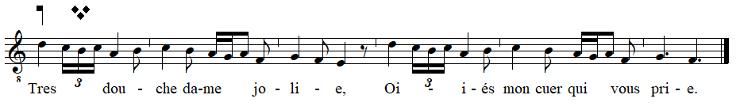
Example 2. transcription of a thirteenth-century carole
Sung by a fox, this love song is comprised of two parallel phrases, both essentially stepwise. The antecedent, mm. 1-3, is a series of tumbling cascades to an open (ouvert) cadence on E. The consequent, mm. 4-6, is exactly parallel, finishing a step higher with a closed (clos) cadence on F.
The fourteenth-century carole need not be any more complicated. A 1338-44 manuscript of the Roman d’Alexandre provides music for the rondeau “Ensi va qui amours” alongside sumptuous illustrations of people singing and dancing in the round, as that of Example 3. My transcription of the song in Example 4 is underlaid note for note from the same page of manuscript.
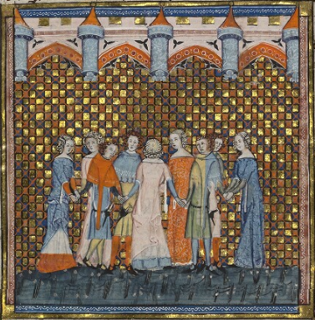
Example 3. dancing the carole “Ensi va qui amours”
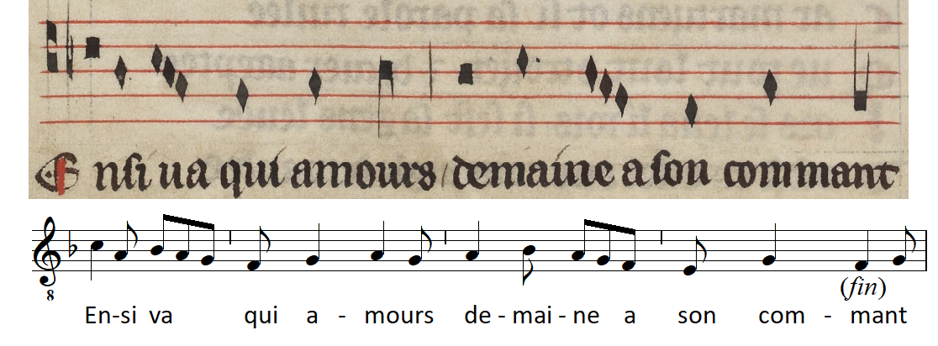
Example 4. manuscript and transcription of “Ensi va qui amours;” refrain
Music for the carole, being a simple dance for bipedal creatures (anthropomorphic animals figure centrally in Renart and other allegorical tales), is conventionally transcribed in duple time (a beat for each foot) and the frequent trochees and iambs of their rhythm surface suggest 6/8. The melody again tumbles downwards in each of two parallel phrases, essentially arpeggiating through the triad: C down to A in mm. 1-2, A to F in mm. 3-4. Example 5 proposes dance steps for “Ensi va qui” following two axioms. First, the dance should start with the left foot so that it will naturally revolve clockwise. Second, the dancers should keep time by stepping on the beat. The beat here is defined as the breve (i.e. the steps articulate the tempus level of mensuration), but this may also be the long or semibreve depending upon the notation level and preferred tempo, how quickly the dancers want to revolve.
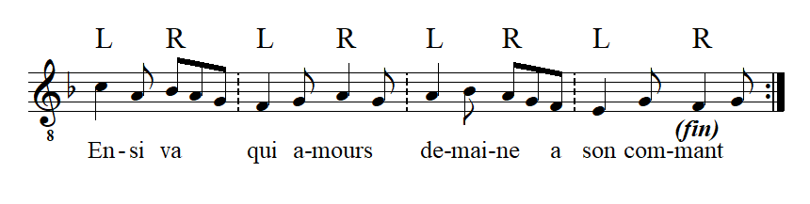
Example 5. Refrain of “Ensi va qui amours;” marked for dance
This step grouping—little more than walking—is unproblematic and wraps back onto itself across repeats of this straightforward song. The dance music of Machaut is of another order. I will first consider the relatively simple dance song “Dame, a vous sans retollir,” from Machaut’s Remede de Fortune (c. 1340s). While the musical interpolations of the Remede include all the formes fixes, Machaut associated dancing explicitly with the chanson baladée (virelai) alone and included an illustration of dancing, given as Example 6, beside the score. Here, the carolers dance and sing this very virelai along with its author.
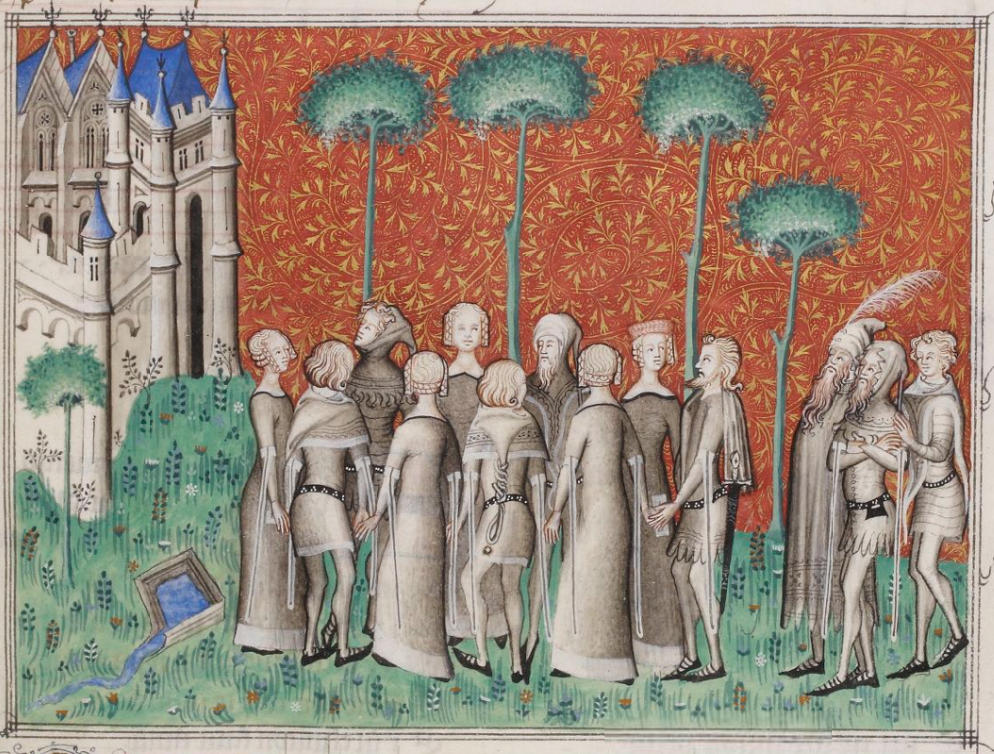
Example 6. dancing Machaut’s virelai “Dame, a vous sans retollir;” detail from F-Pn fr. 1586 (Mach C), 51r
A modern transcription of the song follows as Example 7, including feasible dance steps on every beat and formal labels A and B. The A section opens with tonal articulation of G (mm. 2 and 5), which become subordinate to the final cadence down a step on F (m. 11). The B section floats around C, an open ^5 in reference to the final.
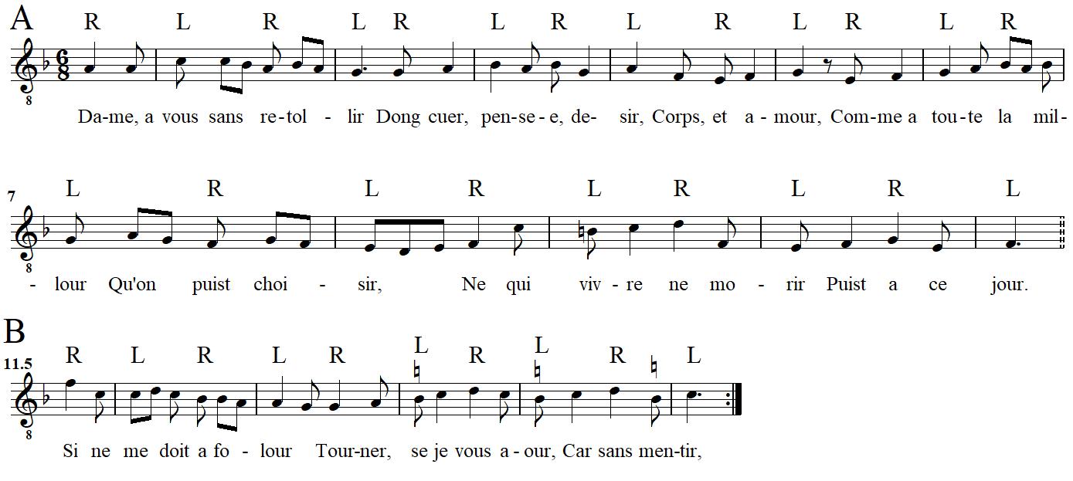
Example 7. Machaut’s “Dame, a vous sans retollir;” marked for dance
Coming a generation after the Renart chanson above, Machaut’s chanson baladée is longer, of wider range, traverses the soft and hard hexachords, and freely mixes trochaic and iambic subdivisions. In whole it demands more from an amateur chorus of singing dancers. Yet because it lacks any grouping disturbances at the beat level, of which the mixed trochees and iambs are subdivisions, to dance this song merely adds locomotion to tapping along with one’s foot. In the anacrustic transcription here, the song’s cadential layout is entirely conventional in tying cadential arrivals to the left foot (ending both the A and B sections and marking every downbeat). This is a strong and characteristic correlation in dance music. Machaut’s virelais cadence on the left foot 91% of the time out of about 120 cadences.
The generic linking of a particular step to tonal articulations provides an illuminating tool for analysis. For example, see the unusual conclusion of the B section (m. 11) in Machaut’s danced song “Loyaute weil tous jours,” given as Example 8.
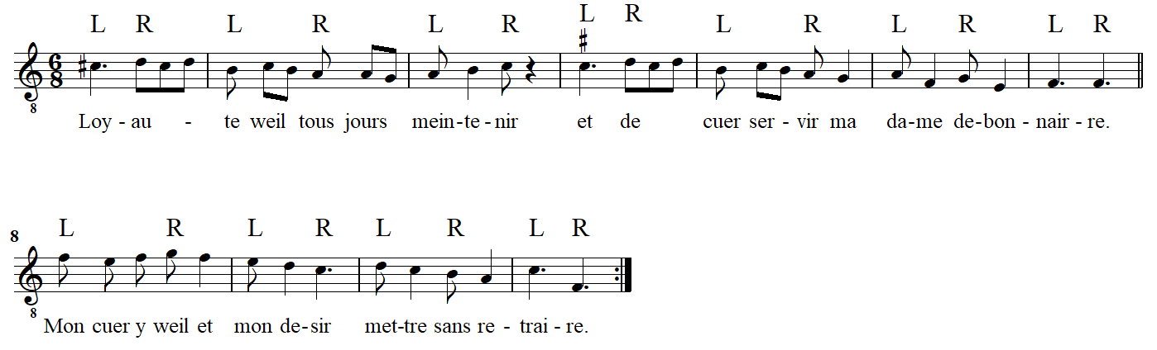
Example 8. Machaut’s “Loyaute weil tous jours” (V2); marked for dance
The pitch center of this song is F, confirmed especially by the refrain’s final cadence (m. 7). Dancing three times through the refrain of this virelai establishes F as a left-foot kind of note. Its regular dance groupings L—R / L—R provide a medium through which to feel the weakness of the melody’s subsequent hop down to F (^1) at the end of the B section (m. 11) and excuse it. In a typical forme fixe, the B section would terminate on an ouvert scale degree, not the clos final of the song. So what looks formally astylistic in V2—a B section ending on the final—does not feel like it because ^1 is relegated to the conventionally weak right foot. In other words, a pitch that is melodically clos is here felt as metrically ouvert, as expressed by the dance.
An important implication arising from the norm of an accented step in medieval dance music is meter. Medieval meter is not explicitly indicated by fourteenth-century French mensuration, which was a quantitative system of notating discrete lengths of pitch and rest. Rather, meter is a qualitative interpretation that accrues from a regular, hierarchical grouping of pulses. Once established, a metrical grouping can be felt to remain in effect until its pattern of accentuation is contradicted by some alternative. It is possible, as will be seen below, for entirely regular mensural notation to be interpreted (and possibly danced) in irregular metrical groupings if the musical organization suggests it. Following David Maw’s extensive work on meter in Machaut’s songs, I identify the sense of medieval meter as a combination of motivic initiation and termination, rhythmic grouping (especially recurrent), agogic accent, text alignment, simultaneous articulations, contrapuntal resolution, and harmonic change. Bipedal dance groupings usually corroborate the feeling of binary meter in medieval danced song, that performance practice likely underlying the conventional choice of binary mensuration in the first place. Indeed, “metrical organization is a necessity for dance music, as the coordination of bodily movements requires audible marking of the bar in the construction of the music” (Maw 2004, 61). In dance music overwhelmingly notated in imperfect (duple) mensurations, meter is embodied as the regular grouping of left – right steps accrues a sense of strong – weak, especially because the same foot gets the tonal accent in the vast majority of cases.
Having established the conventions of caroling above, I proceed to address some potential complications in chansons baladées that map onto dance less easily. The question that I am concerned with here is not so much whether these songs of Machaut were danced in his century, but rather what dance patterning certain melodic, textual, and metrical groupings can suggest to the modern analyst and how a simple alternating dance pattern can ground analyses of the increasing metrical complexity of the ars nova at various mensural levels. As with the previous songs, Machaut’s virelai “J’aim sans penser laidure” can be transcribed in 6/8 and alternating dance steps assigned to each beat, like in Example 9.
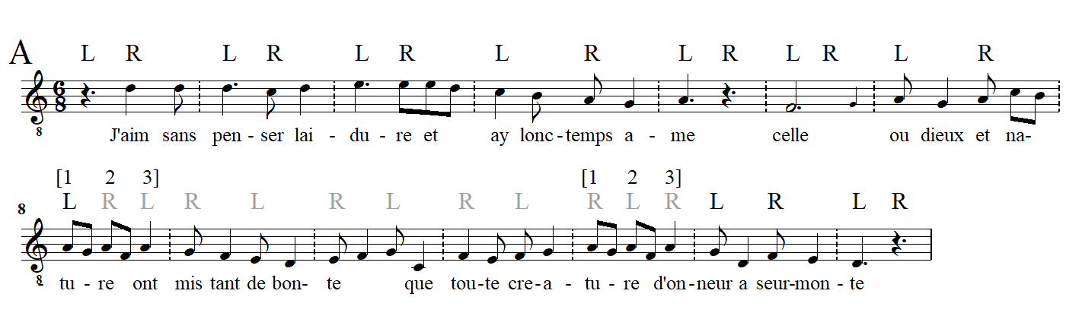
Example 9. Machaut’s Virelai 14, “J’aim sans penser laidure” (refrain only); marked for dance
In this execution of the dance, the usual left foot downbeat is in force until m. 8, where a relatively long stream of 8th notes, free from dependence upon a neighboring quarter to capture them as trochees or iambs, provides an opportunity to consider how a change in grouping—with associated adjustment in dance steps—can shape a narrative of instability to stability across a section. The tight spacing of the consecutive 8th notes in mm. 8 and 12 followed by a generous gap before their final quarter note—potentially demarcating beat 3 of 3/4 rather than breaking up an iamb of 6/8—in all MS sources can be suggestive of an intended grouping change. But the spacing, the system breaks (Mach C), and even the page breaks (Mach A) that occur in some manuscripts between the last F and A of mm. 8 and 12 more likely reflect the line break in the poem, inked in before the music notation was added. However, the way that Machaut repeats the structural pitch A in mm. 7-8, as well as his rate of text declamation, can be used to define logical metric groupings. In V14’s Dorian melody, A is the tenor (^5) and the note on which the ouvert cadence of m. 5 rests. In m. 7, A marks the onset of each of two beats (in 6/8), while in m. 8 the same A now marks each of three beats (a change to 3/4); the same duration segmented differently. The word “na-tu-re” ends the third line of the poem. In Machaut’s rhythmic setting, “na-” is set as a pickup note to the stressed “tu-” on the metrically accented beat 1 (m. 8). The weak syllable “-re” follows naturally on a weak beat (beat 2) and this could have ended a measure of 6/8. Yet Machaut sets another weak syllable, “ont” in m. 8 as beat 3 of 3/4 (beginning the fourth line of the poem), which acts as a pickup into the next measure, descending through the fifth A-D. Mm. 11-12 are slightly different. F marks the two beats of m. 11 before A returns to mark the three beats of m. 12, where again the final A is detached as a pickup to the final descent A-D. Such is the grouping found in Leguy 1977 (from Mach G), an edition remarkable indeed for its flexible approach to metric grouping as a response to Ludwig’s supposed rigidity. David Maw’s recent work (2013, 2004, 2002) explores a similar responsiveness to irregular metrical/textual groupings in Machaut’s songs, and his transcriptions of some chansons baladées also feature rebarrings and changes of time signature. Contrary to these and to my Example 9, Ludwig and Schrade beam mm. 8 and 12 as continued iambs in 6/8.
My reconfiguring of dance steps in these measures and in the examples to follow is an act of modern metrical analysis through the medium of dance, and makes no claims about medieval practice. The dance steps above the staff in m. 8ff convey the perceived change in metrical grouping, swapping imperfect time/major prolation (compound duple) for perfect time/minor prolation (simple triple). While a change in mensuration is not represented here in Machaut’s notation, Leguy renders a uniquely square text setting of one syllable on each of three equal beats in m. 8 and again, the same motive with textual assonance, in m. 12. The opposing groupings 2x3 and 3x2 are of equivalent duration—a demand Medieval mensural theorists called equipollence—but where should the dancers’ feet go? Suppose that stepping with the beat is so conventional that dancers will do so even when the beat changes, as shown in Example 9. The consequences of taking triple time in m. 8 ripple throughout the next few measures (in gray). The time in mm. 9-11 is duple as usual but the accent has been temporarily displaced to the right foot, until a second grouping change of the same sort (m. 12) realigns the left foot with the metrical stress (in black). In this reading, grouping disruptions impart a cross-footed tension that is impossible to detect in manuscript, in modern editions, or in concerted performances.
Theorists of the sixteenth century witness another parsing of triple time, one rooted in the primacy of binary groupings as regulated by the conducting hand and derived from the heartbeat, as mentioned above. In this conception, the first of two beats is elongated to twice the length of the second, yielding an unequal duple 2:1 proportion comprised of three subunits. To extend this motion to the feet in Example 9 is to maintain the usual L/R pairing throughout mm. 8-12, not with equal duration L R | L R as in the foregoing imperfect tempus, but with an extended lurch of the left foot: L— R | L— R. An interpretation of unequal duple here can be supported by the same reasoning that concerned distinguishing a beat 3 of equal triple above, the considerable conceptual difference between them being expressed by the consistency, or not, of the left foot marking downbeats and in how the internal grouping of each measure is felt as anomalous: either by a quick pitter-patter of three steps or by a lurching of two. However widespread stretching the downbeat may have been in a sixteenth-century metrics rooted in duple alternation, ars nova mensuration rather had the triple “perfections” of the ars antiqua as its foundation, of which duple was considered an imperfection. I find no fourteenth-century reference to dancers elongating a single step to cover two semibreves as a means to preserve a norm of binary groupings (or ad hoc entrainment), but Machaut’s motivic grouping and text setting afford this possibility no less than equal triple. Whatever the choice, it fell to the leader who introduced a song to demonstrate its steps no less than to demonstrate its pitches.
The same effect as considered above in V14 can be found in Virelai 24, “En ma cuer,” only reversed. In that song, the prevailing meter is triple and the disruptions duple. In Example 10, alternative groupings in 6/8—pairs of iambs each time—are notated on a separate staff above the score set in 3/4. In the first instance, m. 3, the accompanying tenor matches the cantus’ iambic lilt for a single measure. Because this interpretation contains only two steps per measure, the established dance pattern becomes offset (in gray above, compare to black below). A second change of this same type (m. 7) sets the steps back on track in the cantus alone, the tenor remaining in perfect time. There are five such measures of ambiguous groupings and if they are consistently taken the song’s footing will end opposite to how it would have if taken straight. This is not necessarily a problem, however, because dancing the occasional duple measure sets a few directed progressions onto left foot arrivals when they would land on the right otherwise, including the end of the song (see mm. 4, 12, and 22). The metrical play examined in Vv24 and 14 might well have tripped up a few carolers if not turned the whole dance to ruin on a first try. The more artful of them may have proved their worth at such moments, and maybe that was part of the pleasure of the dance.
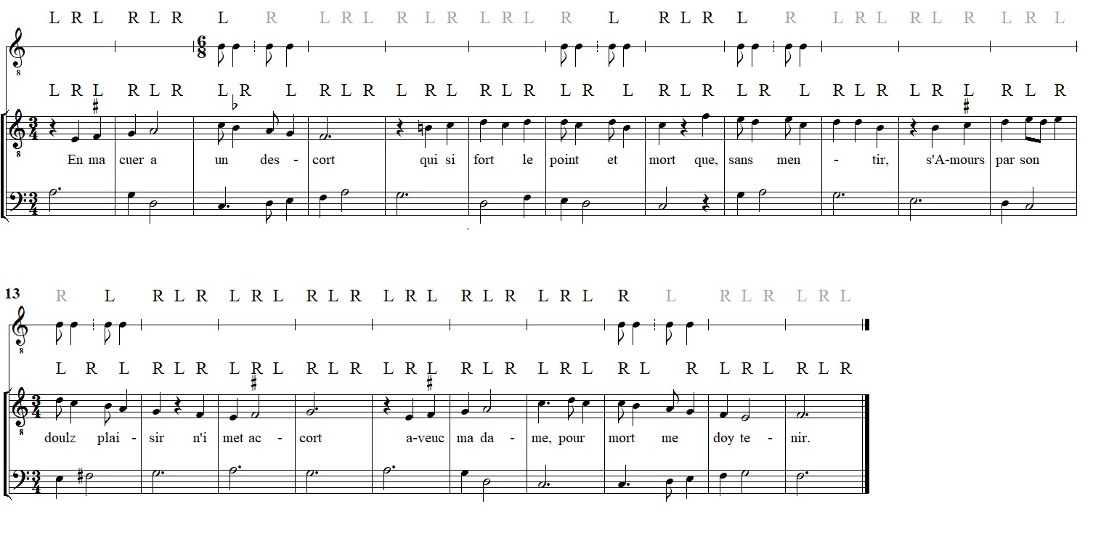
Example 10. Machaut’s Virelai 24, “En ma cuer” (refrain only); marked with two options for dance
Returning to the binary Virelai 14, the first sung pitch would involve the right foot if any step is to be taken on this beat. The opening dotted quarter rest of Example 9 is a transcription of the semibreve rest found in all sources (Mach A, C, G, and Vg); omitted by Ludwig 1926 and restored by Schrade 1956. While an opening rest on beat 1 may make little difference to singing alone, the space provides a necessary starting step for dancers progressing clockwise. Recall that in dancing the carole the left foot advances on the downbeats while the right snaps back to it on upbeats. Example 11 shows this song’s opening in the clear notation of Mach C. Of special interest here is the breve rest that precedes the semibreve rest under discussion, representing a full measure in transcription (noted but omitted by Ludwig and my Example 9 because it does not alter dance steps at the tempus level). Because the opening breve and semibreve rests appear consistently in all sources, I think it unlikely that they represent a mensural mistake, launching the trochees a level greater than the semibreve-minim pairs of notes that follow. Instead, the empty breve (measure) serves an important function in the modus organization of this song. If m. 1 in transcription is taken as a hypermetrical upbeat, adopting the empty breve as downbeat m. 0, then all formal sections of V14 cadence more emphatically on modus downbeats (mm. 14, 18, and 20 of Ludwig). If m. 1 is felt to start the song on a modus downbeat, on the other hand, all formal boundaries—indeed, the end of the song—close on a weak beat at that level. On the smaller side, four of Machaut’s thirty-eight chansons baladées (Vv5, 9, 28, and 36) begin with a single eighth-note pickup in Ludwig’s edition. These are brief enough, I suggest, to be sung before any dancing commences with the left foot on the ensuing downbeat. An awareness of dance explains why measured silences may have been worth the trouble of notating for a medieval composer and audience. Opening rests were crucial for performance insofar as they marked time so that the dance may start conventionally on a strong left foot before singing commenced on a weak right, a special feature of only about 10% of Machaut’s danced songs.
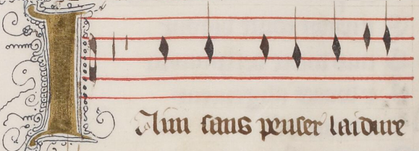
Example 11. a breve and semibreve rest begin the dancing before the singing of Machaut’s Virelai 14; excerpt of F-Pn fr. 1586, f. 153v
A chanson baladée may start in any of three ways, then. Either a given work starts song and dance on the downbeat of m. 1, or it provides an opening beat of rest upon which to start the dancing before the singing, or it provides a short pickup note for singing before a substantive downbeat for dancing in the next measure. In any case, I presume of fourteenth-century French carole practice that the assembled dancers looked to a given song’s leader to commence a first step as appropriate, pickup or not, just as they listened for their first pitch before the group could catch on in singing or in dancing.
The infiltration of complex rhythmic groupings into Machaut’s chansons baladées certainly complicate if not rule out being danced. Even so, Seeta Chaganti makes a convincing case that social dancing so permeated Medieval French society that lyrics were both crafted and read through the virtual embodiment of dance (Chaganti 2018, 2-4 and passim). The irregular or ambiguous metrical grouping evident in some Machaut’s songs can therefore be experienced either way—danced bodily or sung with an awareness of the dance—in our time or in theirs. John Lydgate (c. 1426) may have associated such metrical irregularity with the vicissitudes of life’s march towards death in his metaphorical poem on the danse macabre. Note especially how the frequent changes in footing are associated with varied measure in the words of Lydgate’s minstrel (Chaganti 2018, 181).
This newe daunce / is to me so straunge
Wondir dyuerse / and passyngli contrarie
The dredful fotyng / doth so ofte change
And the mesures / so ofte sithes varie
Wiche nowe to me is nothing necessarie
If it were so that I myght asterte,
But many a man (if I shal not tarie)
Ofte daunceth but nothing of herte (lines 505-12).

It is tempting to read into Machaut’s lyrics for those chansons baladées whose metrical groupings complicate the dance. Characteristically expressing the pains of steadfast loyalty to a beloved, Machaut’s poetry in V2, for example, avows that “loyalty would have me always maintain and lovingly serve my debonair lady… and lovingly obey her without causing harm.” If quite generic, such words seem particularly evocative when courtiers singing about unswerving loyalty become dislodged from the prevailing step in their danced embodiment of the chivalrous lover. Multimedia performance—combining lyric poetry, song, and dance—allows for higher level meanings to emerge as one medium comments upon the other in a way not accessible on the traditional concert stage.
While my reading of V14 features a deviation in its grouping pattern—the intrusion of a triple group within a duple context—the song self-corrected via a second change that sets the whole right again. Other of Machaut’s chansons baladées do not so provide for their own metrical maintenance. Consider Machaut’s Virelai 5, “Comment qu’a moy,” annotated in Example 12.
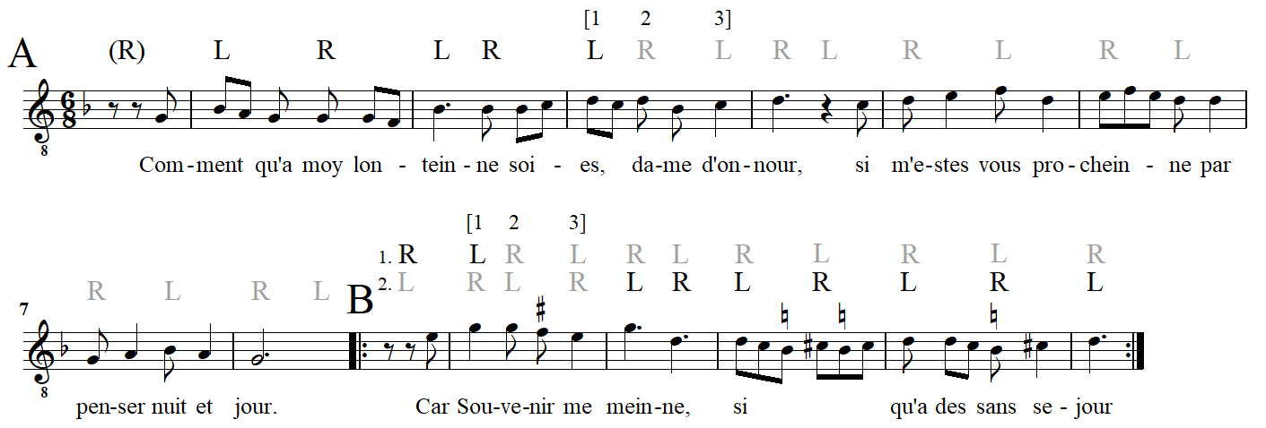
Example 12. Machaut’s Virelai 5, “Comment qu’a moy;” marked for dance
The A theme traces a stepwise path up from tonal center G to an open cadence on D (^5) in m. 4, then back down again for a closed cadence on G in m. 8. The B section floats around high G before settling down on the fifth, D, for an open cadence (m. 13).
Measured in the usual imperfect time/major prolation, I interpret a swap to perfect time/minor prolation in m. 3, transcribed explicitly with beaming and a 3/4 time signature in Leguy’s metrically flexible edition. My argument for this swap relies upon melodic accent, as before, and on text setting, the word “dame” standing alone on beat 2 of a triple group. As mentioned above, the first tonal arrival is the D of m. 4. The ascent up from G reaches this D earlier, on the downbeat of m. 3, but does not come to rest as in m. 4. Instead, the premature D on beat 1 of m. 3 pirouettes on a neighbor C on the weak part of the beat. The same D is touched again on beat 2 (in triple time) before skipping down to B^{b}. This B^{b} does not have the force of the downbeat B^{b}s in mm. 1 or 2, nor do I hear it to initiate beat 2 of 6/8 time. This B^{b} rather decorates the cadential line D-D-C-D across mm. 3-4, all on the beat. While m. 1 has the same syllabic rhythm as m. 3 (trochee followed by iamb), melodic design distinguishes their metrical grouping. The repeated Gs of m. 1 divide the measure in half. The first melodic contour descends a third from B^{b} to G, with passing tone A between them. The second contour departs from the following G on beat 2 (“moy”) down to F. This F acts as the local goal tone of m. 1 and not a subordinate lower neighbor to G (potentially on the beat, if this measure were grouped in 3/4) insofar as the ensuing leap of a fourth—F to B^{b} in m. 2, as wide a gulf as the song contains—portrays the distance that separates the protagonist from the noble lady. The single metrical disruption of m. 3, then, results in a refrain that ends off-kilter. The text underlay of the B section suggests another triple group in m. 9. Here again, repeated Gs set off two distinct beats. Opening on a pickup E, m. 9 steps back down G-F(#)-E across three beats, as shown. This third leap is then outdone by the leap of a fourth in m. 10 as remembrance of the lady guides the protagonist (“Car Souvenir me meinne”) across the same wide interval that separated them in the refrain. The B section concludes with an ouvert ^5 (D) the first time through, then more solidly on the left when that section repeats (in the standard formal representation AbbaA), which sets up the song’s pickup pitch G properly on a right foot. The return of the refrain brings abouts the same metrical change discussed above, but its repeat to end the song (when the original refrain lyric is returned to the melody) acts now as a corrective, the final melodic arrival on a clos ^1 (G in m. 8) now coinciding with a firm stamp of the left foot. The text of V5 is redolent with the sweet sorrow of separation. However far the noble lady may be, the refrain assures that she is always in the lover’s thoughts.
As proposed above, the single pickup note of Virelai 5 (G) is perhaps short enough for dancing to commence on the trochaic downbeat of the first full measure without a right-foot preparation at the start. Because a full beat of anacrusis (two minim rests and one minim pitch) is notated in all sources (Mach A, C, E, G, and Vg), the dance steps conclude neatly. This same anacrusis beat would be marked with a right foot when the last refrain returns and the final cadence would land on the left, according to convention (formal repeat not shown in Example 12). Yet some of Machaut’s virelais have more problematic returns at that final formal juncture where the a section (refrain with new text) meets A (refrain with original text). All but one of the many repeats of Machaut’s “Se d’amer me repentoi” (V20), for example, upend the entrained footing of the prior section.
The examples so far have been danced at the tempus level of mensuration, stepping on each semibreve (i.e. two steps per measure of 6/8). While a French Baroque dance manual attests that dancers’ steps did indeed articulate various levels of metrical organization at various points throughout a piece, there is no record of this practice in medieval round dancing and it seems unlikely as part of amateur outdoor socializing (Little 1975, 116). My analysis of V20 sets the carole’s dance pattern to the modus level of mensuration. The parsing of modus, a measure of breves per long, requires an act of analytical interpretation when longs are not present in a melody’s notation. This study continues modern analytical work on medieval meter by considering mensural levels to be expressed not only by discrete notated rhythms but by free rhythm equivalent to that value. To dance at the modus level is to step not on each beat (semibreve) but on each measure (breve), thus the dance even more closely reflects metrical grouping as described in this study. In Example 13, broken bar lines show breves (with beats counting tempus divisions) while full bar lines show longs (with measures counting modus divisions). The same kinds of grouping complications found at the tempus level above can be found at the modus and maximodus level, too. Grouping disruption at these levels, and their potential effects on the dance, requires interpretation akin to how the construal of hypermeter in later European music rests upon larger congruencies across the notation of measures. Interpretive preferences like locating cadential arrivals on strong beats—secondly, on any beat rather than off—and situating stressed syllables on metrically strong positions while relegating final mute vowels to weak one can clarify broader rhythmic grouping in Medieval French songs and so too, perhaps, their dance pattern.
Dancers of Machaut’s V20 might begin conventionally, with the left foot, as shown in Example 13. As the melody cascades down an octave from high G to low, an inflected ascent through F# overshoots the final G to land on an open A (^2) on the left foot in m. 11. This is only the first time through the two parallel phrases of the refrain, however. Upon repeating the same melody according to the formes fixes, the dancer takes every step on the opposite foot. The second ending, however, is shorter than the first by a measure and thus the closed cadence on G in m. 14 comes properly on the left foot. That is, if both the refrain endings were of the same length either the final cadence would be on the “wrong” foot or the dance would have to begin with a stationary right foot or pickup measure.
The B section sets forth with a right foot (m. 15) opening again on high G, recalling the A section, but only winding down to an open cadence on D (^5) in m. 23. Just as in the A section, the feet are again reversed when the B melody repeats due to the form. Only in the final return of the refrain, where a (same music, new text) is succeeded by A (same music, same text), does V20 return the same music on the same foot. It seems fitting that only at the very end should the same text, same music, and same dance steps be reunited. The threads of the song thus tied together, it finishes. Or perhaps a vacillating step pattern is evidence that this song does not dance at the modus level and should more properly proceed according to tempus. And there is always the possibility that dancers were not so interested in musical structure and simply marched along to a pretty tune, glad to have the hand of a sweetheart on either side.
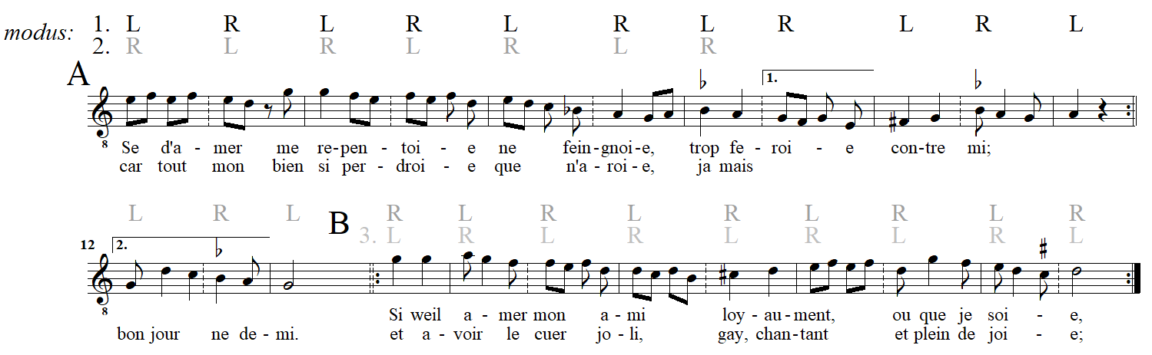
Example 13. Machaut’s Virelai 20, “Se d’amer me repentoi;” marked for dance at the modus level
My transcription of V20 conforms with all but one Machaut manuscript in which this song is represented (Mach B, C, E, G, and Vg). It differs only from Mach A, which appends a breve (half) rest after the ouvert cadence on A in m. 11. If this rest is a measured duration and not merely a section marker, it represents a significant change for dance as it provides a new measure for another step. This extra step would realign the repeat of the refrain on the same footing (i.e. m. 1 would return on the left foot as before), correcting what I described as mismatched dance steps to the same music. However, I take this phantom breve to be a section marker because it is not present when the refrain is renotated with new text later in Mach A (after “oubli;” not shown in the Example).
Most but not all of Machaut’s chansons baladées are monophonic. If the inclusion of a tenor line excludes them from social dancing in fourteenth-century France, it does not exclude investigation into how dance may have influenced the construction of a piece Machaut dubbed a “danced song.” Example 14 presents the refrain of Machaut’s polyphonic virelai “De tout sui si confortee.” Dance steps, virtual or actual, are shown above the score at the modus level for lack of tempus irregularity. This example contains only the cantus part, to discuss its structure in isolation.
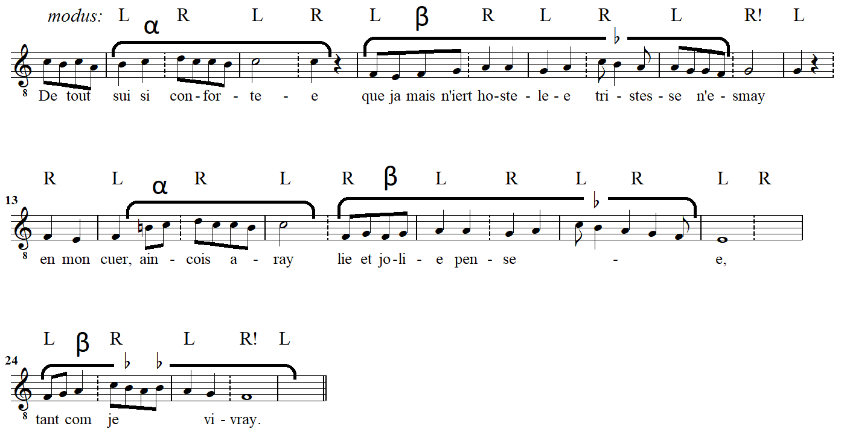
Example 14. Machaut’s Virelai 38, “De tout sui si confortee” (cantus line of the refrain only); marked for dance and for phrase organization
The refrain of “De tout sui si confortee” is essentially comprised of two melodic phrases—labeled α and β in the Example to distinguish them from formal labels A and B—varied in their repetitions melodically, rhythmically, and metrically. The practice and analytical model of dance reifies Machaut’s elastic approach to melodic repetition here, as the same melodic skeleton is embodied across longer or shorter time spans. Phrase α circulates upper- and lower-neighbors around the pitch C, ultimately cadencing on that same open ^5 (mm. 4-5). Phrase α is prepared by what I take to be a pickup (m. 1) before the first downbeat. Commencing the dance on m. 2 best responds to the song’s musical structure for the following reasons. First, doing so ensures that the melodic, textual, and agogic accent on the cadential C in m. 4 is corroborated with a left foot. Second, a very close repeat of phrase α occurs without the pickup in mm. 14-16. Third, when the refrain repeats the pickup will be taken with the right foot, preserving m. 2 as a strong left-foot downbeat. Fourth, this motive is a recurrent one throughout Machaut’s songs, used especially as a windup that targets a more structural pitch on the following downbeat.
Phrase β consists of an essentially stepwise ascent from the song’s final, F, to C and back to down again. Schematically, the tonally open phrase α is followed naturally by the closure of phrase β. While that is ultimately what happens, the detail of V38’s melodic shape is a bit more complex. A summary sketch is presented as Example 15 below, with phrases marked and cadences labeled O for open, C for closed. The song’s final is emphasized by a stem.
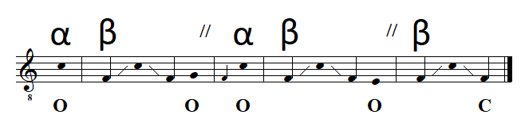
Example 15. tonal summary of V38 (cantus of the refrain only); phrases and cadences marked
In its first occurrence, phrase β’s F-C-F scale is followed by an ouvert termination on ^2 (mm. 11-12), postponing tonal closure for a later phrase. The return of phrase α (mm. 14-16) restarts the same melodic trajectory and is again followed by phrase β, to which is now appended a different ouvert ending (^7 in mm. 22-23). For the refrain’s final phrase, β is stated alone and only now rests conclusively on its final F (mm. 27-28).
Recall in Example 14 that the initial measure was taken as a pickup, the dual benefit of this metrical interpretation being the situation of the first cadence on a left-foot downbeat (m. 4) and its final mute vowel on the weak foot thereafter (m. 5). If this first phrase is right, the remainder of the song is more ambiguous. The other four cadences of the refrain are split 50/50 as to landing on the left or right foot, with the final cadence—the one that ultimately closes the song—ending against convention on the right foot (m. 27). Whichever way one regards the opening measure, the melodic repetitions that represent the heart of the song are metrically inconsistent and cannot feel the same way when danced. The easy bodily entrainment witnessed in my first example (recall Example 5) is frustrated here in a way, I stress again, that cannot be seen in manuscript or current modern editions, nor can it be felt in a concerted performance, but it may have been top of mind to the Medieval composer and singing dancer.
In the following section I will speculate further about how the framework of dance can be extrapolated as a modern analytical tool not only to label a score but also to feel larger grouping congruences and irregularities in Machaut’s danced songs. Just as the left foot accrues a sense of thesis (and the right of arsis) in music designed for caroling, every other left foot can feel weightier and thus parse the musical structure akin to the more modern concept of hypermeter. For example, those left-foot downbeats that mark phrase endings are more salient than those that occur merely out of alternation with the right. Example 16 is a foray into representing these different kinds of danced downbeats, which in mensural terms reflects the difference between modus (breves per long, all bar lines in the example) and maximodus (longs per maxima, only the unbroken bar lines). Both levels are shown here, and I retain L and R insofar as they represent strong (L) and weak (R) at this abstract level of virtual dancing. This analytical presentation is analogous to the layered dots in metrical hierarchy analyses of Lerdahl and Jackendoff, or the pulse frameworks of Graeme M. Boone more recently, and one can easily imagine smaller L/R steps on each beat at the tempus level below what is shown here. I find in the hierarchical organization of medieval French mensuration a similar sense of weightiness accruing over increasingly long time-spans as multiple layers of beats coincide as metrical groupings. Dance qua analysis goes further in characterizing the beats of Machaut’s virelais because they are not all equally weighted in principle, given the association of the left foot with thesis argued here. This norm provides a backdrop against which to interpret, to measure, and, moreover, to embody passages of a danced song being out of step, where that step is specially calibrated to each song’s tonal and formal articulations. It is especially at the deeper levels of Machaut’s music where metrically irregularity is most prominent, and so makes the extension of a regular dance pattern into an analytical tool worth pursuing. In this regard, beginning to dance only in m. 2, if begun well enough, does not produce genre appropriate results throughout. Two cadences (boxed in the Example), including the final one, are overlooked by the feet at this summary analytical level.
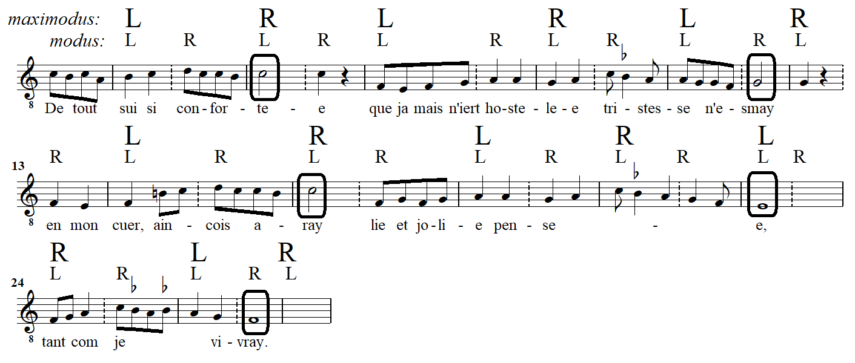
Example 16. dancing V38 at the modus and maximodus level (cantus of the refrain only); cadence points circled
A straightforward duple dance pattern does not closely match this song’s tonal articulations. In order to align melodic accent more closely with dance pulses, the following reading of the same virelai interprets mensural expansions (perfections) at the maximodus level such that all five cadences fall on a step, still more often on the right but at least not in-between steps. Mensural expansion here is simply a group of three thoughtfully inserted into the regular duple entrainment native to caroling. While such an effect can occur anywhere, it is most stylistic and convincing either just before a cadence (as in mm. 8-10, 13-15, and 24-26 of Example 17, effecting a written-out ritard) or in capturing a pickup measure before a prominent downbeat (as in mm. 27-29). In this way, Example 17 offers a more flexible danced analysis for comparison with those regular steps that did not well match the phrase structure (cadences) of Example 16 above. Closely allied to those cadences, I note that the two oxytonic rhymes -smay (m. 11) and -vray (m. 27) are brought into alignment with the left foot in a strong metrical position. While the final pitch of the paroxytonic pen-se-e, an ouvert E pointing towards the final F to come, also falls on a left foot (m. 22), the longest melisma in the song bestows ample stress upon its penultimate syllable (mm. 19-21).
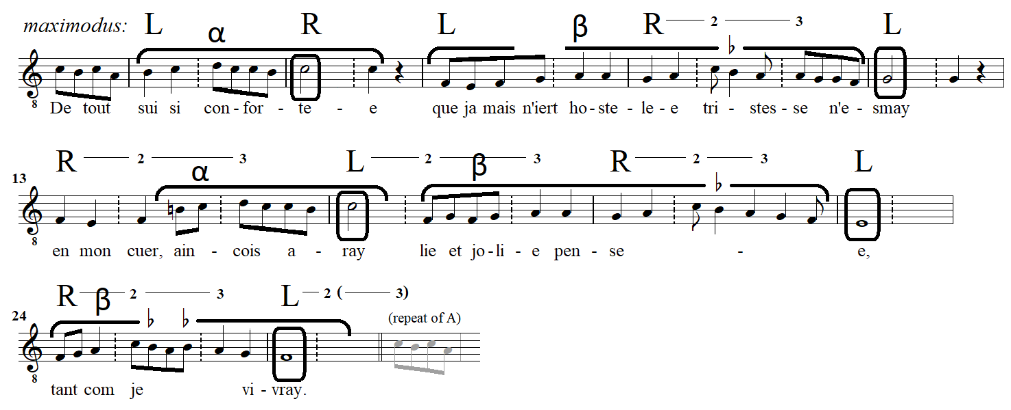
Example 17. dancing V38 flexibly at the maximodus level (cantus of the refrain only)
I have interpreted mensural expansions six times in this refrain. The first occasion is in mm. 8-10, where the right step is extended for three counts (notated R—2—3) before bringing down the left to mark the cadence on G in m. 11, an important melodic pitch that fell between steps (actual or virtual) in Example 16. Delaying the foot on a long drag-triplet before the next downbeat represents a broadening out before cadence, the opposite effect of dancing a quick hemiola shown earlier in V14 (recall Example 9; three little steps in the place of two). The next danced perfection is interpreted across mm. 13-15 for the same end; to unite the conventional left foot thesis with a melodic arrival point, the cadence on C in m. 16, whereas this cadence came on the right foot when danced straight. Mm. 19-21 and 24-26 similarly prepare their cadences, the first an open ending on E (^7) and the last closing the refrain on the song’s final, F, both properly tied to the left foot. The perfection interpreted in mm. 16-18 is an expedient that sets up the usual cadential broadening in mm. 19-21, which preferably begins on the right foot so as to land a cadence on the left. The guiding intent for all these interpretive metrical adjustments is for bodily entrainment to align with the music more conventionally, providing consistency in how the steps approach cadence and in the maintenance of left-foot downbeats found wanting when this song is danced straight (Example 16).
The final measures of V38’s refrain would not wrap around evenly on repeat—assuming the first measure is an undanced anacrusis—without implying another modus perfection (mm. 27-28-1). This final expansion is shown in parentheses running off the end into a repeat of the refrain that occurs at the end of the virelai form. In fairness, V38 does wrap around neatly if one simply walked through this song without regard for cadential placement. The methodology here advocates instead for a dance more sensitive to the phrasing of an individual song; dance as analysis.
I have explored the cross-footed effects latent in this song as an act of modern critical reception, considering some of the practical as well as analytical consequences of dancing “fashionable ars nova rhythms” (Earp 1991, 125). More than just walking in time, a dance that embodies grouping changes and embraces irregularity across the form allows participants to interpret the music and its text. To dance Machaut’s V38 flexibly is to take action towards ensuring harmonious union (between melodic and metric grouping) parallel to the unswerving loyalty pledged by the courtly lover of its poetry.
The cantus may carry the melody here, but it is not the complete song. Restoring the tenor allows an evaluation of harmony and counterpoint in relation to metrical grouping and dance. The polyphonic analysis of Example 18 pursues the flexible reading above as more responsive to V38’s tonal organization.
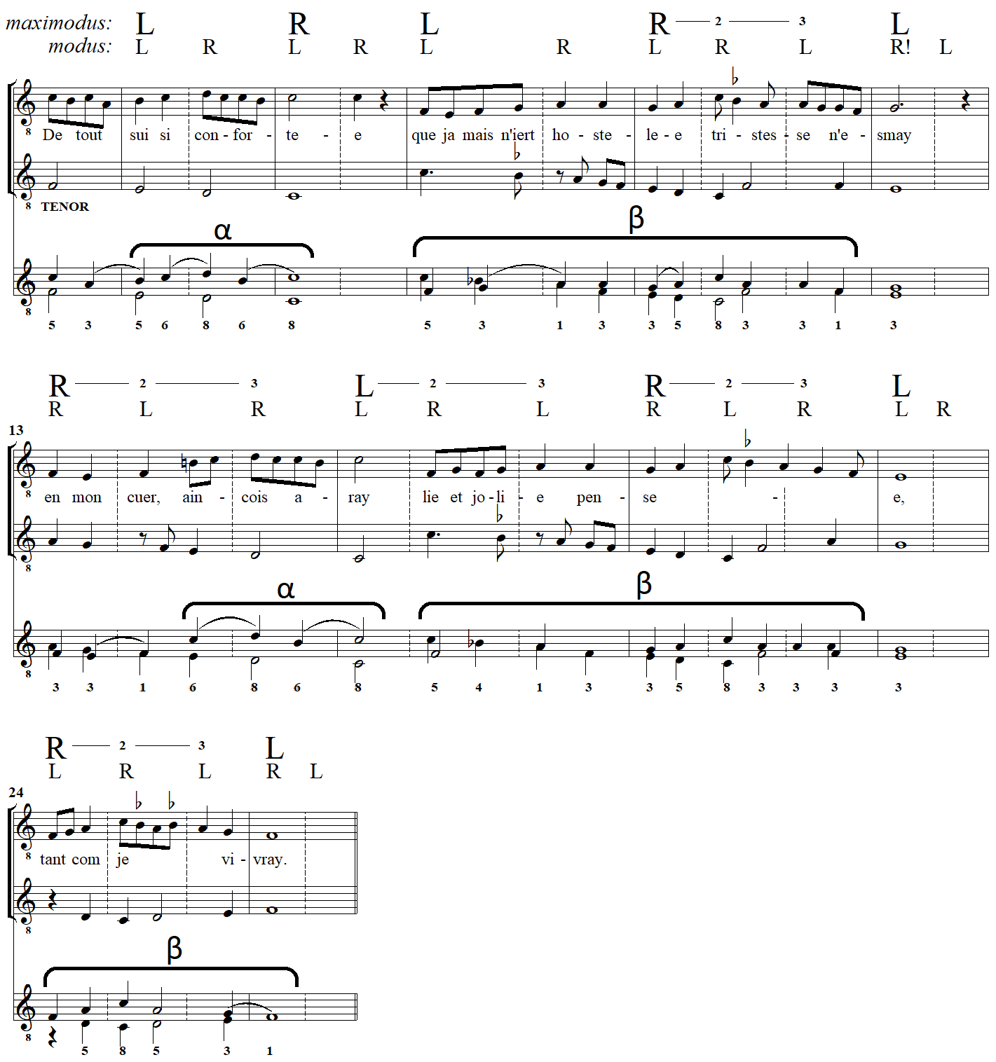
Example 18. Machaut’s V38 (refrain) with dance steps at two levels, phrase organization, and discant reduction
The note-against-note discant reduction at bottom reveals relationships between pitch and grouping, both metrical and dance. For example, Machaut is consistent in employing imperfect consonances on (modus) downbeats only in the approach of cadences, where their strong resolution tendency joins contrapuntal propulsion to the mensural broadening (maximodus perfection) I have suggested at mm. 8-10, 13-15, and 19-21. Machaut’s counterpoint against recurring phrases α and β—recalling that a free tenor voice is composed against the fundamental cantus in secular song, the reverse of sacred cantus firmus style—also shows a high degree of consistency. In both occurrences, phrase α begins with a stable 5th expanding into an unstable 6th, which drives out by stepwise contrary motion to the nearest stable interval, the perfect octave. This 6-8 directed progression occurs twice in descending sequence in each statement of phrase α, while dissonant passing 7ths provide even greater drive for resolution on C (mm. 4 and 16). The first two occurrences of phrase β are also very similar, cadencing each time on the same open dyad E/G that yearns for resolution on F (mm. 11 and 22). The final iteration of β (mm. 24-7) appears in compressed form and is harmonized differently. Replete with perfect consonance, a judicious 3rd is employed only at the final cadence (3-1). Note the special contrapuntal strength of this final arrival, converging in contrary motion down a catalog of the harmonic consonances to the unison: 8-5-3-1 (mm. 25-28). This more solid setting of phrase β perhaps represents the singer’s resolve to remain loyal “as long as I live” [tant com je vivray].
Among Machaut’s chansons baladées, four are set in perfect tempus: Vv26, 27, 31, and 32 in Ludwig’s numbering (23, 24, 28, and 29 in Schrade). While dancing with two feet maps neatly onto imperfect groupings, repeatedly reinforcing one foot as strong and the other weak, dancing three beats per measure (semibreves per breve) with the same two feet results in a feeling of rotation through metrical accents. That is, rather than every metrical accent pairing with the same foot, stepping on each semibreve causes an alternation of feet on the musically accentuated beat 1. However, to the extent that there was a generic convention for left-footed duple accents, that norm may still be experienced as shifted to the next higher mensural level, that of modus. Because Machaut’s triple tempus dances proceed LRL RLR LRL etc., the accrual of left-foot downbeats (every two measures) creates an embodiment of duple modus, often ratified by tonal groupings. The crucial difference for dancing is that not every left foot is equally strong in perfect tempus, but every other left—marching along in imperfect longs—will feel like downbeats. To keep social dancing most accessible, however, the few chansons baladées in triple time may instead encourage dancing at the modus level rather than tempus.
I will address two pertinent consequences of this. Example 19 presents the opening of two of Machaut’s virelais with dance notation at two levels, tempus below and modus above. While the alternation of which foot comes down on beat 1 may feel unnatural, given the preponderance of virelais in imperfect tempus (88%), the characteristic correlation of a dominant foot with tonal articulations is actually left undisturbed. All directed progressions in V27 and V32, except a single interior one, fall on the same foot. Moreover, this is true regardless of whether these songs are danced at the tempus or modus level because virelais in triple time, unlike their duple counterparts, align steps at both of these mensural levels. The difference is hierarchical, as the figure makes clear, with practical implications for tempo of the dance. Because the step on every beat 1 aligns, the decision to dance quickly (stepping on the semibreve beat, likely singing at a slower tempo) or more slowly (stepping on the breve measure, likely singing at a faster tempo) has no impact on the embodiment of tonal organization in virelais of perfect tempus so long as imperfect modus is left undisturbed. Take the first cadences of V27 and V32, for example. In V32, the directed progression to G in m. 4 falls on the right foot regardless of mensural level, as do all the others that follow, including the formal closure of each section. The case is nearly the same in V27, where only one internal, inverted directed progression (to F in m. 21) falls on the left foot while thirteen others fall on the right. The consistency of this result is highly suggestive of dances that should begin with a pickup measure (breve), what David Maw dubs anacrustic modus. The effect is to move all tonal emphases to the left foot, in line with generic convention established above. The inflected ascent of both melodies represents an introductory runup to the structural downbeat in m. 2 to be taken with a firm left foot. I suggest, then, that these dances may begin with a right foot, some prefatory dance gesture such as a plié, or with no step at all.
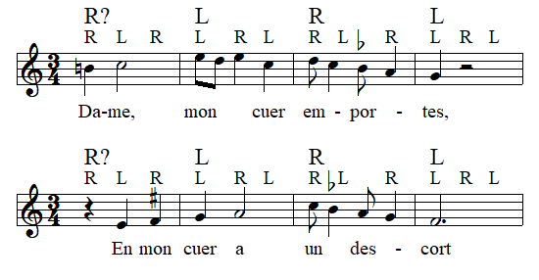
Example 19. beginning of Machaut’s virelais “Dame, mon cuer emportes” (V32) and “En mon cuer” (V27); cantus lines only
An annotated score of the cantus line of V27, omitting tenor accompaniment, is given below as Example 20. All directed progression arrivals are circled. Because this song is also measured in perfect tempus, dance steps will be considered at the imperfect (binary) modus level, offering at least their analytical value in parsing medieval mensuration if not in directing medieval feet.
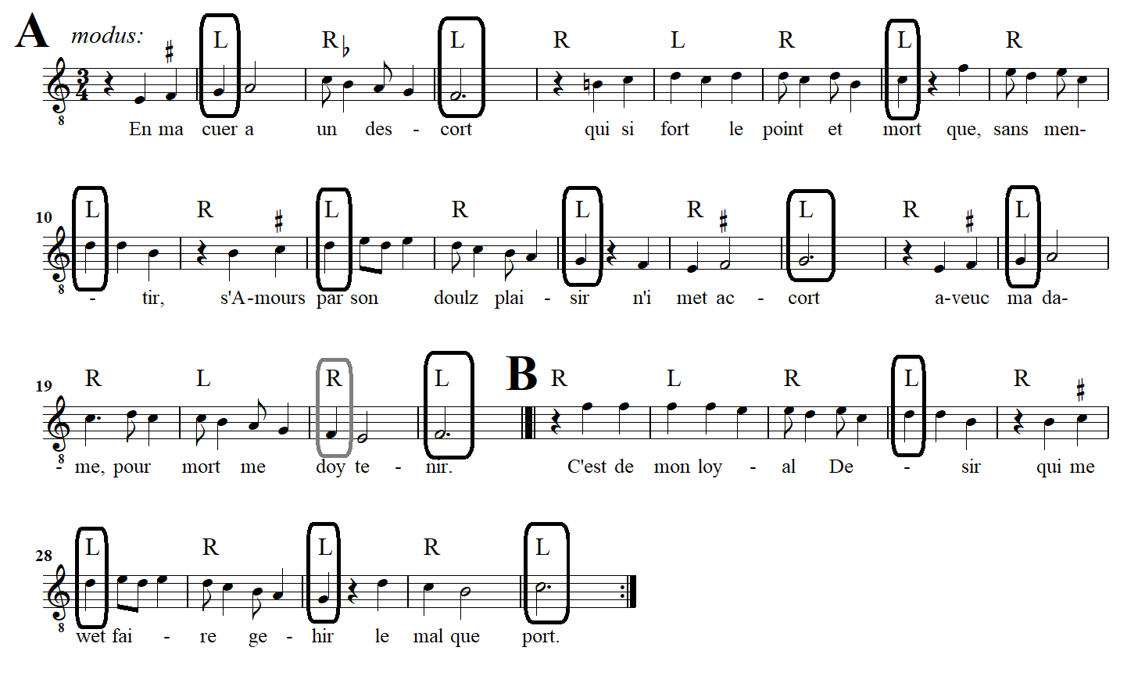
Example 20. annotated score of Machaut’s V27, “En ma cuer;” cantus line only
By approaching the song this way, dancers can maintain the generic correlation of left-foot strong beats. As mentioned above, the only directed progression that falls on the right foot is a weak, inverted one (m31) in m. 21 (boxed in gray), which provides an anticipatory taste of the final F. The F of m. 21 is tonally, metrically, and lyrically subordinate to the stronger M68 directed progression that closes the A section on the left foot in the next measure.
It is only conventional that each section of this song, A and B, should close with cadences on the left foot. Ending on the left prepares all of this chanson baladées’ formal junctures to begin with a right, further reason to infer opening the dance on a right foot. Recall that when dancing at the tempus level, a left foot cadential downbeat is followed by a right foot offbeat before another left foot downbeat begins the next phrase.
The consistent metric placement of preparatory gestures can provide a musical cue for proper dance steps, not only at the beginning but as found throughout a danced song. In V27, the same gesture in m. 1, identified for its melodic directedness, returns often across the song, as at mm. 5, 11, 15, 17, 27, and in varied form at 15 and 23. That in every instance this melodic preparation falls on the right foot confirms the subordinate role of that foot and argues strongly for beginning this dance with a right or other preparatory gesture, as speculated above. The same logic applies to V32, where mm. 15-16 are an exact repetition of mm. 1-2. In V31, the opening figure of m. 1 does not appear so melodically driven as the ascending leading tone of Virelais 27 and 32. Its function becomes clear through Machaut’s consistent use of it as cadential preparation. The formal cadences that close both the A and B sections (mm. 21-22 and 34-35) are motivic repetitions of m. 1, as summarized in Example 21. Insofar as cadential arrivals are conventionally marked by a left foot, their preparatory gesture should be taken with the right, and this norm can be backdated to establish the beginning of a dance.
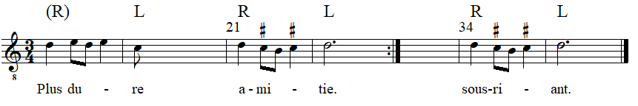
Example 21. weak beat prep to strong cadential arrival in Machaut’s V31, “Plus dure que un dyamant,” mm. 1-2, 21-22 (end of A), and 34-5 (end of B); cantus only
The final danced song in triple time, “Tres bonne et belle” (V26), puts modus dancers off-kilter regardless of how it is begun. The opening cantus melody may be described as a descending tetrachord, G-D, followed by a double-neighbor decoration of C (D in m. 2, B in m. 3), followed by another descending tetrachord, C-G (mm. 4-5). A variation of this melodic skeleton returns within the A section (mm. 16-19), reflecting the poetry’s rhyme scheme (-ueil). But this melodic return comes against the prevailing metrical (modus) entrainment. Not only is the melody now metrically unstable, as felt through the dance, but it is also recontextualized by a different accompaniment in the two lower voices. Example 22 presents these two passages in question for comparison, with steps at the modus level. The embodied metric disturbance here may shed light upon the courtly love lyric. While the lover’s eyes are smitten with the beloved in the first phrase (Tres bonne et belle, mi oueil joyeuse pasture prennent en vostre figure), we know the heart of the second phrase will be stung by the pains of unrequited love rather than enjoy any sweet nurturing (et mes cuers en vostre accueil vie et douce norreture).
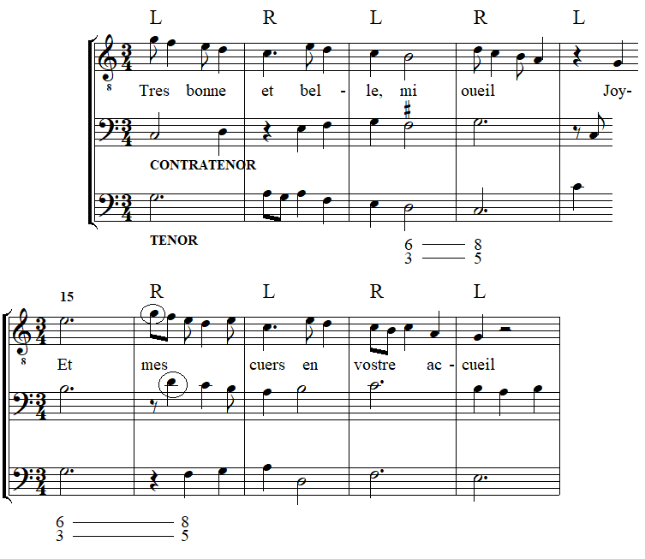
Example 22. melody recontextualized in Machaut’s V26, “Tres bonne et belle,” mm. 1-5 and 15-19
The uneasy footing I am suggesting rests upon the ideal of undisturbed imperfect modus groupings. The directed harmony setting the preparatory word “et” that begins the second phrase (m. 15) suggests a right foot rather than a left. If left were to come down on m. 16, the perfect resolution of that imperfect harmony would kick off this phrase more parallel to the first (decorative upper neighbors are circled in the example). If this step alignment would be to advantage, the dancer may be tempted to interpret a modus perfection of measures 13-15, a triple group whose final measure is the preparatory 15 and which all the more forcefully begins the second phrase at m. 16 on a proper downbeat in all parameters. However, mm. 13-14 form a clear cadence (E6/3 to D8/5) which ought to proceed right—left by the same logic. This in turn pushes back an initiating left foot to m. 12 and the modus perfection somewhere between mm. 9-12, an exercise left to the reader. In any event, the entire A cannot repeat on the same dance footing (at the modus level) when it returns at the end of the virelai form because it is an odd number of measures. If the final cadence (m. 23) is to be a left foot, respecting this as the very strongest convention, m. 1 really ought to be a right and something in the middle will have to be perfected.
This study does not presume to answer how Machaut’s songs were danced, only to grapple with some questions that arise when pairing regular dance steps with irregular musical groupings. A polyphonic and metrically complex song like Machaut’s Virelai 38 stands out as an art song evolved from a dance tradition it no longer exemplifies.
I have applied the framework of simple round dancing to interpret metrical organization in some secular Medieval songs known as a genre, and in some cases individually, to have been danced. While simple left-right alternation fits many works designed for dancing by their very nature, the freer blending of duple and triple groupings at various mensural levels found in some chansons baladées of Machaut—a composer also of complex motets, a genre Johannes de Grocheio famously claimed for the learned—perhaps elevated dance style off the dance floor. The analytical framework developed here was prompted by the carole: begin with the left foot, alternate feet, and cadence on the left. Its simple expectations thrust to the fore the kinds of mensural and metrical sophistication that contributed to a shift from physical to virtual embodiment in how Guillaume de Machaut’s virelais were encountered in the fourteenth century and can guide fresh interpretation—and, indeed, dancing—in our own.

MACHAUT SOURCES
A: Paris, Bibliothèque Nationale de France, fonds français 1584
B: Paris, Bibliothèque Nationale de France, fonds français 1585
C: Paris, Bibliothèque Nationale de France, fonds français 1586
E: Paris, Bibliothèque Nationale de France, fonds français 9221
F-G: Paris, Bibliothèque Nationale de France, fonds français 22545-6
Vg: Ferrell-Vogüé, private ownership of James E. and Elizabeth J. Ferrell

WORKS CITED
Arcangeli, Alessandro. 1994. “Dance under Trial: The Moral Debate 1200-1600.” Dance Research: The Journal of the Society for Dance Research 12 (2): 127-155.
Boone, Graeme M. 2000. “Marking Mensural Time.” Music Theory Spectrum 22: 1-43.
Butterfield, Ardis. 2002. Poetry and Music in Medieval France: from Jean Renart to Guillaume de Machaut. Cambridge: Cambridge University Press.
Chaganti, Seeta. 2018. Strange Footing: Poetic Form and Dance in the Late Middle Ages. Chicago: University of Chicago Press.
Cook, Megan L. and Elizaveta Strakhov, eds. 2019. John Lydgate’s Dance of Death and Related Works. Kalamazoo: Medieval Institute Publications.
Dean Smith, Margaret. 1937. “A Fifteenth Century Dancing Book.” Journal of the English Folk Dance and Song Society 3 (2): 100-109.
Desmond, Karen. 2018. Music and the moderni, 1300-1350. Cambridge: Cambridge University Press.
Earp, Lawrence M. 2012. “Declamation as Expression in Machaut’s Music.” In A Companion to Guillaume de Machaut, ed. Deborah McGrady and Jennifer Bain, 209-238. Boston: Brill.
_______. 2005. “Declamatory Dissonance in Machaut.” In Citation and Authority in Medieval and Renaissance Musical Culture, ed. Suzannah Clark and Elizabeth Eva Leach, 102-122. Rochester: The Boydell Press.
_______. 1991. “Lyrics for Reading and Lyrics for Singing in Late Medieval France: The Development of the Dance Lyric from Adam de la Halle to Guillaume de Machaut.” In The Union of Words and Music in Medieval Poetry, ed. Rebecca A. Baltzer, Thomas Cable, and James I. Wimsatt, 101-31. Austin: University of Texas Press.
Fuller, Sarah. 1992. “Tendencies and Resolutions: The Directed Progression in ‘Ars Nova’ Music.” Journal of Music Theory 36 (2): 229-258.
_______. 1981. “Theoretical Foundations of Early Organum Theory.” Acta Musicologica 53 (1): 52–84.
Grant, Roger Matthew. 2014. Beating Time and Measuring Music in the Early Modern Era. Oxford: Oxford University Press.
Greene, Richard Leighton. 1977. The Early English Carols. Oxford: Clarendon Press.
Harris-Warwick, Rebecca. 2000. “The Phrase Structure of Lully’s Dance Music.” In Lully Studies, ed. John Hajdu Heyer, 32-56. Cambridge: Cambridge University Press.
Hoppin, Richard H. 1960. “Notational Licences of Guillaume de Machaut.” Musica Disciplina 14: 13-27.
Kohn, Karl. 1981. “The Renotation of Polyphonic Music.” The Musical Quarterly 67 (1): 29-49.
Lavacek, Justin. 2022. “Hidden Colouration: Deep Metrical Flexibility in Machaut.” Plainsong and Medieval Music 31/2: 143-167.
Leach, Elizabeth Eva. 2011. Guillaume de Machaut: Secretary, Poet, Musician. Cornell: Cornell University Press.
_______. 2000. “Counterpoint and Analysis in Fourteenth-Century Song.” Journal of Music Theory 44 (1): 45-79.
Leech-Wilkinson, Daniel. 1991. “Not Just a Pretty Tune: Structuring Devices in Four Machaut Virelais.” Sonus 12 (1): 16-31.
Leguy, Sylvette. 1977. Oeuvres Complètes: Vol. 1. Paris: Le Droict Chemin de Musique.
Lerdahl, Fred and Ray Jackendoff. 1983. A Generative Theory of Tonal Music. Cambridge, MA: MIT Press.
Little, Meredith Ellis. 1975. “The Contribution of Dance Steps to Musical Analysis and Performance: ‘La Bourgogne.’” Journal of the American Musicological Society 28 (1): 114.
Ludwig, Friedrich, ed. 1926. Musikalische Werke Vol. 1: Balladen, Rondeaux, und Virelais. Leipzig: Breitkopf & Härtel.
Maw, David. 2013. “‘Bona Cadentia Dictaminum:’ Reconstructing Word Setting in Machaut’s Songs.” Music & Letters 94/3: 383-432.
_______. 2004. “‘Trespasser mesure:’ Meter in Machaut’s Polyphonic Songs.” The Journal of Musicology 21 (1): 46-126.
_______. 2002. “Meter and Word Setting: Revising Machaut’s Monophonic Virelais.” Current Musicology 74: 69-102.
McGee, Timothy J. 1989. “Medieval Dances: Matching the Repertory with Grocheio’s Descriptions.” The Journal of Musicology 7 (4): 498-517.
Moll, Robert. 1998. “Voice Function, Sonority, and Contrapuntal Procedure in Late Medieval Polyphony.” Current Musicology 64: 26-72.
Mullally, Robert. 2011. The Carole: A Study of a Medieval Dance. New York: Routledge.
_______. 1998. “Joahnnes de Grocheo’s ‘Musica Vulgaris.’” Music & Letters 79 (1): 1-26.
_______. 1986. “Cançon de Carole.” Acta Musicologica 58 (2): 224-231.
Nevile, Jennifer. 2008a. “Dance in Europe 1250-1750.” In Dance, Spectacle, and the Body Politick, 1250-1750, ed. Jennifer Nevile, 7-64. Bloomington: Indiana University Press.
_______. 2008b. “Dance Performance in the Late Middle Ages: A Contested Space.” In Visualizing Medieval Performance: Perspectives, Histories, Contexts, ed. Elina Gertsman, 295-310. Burlington: Ashgate.
Page, Christopher. 2000. “Around the Performance of a 13th-Century Motet.” Early Music 28 (3): 343-348 + 351-357.
_______. 1997. Discarding Images: Reflections on Music & Culture in Medieval France. Oxford: Clarendon Press.
_______. 1989. The Owl and the Nightingale: Musical Life and Ideas in France 1100-1300. Berkeley: University of California Press.
Peraino, Judith A. 2011. Giving Voice to Love: Song and Self-Expression from the Troubadours to Guillaume de Machaut. Oxford: Oxford University Press.
Robbins, Harry W., trans. 1962. The Romance of the Rose. New York: E. P. Dutton.
Schrade, Leo. 1956. The Works of Guillaume de Machaut: Part 2. Monaco: L’Oiseau-Lyre.
Stokes, Jordan. 2014. “In Search of Machaut’s Poietics: Music and Rhetoric in Le Remede de Fortune.” The Journal of Musicology 31/4: 395-430.
Strunk, Oliver, ed. 1997. “Marchetto’s Pomerium” in Source Readings in Music History: The Early Christian Period and the Latin Middle Ages. New York: Norton.
Ward, John M. 1976. “The Maner of Dauncying.” Early Music 4 (2): 127-140+142.

For a rich and broad sweep of dance’s importance to western European society—artistic, political, and intellectual–from 1250-1750, see Nevile 2008a and 2008b. Chaganti 2018 details how the central position of dance in late Medieval society informed the creation and reception of lyric poetry. Page 1989, esp. Ch. 5, views the French carole’s social context from the perspective of an evolving clergy. Arcangeli 1994 reviews the colorful denunciation of dance by Medieval clergy and moralists, not limited to claims of adultery, gluttony, paganism, lechery, and disregard for the Sabbath.
After the Old French verb caroler (to dance); also karole and querole. Latin: chorea.
Mullally 2011 discusses the etymology, choreography, and social participants of this simple dance without detailed analysis of musical structure. Greene 1977 offers a wealth of carole lyrics without music, in addition to summaries of the genre and of Medieval English dancing.
See Ward 1976 and Dean Smith 1937 for accounts of a fifteenth-century handbook on the basse danse that presents step patterns for dancing and music. Little 1975 discusses a Baroque dance manual more closely matched to given music, including implications for analysis and musical performance.
The same particularity with direction is also found in Dante’s Inferno (1320), in which the Pilgrim’s spiraling descent through Hell turns only to the left (Canto XIV, 125-7).
Nevile 2008a, 30, gives a recent summary of this widely-accepted description. The carole could be modified to a line dance when progressing through the streets of town; see Page 1990, 115. This distinction has no bearing on the approach here.
Nevile 2008b, 303, notes that Giotto’s early fourteenth-century fresco in the Scrovegni Chapel in Pauda depicts a tambourine player accompanying the carole.
Such is the performance practice described by Machaut in the Remede de Fortune, lines 3437-41; see Peraino 2011, 236. Mullally 1986, 226, also observes that a carole may be sung entirely by a soloist (refrain and verses).
Grant 2014 interprets writings on meter from the sixteenth and seventeenth centuries, which “conceptualized meter through motion,” in dialogue with modern theories. On the battuta of Zarlino, see 5-6 and 33.
Earp 1991, 113-14, credits the infiltration of ars nova motet style into secular song with its dissociation from dance. Earp 2005, 106, “believe[s] that the early virelais of Machaut are better understood as highly artistic works that merely evoke characteristics of the old dance genre.”
Machaut insists upon this terminological distinction in his Remede de Fortune (lines 3448-50) and his Prologue (Section V, lines 14-15); see Peraino 2011, 236. According to Earp 1991, 115, “it appears that Machaut was quite self-consciously preserving this genre [virelai] for the dance.”
See also Mullally 1998, 10 and 17.
Lightly adapted from Mullally 2011, 119, a transcription of F-Pn fr. 25566, f. 129r (refrain vdB 1797). In Mullally’s translation: “My very sweet lively lady, listen to my heart beseeching you.”
Grocheio’s De musica (c. 1300) describes the carole [ductia] as “a light dance song, rapid in its ascent and descent.” See McGee 1989, 506. An open (ouvert) cadence is identified with reference to a song’s terminal pitch and implies future resolution in a closed (clos) cadence. Scale degrees ^2, ^5, and ^7 are customary sites of open cadence, all ultimately seeking ^1.
Both Examples 3 and 4 come from MS Bodley 264, f. 181v. While “Ensi va qui amours” is the only rondeau of this study otherwise concerned with virelais, the interpretation of metrical groupings as pattern for dance steps is abstract enough for pertinence to both genres. The virelais are singled out from Machaut’s output because he himself called them “danced songs.”
That fourteenth-century dance songs should feature simple, consistent rhythmic groupings is taken as obvious by many modern scholars. Earp 1991, 124, for example, states that “we hardly need to mention that the rhythmic projection of such a song would have been strictly metrical, something to move the feet to.”
Inspiration for this simple dance notation was taken from Little 1975.
Concerning notational options in the Ars nova, Jacques de Liège (1320s) observes that “the perfect breve has the same value as had the perfect long for the Ancients,” with consequences for modern transcription; see Maw 2004, 47. The rates at which to sing and to dance a carole are interrelated yet can be adjusted separately to expressive effect. One can choose to step fast (tempus level) or slow (modus) without changing the sung tempo. Doubling or halving the music sung per step in this way produces quite a different feel in performance and can impart a livelier or more somber expression, as desired. Changes to sung tempo increasingly call for changes to dance pacing in inverse proportion. If a song’s tempo is quickened, pressure to dance it at the next broader mensural level accumulates lest the steps break into a jog. On the contrary, if a song is taken slowly, the dancers may better subdivide to avoid dragging their feet. Issues of grouping that can result from these independent choices will be addressed below.
See Peraino 2011, 239-42, for detailed elucidation of this song’s lyrics and function within the Remede.
Earp 1991, 126, claims that the story line of the Remede was contrived to demonstrate each type of song then current. See Earp 2005, 105-6, on the virelai as danced song in the Remede. Peraino 2011, 235, calls Remede “in effect a musical summa.” See Butterfield 2002 on the generic characteristics of romans à chansons and Stokes 2014 on the didactic undertones of Machaut’s Remede, particularly regarding medieval rhetoric. Leach 2011, 139-64, provides an excellent summary of the Remede and analysis of its lyric interpolations in the context of the poetic functions of Hope and Desire.
According to Peraino 2011, 285, “there we see the singer Machaut hand in hand with women in the dance. His voice in the virelai enables the carole….” See also Leach 2011, 159, on Machaut’s identity in this song and its depiction.
My transcriptions of Machaut are based upon Ludwig 1926, differing sometimes in suggested ficta and bar line placement, unless otherwise noted. In this case, however, I prefer the anacrustic transcription of Maw 2002, 82, for its benefit of situating both cadences on downbeats, contra Ludwig and Schrade. Relevant variants among the Machaut manuscripts will be considered throughout. My dance steps L and R in “Dame, a vous sans retollir” correspond to what Earp 1991, 129, calls “metrical units” 1 and 2, adjusted for the anacrusis. Earp 2005, 106-7, uses the same song as an example of conventional text declamation. His bold-numbered syllables correspond to my dance steps.
For Earp 1991, 138, “Machaut’s early dance virelais… are already far more refined than a popular dance song.” Peraino 2011, 356, finds the relatively “off-kilter rhythmic environment” of Machaut’s virelais to result in “a lively tune that dances itself, though it may not be itself fit for dancing.”
Cadence here refers to arrival on a pitch stressed by alignment with the end of a poetic line, agogic accent, being followed by rest, contrapuntal relationship to the last note of the song, and by perfect consonance with other voices in polyphonic cases. Moll 1998, 32, provides a useful table for defining cadence in fourteenth-century French masses.
Boone 2000 undertakes a detailed investigation of regular rhythmic punctuation in the layered mensural pulses of Machaut and others across the medieval and Renaissance periods. Boone then contrasts mensuration as temporal framework with common practice meter. Succinctly put by Maw 2002, 70, “while the theory of mensuration supplied a quantitative understanding of musical time sufficient to make sense of rhythm for the purposes of notation, metrical thought provided a supplementary qualitative understanding of musical time necessary in practice to make sense of rhythm for the purposes of musical effect.”
Further examples of the flexible metrical interpretation of regular mensural notation can be found throughout Maw 2004 and 2013, including transcriptions in mixed meters.
Maw 2004, 62 and passim, addresses the modus barring methodologies and inconsistencies in the complete editions of Machaut’s secular songs by Ludwig and Schrade. See Maw 2002 for a systematic investigation of modus in Machaut’s virelais, a more flexible mensural level that requires analytical interpretation of musical groupings, supplemented by a focus on text setting and meter in Maw 2013. A complementary analytical account of flexible modus barring in Machaut’s motets is undertaken in Lavacek 2022.
The way that alternation of left—right feet in dance parses mensural groupings into strong—weak maps onto the hierarchical organization of Medieval French mensural theory insofar as any subdivision will have its first attack accented by simultaneity with its parent duration.
As noted in Leech-Wilkinson 1991, 16, “hardly any have the regular metrical structures one would expect of a dance accompaniment.”
Earp 2005, and its 2012 extension, document the conventional relationship between metrical pulses and rate of text declamation in Machaut, regarding irregularity (“declamatory dissonance”) as a strategy of poetic expression.
Along with V14, Leguy 1977 assigns the dual time signature 6/8 and 3/4 to virelais 2, 5, 8, 16, 19, 26, 27, 31, and 32 (numbered as in Ludwig), among others with multiple time signatures, and freely beams groups of two and three eighth notes in order to capture different “rhythmic cells” (see Foreword, VI).
Time (tempus) is defined by the triple or duple (perfect or imperfect) subdivision of breves by semibreves. In most modern transcriptions of fourteenth-century French music, as here, the breve is represented by a measure and the semibreve beat by a quarter note (dotted when perfect). Prolation (prolatio) is the next smaller level of subdivision, the triple or duple (major or minor) division of semibreves by minims. In the present transcription, eighths per (dotted) quarter.
Following Earp 1991, 130, “there are no extended melismas, and thus the ear hears the text syllables themselves as providing the musical rhythms.” The “pitch accents” marked in Example 1 of Maw 2002, 72, show a very similar metrical swap to perfect minor within a context of imperfect major in Machaut’s V1, “He! Dame de vaillance.” See m. 5 and mm. 7-9 for passages of 3/4 within a song set in 6/8. Example 14c of Maw 2002, 91, explicitly renotates V18, “Helas! et comment,” along the same lines, switching to 3/4 to capture a measure of rhythm identical to that of mm. 8 and 12 of V14 as I have rendered them in Example 9. Example 8 of Maw 2013, 397, presents essentially the same transcription of V18 in 6/8 (mm. 1-6) then 3/4 (mm. 7-11) based upon the syllabification of those phrases. The text underlay of the MSS (Mach A, C, G, Vg) are not precise enough in these measures of V14 to base a conclusion about scribal intent.
Underlying my analyses is the assumption that one dance step occupied one beat of music. The rare inclusion of a percussion instrument to keep the beat of a carole, as noted above, would likely reinforce a step-beat equivalence.
Grant 2014, especially chapter 3, brings this historical kind of triple meter into dialogue with modern theories using examples from the sixteenth century through Handel. The present discussion responds to Grant’s call to “envision yet other pieces under the same distorted lens: to see the inequality hiding just behind the surface of the music” (78) cast further back in time while Grant prods modern theory.
For example, a breve may be imperfected by an adjacent semibreve, reducing the former to 2/3 of its original value. Thus is produced a 2+1 triple group by medieval subtraction (from 3), rather than Renaissance addition to 1+1.
The issue of dancing those rare virelais set in triple time is taken up below.
A disjunction between two grouping patterns in a polyphonic song begs the question of which grouping the dancers followed, assuming they all stepped together, and likely excludes (complex) polyphony from being danced. As argued throughout this study, and in much work by Earp and Maw, Machaut’s virelais as a genre still bear the imprint of dance however artful they became.
Little 1975, 114 and 119, provides a French Baroque solution to the issue of dancing pickup notes, though it cannot be securely backdated to Machaut’s practice. One of the first European dance manuals to be inlaid with corresponding musical notation shows pickups being danced with a plié before the steps proper began.
With V14, Vv 4, 27, and 36 also begin with a semibreve beat of rest in all MSS. Ludwig reproduces only that of V27, likely to counterpoint the tenor’s entrance, while Schrade begins both Vv27 and 36 with a beat of rest (both polyphonic) but not V4 (monophonic).
In all MSS, Vv 5, 9, and 28 begin with one or two minim rests (in imperfect and perfect time, respectively), enough to complete a full semibreve beat together with their single minim pickup note (excepting Mach E’s rendering of V28). V36 begins with one semibreve rest and then a minim rest in all sources (Mach A, G, and Vg); that is, a full beat of rest followed by enough rest to complete a second beat of imperfect time with the single pickup note. Ludwig represents none of these rests while Schrade restores them all.
Maw 2002, 71, finds the irregular metrical schemes of Machaut’s virelais “unsuitable for dancing except of a stylized nature.” Nevertheless, the pattern of carole dancing is pursued here as, at least, an analytical model to be extended as far as Machaut’s metrical groupings suggest a need.
Chaganti (17) is clear that “Machaut and Deschamps wrote lyrics that were mindful of the aesthetics of dance and dance accompaniment.” The virtual embodiment of dance is in the sense, then, in which these poets took on the norms and limitations of dance music as a scaffolding for the creation of new works. Whether a given work was destined to be danced actually or not, its mensural grouping structure bears the footprints of dance and dance can (in any era) make that manifest. Concerned with music of the sixteen and seventeenth centuries, Grant 2014, 16 (see also 27-9 and passim), concurs that “whether it was performed or served as a figure of imagined demonstration, the motion of the beat rendered temporal division sensible in these theories.”
The complete work is edited in Cook and Strakhov 2019, see esp. 37.
Author’s translation of Loyaute weil tous jours meinteniret de cuer servir ma dame debonnaire… et li obeir com a mis, sans meffaire.
My example follows Schrade in representing the two minim rests that open both A and B sections in all sources of V5 (Mach A, C, E, G, and Vg), omitted by Ludwig. I follow both Ludwig and Schrade in taking the rest that follows the final G closing the refrain (m. 8) as a section break and not as a measured duration. This rest variously appears as a breve (Mach C, E, Vg) or semibreve with additional section break (Mach A, G).
I maintain imperfect major grouping throughout the melisma of free 8th notes in m. 11. The first beat passes through a third while the second decorates local leading tone C# with a lower neighbor.
The complete form with all its repeats is not represented but can be inferred from the example.
See Maw 2004, 60, in response to Hoppin 1960.
Maw 2013 provides a thorough analysis of text setting in the Machaut sources, with reference to their mensural and metrical implications, and reconstructs some principles for fitting words to music in his songs.
But given the sheer length of V20 (repeats can be inferred from the Example) and the verbosity of its lyrics, tempus dancing makes for a busy performance.
I thank my anonymous reader for this important observation.
My transcription here is closer to Schrade (numbered V32), which differs from Ludwig in maintaining duple time throughout, omitting his frequent alternations to quadruple time (notated 4/4). I also maintain duple time through breves 22-24, where Ludwig compresses the same notes into a single measure of 3/2, essentially omitting my breve 23. I will later achieve the same effect, with the benefit of placing the final F on a downbeat (breve 27), by interpreting perfections (triple groups) at the modus level, just as Ludwig implies by his 3/2 time signature within the context of 2/4 and 4/4.
From the virelais alone see examples in Ludwig’s V5 (mm. 4-5), V6 (mm. 15-16), V10 (mm. 14-15), V11 (mm. 4-5, 10-11, and 14-15), V12 (mm. 8-11 and 18-21, second endings), V15 (m. 18), V17 (mm. 8-9), V18 (mm. 9-10), V23 (m. 9), V26 (mm. 12-14), V29 (mm. 4-5), V31 (mm. 14-16, 25-26, and 31-32), and V37 (mm. 10-11 and 19-20), not to mention many more variants of this pattern.
I take that structural pitch to be C, decorated by an accented neighbor B. The modern analyst of Medieval music must always be aware of creating the tonal emphases they wish to find through the creative act of transcribing Medieval music, for example through metrical fitting with bar lines and musica ficta as leading tones. Leach 2000, 45-46, reviews these issues in reference to fourteenth-century song. As explored in this study, dance provides another parameter of Medieval performance that may regulate, and at the same time may tempt, the modern analyst into placing this or that note on or off the beat. Caveat saltator.
See their introduction to metrical hierarchy in Lerdahl and Jackendoff 1983, 18-30. Boone 2000, 4, presents a similar “grid of pulse classes and pulse levels.”
Lerdahl and Jackendoff 1983, 19, do quickly associate undifferentiated beats with strong/weak poetic accent, in which beats 1 and 3 of 4/4 meter are strong while 2 and 4 are weak. In the transcription of Machaut’s virelais here, this corresponds to two measures of imperfect tempus danced L R L R. Dancing at the modus level reveals the first left step to be stronger than the second—parallel to beat 1’s comparative strength over beat 3—because that step is also left at the modus level while the second tempus left falls under a weak right in modus.
On flexible metrical grouping as valued characteristic of deep mensural levels in Machaut, see Boone 2000, Maw 2004, and Lavacek 2022. The analytical pursuit of dancing modus and maximodus here resonates with Lerdahl and Jackendoff 1983, 22: “this large level of metrical analysis [at 4-bars] is open to interpretation, whereas smaller levels are not.”
Corroborating the argument made about the modus level above, the first measure really ought to be a pickup at the weightier maximodus level also or else only two of five cadences fall on a beat at all and both of them are right feet (not shown in the Example).
I rely only upon the generic normativity of duple mensuration in Machaut’s virelais as a backdrop against which to call out irregular groupings for special interpretation.
Other modern scholars have pointed to how the broadening of mensuration can achieve an effect like a ritard before cadence. Adjusting modus and larger mensural groupings to align harmonic units and cadences is central to the analysis of Machaut’s motets in Lavacek 2022. Kohn 1981, 41–2, comments upon a cadential retardation effected through mixed meters in the Dunstable motet Sancta Maria. Desmond 2018, 217 (Example 6.5), shows a change in all voices from imperfect to perfect modus as a cadential retardation that concludes the Fauvel motet “Garrit/In nova.” Maw 2004, esp. 64–5, locates modus perfections in an imperfect context leading up to cadences in Machaut’s ballade “Gais et jolis” (B35), among other examples. He later (86) calls this effect “a reverse hemiola at the cadence.” Further examples from Machaut’s virelais are in Maw 2002, 84, Example 9b.
Earp 1991 traces the development of the danced song genre as a generic mixing of high courtly poetry with low metrical dance.
In the first verse of V38, for example, the singer pledges that to do rightly and with a happy heart means everything, and that he shall do nothing less till death. [Bien faire et avoir cuer gay, c’est tout; plus n’emporteray, quant seray finee;]
My discant reduction was largely produced by the simple omission of dissonances against the tenor, especially when such notes occur off the beat in passing or neighboring melodic motion. Leach 2000 provides an instructive example of modern reductive analysis grounded in Medieval theory.
On the crucial concept of directed progressions in fourteenth-century polyphony, the classic source is Fuller 1992. Essentially, imperfect consonances are felt to drive towards the greater stability of perfect ones through stepwise contrary motion, especially M3P5, M6P8, and m3P1. Polyphonic simultaneity is very tightly linked to consonance/dissonance placement in the mensural theories of John Garland, Franco of Cologne, and Anonymous IV, as detailed in Fuller 1981.
A potential alternative to this, marking triple groups as an unequal binary, maintains the usual L – R alternation per measure. This possibility and its historical support will be considered below.
Table 7 in Maw 2004, 94-5, provides a detailed list of modus organization in Machaut’s formes fixes, including flexible readings of perfect/imperfect alternation. Consult Table 1 of Maw 2002, 76, for a complete list of mensurations, including anacruses, and cadential plans in Machaut’s virelais.
Page 2000 discusses some of the fourteenth-century motet’s elevated characteristics in relation to Grocheio’s witness, including a bolder usage of dissonance, polytextual assonance, learned counterpoint, and some suggestions for performance practice. More comprehensive discussion may be found in Page 1997, chapter 3.

