The task given to the team is to build a buggy robot. To achieve this task, our buggy has to travel through a fixed maze turn around and come back in a certain time frame, which is a maximum of 8 minutes. In addition to this, the buggy also has to play some music at some point of its journey.
Building a buggy robot can be broken down in to planning, which includes accounting for problems and designing, programming, assembly, testing and re-implementing. This report deals with all these stages. In order to be able to complete this task with more facility, we will analyse and plan how the robot will be build.
Nature of the problem & its analysis including equipment
Each team is given a file box which includes a PIC Buggy Self-Assembly Kit. This kit contains the necessary to assemble and accomplish the task. Tools such as a soldering iron are also available and provided in the labs. Each team is allowed to contribute to $10 of their own money to add extra features to the robot, for example proximity sensors.
The equipment given to each team is:
- Pack of PIC Buggy
- Download cable
- 4AA batteries
- Pliers
- Wire cutter
- Cross-head screwdriver
- Buggy manual
In addition to this, the team should download software that will be used to write a functional program for the buggy. The team should familiarize themselves with the code so that errors are avoided.
The robot has to be able to complete its going and coming back in less than 8 minutes. The team should write a program so that the robot can go to the end of the maze and come back. The buggy should also be able to detect once it hits and object or a wall and be able to change its trajectory back going backwards and turning. The team will be able to test their program by placing their buggy in a “flexible” maze. This maze is made up of a board with 10 wooden blocks that can be moved and placed anywhere around the board. A second and different sized maze will be used for the final demonstration. The wooden blocks in this second maze are fixed and the positioning of them can not be altered. Below is a diagram of each maze.
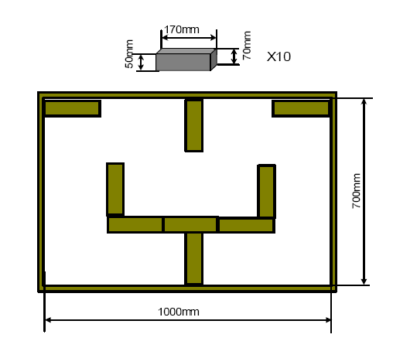
Schematic diagram of the fixed maze for demonstration/competition.

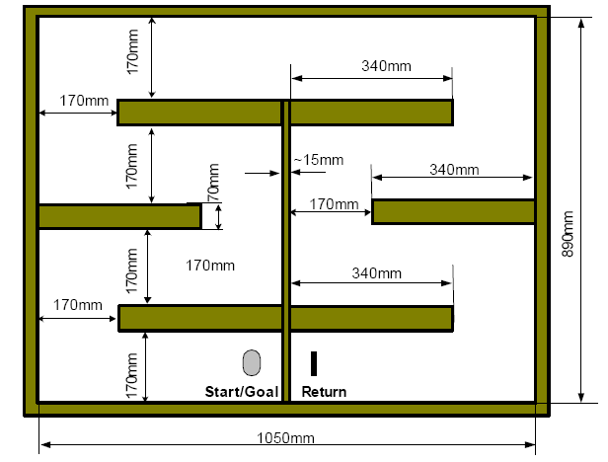
Schematic diagram of the fixed maze for demonstration/competition. The buggy robot starts from “Start/Goal” and reaches “ Return”, then travels back to “Start/Goal”.

(REFERENCE: ELEC1601 Foundations of Computer Systems Course Notebook, D C Levy p. 256)
Initial design, breakdown of tasks & project plan
For the actual design, we decided to follow the instructions given. The initial instructions for assembling the robot are:
Extra Assembly Instructions
1. Use a zero-ohm resistor to connect LK3 at the piezo sounder;
2. Use one of the soldering stations placed at the front of the Lab;
3. Use ribbon cables to connect the Micro switches to the PCB board so that the Micro switches can be flexibly mounted (refer to Figures 4 and 5);
4. To detect obstacles in front, mount the Micro switches as shown in Figure 4;
5. To follow a wall on the right hand side, mount the Micro switch B (right) as shown in Figure 5 so that the arm of the Micro switch can detect the wall.
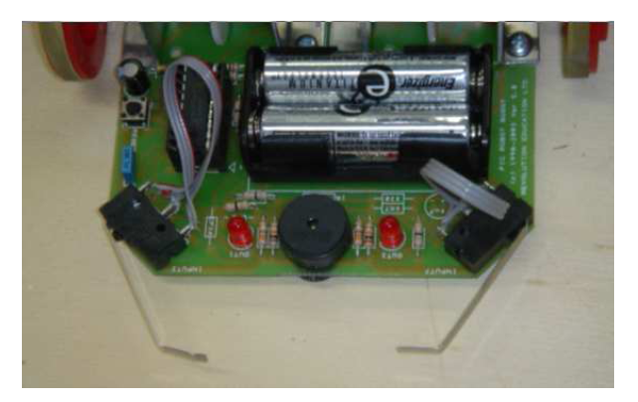
Figure 4: Micro switches are mounted in front to detect obstacles

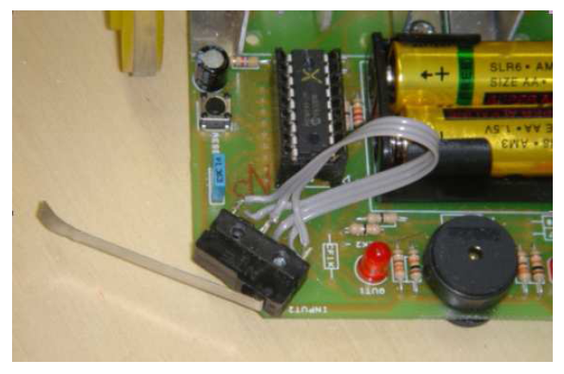
Figure 5: Right hand side Micro switch is mounted to enable its arm to detect a wall on the right hand side

(REFERENCE: ELEC1601 Foundations of Computer Systems Course Notebook, D C Levy p. 262-263)

Task | Task Description | Weeks
A | Demonstration of last year’s robot to see how it performs the task | 1
B | Forming a group | 2-3
C | Getting advice from tutors | 2-3
D | Assemble PIC Buggy using the Assembly Kit and soldering iron | 4-5
E | Programming the robot | 6-8
F | Hand in detailed design report | 7
H | Implementing the program to the robot and testing | 9-10
I | Modifying errors and re-implement | 11
J | Prepare Presentation | 12
K | Writing and submitting final report | 12-13
L | Final Demonstration | 13

Potential difficulties & possible strategies
Various potential difficulties may arise. These include technical and administrative issues. As a group, we have come up with the possible errors that may occur. Below is a list of questions and answers on how each difficulty can be avoided or dealt with.
What if we don’t know how to build/program the robot?
This is a problem that nearly all the teams have to face; it’s just part of the assignment. It is a minor difficulty as it can be overcome easily with practice. Even though none of us has seen what the programming language is like, it should be fairly simple to adapt our previous experience with programming.
What happens if the batteries run low?
From personal background knowledge, we all know that batteries tend to run low. As a team, we have decided that we were going to change the batteries the day of the final demonstration. We also agreed that the robot should be programmed so that it uses the minimal battery possible.
What measures should we take if the buggy gets stuck, say in a corner?
In such a situation, if the buggy finds itself stuck and not able to get back on track and find its right direction, the team is allowed to pick up the buggy and place it on a preferred path. This option of picking up and replacing the robot is allowed once only during the whole course of the demonstration. However even though the team is allowed to reposition the robot, points should be taken off by the marker. As a team, we will make sure that the program is well written so we won’t have to face that kind of problem.
What to do if the buggy fails to operate?

If the buggy fails to operate as desired, the team should assure that all the solder joints are well soldered. The team should also check that there are no accidental solder bridges, which might cause the buggy to malfunction. In addition, the team should also control that the polarized components as well as the two chips are correctly attached onto the buggy. Batteries also have to be checked so that they are well inserted properly and in the right way. Lastly, if all of these are checked and the buggy is still dysfunctional, the program PIC16F627 should be looked at and whether it has been coded properly.

What if the buggy turns incorrectly to what is planned?

Same answer as above, the solder joints should be checked properly, the team should make sure that there are no solder bridges. The program should be checked to see if there are not any anomalies. In addition though, the team should check whether the LED lights on both sides of the buggy light up. To do so, the program has to be slightly altered test by allowing the buggy to turn left and right, back and forth. An additional thing to check is the position of the wheels. Be sure that they are well aligned with the each other. Also, make sure that the batteries are fully functional, because what can happen is that as the robot turns mainly on one side only the batteries used to power up that motor are equally used up more.

What if there is a free loader in the team?
Working as a team, all members of the group should contribute equal amounts of work. In our group we have a team leader. The leader of the group should assign task to each member and should make sure that all the tasks are properly done and achieved on time. If however there is someone that is lacking behind, it is the teams’ responsibility to encourage this person. In the worse scenario where the lacking team member does not keep up with the work, he should be reported. This should happen only if nothing else can be done, because this can greatly penalize the team.

