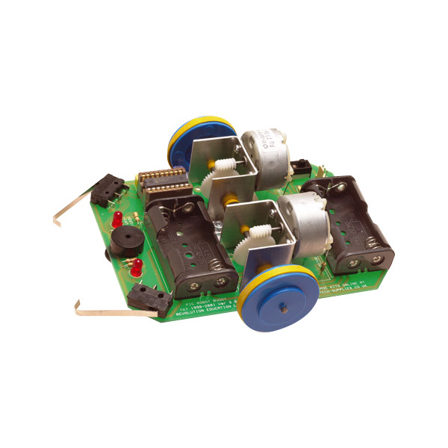
Professional Computer Engineering
ELEC1601
Detailed Design Report
- Nature of the Problem & Statement of Goal
With the aim of achieving the goal, some problems have to be considered at the beginning. Initially, a PIC buggy robot should be assembled properly to perform all the required tasks. Followed by, is the most challenging problem. Programming the micro switches “bumpers” to detect obstacle that enable the buggy robot to go though the maze smoothly, with the two LED “eyes” indicating the motion of the buggy robot during the course. In addition, there is the problem of playing the tune.
Since the buggy has been assembled, the focus now is on getting it to work. The two independently-driven wheels give the buggy robot a better control over speed as well as direction, also two bump micro switches enable the robot to detect and avoid obstacle. This structure gives the buggy robot the ability to turn left, right and rotate enabling the buggy robot to complete the maze successfully. In addition, the two LED “eyes” are located in the front of the buggy robot to indicate its motion. The sound generator will perform the task of playing the tune, indicating the movement of the buggy.
At the end of the project, the buggy robot will be able to navigate through the maze smoothly, play a tune while making turns (left, right and U-turns) and when the buggy robot has completed the maze. The two LED “eyes” will indicate the movement of the buggy robot. For example, the left LED will light up when the buggy makes a left turn, the right LED will light up when the buggy makes a right turn and both LED will light up when it is reversing.
- Project Plan & Time schedule
With the aim of programming the buggy robot to navigate through the maze smoothly and play a tune at some point by Week 12, the project will be done in a few stages including assembling, planning, designing, programming, testing and developing. We managed successfully assemble the buggy robot in Week 4. Therefore only 9 weeks available for completing all the other stages. As a part of the project plan, the Gantt chart below indicates the tasks, the group will do within 9 weeks.
Week | Steps
Week 4 | The buggy robot was assembled.
Week 5 | The sample coding was tested and tested the functional parts
Week 6 | Codes by group members were discussed.
Week 7 | The detailed report was discussed.
Week 8 | Preparation of detailed report and submission.
Week 9 | Try our the turning and essential coding.
Week 10 | Try the music and the other parts of the coding together.
Week 11 | Finalise the coding for the buggy.
Week 12 | Demonstrate the fully functional robot.
Week 13 | Design & handing over the final report.

- 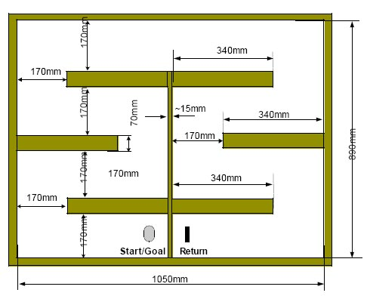
Detailed Design
At the commencement of the maze run, the buggy is orientated in the direction it has to travel. From thereon in, it must navigate through the maze based on our programming. In order to successfully reach the end of the maze, turn around and return to the start several processes have to be coded.
- Going Forward
The buggy robot will go forward only if there is a wall to follow. The algorithm below explains the conditions.
Codes | Explanation
main:  if pin7 = 1 then turn left  if pin2 = 1 then go forward  if pin2 = 0 then find wall  go to main  find wall:  for b0 = 1 to 50  let pins =%00010000 `right turn to find wall  pause 8  if pin7 = 1 then left  if pin2 = 1 then go forward  next  -------〉right turn  Go forward:  let pins =%01000000 `turn left  pause 30  let pins =%01010000 `forward  pause 10  if pin7 = 1 or pin2 = 0 then main  go to forward | Right side motor is activated.  Both motors are functioning at equal pace.  Turn right slightly as moving forward.  Main is the where the program initiates.  When switch B is not hit. The buggy robot will turn right slightly in order to find the wall:  Condition 1: if micro switch B is hit continuously within the time interval, it will go forward with a deviation to the left (in order to avoid getting stuck).  Condition 2: if micro switch B is not hit in this time interval, then it will go to right turn process.
- Turning
The design of the buggy robot only allows the buggy robot to make a right turn if micro switch B is not hit. In this case the motion of right turning is pretty simple. The buggy robot will always make a 90º right turn if no side obstacles (walls) are present. In order to follow a wall on its right, the buggy robot will move forward while micro switch B keeps touching the wall on its right. When there are no more walls on its right, the buggy robot will register this and play a tune as well as lite the right LED lights while starting to perform its pre-programmed motion i.e. making a 90º right turn. However if no wall is found after the 90º turn, the buggy robot will pause itself for a few seconds, then play another short tune before making another 90º right turn. The buggy robot will keep doing this, until a wall is found. In the whole right turn process, micro switch A is disabled in order to prevent it from turning back. The algorithm and enclosed below shows how the design works.
Codes | Explanation
Right turn:  for b0 = 1 to 10  let pins =%01010000 `forward  pause 10  if pin2 = 1 then go forward  next  sound 0,(50,100) `tune for right turn  for b0 = 1 to 100  let pins =%00010010  ` turn right and LED B on  pause 45 `wait until 90  if pin2 = 1 then go forward  next  ……… | When micro switch B does not find a wall, the buggy will move forward a little bit and make a 90º right turn.  Condition 1: if no wall is found, move forward and make a turn (right LED will light up). Then it goes forward and make another turn(right LED lit up) with a slight deviation to the right to find a wall.  Condition 2: if wall is found, moving forward process is initiated
Turning left however is a much more complicated problem. As stated above, the buggy robot will always make a 90º right-turn unless a certain set of conditions is satisfied.
This condition is satisfied if micro switch A hits the front wall, while micro switch B is touching the right wall. If this happens, the left turn motion will then be initiated. Both of the LED will light up for about 2 seconds, and then the robot will reverse to generate enough space for a 90° left turn. After that, the left LED will light, then the left side of the buggy wheel will stop and the right side of the wheel will roll forward for about п/2 times the distance between the two wheels, allowing the robot to make 90° left turn. The algorithm below will further explain the process.
Codes | Explanation
let pins =%10100110 `reverse and LED AB  pause 500  sound 0,(100,50) `tune for left turn  for b0 = 1 to 100  let pins =%01000100 `turn left and LED A on  pause 30 `wait until 90  if pin7 = 1 then re  `if left switch hit twice then return point  if pin2 = 1 then main  next | The buggy robot will only make a left turn if micro switch A is hit while the buggy is in the moving forward process.  The robot reverses and turns left. After this, micro switch B must hit the wall in order to find the wall.
- Returning
The buggy robot does return when touches the last wall before coming back in 2 simple steps When the buggy gets very close to the last end of the maze, micro switch B will continually follow the wall on its right side until micro switch A touches the last end of the maze (corner X). This makes the necessary condition possible for the buggy robot to make a left turn. Therefore, the buggy robot will perform a reverse motion for a few seconds and then make a 90º left turn. However, before the buggy robot actually completed this motion, micro switch A hits the corner Y. This occurrence indicates that the buggy robot is making a return for the start point. Then the buggy robot will pause for 7 seconds while playing a tune before making a left turn until micro switch B finds a wall on its right side. After a wall is found, the buggy robot will continue moving through the rest of the maze.
Codes | Explanation
let pins =%10100110 `reverse  pause 220  let pins = %00000000 `stop  for b0=1 to 5  b1=10*b0  sound 0,(b1,150) `play music  next  for b0=1 to 100  let pins =%01100000 `rotates left  pause 20  if pin2 = 1 then go forward  `touch wall  next  for b0=1 to 100  let pins =%00010000 `right turn for find wall  pause 8  if pin7 = 1 then main  if pin2 = 1 then go forward  let pins =%01010000 `with slightly forward  pause 3  if pin7 = 1 then main  if pin2 = 1 then go forward  next  go to main | Returning is done by using two left turn  processes.  Condition : Two left turns processes must  be initiated at corner X and corner Y  respectively. This will initiate the return  process.  Rotation is used rather than turning as not  enough space is available for the motion.  Subsequently, find wall process is initiated  so that the buggy can return to the start  point.
- Members' Contribution
Group Member | SID | Contribution
Yong Quin | 309611250 | Assembling the buggy, design the report and analysing the code for the buggy.
Bo Sun | 306268116 | Design the code for the inputs of the buggy and design the report and designing the essential coding.
Danan Thilakanathan | 308171195 | Design the report and programming codes and finalization the codes.
Jonathan Maddison | 308203984 | Design the coding for the essential movements and finalization of the project.
Dilanka Jagathvijaya | 308278216 | Assembling the buggy & design the code for the music system.
- References
Alan, S. (2005, September, 05). “CD” Buggy. University of Plymouth [Online] www.plymouth.ac.uk
Rachel and Danny. (2005). Buggy Report. [Online] www.heronsgate.milton-keynes.sch.uk
Revolution Education. (2002). PIC Buggy self-assembly kit. [Online] www.rev-ed.co.uk

