Report Lab 3 – Misha Tsysin, 0033922418

# Area fill

Essentially in this part, we need to write a simple graph traversal algorithm – breadth-first search. The idea is to maintain a list of nodes (pixels) that we want to visit and pop them from the queue as we go. The simple implementation of a queue in C is a linked list. The models based on dynamic arrays are too complicated and don’t provide any improved performance.

The original image is:

Now, the resulting segments for different starting points and thresholds:

s = (67, 45), and T = 2:



s = (67, 45), and T = 1:



s = (67, 45), and T = 3:



The code responsible for finding the area fill is presented below. The logic can be summarized in the two functions:

void ConnectedNeighbors(

struct pixel s,

double T,

unsigned char **img,

int width,

int height,

int *M,

struct pixel c[4]

) {

// Find all the connected neighbours of a pixel s and return them to the array c

*M = 0;

if (s.m > 0 && abs((int)img[s.m][s.n] - (int)img[s.m-1][s.n]) <= T) {

c[(*M)++] = (struct pixel){s.m-1, s.n};

}

if (s.m + 1 < height && abs((int)img[s.m][s.n] - (int)img[s.m+1][s.n]) <= T) {

c[(*M)++] = (struct pixel){s.m+1, s.n};

}

if (s.n > 0 && abs((int)img[s.m][s.n] - (int)img[s.m][s.n-1]) <= T) {

c[(*M)++] = (struct pixel){s.m, s.n-1};

}

if (s.n + 1 < width && abs((int)img[s.m][s.n] - (int)img[s.m][s.n+1]) <= T) {

c[(*M)++] = (struct pixel){s.m, s.n+1};

}

}

void ConnectedSet(

struct pixel s,

double T,

unsigned char **img,

int width,

int height,

int ClassLabel,

unsigned int **seg,

int *NumConPixels

) {

*NumConPixels = 0;

node* b = malloc(sizeof(node));

b->p = s;

b->next = NULL;

node* tail = b;

while (b != NULL) {

// Get a pixel from the list;

pixel_t current_pixel = b->p;

//get neighbors

pixel_t c[4];

int M;

ConnectedNeighbors(current_pixel, T, img, width, height, &M, c);

// find all the

for (int i = 0 ; i < M; ++i) {

pixel_t candidate = c[i];

if (seg[candidate.m][candidate.n]!=ClassLabel) {

seg[candidate.m][candidate.n]=ClassLabel;

(*NumConPixels)++;

node* new_node = malloc(sizeof(node));

new_node->p = candidate;

new_node->next = NULL;

tail->next = new_node;

tail = new_node;

}

}

node* old_b = b;

b = b->next;

free(old_b);

}

}

# Image Segmentation

Now we will essentially run the previous algorithm on every single pixel to generate the segmentation.

For T = 1:

T = 2:

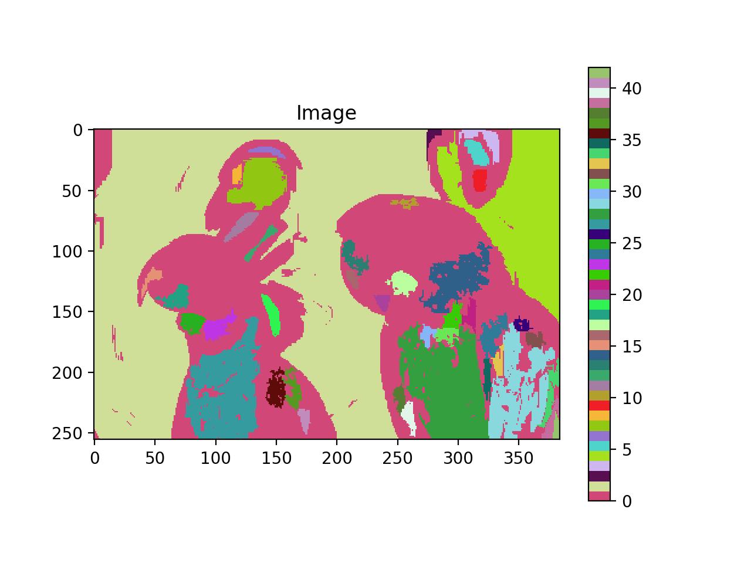

T = 3:

The number of segments is:

|  |  |
| --- | --- |
| T | # Segments |
| 1 | 36 |
| 2 | 41 |
| 3 | 23 |

The code for this part is essentially using the previous routine for each pixel:

void Segment(

double T,

unsigned char **img,

int width,

int height,

unsigned int **seg

) {

int label = 1;

int NumConPixels;

for (int i = 0; i < height; i++)

for (int j = 0; j < width; j++) {

if (seg[i][j] == 0) {

ConnectedSet((pixel_t) {i, j}, (double)T, img,

width, height, label, seg, &NumConPixels);

if (NumConPixels >= 100) {

label ++;

} else {

ConnectedSet((pixel_t) {i, j}, (double)T, img,

width, height, 0, seg, &NumConPixels);

}

}

}

}

# Full Code With Driver:

Main.c:

#include "tiff.h"

#include "allocate.h"

#include <assert.h>

#include "filter.h"

#include "areafill.h"

void error(char *name)

{

printf("usage: %s input.tiff output.tiff pixel_y, pixel_x, T \n\n", name);

printf("this program reads in a 24-bit color TIFF image.\n");

printf("and a customfilter image.\n");

printf("It then performs neighbourhood search\n");

exit(1);

}

int main (int argc, char **argv)

{

FILE *fp = 0;

struct TIFF_img input_img_tiff, output_img_tiff;

unsigned char **input_img;

unsigned int **segmentation;

int32_t i,j, pixel_y, pixel_x, T, NumConPixels;

// Parse args:

if (argc != 6) {

error(argv[0]);

}

pixel_y = atoi(argv[3]);

pixel_x = atoi(argv[4]);

T = atoi(argv[5]);

open_routine(fp, argv[1], &input_img_tiff, 'g');

/* Allocate image of double precision floats */

input_img = (unsigned char **)get_img(input_img_tiff.width, input_img_tiff.height, sizeof(unsigned char));

segmentation = (unsigned int **)get_img(input_img_tiff.width, input_img_tiff.height, sizeof(unsigned int));

/* copy all components */

for ( i = 0; i < input_img_tiff.height; i++ )

for ( j = 0; j < input_img_tiff.width; j++ ) {

input_img[i][j] = input_img_tiff.mono[i][j];

segmentation[i][j] = 0;

}

// ConnectedSet((pixel_t) {pixel_y, pixel_x}, (double)T, input_img, input_img_tiff.width, input_img_tiff.height, 255, segmentation, &NumConPixels);

Segment((double)T, input_img, input_img_tiff.width, input_img_tiff.height, segmentation);

get_TIFF(&output_img_tiff, input_img_tiff.height, input_img_tiff.width, 'g');

//Save the image

for ( i = 0; i < input_img_tiff.height; i++ )

for ( j = 0; j < input_img_tiff.width; j++ ) {

int pix = segmentation[i][j];

if(pix>255) {

output_img_tiff.mono[i][j] = 255;

}

else if(pix<0) {

output_img_tiff.mono[i][j] = 0;

} else {

output_img_tiff.mono[i][j] = pix;

}

}

write_routine(fp, argv[2], &output_img_tiff);

free_TIFF ( &(input_img_tiff) );

free_TIFF ( &(output_img_tiff) );

free_img((void**) input_img);

printf("Success, exiting...\n");

return(0);

}

Areafill.h

#ifndef _AREAFILL_H_

#define _AREAFILL_H_

#include <math.h>

#include "tiff.h"

#include "allocate.h"

#include <assert.h>

struct pixel{

int m, n;

};

typedef struct pixel pixel_t;

struct Node{

pixel_t p;

struct Node* next;

};

typedef struct Node node;

void ConnectedNeighbors(

struct pixel s,

double T,

unsigned char **img,

int width,

int height,

int *M,

struct pixel c[4]

);

void ConnectedSet(

struct pixel s,

double T,

unsigned char **img,

int width,

int height,

int ClassLabel,

unsigned int **seg,

int *NumConPixels

);

void Segment(

double T,

unsigned char **img,

int width,

int height,

unsigned int **seg

);

#endif //_AREAFILL_H_

Areafill.c

#include "areafill.h"

void ConnectedNeighbors(

struct pixel s,

double T,

unsigned char **img,

int width,

int height,

int *M,

struct pixel c[4]

) {

// Find all the connected neighbours of a pixel s and return them to the array c

*M = 0;

if (s.m > 0 && abs((int)img[s.m][s.n] - (int)img[s.m-1][s.n]) <= T) {

c[(*M)++] = (struct pixel){s.m-1, s.n};

}

if (s.m + 1 < height && abs((int)img[s.m][s.n] - (int)img[s.m+1][s.n]) <= T) {

c[(*M)++] = (struct pixel){s.m+1, s.n};

}

if (s.n > 0 && abs((int)img[s.m][s.n] - (int)img[s.m][s.n-1]) <= T) {

c[(*M)++] = (struct pixel){s.m, s.n-1};

}

if (s.n + 1 < width && abs((int)img[s.m][s.n] - (int)img[s.m][s.n+1]) <= T) {

c[(*M)++] = (struct pixel){s.m, s.n+1};

}

}

void ConnectedSet(

struct pixel s,

double T,

unsigned char **img,

int width,

int height,

int ClassLabel,

unsigned int **seg,

int *NumConPixels

) {

*NumConPixels = 0;

node* b = malloc(sizeof(node));

b->p = s;

b->next = NULL;

node* tail = b;

while (b != NULL) {

// Get a pixel form the list;

pixel_t current_pixel = b->p;

//get neighbours

pixel_t c[4];

int M;

ConnectedNeighbors(current_pixel, T, img, width, height, &M, c);

// find all the

for (int i = 0 ; i < M; ++i) {

pixel_t candidate = c[i];

if (seg[candidate.m][candidate.n]!=ClassLabel) {

seg[candidate.m][candidate.n]=ClassLabel;

(*NumConPixels)++;

node* new_node = malloc(sizeof(node));

new_node->p = candidate;

new_node->next = NULL;

tail->next = new_node;

tail = new_node;

}

}

node* old_b = b;

b = b->next;

free(old_b);

}

}

void Segment(

double T,

unsigned char **img,

int width,

int height,

unsigned int **seg

) {

int label = 1;

int NumConPixels;

for (int i = 0; i < height; i++)

for (int j = 0; j < width; j++) {

if (seg[i][j] == 0) {

ConnectedSet((pixel_t) {i, j}, (double)T, img,

width, height, label, seg, &NumConPixels);

if (NumConPixels >= 100) {

label ++;

} else {

ConnectedSet((pixel_t) {i, j}, (double)T, img,

width, height, 0, seg, &NumConPixels);

}

}

}

}