Letter of Transmittal
Group 12
Department of Mechanical and Mechatronics Engineering
University of Waterloo
Date: Monday, April 6, 2026
To:
Dr. Behrad Khamesee
Department of Mechanical and Mechatronics Engineering
University of Waterloo
Dear Dr. Khamesee,
Please find attached the team’s final report for MTE 380: Mechatronics Engineering Design Workshop. This report presents the design, construction, testing, and evaluation of the team's autonomous line-following search and rescue robot developed for the course obstacle challenge. The project involved designing a system capable of navigating a constrained environment and completing the required tasks under given design constraints.
This report documents the team's application of the engineering design process, including problem formulation, concept selection, detailed design, and system implementation. It summarizes the team's final design, key decisions, testing and validation results, and a comparison between predicted and actual performance, along with challenges encountered and design improvements made.
The team is the sole authors of this report and, unless otherwise stated and properly referenced in the report, the entire content of this report is original work done by us. The team has all read the report and are aware of the content. The content of this report has not received credit in this or any other course that the team has taken in the past or are currently taking at this time.
Sincerely,
Irina Khan
Matthew Watts
Owen Grimm
Shreya Sivakumar
Sydney Easton
MTE 380 Final Written Report
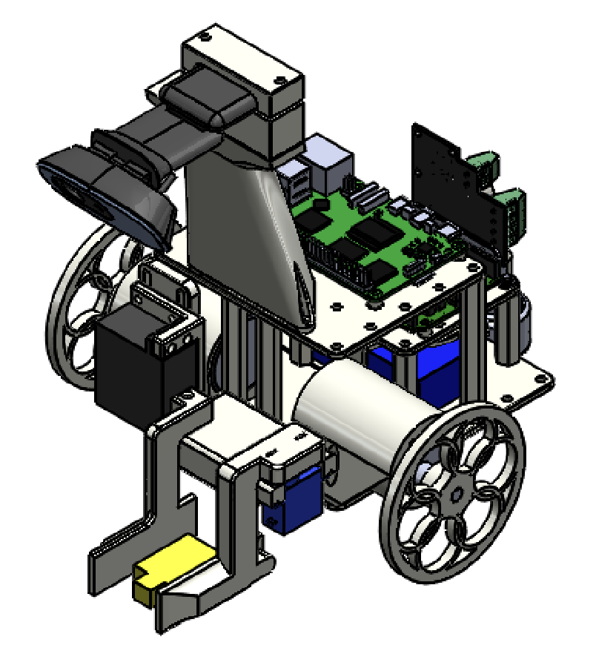
Professor: Behrad Khamesee

Course: MTE 380, Mechatronics Engineering Design Workshop

Group Members:
Sydney Easton
Owen Grimm
Irina Khan
Shreya Sivakumar
Matthew Watt

6th April 2026

Executive Summary
Attached is the final report for the MTE380 project. This project required a team of five 3B Mechatronics students to create a fully autonomous line following robot to complete a predetermined maze and return a LEGO minifigure at the center of the maze to a safe zone. During the academic term, the team created a fully integrated system combining mechanical, electrical, and software design. The project was constrained by a budget of $300, and the physical robot must not have exceeded 0.22m x 0.22m x 0.25m, excluding the camera mount, and must have weighed less than 5 lb or 2.27 kg. The core objective defined by the team was to complete the following tasks with >95% reliability: lift the LEGO minifigure under 5 seconds, track the red lines with tolerance under 10% error during linear portions, reliably drop the LEGO minifigure within one of the two green safe zones, and navigate the course under 25 seconds.
The final design was under budget at $183.03 for the final build and fell within the dimension wright constraints. This final prototype consists of three main design segments, the first of which is software. The robot had a Raspberry Pi 5 which ran the PID controller object class, and color processing with OpenCV. The PID controller computations were fed by the color processing script and then sent to the robot’s Arduino Uno through a serial bus which then controlled all four motors. The second design segment is the mechanical design of the robot’s gripper arms. The third design segment is the electrical design. To maintain different power supply requirements for different electrical components, a PCB buck converter was designed especially for the robot, to allow the entire system to be powered by one 12.4V LiPo battery.
The initial schedule made during the first months of the term was not followed as expected, so progress lagged prior and through midterm week. This delay in work was due to higher-than-expected workload from other courses taken simultaneously with MTE 380. To get back on schedule, designs were simplified and scope of custom PCB was reduced. Those changes brought the team back on track and so the project could be completed on schedule for all remaining milestones.
The robot the team designed was ultimately successful during testing on Game Day. The robot was able to successfully complete the course, retrieve the LEGO minifigure, and return to the starting position during one of three runs. The robot failed the task twice, once due to unexpected ambient lighting affecting color processing, and once due to a motor malfunction.

Table of Contents
Table of figures ii
Table of tables iii
1 Introduction 1
1.1. Background 2
1.2. Problem Statement 2
2. Needs Analysis and Problem Formulation 2
2.1. Objectives, Constraints, and Criteria 2
2.2. Overview of Final Design 4
2.2.1. Software 4
2.2.2. Mechanical 7
2.2.3. Electrical 10
2.3. Design Mapping to Objectives and Constraints 15
2.4. Schedule and Budget 16
2.4.1 Schedule 16
2.4.2 Budget 17
3. Construction and Testing 18
3.1. Built Model (Images) 18
3.1.1 Electronics 18
3.1.2 Chassis and Mounting 18
3.1.3 Gripper 19
3.1.4 Full Assembly 19
3.2. Design Modifications 19
3.3. Testing Plan and Verification Results 20
3.4. As-Built Drawings 21
3.5. Comparison of Calculations vs. Results 22
4. Review and Reflection 23
4.1 Challenges and Lessons Learned 23
4.2 Recommendations 24
4.3 Conclusions 24
5. Appendix 27
5.1 Full Assembly Drawings 27

Table of figures
Figure 1: Final robot design 1
Figure 2: Software system architecture 7
Figure 3: Sketch of drawbridge mechanism of initial leadscrew-based gripper subsystem design. 8
Figure 4: Chassis bottom plate (left), motor mount (middle), and castor mount (right) 9
Figure 5: Power Wiring Diagram 11
Figure 6: Control Wiring Diagram 12
Figure 7: Actuation Wiring Diagram 12
Figure 8: Buck Converter PCB Traces Layout 15
Figure 9: PCB buck converter CAD (left) and assembled (right) 18
Figure 10: Back view of chassis and mounting on robot. 18
Figure 11: 3D CAD model of final gripper subassembly mounted to the main robot body (left) and assembled gripper (right). The black servomotor is the lifting motor, while the blue servomotor rotates the gripper arm inwards/outwards. 19
Figure 12: Full assembly of line-tracking autonomous hemipode (LAH) robot. 19
Figure 13: Full CAD robot assembly 27

Table of tables
Table 1: Itemized Budget 18

1 Introduction
The following report describes the team’s design process of a line following autonomous robot (pictured in
Figure 1: Final robot design), consequential challenges and lessons learned. The robot, also referred to as LAH (line-tracking autonomous hemipode) throughout the report, was designed for the MTE 380 course to follow a red line marked on the ground surface of the course and interact with its course surroundings when presented with external cues in other colors such as green and blue. The specifications and purpose of the robot, LAH, are outlined in later sections.


Figure 1: Final robot design

Over the past academic term (January to March), the robot has been designed and built from the ground up. The entire chassis of the robot was constructed out of 3D-printed parts from online CAD software, and the electronic components consist of a web-camera, Raspberry Pi 5, Arduino Uno, a motor shield, a PCB designed by the team, and several motors. Every piece of the robot, from many of the aforementioned physical components to software design and development, was subject to the design process and critical review by the TAs and all course team members.

Background
The motivation for designing the robot comes from MTE 380 with the goal of autonomously completing a “search and rescue mission” within a preconstructed maze. This project is relevant to the team members of Group 12 (all 3B Mechatronics engineering students) as it requires the team to combine several critical skills necessary in a life-long engineering career. The project presented inside MTE 380 is unique in comparison to other course projects as it pulls together knowledge from several different engineering disciplines from various courses the 3B cohort has completed over the past four years. This robot project combines mechanical, electrical, and software design cycles and necessitates effective integration skills of all subsystems.

Problem Statement
The problem proposed by the MTE 380 project can be summarized as working in a group of 5 and following the design process to create an autonomous line-following robot using computer vision on a 6ft-by-6ft pre-determined course. The robot must navigate to a LEGO minifigure placed in the middle of a red, white, and blue target from the start position, retrieve the LEGO person, and deposit the LEGO figure in a designated green safe zone before returning to the start position with no human interference. The robot cannot deviate from the red line to take shortcuts or fall into any of the sand, rock and obstacle pits.
From this problem statement a needs analysis was created at the beginning of the design process. The robot must navigate a terrain to conduct a search and rescue mission to retrieve a LEGO person and return them to a safety zone.
Guided by the problem statement and needs analysis, the team created a robot using an iterative design process to meet the requirements of the course project.

Needs Analysis and Problem Formulation

Objectives, Constraints, and Criteria
There are four main objectives identified for this project, with the overall goal being to rescue the LEGO minifigure by moving it from its starting position to one of the two green safe zones.
The robot’s function includes the first objective, where a mechanical mechanism would need to be designed to lift the LEGO minifigure under 5 seconds and hold the LEGO minifigure securely with 95% reliability in all practice test runs.
The second objective was to use a camera vision system to track the red lines under a tolerance of 10% error during linear portions, and 25% on red line turns, and to also successfully detect the target where the LEGO minifigure is placed with 95% reliability.
The third objective was to reliably drop the LEGO minifigure within one of the two green safe zones with 95% reliability.
The fourth objective was to ensure that the robot could navigate the course under 25 seconds unidirectionally (and thus, a maximum of 50 seconds for the whole course completion with the LEGO minifigure being successfully rescued). The robot must navigate the course while avoiding all rock pits and obstacles with 100% reliability in the final round of practice test runs before game day.
Given the four main objectives, there were also a few key constraints regarding the project, and a few constraints regarding the design and function of the robot itself.
The constraint for the project is that it must be completed within a $300 budget where $150 is expensed by the department and $150 is provided by the team members of Group 12 if needed. The department expenses may be only applied to components sourced from the list of online suppliers stated by the WatIMake clinic (Digikey, McMaster Carr, Mouser Electronics), or purchases from the school’s workshops themselves. This constraint was enforced by Group 12 to limit shipping times for components purchased online.
The constraints for the robot size are to ensure that the dimensions of the robot do not exceed 0.22m by 0.22m by 0.25m, excluding the camera mount, and to weigh less than 5 pounds or 2.27 kg.
The criteria for the robot follow the formula for the performance index very closely. The first criteria were to pick a design with the fastest completion time (which involves travelling from the starting position to dropping the LEGO minifigure off at the safe zone). This means picking stronger powered motors in order to have the capability of running at high speeds.
The second criteria were to pick a design that weighs the least, which meant using lighter materials such as PLA over heavy acrylic or plywood, and avoiding heavy metal components, such as picking plastic wheels or choosing light caster wheels.
The next criteria were to choose a design that guarantees a higher reliability in all aspects of the performance, such as red-line traversal, picking up the LEGO mini-figure, setting down the minifigure inside the necessary green zones, and travelling back without falling into any of the obstacles. This was done by picking designs that allow for margins of error, such as a wider gripper design that can allow a slightly misaligned angle when picking up the LEGO minifigure, choosing wheels with higher traction in order to prevent slip when deaccelerating from high speeds.
The last criteria for the robot were to choose a design that is easy to service and maintain during competition day, which meant ensuring that the chosen design was modular, and simple fasteners with the same size were used to prevent the need for multiple tools and screwdrivers.

Overview of Final Design

Software

Line Tracking and PID Controller
The line tracking software and PID controller are the core of the robot’s software operation. The PID controller is built as a class object so it can be declared several times with different gain inputs for different operations. For example, a different PID loop was tuned to control the drive motors during the line follow operations versus the robot alignment operations needed for pick-up and drop-off of the LEGO minifigure. The PID controller class contains two functions, the __init__ function and the update function. The __init___ function allows the user to set the proportional, differential and integral gains to tune the controller, and resets the controller’s memory when called. The update function takes care of calculating the P, I and D values and translating the results to a usable output for subsequent objects to interpret.
The LineFollower class is comprised of many functions. Like the PID controller, the LineFollower class used an __init__ function to set up the object when it is called. This __init__ function will set up the OpenCV libraries [1] necessary for the computer vision and call the PID to initialize the tuned conditions for both line following and robot orientation (which will be discussed later in this section). Part of the initialization involves setting the ranges for red, green and blue colour values, which are the only colors the robot uses as cues during its operation. A serial port is also set up to allow the Raspberry Pi 5 to communicate with the Arduino to control the system’s four motors.
The next LineFollower function is detect_special_colors, which is used to mask and track green or blue shapes when it appears in the robot’s vision. The third and most complex LineFollower function is the detect_red_line function. This function is responsible for setting up further OpenCV functions like modifying the dimensions of the field of view (FOV) the robot will process at a given time and finding the contours of red line in view. By modifying the dimension of the FOV, the team used trial and error to find the best view dimensions that balanced fast processing times (where a smaller FOV led to faster processing times) while allowing the robot to see far enough ahead of itself that it can respond to turns in the course. The colour ranges for the function were set up in HSV since it allows for changes in lighting during operation without becoming unreliable. From a design point of view, defining all the colour ranges in one place for all the code allowed the team to easily modify the colour ranges when testing on the official obstacle course as the lighting and base color of the tape were different than the mock course the team had privately set up. Having easy access to these lines of code made testing and modification in different environments very easy.
These contours’ relationship to the center of the screen are fed to the PID loop, which then determines how far away the center of the red line is from the center of the screen. The error calculated by the LineFollower’s detect_red_line function is sent to the drive motors via the serial bus so the Arduino Uno board can control the speed and angle of the robot’s body. The output error ranges from -1 to 1, with the presence of a negative value meaning that the robot is offset one direction, and if it were positive then the robot is offset in the opposite direction. This simple system allowed for smooth integration between the two systems and is discussed later in the report.

Pickup and Dropoff
As discussed in 2.2.1a, the detect_special_colors function was used to detect green and blue shapes in the robot’s field of view. The pickup sequence was initiated by the detection of the blue rings of the target. The dropoff sequence was initiated by the detection of the blue square around the dropoff target.
The pickup sequence consisted of the following steps:
- Stop completely
- Navigate towards the red dot on the target until it is positioned underneath the grippers
- Open the grippers, drop them, close them, and lift them up to pick up the LEGO figure
- Turn around until the red line is detected again, with a short cooldown to prevent detecting the red dot of the target
- Resume line following
The most complicated of these steps is the navigation to the red dot. To complete this navigation, two synchronous PID loops were used to control the forward motion and the rotational motion of the robot. The error fed to the forward PID loop was the vertical distance of the centroid of the target’s center from the center of the grippers, and the error fed to the rotational PID loop was the horizontal distance between those points. The forward PID loop controller the component of each wheel’s commanded signal in the same direction, and the rotational component controlled the component of each wheel’s commanded signal in the opposite direction.
With the rotational PID loop tuned to be slightly more responsive than the forward PID loop, the robot successfully aligned the red dot with the center of the grippers and drove forward until the LEGO figure was in range, adjusting keep the LEGO figure in position as necessary.
The pickup sequence consisted of the following steps:
- Stop the robot
- Drive forward and to the right a prescribed amount
- Lower the gripper, open them, lift them, and close them
- Reverse backwards and to the right to avoid hitting the LEGO figure on exit
- Turn left until the red line is detected again
- Resume line following
The prescribed forward and reverse motions were set to drop off the LEGO figure in the right half of the first drop-off zone and continue on the line without hitting it. There were no safeguards to avoid running the same drop-off sequence at the second drop-off zone had the first one been missed.

Motor Communication
The motor control system was implemented using an Arduino along with an Adafruit Motor Shield. The Arduino was responsible for the two drive motors and two gripper servos. The team chose to offload motor control to the Arduino so the Raspberry Pi could focus entirely on vision.
The drive system uses two DC motors (connected to M3 and M4 on the motor shield) in a differential drive configuration. Each motor is controlled using a signed speed command. A small adjustment was included to account for motor orientation so that positive commands consistently correspond to forward motion. This setup made it easy for the Raspberry Pi to just send left/right speed values without needing to deal with low-level motor control.
The gripper mechanism is controlled using two servos: one for lifting the LEGO figure and one for opening/closing the gripper. Instead of continuous control, we defined a few fixed positions (for example up, down, open, closed) and moved between them using simple sequences. Pickup and drop-off actions were triggered using specific commands and executed as timed sequences of servo movements. Delays were used here for simplicity, which worked fine for this scenario, but it blocks execution during motion and would not scale for complex behaviors.
Communication between the Raspberry Pi and Arduino was done over USB serial. This was chosen over I²C mainly because it was much simpler to implement and debug. I²C would require handling addressing, synchronization, and potential bus issues, whereas serial allowed us to send straightforward text commands and easily monitor them during testing. Commands were sent as newline-terminated strings, either in the form “left, right” for driving or special characters to trigger predefined gripper actions. This kept the interface simple while still being flexible enough for the team's use case and is pictured in Figure 2: Software system architecture.
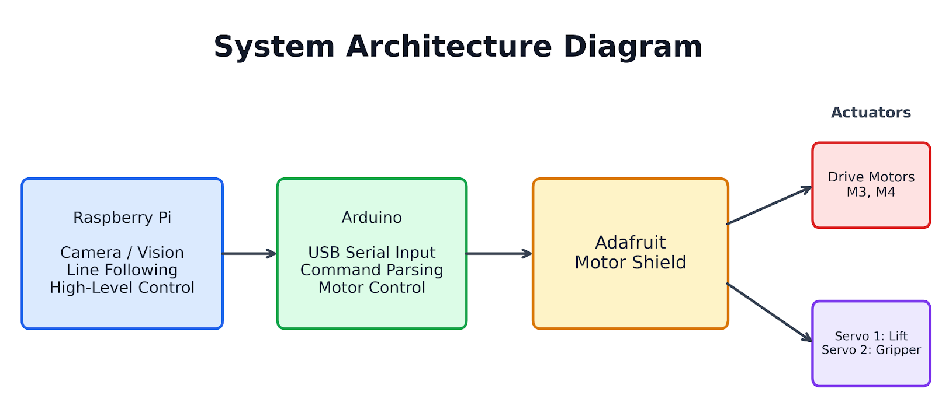
Figure 2: Software system architecture

Mechanical

Gripper Design
The initial design of the gripper consisted of a fixed arm and a mobile arm that would travel in and out on a leadscrew. The LEGO minifigure would be clamped into the fixed arm by the mobile arm moving laterally. The leadscrew would also rotate to wind a rope around the leadscrew, slowly reducing the length of the rope. This rope would be attached to the end of the arm, allowing for the gripper to be pulled upwards in a drawbridge motion once it has gripped onto the LEGO minifigure. The arms would be covered with a thin layer of memory foam to achieve better grip of the LEGO minifigure and provide gentle cushioning from the motor stalling when it compresses the payload. A sketch of the drawbridge mechanism of this gripper can be seen in Figure 3.
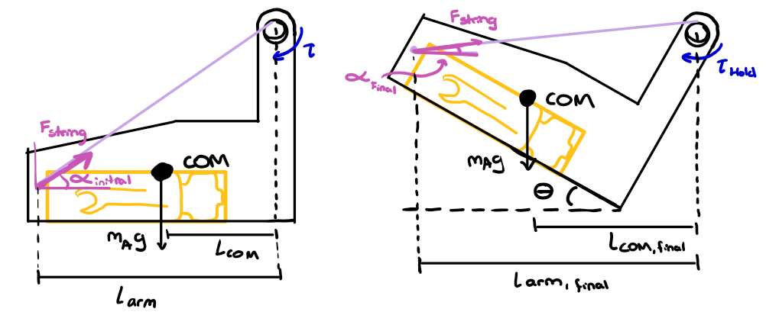
Figure 3: Sketch of drawbridge mechanism of initial leadscrew-based gripper subsystem design.
The initial selected design was chosen for its minimal motor use. It was a design that used only 1 motor for both the lateral and lifting motions needed. The reduction in motor count and the minimal number of pieces for the sub-assembly made it a more light-weight design compared to other brainstormed gripper designs.
However, during the development of the 3D CAD model of the gripper subsystem and the procurement of the mechanical components, it was deemed an unreliable design because it was heavily depended on the assembly process and the length of rope. The assembly process would require very precise fastening and tuning, which was not possible given the time constraints before Milestone 4.
The subsequent gripper design chosen was based on a secondary design from the initial brainstorm that used 2 servomotors for the lateral and lifting motion. The 3D CAD model of the final gripper subassembly can be seen in Figure 11.
The final gripper subassembly used 2 motors rather than just one, and 4 3D-printed parts that would attach the subsystem to the chassis of the robot. However, the design increases the reliability and speed of the system, which was a worthwhile trade-off for the increase in weight.

Chassis Design
The final chassis design used consisted of several 3D printed plates, separated by standoffs, each with a rectangular grid of M3 clearance holes spaced 20 millimeters apart. One such plate is shown in Figure 4. The grids of holes on the plates were used to mount functional parts of the robot with 3D printed adapters, allowing easy relocation and replacement of the parts, as well as the ability to modify the mounting adapters without having to replace the entire chassis.
The final chassis used three plates:
- The base plate, used to mount the motors, battery, castor, and gripper.
- The motor control plate, used to mount the Arduino (and its associated motor driver hat), and buck converter PCB.
- The control & vision plate, used to mount the Raspberry Pi and camera mount.
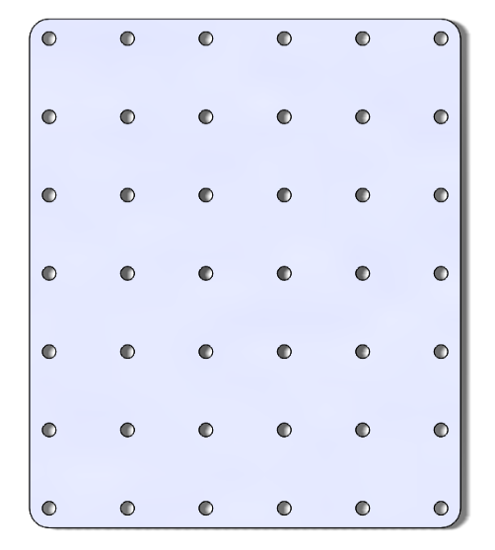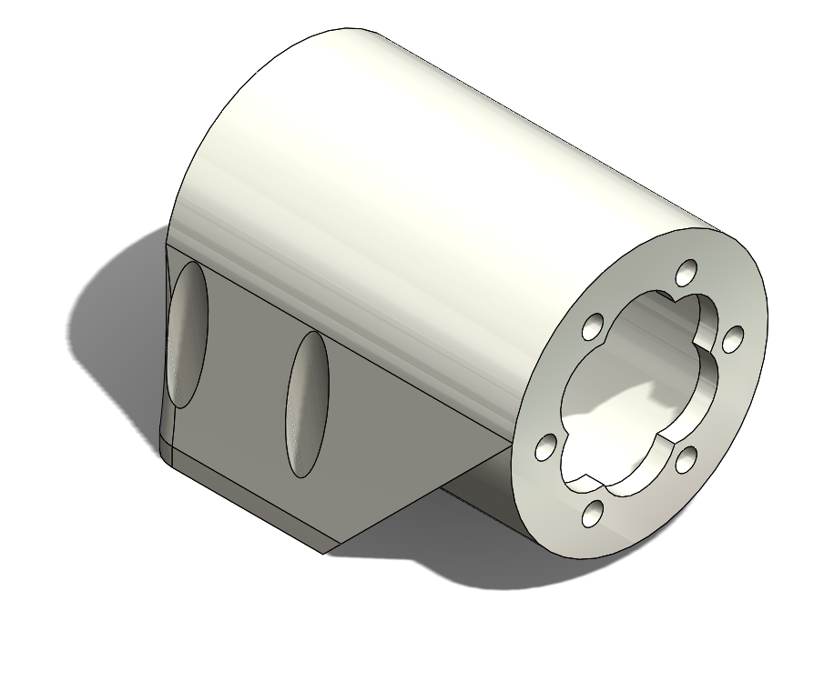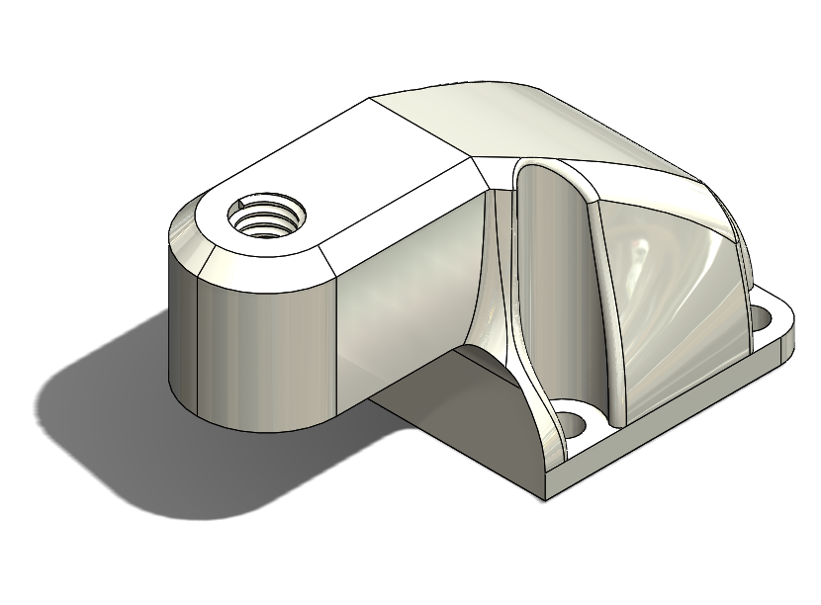
Figure 4: Chassis bottom plate (left), motor mount (middle), and castor mount (right)
Each of the 3D printed adapters (including the motor mounts, castor mount, gripper adapter, battery holder, and camera mount) were installed on the plates using through-bolts and nut attachments.
The standoffs were fitted with M3 heat-set inserts on each end, and the plates were secured by bolting through the plate holes and into the standoffs’ heat set inserts.
The motor mounts secured the motors with M3 bolts through the mounts and into the motors’ face plates. The motor axle was slightly off axis from the motor body’s axis. As such, the motor mounts included a circular pattern of cutouts on the faceplate shroud. While one cutout would have been sufficient to provide clearance for the axle, all six were included to allow rotating the motor in the mount to allow for minor adjustment of the vertical height of the wheels, and by extension the vertical position of the castor. This controls the overall forward or backward tilt of the robot.
The castor mount was a simple cantilever attached to the rear of the base plate. It included a slightly undersized M6 thread that tightly gripped the matching threaded rod on the castor.
The gripper adapter was an L bracket with holes on one face to allow attachment to the base plate. The other face included two slots to allow installation of the gripper at an adjustable height.
The battery holder was a simple cage to secure the battery, fastened near the rear of the robot.
The buck converter mount was mounted to the rear of the motor control plate, and consisted of a flange for the mounting holes, and two vertical fingers to hold the PCB upright behind the Arduino. The design includes holes for bolting the PCB to the mount, but the press-fit provided by the fingers was sufficient to secure the PCB, so no bolted connections were used.
The camera mount consisted of a long arm to raise the height of the camera, and a two-block system to clamp the camera into one of two positions. The two-block system to clamp the camera consisted of two blocks with M3 clearance holes on either side of a cutout to secure the camera. Two M3 screws would go through these blocks and into heat-set inserts in the long arm to clamp the camera in between the blocks. Since the lens of the camera is not aligned with the center of the attachment armature of the camera, the mounting blocks are off-center. Since the orientation of the camera (i.e., upright or upside-down) was undecided when the camera mount was designed, the design can accommodate either of the required left or right horizontal offsets.
The wheels were 3D printed and secured to the motor axles with an M3 set screw, threaded through a heat-set insert in the wheel hubs. The diameters of the wheels were chosen to be 8 centimeters to yield a forward speed of approximately one meter per second at the motors’ maximum no-load speed. It was found that the ASA used to print the wheels in combination with the layer line orientation from printing gave the wheels very little grip on the course. This was remedied by applying electrical tape over the wheels outer edge, which provided adequate traction. The wheel design includes large cutouts to reduce weight, reduce material costs, and to serve as a decorative element.
The Arduino and Raspberry Pi were mounted to their respective plates using their existing mounting holes and corresponding standoffs in their respective plates. They were fastened using M2 self-tapping screws.
The final robot dimensions were under 0.22 m by 0.22 m by 0.25 m, and the weight was approximately 1.2 kg, thus meeting the constraints of the project.

Electrical

Power Architecture
The robot is powered by a Turnigy Bolt 2400mAh 3S 11.4V LiPo battery, which serves as the single power source for all onboard electronics and actuators. This was chosen originally to power the two DC drive motors, and the team was then able to use buck converters to use this battery to power the on board control electronics as well. This was chosen over the kit-provided USB power bank to consolidate power delivery into one source as well as reduce weight for the purposes of scoring on Game Day.
The electrical system is broken down into three subsystems, power, control, and actuation, each illustrated in Figure 5, Figure 6 and Figure 7 respectively.
As shown in the power distribution diagram (Figure 5), the 11.4V LiPo feeds into the custom buck converter PCB designed by the team, which steps the voltage down to a regulated 5V at a maximum of 5A, as well as directly into the Adafruit Motor Shield for motor actuation. The regulated 5V output powers the Raspberry Pi 5, which requires a stable 5V/5A supply in order to operate at full capacity. The webcam, mounted to the front of the chassis, draws power from the Raspberry Pi over USB.
The control diagram in Figure 6 illustrates how the Raspberry Pi communicates with the Arduino Uno over USB serial, which runs off the regulated 5V rail. The Arduino is responsible for interpreting drive commands from the Raspberry Pi and translating them into motor shield outputs.
The actuation diagram in Figure 7 shows how the Motor Shield drives the two DC drive motors on ports M3 and M4, as well as routing control signals to the two gripper servos.
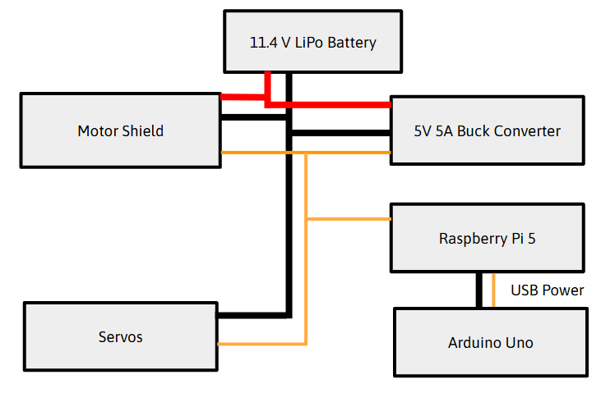
Figure 5: Power wiring diagram, with 11.4V in red, 5V in orange, and ground in black
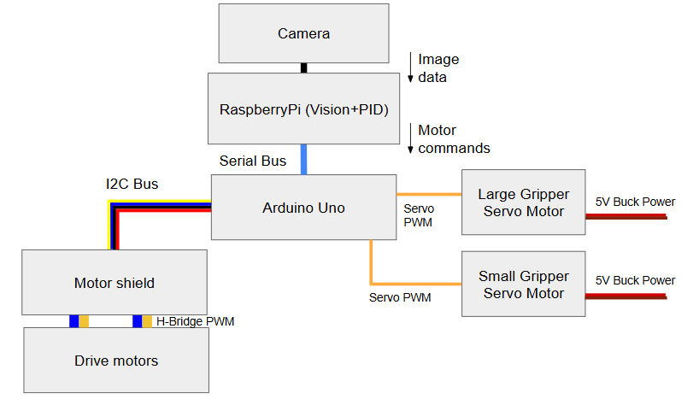
Figure 6: Control wiring diagram
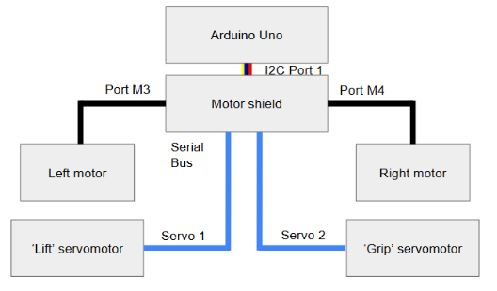
Figure 7: Actuation wiring diagram

Design Trade-Off
One key electrical design decision was the use of a custom buck converter PCB rather than an off-the-shelf voltage regulator module. While designing and manufacturing a PCB introduced additional workload in terms of circuit design, layout, and testing, it allowed for a more compact and integrated power solution.
This decision aligned with the team’s objective of minimizing overall robot weight and reducing wiring complexity. Using a discrete module would have required additional connectors and mounting considerations, increasing both bulk and potential points of failure. In contrast, the custom PCB enabled direct integration into the system and cleaner power distribution.
These design decisions were informed through prior coursework, guidance from the teaching team, and additional research into switching regulator design. In particular, application notes such as Texas Instruments’ Simple Switcher PCB Layout Guidelines (SNVA054C) [2] were used to guide layout strategy and ensure reliable operation of the converter, which was provided by Richard Yan from the Engineering Faculty.

PCB Architecture
The custom buck converter PCB was designed to step the 11.4 V LiPo battery input down to a regulated 5V output capable of supplying up to 5 A, which is required for stable operation of the Raspberry Pi 5.
The implemented circuit was based directly on the recommended application circuit from the switching regulator datasheet [3], selected to match the input voltage range of the LiPo battery and the required output current. Using a datasheet-proven design reduced risk and ensured that the converter would operate reliably under expected loading conditions.

Component Logic
The PCB follows a standard buck converter topology consisting of a switching regulator IC, inductor, diode and input/output capacitors. These components were selected based on the reference design provided in the regulator datasheet.
The regulator IC controls the switching behaviour, while the inductors and capacitors smooth the output into a stable DC voltage. Input capacitors were included to reduce voltage ripples from the battery, and output capacitors ensure a stable 5 V supply for the Raspberry Pi. This approach mirrors standard industry design practices for switching power supplies and ensures consistent performance under varying load conditions.

Placement Logic
Component placement was guided by best practices for switching regulator layout, particularly the need to minimize the high-current switching loop.
Key components, including the regulator IC, inductor, diode, and capacitors, were placed in close proximity to reduce parasitic inductance and improve efficiency. Input capacitors were positioned as close as possible to the regulator input to stabilize the pulsed current drawn from the battery, while output capacitors were placed near the load path.
These decisions were directly informed by the Texas Instruments layout guidelines (SNVA054C) in [2], which emphasize compact placement of the power stage to reduce noise and improve stability.

Routing Logic
Routing focused on minimizing resistance and maintaining clean current paths for all high-current connections. The battery input and 5 V output traces were kept short and direct to reduce voltage drop and power loss.
A ground plane was implemented to provide a low impedance return path and improve both electrical stability and thermal performance. The switching node was kept compact and isolated from other traces to reduce noise coupling into signal lines.
These routing strategies were based on standard switching power supply layout recommendations and reinforced through external design references.

Trace Width Logic
Trace widths were selected based on expected current levels and standard PCB design guidelines. The board was fabricated using 1 oz copper (approximately 35 µm thickness).
For the maximum load condition of 5 V at 5 A (≈25 W output power), high-current traces were designed to be approximately 2mm wide. This ensures that the traces can safely carry the required current while minimizing voltage drop and resistive heating.
Wider traces reduce current density, which helps prevent overheating and improves overall reliability. In contrast, low-current signal traces were kept narrower to conserve board space.
These values were determined using IPC-based trace width guidelines from [4] and verified through reference calculators, ensuring that the PCB could reliably handle the required power delivery.

Layout Implementation (KiCad)
The final PCB layout was implemented in KiCad as seen in Figure 8, incorporating the design decisions described above, including wide power traces, compact switching loops, and a continuous ground plane.
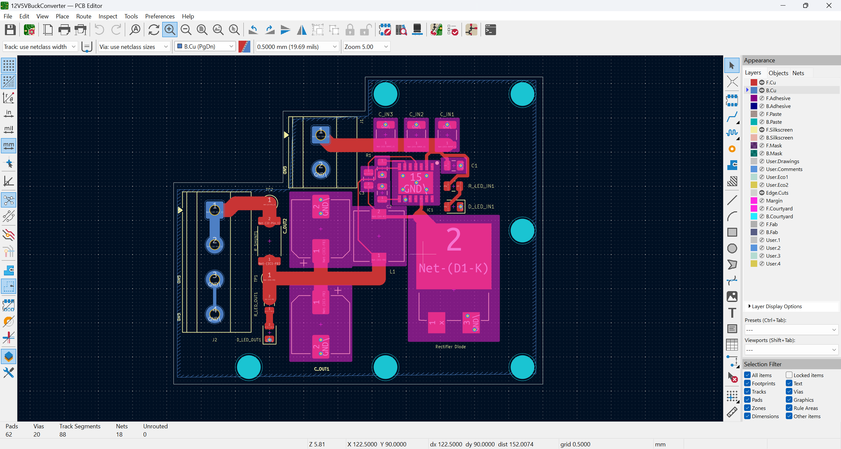
Figure 8: Buck Converter PCB Traces Layout
This figure demonstrates the above-discussed routing of high-current traces, component placement configurations, and overall layout of the power stage. The design reflects the application of the key switching regulator layout design guidelines outlined in [2].

Design Mapping to Objectives and Constraints
The team’s final robot design was developed to directly address the objectives and constraints outlined during the problem formulation phase. The design was selected to ensure reliable completion of the course while meeting size, cost, and performance requirements.
One of the main objectives was to autonomously follow the course and rescue the LEGO figure. This was achieved using a camera-based vision system mounted at the front of the robot, enabling detection of the red course lines. The Raspberry Pi processes this visual input and generates motor commands for line following, allowing the robot to remain within a certain tolerance of the line. A differential drive configuration provides sufficient maneuverability to navigate turns on the course. The objective of safely transporting the LEGO figure was addressed through the team’s gripper mechanism at the front of the robot. The system uses two servo motors: one for vertical lifting and one for opening and closing the gripper. This enables the robot to lower onto the LEGO figure, secure it, and lift it for transport. Predefined servo positions help ensure repeatable pickup and drop-off actions, improving reliability.
In terms of performance, minimizing traversal time was supported by a compact design. The stacked plate chassis maintained structural stability. The differential drive system enabled smooth and simple steering, allowing the robot to maintain speed along straights and turns. It is important to note that reliability was prioritized over maximum speed. The system satisfies dimensional constraints through its compact, vertically integrated layout, with the Raspberry Pi, Arduino, and motor shield stacked neatly within the size limits. The elevated camera placement also improved visibility of the path. Cost constraints were also successfully met. The total project cost was $183.03, well below the $300 limit ($150 provided by the department and up to $150 additional by the team). This was achieved by selecting standard, off-the-shelf components such as the DC motors, servos, and motor shield from MESS.
Finally, the design adopts a modular, stacked layout that separates control (Arduino and Raspberry Pi), actuation (motors and servos), and structural components. This layout supported efficient integration and allowed for easy testing and iteration throughout development.

Schedule and Budget

2.4.1 Schedule
The originally outlined schedule experienced many changes over the course of the project. The original schedule included procuring all required parts before reading week, completion of all subsystems prior to the subsystem check, and integration and testing complete prior to the design specifications and reflection check. The schedule also included tasks that required completion over reading and midterm week. However, many the software tasks were completed ahead of schedule during this period, which would prove helpful in meeting deadlines later.
In the weeks prior to reading week, our group did not have as much capacity as previously expected. As such, a larger volume of work got moved to reading week, including chassis design, PCB design, and some preliminary hardware testing. This also had the effect of delaying some procurement timelines.
This increased workload during reading and midterm week combined with the reduced capacity of our team lead to many delayed tasks and only the most critical tasks being completed. By the end of midterm week, only preliminary designs for the chassis, gripper, and electrical system had been completed, and many parts still needed to be procured. Because of the strict deadline imposed by the subsystem checkup milestone, we implemented several of our backup plans to meet the deadline. These included:
- Pivoting the gripper design to the simpler alternative proposed earlier in the term
- Reducing the scope of the PCB to power distribution only
- Switching from BLDC motors to simple DC motors with an integrated gearbox to avoid development times associated with an external gearbox and complicated motor drivers
- Redistributing tasks according to who had the most bandwidth & was most confident in their ability to complete the tasks
On this accelerated timeline, we were able to build prototype designs for the chassis and gripper system and begin integration with the software system. We were able to complete all objectives for the subsystem checkup milestone. Thanks to this sprint, we were nearly aligned with our original schedule, with the only exception being the PCB which was further delayed by procurement requirements and design reworks due to its narrowed scope.
Integration work continued over the following two weeks, allowing for gradual refinements to the design as we prepared for game day. The power delivery PCB was ordered & assembled in time to be used for game day, reducing the weight of the robot by 200 grams.

2.4.2 Budget
Overall, the cost of our robot design was $188.03 — under the allocated $300 budget. The cost of all the motor systems, including drive motors, gripper motors, and the motor driver board, had a total cost of $69.78. The chassis had a total cost of $23.36, with $6.17 of that cost coming from 3D printed parts and the remainder from fastening hardware. The electrical subsystems were the most costly, totalling $89.90. The majority of the electrical systems cost came from the buck converter PCB, totalling $42.99 for the components and PCBs. The next large electrical cost was from the lithium polymer battery, costing $40.56.
The tabulated budget of the table is available in Table 1: Itemized budget.

Table 1: Itemized Budget
Items | Cost/Item | # of Items | Subtotal | Total (+HST)
Drive Motors | $12.38 | 2 | $24.76 |  | $27.98
Lift Servo | $3.40 | 1 | $3.40 |  | $3.84
Swoop Servo | $13.27 | 1 | $13.27 |  | $15.00
Motor Driver Board | $20.32 | 1 | $20.32 |  | $22.96
3D Printed Parts | $25.99/kg | 210.2g | $5.46 |  | $6.17
M3x35mm BHCS | $0.18 | 2 | $0.36 |  | $0.41
M3x8mm BHCS | $0.09 | 20 | $1.80 |  | $2.03
M3x10 SHCS | $0.13 | 31 | $4.03 |  | $4.55
M3 nut | $0.12 | 31 | $3.72 |  | $4.20
M2x8mm self-tapping SHCS | $0.10 | 10 | $1.00 |  | $1.13
M3x5mm heat-set insert | $0.11 | 20 | $2.20 |  | $2.49
Caster | $1.50 | 1 | $1.50 |  | $1.70
Zip Ties | $0.04 | 15 | $0.60 |  | $0.68
DIODE SCHOTTKY 45V 6A TO263AB | $2.12 | 1 | $2.12 |  | $2.40
IC REG BUCK 5V 5A 14VSON | $11.42 | 1 | $11.42 |  | $12.90
0.47 uF Capacitor_SMD: C_0805_2012Metric | $0.30 | 1 | $0.30 |  | $0.34
1 nF Capacitor_SMD: C_0805_2012Metric | $0.12 | 1 | $0.12 |  | $0.14
0.01 uF/10,000 pF Capacitor_SMD: C_0805_2012Metric | $0.12 | 1 | $0.12 |  | $0.14
15 uF Capacitor_SMD: C_1210_3225Metric | $1.04 | 3 | $3.12 |  | $3.53
180 uF Capacitor_SMD: CP_Elec_8x10 | $2.90 | 2 | $5.80 |  | $6.55
Red LED 0805_2012 Metric | $0.25 | 1 | $0.25 |  | $0.28
Blue LED 0805_2012 Metric | $0.31 | 1 | $0.31 |  | $0.35
Pheonix Terminal Blocks SMD 2P 5.08mm | $1.92 | 1 | $1.92 |  | $2.17
Pheonix Terminal Blocks SMD 4P 5.08mm | $3.64 | 1 | $3.64 |  | $4.11
22uH Inductor SMD L7.3x7.3 mm | $1.49 | 1 | $1.49 |  | $1.68
5.6k Resistor SMD 0805_2012Metric | $0.15 | 3 | $0.45 |  | $0.51
1.5k Resistor SMD 0805_2012Metric | $0.15 | 1 | $0.15 |  | $0.17
0.01 ohms Resistor SMD 2512_6332Metric | $0.75 | 1 | $0.75 |  | $0.85
Wago, SPLICE LEVER 24-12AWG 3POS | $1.63 | 2 | $3.26 |  | $3.68
Electronics Kit | $20.39 | 1 | $20.39 |  | $2.66
PCB Board Cost | $6.09 | 1 | $6.09 |  | $6.88
"Lipo Battery; Turnigy Bolt 2400mAh 3S 11.4V 65~130C High Voltage Lipoly Pack | $35.89 | 1 | $35.89 |  | $40.56
Total |  |  |  |  | $183.03

Construction and Testing

Built Model (Images)

3.1.1 Electronics
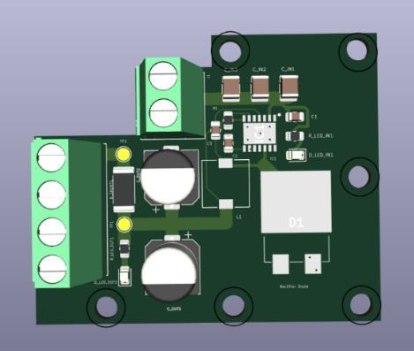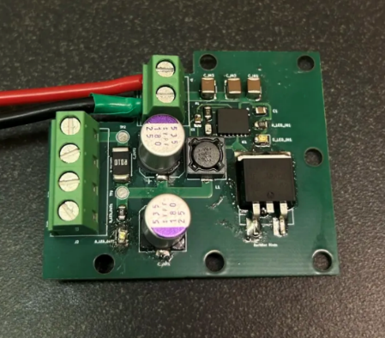
Figure 9: PCB buck converter CAD (left) and assembled (right)

3.1.2 Chassis and Mounting
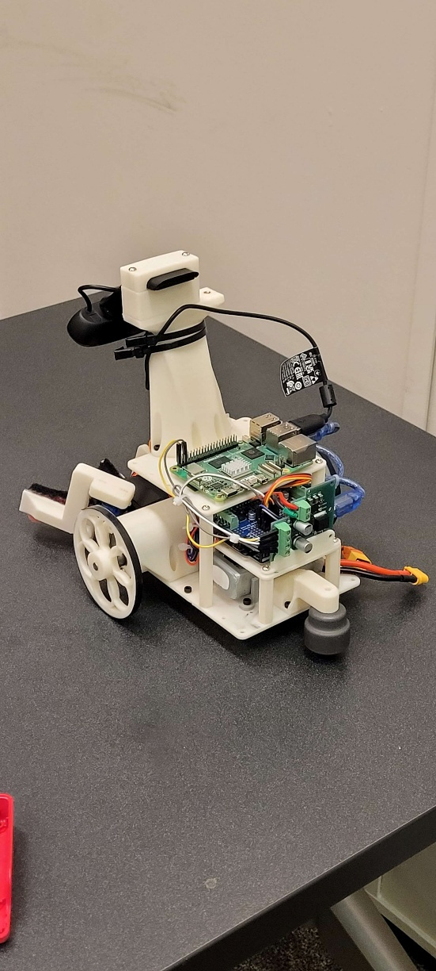
Figure 10: Back view of chassis and mounting on robot.

3.1.3 Gripper
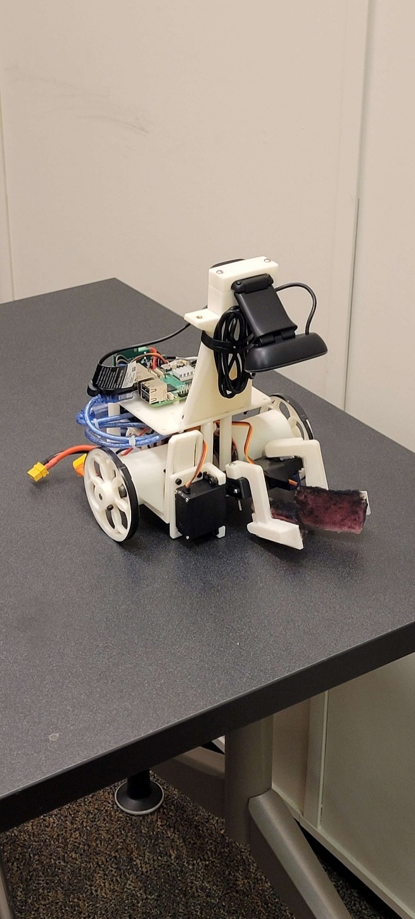
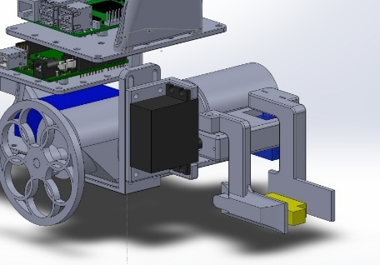
Figure 11: 3D CAD model of final gripper subassembly mounted to the main robot body (left) and assembled gripper (right). The black servomotor is the lifting motor, while the blue servomotor rotates the gripper arm inwards/outwards.

3.1.4 Full Assembly
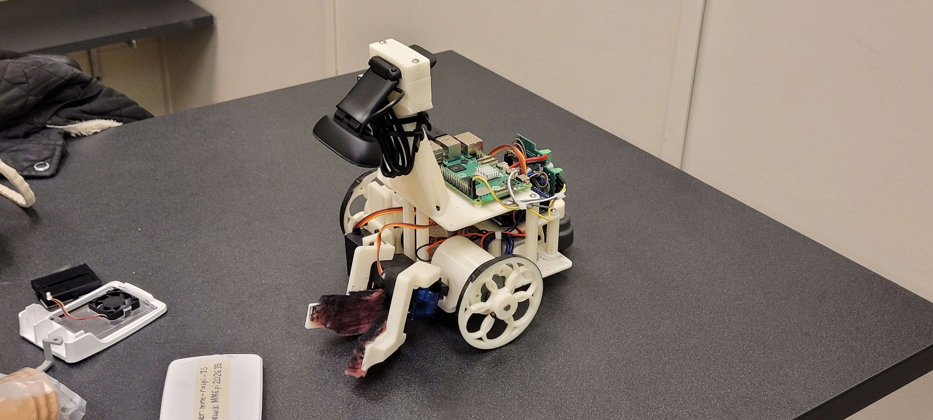
Figure 12: Full assembly of line-tracking autonomous hemipode (LAH) robot.

Design Modifications
From the initial design, there were design modifications made to the wheels, wheel motors, gripper subassembly and the camera mounting.
The number of wheels changed from 4 wheels to 2 wheels and one caster. Although the design choice to have 2 powered wheels remained the same, the passive, free-spinning wheels were replaced with a metal caster that was sourced from WatIMake early in the robot building process. This allowed us to reduce the weight by one wheel and improve the turning radius of the robot.
Due to the field of vision (FOV) of the camera, the height of the stacked plate chassis body of the robot was too low for the camera mount, as the camera couldn’t see far enough ahead of itself. The PID control logic to react to the curved red-line paths. A tall mounting pillar was 3D printed to add additional height to the camera.
The largest modifications involved the change in wheel motors and the gripper sub design. From the original motor calculations done by Shreya, they involved the use of a pair of brushless DC motors and a custom gearbox reduction. To step the speed down from ~1200 rpm with 6 cm diameter wheels down to 318 rpm, a custom gearbox with a reduction of 43:1 would need to be designed and mounted onto the chassis for both drive wheels.
Due to the complexity of the design, the heavy weight of the motors and the additional weight from the gearboxes, and the predicted loss of gearbox efficiency from using the laser cutter in the WatIMake workshop to cut gears out of sheets of wood, the design was scrapped. Instead, a lighter and slower set of brushless DC motors were chosen to be attached directly to the wheels, eliminating the need for a gearbox.
As stated in section 2.2.2d: Gripper Design, the original lead screw design was scrapped due to the complexity in manufacturing and assembly. The design was changed to two servomotors driving the grasping and lifting mechanism of the two-armed gripper. Further details are written in section 2.2.2d.

Testing Plan and Verification Results
By Milestone 5, a testing plan was developed to target 3 key performance goals.
The first performance goal was that the robot needed to traverse the course between 13.79 seconds to 150% of that time limit (20.7 seconds) as calculated by Owen’s design calculations. The traversal speed of the robot needed to be increased from the 50% test speed used when tuning the original PID controllers. The traversal time, also known as the ‘time to travel’, is defined as the time needed for the robot to travel from the starting position to the target. This excludes the time it takes for the second half of the robot’s mission, such as picking up the LEGO minifigure, detecting green lines for drop off or traversing back home safely.
The traversal time testing plan was to place the robot in starting position and start the timer when the robot starts to move. The robot would be allowed to traverse the full course up until it reaches the target, where the timer would be stopped. The traversal time test was considered successful if the robot successfully navigates the path under 20.7 seconds. The performance goal is met if the robot succeeds for 2 out of 3 test runs on the obstacle course.
The second performance goal was that the robot needed to pick-up the LEGO minifigure reliably. The pick-up testing plan was to place the robot at a roughly 20 cm away from the target, allowing it to find the line and navigate to the target. A timer would be started as soon as the robot stopped, which signals that the robot has seen and identified the target. The timer would be stopped once the robot has repositioned itself and engaged its gripper subsystem to pick up the LEGO minifigure. The pick-up test is considered successful if the robot successfully picks up the LEGO minifigure from the target under 12 seconds. The performance goal is met if the robot succeeds for 2 out of 3 tests run on the obstacle course.
The third performance goal was that the robot needed to reorient itself to follow the red line after picking up or dropping off the LEGO minifigure at the blue and green locations. The reorientation testing plan was to place the robot on the target, allowing it to visually identify the red, white and blue target. A timer would be started as soon as the robot starts to move and rotate. The robot is allowed to reorient itself by rotating around, and the timer is stopped when it successfully finds the line and starts following the red line. The reorientation test is considered successful if the robot successfully reorients itself within 20 seconds. The performance goal is met if the robot succeeds for 2 out of 3 test runs on the obstacle course. It is important to note that the target was chosen to test the reorientation speed of the robot because the reorientation requires a full 180-degree rotation of the robot. The first green safety zone only requires a 120-degree turn away from the diagonal green safety zone, which does not test the robot as effectively.
When verifying the three test plans during Milestone 6 on the obstacle course, the ‘time-to-travel’ performance goal and the reorientation performance goal were successfully met, while the pick-up performance goal had failed.
The two successful ‘time-to-travel’ tests took a time of roughly 14 seconds each, proving that the traversal performance goal was met. The two successful reorientation tests took a time of approximately 3 seconds both times, proving a very fast reorientation speed. There were two failed pick-up performance tests, which meant that the pick-up performance goal was failed. After re-tuning and reprogramming the code for the robot on the team’s private mock course, the performance goal was eventually successful, with each of the successful tests taking approximately 3 seconds each time.

As-Built Drawings
Please see the drawings of our robot as assembled in section 5.1 Full Assembly Drawings.

Comparison of Calculations vs. Results
Due to the changes made in the construction of the robot, several of the teams’ design calculations are not useful benchmarks as a basis of comparison to the results. Thus, the main calculation that will be considered in the comparison of predicted results and actual results is the traversal time.
Although the previous robot designs were not implemented, the spirit of the initial calculations from Milestone 3 for wheel motor selection were used to identify a rough range for new time benchmarks for the final robot design.
As stated in section 3.2, from Shreya’s wheel motor selection of a brushless DC motor, she originally concluded that a motor speed of 318 rpm was needed for this project. Before the motors were changed from brushless DC motors to simpler brushless DC motors, the 6 cm diameter wheels meant that the robot would be able to travel at a maximum speed of 99.9 cm/sec.
The course length is calculated to be 386.08 cm in linear distance, and 215.44 cm in curved length for turns. The linear travel speed using the PID controls was assumed to run at 70% of the max motor capacity at 75 cm/sec, and the turning travel speed using PID controls was assumed to run at 50% of the max motor capacity at 50 cm/sec. The final linear traversal time is 5.52 seconds, and the final rotational traversal time is 4.29 seconds, resulting in the final calculated traversal time to be 9.81 seconds.
However, with the change from brushless DC motors to simpler and slower brushless DC motors, the newer DC motors had different parameters which affect the design calculations. This additionally required a change in the wheel diameter to account for the slower top speed of the new motors. Based on simple measurements taken of the robot accelerating, the acceleration of the robot with the new motors was estimated at 2000 millimeters per second squared. An optimistic max speed for the robot was estimated to be 600 and 350 millimeters per second for straight segments and corners, respectively. This yielded an expected traversal time of 13.79 seconds.
The actual traversal time measured on gameday during the team’s best run was 13.56 seconds. This value is around 4 seconds slower than the estimated best–case time for the old motors. These differences can be explained by the changes in motor selection, and that the team was using the best-case scenario time which doesn't account for slowing down on turns and friction on the course.
The measured traversal time aligns very well with our updated estimate for the new motors. The similarity is likely because we tuned our PID until its performance was in line with our predictions.
With the robot’s weight of approximately 1.2 kg, traversal time of about 30 seconds, and despite a reliability factor of 1 for only 1 successful attempt, the robot placed in 6th place overall in the competition.

Review and Reflection

4.1 Challenges and Lessons Learned
There were some major challenges during the development of the team's robot, particularly in line sensing, power management, and mechanical integration.
A major issue was the sensitivity of the vision system to lighting conditions. Changes in ambient lighting, even in the same room, affected how colors were seen by the camera. This was especially noticeable with the blue ring in the target, which was not always reliably identified and sometimes failed to trigger the pickup sequence. This showed that the vision system needed to be more robust to variations in the environment as opposed to relying on fixed values that only worked under specific conditions.
Power delivery also caused some inconsistencies. After switching to the team’s custom buck converter PCB for Raspberry Pi and motor power (from a single LiPo battery), the battery drained much faster than expected. As the voltage dropped, the robot’s behavior seemed to change as well. The changes seen were particularly in motor response and stability. The system performed differently depending on the battery charge level, which made testing less consistent and very difficult to tune.
The physical layout of the robot also created some practical challenges. The battery was mounted at the bottom of the stacked plate chassis, so accessing it required disassembling most of the structure. This slowed down testing and made quick iterations difficult, especially when the battery needed to be replaced with a fresh one.
Another challenge was maintaining a constant camera position as the robot’s line following performance depended on the camera angle. However, there was no reliable way to reposition the camera to the exact same orientation after adjustments. This resulted in setup relying on trial and error. Small changes in position could noticeably affect line following performance, which made repeatability a large concern.
A major hardware issue also occurred during game day. The gripper servo wiring had been routed in front of the mechanism, so when the gripper opened, it pulled on the wires and snapped them, causing a failure. This was discovered after the first run when the robot failed to pick up the LEGO figure. Fortunately, the group had a backup servo to use for the subsequent runs. This situation showed the importance of accounting for full motion ranges for cable management.
In addition, most testing was done on a mock-up course built in a different room, which had different lighting and environmental conditions compared to the actual competition setup. Because of this, the system was tuned for conditions that did not fully match the real course, contributing to inconsistencies on game day. More testing under the actual course conditions would reduce these issues.
Overall, most of the team’s issues came from how different subsystems interacted rather than from individual components. Small issues affected overall system performance, showing the significance of integration and testing under actual condition.

4.2 Recommendations
For improved colour detection, implementing a bright, pure white LED onto the gripper subsystem will control for the variability of environmental light conditions. This would allow the OpenCV colour detection software to detect different hues more reliably, reducing detection errors that the robot experienced when searching for green safety zones on Game Day.
The camera mounting could be improved such that the camera could be secured in place, rather than freely rotating when hitting a wall or from vibrations as the car runs on the obstacle course. The camera mounting should still allow for flexibility in adjusting the angle but could have a method at freezing the mounting position in place.
A redesigned chassis with an easy-to-access slot to store the LiPo battery would allow for faster switches during the extensive testing and tuning phase of the project. Many batteries were drained during the iterative software tuning process, and making the robot easier to service would save at least 5 hours of disassembly and reassembly throughout the project.

4.3 Conclusions
The purpose of the MTE 380 project was to design an autonomous line following robot that could complete a marked path to a LEGO minifigure, retrieve the LEGO minifigure, deposit the LEGO minifigure in a safe zone, and return to the starting position. The team was able to design, manufacture, and assemble the robot to meet the goals described while adhering to and falling within the constraints of the project. Notably, the robot was able to be built under budget, only costing about $180 with the max cost constraint being $300.
While there were some design setbacks that the team had to work through, the final robot successfully integrated electrical, mechanical, and software systems, and placed 6th in the competition, notably for its fast completion speed of 30 seconds on its single successful attempt. Each system was subject to a rigorous design cycle. This project allowed the team of 3B Mechatronics Engineering students to learn how to combine skills and tools learned in previous courses together into one cohesive project.

Works Cited

[1] | OpenCV, 2026. [Online]. Available: https://opencv.org/. [Accessed 16 February 2026].
[2] | Texas Instruments, "AN-1229 SIMPLE SWITCHER® PCB Layout Guidelines," April 2013. [Online]. Available: https://www.ti.com/lit/an/snva054c/snva054c.pdf?ts=1773756522857. [Accessed 06 04 2026].
[3] | Texas Instruments, "LM2679 SIMPLE SWITCHER® 5-A Step-Down Voltage Regulator," June 2016. [Online]. Available: https://www.ti.com/lit/ds/symlink/lm2679.pdf?ts=1775531408670&ref_url=https%253A%252F%252Fwww.google.com%252F. [Accessed 06 04 2026].
[4] | P. Ghosh, "https://www.protoexpress.com/blog/ipc-2221-circuit-board-design/," Sierra Circuits Proto Express, 30 January 2023. [Online]. Available: https://www.protoexpress.com/blog/ipc-2221-circuit-board-design/. [Accessed 06 04 2026].

Appendix

Full Assembly Drawings

Below is a screenshot of the full assembly drawings for our design. The full-resolution drawing is attached as the final page of this report.
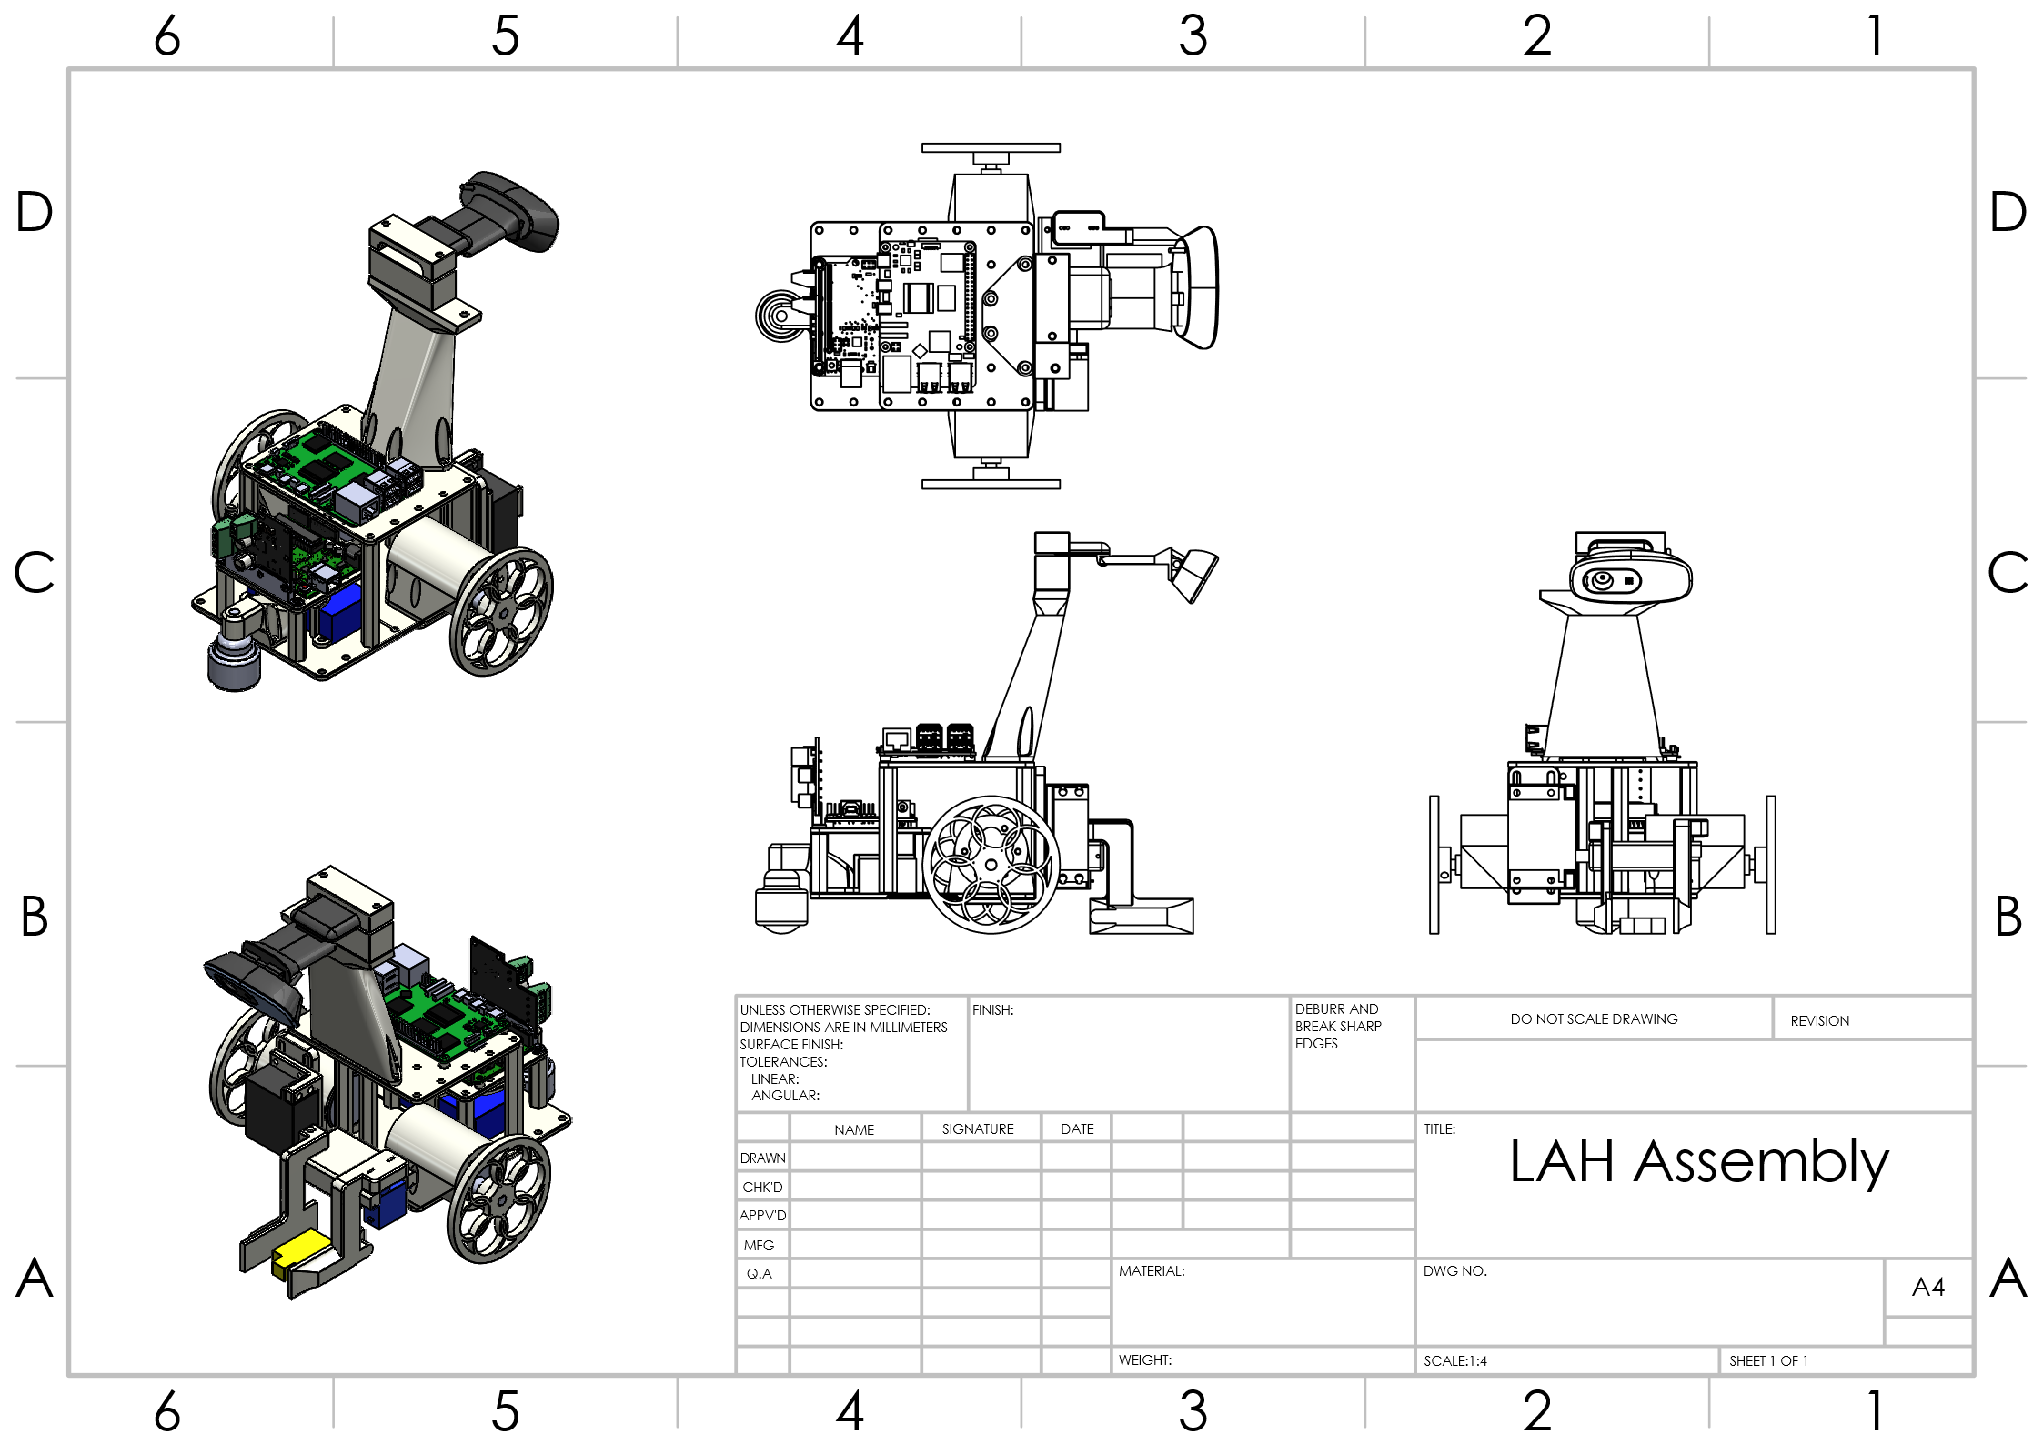
Figure 13: Full CAD robot assembly screenshot
Group 12 Capstone Proposal
The following is a brief proposal for a Capstone Project. The proposed group includes Sydney Easton, Owen Grimm, Irina Khan, Shreya Sivakumar, and Matthew Watts.
Our group proposes an avalanche search-and-rescue device to assist in the location of avalanche victims. Over the past 10 years, there have been 108 reported avalanche -related fatalities in Canada [1]. Response time is a critical factor in the outcome of someone buried in an avalanche due to the risks of asphyxiation and hypothermia. Present search and rescue techniques (e.g., Avalanche transceivers or RECCO) require sending rescuers on the ground to search for signals of buried individuals, or helicopters carrying expensive RADAR equipment to scan from above.
Our group proposes a supplemental search-and-rescue method to quickly find buried individuals using remote operation, improving the outcomes of buried individuals and reducing the risk to search-and-rescue teams, especially on risky terrain. This system will involve the use of a quad-rotor drone equipped with a variety of sensing equipment, including visible light sensors, infrared sensors, RECCO receivers, and avalanche transponder receivers to allow search and rescue teams to quickly scan large areas for signals of buried individuals. This technique will allow for faster searching of large areas, pinpointing areas of concern that search-and-rescue teams can focus their attention on.
The quad-rotor drone used will either be an existing commercially available drone or a custom-designed drone, pending design constraints, budget, and workload. It is currently expected that a commercially available quad-rotor drone will be used.
Our proposed tasks are as follows:
Sydney Easton: Sensor fusion and buried person detection algorithms
Owen Grimm: Sensor selection, mechanical integration, environmental verification
Irina Khan: Drone path planning, anti-collision fail-safes, ground avoidance
Shreya Sivakumar: Drone communication, teleoperation
Matthew Watts: Power distribution, sensor communication, associated electrical design
One major obstacle that may need to be considered is the licensing required to fly large drones. Preliminary investigation will be done to see what size of drone would be appropriate and what licensing would be required by a group member to pilot the drone.
Reference
[1] https://incidents.avalanche.ca/statistics


Works Cited
[1] | OpenCV, 2026. [Online]. Available: https://opencv.org/. [Accessed 16 February 2026].
[2] | Texas Instruments, "AN-1229 SIMPLE SWITCHER® PCB Layout Guidelines," April 2013. [Online]. Available: https://www.ti.com/lit/an/snva054c/snva054c.pdf?ts=1773756522857. [Accessed 06 04 2026].
[3] | Texas Instruments, "LM2679 SIMPLE SWITCHER® 5-A Step-Down Voltage Regulator," June 2016. [Online]. Available: https://www.ti.com/lit/ds/symlink/lm2679.pdf?ts=1775531408670&ref_url=https%253A%252F%252Fwww.google.com%252F. [Accessed 06 04 2026].
[4] | P. Ghosh, "https://www.protoexpress.com/blog/ipc-2221-circuit-board-design/," Sierra Circuits Proto Express, 30 January 2023. [Online]. Available: https://www.protoexpress.com/blog/ipc-2221-circuit-board-design/. [Accessed 06 04 2026].

Im just going to throw things below it for now -mw
So if you go in to where you need the reference to be in the text, go to the references tab in the tool bar, click insert citation (make sure you have it set to IEEE in the drop down to the right of the insert button) and then fill in the info. It will auto populate the works cited

Appendix

Full Assembly Drawings
Below is a screenshot of the full assembly drawings for our design. The full-resolution drawing is attached as the final page of this report.

Figure 13: Full CAD robot assembly screenshot
Group 12 Capstone Proposal
The following is a brief proposal for a Capstone Project. The proposed group includes Sydney Easton, Owen Grimm, Irina Khan, Shreya Sivakumar, and Matthew Watts.
Our group proposes an avalanche search-and-rescue device to assist in the location of avalanche victims. Over the past 10 years, there have been 108 reported avalanche -related fatalities in Canada [1]. Response time is a critical factor in the outcome of someone buried in an avalanche due to the risks of asphyxiation and hypothermia. Present search and rescue techniques (e.g., Avalanche transceivers or RECCO) require sending rescuers on the ground to search for signals of buried individuals, or helicopters carrying expensive RADAR equipment to scan from above.
Our group proposes a supplemental search-and-rescue method to quickly find buried individuals using remote operation, improving the outcomes of buried individuals and reducing the risk to search-and-rescue teams, especially on risky terrain. This system will involve the use of a quad-rotor drone equipped with a variety of sensing equipment, including visible light sensors, infrared sensors, RECCO receivers, and avalanche transponder receivers to allow search and rescue teams to quickly scan large areas for signals of buried individuals. This technique will allow for faster searching of large areas, pinpointing areas of concern that search-and-rescue teams can focus their attention on.
The quad-rotor drone used will either be an existing commercially available drone or a custom-designed drone, pending design constraints, budget, and workload. It is currently expected that a commercially available quad-rotor drone will be used.
Our proposed tasks are as follows:
Sydney Easton: Sensor fusion and buried person detection algorithms
Owen Grimm: Sensor selection, mechanical integration, environmental verification
Irina Khan: Drone path planning, anti-collision fail-safes, ground avoidanc
Shreya Sivakumar: Drone communication, teleoperation
Matthew Watts: Power distribution, sensor communication, associated electrical design
One major obstacle that may need to be considered is the licensing required to fly large drones. Preliminary investigation will be done to see what size of drone would be appropriate and what licensing would be required by a group member to pilot the drone.
Reference
[1] https://incidents.avalanche.ca/statistics


