Support Vector Machines

Prolog file to automatically generate CSV from generated trains. (see folder)

Number of features (see Excel files):

3 (Length)

17 (SingleFeatures)

5*12 (OneCarCombined)
2*10
4*6
3*3

17*17 (infront)

= 422

Training set: 60 instances
Testing set: 25 instances

kernel type | kernel degree | accuracy
anova | 2 | 92.00%
dot |  | 96.00%
polynomial | 1 | 92.00%
polynomial | 2 | 80.00%
polynomial (unscaled) | 1 | 96.00%
polynomial (unscaled) | 2 | 96.00%

(see folder for more details)
→ high accuracy, however blackbox. I do not get any information how the algorithm chooses.

Aleph

Prolog file to automatically convert train to Aleph format. (see folder)

used: Package “aleph” for SWI by Fabrizio Riguzzi

Algorithm:

build most-specific clause → generalize

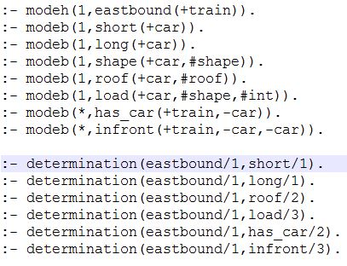
Mode declarations (declare mode of call for predicates) and determinations (predicates used to create the hypothesis):

for more details see file.

Results (see folder), really good.

Question:

From bottom clause to rule? (esp. experiment 3).

Questions/Further Approach

How can Aleph and SVM be compared?

Possibility to apply rules of Aleph on a testing set?
test(File,Flag,Covered,Total)

SVM: accuracy and model (no rules)

Aleph: rules

Research question:

Which relations can be learned better with either of the two techniques?
→ Apply algorithms with different rules

