Disease Prediction from Symptom Profiles:
A Comparative Study of Supervised and Unsupervised Machine Learning

Matthew Setiadi
CIS 3715: Principles of Data Science | Dr. Hongchang Gao | Temple University | Spring 2026

1. Introduction
Getting a timely and accurate medical diagnosis remains a real problem, especially in healthcare systems where physician access is limited. When doctors are unavailable, patients wait or go without answers entirely. This is not an abstract issue for me. From 2009 to 2016, I helped coordinate community medical clinics in Indonesia, where limited physician access meant that many patients went without timely diagnoses. Building tools that can assist in identifying potential illnesses from symptoms is something I have wanted to do for a long time.
In this project, I built and compared machine learning models that predict diseases from patient symptom profiles. The core task is multi-class classification: given a set of binary symptom indicators for a patient, identify which of several diseases is most likely present. Beyond classification, I applied unsupervised clustering to the same dataset to examine whether natural disease groupings emerge from symptom patterns without the use of labels.
The project makes three contributions. First, I trained and evaluated three supervised classifiers (Logistic Regression, K-Nearest Neighbors, and Random Forest) on a large-scale symptom dataset, achieving up to 97.23% accuracy across 15 disease classes. Second, I applied K-Means and Agglomerative Clustering and demonstrated that unsupervised methods can recover up to 96% of the true disease groupings without any label information (NMI = 0.9632). Third, I conducted a comparative analysis showing that the same disease pairs that confuse supervised models also produce overlap in unsupervised clusters, confirming that these ambiguities are inherent to the symptom data rather than artifacts of any particular model.
2. Approach
2.1 Dataset
I used the Kaggle Disease-Symptom Dataset (Final_Augmented_dataset_Diseases_and_Symptoms.csv), which contains 246,945 patient records with 377 binary symptom features and 773 unique disease labels. All features are one-hot encoded (0/1), and the dataset contains zero missing values. Because 773 classes is too large for meaningful comparative analysis, I selected the top 15 most frequent diseases (approximately 1,212 to 1,219 samples each), producing a working subset of 18,228 rows.
2.2 Preprocessing
Within the top-15 subset, I identified and removed 276 symptom features with zero variance (features that are uniformly zero across all 15 disease classes), reducing the feature matrix from 377 to 101 informative columns. Min-Max normalization was applied to scale all feature values to the [0, 1] range. Disease labels were encoded numerically using LabelEncoder (classes 0 through 14). The data was split 80/20 using stratified sampling (random_state=42), yielding 14,582 training samples and 3,646 test samples.
2.3 Supervised Learning
I trained three classifiers. Logistic Regression (max_iter=1000, random_state=42) served as the interpretable linear baseline. K-Nearest Neighbors used 5-fold cross-validation over k values {3, 5, 7, 9, 11, 13, 15} to select the optimal k, which was 15. Random Forest was configured with 100 estimators (random_state=42). All three models were evaluated using accuracy, macro-averaged precision, recall, F1 score, and confusion matrices on the held-out test set.
2.4 Unsupervised Learning
Before clustering, I applied PCA with 30 components to reduce dimensionality and mitigate noise in distance computations. K-Means clustering (k=15, n_init=10, random_state=42) and Agglomerative Clustering (k=15, Ward linkage) were then applied to the PCA-reduced data. Normalized Mutual Information (NMI) was used to quantify how closely the discovered clusters align with the true disease labels, where 1.0 indicates perfect alignment. A separate 2D PCA projection was generated for visualization.
2.5 Related Work
The approach builds on established methods. Guo et al. (2003) demonstrated KNN's effectiveness for medical classification based on patient similarity. Breiman (2001) introduced Random Forest, which handles correlated features common in medical data. Xu and Wunsch (2005) showed that clustering methods like K-Means and Agglomerative Clustering can reveal hidden patient groupings from symptom co-occurrence patterns.
3. Results
3.1 Exploratory Data Analysis
The class distribution across the top 15 diseases is nearly uniform at approximately 1,200 samples per class (Figure 1), confirming a well-balanced subset. Symptom frequency analysis revealed that sharp abdominal pain is the most prevalent feature (~32,000 occurrences across the full dataset), followed by vomiting (~28,000) and headache (~24,500). I identified 49 symptoms with zero occurrences in the full dataset and 276 zero-variance features within the top-15 subset. The symptom co-occurrence heatmap (Figure 2) shows pronounced diagonal block structure, indicating that each disease clusters around a distinct symptom profile with minimal cross-disease overlap. This structure was a strong early signal that the data would support effective classification.
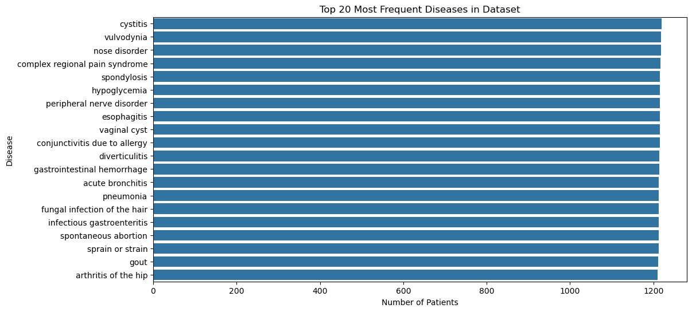
Figure 1. Top 20 Most Frequent Diseases. Distribution is nearly uniform (~1,200 per class).
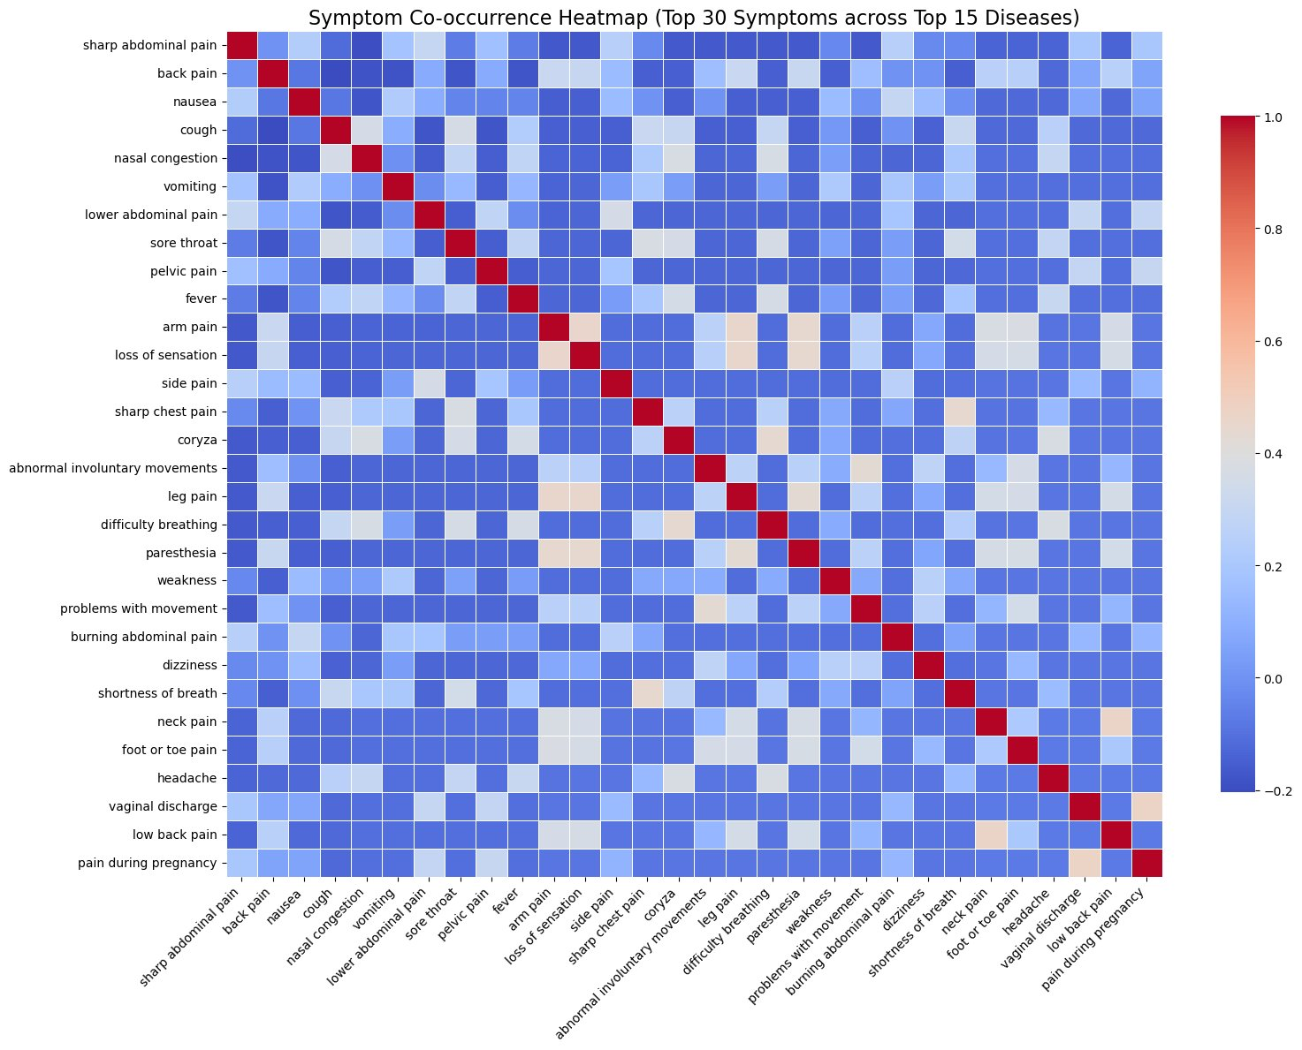
Figure 2. Symptom Co-occurrence Heatmap (Top 30 Symptoms x Top 15 Diseases). Diagonal blocks confirm disease-specific symptom profiles.
3.2 Supervised Learning Results
All three supervised models achieved strong performance on the 3,646-sample test set. Logistic Regression and KNN both reached 97.23% accuracy with a macro F1 of 0.97. Random Forest scored slightly lower at 96.90% but maintained the same macro F1. Table 1 summarizes the full results.
Model | Accuracy | Precision | Recall | F1 | Support
Logistic Regression | 97.23% | 0.97 | 0.97 | 0.97 | 3,646
KNN (k=15) | 97.23% | 0.97 | 0.97 | 0.97 | 3,646
Random Forest | 96.90% | 0.97 | 0.97 | 0.97 | 3,646

Table 1. Supervised model performance (macro-averaged metrics, 15-class test set).
The confusion matrices (Figures 3 and 4) reveal that misclassifications are concentrated in two specific disease pairs. Acute bronchitis and pneumonia were consistently confused across all three models: Logistic Regression misclassified 14 bronchitis cases as pneumonia and 19 pneumonia cases as bronchitis. Complex regional pain syndrome and peripheral nerve disorder produced similar overlap, with 7 to 15 cross-misclassifications depending on the model. All other disease pairs were classified at or near 100% accuracy.
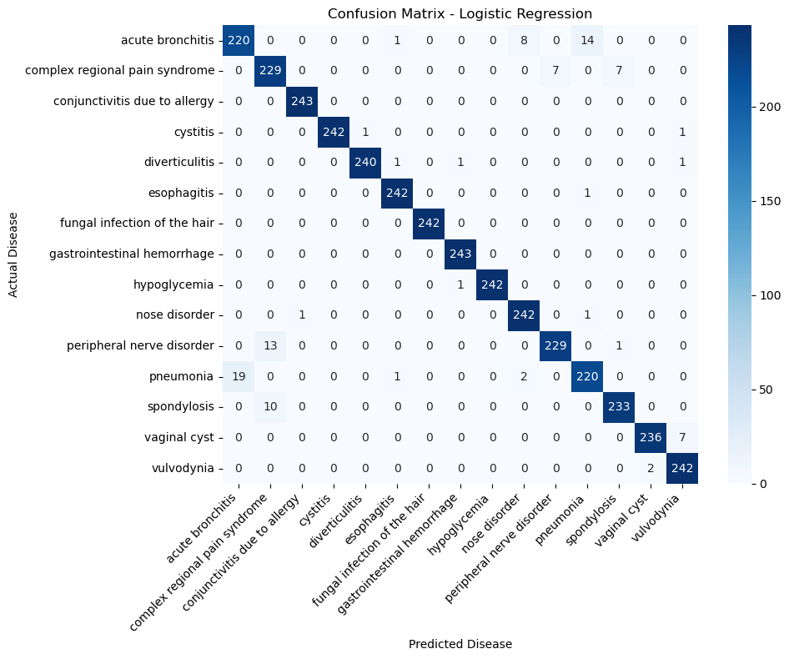
Figure 3. Confusion Matrix: Logistic Regression (97.23%). Off-diagonal errors cluster in the bronchitis/pneumonia and CRPS/nerve disorder pairs.
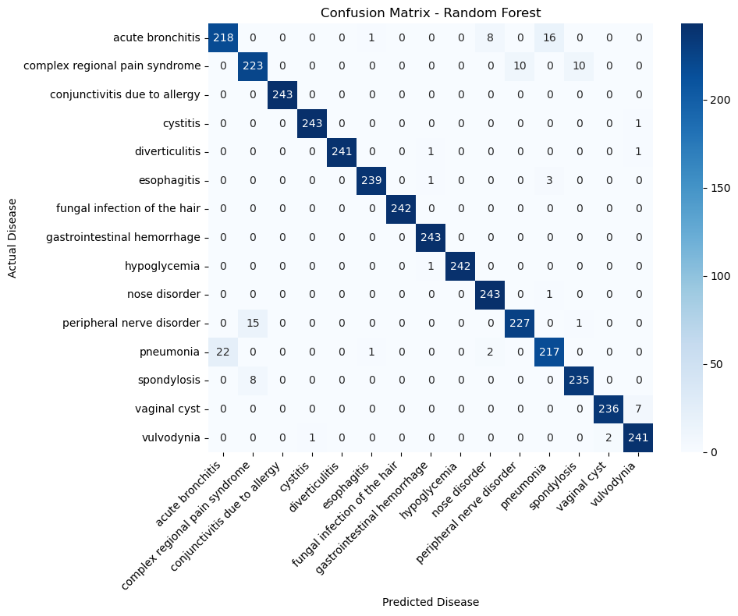
Figure 4. Confusion Matrix: Random Forest (96.90%). The same two disease pairs produce the dominant misclassification pattern.
3.3 Unsupervised Learning Results
Both clustering methods achieved exceptionally high NMI scores (Table 2). K-Means recovered 96% of the true disease groupings (NMI = 0.9632), while Agglomerative Clustering reached 93% (NMI = 0.9316). These results indicate that the 101 symptom features carry sufficient discriminative structure for clustering to nearly replicate supervised label assignments without any label information.
Method | NMI Score | Notes
K-Means (k=15) | 0.9632 | PCA 30 components, n_init=10
Agglomerative (k=15) | 0.9316 | PCA 30 components, Ward linkage

Table 2. Clustering results. NMI ranges from 0 (no alignment) to 1 (perfect match with true labels).
The PCA 2D visualization (Figure 5) confirms these scores visually. The 15 disease classes form distinct ray-like structures emanating from a central region. K-Means clusters closely match the true label layout, while Agglomerative Clustering shows slightly more color mixing in the high-overlap central zone.
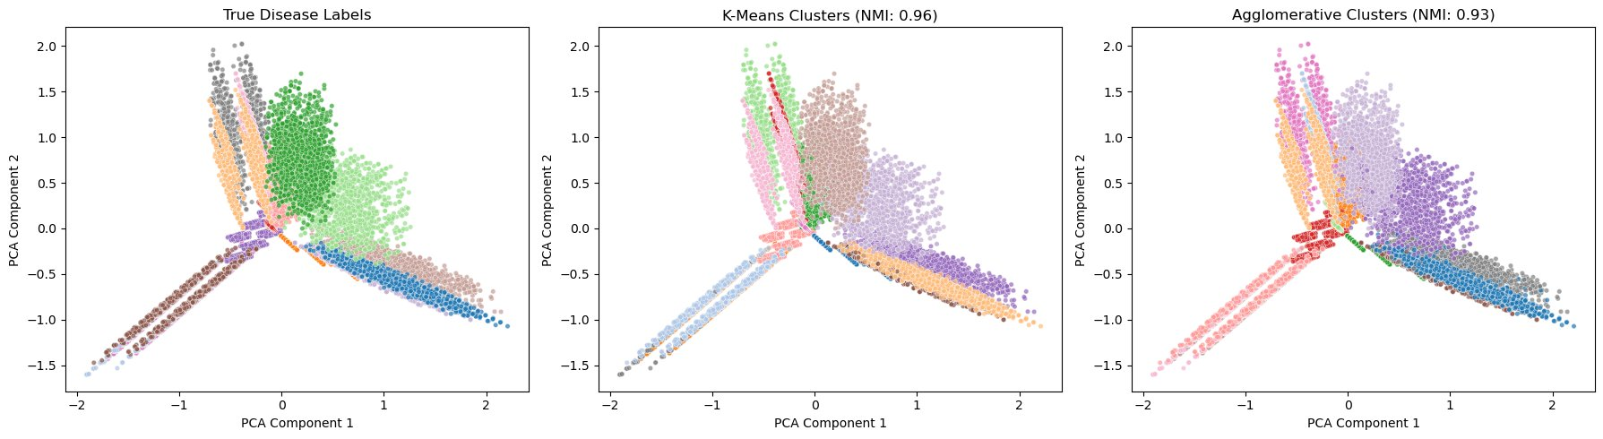
Figure 5. PCA 2D projection: true labels (left), K-Means clusters (center, NMI=0.96), Agglomerative clusters (right, NMI=0.93).
3.4 Comparative Analysis
Comparing supervised and unsupervised results reveals a consistent picture. All three supervised models achieved 96.9 to 97.2% accuracy, with Logistic Regression and KNN performing identically. The fact that a simple linear model (Logistic Regression) matches KNN and nearly matches Random Forest suggests that the decision boundaries in the 101-dimensional symptom space are largely linear. This is consistent with the heatmap's block-diagonal structure: each disease activates a distinct, non-overlapping set of symptoms.
The unsupervised methods performed remarkably close to the supervised models. K-Means' NMI of 0.9632 means that the algorithm, without any labels, produced cluster assignments that share 96% mutual information with the true disease labels. The gap between supervised accuracy (97.2%) and unsupervised NMI (96.3%) is small enough to confirm that the symptom features are inherently well-structured for disease separation.
The disease pairs that confuse supervised models (bronchitis/pneumonia, CRPS/peripheral nerve disorder) also appear as merged or overlapping regions in the clustering output. This consistency across paradigms confirms that the ambiguity is a property of the data itself. These conditions share overlapping symptom codes in the dataset, and no amount of model complexity would resolve this without additional clinical features (e.g., imaging results, lab values, patient history).
4. Conclusion
This project demonstrated that machine learning models can predict diseases from binary symptom profiles with high accuracy. Logistic Regression and KNN both achieved 97.23% accuracy on a 15-class disease prediction task, and Random Forest reached 96.90%. Unsupervised clustering produced NMI scores of 0.9632 (K-Means) and 0.9316 (Agglomerative), confirming that symptom features carry enough structure for algorithms to discover disease groupings without labels.
The consistent confusion between bronchitis/pneumonia and CRPS/peripheral nerve disorder across all five models highlights a genuine limitation of symptom-only data. Future work could address this by incorporating additional clinical features, exploring deep learning architectures, or testing on datasets with more granular symptom encodings. The strong unsupervised results also suggest potential applications in clinical triage systems where labeled data may not be available.
5. Acknowledgements
I would like to acknowledge Claude (Anthropic) for assisting with code debugging, report formatting, and presentation preparation throughout this project. The dataset used in this project was sourced from Kaggle (Disease-Symptom Dataset by itachi9604). All machine learning models were implemented using scikit-learn. Visualizations were generated using matplotlib and seaborn.
6. References
Breiman, L. (2001). Random forests. Machine Learning, 45(1), 5–32.
Guo, G., Wang, H., Bell, D., Bi, Y., & Greer, K. (2003). KNN model-based approach in classification. In Proceedings of OTM Confederated International Conferences.
Xu, R., & Wunsch, D. (2005). Survey of clustering algorithms. IEEE Transactions on Neural Networks, 16(3), 645–678.
Kaggle. Disease-Symptom Dataset. https://www.kaggle.com/datasets/itachi9604/disease-symptom-description-dataset

