CIS 3715: Principles of Data Science — Progress Report I
Disease Prediction from Symptom Profiles:
A Comparative Study of Supervised and Unsupervised Machine Learning

Matthew Setiadi | Dr. Hongchang Gao | Temple University | April 6, 2026

I. What Has Been Done
Since the project proposal was submitted on March 27, 2026, I have completed the initial data acquisition and exploratory data analysis (EDA) phase of the project. The following tasks have been finished:

Dataset Change and Proposal Update. The original proposal was submitted using the Kaggle Disease Symptoms and Patient Profile Dataset, which contains only 349 records. Upon closer inspection during the data acquisition phase, it became clear that this sample size was too small to train robust machine learning models and would not produce statistically meaningful results for either supervised classification or unsupervised clustering. In response, I switched to a significantly larger dataset — the Kaggle Disease-Symptom Dataset — which contains approximately 246,000 records with 377 binary symptom features and 773 unique disease labels. This dataset is already one-hot encoded, making preprocessing more straightforward, and provides far more stable training and evaluation conditions. The project proposal has been updated accordingly to reflect this dataset change.

Dataset Acquisition and Verification. I downloaded the Kaggle Disease-Symptom Dataset (Final_Augmented_dataset_Diseases_and_Symptoms.csv), confirmed the dataset shape is (246,945 × 378), and verified that all feature values are binary (0 or 1), consistent with the one-hot encoded format. A total missing value check confirmed 0 missing values across all 377 symptom columns. Memory usage is approximately 712.2 MB, and the dataset contains 377 integer-typed feature columns and 1 object-typed target column (diseases).

Class Distribution Analysis. I computed the frequency of each disease label across all records and identified 773 unique disease classes. The distribution is roughly uniform at approximately 1,200–1,220 samples per class. The top 15 most frequent diseases are: cystitis (1,219), vulvodynia (1,218), nose disorder (1,218), complex regional pain syndrome (1,217), spondylosis (1,216), hypoglycemia (1,215), peripheral nerve disorder (1,215), esophagitis (1,215), vaginal cyst (1,215), conjunctivitis due to allergy (1,215), diverticulitis (1,214), gastrointestinal hemorrhage (1,214), acute bronchitis (1,213), pneumonia (1,212), and fungal infection of the hair (1,212). These 15 classes were selected as the working subset, producing a filtered dataset of 18,228 rows.

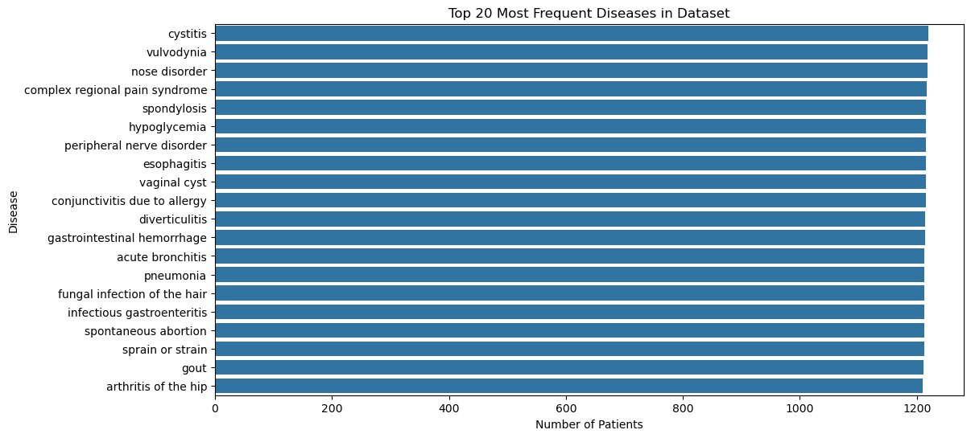
Figure 1. Top 20 Most Frequent Diseases in Dataset. The distribution is nearly uniform (~1,200 patients per class), confirming a well-balanced dataset across all 773 disease classes.

Symptom Frequency Analysis. I computed the total frequency of each of the 377 symptom columns across all records. The most prevalent symptom is sharp abdominal pain (~32,000 occurrences), followed by vomiting (~28,000), headache (~24,500), cough (~24,500), and sharp chest pain (~24,000). I also identified that 49 symptoms have zero occurrences in the full dataset and are effectively uninformative for modeling. The 15 least common non-zero symptoms include “feeling hot” (1 occurrence), “skin pain” (1), and “thirst” (1). These sparse features will be candidates for removal during feature selection in the modeling phase.

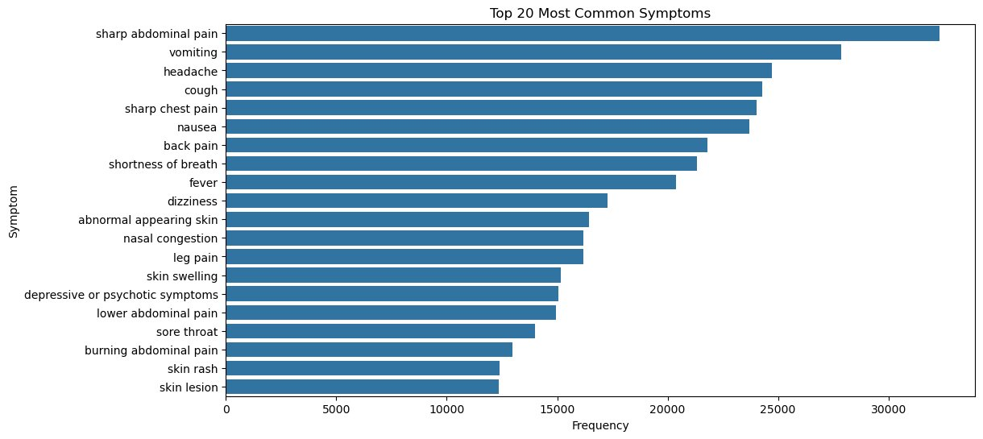
Figure 2. Top 20 Most Common Symptoms across the full dataset. Sharp abdominal pain is the most prevalent feature, appearing in over 32,000 patient records.

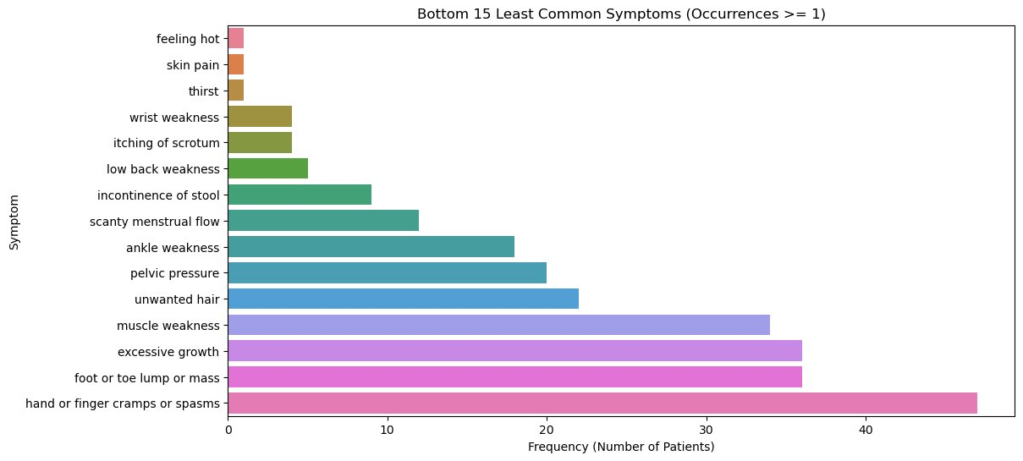
Figure 3. Bottom 15 Least Common Symptoms (with ≥1 occurrence). These near-zero features are candidates for removal in the feature selection step.

Data Preprocessing. I applied Min-Max normalization to the feature matrix of the top-15 disease subset. The filtered dataset has shape (18,228 × 377), and after scaling, all feature values fall in the range [0.0, 1.0], confirming correct normalization. Disease labels were encoded numerically using LabelEncoder, producing integer class labels 0–14 for the 15 disease categories.

Symptom Co-occurrence Heatmap. I generated a symptom co-occurrence correlation heatmap using the top 30 most frequent symptoms across the top 15 disease classes. The heatmap reveals clearly distinguishable diagonal blocks, indicating that each disease in the subset tends to cluster around a distinct symptom profile with low cross-disease overlap. This is a strong early signal that the symptom features carry sufficient discriminative structure for both supervised classification and unsupervised clustering.

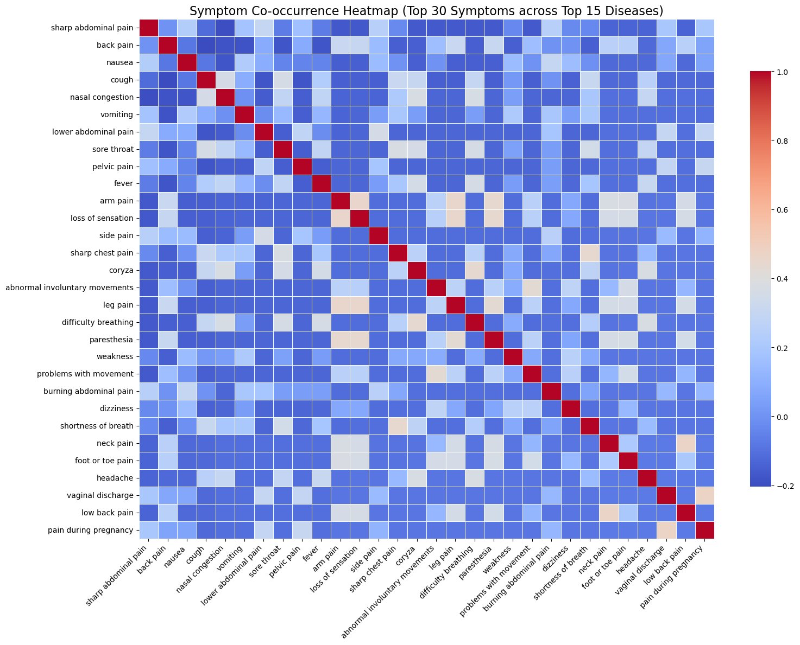
Figure 4. Symptom Co-occurrence Heatmap (Top 30 Symptoms × Top 15 Diseases). The pronounced diagonal block structure indicates disease-specific symptom profiles with minimal cross-cluster overlap.

II. What Has Not Been Done
The following tasks remain outstanding as of this report:

- No supervised models have been trained yet. Logistic Regression, KNN, and Random Forest are all scheduled for the Progress Report II phase.

- No unsupervised clustering has been applied. K-means and agglomerative clustering will be implemented alongside the supervised models.

- Hyperparameter tuning via cross-validation has not been completed. This will follow after baseline models are established.

- PCA visualizations for clustering results have not been generated. These depend on clustering being completed first.

- No comparative analysis has been conducted yet, as there are no model outputs to compare.

III. What Will Be Done During the Following Week
By Progress Report II (April 13, 2026), I plan to complete the full modeling phase:

- Train all three supervised classifiers — Logistic Regression, KNN (with cross-validated k selection), and Random Forest — and record accuracy, precision, recall, F1, and confusion matrices for each.

- Apply K-means and agglomerative clustering to the label-free feature matrix, set k = 15 clusters, and compute NMI scores against the true disease labels.

- Generate PCA visualizations (2D) of clustering results to inspect whether symptom-based clusters visually correspond to known disease groupings.

- Begin the comparative analysis, documenting initial observations on how supervised and unsupervised results relate and which supervised model performs strongest.

IV. Challenges and Notes
One practical consideration that emerged during EDA is the high dimensionality of the feature space — 377 binary symptom columns is large relative to the number of selected classes, and 49 of those columns have zero occurrences across the entire dataset. These will be dropped prior to modeling to reduce noise. I will also apply PCA before clustering (not just for visualization) to reduce dimensionality noise in the distance computations for K-means and agglomerative methods, consistent with the techniques covered in Lab 7.

No major blockers have been encountered. The dataset loads cleanly, the class subset is well-defined, the preprocessing pipeline is complete, and the visualizations confirm that the feature space has clear structure. The project is on schedule.

