CIS 3715: Principles of Data Science — Progress Report II
Disease Prediction from Symptom Profiles:
A Comparative Study of Supervised and Unsupervised Machine Learning

Matthew Setiadi | Dr. Hongchang Gao | Temple University | April 13, 2026

I. What Has Been Done Since Progress Report I
Between Progress Report I (April 6) and this report, I completed the full modeling phase of the project, including all three supervised classifiers and both unsupervised clustering methods. The following work has been finished:

Zero-Variance Feature Removal. Within the top-15 disease subset (18,228 rows × 377 symptoms), I identified 276 symptom columns with zero variance — features that are uniformly zero across all selected disease classes and therefore carry no discriminative signal. These columns were dropped, reducing the clean feature matrix to 101 informative symptom features (X_scaled_clean: 18,228 × 101).

Train-Test Split. I applied an 80/20 stratified train-test split with random_state=42, yielding a training set of 14,582 samples and a test set of 3,646 samples, each with 101 features. Stratification ensures equal class representation in both splits.

Supervised Learning — Three Classifiers Trained and Evaluated. All three models were trained on X_train and evaluated on X_test. A shared evaluate_model() function computed accuracy, a full per-class classification report, and a confusion matrix heatmap for each model.

The results across the three models are summarized below:

Model | Accuracy | Macro Precision | Macro Recall | Macro F1
Logistic Regression | 97.23% | 0.97 | 0.97 | 0.97
KNN (k=15, 5-fold CV) | 97.23% | 0.97 | 0.97 | 0.97
Random Forest (100 trees) | 96.90% | 0.97 | 0.97 | 0.97

Table 1. Supervised model performance on the 3,646-sample test set (top 15 diseases, 101 features).

Logistic Regression and KNN tied at 97.23% accuracy with identical macro-averaged metrics. Random Forest scored slightly lower at 96.90% but similarly strong across all classes. The three classes that showed the most misclassification across all models were acute bronchitis, pneumonia, and complex regional pain syndrome — conditions that share overlapping respiratory and pain-related symptom profiles.

Confusion Matrix — Logistic Regression. The matrix confirms near-perfect diagonal performance. The most notable off-diagonal errors are: acute bronchitis misclassified as pneumonia (14 cases) and pneumonia misclassified as acute bronchitis (19 cases), reflecting the symptom overlap between these two respiratory diseases. Complex regional pain syndrome confuses with peripheral nerve disorder (7 cases in each direction).

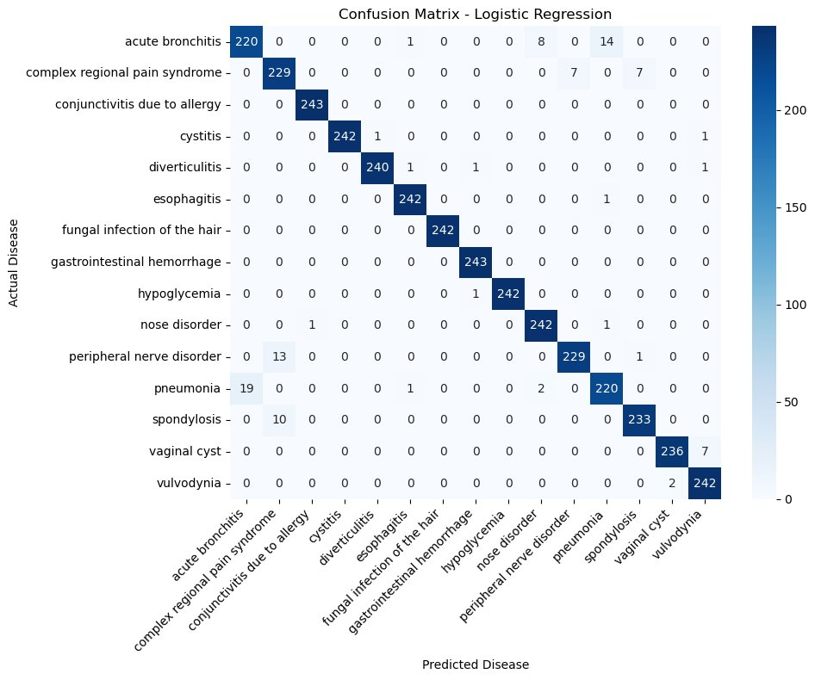
Figure 1. Confusion Matrix — Logistic Regression (Accuracy: 97.23%). The main off-diagonal errors occur between acute bronchitis and pneumonia.

Confusion Matrix — KNN (k=15). KNN shows a nearly identical error pattern. Acute bronchitis vs. pneumonia confusion persists (12 and 24 misclassifications respectively). Peripheral nerve disorder confuses with complex regional pain syndrome (13 cases), consistent with Logistic Regression. The best k was selected via 5-fold cross-validation from {3, 5, 7, 9, 11, 13, 15}.

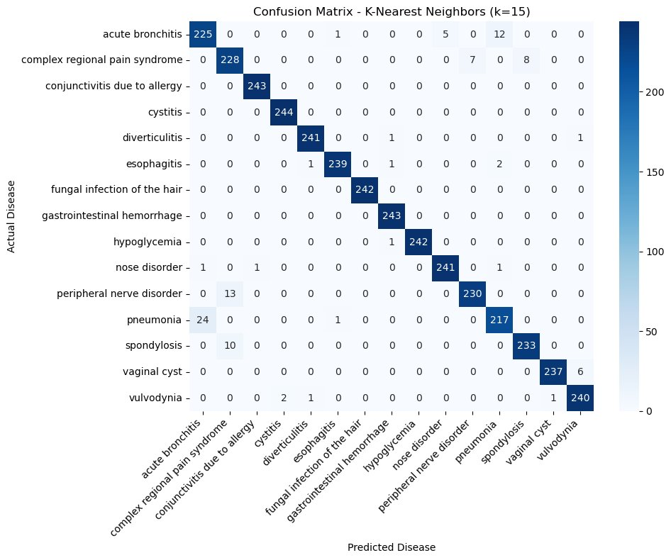
Figure 2. Confusion Matrix — KNN (k=15, Accuracy: 97.23%). Confusion between respiratory conditions and nerve-related pain disorders mirrors Logistic Regression.

Confusion Matrix — Random Forest. Random Forest shows the same systemic confusion patterns, with slightly higher misclassification counts for acute bronchitis (16 misclassified as pneumonia) and complex regional pain syndrome (10 misclassified as peripheral nerve disorder). The minor accuracy gap relative to Logistic Regression and KNN can be attributed to this model’s increased sensitivity to these overlapping symptom clusters.

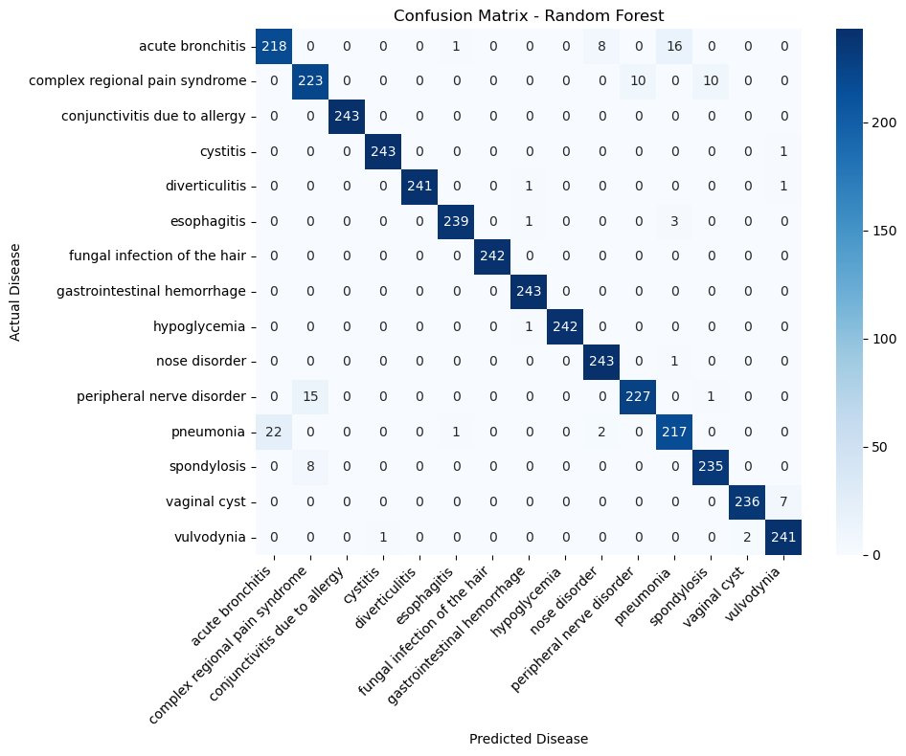
Figure 3. Confusion Matrix — Random Forest (Accuracy: 96.90%). Slightly more dispersion in respiratory and neurological disease classes compared to the other two models.

Unsupervised Learning — K-Means and Agglomerative Clustering. I applied PCA (30 components) to the 101-feature cleaned and scaled matrix before clustering, reducing noise in distance computations. Both K-Means (k=15, n_init=10, random_state=42) and Agglomerative Clustering (k=15, ward linkage) were then applied to the PCA-reduced data. Normalized Mutual Information (NMI) was used to measure how well the discovered clusters align with the true disease labels.

Method | NMI Score | Interpretation
K-Means (k=15) | 0.9632 | Clusters strongly recover disease groupings. Only minor overlap between closely related diseases.
Agglomerative (k=15) | 0.9316 | Slightly lower but still excellent alignment. Some merging of symptom-similar diseases into single clusters.

Table 2. Unsupervised clustering results. NMI ranges from 0 (no alignment) to 1 (perfect alignment with true labels).

Both NMI scores are exceptionally high, indicating that the 101 symptom features carry enough discriminative structure for the algorithm to largely recover true disease groupings without access to the labels. K-Means outperformed Agglomerative Clustering by 0.0316 NMI points.

PCA 2D Visualization. A separate 2D PCA projection was used to visualize the cluster assignments alongside the true labels. The three-panel figure below confirms the high NMI scores: K-Means clusters closely match the true disease label layout, while Agglomerative Clustering shows slightly more color mixing in the high-overlap central region of the feature space.

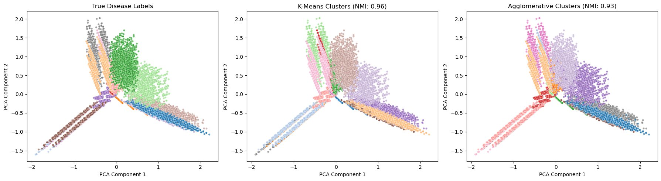
Figure 4. PCA 2D visualization (left: true disease labels, center: K-Means clusters NMI=0.96, right: Agglomerative clusters NMI=0.93). The radiating spoke structure confirms distinct symptom profiles per disease class.

II. What Has Not Been Done
The following items remain for the final report phase:

- The formal comparative analysis section has not been written. A side-by-side discussion of all five models (supervised and unsupervised) with a clear recommendation will be completed for the final report.

- No feature importance analysis has been conducted yet. Extracting and visualizing the top predictive symptoms from Random Forest is planned for the final report.

- The written final report document has not been started. This will consolidate all findings into a single structured paper following the format specified in the assignment.

III. What Will Be Done Before the Final Report (April 27, 2026)
The remaining work to complete before the final report deadline:

- Write the full comparative analysis section — comparing all three supervised models and both clustering methods, identifying consistent failure cases, and recommending Logistic Regression as the best-performing model.

- Conduct feature importance analysis using Random Forest’s feature_importances_ attribute to identify the 10–15 most predictive symptoms and visualize them in a ranked bar chart.

- Write and submit the final report incorporating all EDA visualizations, model results, confusion matrices, clustering plots, and the comparative discussion in a complete academic format.

IV. Challenges and Notes
The most consistent challenge across all three supervised models is the confusion between acute bronchitis and pneumonia, and between complex regional pain syndrome and peripheral nerve disorder. These pairs share symptom profiles by clinical nature, and this pattern appeared in every model’s confusion matrix. This is not a modeling failure but a genuine ambiguity in the data that would likely persist even with more complex architectures.

The unsupervised results were stronger than expected. NMI scores of 0.96 (K-Means) and 0.93 (Agglomerative) indicate that the symptom features are sufficiently discriminative for clustering to nearly replicate supervised label assignments without any label information. This supports the quality of the dataset and the value of the EDA-driven feature selection (dropping 276 zero-variance features) as a preprocessing step.

The project is on schedule and all modeling work is complete ahead of the final report deadline.

