**PROJECT REPORT**

**1. INTRODUTION:**

**I.I OVER VIEW**

**ZOHO BOOKS is your one – stop accounting platform for managing our accounting tasks and organizing your transaction.**

**1.2 PURPOSE:**

**ZOHO BOOKS is single secure location to keep up with your company’s bills and invoice , reconcile your bank statement and GST related worries of fresh bites catering.**

**Preparation and maintenance of ZOHO books for fresh bites catering**

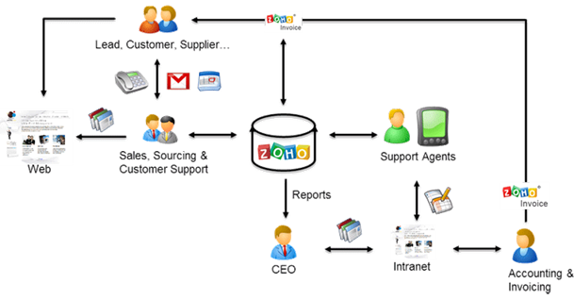

**2 PROBLEM DEFINTION & DESIGN THINKING:**

**2.1 Empathy Map:**

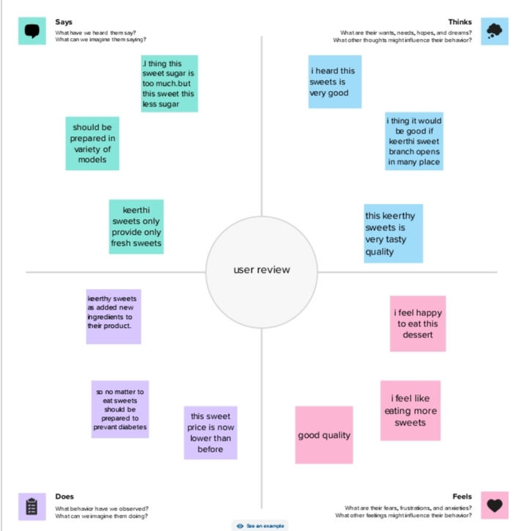

**2.2 Ideation & Brainstorming Map**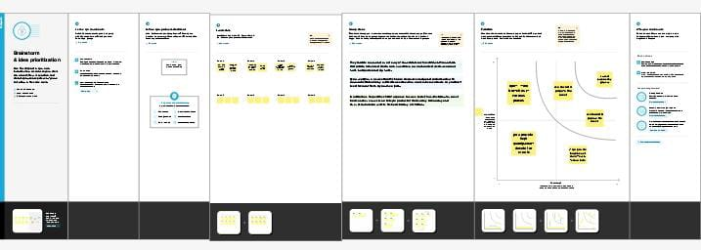

**3. RESULT:**

**Item Creation**

**Here the items creation by fresh bite catering for supply of services,**

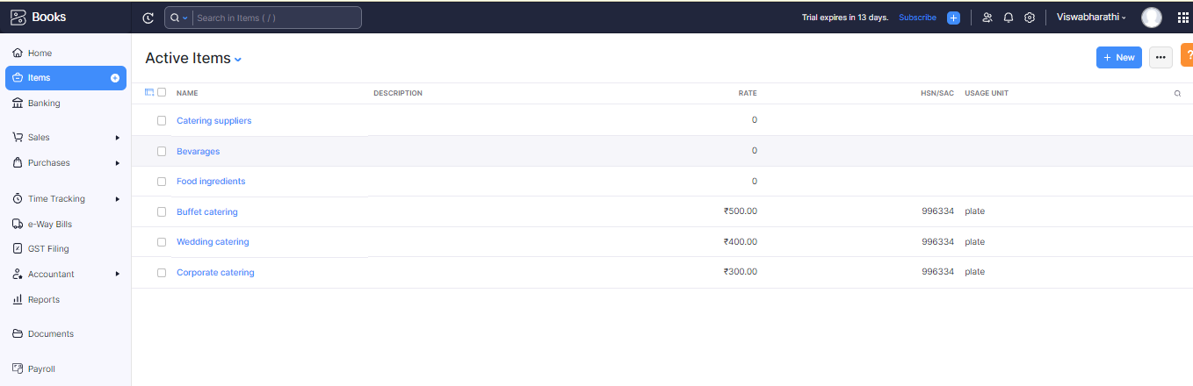

**Vendor Creation**

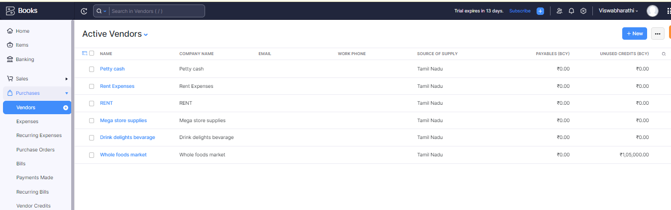

**Purchase Order**

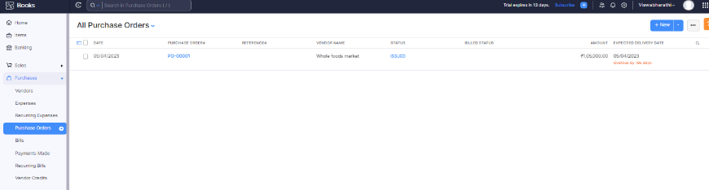

**Sales Order**

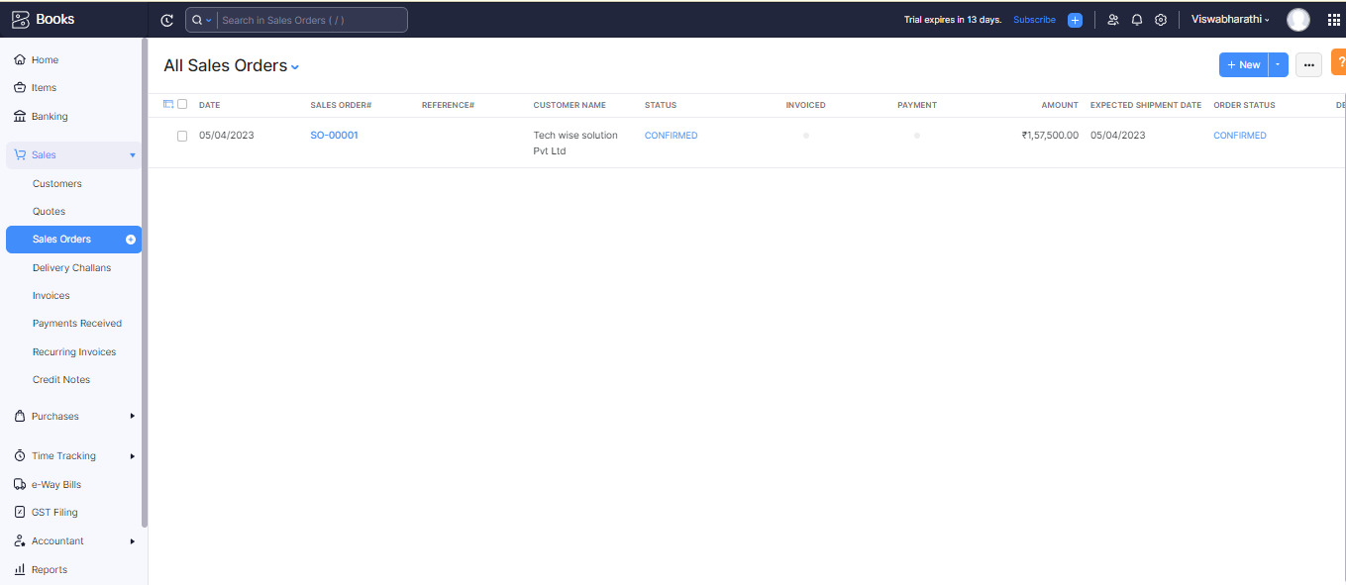

**Here the output of sales order create by , Fresh bites catering**

**Profit & Loss**

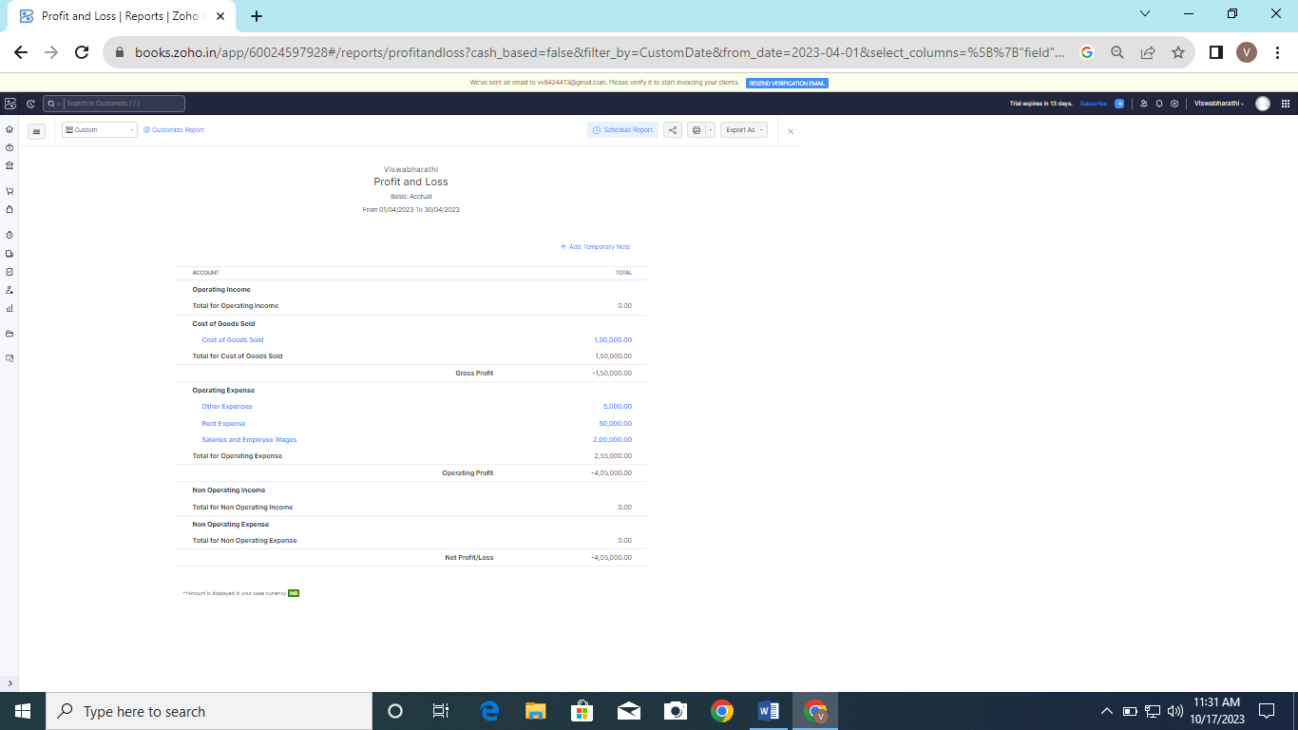

**Profit and loss account of fresh bites catering is given below,**

**Balance Sheet:**

**Balance sheet of fresh bites catering is given below,**

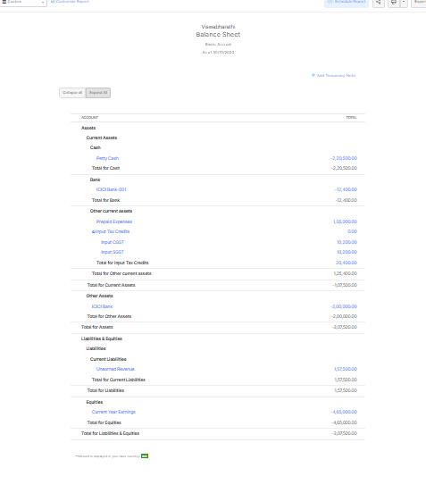

**GST summary:**

**Tax (GST) summary for the year for fresh bites catering is given below,** 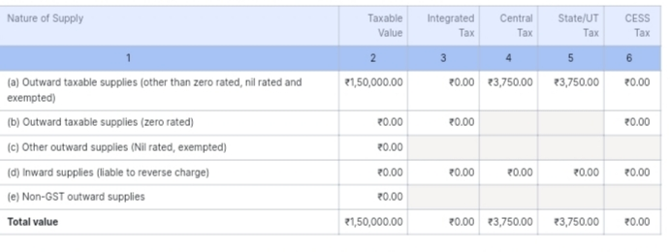

**ADVANTAGES & DISADVANTAGES**

**Advantages:**

**Corparate catering saves business time and and effort by handling all aspects of food preparation, delivery, and setup.This allows employee of focus on their work without having to worry about arranging meals or leaving the premises for lunch.**

**Disadvatages:**

* **You”ll have a lot of responsibility.**
* **You”ll be extremely busy.**
* **You”ll have a lot of stress**
* **It”ll be difficult in the beginning of your career.**

**Application**

**So,what is catering service and what is the purpose of catering? It is a service that deliver, cooks and or serves food on site at a client’s location.**

**CONCLUSION :**

**Catering demands quality ingredients professional service creative flair and excellent presentation for artistic perfection.**

**FUTURE SCOPE:**

**Personalization is becoming increasingly important in catering industry. As consumes seak out unique customized experiences catering offering more more means service and dining experience.**

**APPENDIX:**

**SOURCE CODE: Computer Data.**