
Swinburne University of Technology
School of Science, Computing and Engineering Technologies

Task 1: Desktop Application Deployment with WiX Toolset

Deployment Portfolio Task 2

Semester 2, 2026

Hoang Minh Tuan (Nick) Nguyen – 104527639
Target Level: 2.3 (Distinction Level)
Unit Tutor: Naveed Ali
SWE – Software Deployment and Evolution
Date of submission: 31/08/2026
Source code: https://github.com/mtuannh/SWE40006_Software_Development_and_Evolution_Task_1

- Pass Level
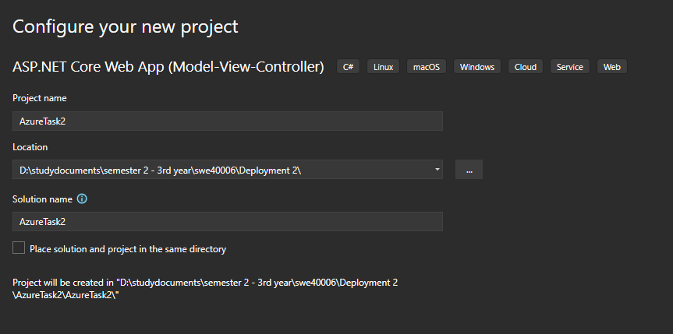
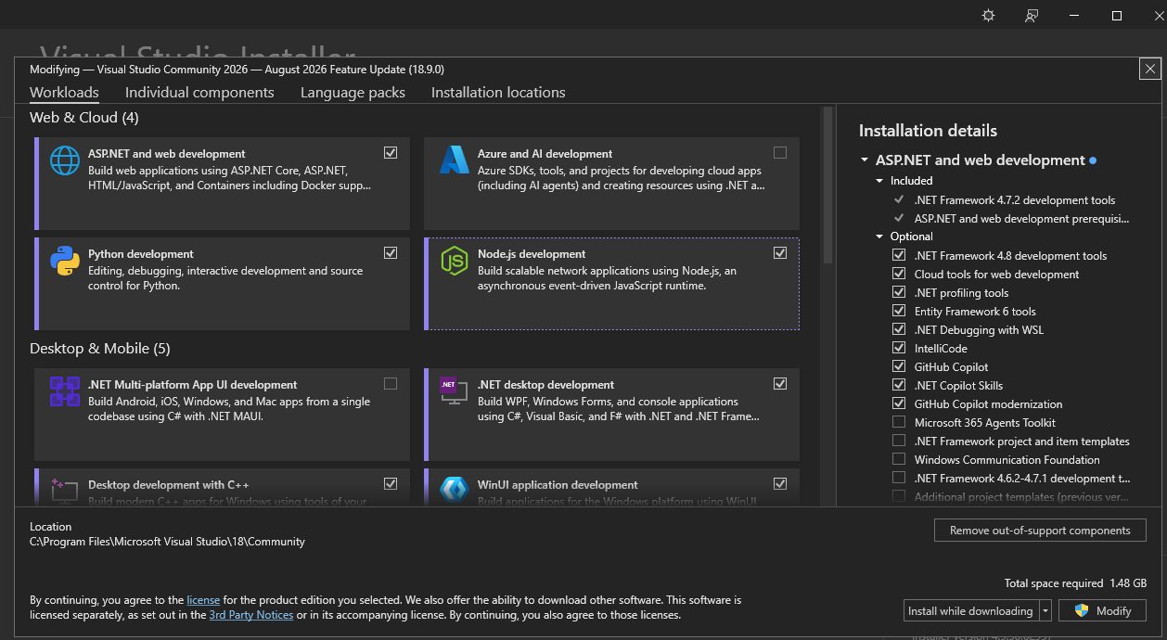
Figure 1: Visual Studio 2026 with the ASP.NET and web development workload installed.

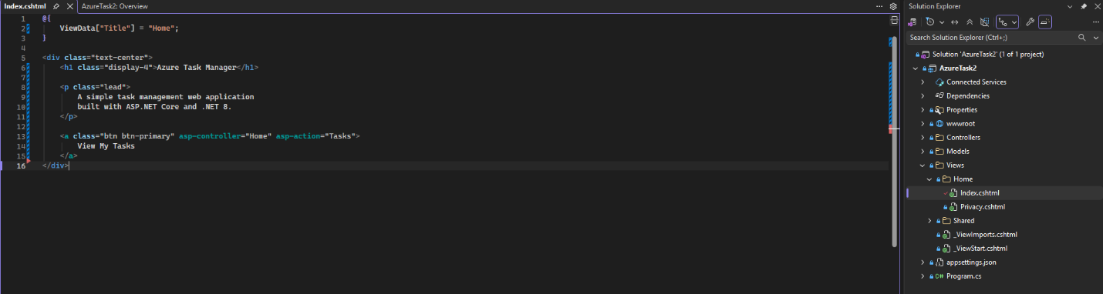
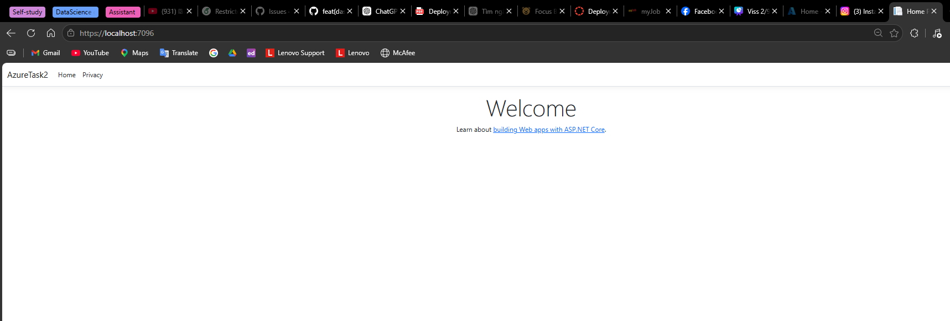
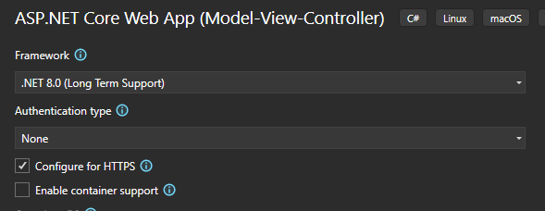
Figure 5: Modified Index.cshtml
Figure 4: Initial ASP.NET Core application running successfully in the local development environment.
Figure 3: ASP.NET Core Web App configuration targeting .NET 8.0 with HTTPS enabled.

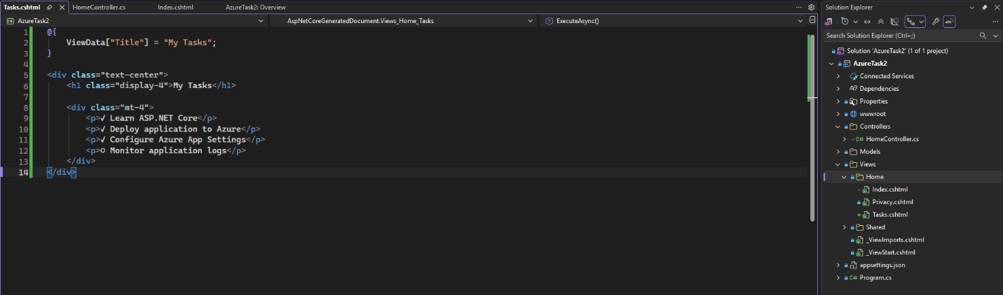
Figure 2: Tasks.cshtml
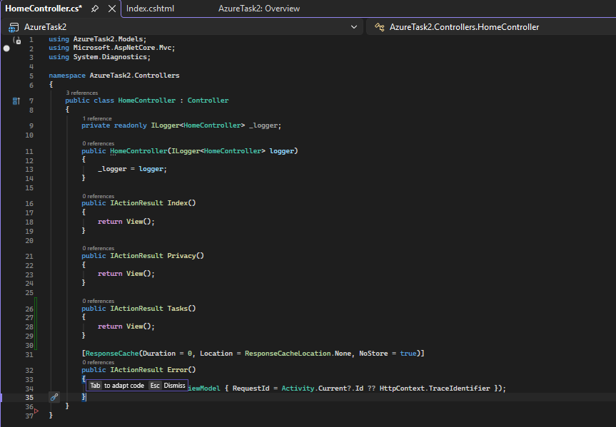
Figure 3: Modified HomeController.cs

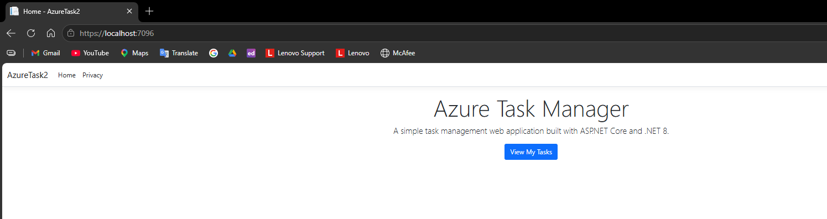
Figure 4: Custom Azure Task Manager home page running successfully in the local development environment.
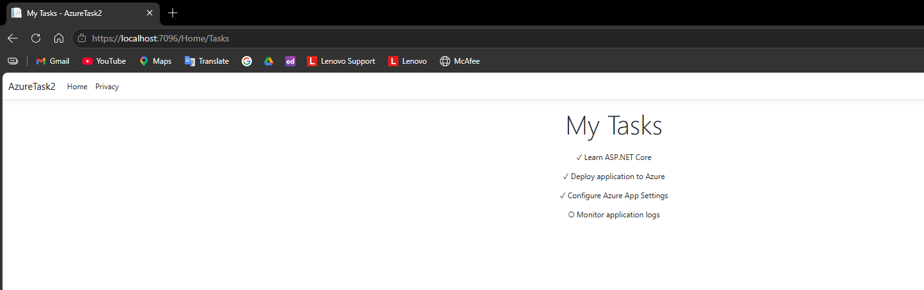
Figure 5: Custom Tasks page successfully accessed from the home page.

