



TRƯỜNG ĐẠI HỌC NÔNG LÂM TP. HỒ CHÍ MINH
KHOA CÔNG NGHỆ THÔNG TIN
--------



SYSTEM REQUIREMENTS SPECIFICATION DOCUMENT

MÔN: ĐẢM BẢO CHẤT LƯỢNG VÀ KIỂM THỬ PHẦN MỀM

ĐỀ TÀI : TRANG THƯƠNG MẠI ĐIỆN TỬ FPT SHOP

Giảng viên hướng dẫn: Th.S Trần Thị Thanh Nga

Sinh viên thực hiện: 21130604 – Trần Minh Tường

TP.HCM, ngày 18 tháng 10 năm 2024

DOCUMENT HISTORY AND INFORMATION

History of Amendments:
Date | Version | Modified Section | Summary of Change | Author
18/10/2024 | 0.1 | ALL | SRS for function ORDER PRODUCTS | Tran Minh Tuong

Table of contents

1 Introduction 4
2 Purpose 4
3 Functionality Requirements 4
3.1 Order Products 4
3.1.1 Product Selection 4
3.1.2 Product Detail 5
3.1.3 Shopping Cart 6
3.1.4 Confirm Order Products 6
3.1.4.1 Customer Information 7
3.1.4.2 Delivery Options 8
3.1.4.3 Discounts and Loyalty Points 13
3.1.4.4 Electronic Invoice Request 15
3.1.4.5 Payment Methods 17
3.1.5 Payment 19

Introduction
This Software Requirements Specification (SRS) document is dedicated to detailing the "Order Products" functionality.
The functionality design is inspired by the successful user interface and transaction processes observed on FPT Shop , which is renowned for its streamlined online shopping experience.

Purpose
The primary purpose of this document is to establish a comprehensive set of requirements that will guide the development of the Order Products functionality. The document aims to ensure that the final product is robust, user-friendly, and aligns with the best practices of e-commerce platforms, ultimately enhancing user satisfaction and operational efficiency.

Functionality Requirements

Order Products

Product Selection
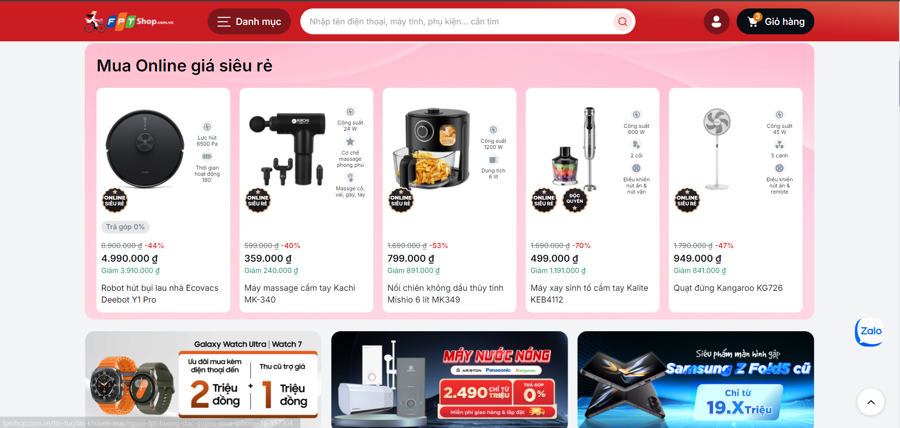
Description: This screen allows users to browse through various products offered, focusing on a user-friendly interface that showcases product details effectively. Clicking on a product image or name to redirect the user to the product detail page.

Product Detail
. 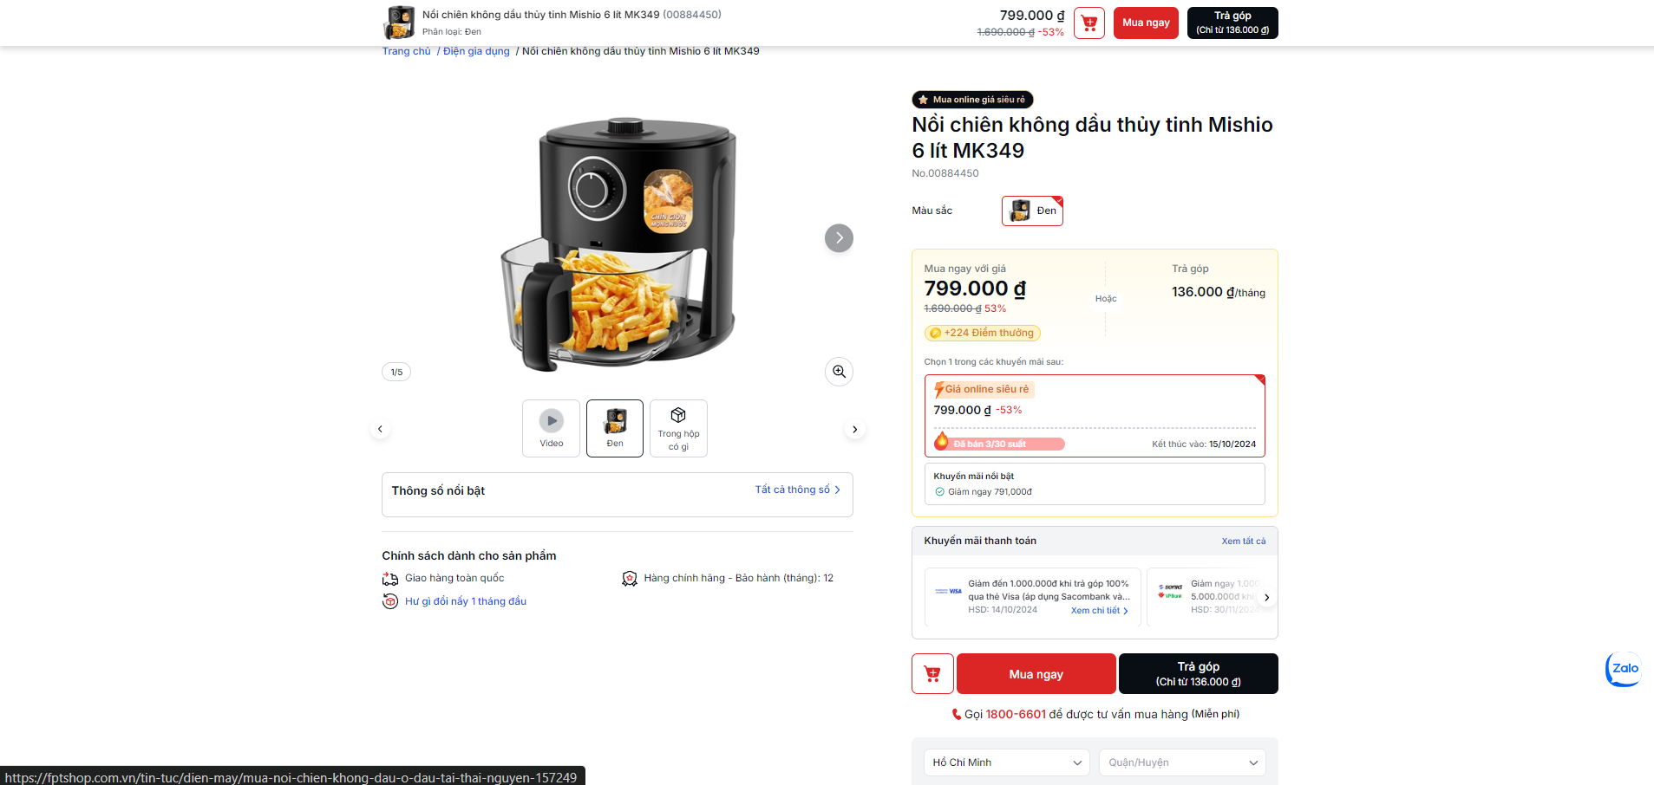

Description: The product detail page features high-quality images, detailed descriptions, specifications, and pricing information.

Options: Users can choose to either add the product to their shopping cart to continue shopping or click on 'Mua ngay' to proceed directly to the checkout.
- Add to Cart: If the user selects icon 🛒, the product is added to their cart, and they remain on the product detail page to possibly continue shopping.
- Buy Now: If the user selects 'Mua ngay, they are redirected to the shopping cart page which lists all items they have selected to purchase.

Shopping Cart
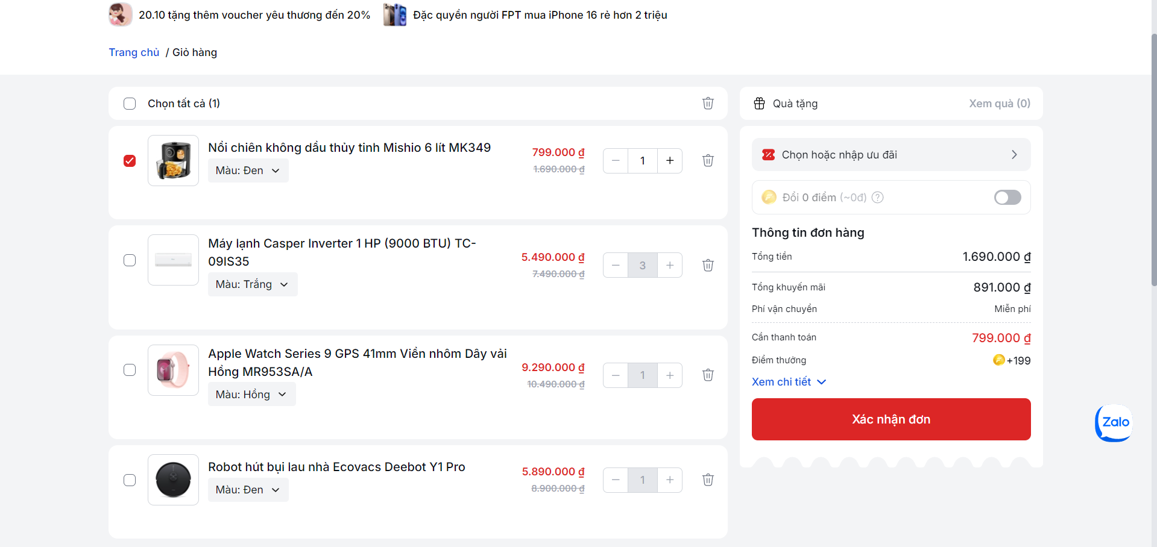

Cart Interface: The shopping cart page displays all items in the cart, quantities, prices, potential discounts, and the total cost.
Adjustments: Users can modify the quantity of products, remove items, or return to the shopping to add more items.
Proceed: After reviewing and adjusting their cart, the user can click 'Xác nhận đơn' to proceed

Confirm Order Products

After clicking “Xác nhận đơn” from shopping cart screen, go to order screen. This page allows users to review and edit information about the products they have selected to purchase, along with shipping and payment information.
Main Components:
- Product Information: Displays each item with an image, description, and price.
- Customer Information: Fields for the customer’s name and contact details.
- Delivery Options: Options for home delivery or store pickup, including address and timing details.
- Order Summary: Breakdown of the total cost, including itemized costs, discounts, shipping charges, and the total payable amount.
- Discounts and Loyalty Points: Input for discount codes or loyalty points to adjust the total cost.
- Electronic Invoice Request: Option to request an electronic invoice with necessary tax details.
- Payment Methods: Selection of preferred payment method.
- Final Confirmation: Button to place the order with a terms of service agreement checkbox.

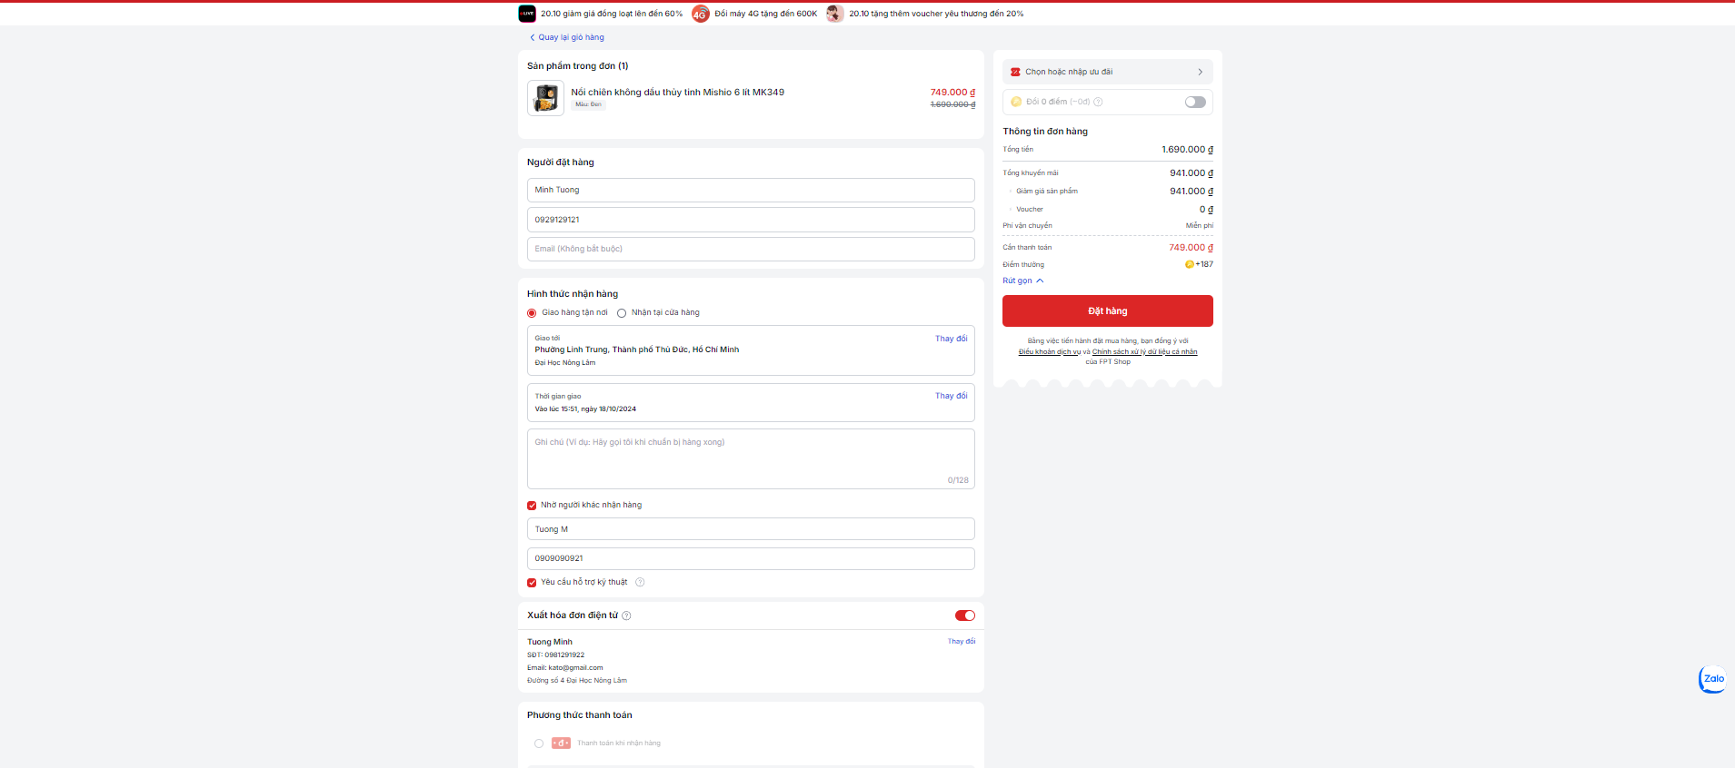

3.1.4.1 Customer Information

This section collects essential contact details from the customer necessary for processing and tracking the order.

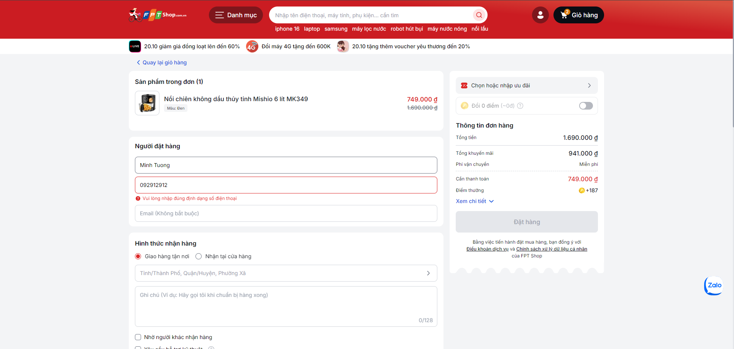

Fields and Validation Rules:
- Full Name:
  - Description: The customer must enter their full legal name to ensure accurate identification for the order.
  - Validation: The field must not be empty and should accept only alphabetic characters and basic punctuation (e.g., hyphens, apostrophes). Typically, a minimum and maximum character length is enforced (e.g., 2 to 50 characters).
- Phone Number:
  - Description: A valid phone number is required for order updates and potential delivery coordination.
  - Validation: This field must not be empty and should match a standard phone number format, including country and area codes if necessary. The system usually checks for 10-15 digits, allowing spaces and dashes for readability.
- Email Address:
  - Description: Used for sending order confirmations and receipts. It's optional but recommended for full order tracking and service updates.
  - Validation: If provided, the email must adhere to a standard email format (e.g., user@example.com). Validation checks typically include ensuring there is an '@' symbol followed by a domain.

3.1.4.2 Delivery Options

This section provide customers with flexible delivery options, either direct home delivery or store pickup, based on their convenience and preference.

There are 2 options for users to choose:

Home Delivery
- Description: Allows customers to have their order delivered directly to their specified address. This option is ideal for customers looking for convenience.
- Features:
  - Address Selection: Customers can select or input a new delivery address where they want the order shipped.
  - Delivery Timing: Customers can choose specific dates and time slots that best suit their availability for receiving the order.
  - Alternate Recipient: Provides an option to specify another person to receive the delivery, useful in scenarios where the primary recipient might not be available.

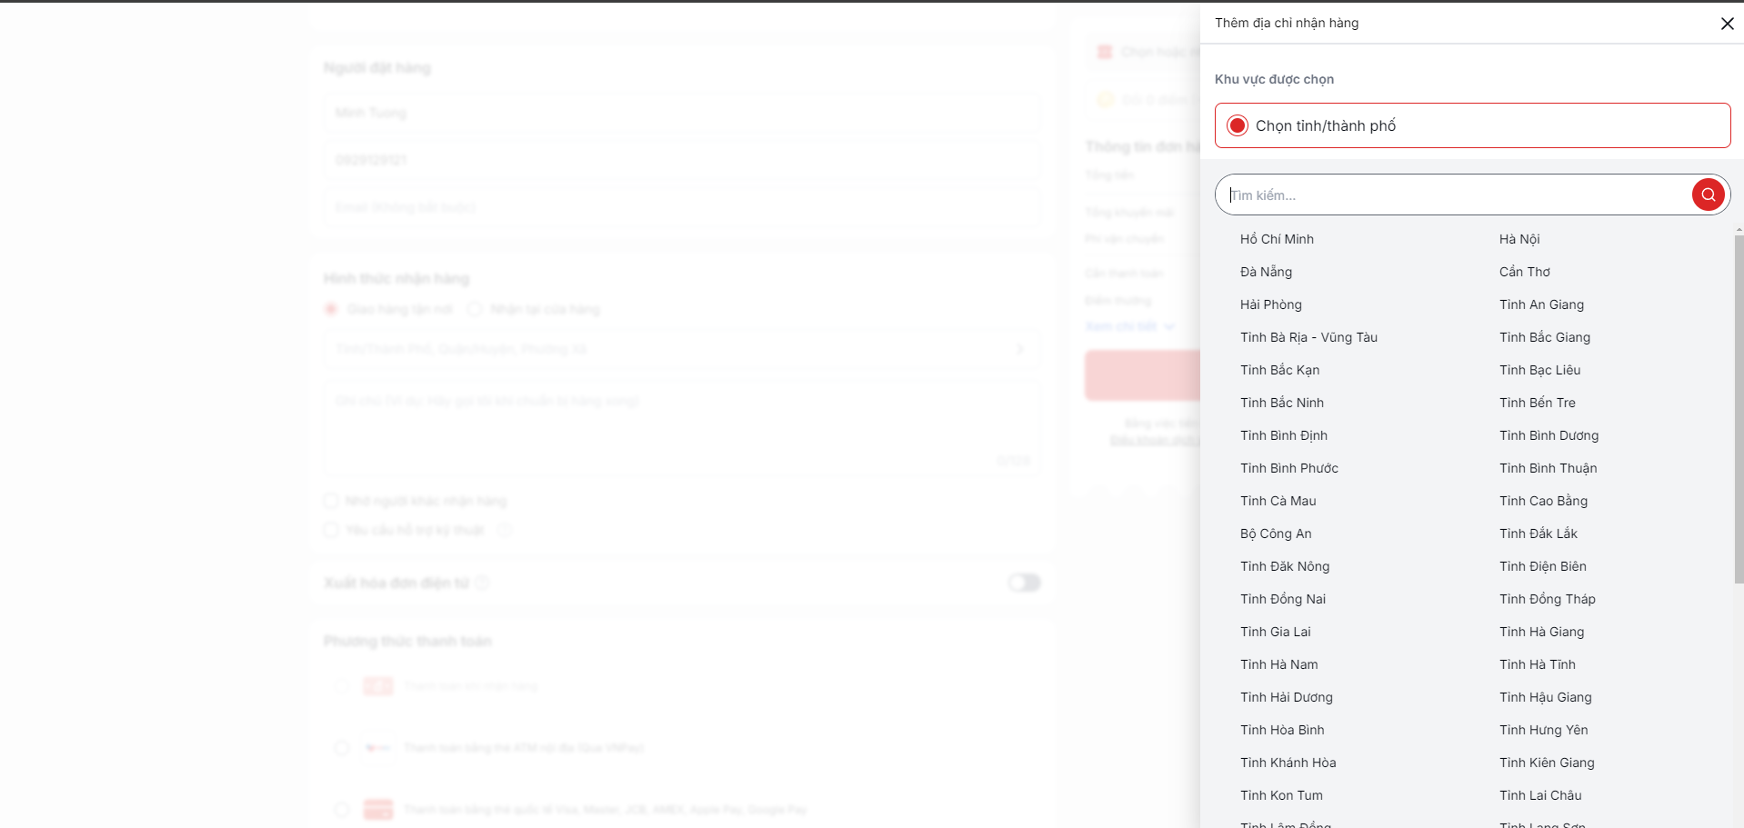

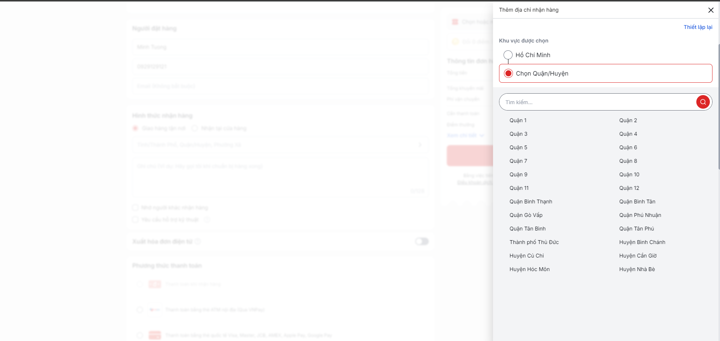

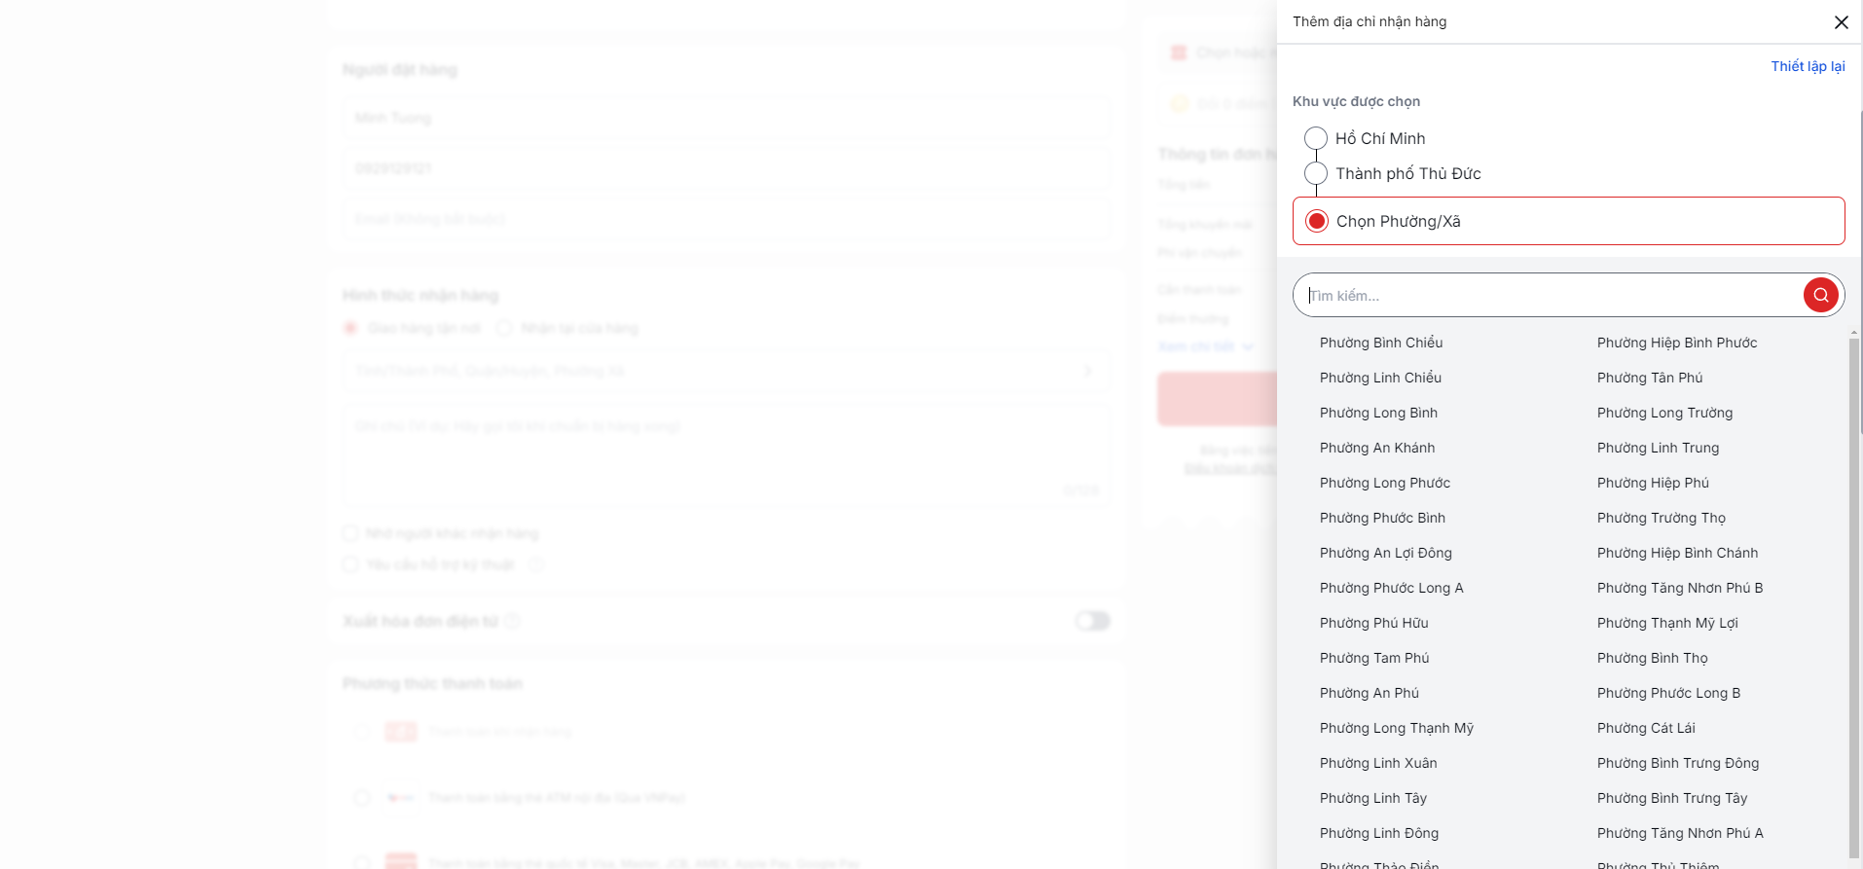

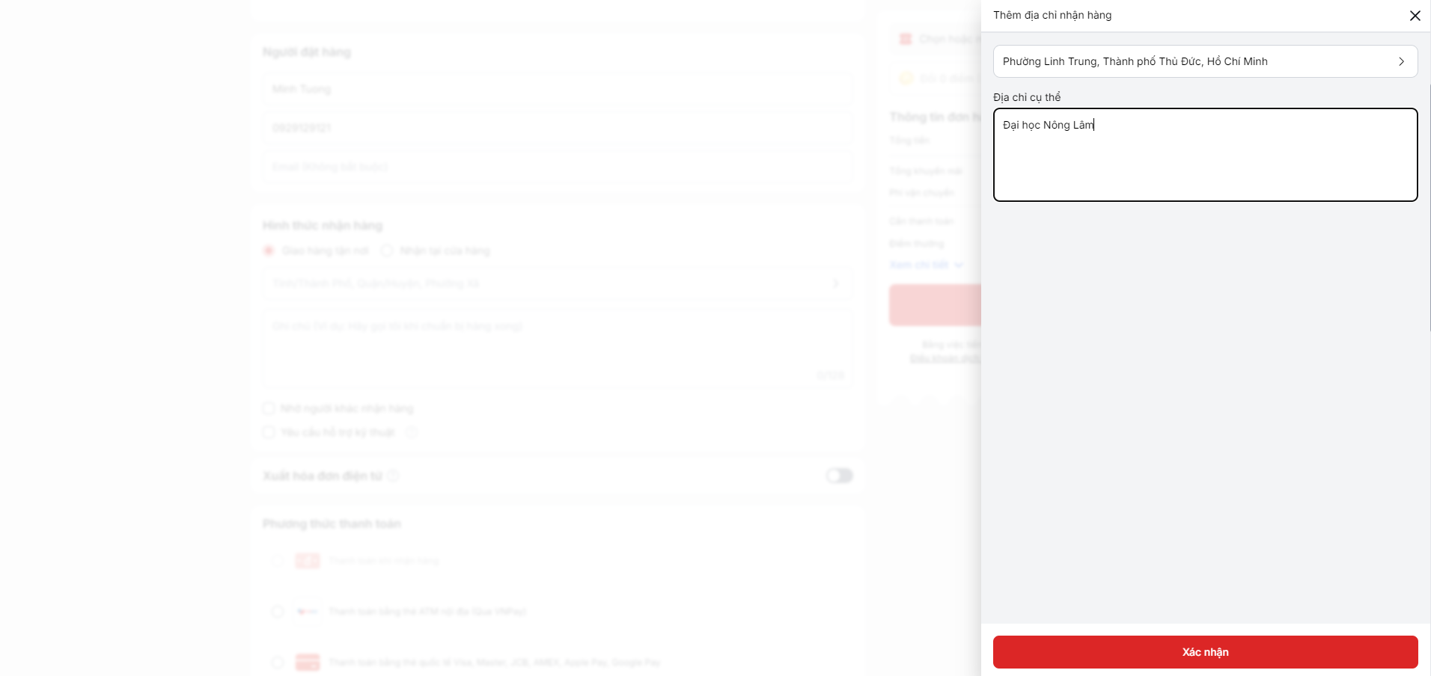

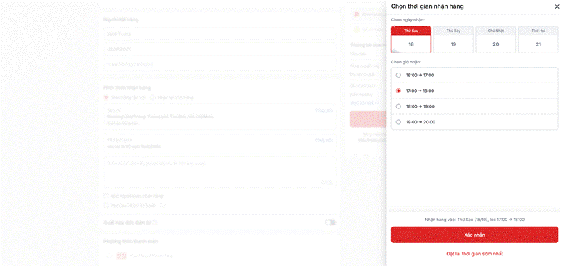

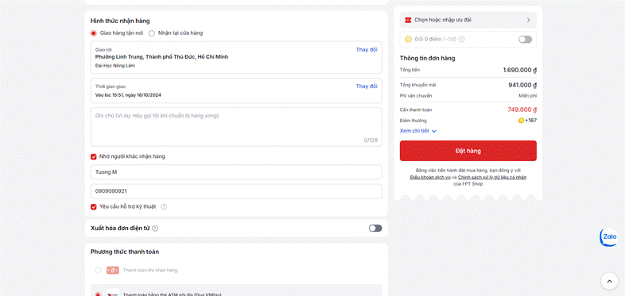

Store Pickup
- Description: Allows customers to pick up their order from a selected store location. This option caters to those who may want to receive their goods faster or at their own convenience without waiting for home delivery.
- Features:
  - Store Location Selection: Customers can choose from a list of available store locations where they wish to pick up their order. The selection list includes addresses and possibly store hours.
  - Technical Support Request: An option to request technical support at the time of pickup, which can be useful for electronic or technical products requiring initial setup or demonstration.
- Validation Rules:
  - Store Location: Must be selected from the available options.
  - Technical Support: Checkbox option; no validation required unless additional information is requested based on the support type.
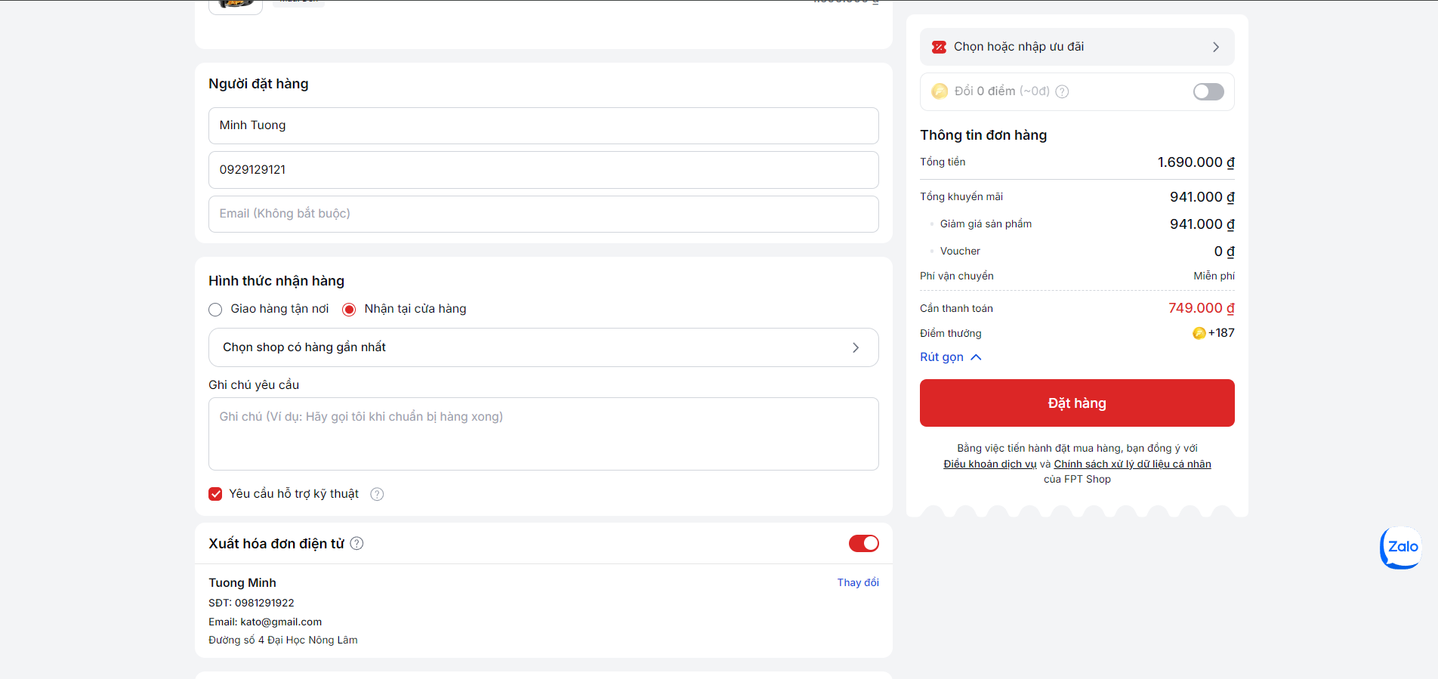

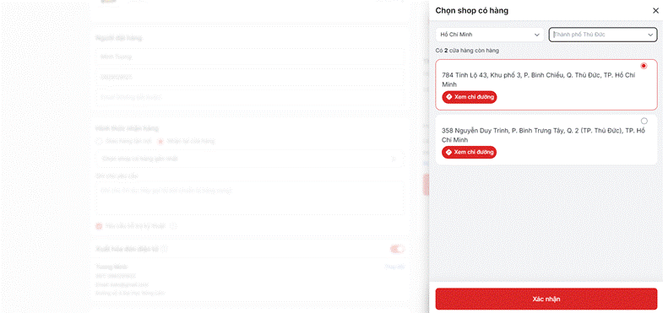

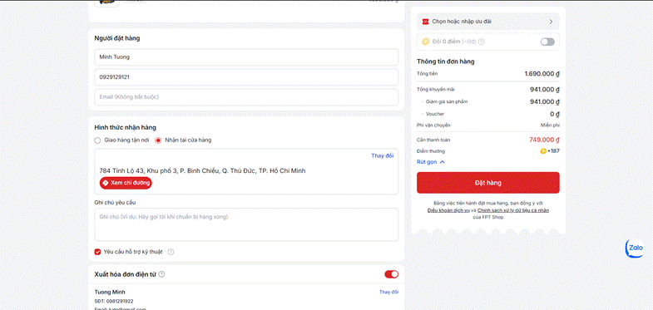

Common Features for Both Options:
- Technical Support Request: Both delivery methods include an option to request technical support, ensuring that customers can get help with their products as needed, either upon delivery or at the store during pickup.

3.1.4.3 Discounts and Loyalty Points

This section enables customers to apply discount codes and redeem loyalty points to obtain discounts on their orders, enhancing savings and customer loyalty.

Discount Code Entry:
- Description: Customers can enter a promotional or discount code to receive a specified discount on their purchase.
- Fields:
  - Code Entry: A text input field for entering the discount code.
  - Apply Button: Submits the code for validation and application to the total cost.
- Validation:
  - The code must match active promotions in the system.
  - Feedback is immediately given if the code is invalid or expired, with an error message displayed.

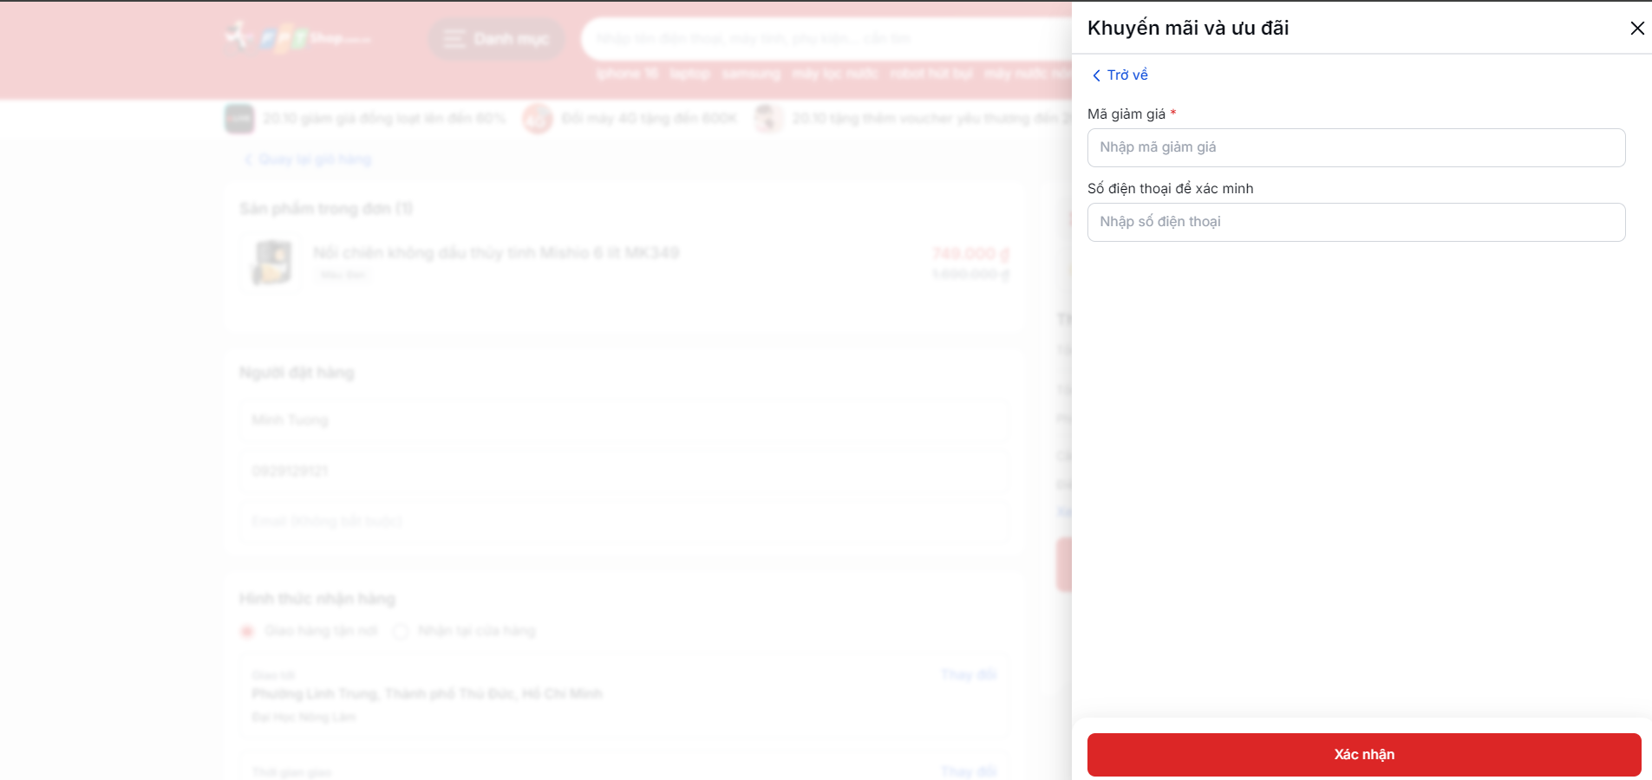

Loyalty Points Usage (Login Required):
- Description: Allows logged-in customers who participate in the loyalty program to use their accrued points towards the purchase for a discount.
  - Fields:
- Points Usage Toggle: An option for customers to select if they wish to use their points.
- Points Input: If enabled, customers can specify the amount of points they want to apply.
- Validation:
- The customer must be logged in to access and use their loyalty points.
- Ensures the inputted points do not exceed the customer's available balance.
- Points are converted into a monetary discount according to the loyalty program's terms and reflected in the total cost.

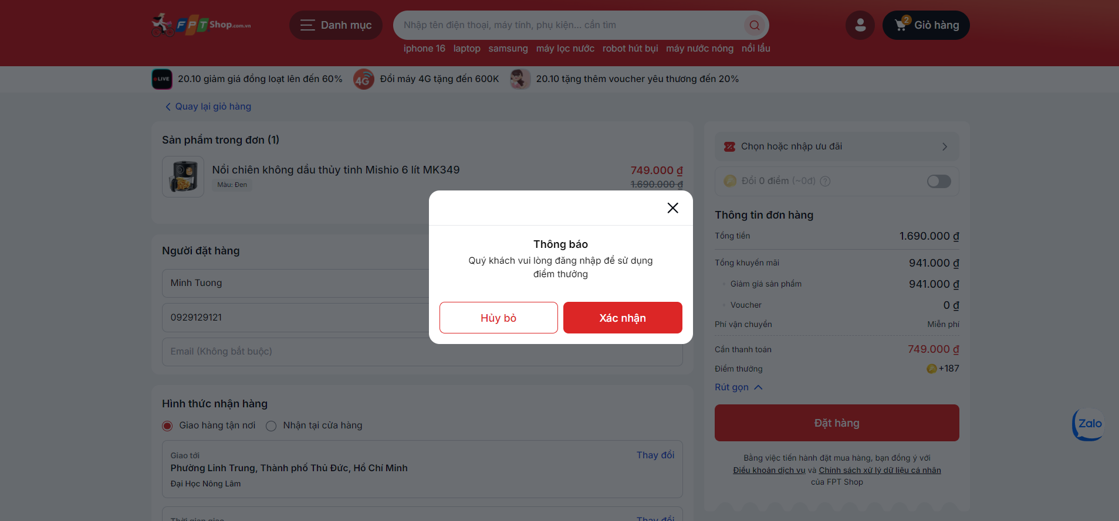

Additional Notes:
- Discount codes may be used by any customer, including guests, but loyalty points require the customer to log into their account, ensuring a personalized and secure experience.
- The interface dynamically updates the total price as discounts are applied, maintaining transparency and clarity in the final amount due.

3.1.4.4 Electronic Invoice Request

This section allows customers to request an electronic invoice for their purchase, suitable for both personal and corporate use, ensuring compliance with tax regulations or company reimbursement policies.

There are 2 options for user to choose:

Company: For businesses requiring an invoice with specific company details.

- Company Name:
- Description: Name of the company to be invoiced.
- Validation: Must not be empty when 'Company' type is selected; validates for string input.
- Tax Identification Number:
- Description: The tax ID number for the company, necessary for tax compliance.
- Validation: Required for company invoices. Must match the standard format for tax identification numbers (varies by country).
- Company Address:
- Description: Official address of the company.
- Validation: Must be provided for company invoices; checked for a valid address format.

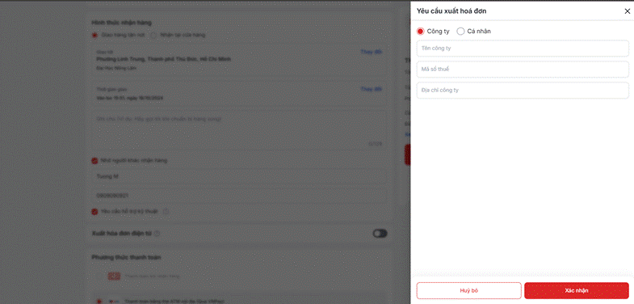

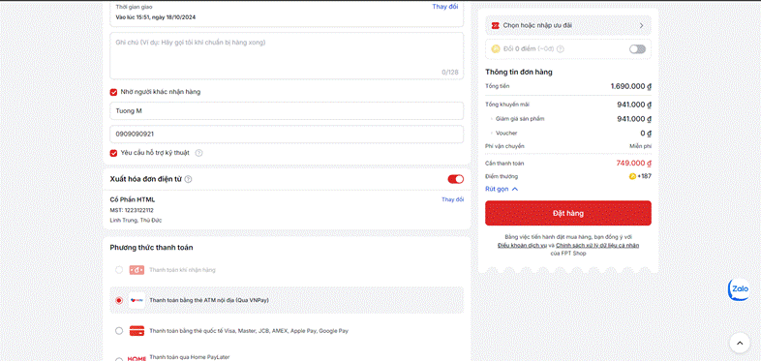

Personal: For customers needing a personal invoice.
- Email Address for Invoice Delivery:
- Description: The email address where the electronic invoice will be sent.
- Validation: Must be in a valid email format (e.g., user@example.com). The system checks for the presence of an '@' symbol followed by a domain, providing instant feedback if the format is incorrect.
- Address:
- Description: The physical address associated with the invoice. This can be useful for personal records or accounting purposes.
- Validation: Requires a valid address format. This field must not be empty and should match typical address structure expectations (e.g., include street name, number, city, and postal code).

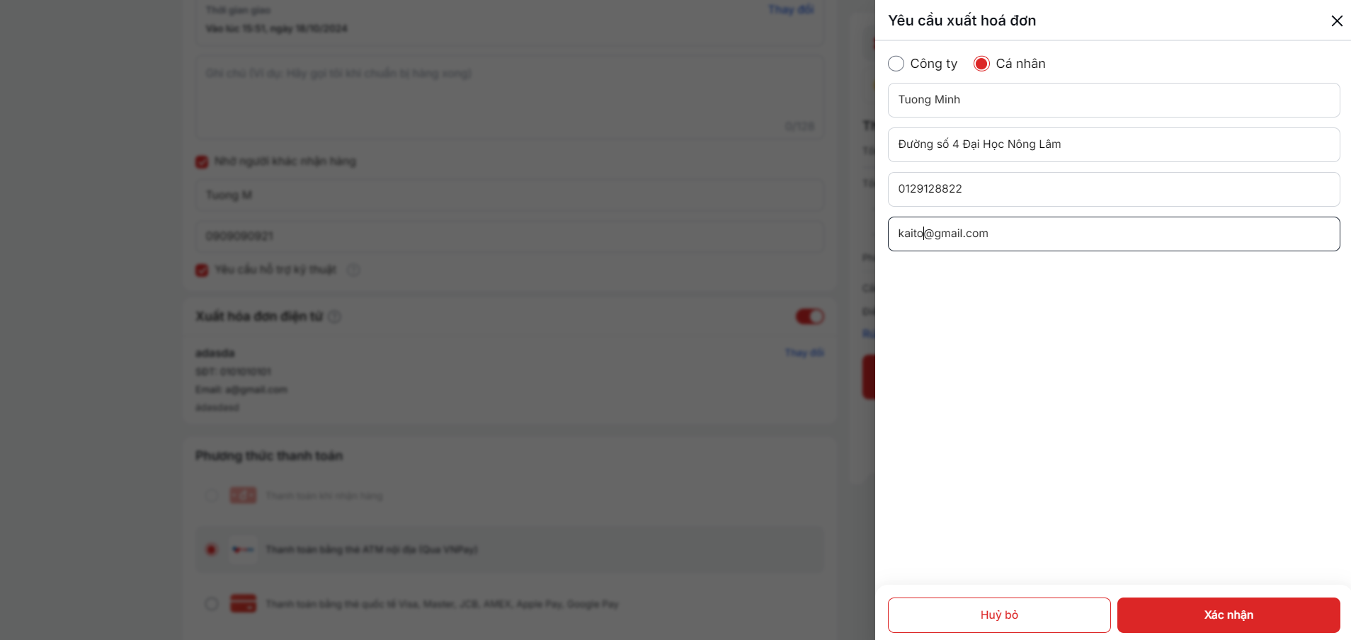

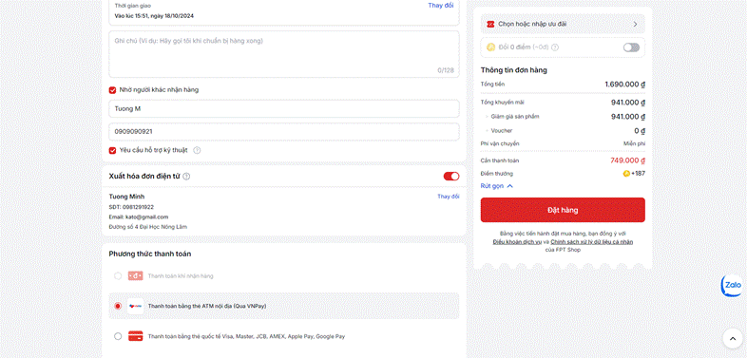

3.1.4.5 Payment Methods

This section enables customers to choose their preferred method of payment from a variety of options, ensuring a smooth and secure transaction process.

Available Payment Options and Features:
- Credit/Debit Card:
  - Description: Allows customers to pay using their credit or debit cards. Supported cards typically include Visa, MasterCard, and other major brands.
  - Validation: Card number, expiration date, and CVV must be entered correctly. The system performs real-time validation to check for the validity of the card details.
- Online Wallets:
  - Options: Include popular services like Apple Pay, Google Pay, and other regional wallets.
  - Description: Offers a fast and secure way to pay using digital wallet services, which can store card and bank information for quick access.
  - Validation: Customers must be logged into their respective accounts to use this payment method.
- Bank Transfer:
  - Description: Enables direct bank transfers from the customer’s account to the merchant's account.
  - Validation: Customers need to follow the instructions provided for bank transfers, usually involving logging into their online banking environment to authorize the payment.
- Payment on Delivery:
  - Description: Allows customers to make a payment at the time of delivery, either via card or cash, depending on the options offered by the delivery service.
  - Validation: This option may require verification that the delivery location is eligible for such a payment method.

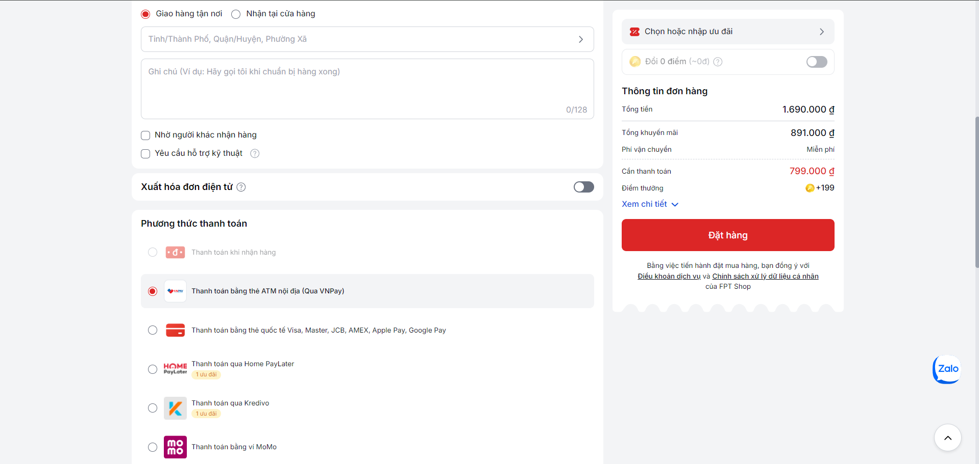

After completing, the user starts to check all the information and clicks the “Đặt hàng” button to place the order.

Payment
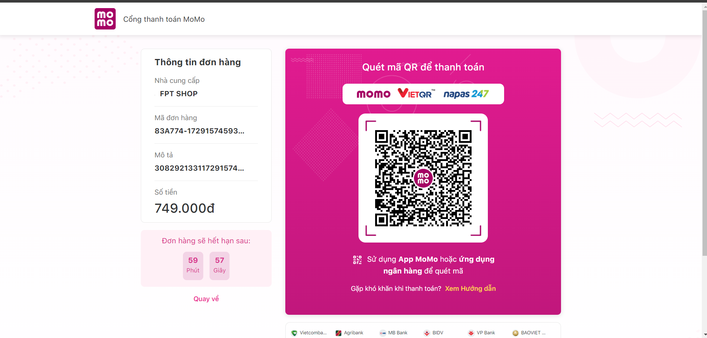

After clicking “Đặt hàng”, the user will be redirected to the payment screen.
This checkout screen is designed to facilitate a quick and secure payment process by allowing customers to complete their purchase using a QR code.
The checkout page prominently features a QR code for payment, streamlining the transaction process. This page is accessible after the customer confirms their order and is ready to make a payment.

