Concept: Our project will be a boardgame information and recommendation Dashboard. From boardgamegeek.com, we will use api requests to acquire data about boardgames. This data will then be transformed using python and loaded into a mo ngoDB database. Using a Flask app and JavaScript, users will be able to search for boardgames with various filtering and sorting options. Results will be displayed using the Swiper library.

Dataset API link:

https://boardgamegeek.com/wiki/page/BGG_XML_API2

Metadata:

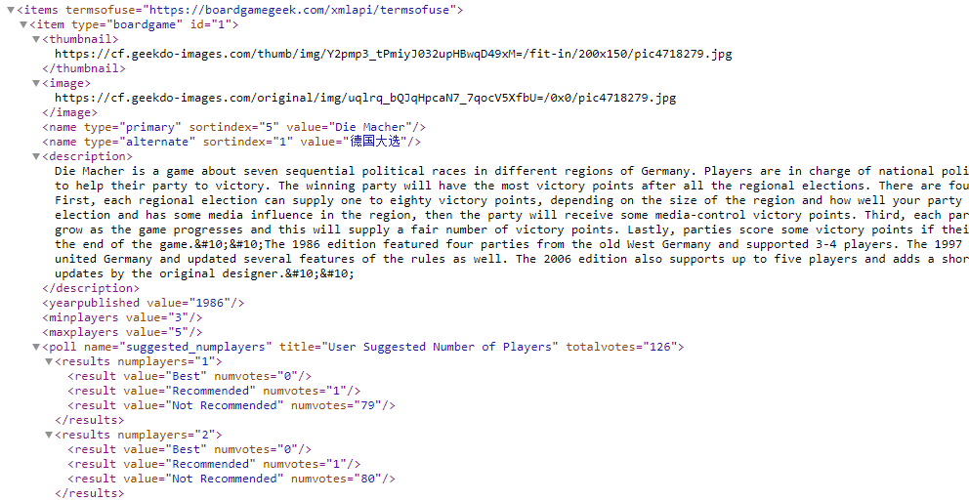

Design Sketch:

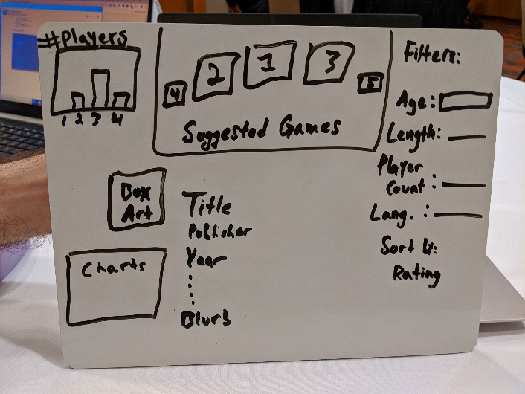

Inspiration screenshots:

