ME759 Final Project Report
University of Wisconsin-Madison
2017

Normalized Cross Correlation GPU Implementation for Ultrasound Elasticity Imaging

Rashid Al Mukaddim, Michael Turney, Robert Pohlman

December 21

Abstract

The text of the abstract is put here. Times new roman with font size 11.

Contents
1. Motivation 4
2. Problem Statement 4
3. Implementation 4
3.1 Normalized Cross-Correlation for Elastography 4
3.2 MATLAB vs C Implementation 5
4. Results 5
4.1 Graphs 5
4.1.1 Changes in Kernel Size 5
4.1.2 Changes in Search Range 5
4.1.3 Changes in Overlap 5
4.2 Speed-Ups 5
5. Conclusions 5
5.1 Successes 5
5.2 Future Work 5
6. References 5

Motivation

Elastography is a process of using Ultrasound to measure the elasticity of a material from an applied force. This has many important uses, especially in medical imaging. In our Ultrasound Lab in the Medical Physics Department, we work on calculating the elasticity for cardiac and liver applications. This done by calculating displacement from a given force in the tissue. The gradient of the displacement is then taken to give a relative strain measurement of the tissue. This strain is an important aspect for clinicians to deduce the tissue properties for assessing current treatments or ailments.
Current methods we use for calculating the displacement include the Multilevel using 2D Normalized Cross Correlation; the displacement estimation method developed in our lab. The Multilevel algorithm operates as a pyramid, where initial displacements are computed starting on a coarse grid using large kernels, followed by computations on finer and finer spatial grids to obtain high SNR estimates with high spatial resolution. This method is very computationally expensive and time consuming, so it currently is done post-procedure due the time constraints of procedures. Similar processes to the Multilevel method have been implemented [1-4].
We aim to create our own GPU implementation of this displacement estimation method in hopes of speeding up processing time, leading towards a real-time implementation.

B-Mode | Strain
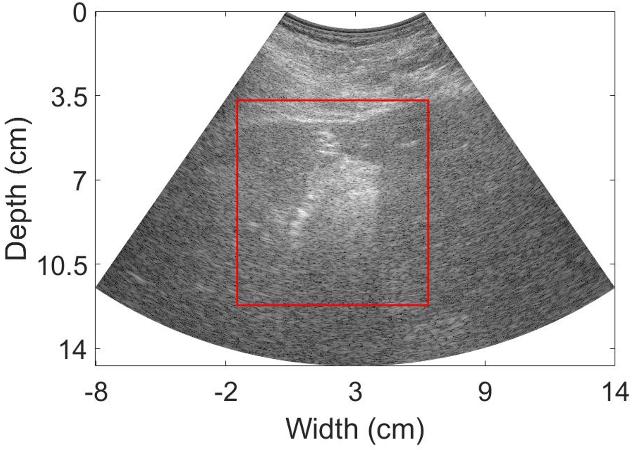 | 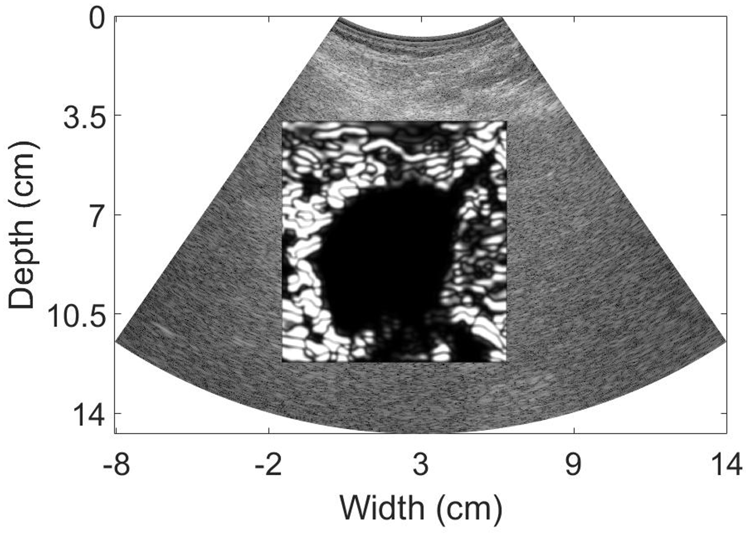
Figure 1 – Sector Ultrasound image of a liver after Microwave ablation procedure. Left image shows B-mode image with box surrounding ablated region, right image demonstrates the strain image of the boxed region.

Problem Statement
We aim to create a GPU implementation for one grid level of the Multilevel using 2D Normalized Cross Correlation to speed up displacement estimation computational time. This single level can easily be repeated in the future for the other levels to create the pyramidal scheme that the Multilevel ensues.

Implementation

Normalized Cross-Correlation for Elastography
Explain how NCC for Elastography works.

MATLAB vs C Implementation
C implementation would be much faster.
MATLAB is much easier to use for research purposes to study and is what is used in our lab.
We settled to use MATLAB with a C++ wrapper.

Results

Graphs

Changes in Kernel Size

Changes in Search Range

Changes in Overlap

Speed-Ups

Conclusions

Successes

Future Work

References
There are no sources in the current document.

References:

[1] S. Deka, "A CPU-GPU Hybrid Approach for Accelerating Cross-correlation Based Strain Elastography," Texas A & M University, 2011.
[2] N. Deshmukh, H. Rivaz, and E. Boctor, "GPU-based elasticity imaging algorithms," in Proc. Int. Conf. Med. Imag. Comp. & Comp. Assist. Interven, 2009.
[3] N. H. Meshram and T. Varghese, "Fast multilevel Lagrangian carotid strain imaging with GPU computing," in Ultrasonics Symposium (IUS), 2017 IEEE International, 2017, pp. 1-4: IEEE.
[4] E. Montagnon, S. Hissoiny, P. Després, and G. Cloutier, "Real-time processing in dynamic ultrasound elastography: A GPU-based implementation using CUDA," in Information Science, Signal Processing and their Applications (ISSPA), 2012 11th International Conference on, 2012, pp. 472-477: IEEE.

