Documentation of To-Do Application

By: Melissa Heredia

# Functional Requirements

Users need to be able to (1) view tasks in the task list, (2) add tasks to task list,(3)delete tasks from task list.

# Non-Function Requirements

The website needs to have (1) Neat and easily readable design (2) Easy to use interface(3) Fast performance.

System Architecture Diagram one for the complete system

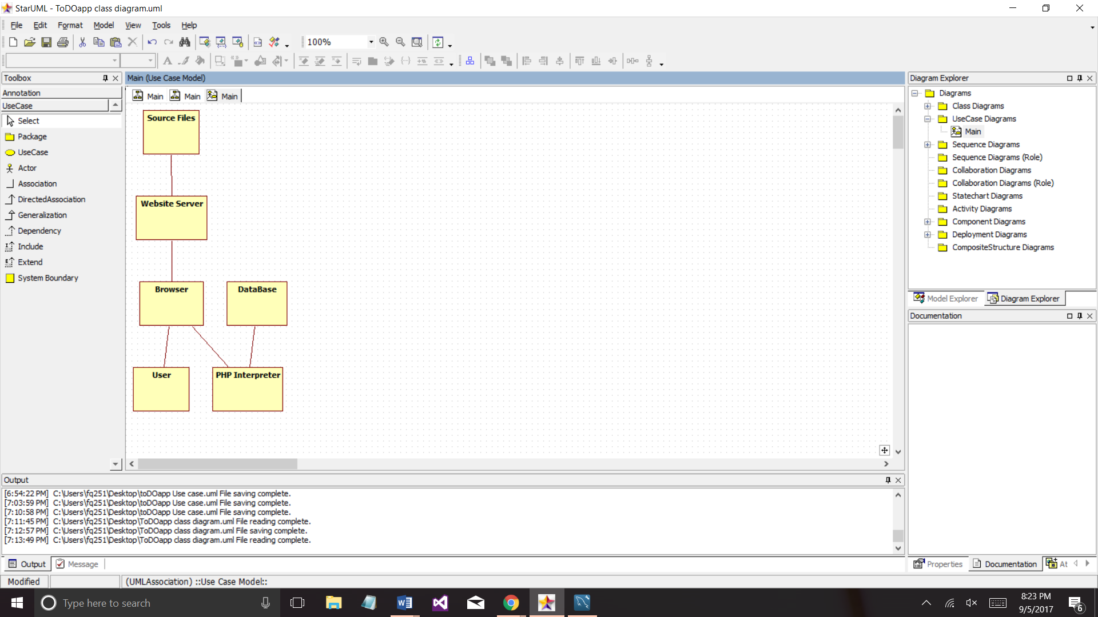

Data Flow Diagram one for the complete system ( level 2)

Use case 3 use cases

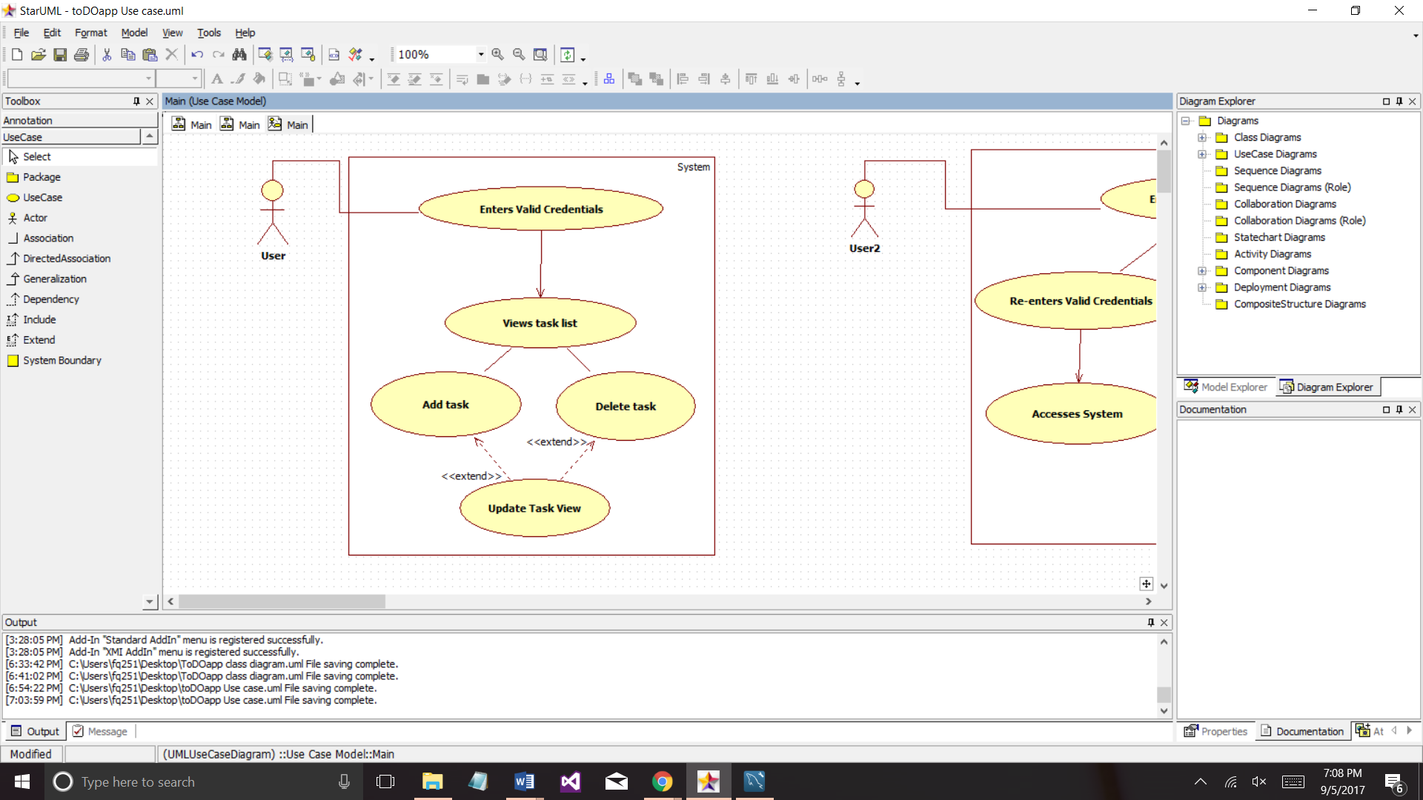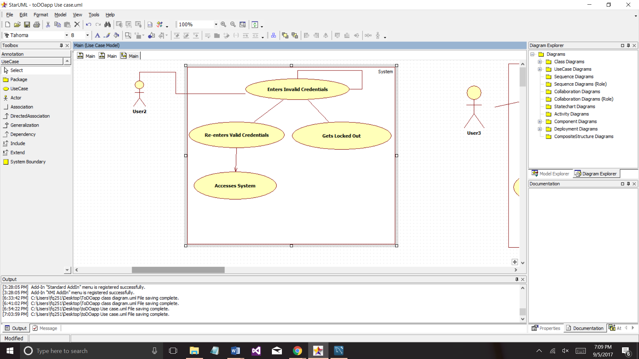

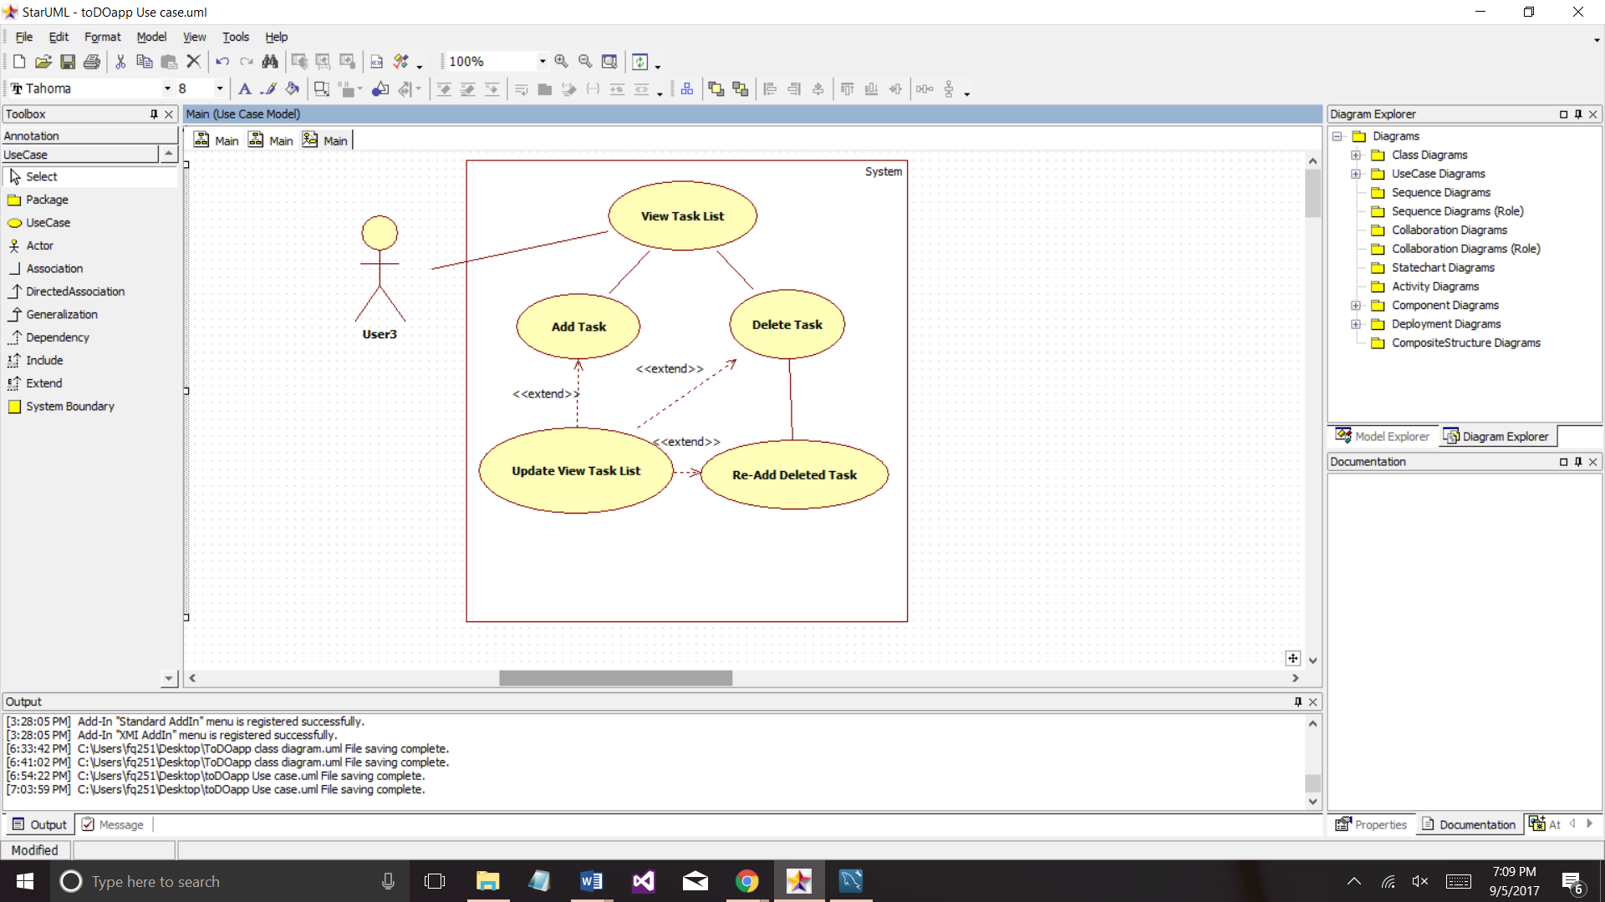

Sequence Diagram 3 sequence diagrams

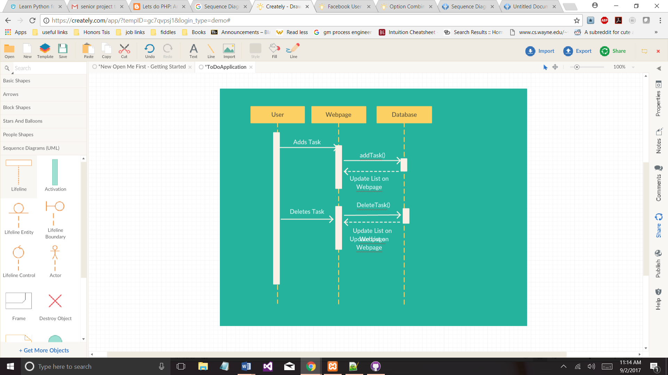

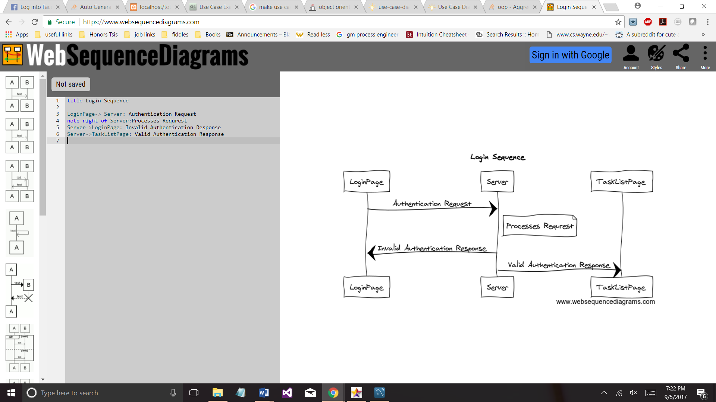

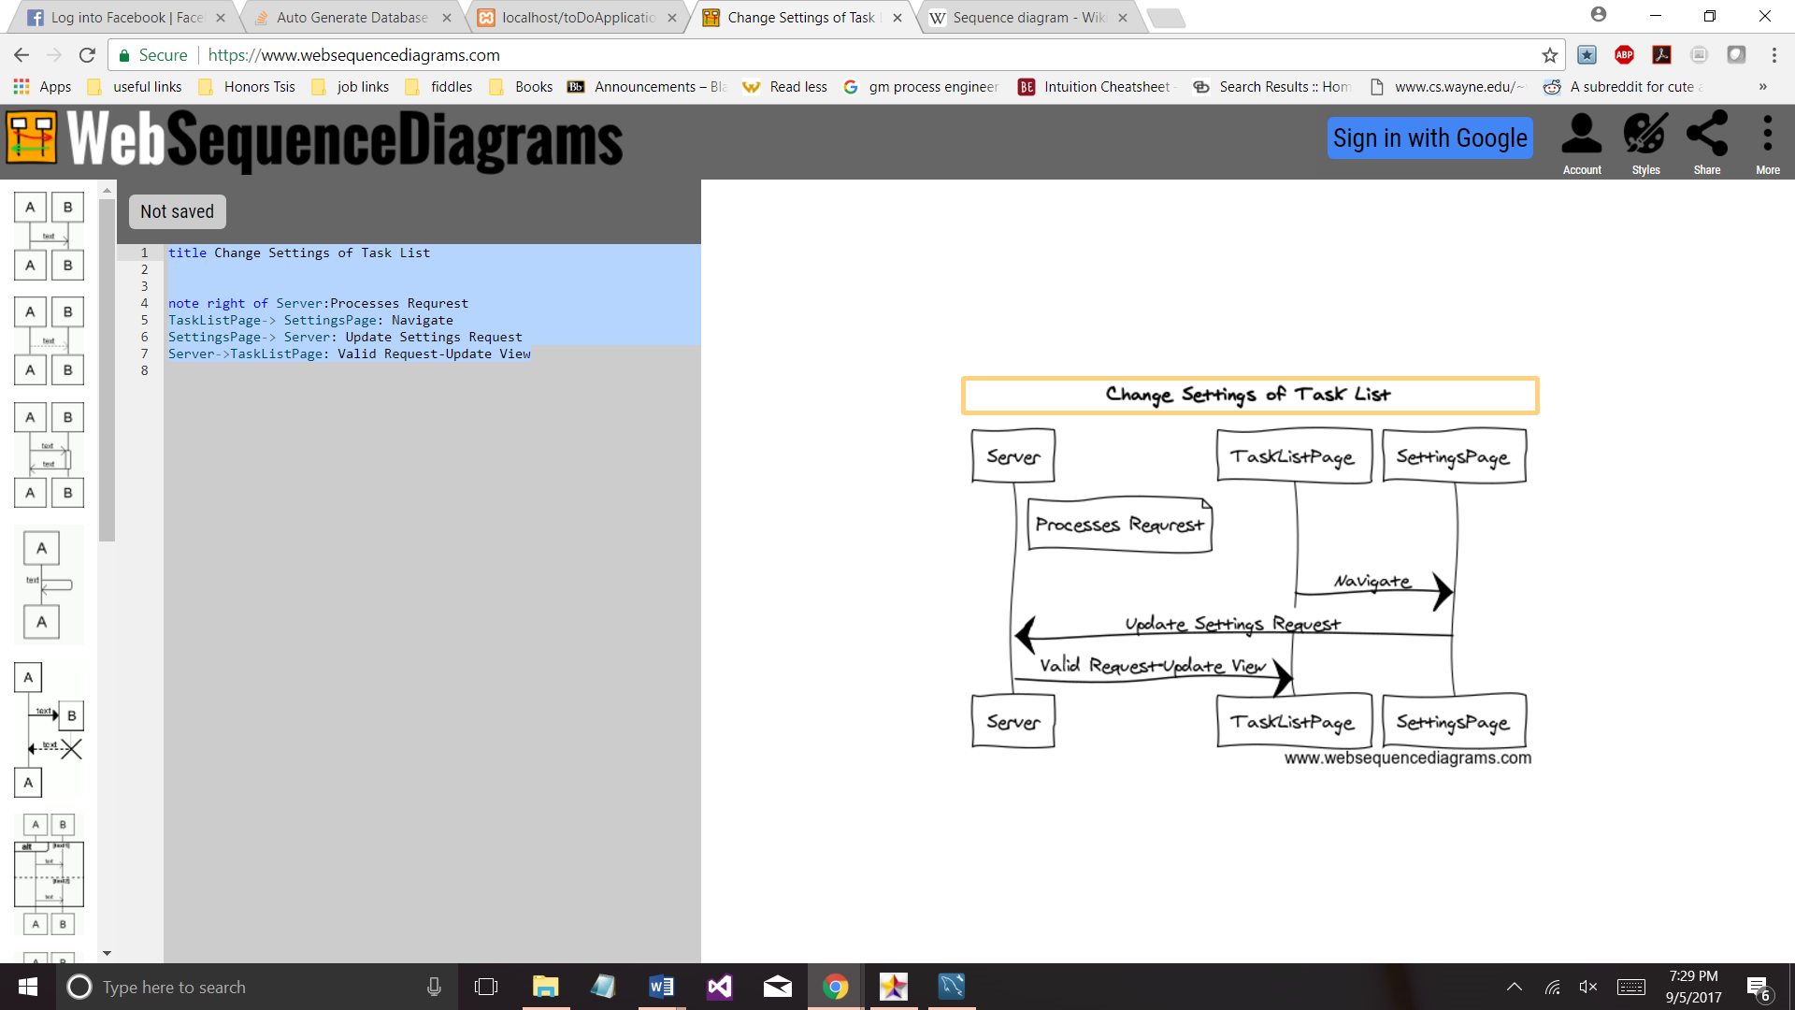

# Database Design

one for the system, 3 tables

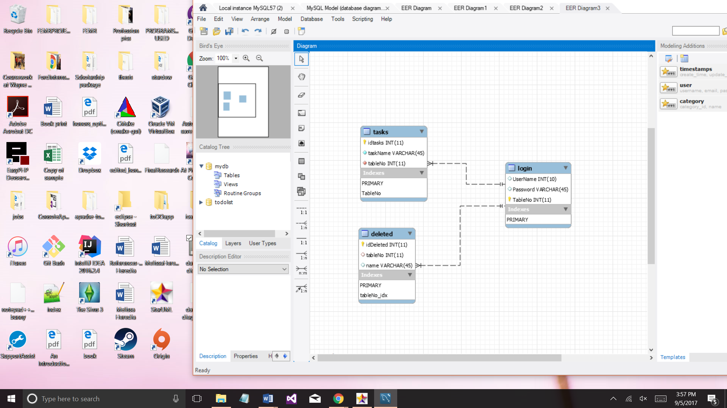

Class diagram one for the system, 3 classes

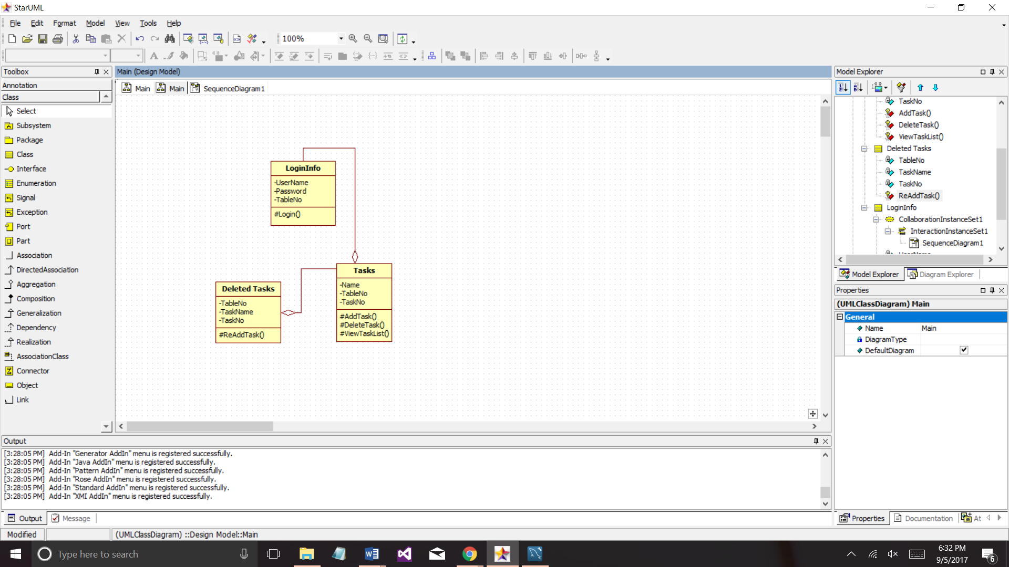

Test Case 3 operations to be tested

|  |  |  |  |
| --- | --- | --- | --- |
| **Scenario** | **Test Step** | **Expected Result** | **Actual Outcome** |
| Verify the add functionality adds new task to list. | Type in new task name in the add task text box and click the Add Task submit button. | The new tasks name and id should be displayed at the bottom of the task list. | The new tasks name and id is displayed at the bottom of the task list. |
| Verify the delete functionality deletes valid task from list. | Type in an existing task id in the delete task text box and click the Add Task submit button. | The task name associated with the task id typed in should be deleted from the table. | The task name associated with the task id is deleted from the table. |
| Verify the user can view the task list at the proper time. | Add tasks to the table and the user should be able to view the table. Delete all tasks from list, the user should not be able to view the table. | If there are tasks in the table the user should be able to view the table, otherwise the table should be hidden. | When there are tasks in the table the user can view the table, otherwise the table is hidden. |

# Work Breakdown

|  |  |  |  |  |
| --- | --- | --- | --- | --- |
| Name of task | Est. No. Hours | Time Spent | Notes | Issues |
| Initial Scaffolding | 1 | .5 |  | None |
| View Task | 3 | 1 |  | None |
| Add Task | 3 | 1 |  | None |
| Delete Task | 3 | 2 |  | Issues with the MySql query and validation was necessary |
| CSS | 1 | 1 |  | Issues with css not updating on site |
| Learn about the various diagrams/documentation | 2 | 1 |  | None |
| Function and nonfunctional requirements | 1 | .25 |  |  |
| Use case | 1 | .5 |  |  |
| System Architecture Diagram | .5 | 1 |  | -Issue finding software to make diagram |
| Data Flow Diagram | 1 |  |  |  |
| Sequence Diagram | 1 | .5 |  |  |
| Database Design | .5 | .75 |  | Problems with software to create diagram |
| Class diagram | .5 | .3 |  |  |
| Test Case | 1 | .25 |  |  |