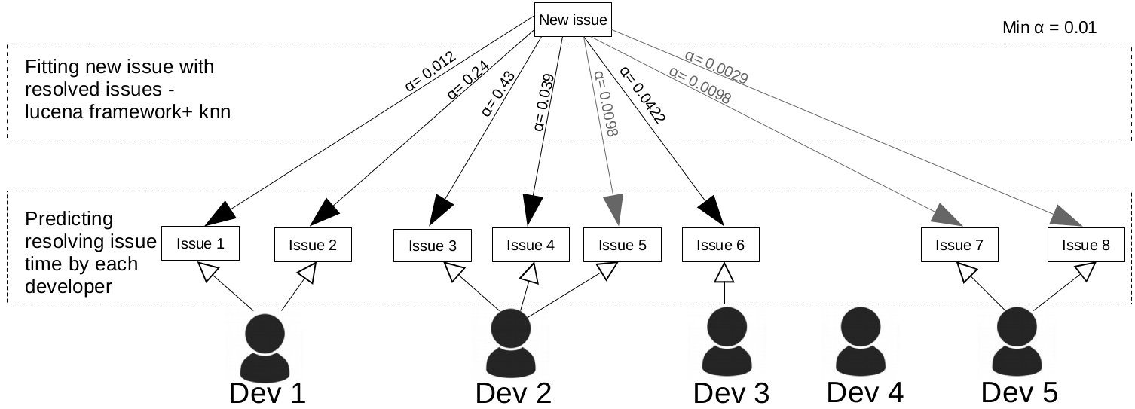

When new Jirra issue is reported, similiar issues are going to be founded in the database which holds resolved issues. Lucena framework and k-nearest neighbours algorithm are responsible for it. We introduced parameter α, which means level of similarity to the original issue. We also set minimum threshold similarity in order to reject issues, which are not similar enough to make prediction.
We take issue with appropriate α level, we take time to resolve and we create Table 1.
We're able now to make prediction about estimated time for fixing issue. Developer 4 has no issue resolved, developer 5 does not have any resolved issue with minimum α level, hence we can compute estimation time only for the first three developers.
We computed arithmetic mean α, which is sum of all α for developer divided by their quantity. It specifies the level of belief for computed estimated time. For example for first developer it is (0,012 + 0.24 / 2) ≈ 0.13. Estimated time is sum of α multiplied by time resolved dived by arithmetic mean α. For first developer it is (0.012 * 2 + 0.24 * 4) / 0.13 ≈ 3.90

