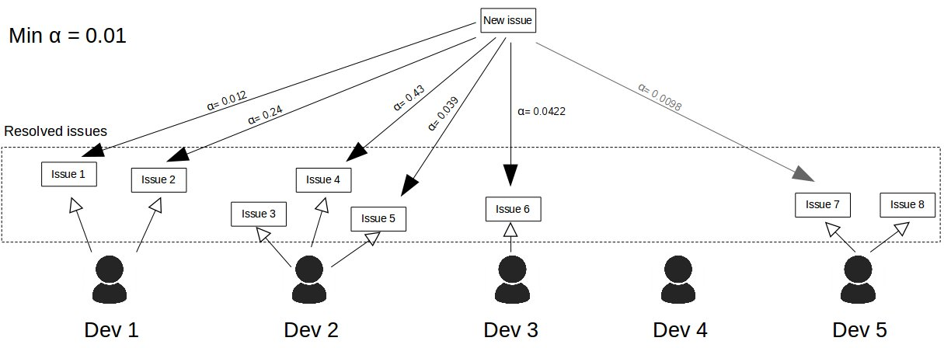

When new issue is reported, similiar issues are being founded in the database which holds resolved issues. We introduce parameter α, which means level of similarity to the original issue. We have possibility to set minimum threshold similarity. We take issue which have appropriate α level, we take time to resolve and we create Table 1.
We're able now to make prediction about estimated time for fixing issue. Dev 4 has no issue resolved, Dev 5 does not have any resolved issue with minimum α level, hence we can compute estimation time only for the first three developers. We computed weighted α, which is sum of all α for developer divided by their quantity. Estimated time is sum of α multiplied by time resolved dived by sum of α.
Weighted α means the level of belief for computed estimated time.

