A+ Computer Science PONG PART V

Lab Goal : This lab was designed to teach you more object oriented programming and how to write a very simple game.

Lab Description : Add in an interface to standardize methods.

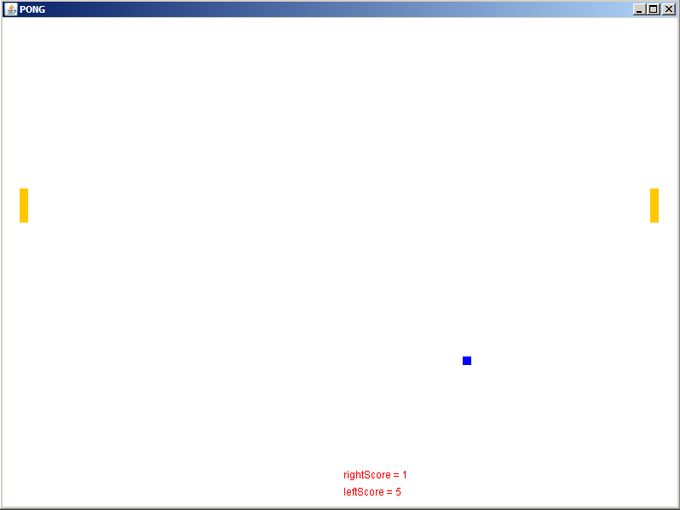

PONG GAME EXTENSIONS - INTERFACES

1. Create the following Collidable interface. Have Ball implement this interface as it will be doing all of the colliding.

public interface Collidable
{
boolean didCollideLeft(Object obj);
boolean didCollideRight(Object obj);
boolean didCollideTop(Object obj);
boolean didCollideBottom(Object obj);
}

These methods will receive objects and determine if a collision has occurred between this object and the other object.
Move the collision detection code from paint into the appropriate method. Make calls to the new methods.

2. Create a Wall class that is an extension of Block. Then, make new instance variables for all 4 Walls. Finally, rewrite your code so
that you actually check to see if the Ball collides with the Walls rather than will fixed number boundaries.

3. Save a copy of your Pong game and turn it into BreakOut. BreakOut was a cool 80s game with a field of Blocks at the top, a ball,
and a paddle that moved across the bottom of the screen. The ball bounced off of the paddle and hit the Blocks. Once a Block was hit, that Block would disappear.

